EMPLOYEE ATTRITION ANALYSIS PROJECT
Key Drivers of Attrition — Root Cause Analysis
Phase 6: Why Employees Leave — 8-Factor Deep Dive

1. Executive Summary
Eight factors commonly cited as attrition drivers — Salary, Overtime, Promotion, Work-Life Balance, Job Satisfaction, Environment Satisfaction, Distance From Home, and Years At Company — were each tested against actual attrition rates. Four emerged as very strong, consistent drivers (Overtime, Tenure, Salary, Work-Life Balance); three are moderate/strong secondary drivers (Environment Satisfaction, Job Satisfaction, Distance From Home); and one — Promotion recency — turned out to be a weak, inconsistent predictor on its own, despite being frequently assumed to be a top attrition cause.

2. Ranked Driver Summary
Factors ranked by the size of the attrition-rate gap between their best and worst groups (a larger spread means a stronger driver):
# | Factor | Rate Range | Spread | Strength
1 | OverTime | 10.4% -> 30.5% | +20.1 pts | Very Strong
2 | Years At Company (0-2 vs 11-20 yrs) | 6.7% -> 29.8% | +23.1 pts | Very Strong
3 | Salary (Q1 vs Q4) | 10.3% -> 29.3% | +19.0 pts | Very Strong
4 | Work-Life Balance (Best vs Worst) | 14.2% -> 31.3% | +17.1 pts | Very Strong
5 | Environment Satisfaction (High vs Low) | 13.4% -> 25.4% | +12.0 pts | Strong
6 | Job Satisfaction (High vs Low) | 11.3% -> 22.8% | +11.5 pts | Strong
7 | Distance From Home (Near vs Far) | 13.8% -> 22.1% | +8.3 pts | Moderate
8 | Promotion Recency (Years Since Last Promotion) | 10.1% -> 18.9% | +8.8 pts* | Weak / Inconsistent
*Promotion's spread looks moderate on paper, but the pattern across groups is not linear or consistent (see Section 4) — the size of the gap alone overstates its reliability as a predictor.

3. Salary
Employees were split into four equal-sized pay quartiles to test whether attrition tracks with compensation level.
Salary Quartile | Employees | Attrition Rate
Q1 (Lowest) | 369 | 29.27%
Q2 | 366 | 14.21%
Q3 | 367 | 10.63%
Q4 (Highest) | 368 | 10.33%
Business observation: The relationship is sharp and almost linear — the bottom pay quartile has an attrition rate nearly 3x the top quartile (29.27% vs. 10.33%). Average monthly income for leavers is $4,787 versus $6,833 for stayers — a $2,046 gap. This is one of the most direct, controllable levers available: entry-level and lower-band compensation review is likely to yield a measurable retention improvement, particularly when combined with the tenure finding below (new hires are disproportionately in the lowest pay quartile).

4. Overtime
Employees who work overtime leave at 30.53%, compared to 10.44% for those who don't — a 3x difference, the single sharpest divide of any binary factor tested. Business observation: overtime is best read as a symptom of understaffing or workload imbalance in specific teams rather than an isolated policy issue. Because overtime combines with other risk factors particularly severely (see Section 8), it is the most urgent operational lever to investigate — likely through headcount planning, workload audits, and manager-level workload distribution reviews in the highest-overtime teams (notably Sales).

5. Promotion
Years Since Last Promotion was grouped into bands to see whether being 'overdue' for a promotion predicts attrition.
Years Since Last Promotion | Employees | Attrition Rate
0 (Promoted this year) | 581 | 18.93%
1-2 years | 516 | 14.73%
3-5 years | 158 | 10.13%
6-15 years | 215 | 16.28%
Business observation: Unlike salary or overtime, promotion recency does NOT show a clean pattern — attrition dips in the 3-5 year band (10.13%) rather than rising steadily, and the average Years Since Last Promotion is actually slightly LOWER for leavers (1.95 years) than stayers (2.23 years). This means employees are not, on average, leaving because they've been passed over for a long time — many leave relatively soon after a promotion or early in their promotion cycle. Business implication: promotion cadence alone is not a reliable lever here; if used, it should be combined with satisfaction and compensation signals rather than treated as a standalone retention fix.

6. Work-Life Balance, Job Satisfaction & Environment Satisfaction
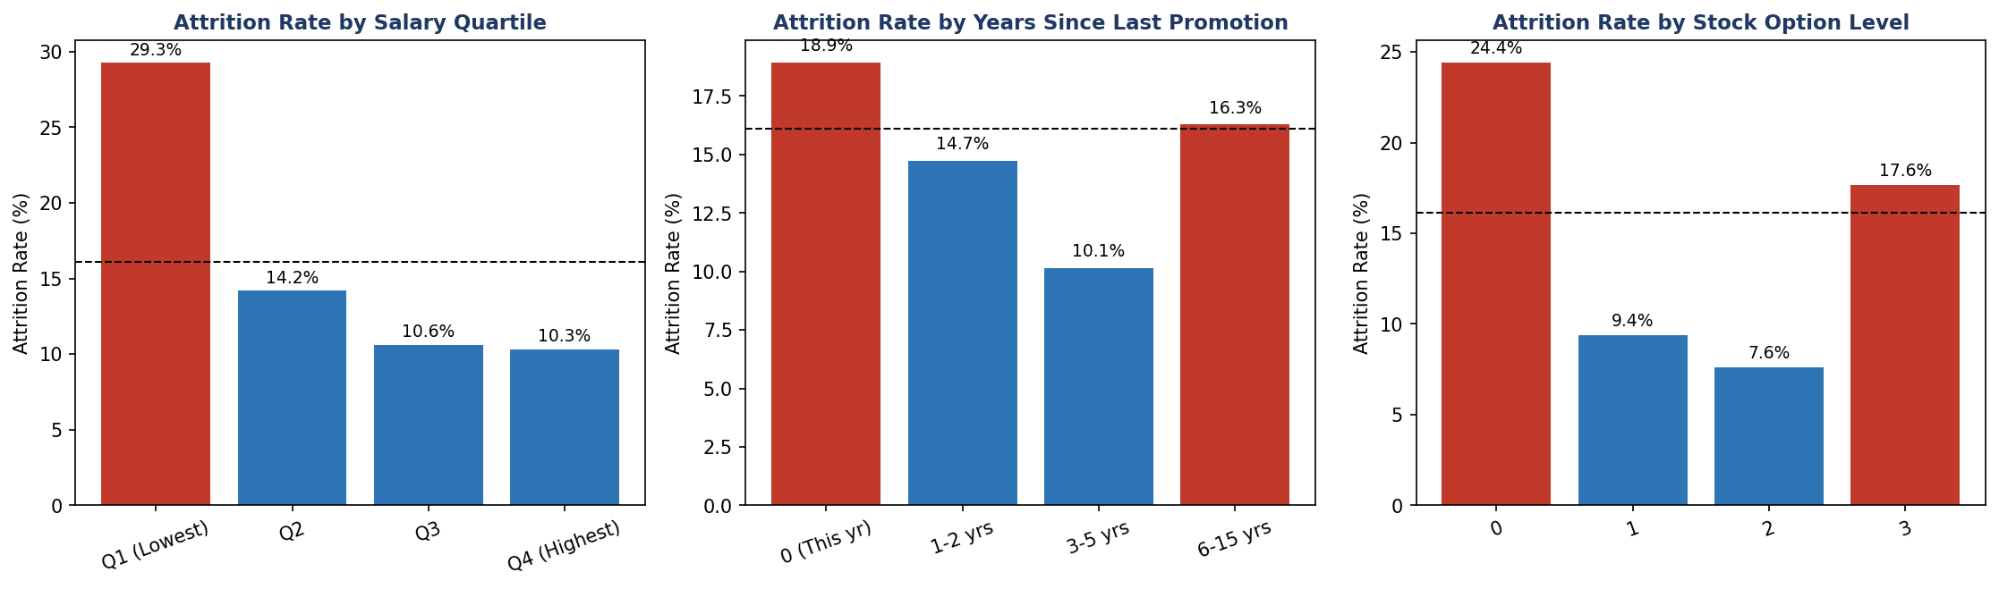
Figure 1: Attrition rate by Salary Quartile, Years Since Last Promotion, and Stock Option Level.
Work-Life Balance shows the widest swing among the satisfaction-type metrics: employees with the worst rating (level 1) leave at 31.3%, more than double the rate of those with the best balance (14.2%). Job Satisfaction shows a similarly steep, consistent decline from 22.8% (lowest) to 11.3% (highest). Environment Satisfaction follows the same pattern, from 25.4% down to 13.4%. Business observation: all three are genuine, consistent, and monotonic (steadily improving) drivers — meaning they behave the way intuition would predict, unlike Promotion. Because these are measured through regular engagement/pulse surveys, they are also the most immediately actionable: a low score on any of these three should be treated as an early flight-risk flag for that individual or team, not just an aggregate statistic.
As a side note, Stock Option Level (shown above) also shows a strong, consistent pattern — employees with zero stock options leave at 24.4%, dropping to 7.6-9.4% for those with options — reinforcing that tangible, ongoing financial incentives (not just base salary) measurably support retention.

7. Distance From Home
Attrition rises from 13.8% for employees living within 5 miles/km of work to 22.1% for those 21-29 miles/km away — a meaningful but not dominant gradient, with some noise in the middle bands. Business observation: commute distance is a real but secondary factor. It's unlikely to justify a company-wide policy change on its own, but is a reasonable factor to weigh in hybrid/remote-eligibility decisions, particularly for employees who also show other risk signals (low satisfaction, overtime).

8. Years At Company — and Compounding Risk
Tenure is one of the strongest single predictors on its own: employees in their first two years leave at 29.8%, compared to just 6.7% for those with 11-20 years of service. But its real power shows up in combination with the other factors above:
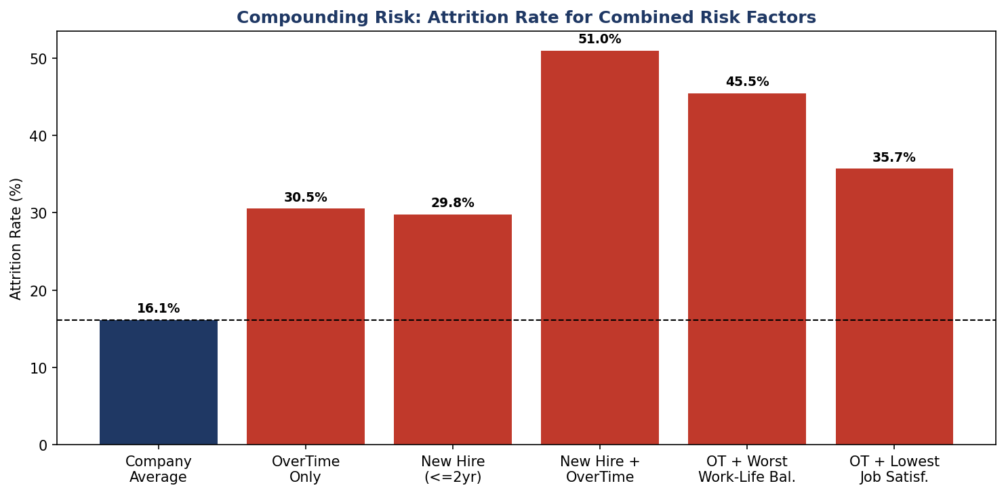
Figure 2: Attrition rate compounds sharply when multiple risk factors overlap in the same employee.
Business observation: A new hire (0-2 years) who also works overtime leaves at 50.96% — more than 3x the company average, and roughly 60 employees out of every 100 in that combined group. Overtime combined with the worst work-life balance score reaches 45.45%; overtime combined with the lowest job satisfaction reaches 35.71%. This is the most important insight in the analysis: attrition risk is not additive, it compounds. A single risk factor raises concern; two or more overlapping in the same employee should be treated as a near-certain flight risk requiring immediate manager attention.

9. Overall Business Observations
- Salary, Overtime, Work-Life Balance, and Tenure are the four dominant, reliable drivers of attrition — each shows a large, consistent, and logical gap between high-risk and low-risk groups.
- Job Satisfaction and Environment Satisfaction are strong secondary drivers, both behaving consistently and both measurable through regular pulse surveys, making them useful early-warning indicators.
- Distance From Home is a real but modest factor — worth including in flexible-work decisions, not a standalone policy priority.
- Promotion recency is the one factor that does NOT behave as commonly assumed — leavers are not disproportionately 'overdue' for promotion, so promotion-cadence policy changes alone are unlikely to meaningfully reduce attrition.
- The most powerful insight is compounding risk: employees combining two or more risk factors (especially new tenure + overtime) leave at 3x the company average or higher. Retention efforts will have the highest return if they specifically target employees who show multiple overlapping risk signals, rather than applying uniform, company-wide interventions.

