EMPLOYEE ATTRITION ANALYSIS PROJECT
Segment-Wise Attrition Analysis Report
Phase 4: Attrition Rate by Employee Segment (15 Factors)

1. Methodology
Rather than comparing raw headcounts (which are misleading when groups have different sizes), every factor below is analyzed using ATTRITION RATE — the percentage of employees in each group who left. The overall company attrition rate is 16.12%; this is used as the benchmark line in every chart. Groups above the benchmark are shown in red (elevated risk), groups at or below it in blue (lower risk).

2. Core Workforce Factors: Gender, Department, OverTime, Marital Status
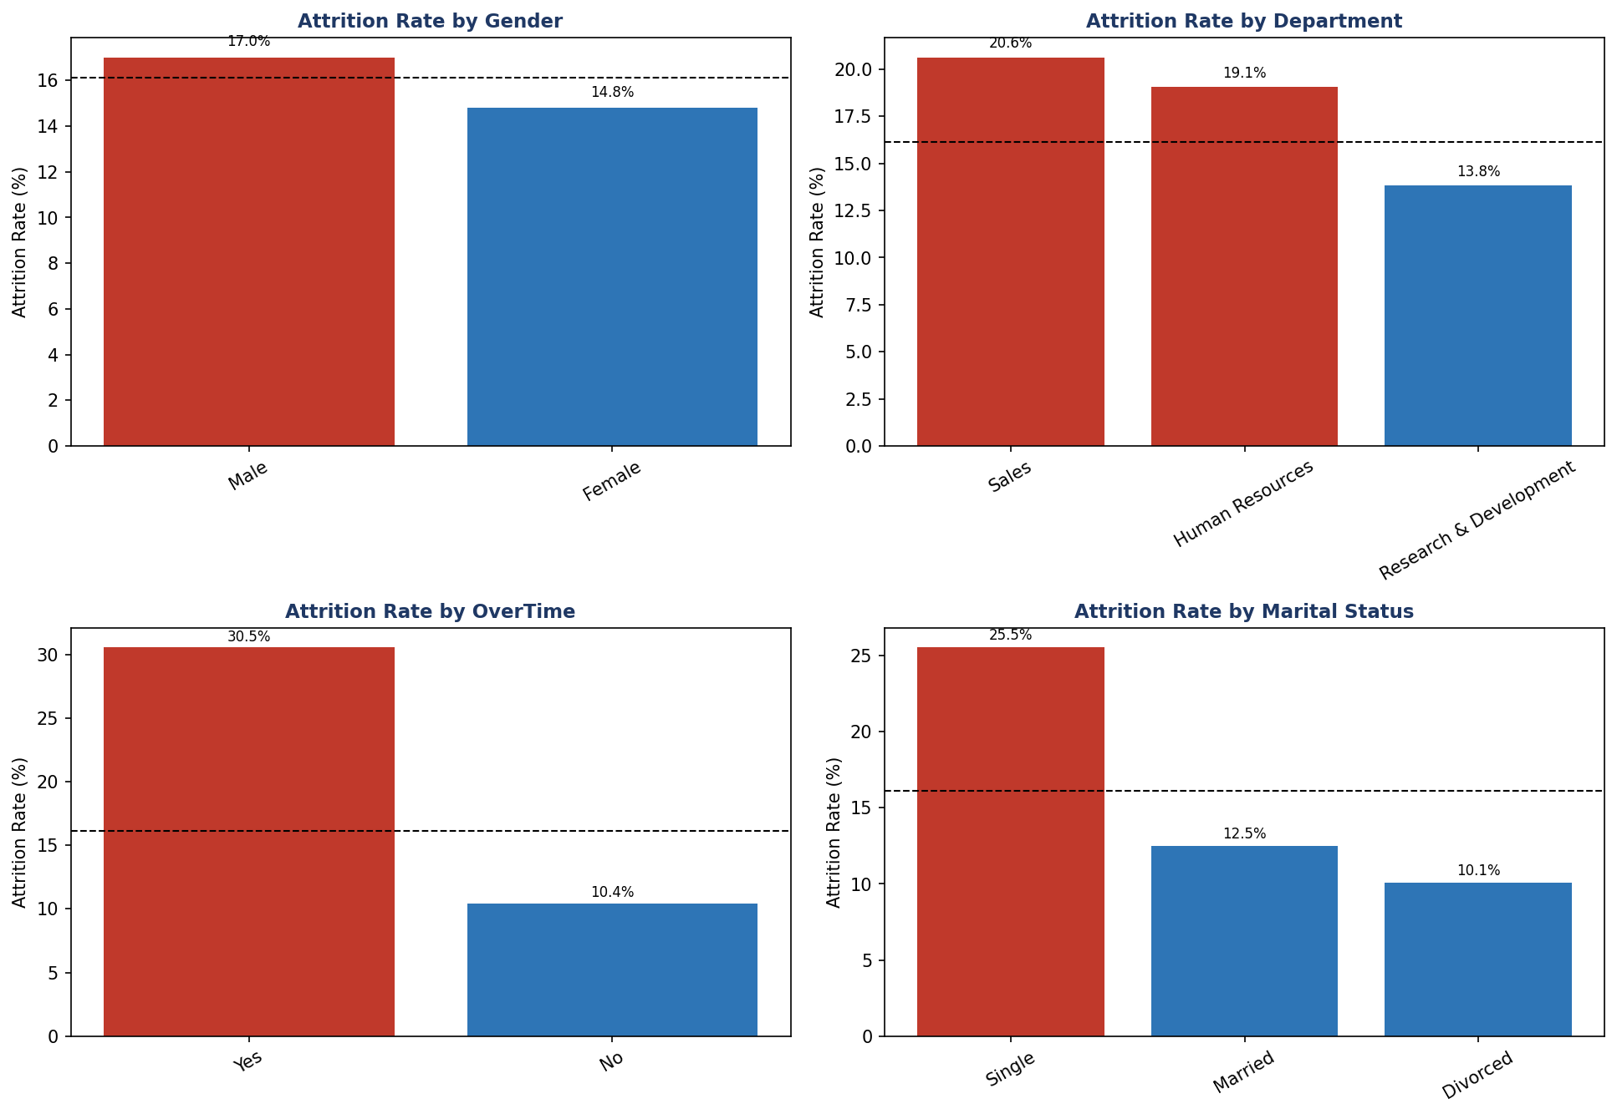
Figure 1: Attrition rate by Gender, Department, OverTime, and Marital Status. Dashed line = company-wide average (16.12%).

Gender
Male employees leave at 17.0% versus 14.8% for female employees — both close to the company average. Business insight: gender is not a meaningful driver of attrition here; retention strategy does not need to be gender-differentiated.

Department
Sales has the highest attrition rate at 20.6%, followed by Human Resources at 19.1%, while Research & Development sits lowest at 13.8%. Business insight: Sales roles likely carry higher pressure (targets, client-facing stress, commission variability) contributing to turnover. Since Sales is also a revenue-critical function, even a moderate rate here has outsized business impact and deserves focused retention attention.

OverTime
This is the single sharpest divide in the entire dataset: employees who work overtime leave at 30.5%, nearly 3x the rate of those who don't (10.4%). Business insight: overtime is a strong, actionable burnout signal. Reviewing workload distribution, staffing levels, and overtime policy in high-overtime teams could meaningfully reduce attrition.

Marital Status
Single employees leave at 25.5%, versus 12.5% for married and 10.1% for divorced employees. Business insight: single employees typically have fewer financial/household anchors and more career mobility, making them more prone to exploring other opportunities. This group may benefit from targeted engagement or career-growth conversations early in their tenure.

3. Job Role
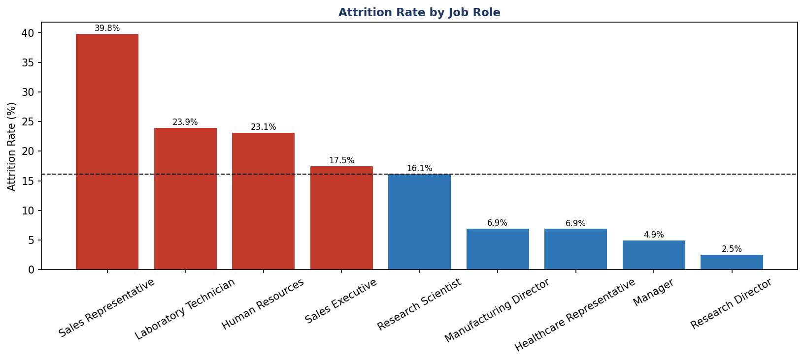
Figure 2: Attrition rate by Job Role, sorted highest to lowest.
Sales Representatives have by far the highest attrition rate at 39.8% — more than double the company average — followed by Laboratory Technicians (23.9%) and Human Resources staff (23.1%). At the other end, Research Directors (2.5%), Managers (4.9%), and Healthcare Representatives (6.9%) are the most stable roles. Business insight: attrition is heavily concentrated in front-line, individual-contributor roles rather than leadership roles — consistent with typical career-stage patterns, but the Sales Representative rate is high enough to warrant a dedicated retention review (compensation structure, career pathing, or manager support in that specific role).

4. Business Travel & Education
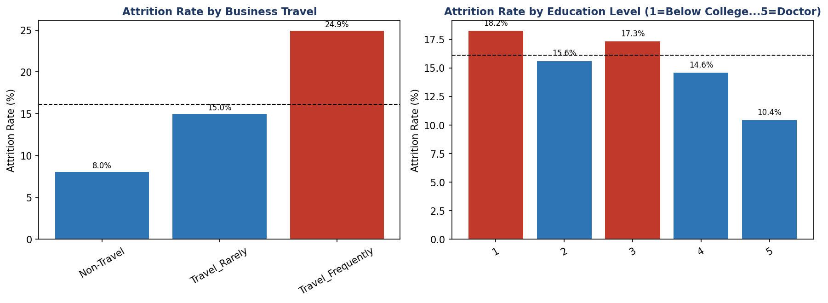
Figure 3: Attrition rate by Business Travel frequency and Education level.

Business Travel
Attrition rises steadily with travel frequency: 8.0% for non-travelers, 15.0% for rare travelers, and 24.9% for frequent travelers. Business insight: travel intensity is a genuine burnout/lifestyle-disruption factor. For frequent-traveling roles, consider travel caps, compensating time off, or travel-related allowances as retention levers.

Education
Attrition is relatively flat across education levels (10.4%–18.2%), with no strong linear pattern — Level 5 (Doctorate) has the lowest rate (10.4%) and Level 1 (Below College) the highest (18.2%), but the middle levels don't follow a clean trend. Business insight: education level alone is a weak, inconsistent predictor and is not a priority lever for retention policy.

5. Satisfaction & Balance Factors
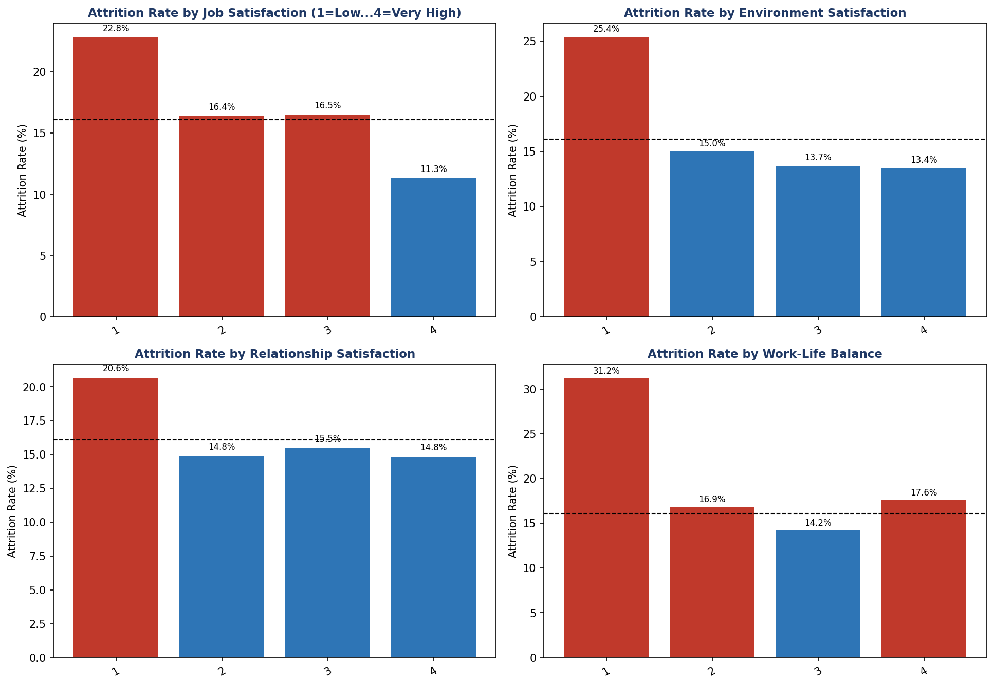
Figure 4: Attrition rate by Job Satisfaction, Environment Satisfaction, Relationship Satisfaction, and Work-Life Balance (1 = lowest, 4 = highest).

Job Satisfaction
A clear downward trend: employees with the lowest satisfaction (level 1) leave at 22.8%, dropping to 11.3% at the highest level (4). Business insight: this is a directly actionable metric — regular pulse surveys and manager check-ins targeting low-satisfaction employees can catch flight risk early.

Environment Satisfaction
An even sharper gradient: 25.4% attrition at the lowest satisfaction level versus 13.5% at the highest — almost a 2x difference. Business insight: workplace conditions (physical environment, team culture, tools) meaningfully affect retention and are a relatively low-cost area to improve compared to compensation.

Relationship Satisfaction
A smaller but still visible effect: 20.7% at the lowest level versus roughly 14.8-15.5% at higher levels. Business insight: quality of workplace relationships matters, though less strongly than job or environment satisfaction — still worth including in manager training and team-building initiatives.

Work-Life Balance
The lowest work-life balance group (level 1) has a striking 31.3% attrition rate — the highest of any satisfaction-type factor — while the 'best' balance group (level 3, the most common) has the lowest rate at 14.2%. Interestingly, level 4 ('Best') ticks back up slightly to 17.7%, a small anomaly likely due to a smaller sample size in that group. Business insight: poor work-life balance is one of the most severe attrition triggers in the dataset and should be treated as a high-priority red flag in engagement surveys.

6. Age, Income, Distance From Home, and Tenure
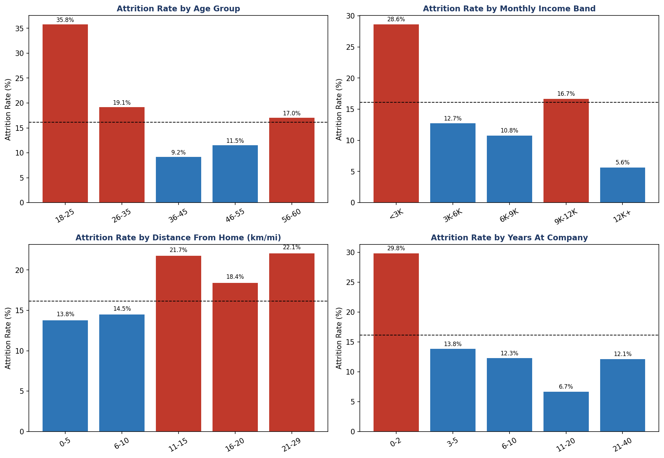
Figure 5: Attrition rate by Age Group, Monthly Income Band, Distance From Home, and Years At Company.

Age
Attrition is highest among the youngest employees: 35.8% for ages 18-25, dropping sharply to 9.2% for ages 36-45, before ticking up slightly for the 56-60 group (17.0%, likely early retirement decisions). Business insight: early-career employees are the highest flight-risk group by a wide margin — onboarding quality, early mentorship, and clear growth paths in the first 1-2 years are the highest-leverage retention interventions available.

Monthly Income
A clear, almost linear pattern: attrition is 28.6% for employees earning under $3,000/month, falling to just 5.6% for those earning $12,000+. There's a small uptick at the $9K-12K band (16.7%) which may reflect a specific role mix rather than a true reversal. Business insight: compensation is one of the most powerful and directly controllable levers for retention, particularly for entry-level pay bands.

Distance From Home
Attrition rises for employees living farther away: 13.8% for those within 5 miles/km, climbing to 22.1% for those 21-29 miles/km away, though the relationship isn't perfectly linear (dips slightly at 16-20). Business insight: long commutes are a meaningful, moderate risk factor — remote/hybrid flexibility or relocation support for long-commute employees could help.

Years At Company
The clearest tenure pattern in the dataset: employees in their first 2 years leave at 29.8%, nearly double the company average, then attrition drops steadily to just 6.7% for the 11-20 year group. Business insight: the first two years are the highest-risk retention window by far. This aligns with the age and income findings — new, younger, lower-paid employees are consistently the group most likely to leave, and a strong early-tenure retention program (structured onboarding, mentorship, 90-day and 1-year check-ins) would likely have the largest overall impact on attrition numbers.

7. Cross-Cutting Insight
Nearly every strong risk factor identified here points to the same underlying profile: a young, early-tenure, lower-paid employee working overtime with low job/environment satisfaction or poor work-life balance, often in a Sales or front-line individual-contributor role. This is not eight separate problems — it's largely one persona showing up across multiple variables. A retention program targeted at this specific segment (rather than broad company-wide policy changes) is likely to deliver the highest return on effort.

8. Full Python Code
Complete script used to calculate every attrition rate and generate every chart in this report:
"""
==============================================================
EMPLOYEE ATTRITION — SEGMENT-WISE ATTRITION RATE ANALYSIS
==============================================================
For each requested factor, this script computes the ATTRITION
RATE (%) per group (not just raw counts), since rate is what
matters for fair business comparison across groups of different
sizes. Charts are sorted by attrition rate, high to low.
==============================================================
"""

import pandas as pd
import numpy as np
import matplotlib
matplotlib.use("Agg")
import matplotlib.pyplot as plt

NAVY, ACCENT, RED = "#1F3864", "#2E75B6", "#C0392B"

df = pd.read_csv("employee_attrition_cleaned.csv")
OVERALL_RATE = df["Attrition_Flag"].mean() * 100
print(f"Overall attrition rate (benchmark): {OVERALL_RATE:.2f}%")

def attrition_rate_by(col, order=None):
"""Return attrition rate (%) and headcount per category, sorted desc by rate."""
t = df.groupby(col, observed=True)["Attrition_Flag"].agg(["mean", "count"])
t["mean"] = (t["mean"] * 100).round(2)
if order is None:
t = t.sort_values("mean", ascending=False)
else:
t = t.reindex(order)
return t

def plot_rate_bar(ax, table, title, benchmark=OVERALL_RATE):
"""Horizontal/vertical bar chart of attrition rate with a benchmark line."""
colors = [RED if v >= benchmark else ACCENT for v in table["mean"]]
bars = ax.bar(table.index.astype(str), table["mean"], color=colors)
ax.axhline(benchmark, color="black", linestyle="--", linewidth=1)
ax.set_title(title, fontweight="bold", color=NAVY, fontsize=11)
ax.set_ylabel("Attrition Rate (%)")
ax.tick_params(axis="x", rotation=30)
for bar, val in zip(bars, table["mean"]):
ax.text(bar.get_x() + bar.get_width()/2, val + 0.5, f"{val:.1f}%",
ha="center", fontsize=8)

# --------------------------------------------------------------
# 1. CATEGORICAL FACTORS — direct group-by
# --------------------------------------------------------------
categorical_factors = {
"Gender": None,
"Department": None,
"JobRole": None,
"OverTime": None,
"BusinessTravel": ["Non-Travel", "Travel_Rarely", "Travel_Frequently"],
"Education": [1, 2, 3, 4, 5],
"MaritalStatus": None,
"JobSatisfaction": [1, 2, 3, 4],
"EnvironmentSatisfaction": [1, 2, 3, 4],
"RelationshipSatisfaction": [1, 2, 3, 4],
"WorkLifeBalance": [1, 2, 3, 4],
}

tables = {}
for col, order in categorical_factors.items():
tables[col] = attrition_rate_by(col, order=order if order is None else None)
# keep sorted by rate for bar charts except ordinal scales (more readable in natural order)
if order is not None:
tables[col] = tables[col].reindex(order)

# Plot in three figures (grouped)
fig, axes = plt.subplots(2, 2, figsize=(13, 9))
plot_rate_bar(axes[0,0], tables["Gender"], "Attrition Rate by Gender")
plot_rate_bar(axes[0,1], tables["Department"], "Attrition Rate by Department")
plot_rate_bar(axes[1,0], tables["OverTime"], "Attrition Rate by OverTime")
plot_rate_bar(axes[1,1], tables["MaritalStatus"], "Attrition Rate by Marital Status")
plt.tight_layout()
plt.savefig("seg_core_factors.png", dpi=150, bbox_inches="tight")
plt.close()

fig, ax = plt.subplots(figsize=(11, 5))
plot_rate_bar(ax, tables["JobRole"], "Attrition Rate by Job Role")
plt.tight_layout()
plt.savefig("seg_jobrole.png", dpi=150, bbox_inches="tight")
plt.close()

fig, axes = plt.subplots(1, 2, figsize=(12, 4.5))
plot_rate_bar(axes[0], tables["BusinessTravel"], "Attrition Rate by Business Travel")
plot_rate_bar(axes[1], tables["Education"], "Attrition Rate by Education Level (1=Below College...5=Doctor)")
plt.tight_layout()
plt.savefig("seg_travel_education.png", dpi=150, bbox_inches="tight")
plt.close()

fig, axes = plt.subplots(2, 2, figsize=(13, 9))
plot_rate_bar(axes[0,0], tables["JobSatisfaction"], "Attrition Rate by Job Satisfaction (1=Low...4=Very High)")
plot_rate_bar(axes[0,1], tables["EnvironmentSatisfaction"], "Attrition Rate by Environment Satisfaction")
plot_rate_bar(axes[1,0], tables["RelationshipSatisfaction"], "Attrition Rate by Relationship Satisfaction")
plot_rate_bar(axes[1,1], tables["WorkLifeBalance"], "Attrition Rate by Work-Life Balance")
plt.tight_layout()
plt.savefig("seg_satisfaction.png", dpi=150, bbox_inches="tight")
plt.close()

# --------------------------------------------------------------
# 2. NUMERIC FACTORS — binned into business-meaningful groups
# --------------------------------------------------------------
df["AgeGroup"] = pd.cut(df["Age"], bins=[17,25,35,45,55,60],
labels=["18-25","26-35","36-45","46-55","56-60"])
df["IncomeGroup"] = pd.cut(df["MonthlyIncome"], bins=[0,3000,6000,9000,12000,20000],
labels=["<3K","3K-6K","6K-9K","9K-12K","12K+"])
df["DistGroup"] = pd.cut(df["DistanceFromHome"], bins=[0,5,10,15,20,30],
labels=["0-5","6-10","11-15","16-20","21-29"])
df["TenureGroup"] = pd.cut(df["YearsAtCompany"], bins=[-1,2,5,10,20,40],
labels=["0-2","3-5","6-10","11-20","21-40"])

binned_factors = ["AgeGroup", "IncomeGroup", "DistGroup", "TenureGroup"]
binned_tables = {c: attrition_rate_by(c) for c in binned_factors}
# restore natural (non-sorted) order for these ordinal bins for readability
natural_order = {
"AgeGroup": ["18-25","26-35","36-45","46-55","56-60"],
"IncomeGroup": ["<3K","3K-6K","6K-9K","9K-12K","12K+"],
"DistGroup": ["0-5","6-10","11-15","16-20","21-29"],
"TenureGroup": ["0-2","3-5","6-10","11-20","21-40"],
}
for c in binned_factors:
binned_tables[c] = binned_tables[c].reindex(natural_order[c])

fig, axes = plt.subplots(2, 2, figsize=(13, 9))
plot_rate_bar(axes[0,0], binned_tables["AgeGroup"], "Attrition Rate by Age Group")
plot_rate_bar(axes[0,1], binned_tables["IncomeGroup"], "Attrition Rate by Monthly Income Band")
plot_rate_bar(axes[1,0], binned_tables["DistGroup"], "Attrition Rate by Distance From Home (km/mi)")
plot_rate_bar(axes[1,1], binned_tables["TenureGroup"], "Attrition Rate by Years At Company")
plt.tight_layout()
plt.savefig("seg_numeric_bands.png", dpi=150, bbox_inches="tight")
plt.close()

# --------------------------------------------------------------
# 3. PRINT ALL TABLES FOR THE REPORT
# --------------------------------------------------------------
print("\n\n" + "=" * 60)
print("FULL RESULTS TABLES")
print("=" * 60)
for name, t in {**tables, **binned_tables}.items():
print(f"\n--- {name} ---")
print(t)

print("\nAll segment-wise attrition charts saved.")

