**Design Phase Document**

Design Overview:

1. Capstone Project Technological Tool Stack:

To build the python flask app using the DevOps approach in building production ready CI/CD pipeline,the tools we are going to use are listed below:

1. Python
2. Github: as a single source of truth.
3. Docker:

* Build the flask image
* To containerize the Jenkins image

1. Docker hub:

* To push the docker flask image as an artifact.
* To pull the docker flask image from the artifact.

1. Jenkins: Jenkins is the heart of the entire CI/CD pipeline where we are going to:

* Build the image from Dockerfile.
* Push the image to the Docker-hub.
* Declare our environment credentials for Jenkins to interact with the docker hub.
* Perform a SVM checkout.
* Build the project
* Deploy the application using ansible.
* Webhooks to trigger push.

1. Kubernetes: we are going to use kubernates as a container management tool.

* Using a yml file we are going to set details of our deployment and service.
* The number of repilicas of 3 flask app which later as part of continuous deployment will scale to 5.

1. Ansible: plays the role of IaC and provision the flask application over the Kubernetes cluster.

* Ansible runs the playbook which launches the kubernetes cluster.
* Kubernetes Cluster:
* 1 Kubernetes Master node
* 3 Worker nodes/ 1 wokernodes

1. AWS: using AWS we are leveraging the cloud features:

* Creating EC-2 instances of our linux environments.(JenkinsMasterBox,KubernetesMasterBox and 3 WorkernodeBox)
* AWS instances will provide the complete environment to run our CI/CD pipeline.

1. Mobaxterm and PUTTY: using this tool we can ssh into our ec2 instances and work into them.

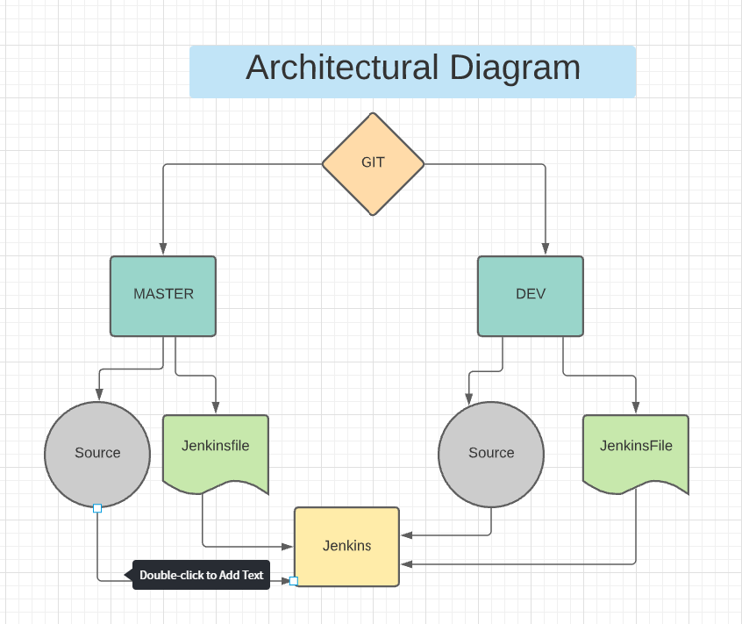

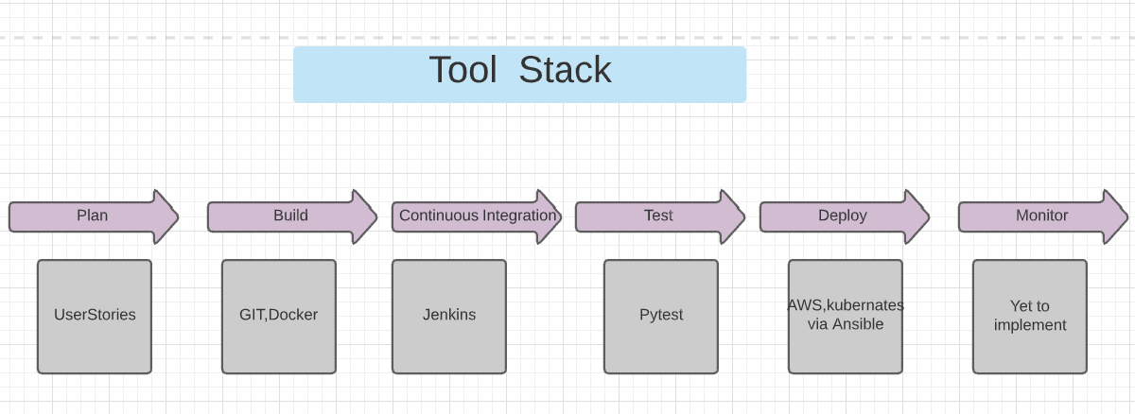

CI/CD Delivery Pipeline:

