Program & Output:
Program: Wisteria, a binary search tree visualizer (JavaScript)
// Part 1: binary search tree abstract data type (from bst-wisteria.html)
class Node { constructor(v){ this.v=v; this.l=null; this.r=null; } }
class BST {
constructor(){ this.root=null; this.size=0; }
isEmpty(){ return this.root===null; }
route(v){
const path=[]; let n=this.root;
while(n){ path.push(n); if(v===n.v) return {path,found:n}; n = v<n.v ? n.l : n.r; }
return {path,found:null};
}
insert(v){
const {path,found}=this.route(v);
if(found) return {ok:false,path};
const nn=new Node(v);
if(!this.root) this.root=nn;
else { const p=path[path.length-1]; if(v<p.v) p.l=nn; else p.r=nn; }
this.size++;
return {ok:true,path};
}
min(n=this.root){
const path=[];
while(n){ path.push(n); if(!n.l) break; n=n.l; }
return path;
}
max(n=this.root){
const path=[];
while(n){ path.push(n); if(!n.r) break; n=n.r; }
return path;
}
remove(v){
const {path,found}=this.route(v);
if(!found) return {ok:false,path};
let succPath=null;
const del=(n,val)=>{
if(!n) return null;
if(val<n.v){ n.l=del(n.l,val); return n; }
if(val>n.v){ n.r=del(n.r,val); return n; }
if(!n.l) return n.r;
if(!n.r) return n.l;
succPath=this.min(n.r);
const s=succPath[succPath.length-1];
n.v=s.v; n.r=del(n.r,s.v);
return n;
};
this.root=del(this.root,v); this.size--;
return {ok:true,path,succPath};
}
height(n=this.root){ return n ? 1+Math.max(this.height(n.l),this.height(n.r)) : 0; }
traverse(kind){
const out=[];
const go=n=>{
if(!n) return;
if(kind==='pre') out.push(n);
go(n.l);
if(kind==='in') out.push(n);
go(n.r);
if(kind==='post') out.push(n);
};
if(kind==='level'){
const q=this.root?[this.root]:[];
while(q.length){
const n=q.shift(); out.push(n);
if(n.l) q.push(n.l);
if(n.r) q.push(n.r);
}
} else go(this.root);
return out;
}
rebuild(vals){
const b=(lo,hi)=>{
if(lo>hi) return null;
const m=(lo+hi)>>1;
const n=new Node(vals[m]);
n.l=b(lo,m-1); n.r=b(m+1,hi);
return n;
};
this.root=b(0,vals.length-1); this.size=vals.length;
}
clear(){ this.root=null; this.size=0; }
}

// Part 2: walking the search path and the Insert button
async function walk(nodes,cls='visit'){
for(let i=0;i<nodes.length;i++){
hl.set(nodes[i].v,cls); render();
await sleep(delay());
}
}

$('btnInsert').onclick=()=>{
const v=readVal(); if(v===null) return;
run(async()=>{
clearHl();
say(`Inserting ${v}: go left if smaller, right if larger, until there is an empty spot.`);
const r=tree.insert(v);
await walk(r.path);
if(!r.ok){
hl.set(v,'found'); render(); await sleep(delay()*1.5);
say(`${v} is already in the tree. A BST keeps each value once.`,'bad');
} else {
hl.clear(); fresh=v; render(); petals();
say(`Inserted ${v} after ${r.path.length} comparison${r.path.length===1?'':'s'}.`,'good');
await sleep(delay()*1.5);
}
clearHl(); input.value=''; input.focus();
});
};
Output:
All outputs start from the example tree the site loads (50, 30, 70, 20, 40, 60, 80). Outputs 3 and 4 are taken after 35 is inserted; outputs 5 and 6 after 85, 90 and 95 are inserted.
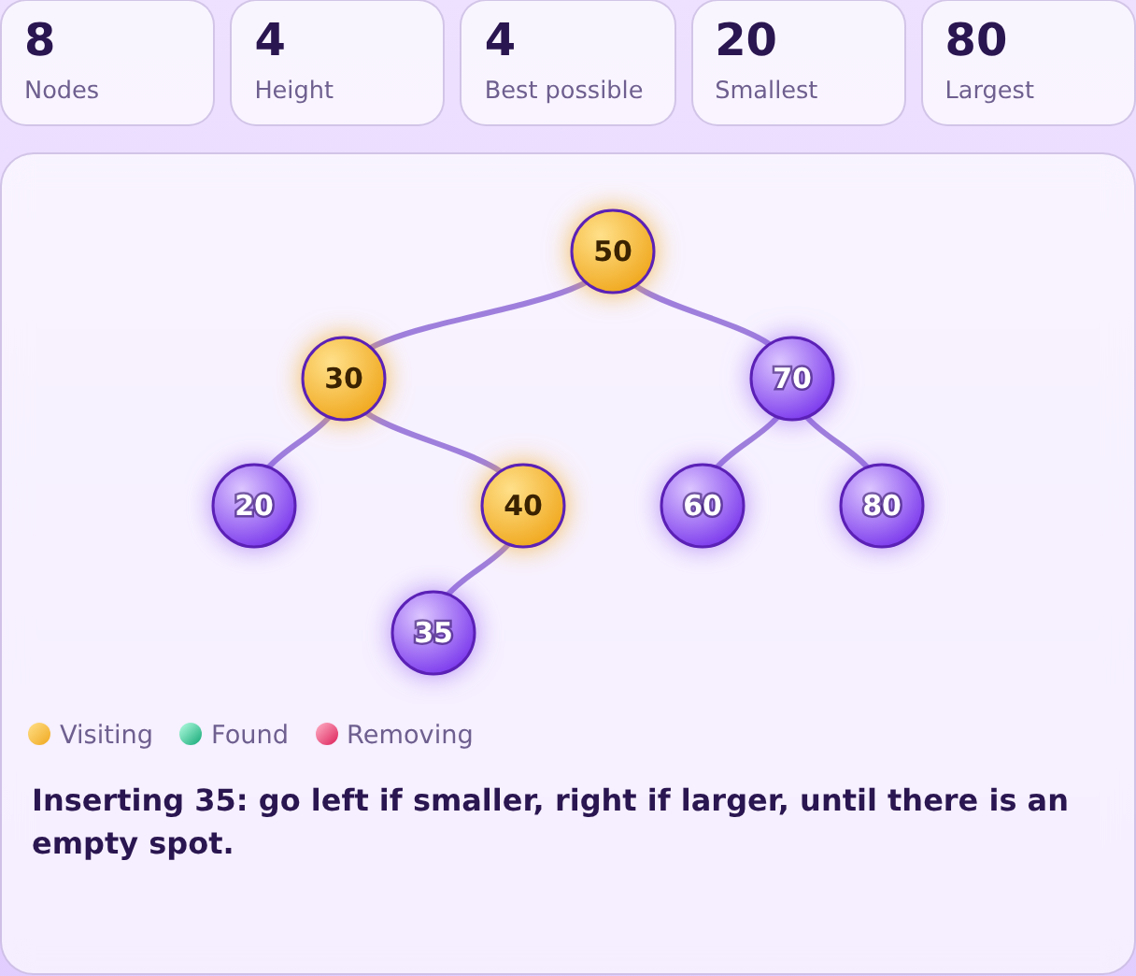  Output 1: Insert 35. The search path 50, 30, 40 is highlighted before 35 is placed. | 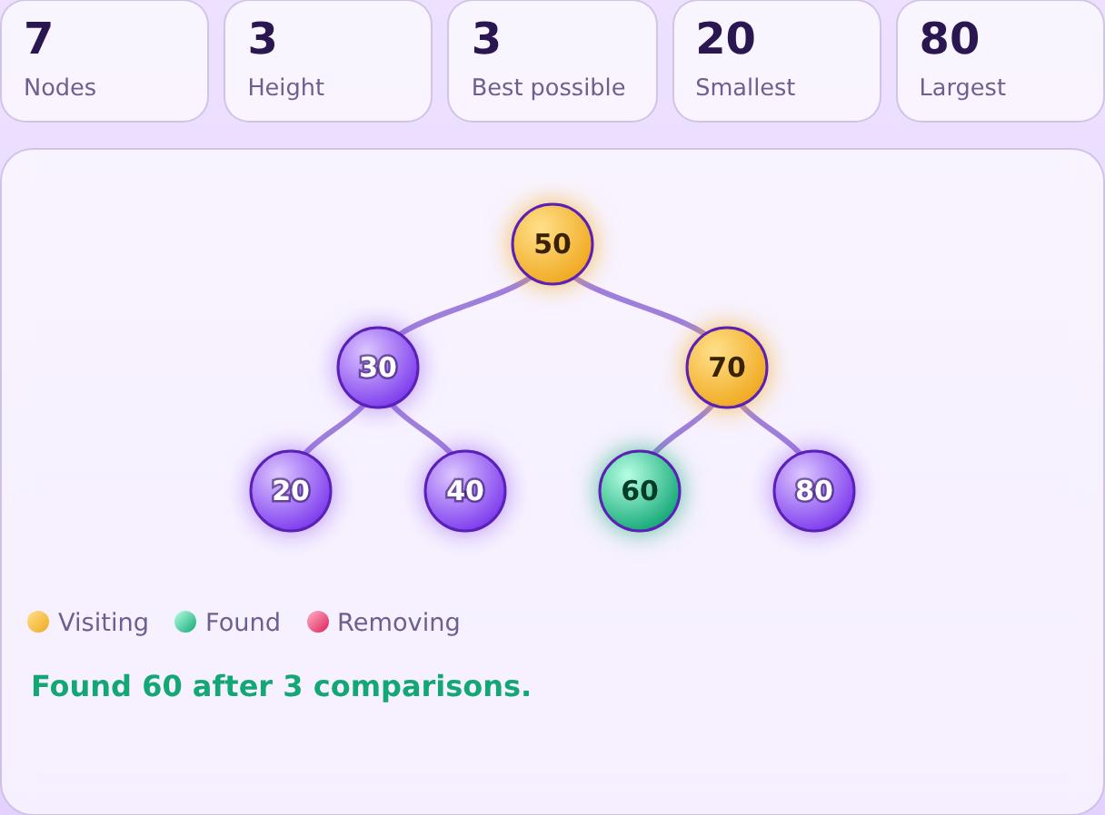  Output 2: Search 60. Nodes 50 and 70 are visited, then 60 turns green: Found 60 after 3 comparisons.
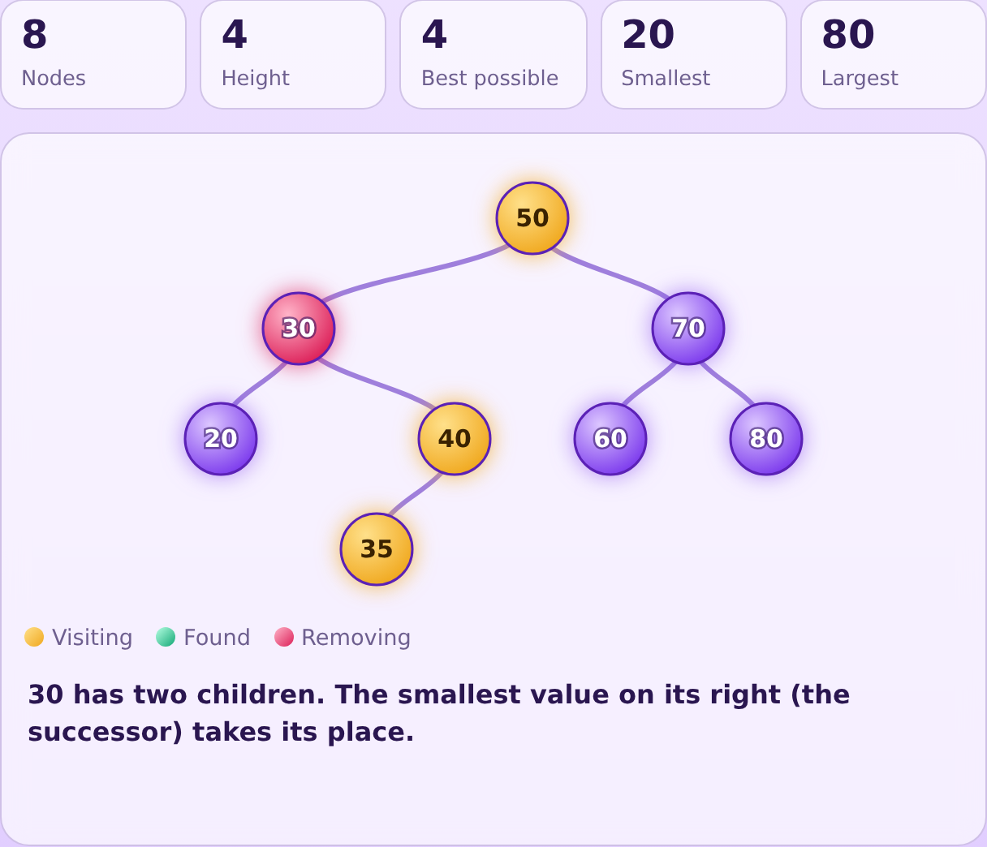  Output 3: Delete 30. The red node has two children, so the smallest value on its right (35) takes its place. | 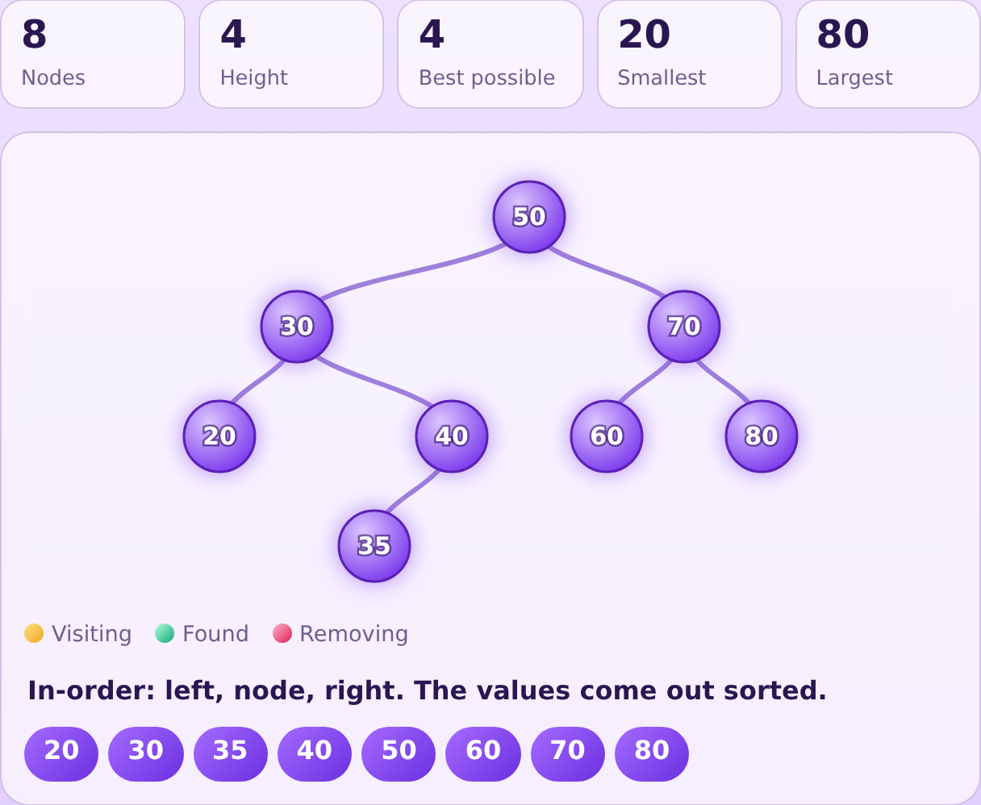  Output 4: In-order traversal returns the sorted values 20 30 35 40 50 60 70 80.
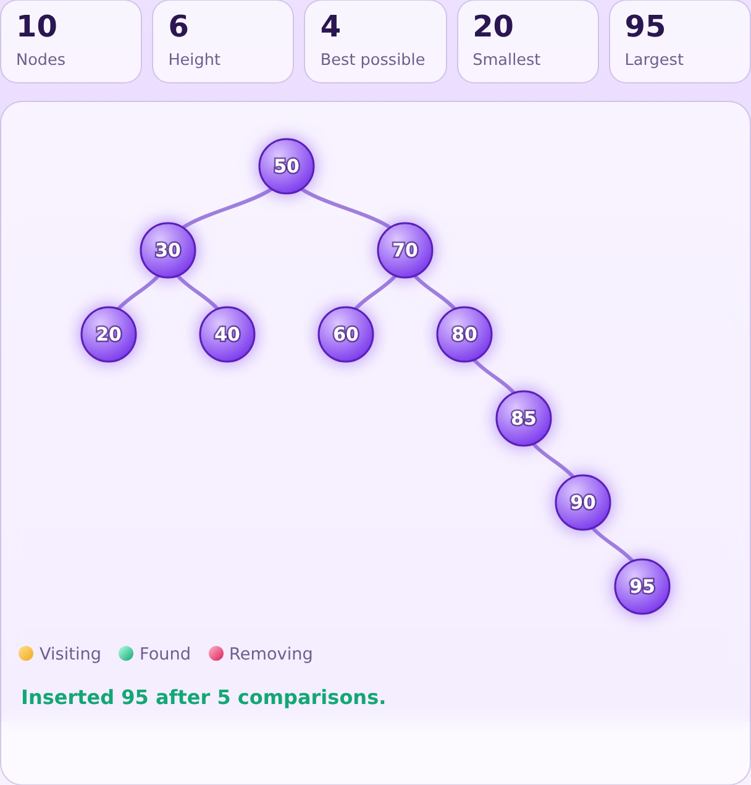  Output 5: After inserting 85, 90 and 95 the tree is skewed: height 6, best possible height 4. | 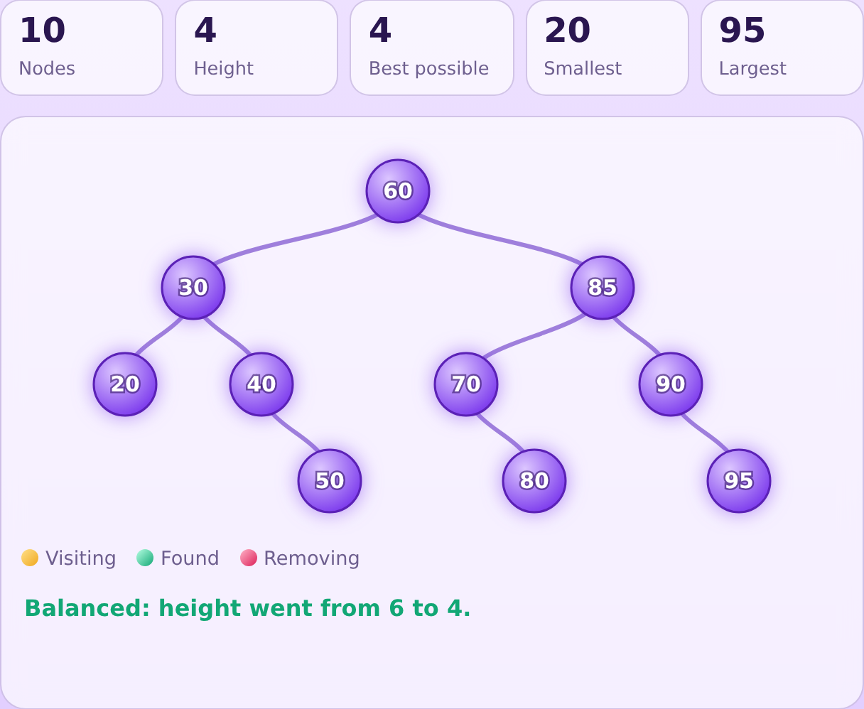  Output 6: After Balance the same 10 nodes have height 4.

