Home Page
Headline
Service Above Self. Leadership Beyond Limits.
Sub Heading
Building Leaders, Creating Impact, Transforming Communities.
Buttons
- Join Rotaract - direct to green rotaractors recruitment page
- Explore Projects

Live Club Statistics
Animated Counter Section
- ❤️ Blood donated - 2000+ units
- 👨‍🎓 Members - 100+
- 🏆 Awards - 10+
- 📅 Projects - 50+

About Rotaract

Formation of Rotary
Rotary was founded in Chicago, Illinois, USA, on 23 February 1905 by Paul P. Harris, a lawyer who envisioned a fellowship of professionals committed to service, integrity, and community improvement. The first Rotary Club brought together people from different vocations, creating a unique model of friendship and ethical leadership.
What began as a small gathering of like-minded individuals soon grew into a global movement dedicated to addressing humanitarian challenges and building peace. Over time, Rotary expanded across continents, inspiring millions of members to serve their communities through impactful projects and international collaboration.
Today, Rotary International is one of the world’s leading service organizations, uniting clubs in more than 200 countries and geographical regions. Its legacy continues to guide Rotarians and Rotaractors alike in the shared mission of Service Above Self.
Rotary empowers experienced professionals to serve communities, while Rotaract empowers young leaders to grow through service, leadership, and fellowship.
What is Rotaract?
Rotaract is a global network of passionate young leaders aged 18 and above who are committed to creating sustainable solutions for the world's most pressing challenges.
More than just a service organization, Rotaract is a platform where individuals discover their potential, build lifelong friendships, develop professional skills, and make meaningful contributions to society.
Every Rotaract club is self-governed and member-driven, giving young leaders the opportunity to plan impactful service projects, organize community initiatives, collaborate internationally, and inspire change at both local and global levels.
At its heart, Rotaract believes that leadership is best learned through service.

Our Objectives
Rotaract strives to empower young people by fostering leadership, encouraging ethical decision-making, and promoting a lifelong commitment to service.
Our objectives are to:
- Develop responsible and compassionate leaders.
- Encourage personal and professional growth.
- Promote fellowship through meaningful service.
- Address community needs through sustainable projects.
- Foster international understanding and cultural exchange.
- Inspire innovation, collaboration, and social responsibility.
- Build lasting partnerships that create measurable impact.

The Four-Way Test
The Four-Way Test is Rotary's timeless ethical guide, helping members make decisions with integrity in their personal, professional, and community lives.
Of the things we think, say, or do:
1. Is it the TRUTH?
2. Is it FAIR to all concerned?
3. Will it build GOODWILL and BETTER FRIENDSHIPS?
4. Will it be BENEFICIAL to all concerned?
These four questions continue to guide every Rotarian and Rotaractor across the world.

The Seven Areas of Focus
Every Rotary and Rotaract project is designed around seven global causes that create sustainable and measurable impact.

🕊️ Promoting Peace
Supporting dialogue, conflict resolution, peacebuilding, and stronger communities through understanding and collaboration.

❤️ Fighting Disease
Improving public health through medical camps, awareness campaigns, vaccinations, blood donation drives, and disease prevention initiatives.

💧 Water, Sanitation & Hygiene
Ensuring access to clean water, sanitation facilities, and hygiene education to improve quality of life.

👩‍👧 Maternal & Child Health
Supporting mothers and children through healthcare initiatives, nutrition programs, immunization, and access to quality medical care.

📚 Basic Education & Literacy
Promoting quality education, improving literacy, supporting schools, and empowering learners with knowledge and opportunities.

💼 Community Economic Development
Creating opportunities for entrepreneurship, skill development, financial literacy, and sustainable livelihoods.

🌱 Supporting the Environment
Protecting natural resources through tree plantation, waste management, climate action, biodiversity conservation, and environmental awareness.

About Club

Our Club History
The Rotaract Club of VIT Chennai was chartered in 2019 with the vision of developing young leaders through service, fellowship, and professional growth. Since its inception, the club has been committed to creating meaningful impact through community service, environmental initiatives, leadership development, and collaborative projects.
The club was led by its Charter President, Rtr. Parvathi Suresh (2019–2020), whose leadership laid the foundation for a culture of service and excellence.
Today, the Rotaract Club of VIT Chennai continues to empower students to lead with purpose, serve with compassion, and create lasting change in their communities.

Vision
To inspire a generation of socially conscious leaders who create sustainable impact through service, innovation, and collaboration.

Mission
To empower students with opportunities to lead, serve, and grow by fostering meaningful projects, lifelong fellowship, and ethical leadership that transforms communities.

Achievements & Awards
The Rotaract Club of VIT Chennai has been consistently recognized at the District level for its excellence in leadership, innovation, service, and club administration. These accolades reflect the dedication of our members and the impact of our initiatives.

2025–26
- 🏆 Rising President – Rtr. Shobini
- ⭐ Star of Rotaract – Rtr. Surajiv Arul
- ⭐ Star of Rotaract – Rtr. Iniyaa S
- 🌱 Excellence in Sustainable Innovation – Project Kadal Karai

2024–25
- 🏅 Best Installation (College-Based Club)
- 🎖️ President's Recognition – "Threads of Magic" – Rtr. Kavin Priyadarrsan
- ⭐ Star of Rotaract – Rtr. Keerthana Kumar
- ⭐ Star of Rotaract – Rtr. Shobini G
- ⭐ Star of Rotaract – Rtr. Shanmughapriyan S.K.

2023–24
- 👑 Best President – Rtr. Sruthi Jain
- 📱 Best Social Media Branding
- 🏆 Outstanding Club
- 🌊 Outstanding Community Service Project – Project Kadal Karai
- Outstanding Project by a Rotaract (Rotaract South Asia) - Kadal Karai
These milestones inspire us to continuously innovate, lead with purpose, and create meaningful impact through service.
Past Presidents
President 2026-27
Surajiv Arul
President 2025-26
Shobini G
President 2024-25
Kavin Priyadarrsan M
President 2023-24
Sruthi Jain
President 2022-23
Saravanan G
President 2021-22
Varun Vignesh R
President 2020-21
Lenin M
President 2019-20
Parvathi Suresh

Our Parent Club
The Rotaract Club of VIT Chennai is proudly sponsored by the Rotary Club of Chennai Spotlight, whose unwavering guidance and mentorship have been instrumental since our charter in 2019. As our parent club, they support us in nurturing leadership, strengthening service initiatives, and upholding the values of Rotary International. Their encouragement and partnership continue to inspire us to grow, serve, and create lasting impact in our communities.

Rotary International District 3234
The Rotaract Club of VIT Chennai is a proud part of Rotary International District 3234, a vibrant district comprising Rotary and Rotaract clubs across Chennai and its surrounding regions. The district serves as a platform for leadership development, collaboration, fellowship, and impactful service, empowering clubs to create sustainable change within their communities.
Through District 3234, our members participate in leadership training, district conferences, service initiatives, competitions, and international opportunities, fostering lifelong connections while contributing to Rotary's mission of Service Above Self.

Meet our team
Core Team 2026-27
President 2026-27 - Surajiv Arul
Secretary 2026-27 - Iniyaa S
Vice President 2026-27 - S G Anjana
Joint Secretary 2026-27 - N V Tejaharshini

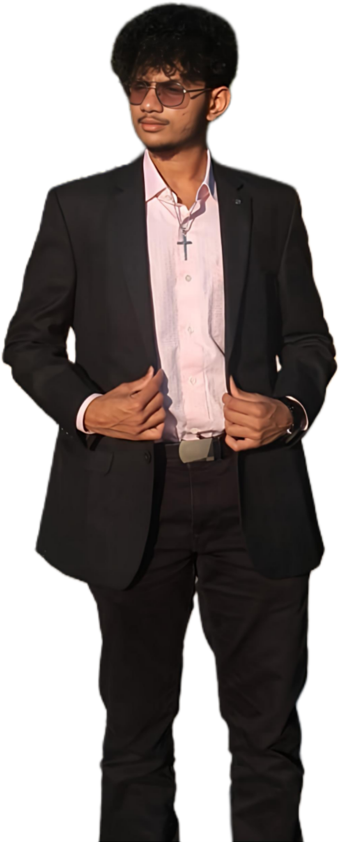




Signature Projects
Kadal Karai
Kadal Karai is the flagship environmental initiative of the Rotaract Club of VIT Chennai, dedicated to preserving Chennai's coastline through consistent beach clean-up drives and environmental awareness. Conducted every alternate weekend, the project brings together volunteers who are passionate about protecting marine ecosystems and promoting sustainable living.
With each cleanup, volunteers remove plastic waste, bottles, packaging materials, and other non-biodegradable debris from the shoreline, restoring cleaner and safer beaches for both people and marine life. Beyond waste collection, Kadal Karai aims to educate participants and the public on the importance of responsible waste disposal, environmental conservation, and collective action.
More than just a clean-up drive, Kadal Karai has grown into a movement that inspires youth to become active environmental stewards. Through consistency, community participation, and a shared commitment to sustainability, the initiative continues to create a lasting impact - one beach, one volunteer and one cleanup at a time.
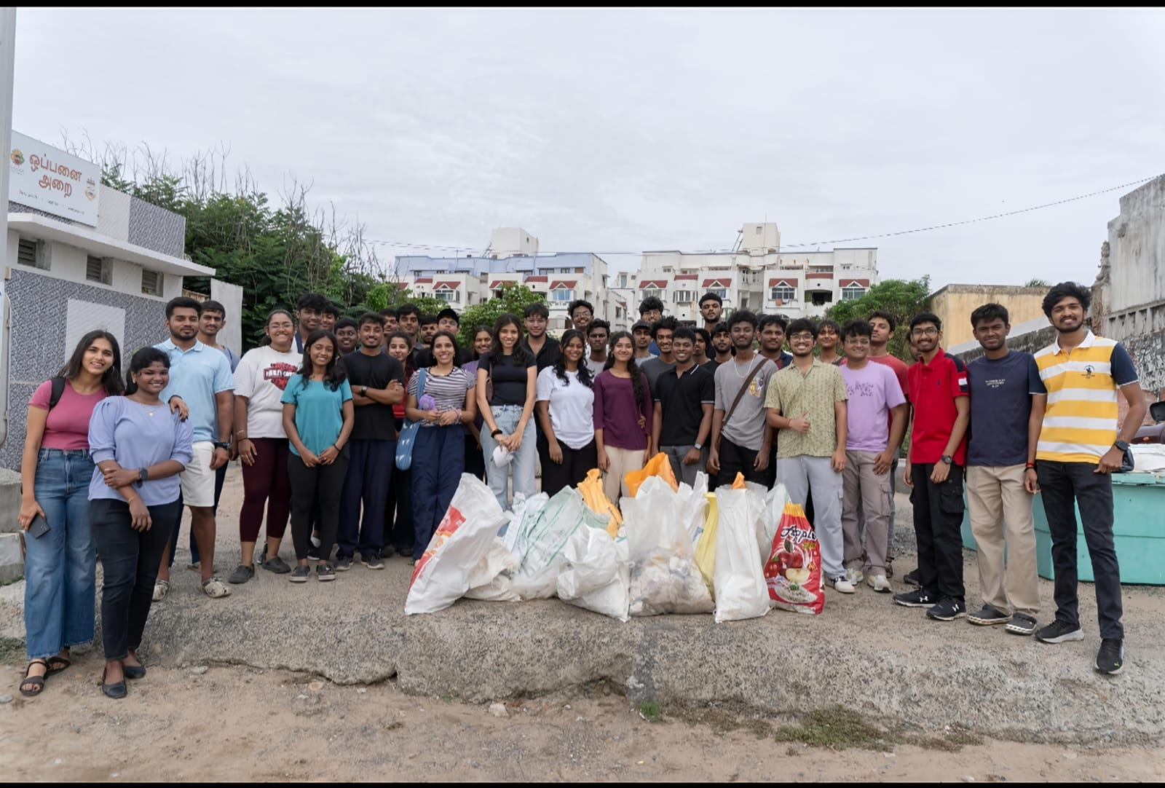
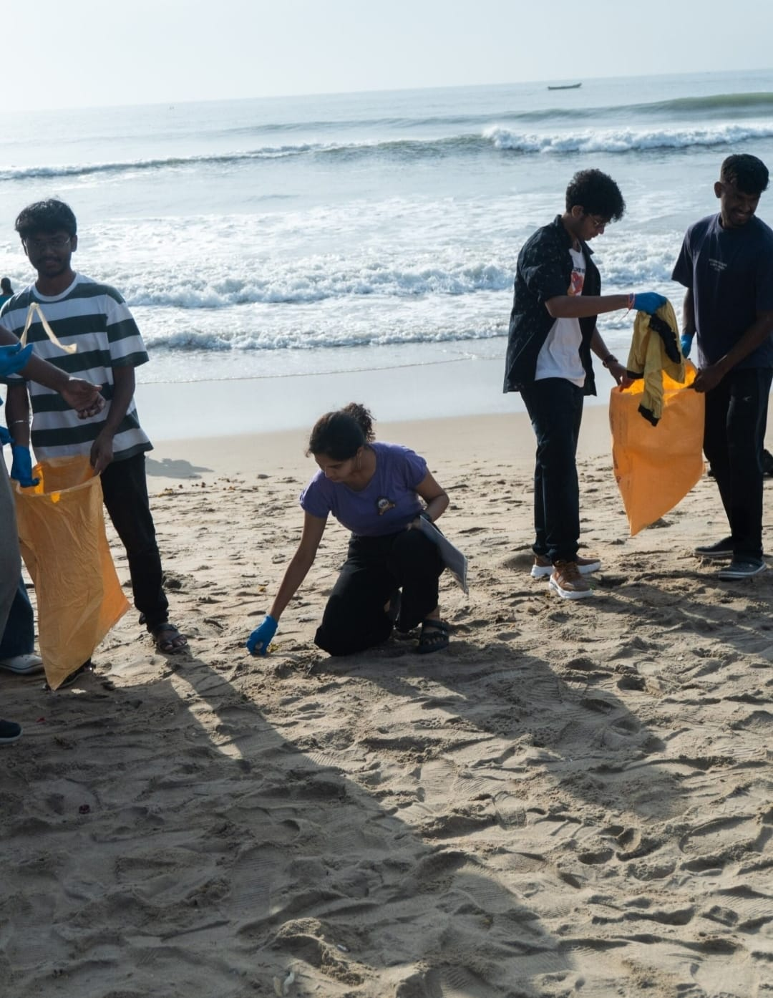

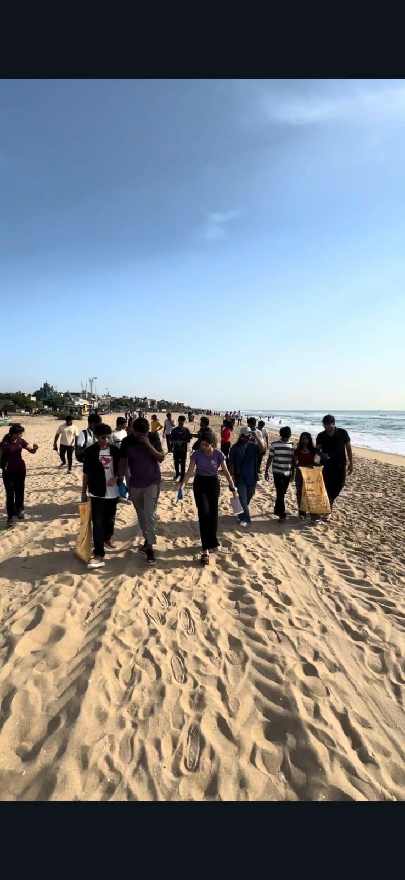

Avenues of Service

Avenues of Service
Every Rotaract project is driven by a purpose. Through the Avenues of Service, Rotaractors channel their passion into meaningful action, creating lasting impact within the club, the community, and across the world. These avenues serve as the foundation for planning projects, developing leaders, and strengthening fellowship.

💙 Club Service
A strong club builds strong leaders. Club Service focuses on strengthening the internal functioning of the club by fostering teamwork, fellowship, member engagement, and effective leadership.
Through regular meetings, training sessions, fellowship activities, and club administration, members develop essential leadership and organizational skills while building lifelong friendships.
Focus Areas
- Member Engagement
- Leadership Development
- Fellowship Activities
- Club Administration
- Capacity Building

🌍 Community Service
Community Service lies at the heart of Rotaract. It addresses local needs through sustainable projects that improve lives and create positive social change.
From health camps and educational initiatives to disaster relief and social awareness campaigns, Rotaractors work alongside communities to identify challenges and implement meaningful solutions.
Focus Areas
- Education & Literacy
- Healthcare Initiatives
- Rural Development
- Social Welfare
- Disaster Response
- Community Outreach

💼 Professional Development
Rotaract prepares members to become future leaders in their professions. This avenue encourages personal growth by developing professional skills, expanding networks, and creating opportunities for career advancement.
Members participate in workshops, mentorship programmes, industry interactions, entrepreneurship sessions, and leadership training to build confidence and competence.
Focus Areas
- Leadership Workshops
- Career Guidance
- Skill Development
- Entrepreneurship
- Networking
- Mentorship

🤝 International Service
International Service promotes friendship, understanding, and collaboration beyond borders. It connects Rotaractors from different cultures to exchange ideas, share experiences, and work together on global initiatives.
Through international partnerships, cultural exchanges, and joint service projects, members develop a global perspective while contributing to worldwide humanitarian efforts.
Focus Areas
- International Collaborations
- Cultural Exchange
- Twin Club Partnerships
- Global Service Projects
- International Conferences

While these are our core Avenues of Service, our impact extends far beyond them. Dedicated teams such as Women Empowerment, Public Relations & Social Media, Photography & Videography, Creative Design and other special committees work collaboratively across every avenue to amplify our reach and ensure the success of every initiative.
These teams are the driving force behind our storytelling, community engagement, branding, documentation, and advocacy, bringing every project to life and enabling us to create a lasting impact both on the ground and online.

"One Club. Many Avenues. Infinite Possibilities."

Events
Upcoming Events
Past Events
Calendar View

Gallery
Photos
Videos
Event Albums
Awards

Green Rotaractors
About Green Rotaractors
Green Rotaractors are the newest members of the Rotaract Club of VIT Chennai, bringing fresh perspectives, enthusiasm, and a shared passion for service. This is where every Rotaractor begins their journey—learning, growing, and becoming part of a vibrant community of young leaders.
As a Green Rotaractor, you'll have the opportunity to:
- Participate in orientation sessions, club activities, and impactful community service projects.
- Learn about the values, culture, and functioning of Rotaract.
- Build friendships, develop leadership skills, and gain hands-on experience.
- Gradually take on responsibilities that prepare you for future leadership roles within the club.
Being a Green Rotaractor is more than just joining a club—it's the first step towards becoming a leader committed to creating meaningful impact through service.
Become Green Rotaractor
Take the first step towards meaningful service, lifelong friendships, and unforgettable experiences.
Ready to begin your Rotaract journey?
Complete the registration form below and become a Green Rotaractor today!

Embedded Registration Form : https://forms.gle/vsjSHSti5qAb8yVD7

FAQs

Frequently Asked Questions

1. What is Rotaract?
Rotaract is a global network of young leaders aged 18 and above who come together to serve communities, develop leadership skills, build friendships, and create lasting impact through meaningful projects.

2. Who can join the Rotaract Club of VIT Chennai?
Any VIT Chennai student who is passionate about service, leadership, teamwork, and personal growth is welcome to apply. No prior volunteering experience is required.

3. What is a Green Rotaractor?
Green Rotaractors are our newly inducted members. They participate in orientations, service activities, and club events while learning the culture and functioning of the club before taking on greater responsibilities.

4. Is there a membership fee?
Yes. A nominal annual membership fee is collected to cover Rotary International, District, and club administrative expenses. The exact amount will be communicated during recruitment.

5. How much time do I need to commit?
Your involvement depends on your availability. Members are encouraged to actively participate in projects, meetings, and events while maintaining a healthy balance with academics.

6. What kind of projects does the club organize?
Our club conducts projects across community service, environmental sustainability, professional development, education, healthcare, women empowerment, social awareness, and fellowship. Our signature beach clean-up initiative, Kadal Karai, is one of our flagship projects.

7. What are the benefits of joining Rotaract?
As a member, you'll:
- Develop leadership and communication skills.
- Volunteer for impactful community projects.
- Build lifelong friendships and professional networks.
- Attend district, national, and international events.
- Gain hands-on experience in organizing large-scale initiatives.
- Earn recognition and certificates for your contributions.
- Experience fun, fellowship, and memories that go beyond college life.

8. Can first-year students join?
Absolutely! Students from all years are encouraged to join. Rotaract provides an excellent platform to learn, grow, and build leadership skills from the very beginning of your college journey.

9. Do I need prior leadership or volunteering experience?
Not at all. Rotaract welcomes beginners and provides opportunities to learn through hands-on experience, mentorship, and teamwork.

10. How can I become a member?
Simply fill out the Green Rotaractors Registration Form available on our website. Shortlisted applicants will be contacted with details about the induction process.

11. Can I volunteer without becoming a member?
Yes! We occasionally welcome volunteers for selected public initiatives and campaigns. Follow our social media pages to stay updated on upcoming opportunities.

12. How can I stay connected with the club?
Follow us on Instagram, LinkedIn, and our other official social media platforms for updates on projects, events, recruitment, and club activities.

Partner With Us

Partner With Us
At the Rotaract Club of VIT Chennai, we believe that meaningful impact is created through meaningful partnerships. From community service initiatives and environmental campaigns to large-scale college events and leadership programmes, we collaborate with organizations that share our vision of creating positive change.
Partnering with us gives your brand the opportunity to connect with one of Chennai's most dynamic student communities. With a diverse and talented student population at VIT Chennai, our events provide excellent visibility, authentic engagement, and a platform to showcase your products, services, or CSR initiatives to a highly active audience.
Whether you're looking to sponsor an event, support a social cause, collaborate on a project, or engage with the next generation of leaders, we'd love to work with you to create experiences that are impactful for both the community and your brand.

Why Partner With Us?
- Reach a vibrant and diverse student audience at VIT Chennai.
- Enhance your brand visibility through our events and digital platforms.
- Support impactful community service and sustainability initiatives.
- Collaborate on innovative projects with passionate young leaders.
- Strengthen your CSR and community engagement efforts.
Together, we can create opportunities, inspire change, and make a lasting impact.
For sponsorships, collaborations, or partnership enquiries, please contact:
Rtr. Surajiv Arul
📞 +91 8072 808 036
📧 rotaractclubvitcc@gmail.com

Contact Us

Contact Us
Have a question, want to collaborate, sponsor an event, or simply learn more about the Rotaract Club of VIT Chennai? We'd love to hear from you!

Get in Touch
📧 Email
rotaractclubvitcc@gmail.com
📞 Contact Numbers
- +91 80728 08036
- +91 99624 09445

Visit Us
Rotaract Club of VIT Chennai
VIT Chennai Campus
Vandalur–Kelambakkam Road,
Chennai – 600127, Tamil Nadu, India
📍 Interactive Google Map

Connect With Us
Stay updated with our latest projects, events, and club activities.
📸 Instagram
@rotaractclubvitcc
https://www.instagram.com/rotaractclubvitcc?igsh=dWdhYXQ3NGVsbjc0
💼 LinkedIn
Rotaract Club of VIT Chennai
https://www.linkedin.com/company/rotaract-club-vitcc/

Whether you're interested in becoming a member, partnering with us, volunteering, or simply have a question, don't hesitate to reach out. We're always happy to connect!

