

**Srinath Ramachandran**

**PROJECT FINAL REPORT**

**MULTI-SPORT DATABASE SYSTEM**

[Document title]

**SECTION II**

**PROJECT SUMMARY:**

The project is about designing a multi-sport database system that intends to integrate information of multiple sports so that the sport lovers can access the data in a single platform. This solution would be helpful to the organization in promoting all kind of sports to the end users. By doing so, it would help users especially young boys and girls who want to pursue a particular sport to understand that sport in a better way.

There exists a problem among some set of users according to the geographic location i.e. people from Asia do not have idea of American sports like Rugby, Baseball, the NBA while the Americans know very less about Asian sports like Kabaddi and Cricket. This disconnect between the sports of the West and the East would be solved with this database model.

The database basically includes information of team sports like Baseball, Basketball, Rugby, Football, Cricket etc. The users would therefore be able to obtain statistics of players, teams, leagues and sports. Also the users would come to know the popularity of a particular sport by seeing the ratings. The ratings would be on year-to-year basis meaning the users would come to know which sport has dominated in terms of viewership ratings for that particular year.

The Multi-Sport Database would therefore make users aware of the most followed sports with the help of viewership ratings as well as provide them with the data of the sport they follow passionately.

**SECTION III**

**ER DIAGRAM: VISIO**

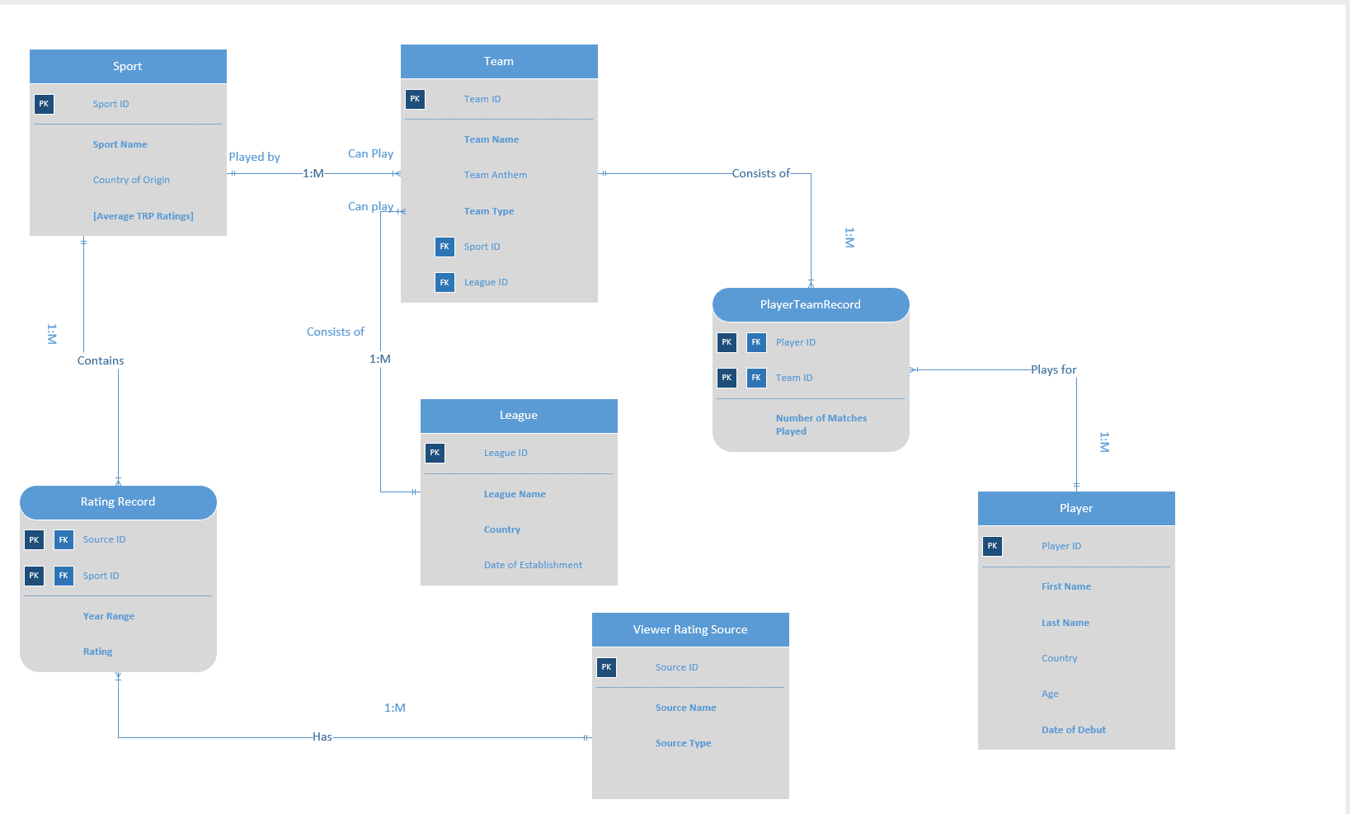

**RELATIONSHIP MODEL: ACCESS**

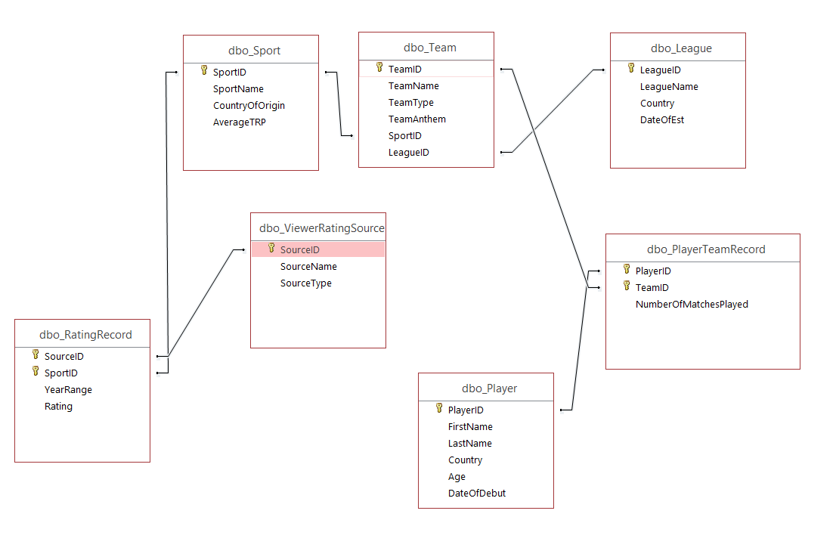

**TABLES & ATTRIBUTES**

|  |  |
| --- | --- |
| ***DATA OBJECT:***  ***MULTI-SPORT DATABASE*** | ***This database contains relations of different sports, Players, Teams, Leagues & Viewer Ratings from various sources.*** |
|  |  |
| **SPORT** | **Stores information of different sports.** |
| Sport ID | PRIMARY KEY: Each Sport will have a unique ID to identify sport. |
| Sport Name | Name of the sport. |
| Country of Origin | Country where the sport originated. |
| Average TRP Ratings | *This will be in a scale of 10. This is a derived attribute and it will be obtained by calculating the average of ratings of a particular sport from all the users.* |
|  |  |
| **PLAYER** | **Stores information of different players.** |
| Player ID | PRIMARY KEY: Each Player will have unique ID to identify player. |
| First Name | First Name of the player. |
| Last Name | Last Name of the player. |
| Country | Country which the player belongs to. |
| Age | Age of the player. |
| Date of Debut | Date when the player started his career. |
|  |  |
| **TEAM** | **Stores information of different teams.** |
| Team ID | PRIMARY KEY: Each Team will have unique ID to identify team. |
| Team Name | Name of the team. |
| Team Anthem | Anthem of the team. |
| Team Type | Describes whether the team is a National or a Domestic Team. |
| Sport ID | FOREIGN KEY: Associated with the Primary key of Sport. Each team’s sport will be identified by the sport ID.  *Relationship: A team can play one and only one sport. A sport can be played by one or many teams.* |
| League ID | FOREIGN KEY: Associated with the Primary key of League. Each team’s league will be identified by the league ID.  *Relationship: A team can play in one and only one league. A league can be played by one or many teams.* |
|  |  |
| **LEAGUE** | **Stores information of different leagues.** |
| League ID | PRIMARY KEY: Each League will have unique ID to identify league. |
| League Name | Name of the league. |
| Country | Shows the league belongs to which country. |
| Date of Establishment | Date when the league was established |
|  |  |
| **VIEWER RATING SOURCE** | **Stores information of source of viewer ratings of various sports.** |
| Source ID | PRIMARY KEY: Each Source will have a unique ID. |
| Source Name | Describes the source from where the ratings were obtained. |
| Source Type | Specifies the type of source i.e. ratings can be television ratings, non-television ratings like online streaming & web browsing. |
|  |  |

**ASSOCIATIVE ENTITIES:**

|  |  |
| --- | --- |
| **RATING RECORD** | **It connects the Sport entity and the Viewer rating source entity since there exists many to many relationship between sport and Viewer rating source entities.**  **i.e. *Sports ratings can be obtained from multiple sources; Sources can give ratings for multiple sports.***  **NOTE: This is an identifying relationship since a rating record cannot have source ID and Sport ID as NULL.** |
| Source ID | PRIMARY KEY,FOREIGN KEY: Associated with the Primary Key of Viewer Rating Source. |
| Sport ID | PRIMARY KEY, FOREIGN KEY: Associated with the Primary Key of Sport. |
| Year Range | Specifies the year range for which the rating was given for a particular sport. |
| Rating | Specifies the rating (in a scale of 10) given to each sport. |
|  |  |
| **PLAYERTEAMRECORD** | **It connects the Player entity and the Team entity since there exists many to many relationship between Player and Team entities.**  **i.e. A player can play for many teams; A team can have many players.**  **NOTE: This is an identifying relationship since a playerteamrecord cannot have player ID and team ID as NULL.** |
| Player ID | PRIMARY KEY,FOREIGN KEY: Associated with the Primary Key of Player. |
| Team ID | PRIMARY KEY,FOREIGN KEY: Associated with the Primary Key of Team. |
| Number of Matches Played | Specifies the number of matches played by a player for a particular team. |

**SECTION IV**

**SQL SCRIPTS:**

***Creating Tables:***

CREATE TABLE Sport

(

SportID VARCHAR(20) NOT NULL,

SportName VARCHAR(20) NOT NULL,

CountryOfOrigin VARCHAR(20),

AverageTRP FLOAT,

CONSTRAINT Sport_ID PRIMARY KEY (SportID)

);

CREATE TABLE League

(

LeagueID VARCHAR(20) NOT NULL,

LeagueName VARCHAR(20) NOT NULL,

Country VARCHAR(20) NOT NULL,

DateOfEst DATE,

CONSTRAINT League_ID PRIMARY KEY (LeagueID)

);

CREATE TABLE Player

(

PlayerID VARCHAR(20) NOT NULL,

FirstName VARCHAR(20) NOT NULL,

LastName VARCHAR(20) NOT NULL,

Country VARCHAR(20),

Age NUMERIC(10,0),

DateOfDebut DATE NOT NULL,

CONSTRAINT Player_ID PRIMARY KEY (PlayerID)

);

CREATE TABLE Team

(

TeamID VARCHAR(20) NOT NULL,

TeamName VARCHAR(20) NOT NULL,

TeamType VARCHAR(20) NOT NULL,

TeamAnthem VARCHAR(20),

SportID VARCHAR(20),

LeagueID VARCHAR(20),

CONSTRAINT Team_ID PRIMARY KEY (TeamID),

CONSTRAINT sport_ID_fk FOREIGN KEY(SportID) REFERENCES Sport(SportID),

CONSTRAINT league_ID_fk FOREIGN KEY(LeagueID) REFERENCES League(LeagueID));

CREATE TABLE ViewerRatingSource

(

SourceID VARCHAR(20) NOT NULL,

SourceName VARCHAR(20) NOT NULL,

SourceType VARCHAR(20) NOT NULL,

CONSTRAINT Source_ID PRIMARY KEY (SourceID)

);

CREATE TABLE PlayerTeamRecord

(

PlayerID VARCHAR(20) NOT NULL,

TeamID VARCHAR(20) NOT NULL,

NumberOfMatchesPlayed NUMERIC(10,0),

CONSTRAINT playerteam_composite PRIMARY KEY(PlayerID,TeamID),

CONSTRAINT playerID_fk FOREIGN KEY(PlayerID) REFERENCES Player(PlayerID),

CONSTRAINT teamID_fk FOREIGN KEY(TeamID) REFERENCES Team(TeamID)

);

CREATE TABLE RatingRecord

(

SourceID VARCHAR(20) NOT NULL,

SportID VARCHAR(20) NOT NULL,

YearRange VARCHAR(20) NOT NULL,

Rating FLOAT NOT NULL,

CONSTRAINT sourcesport_composite PRIMARY KEY(SourceID,SportID),

CONSTRAINT sportID_fk FOREIGN KEY(SportID) REFERENCES Sport(SportID),

CONSTRAINT sourceID_fk FOREIGN KEY(SourceID) REFERENCES ViewerRatingSource(SourceID)

);

***Inserting values into Tables:***

INSERT INTO Sport VALUES('SP001', 'Baseball', 'USA', NULL);

INSERT INTO Sport VALUES('SP002', 'Basketball', 'USA', NULL);

INSERT INTO Sport VALUES('SP003', 'Cricket', 'England', NULL);

INSERT INTO Sport VALUES('SP004', 'Kabaddi', 'India', NULL);

INSERT INTO Sport VALUES('SP005', 'Soccer', 'England', NULL);

SELECT * FROM Sport;

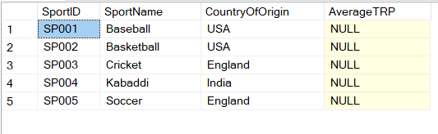

INSERT INTO League VALUES('L001', 'MLB', 'USA', '01-01-1903');

INSERT INTO League VALUES('L002', 'NBA', 'USA', '01-01-1946');

INSERT INTO League VALUES('L003', 'IPL', 'India', '01-01-2008');

INSERT INTO League VALUES('L004', 'Big Bash', 'Australia', '01-01-2010');

INSERT INTO League VALUES('L005', 'EPL', 'England', '01-01-1992');

INSERT INTO League VALUES('L006', 'NCAA', 'USA', '01-01-1968');

SELECT * FROM league

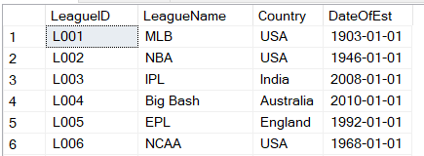

INSERT INTO Player VALUES('P001', 'Mike', 'Trout', 'USA',35,'01-01-2005');

INSERT INTO Player VALUES('P002', 'LeBron', 'James', 'USA',34,'01-01-2003');

INSERT INTO Player VALUES('P003', 'Roberto', 'Firmino', 'Brasil',26,'01-01-2012');

INSERT INTO Player VALUES('P004', 'Virat', 'Kohli', 'India',30,'01-01-2008');

INSERT INTO Player VALUES('P005', 'Anup', 'Kumar', 'India',35,'01-01-2007');

SELECT * FROM Player

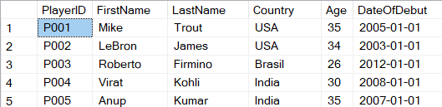

INSERT INTO Team VALUES('T001', 'Liverpool', 'National', 'You Never Walk Alone','SP005','L005');

INSERT INTO Team VALUES('T002', 'RCB', 'National', 'NA','SP003','L003');

INSERT INTO Team VALUES('T003', 'Syracuse Orange', 'Domestic', 'NA','SP002','L006');

INSERT INTO Team VALUES('T004', 'Los Angeles Angels', 'National', 'Build Me Up','SP001','L001');

INSERT INTO Team VALUES('T006', 'Melbourne Renegades', 'National', 'NA','SP003','L004');

INSERT INTO Team VALUES('T007', 'Chelsea', 'National', 'KTBFFH','SP005','L005');

SELECT * FROM team

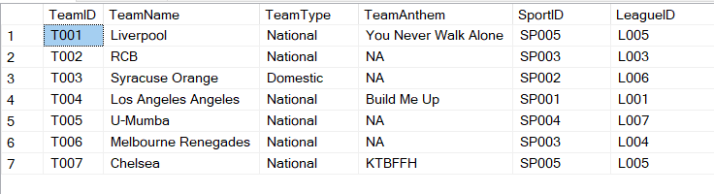

INSERT INTO ViewerRatingSource VALUES('S001', 'ESPN Ratings', 'Web Browsing');

INSERT INTO ViewerRatingSource VALUES('S002', 'FOX Sport Ratings', 'Television');

INSERT INTO ViewerRatingSource VALUES('S003', 'Hotstar', 'Online Streaming');

SELECT * FROM ViewerRatingSource

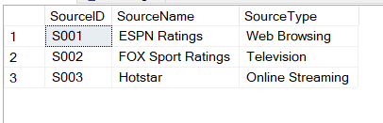

INSERT INTO PlayerTeamRecord VALUES('P001', 'T004', 100);

INSERT INTO PlayerTeamRecord VALUES('P003', 'T001', 150);

INSERT INTO PlayerTeamRecord VALUES('P004', 'T002', 135);

INSERT INTO PlayerTeamRecord VALUES('P007', 'T007', 50);

SELECT * FROM PlayerTeamRecord

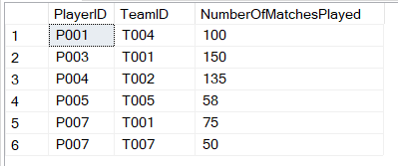

INSERT INTO RatingRecord VALUES('S001', 'SP005','2015-2016', 10);

INSERT INTO RatingRecord VALUES('S002', 'SP005','2015-2016', 9);

INSERT INTO RatingRecord VALUES('S003', 'SP003','2015-2016', 7);

INSERT INTO RatingRecord VALUES('S002', 'SP003','2015-2016', 9);

INSERT INTO RatingRecord VALUES('S003', 'SP005','2015-2016', 9);

INSERT INTO RatingRecord VALUES('S001', 'SP003','2015-2016', 9);

INSERT INTO RatingRecord VALUES('S001', 'SP001','2015-2016', 9);

INSERT INTO RatingRecord VALUES('S002', 'SP001','2015-2016', 8);

INSERT INTO RatingRecord VALUES('S001', 'SP002','2015-2016', 8);

INSERT INTO RatingRecord VALUES('S002', 'SP002','2015-2016', 9.5);

INSERT INTO RatingRecord VALUES('S001', 'SP004','2015-2016', 7);

INSERT INTO RatingRecord VALUES('S002', 'SP004','2015-2016', 8);

SELECT * FROM RatingRecord

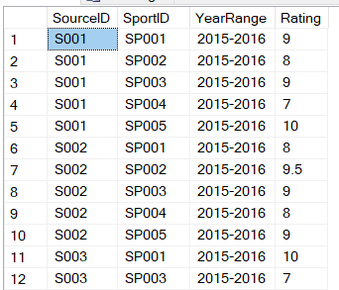

**SECTION V**

**MAJOR DATA QUESTIONS:**

* What is the Average TRP of a sport for a given year?
* For how many teams has a player played for?
* How many matches a player has played for a particular team?

The above mentioned questions are important because it lets the user know the current statistics of a particular sport or a particular player or team and in doing so keeps the user updated.

* By knowing the Average TRP, the user would know the most followed sport of a particular year.
* By knowing the number of teams a player has played, the user would get to know more about the player and his or her journey.
* By knowing how many matches a player has played for a particular team, the user would know the professional experience of that player in terms of the number of matches he/she has played.

***Following are the queries of the above asked data questions along with their output:***

* **What is the Average TRP of a sport for a given year?**

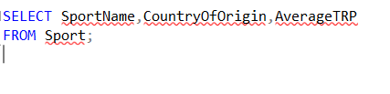

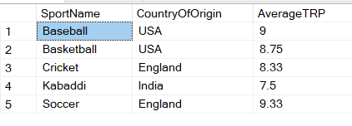

* **For how many teams has a player played for?**

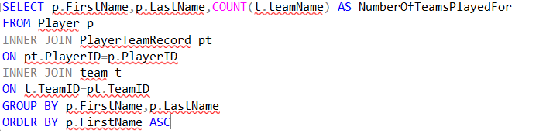

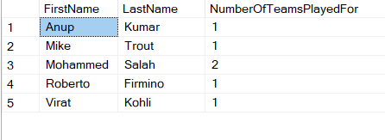

* **How many matches a player has played for a particular team?**

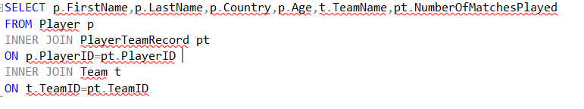

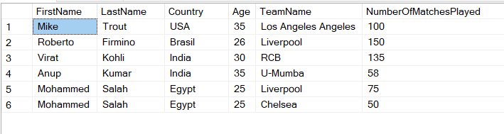

**SECTION VI**

**INTERFACES:**

**There were 2 forms created for the purpose of inputting the data.**

1. ***Player Information: Allows you to add & view information of a player in the Player Table.***

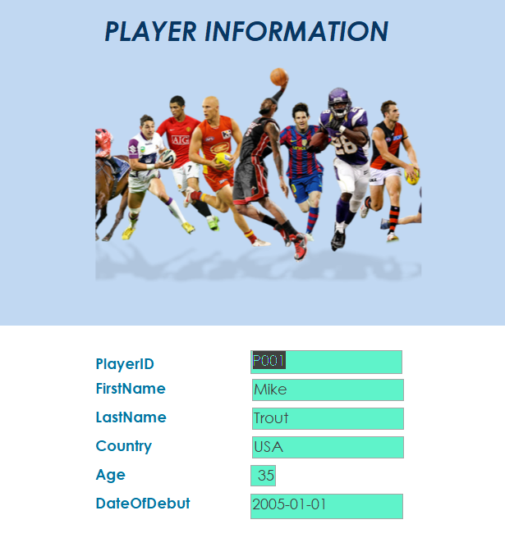

1. ***Team Information: Allows you to add & view information of a team in the Team Table.***

**Here combo box is used in team name, and this combo box allows you to select the team names from the available options.**

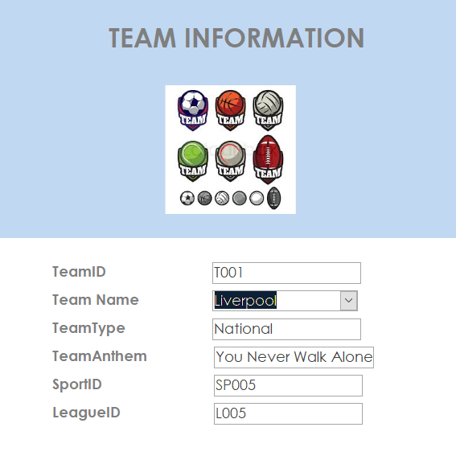

**REPORTS ANSWERING MAJOR DATA QUESTIONS:**

* **What is the Average TRP of a sport for a given year?**

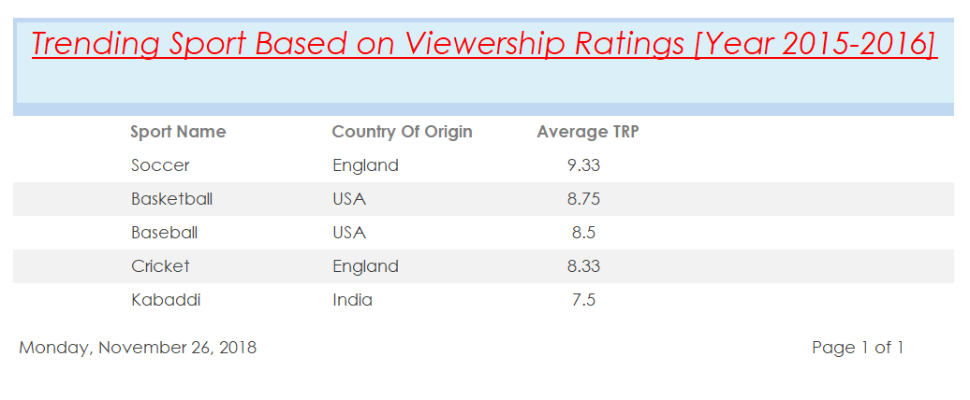

* **For how many teams has a player played for?**

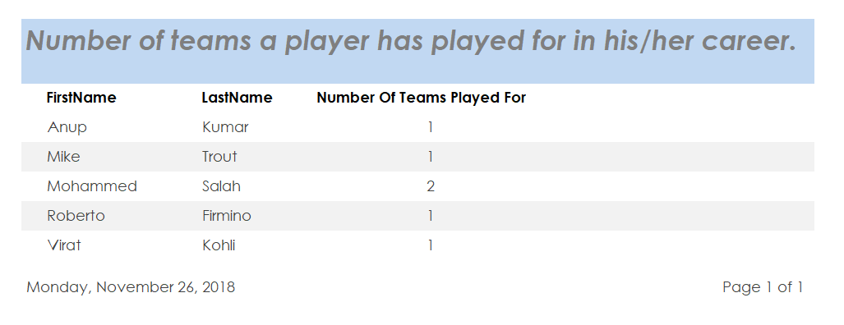

* **How many matches a player has played for a particular team?**

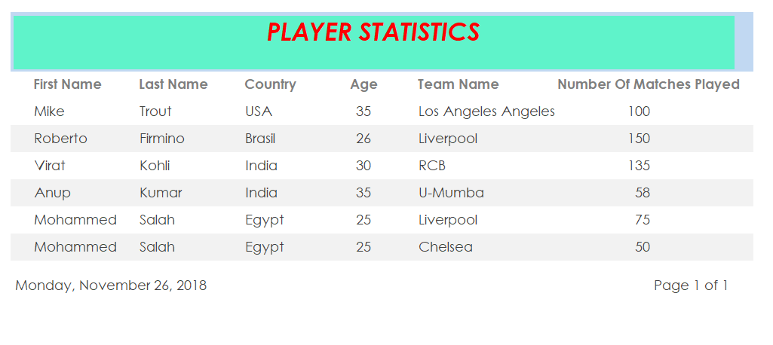

**SECTION VII**

**TRIGGER:**

***I have used a trigger for the purpose of calculation of Average TRP. Ratings for a particular sport may be obtained from different sources. For example, rating of soccer could be obtained from espn, foxsports and so on. Also ratings can be of different types i.e. ratings can be of online streaming viewership, online browsing or television viewership. Thus all these ratings are recorded in RatingRecord Table and the trigger which is shown below will calculate the average TRP and update the Sport Table once a new record is either added, updated or deleted.***

**TRIGGER QUERY:**

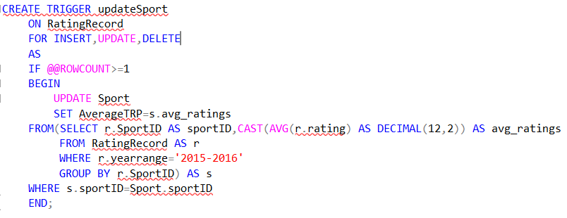

***SPORT TABLE BEFORE TRIGGER EXECUTION:***

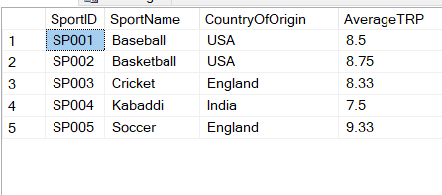

***SPORT TABLE AFTER TRIGGER EXECUTION:***

INSERT INTO RatingRecord VALUES('S003', 'SP001','2015-2016', 10);

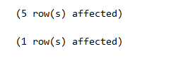

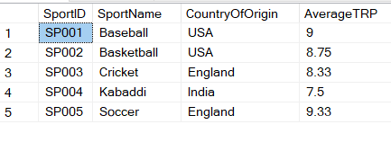

**TRANSACTIONS:**

I have created a transaction to enter a new PlayerTeam Record. For that the player should exist in Player table and the team should exist in the team table.

**TRANSACTION QUERY:**

SET XACT_ABORT ON;

BEGIN TRANSACTION newTeam

INSERT INTO Player

VALUES('P008', 'MS', 'Dhoni', 'India',35,'01-01-2005');

INSERT INTO Team

VALUES('T008', 'CSK', 'National', 'NA','SP003','L003');

INSERT INTO PlayerTeamRecord

VALUES('P008', 'T008', 200);

COMMIT TRANSACTION newTeam;

***Select Query before executing the transaction:***

SELECT * FROM Player

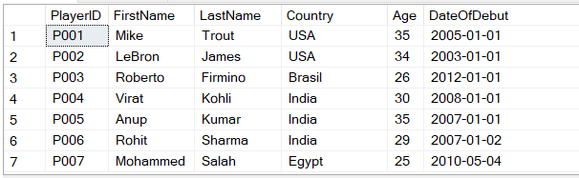

SELECT * FROM team

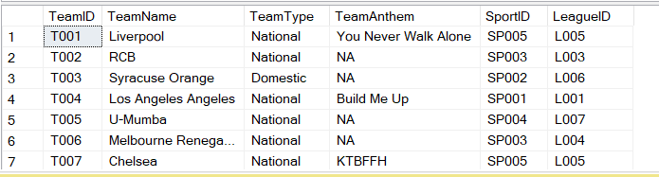

SELECT * FROM PlayerTeamRecord

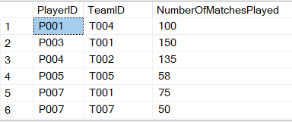

***After executing the transaction:***

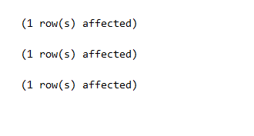

SELECT * FROM Player

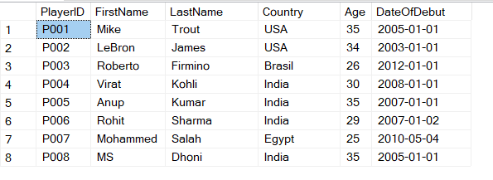

SELECT * FROM team

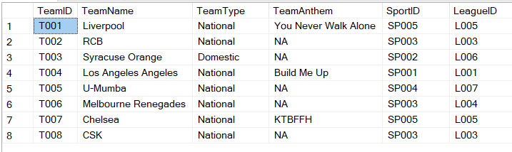

SELECT * FROM PlayerTeamRecord

