**Raters_app:**

**Section 1 –** Created the database using the table schemas.

Create a Database named “raters”.

The following tables are created in the raters database by implementing the schema in the models.py file in the raters_app application in the raters Project folder.

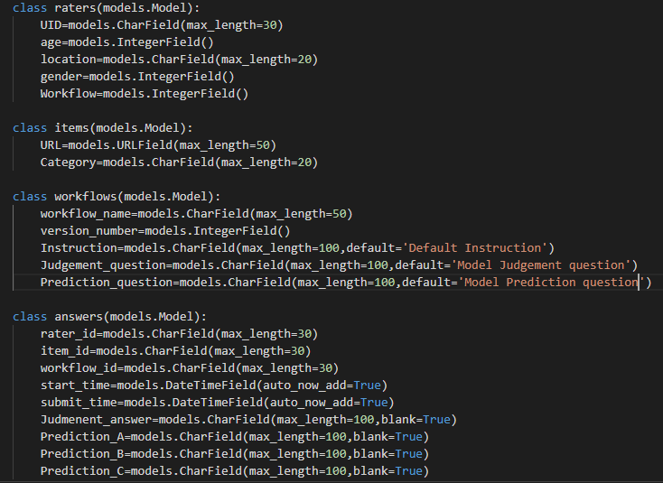

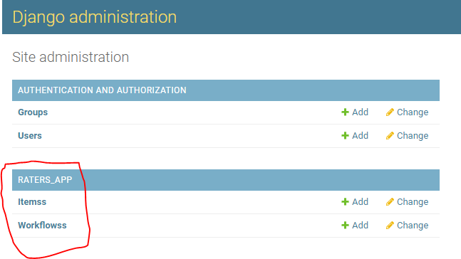

Items table:

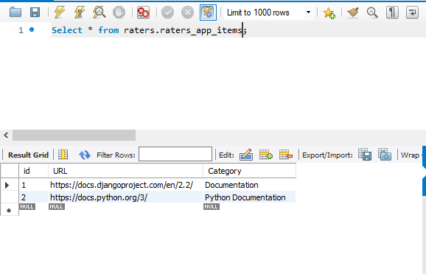

Workflow table:

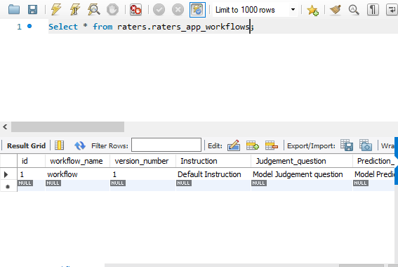

Form 1: Login/Registration page - Create a webpage to populate the *Raters* table.

