library(leaflet)

my_map <- leaflet() %>%
addTiles() %>%
addMarkers(lat=25.033199, lng=102.721457, popup="Tobacco Building")
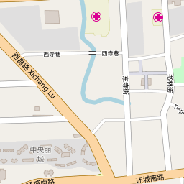
my_map

