ElectViz: Election Data Visualization for Media
Project Report
Student Name: P.Srinath
Course: B.Tech CSD
Project Title: ElectViz – Election Data Visualization for Media

Abstract

ElectViz is a data visualization project that focuses on analyzing Indian election data and presenting it in an easy-to-understand visual format. Elections generate a huge amount of data such as voter turnout, party performance, demographic participation, and historical trends. Traditional methods of analyzing this information are complex and time-consuming. This project uses data visualization techniques to transform raw election data into interactive dashboards that help media organizations, analysts, and the public understand election results more effectively. The project includes multiple dashboards such as election analysis, historical trends, real-time monitoring, and demographic turnout analysis. These dashboards help identify patterns, compare election results across years, and provide insights into voting behavior.

Introduction

Elections are one of the most important democratic processes in India. During elections, a large amount of data is generated, including candidate information, party performance, voter turnout, and constituency-level results. Analyzing this data manually can be difficult and time-consuming. Data visualization provides a powerful way to convert complex datasets into meaningful visual insights.
The ElectViz project focuses on creating dashboards that visually represent election data in an interactive and easy-to-understand format. Using modern visualization tools such as Power BI, the project aims to help media organizations and analysts quickly interpret election results and trends. By transforming raw data into charts, graphs, and dashboards, ElectViz makes election analysis more accessible and informative.

Objectives

The main objectives of the ElectViz project are:
• To analyze Indian election data using data visualization techniques.
• To create dashboards that present election insights clearly.
• To identify voting patterns and trends across different elections.
• To analyze voter turnout based on demographic factors.
• To support media and analysts in understanding election outcomes quickly.

3. Project Modules

3.1 Indian Election Analysis Dashboard

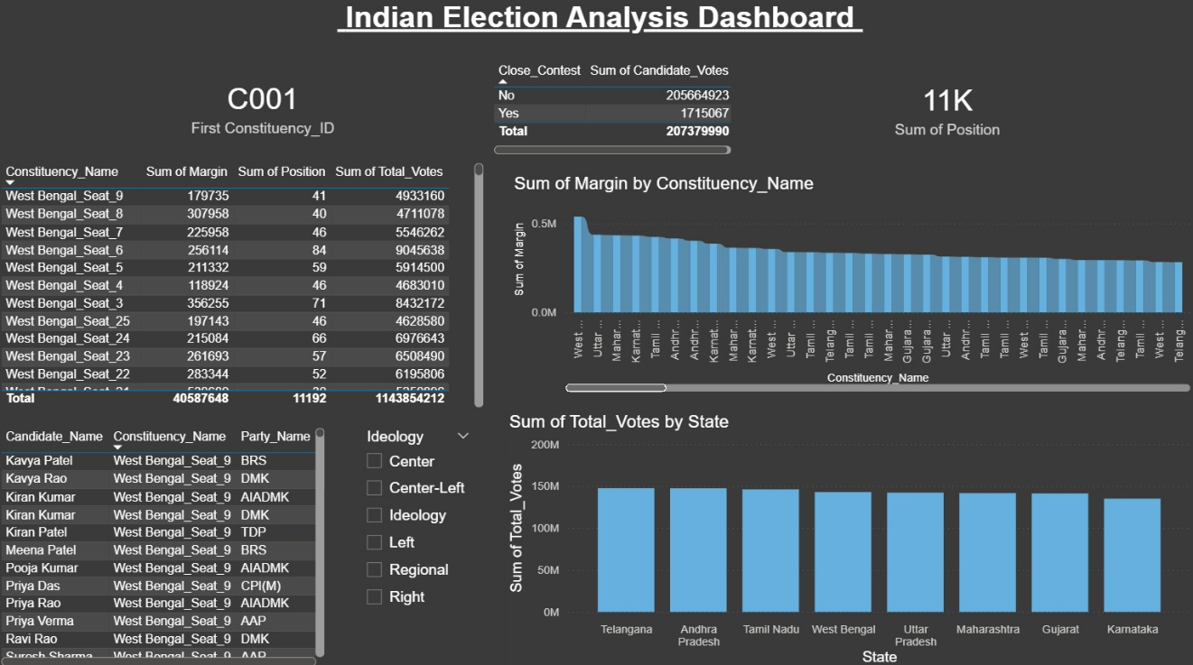

Dashboard Overview
This dashboard provides a comprehensive analysis of election data across different constituencies and states in India. It helps users understand voting patterns, margins, candidate performance, and overall election trends.

Key Components
Constituency Summary : Displays the selected constituency ID (C001).
A table shows:
Total votes
Margin of victory
Candidate positions
Helps compare performance across constituencies.
Close Contest Analysis :
Shows the number of close contests (Yes/No).
Provides insight into highly competitive elections.
KPI Cards :
Displays Sum of Positions (11K).
Indicates total candidate rankings across all constituencies.

Visualizations
Margin by Constituency :
Bar chart showing victory margins across constituencies.
Helps identify:
Stronghold areas (high margin)
Competitive areas (low margin)
Total Votes by State :
Compares total votes across states like Telangana, Andhra Pradesh, Tamil Nadu, etc.
Useful for analyzing voter participation and regional engagement.

Candidate Details
Displays:
Candidate names
Party affiliation
Constituency
Enables detailed drill-down into candidate-level performance.

Filters
Ideology filter (Center, Left, Right, Regional, etc.)
Allows users to analyze results based on political alignment.

3.2 Indian Historical Trends Dashboard

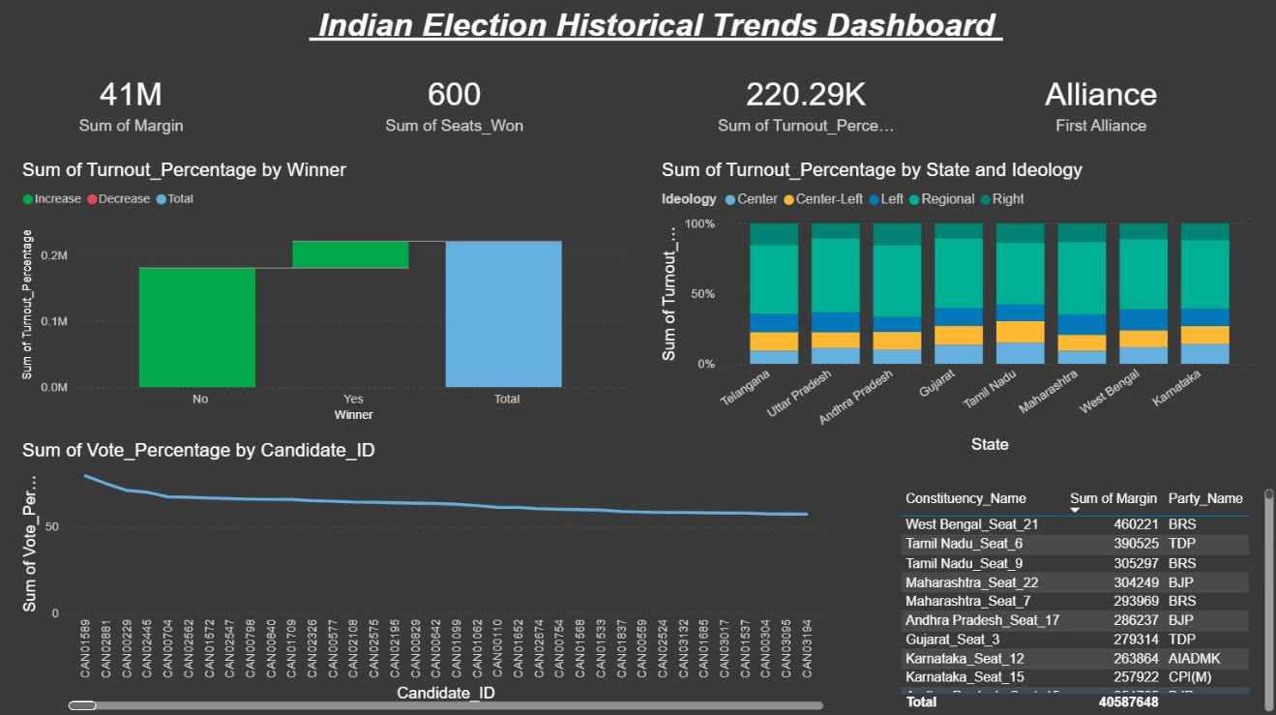

Dashboard Overview
This dashboard focuses on analyzing historical election trends across different states in India. It helps in understanding changes in voter turnout, party ideology impact, and candidate performance over time.

Key Performance Indicators (KPIs)
Sum of Margin (41M)
Represents the total victory margins across all constituencies, indicating overall competitiveness.
Sum of Seats Won (600)
Shows the total number of seats won by parties.
Sum of Turnout Percentage (220.29K)
Reflects overall voter participation across elections.
Alliance
Displays alliance-level grouping to analyze coalition performance.

Visualizations
Turnout Percentage by Winner (Left Chart)
Compares voter turnout for winning and non-winning candidates.
Highlights whether higher turnout influences winning chances.
Turnout by State and Ideology (Top Right Chart)
Stacked bar chart showing turnout distribution across:
States (Telangana, Gujarat, Tamil Nadu, etc.)
Political ideologies (Center, Left, Right, Regional)
Helps understand which ideology dominates in different regions.
Vote Percentage by Candidate (Bottom Line Chart)
Displays trends in vote share across candidates.
Useful for identifying top-performing and consistent candidates.

Detailed Table
Shows constituency-level data including:
Constituency name
Margin of victory
Party name
Enables deeper analysis of strong and weak regions.

3.3 Real-Time Analysis of Election Data

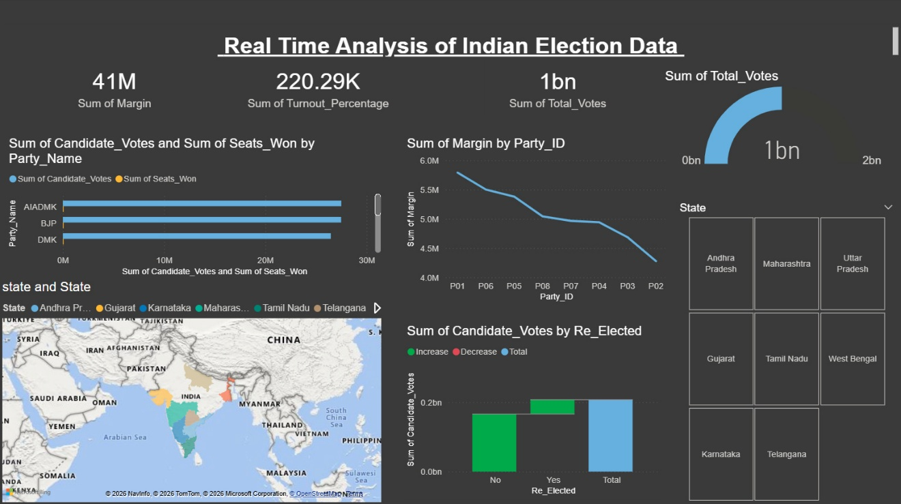

Dashboard Overview
This dashboard provides a real-time overview of election data across India, helping users quickly understand voting patterns, party performance, and regional trends.

Key Metrics
Total Margin (41M): Represents the overall winning margin across all constituencies.
Turnout Percentage (220.29K): Aggregated voter turnout data.
Total Votes (1 Billion): Shows the total number of votes cast in the election.

Party-wise Performance
The bar chart compares:
Candidate Votes vs Seats Won for parties like AIADMK, BJP, and DMK.
It helps identify which party gained more votes and how many seats they secured.

Margin by Party
The line chart shows how the winning margin varies across different party IDs.
It helps analyze which parties had stronger or weaker victories.

State-wise Analysis
The map visualization highlights different Indian states such as Andhra Pradesh, Gujarat, Karnataka, Maharashtra, Tamil Nadu, and Telangana.
It gives a geographical view of election activity and distribution.

Re-Elected Candidates
The column chart compares votes for:
Candidates who were re-elected (Yes)
Candidates who were not re-elected (No)
This helps understand voter preference for incumbents.

Filters
Users can filter data by states like Uttar Pradesh, West Bengal, Tamil Nadu, etc.
This enables interactive and customized analysis.

Total Votes Gauge
The gauge chart visually represents total votes (1 billion), showing progress or scale.

3.4 Turnout Analysis by Demographics

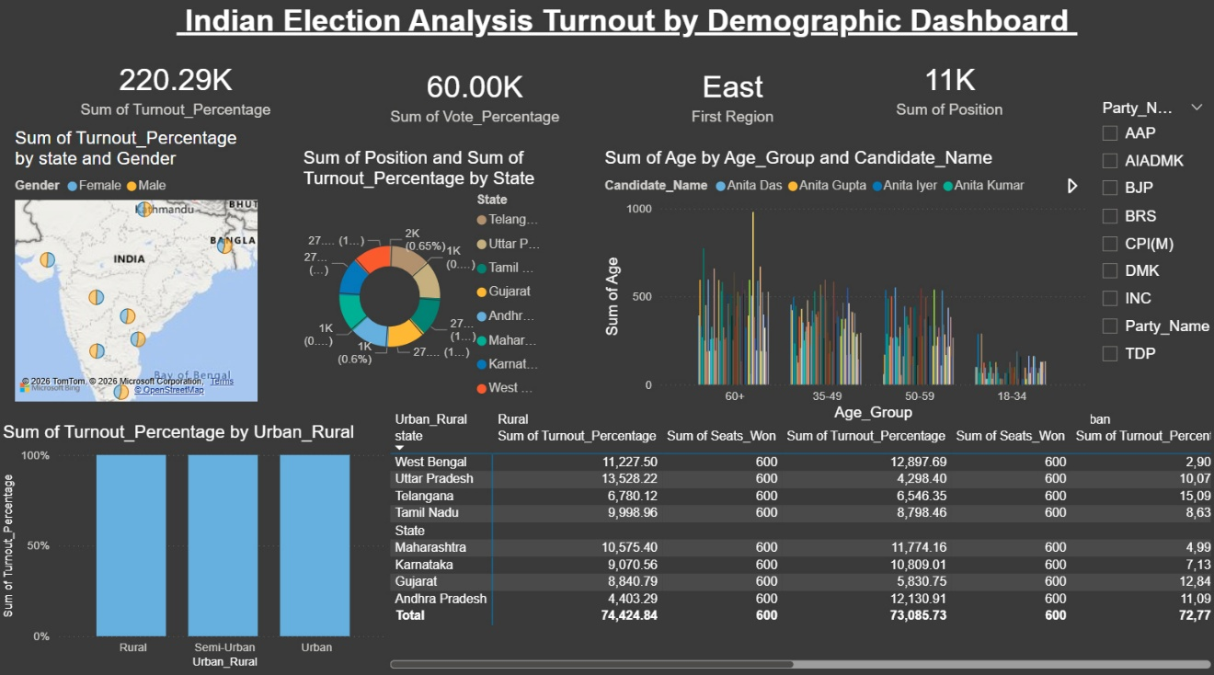

Dashboard Overview
This dashboard focuses on analyzing voter turnout based on demographic factors such as gender, age group, region, and area type.

Key Metrics
Turnout Percentage (220.29K): Total voter turnout across all regions.
Vote Percentage (60K): Overall voting share.
Region (East): Highlights the primary region selected for analysis.
Position (11K): Represents total positions/seats considered.

Gender-wise Turnout
The map visualization shows voter turnout distribution across states based on male and female participation.
Helps identify gender-wise voting patterns geographically.

State-wise Analysis
The donut chart displays turnout percentage and positions across different states like Telangana, Uttar Pradesh, Tamil Nadu, etc.
Useful for comparing state-level performance.

Age Group Analysis
The bar chart shows voter distribution across age groups:
18–34, 35–49, 50–59, 60+
It compares candidate participation and engagement among different age categories.

Urban vs Rural Turnout
The column chart compares turnout in:
Rural
Semi-Urban
Urban areas
Helps understand how location impacts voting behavior.

Detailed Table
The table provides state-wise detailed data including:
Turnout percentage
Seats won
Urban vs Rural comparison

Filters (Right Side)
Users can filter by political parties like AAP, BJP, DMK, INC, etc.
Enables interactive and customized analysis.

3.5 Party and Candidate Performance Tracker

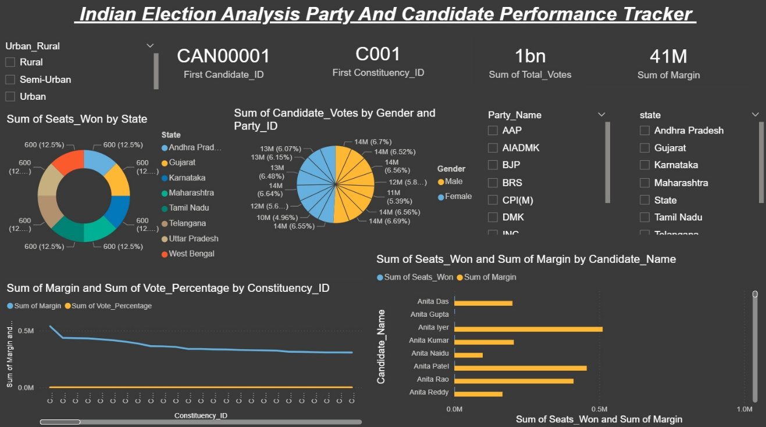

Dashboard Overview
This dashboard focuses on analyzing the performance of political parties and individual candidates across different states and constituencies.

Key Metrics
Candidate ID (CAN00001): Displays selected candidate.
Constituency ID (C001): Shows selected constituency.
Total Votes (1 Billion): Total votes cast.
Total Margin (41M): Overall winning margin.

Seats Won by State
The donut chart shows the number of seats won across states like Andhra Pradesh, Gujarat, Karnataka, etc.
Helps compare state-wise political performance.

Votes by Gender & Party
The pie chart represents candidate votes divided by:
Gender (Male vs Female)
Party IDs
Useful for understanding gender participation in voting.

Constituency-wise Analysis
The line chart shows:
Margin of victory
Vote percentage
across different constituencies.
Helps identify strong and weak constituencies.

Candidate Performance
The bar chart compares candidates based on:
Seats won
Winning margin
Helps identify top-performing candidates.

Filters
Users can filter by:
Urban/Rural areas
Political parties (AAP, BJP, DMK, INC, etc.)
Enables interactive and customized analysis.

4. Tools and Technologies Used

The ElectViz project uses modern data visualization and analytics tools to convert raw election data into meaningful insights. The key tools and technologies used are:
1. Power BI
Purpose: Main tool for creating interactive dashboards and visualizations
Usage in Project:
Designed all dashboards (Election Analysis, Historical Trends, Real-Time Analysis, Demographics, Party Tracker)
Created charts like bar charts, line charts, maps, KPI cards, and gauges
Enabled filters and slicers for interactive data exploration

2. Microsoft Excel
Purpose: Data preprocessing and cleaning
Usage in Project:
Stored raw election datasets
Removed duplicates and handled missing values
Structured data into tables before importing into Power BI

3. Data Modeling (Power BI Data Model)
Purpose: Organizing and connecting data tables
Usage in Project:
Created relationships between datasets (candidates, constituencies, states, parties)
Enabled efficient querying and filtering across dashboards

4. DAX (Data Analysis Expressions)
Purpose: Used for calculations and KPIs
Usage in Project: Calculated metrics such as:
Total Votes
Margin of Victory
Turnout Percentage
Seats Won
Created dynamic measures for real-time insights

5. Data Visualization Techniques
Purpose: Representing data in graphical form
Usage in Project:
Bar charts → Compare margins and votes
Line charts → Show trends over time
Maps → State-wise election analysis
Pie/Donut charts → Distribution analysis
KPI Cards → Highlight key metrics

5. Methodology

The ElectViz project follows a structured process:
1. Data Collection – Election data is collected from reliable datasets and sources.
2. Data Cleaning – Raw data is cleaned and formatted to remove errors or missing values.
3. Data Processing – The cleaned data is processed and organized for analysis.
4. Data Visualization – Charts, graphs, and dashboards are created using Power BI.
5. Analysis – The dashboards are analyzed to extract meaningful insights.

6. Results and Findings

The ElectViz project successfully transformed complex Indian election data into interactive and easy-to-understand dashboards, enabling clear analysis of voting patterns, party performance, and demographic behavior. The results show that data visualization significantly improves the interpretation of large datasets by presenting key insights such as voter turnout, margin of victory, and seat distribution in a simplified format. Through the election analysis dashboard, it was observed that certain constituencies consistently show high victory margins, indicating strong political dominance, while others reflect close contests, highlighting competitive regions. The historical trends dashboard revealed noticeable variations in voter turnout across different states and elections, along with the influence of political ideologies on regional voting behavior.
The real-time analysis module provided a comprehensive overview of total votes, turnout percentage, and party-wise performance, showing how different political parties perform across regions and how vote share does not always directly translate into seats won. The demographic analysis highlighted important patterns such as differences in voter participation based on gender, age groups, and urban-rural distribution, indicating that younger voters and urban populations tend to have varying engagement levels compared to older and rural voters. Additionally, the party and performance tracker identified top-performing candidates and parties by analyzing seats won, vote share, and winning margins.

7. Conclusion

The ElectViz project successfully demonstrates how data visualization techniques can be used to simplify and analyze complex Indian election data. By transforming large volumes of raw data into interactive dashboards, the project makes it easier to understand key aspects such as voter turnout, party performance, constituency trends, and demographic participation. The use of tools like Power BI enabled the creation of dynamic and user-friendly visualizations that allow users to explore data efficiently.
Through various modules such as election analysis, historical trends, real-time monitoring, and demographic analysis, the project provides comprehensive insights into election patterns and behavior. It highlights how visualization helps in identifying trends, comparing results across regions and years, and supporting better decision-making for media organizations and analysts.
Overall, ElectViz proves that data visualization is a powerful approach for handling large datasets and presenting them in a meaningful way. The project not only improves the accessibility of election data but also enhances the ability to derive valuable insights quickly and accurately.

8. References

Election Commission of India (ECI). Official Election Data. Available at: https://eci.gov.in/
- Source of election-related datasets including voter turnout and constituency details.
Kaggle. Election Datasets. Available at: https://www.kaggle.com/
- Used for accessing sample and historical election datasets.
Data Visualization Concepts.
- Various online tutorials and educational resources were referred to understand visualization techniques such as charts, graphs, and dashboards.

