

Torry Harris Business Solutions

STEPS TO GENERATE RT REPORT

Amendment History

Sl.No | Author (s) | Version | Date | Approved by | Change Description
1 | SRINATH D S | 0.1 | 17/09/2019 |  | Initial draft version

Contents
1. Purpose of the document 4
2. Steps to generate RT Report 4
3. Snapshots……………………………………………………………………………………..5

Purpose of the document
The purpose of this document is to provide steps on how to generate RT report from 2 Servers(.22 and .23)

Steps to generate RT report
- Login to .22 server
- Traverse to cd /usr/ie/osb/logs
- Check for the logs
3.1 If RT report needs to be generated for the current date , copy "soalogs" to a folder in the same directory(cd /usr/ie/osb/logs) in the format(System.log.2019-08-02.1)
3.2 zip the destination file created using gzip command(ex: gzip System.log.2019-08- 02.1)
4. If Report to be generated for previous days, check weather the logs are saved with the dates you ae looking for in the path(cd /usr/ie/osb/logs) it will be saved in this format(System.log.2019-08-02.1)
5. If logs are not present in (cd /usr/ie/osb/logs) hit a request in both the servers(.22 and .23) . Folder will be created in the above format (System.log.2019-08-02.1).
6. Traverse to "cd /usr/ie/mis_log_archive/ManagedServer/Services_Logs" and create a directory using mkdir command(mkdir 20190213).
NOTE: directory name should be future date as the script will take future date(current date +1) directory to get the logfile inside it.
7. Traverse to cd /usr/ie/osb/logs and copy the logs to the destination (/usr/ie/mis_log_archive/ManagedServer/Services_Logs/directoryname)
ex: cp System.log.2019-08-02.1 /usr/ie/mis_log_archive/ManagedServer/Services_Logs/ 2019082019
8. Go to the directry (cd 2019082019)
9. Zip the folder (ex: gzip System.log.2019-08-02.1)
10. Traverse to cd /export/home/wlapp/tools/jobs/Statistics_Report_Scripts
11.Type “./soa_daily_report_nob.pl” and enter the date for which the RT needs to be generated.(ex: ./soa_daily_report_nob.pl 13/08/2019)
12.Go to winscp , traverse to "/export/home/wlapp/tools/jobs/Statistics_Report_Scripts/logs " copy the file to local .Find the standard sample RT template in cvs().

13. Copy the success transactions in "Service_Statistics" page. and refresh the first row of the column service name so that Sum of Total Requests , Average of Min Time (ms),Average of Max Time (ms) and Average of Avg Time (ms) fields will be updated based on the copied transactions.
14. Go to consumer statistics page , refresh the firrst row of the column "Application”.
15. Go to TPS Pivot refresh the first row of the column "Time".
16. Go to "Fault" tab , copy the fault transactions from the report generated , refresh the first row of columns "sum of count"(for all V, E and F columns)
17.Go to Fault Pivot page ,refresh the first row of the column "Time"
18. Repeat the steps for .23 server and merge generated report of 22 and 23 servers.

Figure 1.a : Service statistics sheet

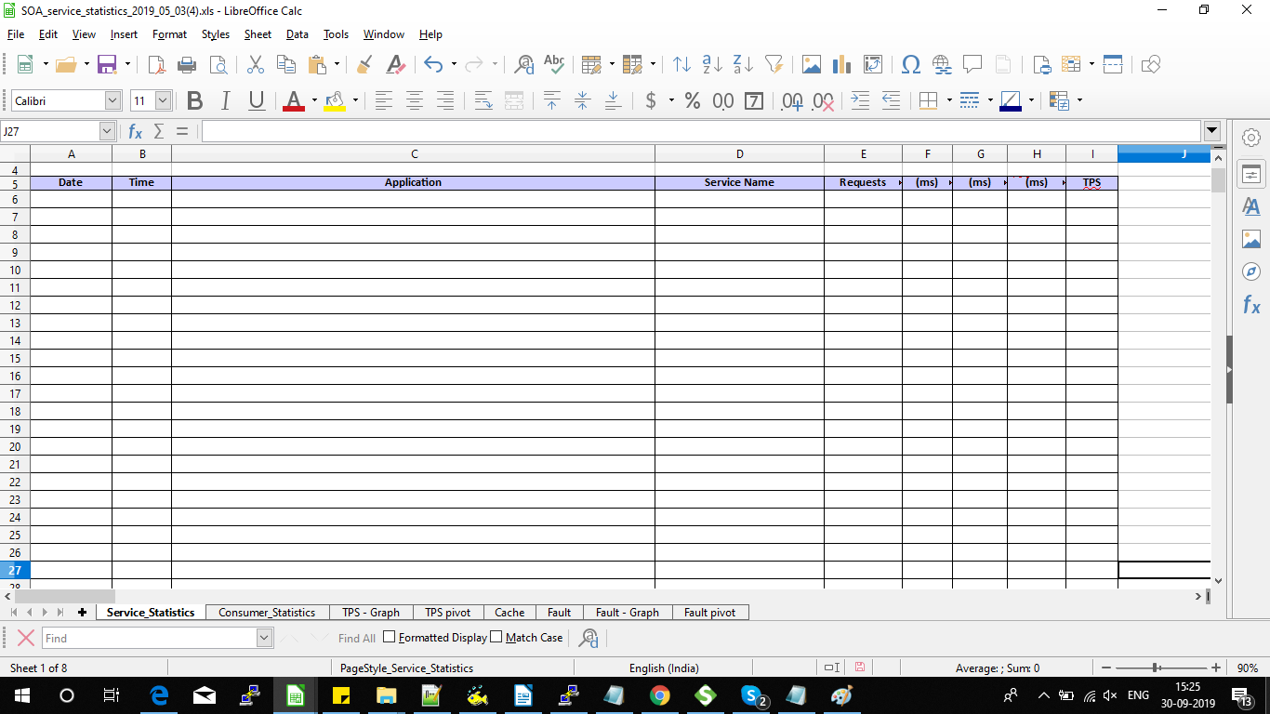

Figure : Service statistics with detailed transactions.

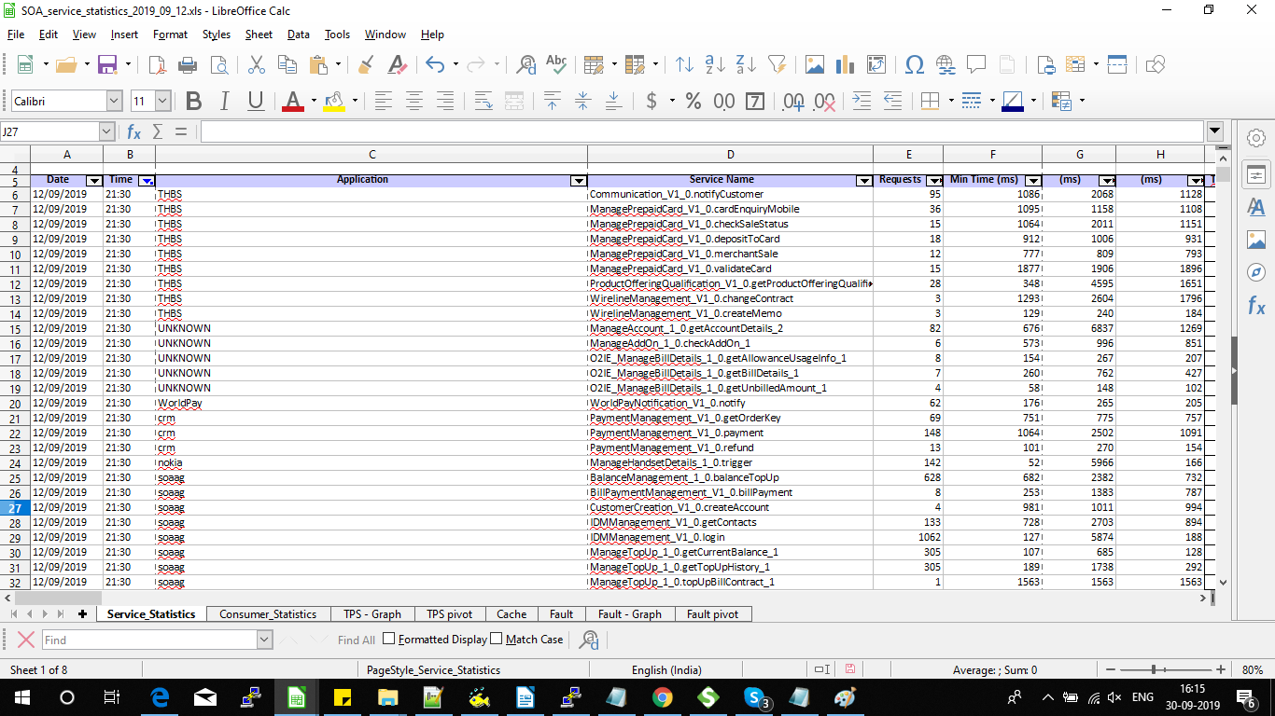

Figure : TPS pivot

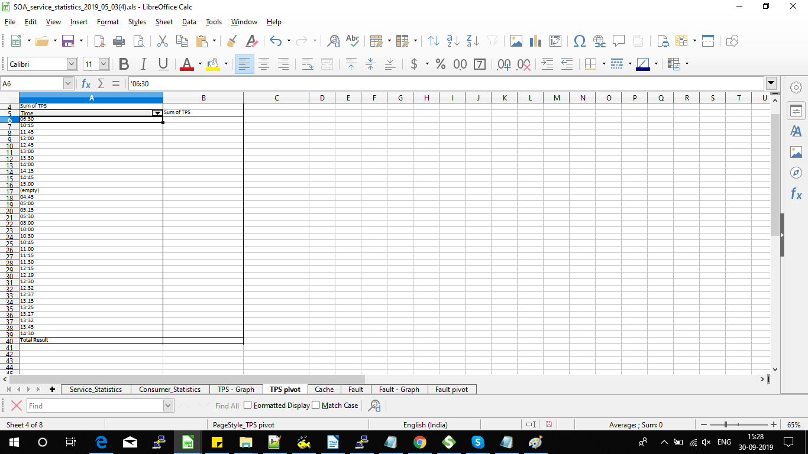
Figure : Consumer Statistics

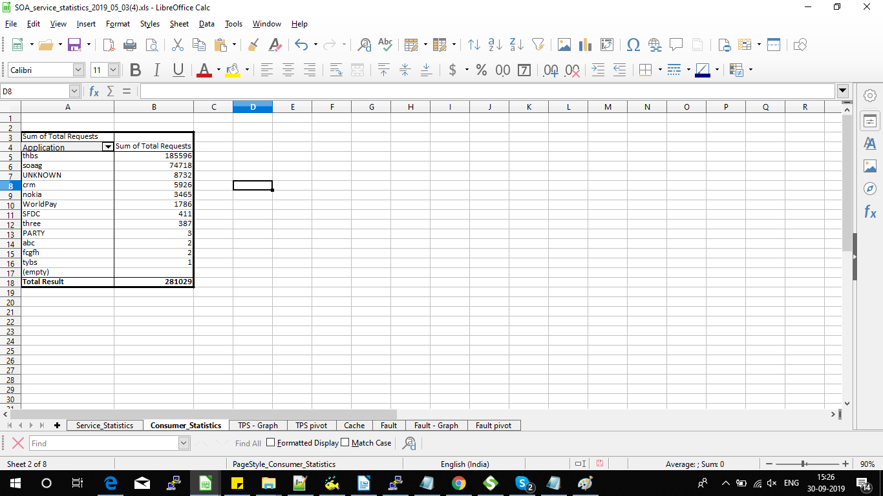

Figure : Fault Page

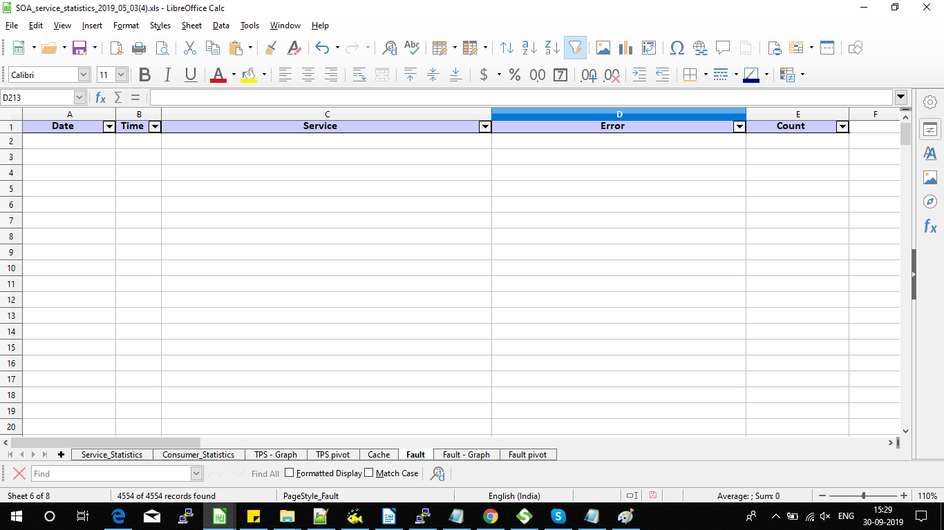

Figure: Fault page with detailed transactions

Figure: Fault Pivot

