First step in assignment

[SeleniumLibrary](https://github.com/robotframework/SeleniumLibrary) is a web testing library for [Robot Framework](http://robotframework.org/) that utilizes the [Selenium](http://seleniumhq.org/) tool internally. The project is hosted on [GitHub](https://github.com/robotframework/SeleniumLibrary) and downloads can be found from [PyPI](https://pypi.python.org/pypi/robotframework-seleniumlibrary).

pip install --upgrade robotframework-seleniumlibrary

Download the chome driver and add the path of driver to windows PATH.

Command to run the test cases(navigate to extracted folder):

#pybot -s Tests .

Sample run on execution of above command

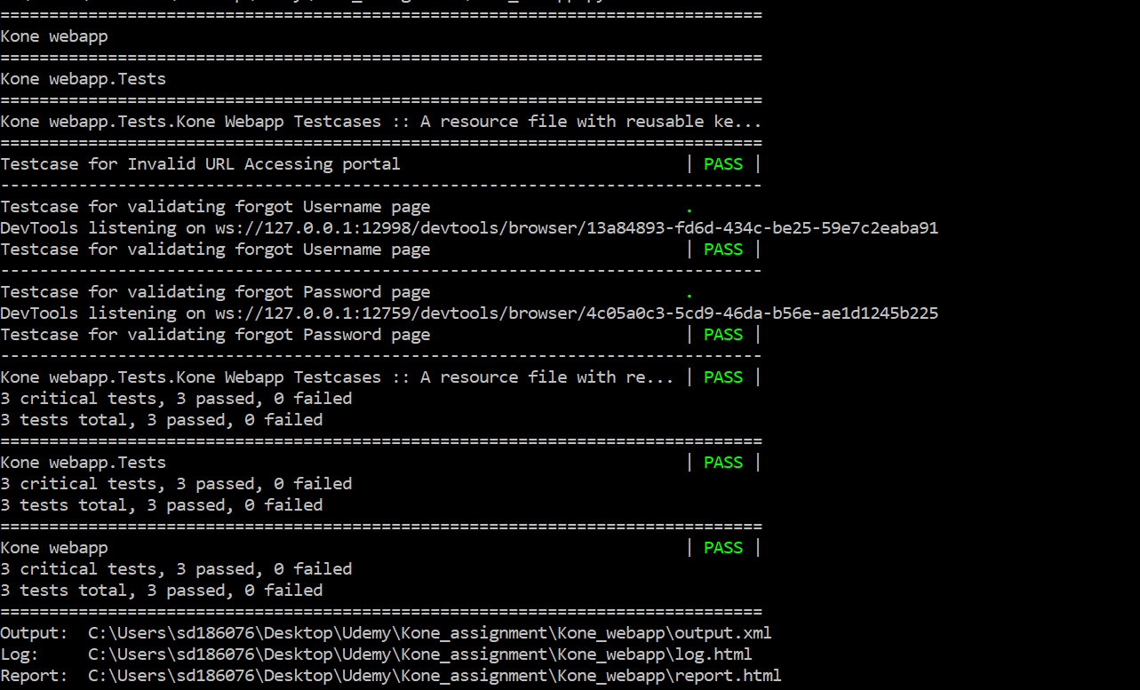

The Two Unit test cases have following multiple scenarios of which the following are implemented:

1. Check the portal is up or not. Also check if the random URL does not open the portal link
2. Navigating to first level by clicking button Cloud_Directory_UAT
3. Logging in to the portal
4. Accessing the forgot username and password pages.
5. Find if the search key results has the equipment ID
6. Logged user and userid should match

Scenarios which have not been implemented are:

1. Multiple login for different browsers
2. Multiple login attempts of userid
3. Copying the password from textbox
4. After logging in the user waits for one hour to give search key (Session time out )
5. User modifying the link manually to access a search result
6. Accessing the Kone Button and trying to login with given credentials.
7. Modify language and give searches

All the scenario’s implemented have multiple test cases which can accessed from LOG file of report

The approach to validate various data has been done in two ways:

1. The script way -> The python script validates before sending it to web page

Ex. Python script tests if username and password given is valid and if only it satisfies the condition then the script sends to web page

1. The webpage way -> Python scripts send the data without validating.

Ex. If invalid username and password is given the script sends the data to web page and checks if the web page is handling the condition correctly

The python script has documentation for all the functions and their usage.

*Extensions/Enhancements*

*The parser can be upgraded to parse the complete document and extract all the necessary elements for validation.*

*Functionality to preprocess the data being sent to test more features of web page.*