**BTP Project Report**

**Go Green - B22NT03**

**Abstract:**

The majority of Indian institutions still rely heavily on paper for their administrative procedures. All paperwork is primarily paper-based, including those for entrance, enrollment, attendance, pre- and post-examinations, and degree awards. It necessitates the use of a significant amount of paper, results in knowledge loss and overlapping, and erects administrative barriers for teachers and pupils.

In Indian higher education institutions, paperless administration is increasingly necessary. It is not only economical but also quick and environmentally friendly. This idea was widely incorporated into university administration. The advantages and difficulties of paperless administration can be understood after this project.

**Introduction:**

Since the Industrial Revolution, paper use has begun to gain popularity. Due to the increasing demand for printed money and the production of manuals, newsletters, books, newspapers, magazines, and other publications, it has evolved into a necessary component of daily life. Paper factories emerged as the need for paper grew, and this coincided with an increase in the reliance of the industry on trees or forests. It was discovered that due to the paper industries' consumption of 1.6 billion trees, or 43% of all trees used globally, the area of forests has decreased by 60,000 square kilometers annually. Thus, the world's forest ecosystems are significantly impacted by the usage of paper.

Physical documents must be handled, copied, archived, and retrieved from a file cabinet as part of paper-based procedures. Processes that use paper are inefficient, waste money on office space, and present security problems. According to Kissell (2013), filing systems result in unproductive searches for previously filed documents and demand a lot of physical space. Approximately "6% of revenue for small and medium enterprises, and 5% at large firms" goes on the rent for actual filing space.

Paper papers that have (a) been misplaced, (b) suffered damage, (c) been misfiled, (d) come into the possession of the wrong people, or (e) all of the above, pose security threats to organizations that employ paper-based operations. According to Brusco (2011), "a growing number of businesses and organizations are switching to electronic filing, which increases security and frees up space. Large computer servers have the capacity to store vast amounts of data in a safe environment. These servers allow for the quick retrieval of digital data, which boosts employee productivity by eliminating the need to spend time looking for misplaced physical documents.

Collaboration on paper papers might be difficult at times. Compared to their digital equivalents, employees find it difficult to communicate or distribute paper papers. Digital documents offer more flexibility for businesses that have switched from paper-based operations to paperless processes carried out on a computer or other device. "Digital papers take up virtually no space and are easier to find, exchange, and backup than physical documents." However, in reality, a paperless environment closely resembles an office using integrated information systems with multiple software tools to reduce paper consumption and improve efficiency in retrieving electronic documents. The phrase "paperless office" conjures images of an office without paper documents. Office productivity and collaboration are increased in paperless settings due to the simplicity of sharing and retrieving digital documents. Additionally, paperless meetings can be held when mobile devices and digital documents are used together. Attendees of meetings held using mobile devices can access agendas and handouts without printing or copying paper documents.

The trend of going paperless has now included services that businesses provide to their clients. Major institutions, for instance, give their customers the choice to receive electronic invoicing and the convenience of mobile applications. It is becoming more and more uncommon to find banks, utilities, and other providers that do not offer paperless billing and payment, according to Kissell (2013). Some organizations, like banks, have taken things a step further by providing their customers with a mobile application. The institutions that provide a variety of options, such as a mobile application, electronic billing, and electronic payment, benefit by avoiding the need to send out paper invoices, and their customers appreciate the convenience of being able to perform tasks like money transfers, bill payments, and account balance checks from anywhere at any time. Furthermore, the security issues related to conventional payment methods like cash and cheques have been reduced by using electronic payments. Paper payments have security issues because it was possible to falsify check signatures and counterfeit cash. Therefore, businesses that accept electronic payments do away with these problems.

**Related Work:**

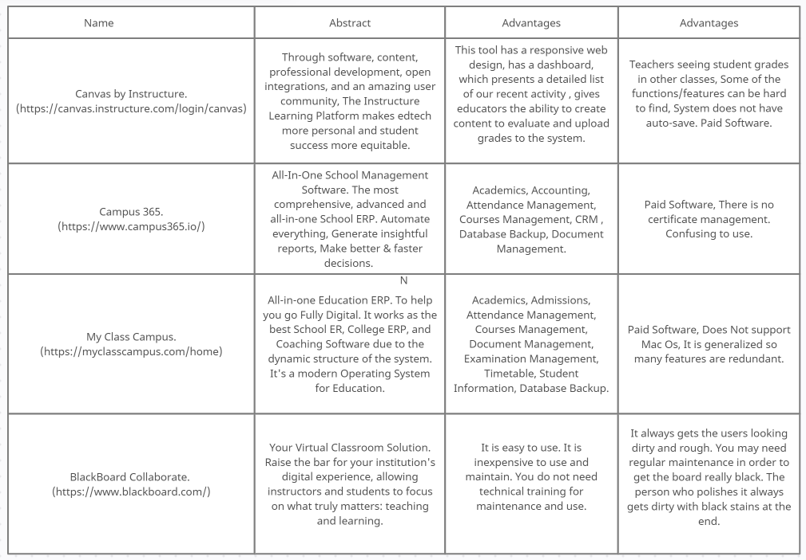

**Problem Statement and Motivation:**

The transition to paperless business practices is supported by technology, but not all firms can afford the IT infrastructure required to accomplish the change. Small and medium-sized businesses (SMBs) frequently lack the IT infrastructure and resources needed to swiftly boost server performance and/or storage capacity, both of which are necessary for the internal computing infrastructure required for efficient digital document storage and retrieval. An SMB must therefore find additional ways to maintain its competitiveness. One of the methods an SMB can use to immediately expand its IT infrastructure is cloud computing. "Internet-based computing, where shared resources, software, and information are delivered to computers and other devices" is how Wang (2013) defines cloud computing. Additionally, cloud computing, and notably cloud storage, enables users to save and access files on any Internet-connected device from any location at any time. Cloud computing provides a practical way for SMBs to switch to electronic document storage and retrieval at a low cost.

The study by Sandhu and Seth (2014) indicated that despite the paperless office initiative's primary goal of reducing or eliminating paper use in the workplace, paper consumption is still quite high and still dominates knowledge-based tasks like reading and collaborating. Therefore, the goal of this research is to investigate a deeper knowledge of paperless implementation and investigate its benefits and drawbacks.

We can try to minimize the adverse effect the paper industry is causing on the environment and make employees more productive by adapting to a Paperless Administration. A paperless office is a workplace that has minimal paper-based processes and relies on digitized documents instead. This typically involves transitioning to an electronic document managing system that digitizes files and stores them in a central repository. We are trying to digitize all things which require paper and solve those problems through our web application.

**Proposed Methodology:**

We aim to build a web application that would solve the problem of the wastage of paper. We tried to cover the majority of use cases that would require the usage of paper and tried to build a digitized version of that in our application. This application should be able to be a self-sufficient application all by itself and once deployed need not be tampered with unless we require new features.

To build our web application we mainly need to fixate on what technologies would be best suited for our use case. We can divide the project into three major components: frontend, backend, and database.

For the frontend component, we decided to use React Js library along with Redux for state management. Facebook created the open-source React.js framework and library for JavaScript. In comparison to using pure JavaScript, it is used to quickly and effectively create interactive user interfaces and web applications. Reusable components are created as you construct your applications in React. These elements are separate parts of a final interface that, when put together, make up the full user interface for the application. By offering the best and most effective rendering execution, React's main function in an application is to manage the view layer of that application, much like the V in a model-view-controller (MVC) paradigm. This allows the ReactJS framework to render web pages more quickly and develop highly dynamic and responsive online applications by combining the speed and efficiency of JavaScript with a more effective way to manipulate the DOM. Redux enables you to control the state of your app from a single location, making updates more predictable and traceable. It makes it simpler to analyze changes that take place in your app. However, each of these advantages has trade-offs and limitations.

For the backend component of our project, we decided to use Node Js for building our application. Node.js is an open-source server-side script that uses Google's free and open-source V8 scripting engine as its foundation. Node.js is quick, light, and effective. Instead of using conventional threads or different threads for each task, it operates in an asynchronous mode and leverages event-driven input and output. The best platform for creating real-time web apps is Node.js. It offers cross-platform programs that function well on any website. Therefore, nothing extra is really required for setting up a node application. We used the NPM package manager for managing the various packages which we used to build this application.

For the database, we decided to use MongoDB with mongoose as the ODM. The scale-out architecture that MongoDB is based on has gained popularity among developers of all stripes for creating scalable applications with changing data formats. MongoDB's document database architecture makes it simple for programmers to store both structured and unstructured data. It stores documents in a format akin to JSON. Since developers don't have to worry about normalizing data, this format naturally maps to native objects in the majority of contemporary programming languages. In order to support heavy data loads, MongoDB can scale both vertically and horizontally and handle the huge volume.

**Results:**

We stared building this application with Node Js and used Express Js. For this application, we required 8 models: Admin Model, Student Model, Student Attendance, Teacher Model, Teacher Attendance, Teacher Salary, Student Leave, and Student Fees. We then built the routes for this application and followed the MVC (Model, View, Controller) architecture where the views are being handled by React Js. We used JWT for the authentication part of this application.

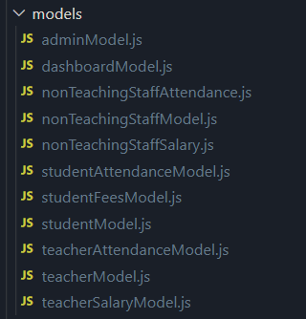 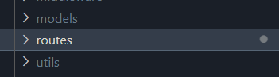  
All the models MVC Architecture.

As we are using MongoDB, we have to keep references between the different models to maintain the relations between them. So, for our models, we have references between the Student Attendance Model and Student Fees Model, and they contain references to the Student Model. Similarly, we have references between the Teacher Model, Teacher Attendance Model and Teacher Salary model.

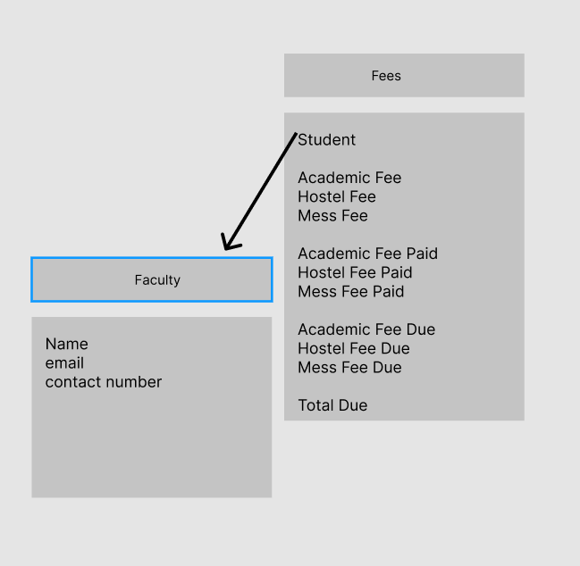  
References between the Teacher Model and Salary Model

All the API routes can be tested and interacted with, on our Swagger UI.

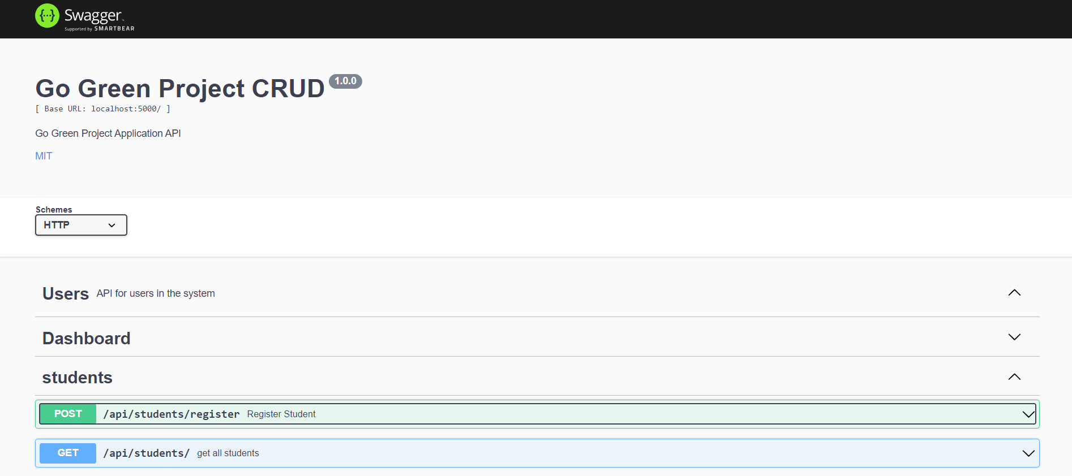

Swagger UI for our API.

As mentioned above, we are using React Js for the frontend and using Redux for the state management. We have divided the frontend into mainly three parts: a) The Admin Panel b) The Student Panel c) The Teacher Panel.

We have separate login pages for each of this components. And based on the user, they can login based on who they are. The Admin is the super-user who has all the important functionalities and can control and monitor the activities of the Students and Teachers. The Admin can mark the attendance of both Teachers and Students. He can manage the funds and pay the salaries of Teachers, collect the fees from the students.

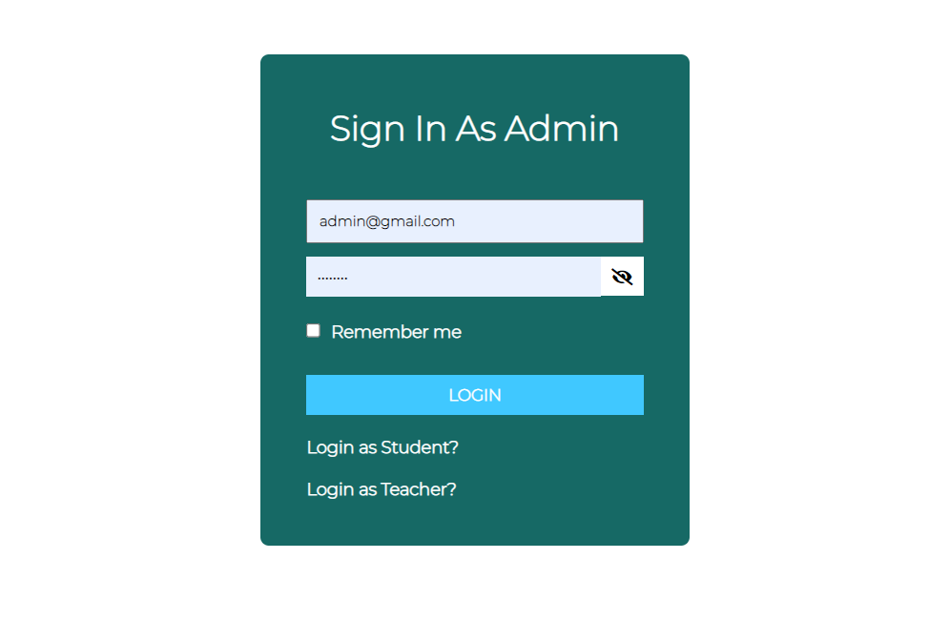

The login page for Admin

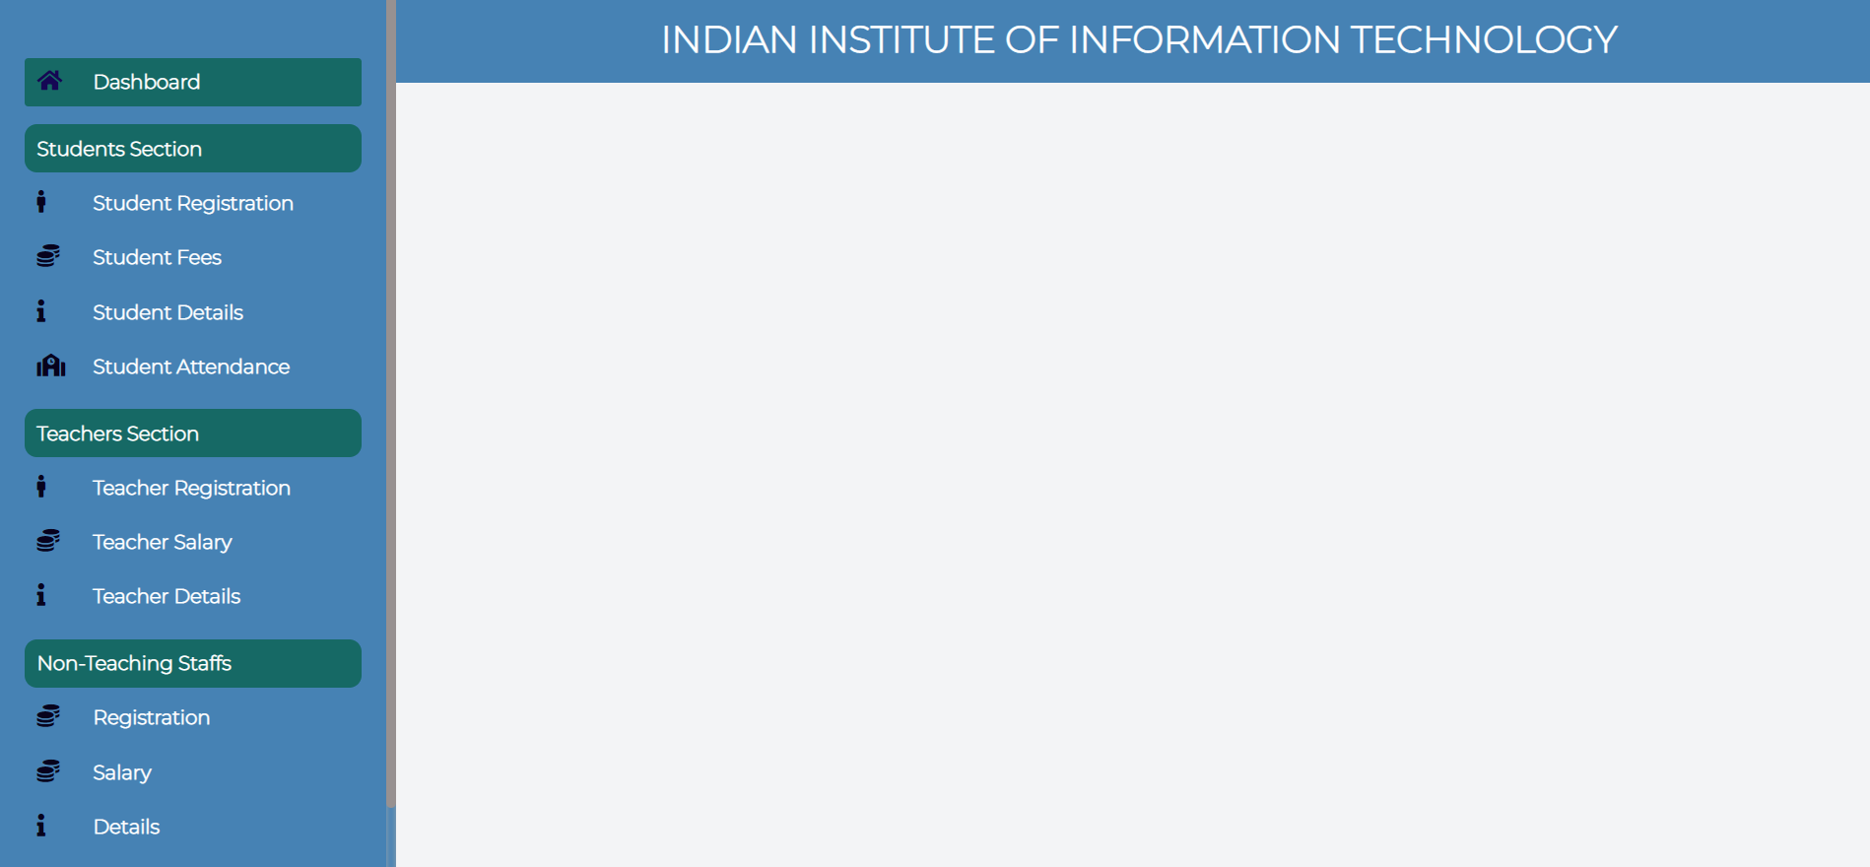Admin Panel

The Admin can register the new incoming students and Teachers and add them to our database.

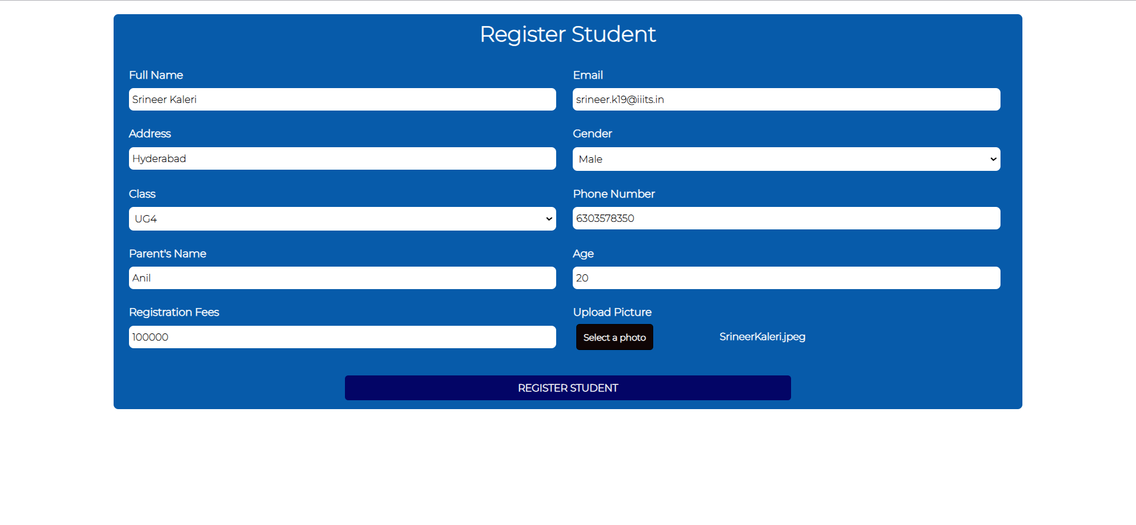

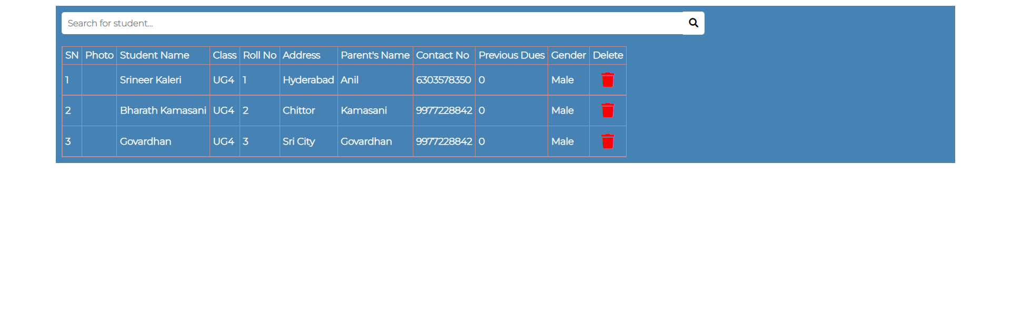

List of Students



Attendance for the Students

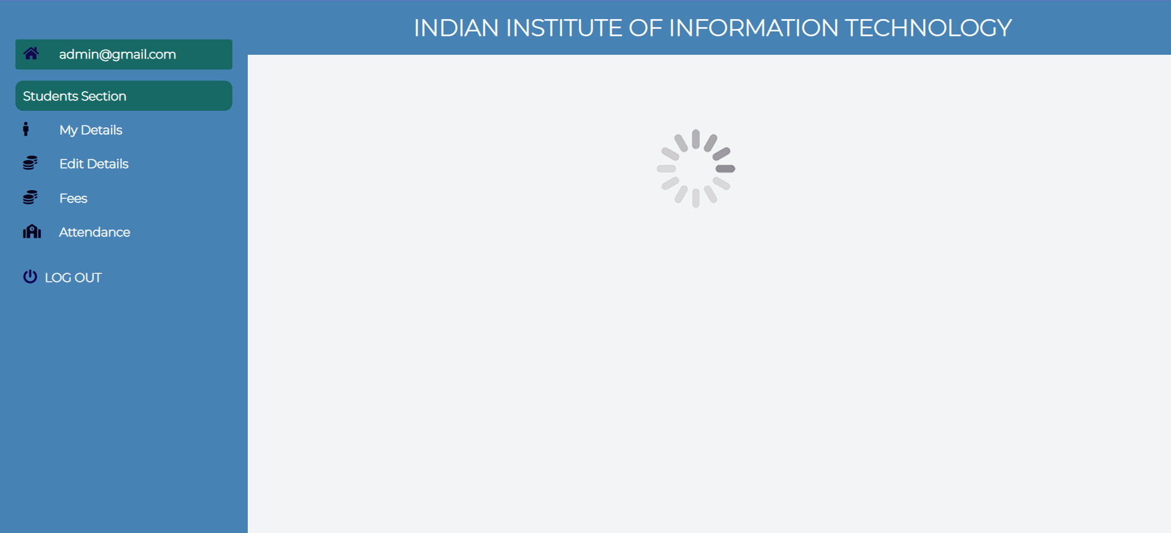  
Student Panel

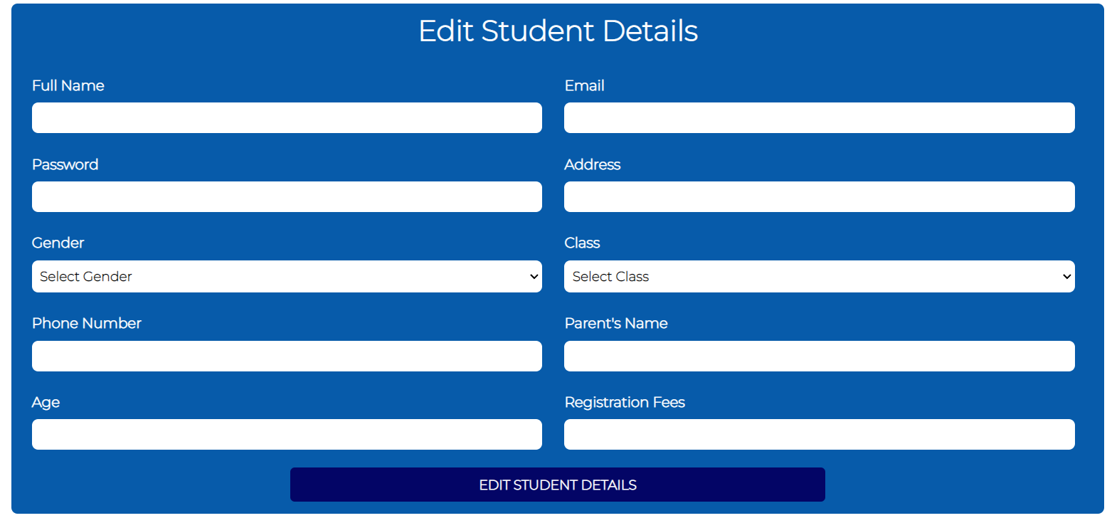

Student Details Edit Panel

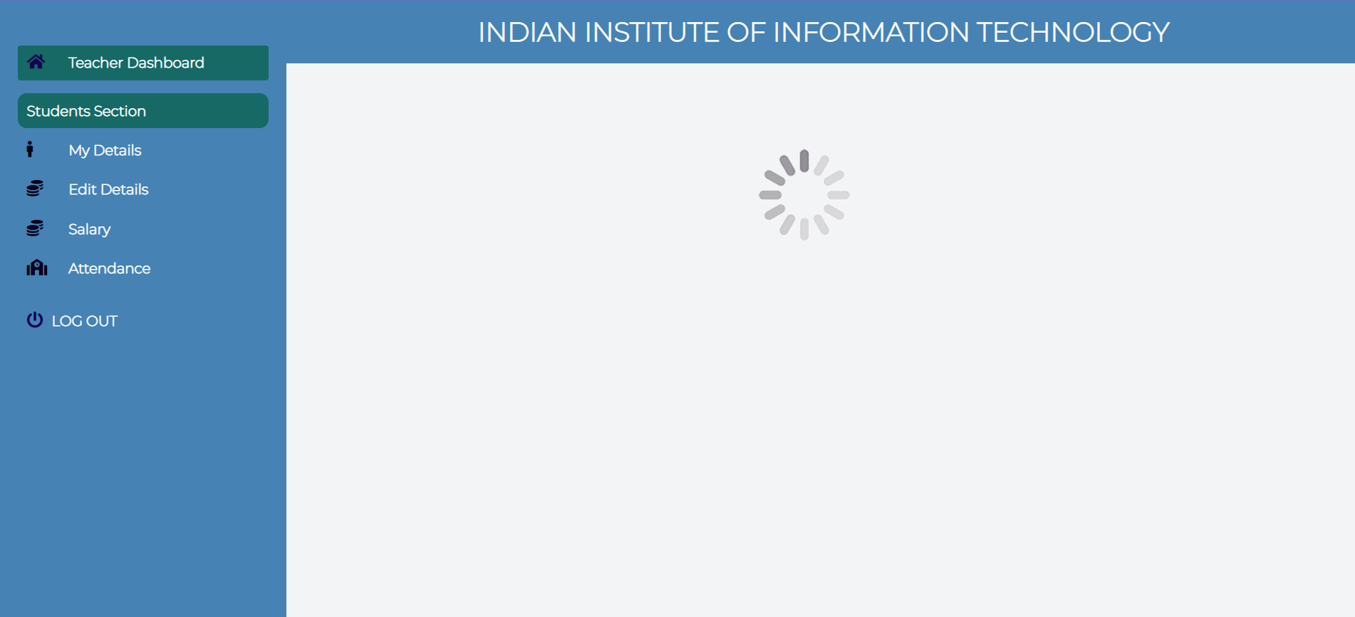

Teacher Panel

Thus, as we can see we can achieve the paperless administration by using a fully digitized application for running the day to day activities of an Institution.

**Conclusion and Future Work:**

For the benefit of all parties involved, paperless applications are being used to improve and streamline every aspect of the university administration. Websites and intranets have been created to fully realize the benefits of becoming paperless. The UGC and other higher education regulatory agencies also offer a wide range of Internet-based tools and solutions that take advantage of the capabilities of the online environment. Numerous groups that support paperless workplaces have not yet reached their goal. Before promoting or suggesting a technological solution, such as knowledge management, data warehouse, storage area network, etc., organizations need to be aware of the reasons why people still use paper. Real paperless environments must therefore start at the cultural level in order for enterprises to comprehend their necessity and significance. Organizations need to introduce the culture to new ways of viewing, reading, and transmitting information and learning materials in order to transform the culture and promote paperless environments.

In this way we tried to build an self-sufficient application to try to minimize the usage of paper in day to day activities of an organization.

For the future work of this project, we should try to extensively test the application. We can then find a suitable domain name and host the application, which will make the application ready to use for this college.

**References:**

* https://www.worldatlas.com/articles/how-many-trees-does-it-take-to-make-1-ton-of-paper.html [1]
* https://www.hyland.com/en/resources/terminology/paperless-office [2]
* https://myclasscampus.com/home [3]
* https://www.campus365.io/ [4]
* https://www.m-files.com/ [5]
* https://canvas.instructure.com/login/canvas [6]
* http://indianresearchjournals.com/pdf/APJMMR/2013/September/10.pdf [7]
* https://core.ac.uk/download/pdf/36693527.pdf [8]
* file:///C:/Users/SRINEER/Downloads/Vidyawarta_Paperless_Office_Jan_18.pdf [9]

**Contributions:**Kaleri Srineer - UG4 - CSE - S20190010079  
*(srineer.k19@iiits.in)*

Kamasani Bharath - UG4 - CSE - S20190010080  
*(govardhannaik.p19@iiits.in)*

Pathlavath Govardhan Naik - UG4 - CSE - S20190010135

*(bharath.k19@iiits.in)*

**Mentor:** Dr. Nikhil Tripathi (*nikhil.t@iiits.in)*