Project Documentation – AI Study Buddy API

INTRODUCTION

Project Title – AI Study Buddy API

Team ID – SWTID-2026-2901

Team Leader – SRINIVASAN J & srini23700@gmail.com

Team Member –

- ASHWINI V & ashwiniachu@gmail.com
- ATSHAYA R & atshayarajamani.18@gmail.com
- VISHAL A M & vishalannika2007@gmail.com

Description
LearnMate is an AI-powered learning assistant designed to make studying easier and more personalized. Students can upload their study materials, and the system uses Google Gemini AI to automatically generate summaries, flashcards, quizzes, and personalized study plans.
The backend is built using Node.js, Express.js, MongoDB, and Mongoose, with JWT authentication, bcryptjs password encryption, and Role-Based Access Control (RBAC) for security.
Main objective: Reduce the time students spend manually preparing notes and revision materials while providing a centralized platform for effective learning.

Scenario-Based Case Study
Sanjay is a third-year engineering student preparing for multiple semester examinations while simultaneously learning new technical skills for internships and placement opportunities. His study materials are scattered across lecture notes, PDFs, textbooks, online articles, and handwritten notes, making it difficult to organize and revise effectively. Due to the large volume of content and limited preparation time, Rahul often struggles to identify important concepts, create revision notes, and evaluate his understanding before examinations.
Traditional study methods require significant manual effort to summarize lengthy materials, prepare practice questions, and create revision schedules. This process is repetitive, time-consuming, and often results in inconsistent learning outcomes.

Problem
Rahul encounters several challenges during his preparation:
- Difficulty understanding lengthy study materials within limited time.
- Manual preparation of notes consumes a significant amount of study time.
- Creating flashcards and revision questions is repetitive and labor-intensive.
- Lack of personalized study plans based on available time and examination schedules.
- No centralized platform to securely store AI-generated learning resources.
- Difficulty assessing knowledge through self-generated quizzes.
- Switching between multiple applications for note-taking, quizzes, and scheduling reduces productivity.

Solution
The AI StudyBuddy backend provides a centralized, AI-powered learning platform that automates several academic tasks through intelligent content generation. The system enables authenticated users to upload or enter study materials and leverage the Google Gemini AI API to generate educational resources automatically.
The backend processes incoming requests through secure RESTful APIs and performs the following operations:
- Authenticates users using JWT-based security.
- Stores user information and study resources in MongoDB.
- Sends study content to the Google Gemini AI model through dedicated AI service modules.
- Generates concise summaries for faster revision.
- Creates flashcards for active recall learning.
- Produces multiple-choice quizzes for self-assessment.
- Generates personalized study plans based on user preferences and examination timelines.
- Stores generated learning resources for future retrieval and continuous learning.
By separating authentication, business logic, database operations, and AI processing into modular components, the backend ensures maintainability, scalability, and efficient request handling.

Usage
Students register and log in to the application before accessing AI-powered learning features. After authentication, they can upload study material or provide textual content and choose the desired AI functionality, such as generating summaries, quizzes, flashcards, or personalized study plans. The generated content can be reviewed immediately and stored for future reference.
Administrators manage registered users, monitor application activity, oversee system usage, and maintain platform integrity. Administrative privileges include managing user accounts, monitoring AI service utilization, reviewing system logs, and ensuring smooth backend operations.

Software Requirements
- Operating System: Windows 10/11, macOS, or Linux (supports cross-platform operations).
- Node.js (v16 or above): Runtime ecosystem running server logic and routing infrastructure.
- npm (v8 or above): Node package manager to control operational dependencies.
- Express.js: Lightweight routing web framework to construct backend RESTful entry points.
- MongoDB: Document NoSQL engine storing users, posts, categories, comments, and analytics metrics.
- Postman: API verification toolkit to assert schema validation responses across administrative route shields.
- Code Editor: Visual Studio Code or similar IDE environment.

Hardware Requirements
- Processor: Intel Core i5 (8th Gen or above) / AMD Ryzen 5 or equivalent.
- RAM: 8 GB minimum (16 GB recommended for concurrent instances of MongoDB, processing layers, and execution nodes).
- Storage: 1 GB of available disk workspace.

Project Architecture
The AI StudyBuddy backend follows a modular RESTful architecture designed to provide secure, scalable, and AI-powered learning services. The system processes client requests through Express.js, validates users using JWT authentication, interacts with the MongoDB database for data storage, and communicates with the Google Gemini AI API to generate intelligent study resources.
The architecture separates authentication, business logic, AI services, and database operations into independent modules, making the application easier to maintain, extend, and debug.

Components Definition
• Client Application: The frontend (React.js) allows users to register, log in, upload study material, and access AI-powered features such as summaries, quizzes, flashcards, and study plans through REST APIs.
• Express Server: The Express.js server receives HTTP requests, handles routing, processes middleware, and sends appropriate responses to the client.
• Authentication Middleware: JWT-based middleware verifies user identity, protects private routes, and ensures that only authenticated users can access AI services and study resources.
• Route Handlers: Routes manage API endpoints related to user authentication, study materials, AI features, and administrative operations.
• AI Service Layer: A dedicated AI service communicates with the Google Gemini API to generate summaries, quizzes, flashcards, and personalized study plans based on the user's study content.
• Database Layer: MongoDB, together with Mongoose ODM, stores user information, uploaded study materials, and AI-generated learning resources securely.

Entity-Relationship (ER) Diagram Description

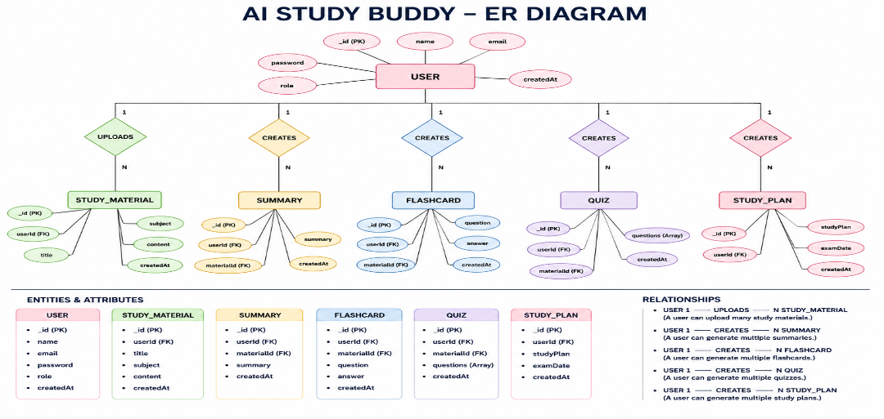

The AI StudyBuddy backend manages data through interconnected MongoDB collections that store user information, study materials, and AI-generated learning resources. Each entity is linked using logical relationships to ensure efficient data management and retrieval.

1. User Entity
Stores the details of registered users and administrators.
Attributes:
- _id (Primary Key - ObjectId)
- name (String, Required)
- email (String, Required, Unique)
- password (String, Hashed)
- role (String - Student/Admin)
- createdAt

2. Study Material Entity
Stores study content uploaded by students for AI processing.
Attributes:
- _id (Primary Key)
- userId (Foreign Key → User)
- title
- subject
- content
- createdAt

3. Summary Entity
Stores AI-generated summaries.
Attributes:
- _id (Primary Key)
- userId (Foreign Key → User)
- materialId (Foreign Key → Study Material)
- summary
- createdAt

4. Flashcard Entity
Stores AI-generated flashcards.
Attributes:
- _id (Primary Key)
- userId (Foreign Key → User)
- materialId (Foreign Key → Study Material)
- question
- answer
- createdAt

5. Quiz Entity
Stores AI-generated quizzes.
Attributes:
- _id (Primary Key)
- userId (Foreign Key → User)
- materialId (Foreign Key → Study Material)
- questions
- createdAt

6. Study Plan Entity
Stores personalized study plans generated by AI.
Attributes:
- _id (Primary Key)
- userId (Foreign Key → User)
- studyPlan
- examDate
- createdAt

Key Features
The AI StudyBuddy backend provides intelligent learning assistance through secure and scalable REST APIs. The major features of the system are as follows:
- Secure User Authentication: Implements JWT-based authentication with encrypted passwords using bcrypt for secure user access.
- Study Material Management: Allows users to upload and manage study materials that serve as input for AI-powered learning features.
- AI Summary Generation: Generates concise and easy-to-understand summaries from uploaded study content using the Google Gemini API.
- AI Flashcard Generation: Automatically creates flashcards from study materials to improve concept revision and active recall.
- AI Quiz Generation: Produces multiple-choice quizzes based on uploaded content, enabling students to test their knowledge.
- AI Study Plan Generation: Generates personalized study plans according to the user's learning goals and available study time.
- Role-Based Access Control (RBAC): Provides different access privileges for Students and Administrators to ensure secure system management.
- MongoDB Data Storage: Efficiently stores user information, uploaded materials, and AI-generated learning resources using MongoDB.

MVC Architecture Pattern
The AI StudyBuddy backend follows the Model-View-Controller (MVC) architecture to organize the application into separate layers, making the code modular, maintainable, and scalable.

Model Layer (Data Layer)
The Model layer defines the MongoDB collections using Mongoose schemas. It is responsible for managing user information, uploaded study materials, and AI-generated learning resources while ensuring data validation and database interactions.

View Layer (API Response Layer)
Since AI StudyBuddy is a backend REST API, there is no traditional user interface in the View layer. Instead, the API returns structured JSON responses to the React frontend, allowing users to interact with the application through REST endpoints.

Controller Layer (Business Logic)
The Controller layer processes incoming API requests, validates user input, performs authentication and authorization, communicates with the database models, invokes the Google Gemini AI service when required, and returns the appropriate response to the client.

MVC Benefits
The MVC architecture separates data management, business logic, and client communication into independent components. This improves code readability, simplifies debugging and testing, and allows new features to be integrated without affecting existing modules.

Project Setup and Configuration

Creating the Project Folder
- Create a new folder named AI StudyBuddy .
- Open the project folder in Visual Studio Code.
- Initialize the project using Node.js and install the required dependencies.

Environment Configuration
Create a .env file in the project root and configure the required environment variables.
PORT=5000
MONGO_URI=your_mongodb_connection_string
JWT_SECRET=your_jwt_secret
GEMINI_API_KEY=your_gemini_api_key

Backend Development
The AI StudyBuddy backend is developed using Node.js, Express.js, and MongoDB, following a modular architecture.
The application separates routing, controllers, middleware, models, and utility modules to improve code maintainability and scalability.
The backend exposes secure REST APIs for authentication, study material management, AI-powered content generation, and administrative operations.

Backend Structure



API Route Interface Endpoints
The backend exposes RESTful APIs to interact with the database and AI services.

1. Authentication APIs
Handles user registration, login, JWT authentication, and protected route access.

2. Study Material APIs
Allows users to upload, retrieve, update, and manage study materials.

3. AI Feature APIs

Provides endpoints for:
- AI Summary Generation
- AI Flashcard Generation
- AI Quiz Generation
- AI Study Plan Generation

4. Administrative APIs
Provides administrator-only endpoints for managing users and monitoring system activities.

Project Execution
The AI StudyBuddy backend can be executed locally using Node.js. Before running the application, ensure that MongoDB is running and the required environment variables are configured correctly. The backend exposes REST APIs that can be tested using Postman or Thunder Client.

Running the Backend Server
Install all required dependencies:
npm install
Start the development server:
npm start
After successful execution, the server connects to MongoDB and starts listening for incoming API requests.

API Testing
The backend APIs can be tested using Postman.

1. User Registration
Registers a new user by accepting the required details and securely storing the encrypted password in the MongoDB database.
Endpoint:
POST /api/auth/register

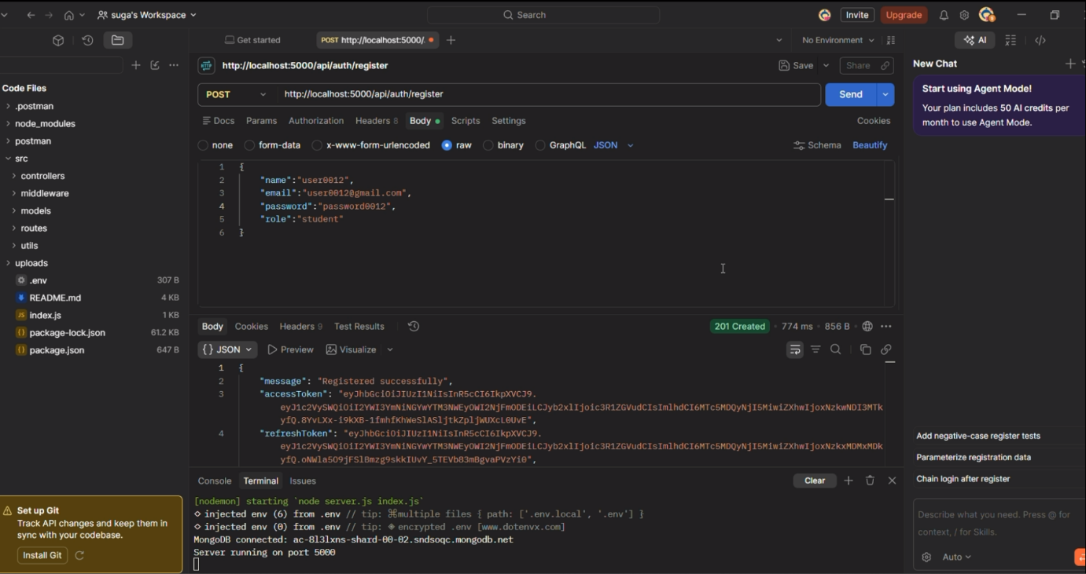

2. User Login
Authenticates the registered user and generates a JWT access token for accessing protected APIs.
Endpoint:
POST /api/auth/login

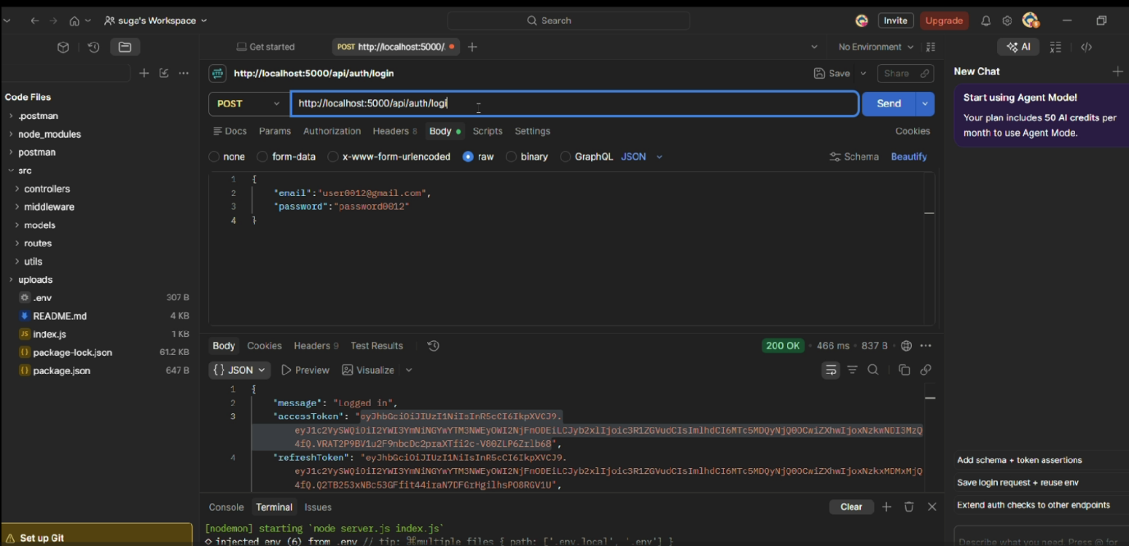

3. Upload Study Material
Allows authenticated users to upload study material that will be used as input for AI-powered content generation.
Endpoint:
POST /api/material/upload
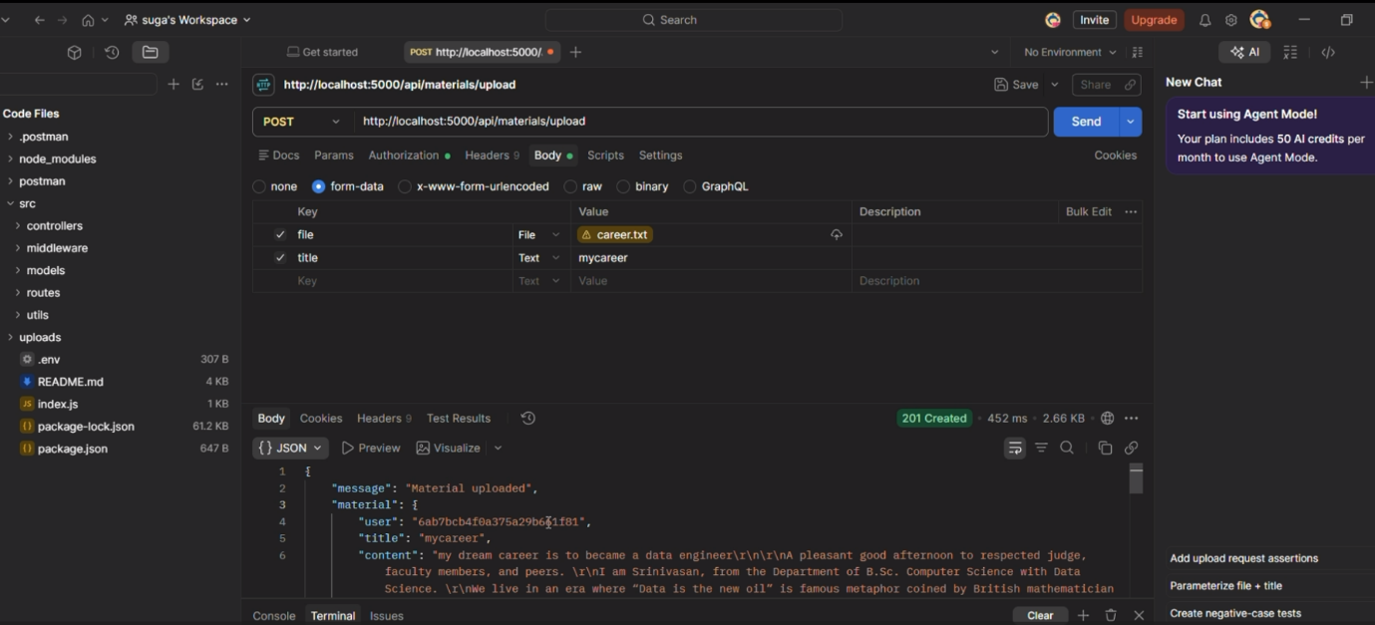

4. Generate AI Summary
Sends the uploaded study material to the Google Gemini API and generates a concise summary.
Endpoint:
POST /api/materials/:id/summarize
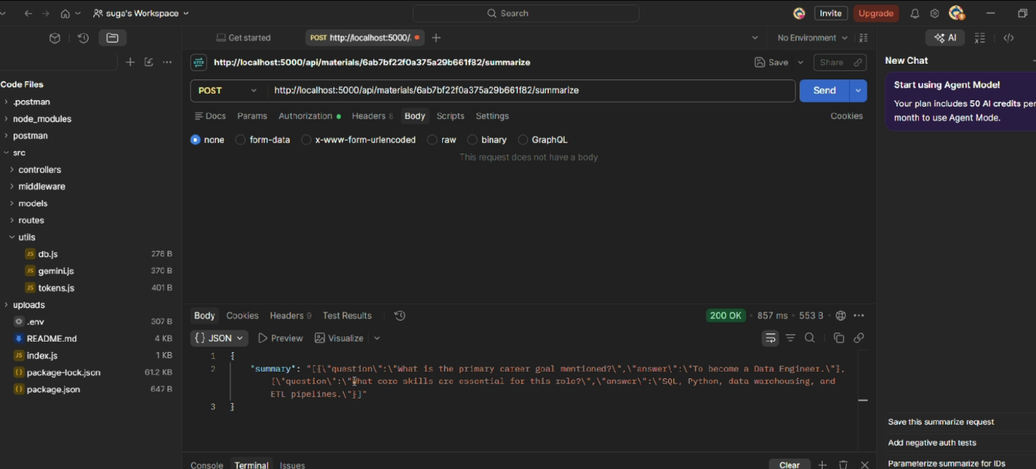

5. Generate AI Flashcards
Creates AI-generated flashcards from the uploaded study material for effective revision.
Endpoint:
POST /api/ai/flashcards

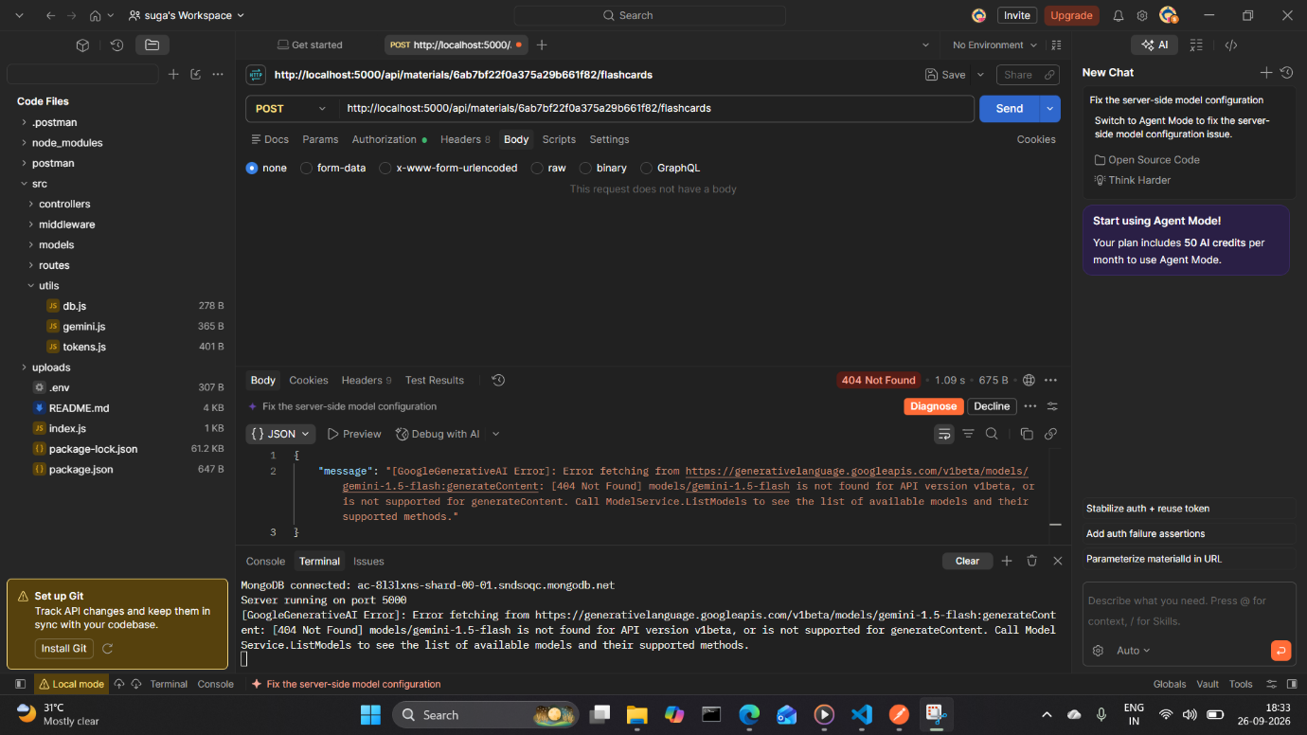

6. Generate AI Quiz
Generates multiple-choice questions from the uploaded study material to help users assess their understanding.
Endpoint:
POST /api/ai/quiz

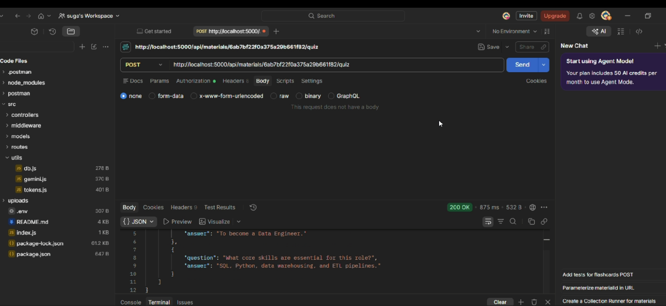

7. Generate AI Study Plan
Creates a personalized study schedule based on the user's learning goals and available study time.
Endpoint:
POST /api/ai/study-plan

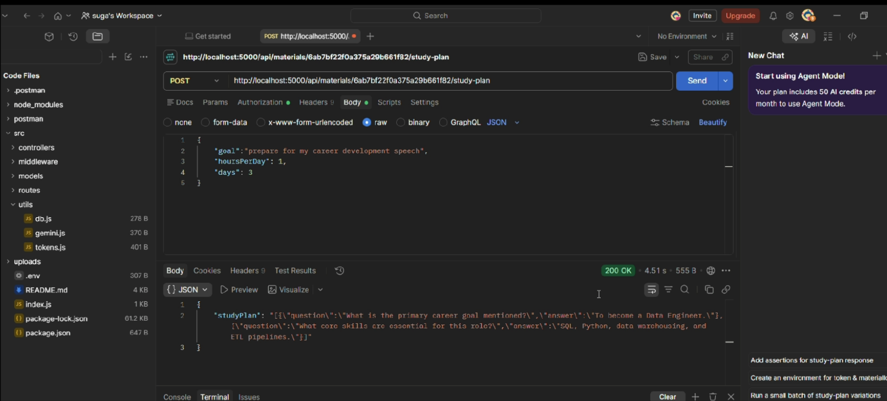

API TESTING LINK:

https://drive.google.com/file/d/1A1xQH-z_zhQKZY2Ax1cfZpfNSs1vG-2j/view?usp=sharing

