Project Documentation – AI Study Buddy API

INTRODUCTION
Project Title – AI Study Buddy API
Team ID – SWTID-2026-2901
Team Leader – SRINIVASAN J & srini23700@gmail.com
Team Members –
- ASHWINI V & ashwiniachu@gmail.com
- ATSHAYA R & atshayarajamani.18@gmail.com
- VISHAL A M & vishalannika2007@gmail.com

PROJECT OVERVIEW
LearnMate is an AI-powered learning assistant designed to make studying easier and more personalized. Students can upload their study materials, and the system uses Google Gemini AI to automatically generate summaries, flashcards, quizzes, and personalized study plans.
The backend is built using Node.js, Express.js, MongoDB, and Mongoose, with JWT authentication, bcryptjs password encryption, and Role-Based Access Control (RBAC) for security.
Main objective: Reduce the time students spend manually preparing notes and revision materials while providing a centralized platform for effective learning.

1. Brainstorming & Ideation Phase
  - Project Idea
AI StudyBuddy is an AI-powered learning assistance platform designed to simplify the study process by combining a RESTful backend with Generative AI. The project focuses on helping students upload study materials and automatically generate useful learning resources such as summaries, flashcards, quizzes, and personalized study plans.
1.2 Scenario-Based Case Study
Sanjay is a first-year engineering student preparing for semester examinations while also learning technical skills for internships and placement opportunities. His study materials are scattered across lecture notes, PDFs, textbooks, online articles, and handwritten notes. Because of the large volume of content and limited preparation time, he finds it difficult to identify important concepts, prepare revision notes, and evaluate his understanding.
The traditional approach requires students to manually summarize lengthy materials, create flashcards, prepare practice questions, and plan revision schedules. This is repetitive and time-consuming. The proposed AI StudyBuddy platform addresses these difficulties through a centralized AI-powered backend.
1.3 Problem Identification
- Difficulty understanding lengthy study materials within limited time.
- Manual preparation of notes consumes significant study time.
- Creating flashcards and revision questions is repetitive and labor-intensive.
- Lack of personalized study plans based on available time and examination schedules.
- No centralized platform to securely store AI-generated learning resources.
- Difficulty assessing knowledge through self-generated quizzes.
- Switching between multiple applications reduces productivity.
1.4 Proposed Solution
The solution is a centralized AI-powered learning platform using secure REST APIs, MongoDB, JWT authentication, and the Google Gemini AI API. The backend receives authenticated requests, processes study material, communicates with the AI service, and returns structured learning resources.
- Secure user authentication using JWT.
- MongoDB-based storage for users and study resources.
- AI-generated summaries for quick revision.
- AI-generated flashcards for active recall.
- AI-generated quizzes for self-assessment.
- Personalized AI-generated study plans.
- Modular architecture for maintainability and scalability.
1.5 Key Features
- Secure User Authentication
- Study Material Management
- AI Summary Generation
- AI Flashcard Generation
- AI Quiz Generation
- AI Study Plan Generation
- Role-Based Access Control (RBAC)
- MongoDB Data Storage
1.6 Users
Student: registers, logs in, uploads study materials, and uses AI-powered learning features.
Administrator: manages registered users, monitors application activity, and maintains platform integrity.

2. Requirement Analysis Phase
2.1 Functional Requirements
- User registration and login.
- JWT authentication and protected routes.
- Role-based authorization.
- Study material upload and management.
- AI summary generation.
- AI flashcard generation.
- AI quiz generation.
- AI study plan generation.
- Storage and retrieval of generated resources.
- Administrative user management.
2.2 Non-Functional Requirements
- Security of authentication credentials and protected resources.
- Maintainability through modular backend components.
- Scalability through RESTful API architecture.
- Reliable MongoDB connectivity.
- Efficient request and response handling.
- Structured JSON responses for frontend integration.
2.3 Software Requirements
Requirement | Specification
Operating System | Windows 10/11, macOS, or Linux
Runtime | Node.js v16 or above
Package Manager | npm v8 or above
Backend Framework | Express.js
Database | MongoDB
ODM | Mongoose
API Testing | Postman
Code Editor | Visual Studio Code or similar IDE
AI Service | Google Gemini AI API

2.4 Hardware Requirements
Component | Requirement
Processor | Intel Core i5 8th Gen+ / AMD Ryzen 5 equivalent
RAM | 8 GB minimum; 16 GB recommended
Storage | 1 GB available disk workspace

3. Project design Phase
3.1 Project Architecture
The AI StudyBuddy backend follows a modular RESTful architecture. The system separates client requests, authentication, route handling, AI services, and database operations into independent components. This design improves maintainability, scalability, and request handling.
3.2 Main Components
Component | Responsibility
React Frontend / Client | Provides the client-side interface and communicates with backend APIs.
Express Server | Handles HTTP requests, routing, middleware, and API responses.
JWT Authentication Middleware | Validates authentication tokens and protects routes.
Route Handlers | Defines API endpoints and connects requests to application logic.
AI Service Layer | Communicates with the Google Gemini AI API.
MongoDB / Mongoose Layer | Stores and manages application data using schemas and collections.

3.3 Entity-Relationship Design
The source project defines the following major entities: User, Study Material, Summary, Flashcard, Quiz, and Study Plan.
Entity | Purpose
User | Stores registered user information and role details.
Study Material | Stores uploaded learning material and associated information.
Summary | Represents AI-generated summarized learning content.
Flashcard | Represents AI-generated question-and-answer revision cards.
Quiz | Represents AI-generated quiz content for self-assessment.
Study Plan | Represents personalized study planning information.

3.4 Relationships
- A user can upload multiple study materials.
- A study material can be used to generate a summary.
- A study material can be used to generate flashcards.
- A study material can be used to generate quizzes.
- A study material can be used to generate a personalized study plan.
3.5 MVC Architecture Pattern
The backend follows an MVC-oriented organization. Models represent database structures and data access. The controller layer handles application logic and request processing. The API response layer acts as the view/output layer by returning structured responses to the client.
Layer | Responsibility
Model | Defines database schemas and data structures.
Controller | Processes requests and implements application logic.
View / API Response | Returns structured JSON responses to the client.

3.6 User Flow
- User registers an account.
- User logs in and receives authentication tokens.
- User uploads study material.
- Backend stores the material in MongoDB.
- User requests an AI feature.
- Backend sends relevant content to the Gemini AI service.
- Generated learning content is returned and can be stored/retrieved.

4. Project Planning Phase
4.1 Development Plan
Stage | Planned Activity
Architecture | Design modular RESTful backend architecture.
Environment Setup | Initialize Node.js project and install dependencies.
Authentication | Implement registration, login, JWT, password encryption, and RBAC.
Database | Configure MongoDB and Mongoose models.
AI Integration | Connect Google Gemini AI API through a dedicated service layer.
Material Management | Implement material upload and storage.
AI Features | Implement summary, flashcard, quiz, and study-plan generation.
Testing | Test APIs using Postman and verify successful responses.
Demo | Prepare API testing screenshots/video and project demonstration links.

4.2 Project Setup
The source project creates an AI StudyBuddy project folder and initializes a Node.js application.
mkdir AI-StudyBuddy
cd AI-StudyBuddy
npm init -y
The required backend dependencies are installed for server creation, database connectivity, authentication, file upload, environment configuration, and Google Gemini integration.
npm install express mongoose bcryptjs jsonwebtoken cors dotenv multer @google/genai
npm install --save-dev nodemon
4.3 Project Structure
AI-StudyBuddy/
|--src/
|-- controllers/
|--middleware/
│-- models/
│--routes/
│-- utils/
│--db.js
|--gemini.js
│--tokens.js
|--uploads/
|--.env
|--index.js
|-- package.json
|-- README.md
4.4 Environment Configuration
The project uses environment variables to keep configuration values outside the source code.
PORT=5000
MONGO_URI=<MongoDB connection string>
JWT_SECRET=<JWT secret>
GEMINI_API_KEY=<Gemini API key>

5. Project Development Phase
5.1 Backend Development
The backend is implemented using Node.js and Express.js. The development follows a modular structure so that authentication, database connectivity, AI integration, token handling, routes, controllers, and middleware can be maintained independently.
5.2 Core Backend Modules
Module | Purpose
index.js | Starts the Express server and connects the application components.
db.js | Handles MongoDB database connectivity.
gemini.js | Provides integration with the Google Gemini AI service.
tokens.js | Handles token-related authentication functionality.
controllers/ | Contains request-processing and application logic.
middleware/ | Provides authentication and request middleware.
models/ | Contains MongoDB/Mongoose schemas.
routes/ | Defines REST API endpoints.
uploads/ | Stores uploaded study material files.

5.3 Authentication Development
The authentication module provides user registration and login. Passwords are protected using bcryptjs, and JWT tokens are used for authenticated access to protected API resources. Role-Based Access Control is used to separate student and administrator permissions.
5.4 Database Development
MongoDB is used as the NoSQL database and Mongoose is used as the Object Data Modeling layer. The source project includes User and Study Material schemas and uses collections to persist application data.
5.5 AI Service Development
The Google Gemini AI API is integrated through a dedicated AI service layer. The service receives study-related content and supports generation of summaries, flashcards, quizzes, and study plans.
5.6 API Endpoints
Method | Endpoint | Purpose
POST | /api/auth/register | Register a new user.
POST | /api/auth/login | Authenticate an existing user.
POST | /api/material/upload | Upload study material.
POST | /api/materials/:id/summarize | Generate a summary for a study material.
POST | /api/ai/flashcards | Generate AI flashcards.
POST | /api/ai/quiz | Generate an AI quiz.
POST | /api/ai/study-plan | Generate a personalized study plan.

5.7 API Execution Shown in the Project Screenshots
The provided Postman screenshots demonstrate the implemented project running locally on port 5000. The screenshots show successful registration, login, material upload, summary generation, quiz generation, flashcard generation, and study-plan generation requests.

6. Project Testing Phase
6.1 Testing Environment
- Backend server running locally on port 5000.
- MongoDB connected to the application.
- Postman used for REST API testing.
- JSON request and response data verified through Postman.
- Authentication token used for protected endpoints.
6.2 Test Cases
Test Case | API | Expected Result | Observed Result
User Registration | POST /api/auth/register | User registered successfully | Successful response shown
User Login | POST /api/auth/login | Authentication tokens returned | Successful response shown
Material Upload | POST /api/materials/upload | Material uploaded and stored | 201 Created shown
Summary | POST /api/materials/:id/summarize | AI-generated summary returned | 200 OK shown
Quiz | POST /api/materials/:id/quiz | AI-generated quiz returned | 200 OK shown
Flashcards | POST /api/materials/:id/quiz/flashcards flow | AI-generated flashcards returned | 200 OK shown
Study Plan | POST /api/materials/:id/study-plan | Personalized study plan returned | 200 OK shown

6.3 Testing Screenshots

1. User Registration
Registers a new user by accepting the required details and securely storing the encrypted password in the MongoDB database.
Endpoint:
POST /api/auth/register

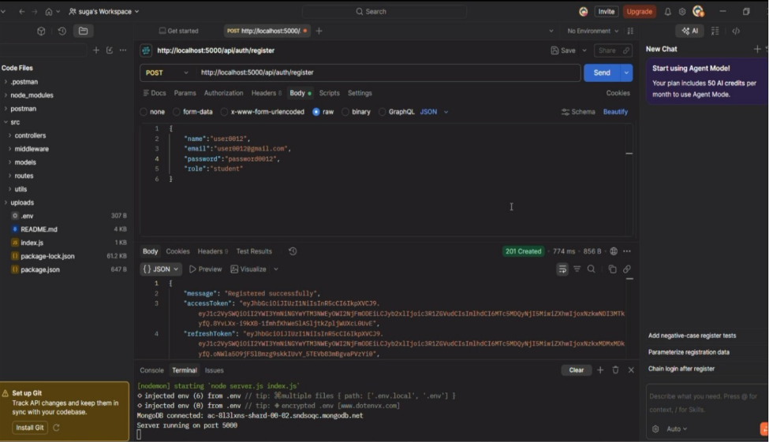

2. User Login
Authenticates the registered user and generates a JWT access token for accessing protected APIs.
Endpoint:
POST /api/auth/login

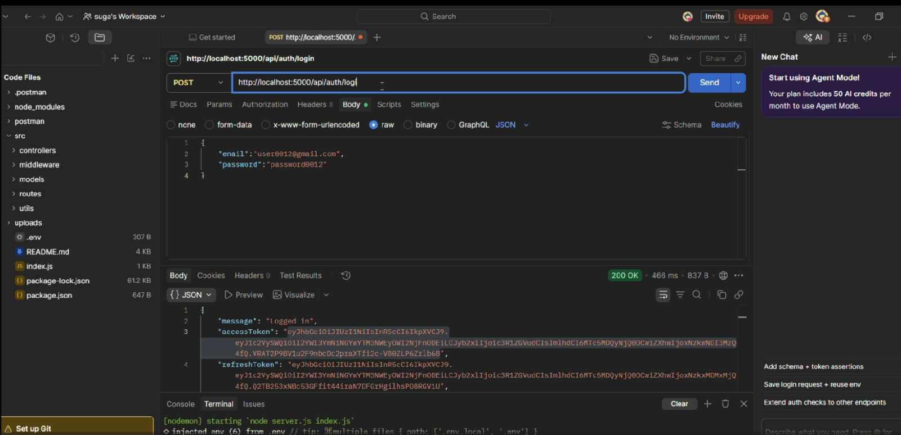

3. Upload Study Material
Allows authenticated users to upload study material that will be used as input for AI-powered content generation.
Endpoint:
POST /api/material/upload

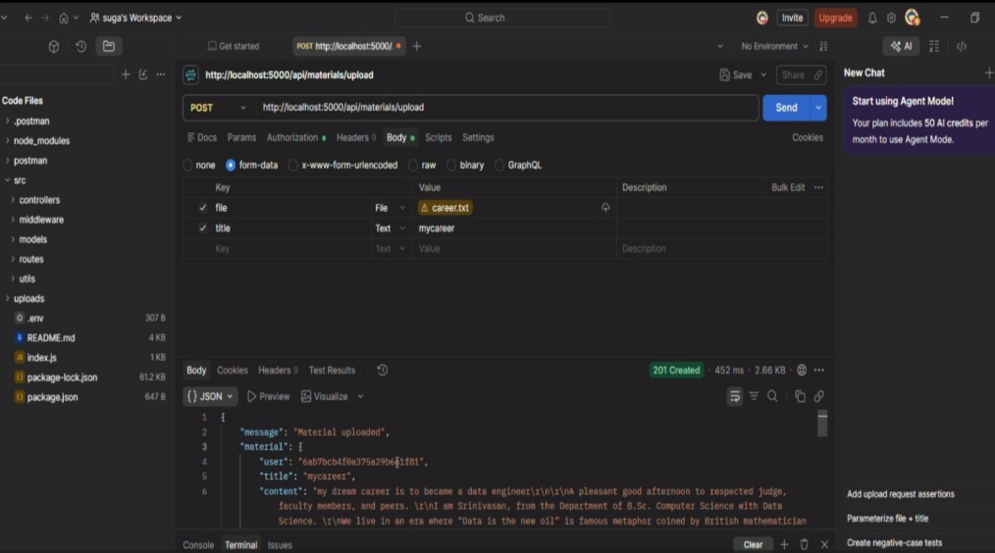

4. Generate AI Summary
Sends the uploaded study material to the Google Gemini API and generates a concise summary.
Endpoint:
POST /api/materials/:id/summarize

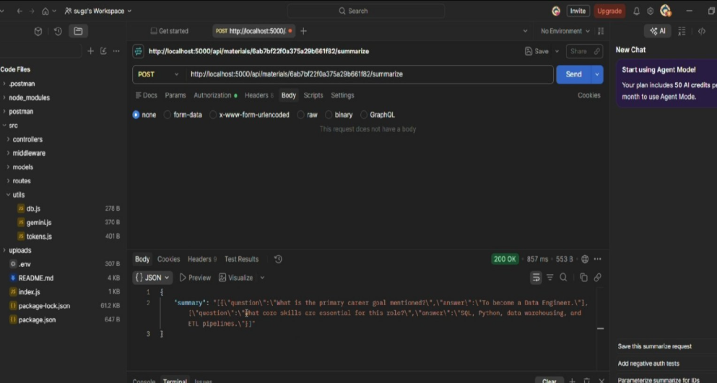

5. Generate AI Flashcards
Creates AI-generated flashcards from the uploaded study material for effective revision.
Endpoint:
POST /api/ai/flashcards

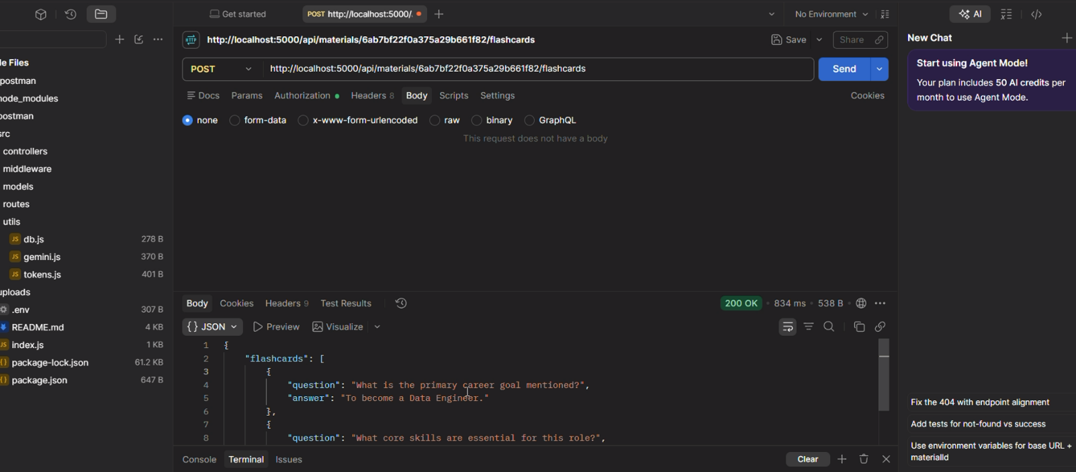

6. Generate AI Quiz
Generates multiple-choice questions from the uploaded study material to help users assess their understanding.
Endpoint:
POST /api/ai/quiz

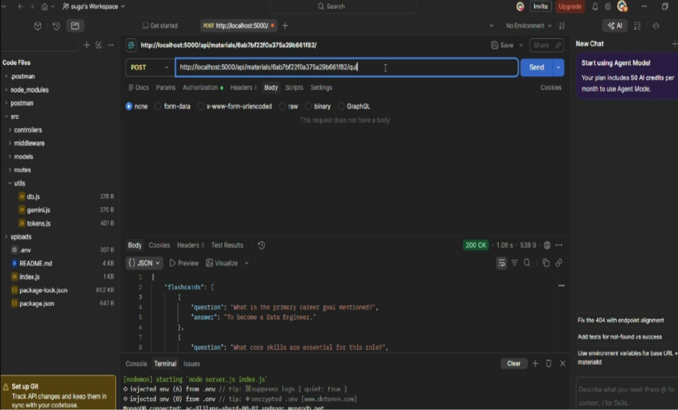

7. Generate AI Study Plan
Creates a personalized study schedule based on the user's learning goals and available study time.
Endpoint:
POST /api/ai/study-plan

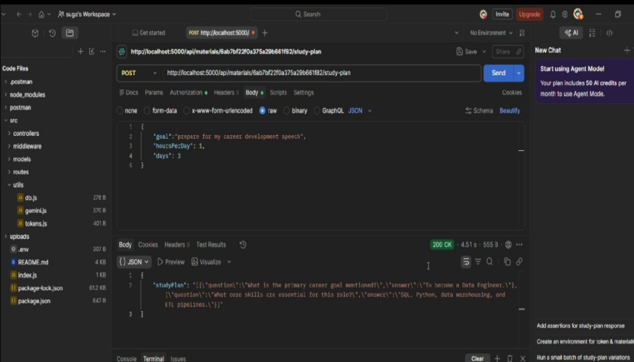

Conclusion
AI StudyBuddy provides a centralized AI-powered learning assistance platform that combines RESTful backend services, MongoDB, JWT authentication, Role-Based Access Control, and Google Gemini AI integration. The system supports study material management and automated generation of summaries, flashcards, quizzes, and personalized study plans.
The development and testing evidence demonstrates the backend API working through Postman with successful HTTP responses. The modular architecture also provides a structured foundation for future enhancement of the learning platform.

API Testing Demo:
https://drive.google.com/file/d/1A1xQH-z_zhQKZY2Ax1cfZpfNSs1vG-2j/view?usp=sharing

Code Drive Link:
https://drive.google.com/drive/folders/1mfJrGr63VDaF4zhXO7j9DIS_EWGJWjK0

