**Task:** Convert multiple rows into comma separated values in MS Excel.

**Approach Used:**

We can achieve this using simple Excel formulas.

**Example:**

Let’s say we have following table that has records for couple of movies. The actors are stored in multiple rows and we want to convert this into comma separated values. Such that, there will be only one row for a Movie/Year Released/Director

|  |  |  |  |
| --- | --- | --- | --- |
| **Movie** | **Year Released** | **Director** | **Actors** |
| Logan | 2017 | James Mangold | Hugh Jackman |
| Logan | 2017 | James Mangold | Patrick Stewart |
| Logan | 2017 | James Mangold | Dafne Keen |
| Logan | 2017 | James Mangold | Boyd Holbrook |
| Logan | 2017 | James Mangold | Stephen Merchant |
| Logan | 2017 | James Mangold | Elizabeth Rodriguez |
| Logan | 2017 | James Mangold | Richard E. Grant |
| The Dark Knight | 2008 | Christopher Nolan | Christian Bale |
| The Dark Knight | 2008 | Christopher Nolan | Heath Ledger |
| The Dark Knight | 2008 | Christopher Nolan | Aaron Eckhart |
| The Dark Knight | 2008 | Christopher Nolan | Michael Caine |
| The Dark Knight | 2008 | Christopher Nolan | Maggie Gyllenhaal |
| The Dark Knight | 2008 | Christopher Nolan | Gary Oldman |
| The Dark Knight | 2008 | Christopher Nolan | Morgan Freeman |

**Steps:**

1. Sort the Movie by ascending order.

Remove duplicates rows.

Add a new column “ConcatActors” to store the concatenated values.

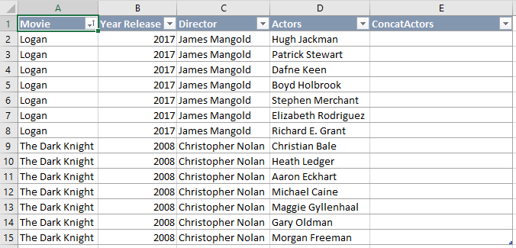

1. Add the following formula to 2nd row in Column E (i.e. E2).

=IF(A2=A1,E1&”,”&D2,D2)

This formula does the following,

* 1. Compare if movie value in A2 (i.e. Current Row) is = movie value in A1 (i.e. Previous row).
  2. If 2.1 is TRUE, Then append the Actors value in D2 (i.e. Current Row) with concatenated actors in previous row.
  3. If 2.1 is FALSE, Then populate the Actors value in D2 (i.e. Current Row). Means, this is the starting row.

Drag/Fill (or) copy/paste the formula to rest of the rows.

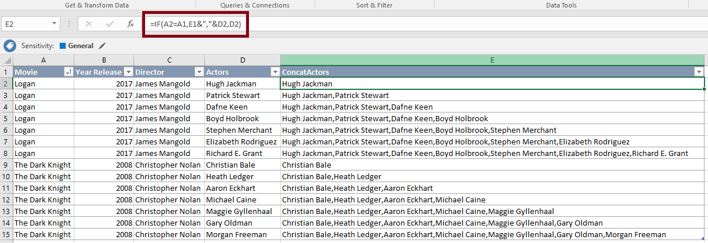

1. Copy the ‘ConcatActors’ Column

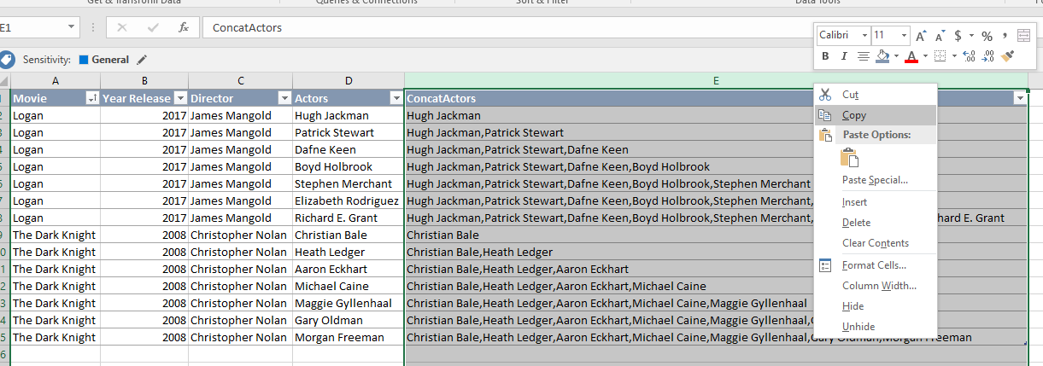

1. Paste the copied content as “Values” in the same column. This is to remove the formula & retain only the values.

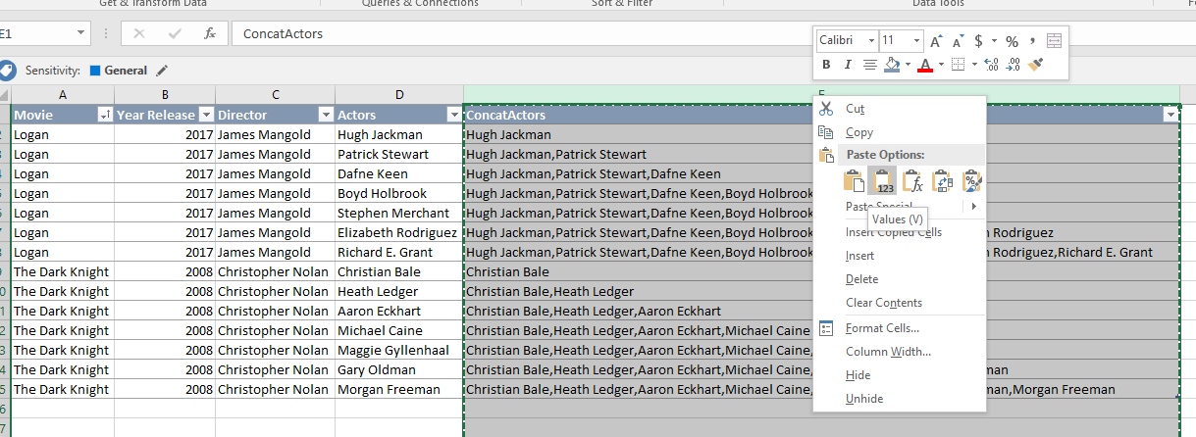

1. Create a new column called “DeleteRow”. Add the below formula in first row of that column (i.e. in case of below example, it will be F2)

=IF(A2=A3,1,0)

This formula simply identifies the last row for a movie. We want to retain only the last row (which has the complete actor list comma separated for a movie).

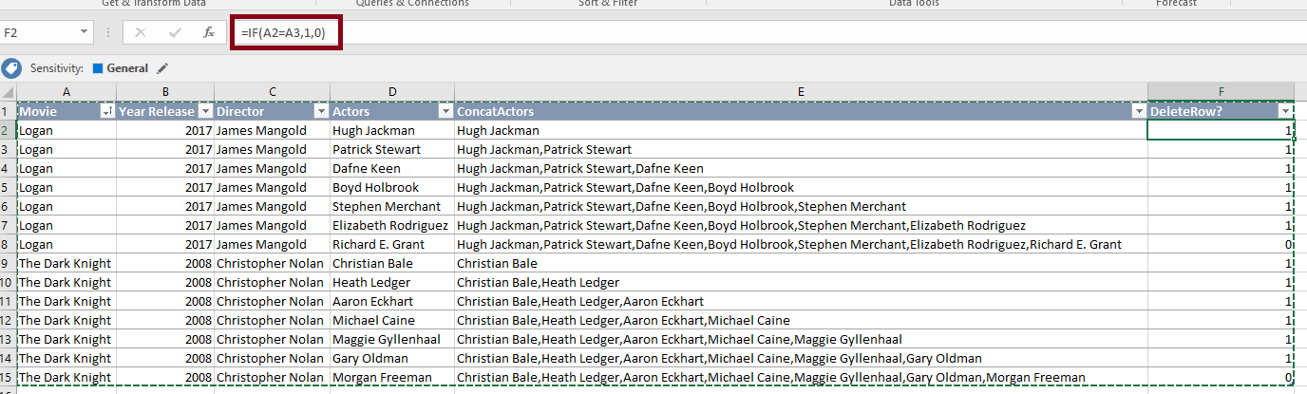

1. Repeat step 3 & 4 for the values in DeleteRow column (i.e. copy and paste it as values in the same column)
2. Apply filter on DeleteRow column to select only those rows with 1 (i.e. TRUE) as value.

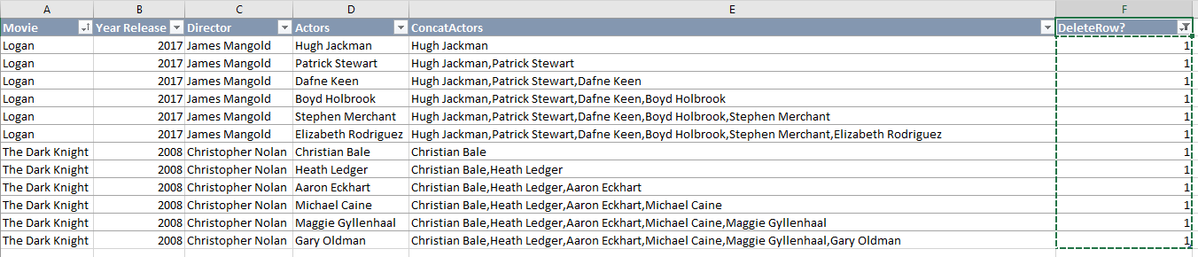

1. Select and delete the rows with DeleteRow = 1

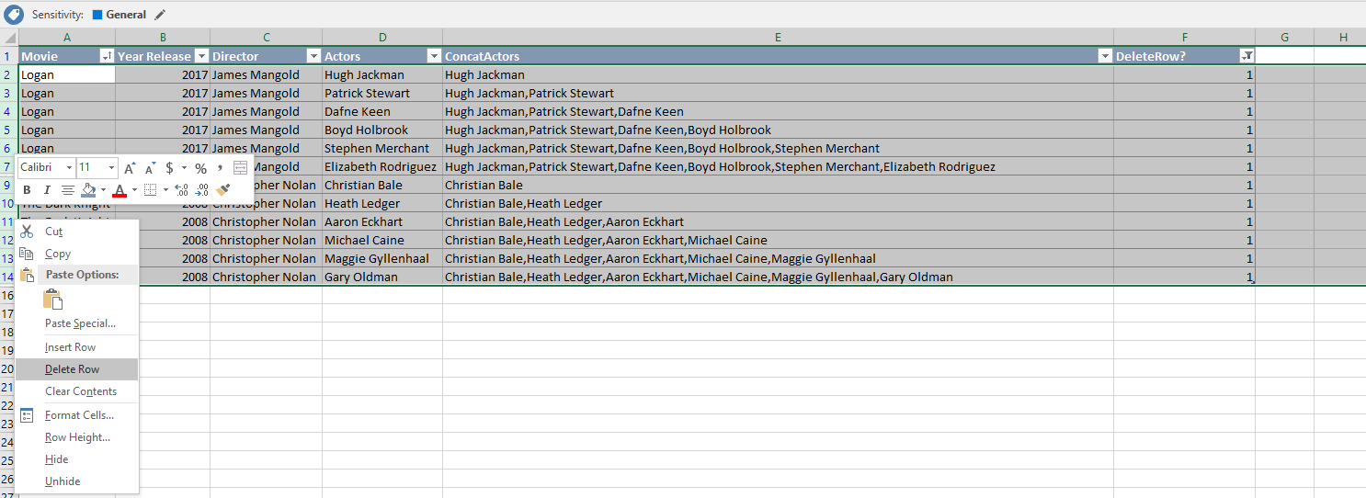

1. Clear all filters. Now we are left with only the full list of comma separated actors for a movie.



1. We can delete the Column D & F from the example in step 9 as they are not needed anymore.

