**Task:** Convert comma separated values into long format in MS Excel.

**Approach Used:**

We can achieve this using Excel Power Query. Based on my experience, this is the easiest/faster method to convert comma separated values into long format in MS Excel.

**Example:**

Let’s say we have following table that has records for couple of movies. The actors are comma separated and we want to convert this into long format.

|  |  |  |  |
| --- | --- | --- | --- |
| **Movie** | **Year Release** | **Director** | **Actors1** |
| Logan | 2017 | James Mangold | Hugh Jackman,Patrick Stewart,Dafne Keen,Boyd Holbrook,Stephen Merchant,Elizabeth Rodriguez,Richard E. Grant |
| The Dark Knight | 2008 | Christopher Nolan | Christian Bale,Heath Ledger,Aaron Eckhart,Michael Caine,Maggie Gyllenhaal,Gary Oldman,Morgan Freeman |

**Steps:**

1. Convert the data range into Table in Excel (click Ctrl + T). Select data range and click ok on below pop-up window.

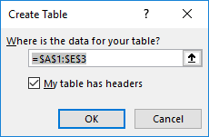

1. Select the “Actors1” column. Go to Data menu 🡪 “Text To Column” option. Following window will show up.

Select the Delimited check box and click Next.

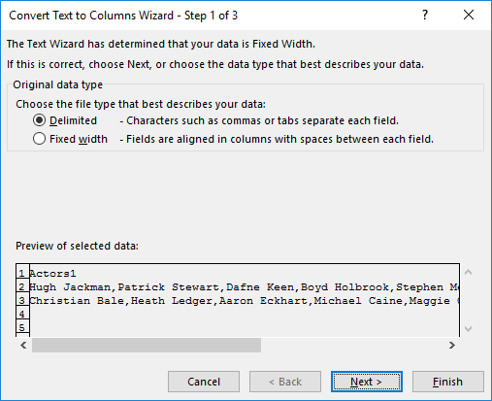

1. Select “Comma” check box and click Next. *(If the delimiter is other than comma, you can specify that here)*

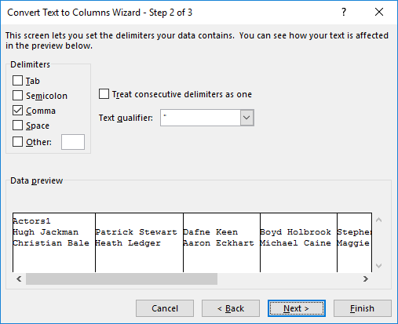

1. Click Finish.

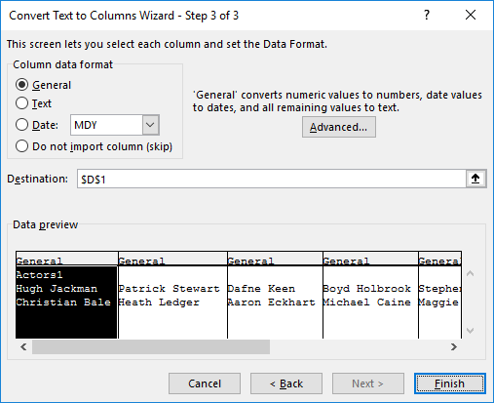

1. Now, the values will get split and few more columns will get created.

Note that, the columns names are incremental i.e. Actors2, Actors3, Actors4.

Excel will automatically fill the series if the original column (in our case, it is Actor1) is suffixed with numeric value.

|  |  |  |  |  |  |  |  |  |  |
| --- | --- | --- | --- | --- | --- | --- | --- | --- | --- |
| **Movie** | **Year Release** | **Director** | **Actors1** | **Actors2** | **Actors3** | **Actors4** | **Actors5** | **Actors6** | **Actors7** |
| Logan | 2017 | James Mangold | Hugh Jackman | Patrick Stewart | Dafne Keen | Boyd Holbrook | Stephen Merchant | Elizabeth Rodriguez | Richard E. Grant |
| The Dark Knight | 2008 | Christopher Nolan | Christian Bale | Heath Ledger | Aaron Eckhart | Michael Caine | Maggie Gyllenhaal | Gary Oldman | Morgan Freeman |

1. Go to Data menu 🡪 From Table/Range option, to open the power query.

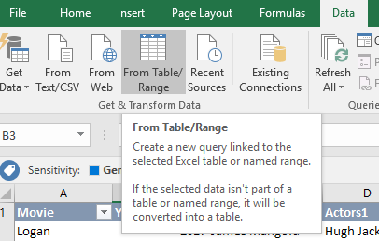

1. It will open the below power query editor window.

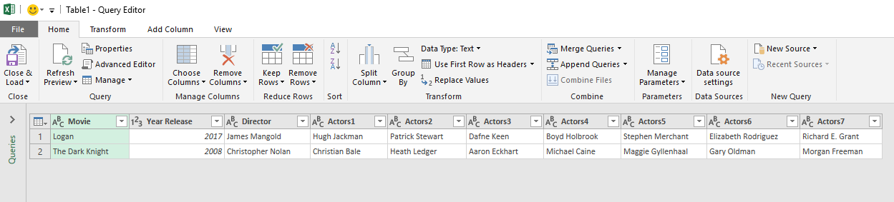

1. Select all the column which we do not want to transpose (i.e. not want to convert them into long format)

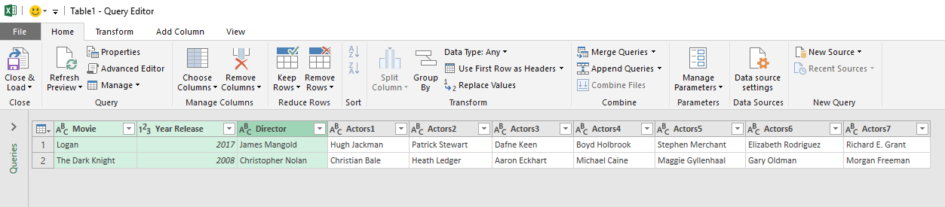

1. Go to Transform menu 🡪 Unpivot Column drop down 🡪 select “Unpivot other columns”

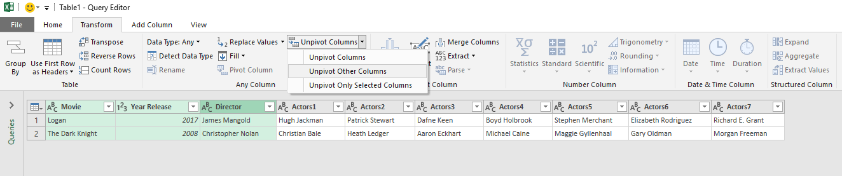

1. Now, the Actors columns will get transposed as below.

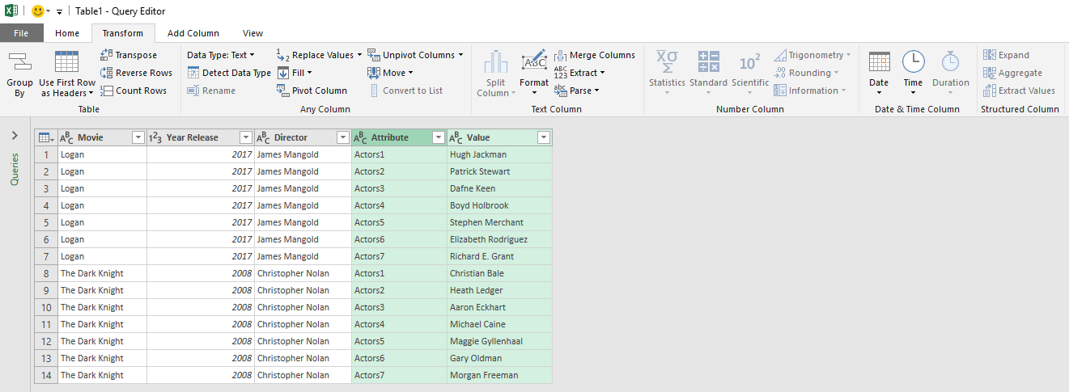

1. Go to Home menu 🡪 Close & Load to load it to the excel workbook.

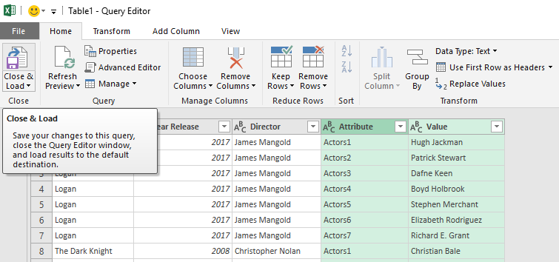

1. The comma separated actor values are now split and converted to long format.

