**Introduction:**

This document will demonstrate the steps to create Cross Functional Visio diagram from Excel, a feature available only on Visio Pro for Office 365 (at the time of writing this article).

This has simple steps, does not require any programming knowledge and the Visio diagram can be easily created/refreshed in few clicks. It will take away the time & pain in creating Visio diagram manually from scratch.

**Pre-Requisites:**

This approach will work only on Visio Pro for Office 365 (version limitation at the time of writing this article, it is not clear if Microsoft will extend this feature to desktop version in future).

This approach requires knowledge on creating tables in Excel, and it does not require any programming knowledge.

The input Excel data needs to be in a certain format which will be described in below steps.

**Steps:**

1. Create an excel with following columns, fill the content and convert this into a table.

Each of these columns are required.

|  |  |  |  |  |  |  |
| --- | --- | --- | --- | --- | --- | --- |
| **Process Step ID** | **Process Step Description** | **Next Step ID** | **Connector Lable** | **Shape Type** | **Function** | **Phase** |
| 1 | dbo.Resource | 3 | Acquire_ETL | External Data | External Source | Data |
| 2 | dbo.Booking | 4 | Acquire_ETL | External Data | External Source | Data |
| 3 | dbo.Resource | 5 | Integrate_ETL | Data | Staging | Data |
| 4 | dbo.Booking | 6 | Integrate_ETL | Data | Staging | Data |
| 5 | dbo.ResourceDimension | 7 | Reported_In | Data | Data Mart | Data |
| 6 | dbo.BookingFact | 7 | Reported_In | Data | Data Mart | Data |
| 7 | Resource Booking Details Report |  |  | Document | Reports | Data |

Refer to “How Excel columns interact with Visio flowchart components” section [here](https://support.office.com/en-us/article/Create-a-Data-Visualizer-diagram-17211b46-d144-4ca2-9ea7-b0f48f0ae0a6?ui=en-US&rs=en-US&ad=US#ID0EBADAAA=ID) in MS Document to get a description on these column.

In summary,

1. **Process Step ID** - Unique ID for each shape that needs to be created in Visio
2. **Process Step Description** - Description for each shape that needs to be created in Visio
3. **Next Step ID** - To indicate the next process step that a step/share needs to connect to
4. **Connect Lable** - A description/name for the connector
5. **Share Type** - Visio shape type. i.e.

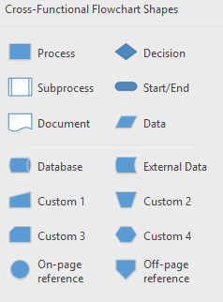

1. **Function** - Function name for Visio cross-functional flowchart, that a shape belongs to
2. **Phase** - Phase name for Visio cross-functional flowchart, that a shape belongs to
3. Open Visio and create a blank “Cross-Functional flowchart”. Once done, Go to Data 🡪 click “Create” from data. Click Next.

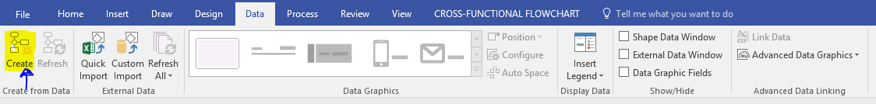

1. Select diagram type, excel workbook and table name in pop-up window. Click Next.

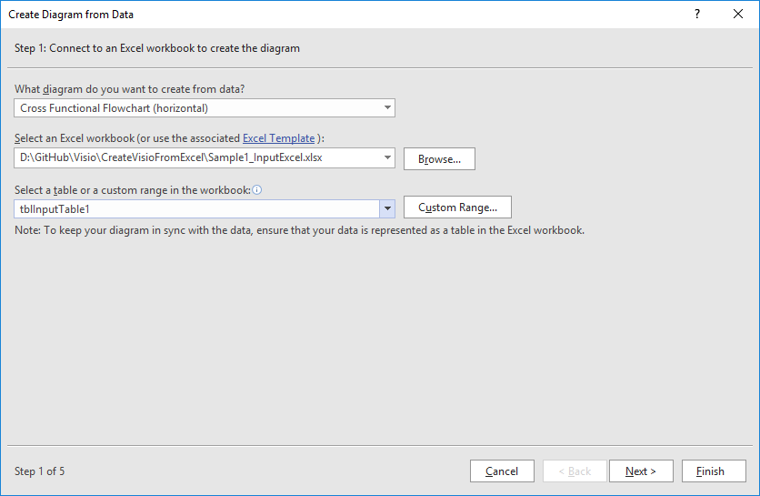

1. Map the Function & Phase fields from the excel table. Click Next.

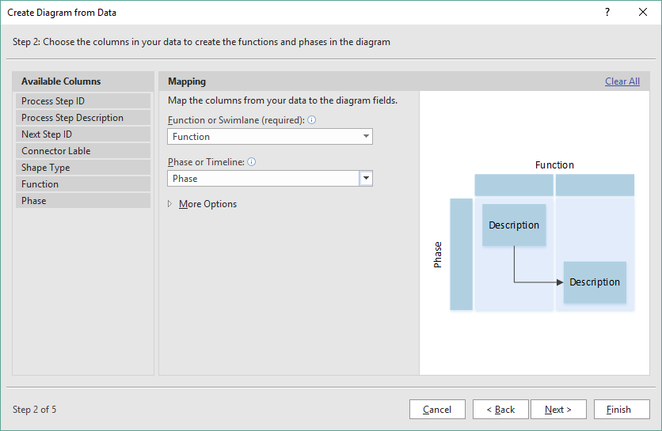

1. Map the Process Step ID, Description & Shape Type fields from the excel table. Click Next.

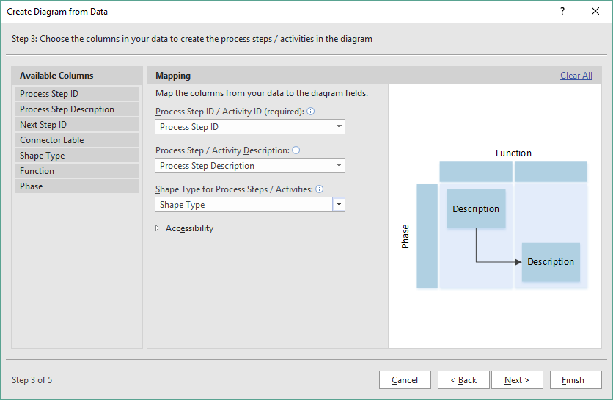

1. Map the Shape Type to relevant shapes. Click Next.

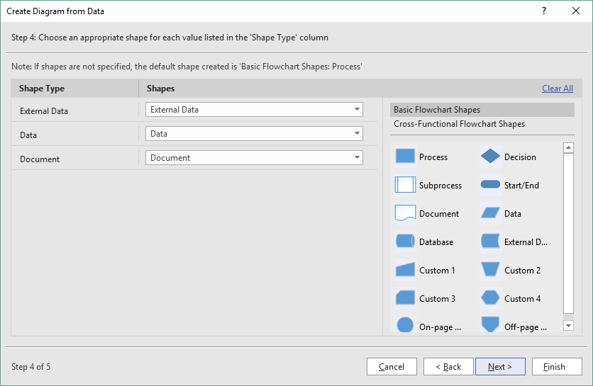

1. Map Next Step ID & Connector Lable. Click Finish.

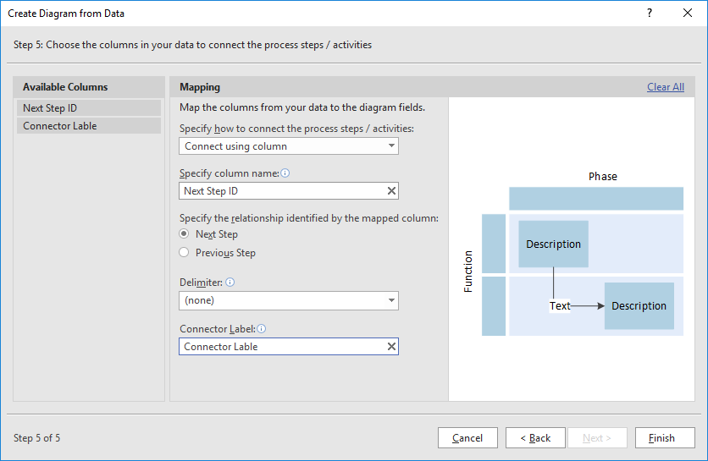

1. The below Visio diagram will be created.



**Reference:**

[Microsoft Article: Create a Data Visualizer diagram](https://support.office.com/en-us/article/Create-a-Data-Visualizer-diagram-17211b46-d144-4ca2-9ea7-b0f48f0ae0a6?ui=en-US&rs=en-US&ad=US)

**Note:**

* I have created Horizontal Cross-Functional flowchart and would suggest using the same at this point, because the Vertical flowchart is not aligning properly (assuming it as a limitation with this approach) hence the bigger charts are not readable.
* If the underlying Excel data is updated, then the same can be reflected to Visio diagram with a single click.

