1. Dyntrace update jobs:

ansible-playbook d1.yml --ask-vault-pass -e "@vault_api_key.yml"

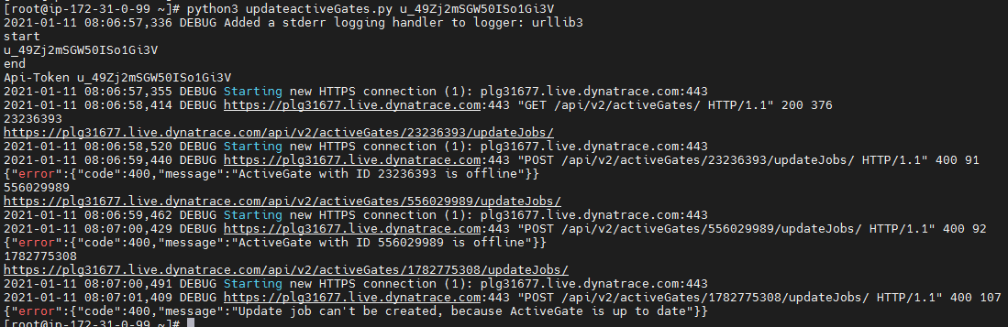



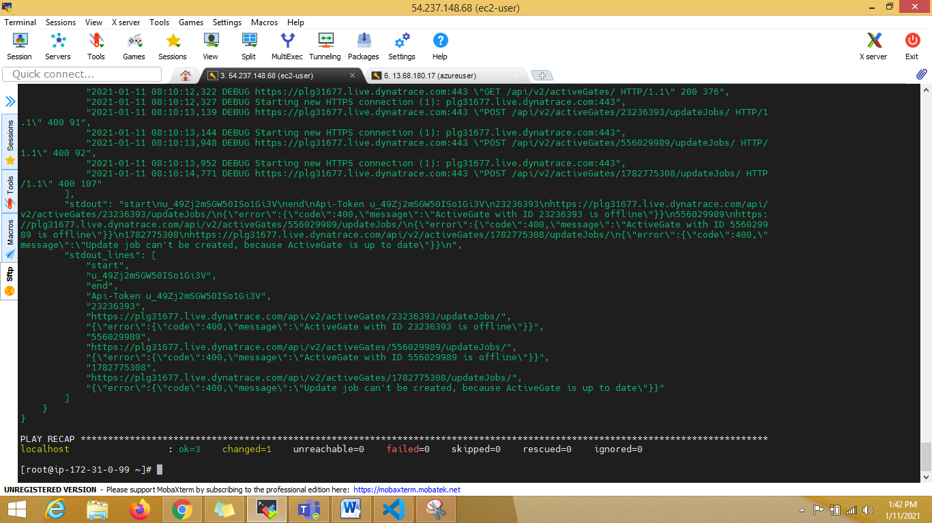

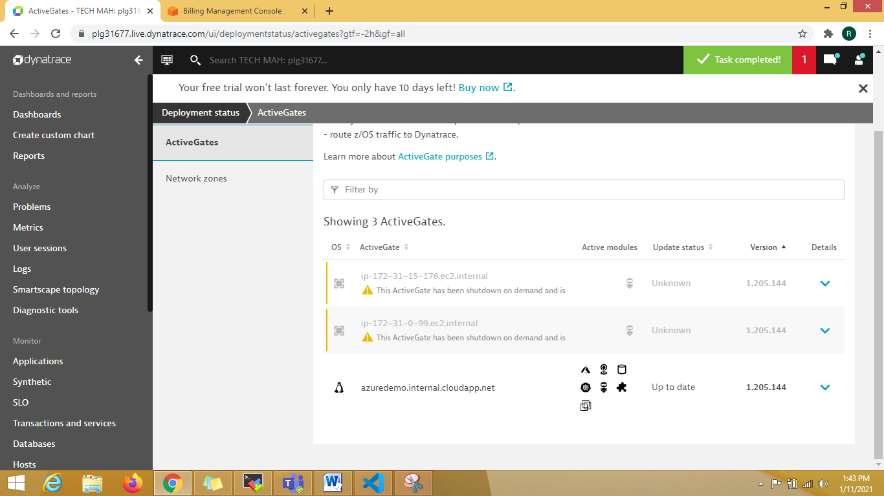

1. AWS SSM and Azure runbook

Using CLI for both. [Setup CLI infra on remote machine]

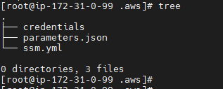

ansible-playbook ssm.yml

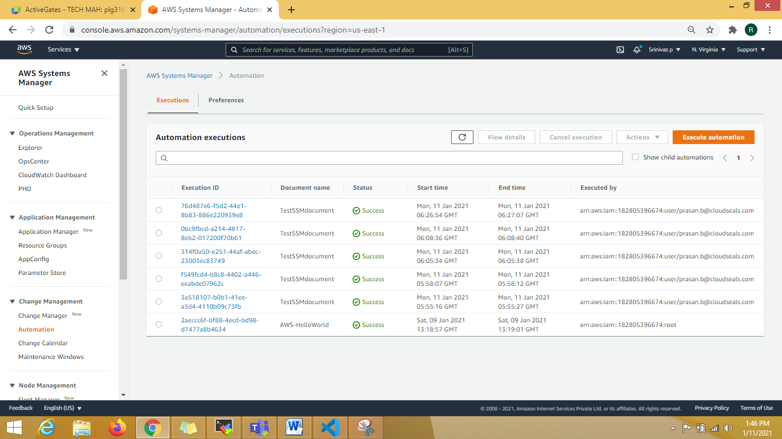

TASK [lookup ssm parameter store in the current region] ************************************************************************************************************

ok: [localhost] => {

"msg": "Techm@123"

Azure:

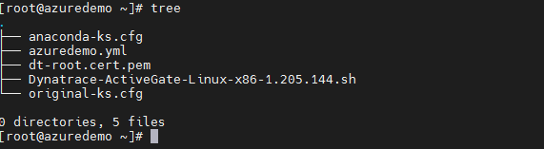

ansible-playbook azuredemo.yml

