**OBJECTIVE:**

The objectives of the Traffic Management System project are to leverage IoT devices and data analytics to monitor traffic flow and congestion in real-time and provide commuters with access to this information through a public platform or mobile apps. The primary goals and objectives of the project include:

**Real-Time Traffic Monitoring**: Implement a system that can continuously and accurately monitor traffic conditions in real-time at various locations within a designated area. This involves collecting data on vehicle flow, speed, and congestion.

**Congestion Detection**: Develop algorithms and analytics to detect traffic congestion and anomalies promptly. This includes identifying areas with high traffic volume or slow-moving traffic.

**Route Optimization**: Provide commuters with intelligent route suggestions based on real-time traffic data. This can help users choose the most efficient and congestion-free routes for their journeys.

**Improved Commuting Experience**: Enhance the overall commuting experience for the public by giving them access to up-to-date traffic information. This empowers commuters to make informed decisions about their routes, potentially reducing travel time and frustration.

**Historical Data Analysis**: Optionally, integrate historical traffic data and machine learning algorithms to predict congestion patterns, improving the accuracy of route recommendations.

**User-Friendly Platform**: Create a user-friendly web-based platform and mobile apps that allow the public to easily access and visualize real-time traffic information.

**Data Security**: Ensure the security and privacy of data collected from IoT sensors and transmitted through the system.

**Scalability:** Design the system to be scalable, allowing for the addition of more sensors and expanded coverage in the future if needed.

**Documentation and Replicability**: Document the project thoroughly to enable others to replicate the system, deploy IoT sensors, develop the transit information platform, and integrate them using Python.

Overall, the project's objectives aim to improve traffic management and commuting experiences for the public by providing timely and accurate information for decision-making and optimization of travel routes.

**SENSOR SETUP:**

Setting up IoT sensors for a Traffic Management System involves carefully selecting and deploying sensors to monitor traffic conditions in real-time.

1. **Define Sensor Requirements**:

Identify the specific data you need to collect, such as vehicle count, speed, and congestion detection.

Determine the coverage area and the number of sensors required.

**2. Sensor Selection:**

Choose appropriate sensors based on your requirements. Common traffic-related sensors include:

**Ultrasonic Sensors**: Measure distance and can be used for vehicle presence detection.

**Inductive Loop Sensors**: Detect the presence of vehicles by changes in electromagnetic fields.

**Infrared Sensors**: Detect the heat emitted by vehicles.

**Camera Sensors**: Capture images or video feeds for more advanced analysis.

Ensure selected sensors are compatible with your IoT platform and communication protocols.

**3. Sensor Deployment:**

Identify strategic locations for sensor placement, such as intersections, highways, or congested areas.

Install sensors securely, ensuring they are protected from weather and vandalism.

Calibrate sensors for optimal accuracy.

**4. Power Supply:**

Determine the power source for your sensors. Options include batteries, solar panels, or a wired power supply.

Ensure a reliable power source to prevent sensor downtime.

**5. Data Transmission:**

Connect the sensors to a central data hub, such as a Raspberry Pi or a microcontroller.

Use suitable communication protocols (e.g., MQTT, HTTP) for transmitting data from sensors to the central hub.

**6. Data Processing Hub (e.g., Raspberry Pi):**

Set up the central data processing hub, which will collect, process, and transmit data to the cloud or a server.

Interface sensors with the hub using GPIO pins or sensor-specific interfaces.

Develop Python scripts or code to read data from sensors.

**7. Data Security:**

Implement security measures to protect data during transmission and storage.

Use encryption and authentication to ensure data integrity.

**8. Data Storage and Analysis**:

Store collected data in a database or cloud storage for further analysis.

Implement data analytics to detect traffic patterns, congestion, and anomalies.

**9. Real-time Monitoring:**

Set up real-time monitoring of sensor data for immediate detection of traffic issues.

Develop alerts or notifications for congestion or unusual traffic events.

**10. Remote Access:**

Configure remote access to the sensor system for maintenance and troubleshooting.

Implement secure remote access methods.

**11. Testing and Calibration:**

Thoroughly test the sensor system to ensure accurate data collection.

Calibrate sensors regularly to maintain accuracy.

**12. Scalability:**

Design the sensor setup to be scalable, allowing for the addition of more sensors to cover a larger area or address changing traffic patterns.

**13. Documentation:**

Document sensor specifications, deployment locations, wiring diagrams, and calibration procedures.

Keep records of maintenance and troubleshooting activities.

**14. Maintenance and Monitoring:**

Establish a maintenance schedule to inspect and maintain sensors regularly.

Implement monitoring systems to detect sensor failures or connectivity issues.

A well-designed and properly deployed IoT sensor setup is crucial for the success of your Traffic Management System, as it forms the foundation for collecting accurate and reliable traffic data in real-time.

**CODE:**

import RPi.GPIO as GPIO

import time

# Define GPIO pin numbers for the traffic lights

red_pin = 17

yellow_pin = 27

green_pin = 22

# Set up GPIO mode

GPIO.setmode(GPIO.BCM)

GPIO.setup(red_pin, GPIO.OUT)

GPIO.setup(yellow_pin, GPIO.OUT)

GPIO.setup(green_pin, GPIO.OUT)

defset_traffic_lights(red, yellow, green):

GPIO.output(red_pin, red)

GPIO.output(yellow_pin, yellow)

GPIO.output(green_pin, green)

deftraffic_signal_cycle():

while True:

# Green signal (North-South)

set_traffic_lights(False, False, True)

time.sleep(30) # Green light for 30 seconds

# Yellow signal (North-South)

set_traffic_lights(False, True, False)

time.sleep(5) # Yellow light for 5 seconds

# Red signal (North-South)

set_traffic_lights(True, False, False)

time.sleep(10) # Red light for 10 seconds

# Repeat the cycle for East-West traffic

if __name__ == "__main__":

try:

traffic_signal_cycle()

except KeyboardInterrupt:

GPIO.cleanup() # Clean up GPIO pins on keyboard interrupt

**Raspberry Pi integration:**

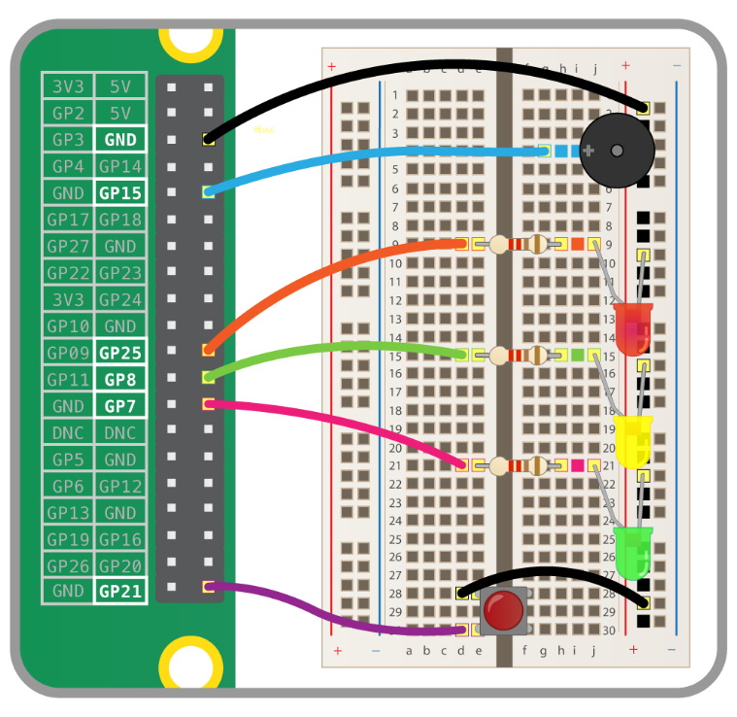

**MOBILE APP DEVELOPMENT:**

import 'package:flutter/material.dart';

void main() =>runApp(TrafficSignalApp());

class TrafficSignalApp extends StatefulWidget {

@override

_TrafficSignalAppStatecreateState() => _TrafficSignalAppState();

}

class _TrafficSignalAppState extends State<TrafficSignalApp> {

Color _currentSignalColor = Colors.red;

void _changeSignalColor() {

setState(() {

if (_currentSignalColor == Colors.red) {

_currentSignalColor = Colors.green;

} else if (_currentSignalColor == Colors.green) {

_currentSignalColor = Colors.yellow;

} else {

_currentSignalColor = Colors.red;

}

});

}

@override

Widget build(BuildContext context) {

return MaterialApp(

home: Scaffold(

appBar: AppBar(

title: Text('Traffic Signal Control'),

),

body: Center(

child: Container(

width: 100,

height: 300,

color: _currentSignalColor,

child: FlatButton(

onPressed: _changeSignalColor,

child: Text(

'Change Signal',

style: TextStyle(color: Colors.white),

),

),

),

),

),

);

}

}

**HOW THE REAL-TIME TRAFFIC MONITORING SYSTEM CAN ASSIST COMMUTERS IN MAKING OPTIMAL ROUTE DECISIONS AND IMPROVING TRAFFIC FLOW:**

A real-time traffic monitoring system can significantly assist commuters in making optimal route decisions and contribute to improving traffic flow in several ways:

**Real-Time Traffic Updates**: The system continuously collects and processes data from various sources, such as traffic cameras, sensors, and GPS devices. It provides commuters with up-to-the-minute information about current traffic conditions on their chosen routes.

**Traffic Congestion Alerts:** Commuters receive alerts and notifications about traffic congestion, accidents, road closures, and other incidents that could impact their journeys. This allows them to plan alternative routes or delay their trips to avoid traffic disruptions.

**Route Optimization**: The system uses advanced algorithms to analyze traffic data and suggest the most efficient and congestion-free routes based on real-time information. Commuters can select optimized routes that minimize travel time and reduce the chances of getting stuck in traffic.

**Estimated Time of Arrival (ETA):** By considering current traffic conditions, the system provides accurate ETAs for reaching their destinations. Commuters can plan their departures more effectively, reducing unnecessary wait times and stress.

**Alternative Transportation Options:** Some traffic monitoring systems also integrate data on public transportation options, ridesharing services, and bike-sharing programs. Commuters can explore alternative modes of transport when road conditions are unfavorable.

**Reduced Congestion:** As commuters receive real-time updates and opt for less congested routes, traffic congestion on heavily used routes can be reduced. This contributes to smoother traffic flow for everyone on the road.

**Improved Traffic Management**: Traffic authorities can use the data collected by the system to make informed decisions about traffic management strategies. This may include adjusting traffic signal timings, rerouting traffic, or deploying emergency services more effectively in response to incidents.

**Environmental Benefits:** Reduced congestion and more efficient traffic flow can lead to lower fuel consumption and reduced emissions, contributing to improved air quality and environmental sustainability.

**Public Awareness and Safety:** Commuters are more aware of current traffic conditions and potential hazards, which can lead to safer driving practices. Reduced accidents and incidents further enhance traffic safety.

**Data-Driven Planning:** Traffic monitoring systems accumulate valuable data over time. City planners and transportation authorities can use this historical data to identify traffic patterns, plan road infrastructure improvements, and make informed decisions about urban development.

**Public Engagement:** By providing commuters with real-time traffic information and involving them in the decision-making process through mobile apps and web platforms, traffic authorities can engage the public in traffic management efforts and receive feedback.

In summary, a real-time traffic monitoring system empowers commuters with valuable information to make informed route decisions, optimize travel time, and avoid traffic-related stress. Simultaneously, it contributes to the overall improvement of traffic flow, reduced congestion, and enhanced safety and sustainability in urban transportation systems.

**Python code:**

Developing a full-fledged traffic management and transit information system in Python, especially with IoT integration, is a substantial undertaking, and the complete code for such a system would be extensive and beyond the scope of a single response. However, I can provide a simplified example of how you might collect and process IoT data related to vehicle locations using Python. This example demonstrates the basic concept, and you would need to expand upon it for a complete system.

Let's assume you have GPS trackers on vehicles that send their location data to a server. You can use Python for data processing on the server. Below is a simplified example using Python to receive and process GPS data:

**Python**

# This is a simplified server to receive and process GPS data from IoT devices.

import socket

# Create a socket to listen for incoming data from IoT devices

server_address = ('0.0.0.0', 12345)

buffer_size = 1024

with socket.socket(socket.AF_INET, socket.SOCK_DGRAM) as server_socket:

server_socket.bind(server_address)

print("Server is listening...")

while True:

data, client_address = server_socket.recvfrom(buffer_size)

data = data.decode('utf-8')

# Process and store the received GPS data

vehicle_id, latitude, longitude = data.split(',')

# Here, you can store the data in a database or perform real-time analysis.

# For example, you can use a library like pandas to process and analyze data.

# You can also update a real-time dashboard or trigger alerts as needed.

print(f"Received GPS data from Vehicle {vehicle_id}: Lat {latitude}, Long {longitude}")

# You would expand this code to handle real-time traffic and transit information.

This code listens for incoming GPS data from IoT devices, extracts information, and can then store or process the data further as needed.

To create a complete transit information platform with traffic management, you would need to integrate multiple components, including databases, APIs, web services, data visualization, machine learning, and user interfaces, among others. Each of these components would require its own code implementation and may involve multiple Python files and libraries.