**Introduction**

This document explains the how does client and server communicate using socket programming.

**Prerequisites**

* libXml2
* pthread

**Design approach**

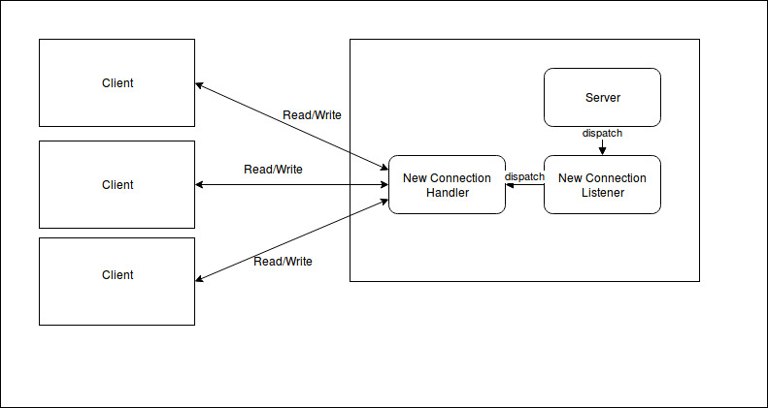

**Design Description**

* We have AbstractSocket, it is extended to TcpSocket and UdpSocket(Yet to implement)
* Client.cpp for initialize the client
* TcpServer for listening clients, it uses ptherd to run seperate process for listening new conection and handling new connection
* Server.cpp for initialize the server

**Usage:**

cd to working directory

run make

run ./TcpServer and run ./TcpClinet from another commad prompt.