Low-Level Design Document

Address Verification Service (`/v1/addresses`)

1. Overview
The `/v1/addresses` endpoint validates and normalizes both domestic and international postal addresses. It integrates with third-party services like USPS and Loqate to perform validation and normalization tasks.

2. Functional Requirements
- Validate address structure and fields.
- Normalize valid addresses.
- Handle domestic (US/UK/IRL) and international addresses.
- Return detailed error messages for invalid input.

3. Class Diagram
The class diagram represents the structure and relationships between core components of the address verification module.
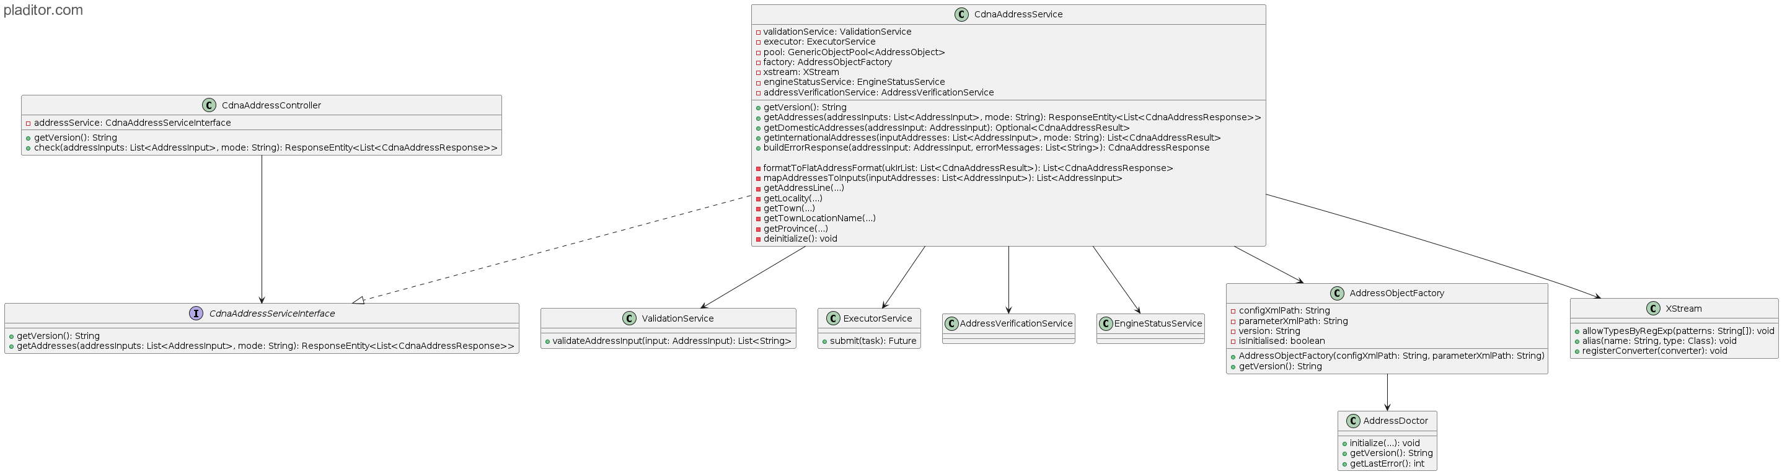

4. Sequence Diagram
This diagram illustrates the sequence of interactions from the client to downstream services.
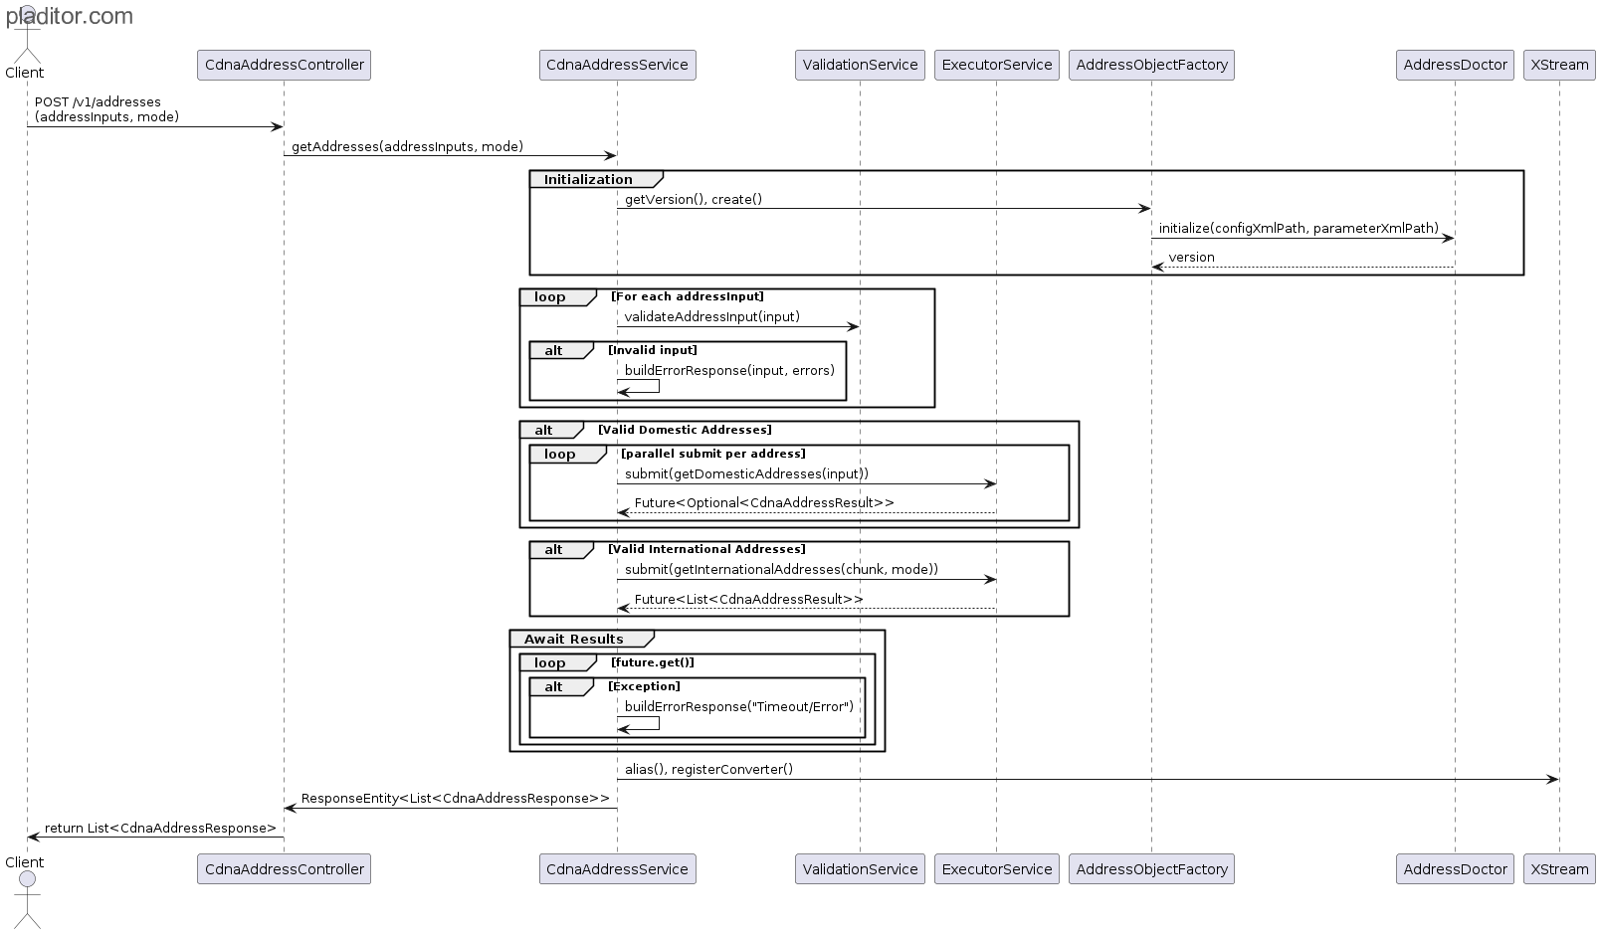
(Insert sequence diagram image here)

5. API Specification
POST `/v1/addresses`
- Headers: `Content-Type: application/json`
- Request and response structure follows a list of address inputs and normalized results with error messages if applicable.

6. Validation Logic
- Validates required fields based on country.
- Checks postal code format using regex.
- Leverages ValidationService for centralized rule enforcement.

7. Security
- JWT authentication required.
- Input sanitization to prevent injection.
- Logging excludes sensitive address data.

8. Error Handling & Retry
- Retry logic for transient failures (max 3 attempts).
- Graceful fallback with standardized error responses.
- Timeout and exception tracking included.

9. Data Models
- `AddressInput`: Request model.
- `CdnaAddressResponse`: Response wrapper with result and error details.
- `CdnaAddressResult`: Internal intermediate model.

10. Algorithms
- Chunking of large input sets.
- Field validation and regex checks.
- Parallel task execution and future result aggregation.

11. Metrics and Logging
- Log validation time, address count, and status per request.
- Collect metrics for API latency, validation success rate, and third-party response times.

12. Exception Flows
- Handle missing/invalid inputs with 400 errors.
- Catch external API timeouts and fail gracefully.
- Fallback for internal exceptions returns 500 with trace ID.

13. Testing Strategy
- Unit tests for all validators and utility functions.
- Integration tests with USPS sandbox.
- Mock APIs for third-party services.
- Load testing with large datasets.

14. Future Improvements
- Add address autocomplete.
- Support multiple languages/locales.
- Cache verified address results for faster re-verification.

15. Design Patterns Used
- Factory Pattern: Used in AddressObjectFactory to create AddressDoctor objects.
- Object Pool Pattern: Reuses AddressDoctor instances via GenericObjectPool.
- Strategy Pattern (recommended): For country-specific verification logic.
- Singleton: Spring-managed beans (services and executors).
- Adapter Pattern (optional): Abstract integration with multiple third-party validators.

16. Deployment / Integration View
- Deployed as a Spring Boot microservice.
- Depends on external services (USPS, Loqate, etc.).
- Integrates with API Gateway, logging and monitoring infrastructure.

17. Data Structures Used
- List<AddressInput>
- List<CdnaAddressResult>
- GenericObjectPool<AddressObject>
- Future<List<Result>>
- Map<String, List<AddressInput>> (if optimized by country)

18. Algorithms
- Chunking large address lists.
- Regex-based postal code validation.
- Asynchronous address processing using ExecutorService.
- XML parsing with XStream for AddressDoctor responses.

19. Performance Considerations
- ExecutorService enables parallel validation.
- Object pooling reduces memory and object creation time.
- Timeout and retry configurations help manage SLA.
- Caching and circuit breakers are future scalability enhancements.

