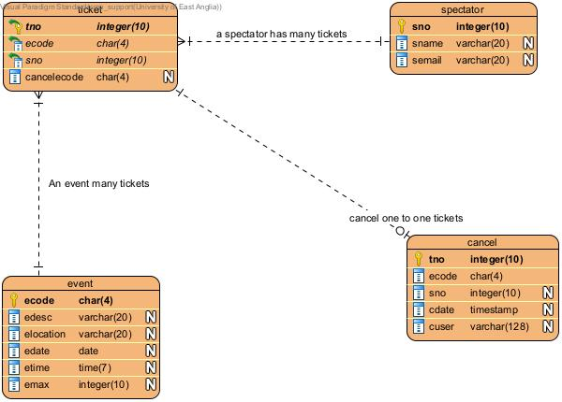

Assumptions: Cancel (ecode,tno,sno) retains the record for only the ecode tno , while ecode in from primary table Event gets deleted in when event gets deleted, tno gets too deleted in the cascade relationship with event.In view of the requirement to retain the cancelled tickets no constraint on tno,ecode to respective event,ticket table.

**Test Evidence**

1. Insert spectator **- Transactions of Interest(A)**

Sql - call insert_spectator(12,'sname12','sname12@mail.com');

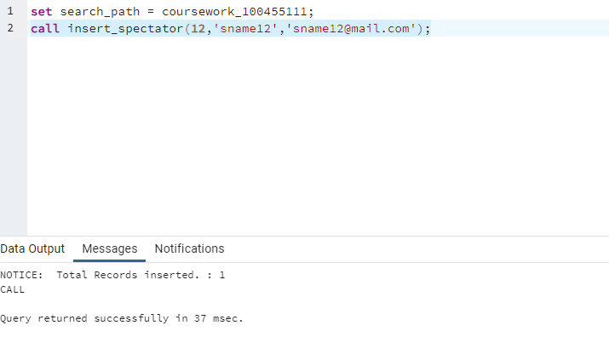

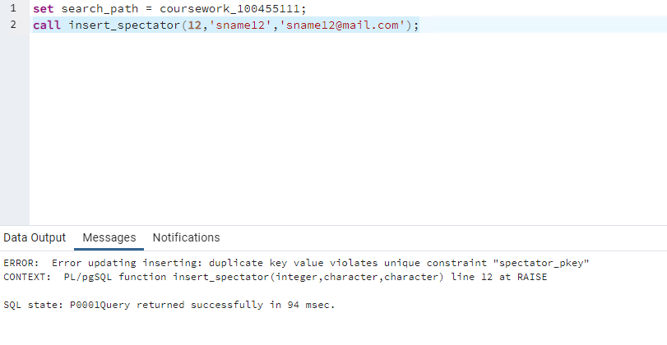

Insert event **- Transactions of Interest(B)**

* **Insert** **event**

Sql - call insert_event('A114','event114','location114','2024-07-01','17:00',10);

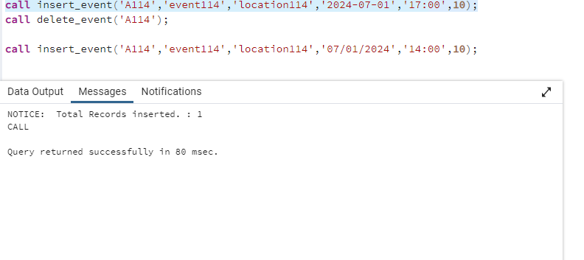

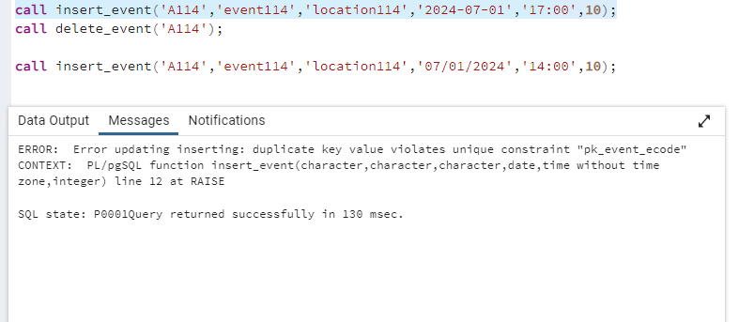

* **Insert into event fails when edate is not July 2024**

Sql - call insert_event('A114','event114','location114','2024-08-01','17:00',10);

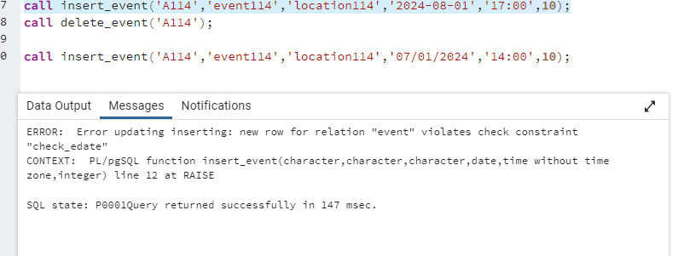

* **Insert into event fails when when etime is before 9:00 hrs**
* **Sql -** call insert_event('A114','event114','location114','2024-07-01','08:00',10);

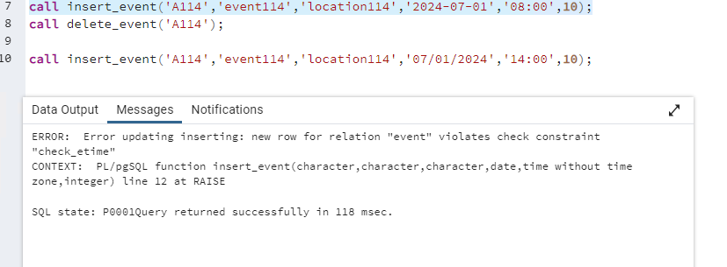

* **Insert into event fails when when emax -0**

sql - call insert_event('A114','event114','location114','2024-07-01','09:00',0);

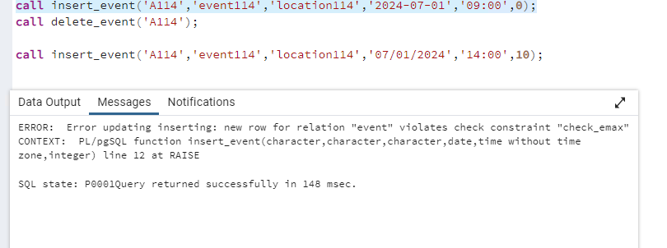

**Transactions of Interest(C)**

* Insert Spectator

Sql - call insert_spectator(13,'sname13','sname13@mail.com');

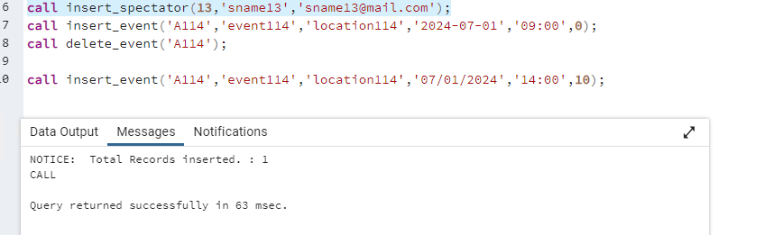

* Delete Spectator when spectator doesn’t have tickets

call delete_spectator(13);

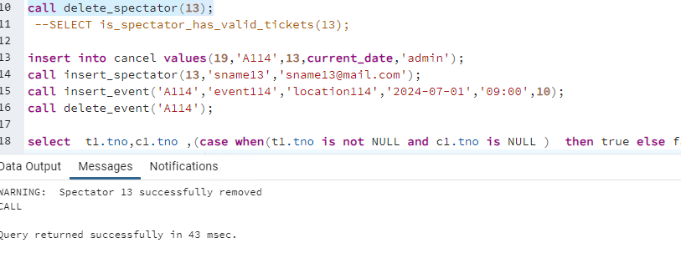

* Delete Spectator when spectator has valid tickets not cancelled

call insert_ticket('A114',13);

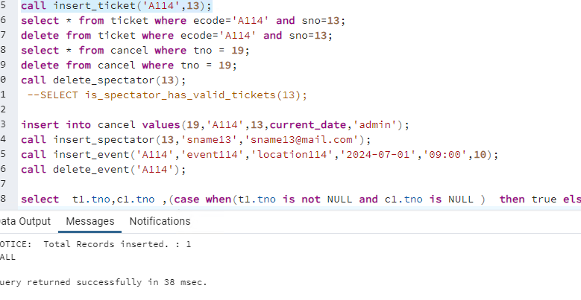

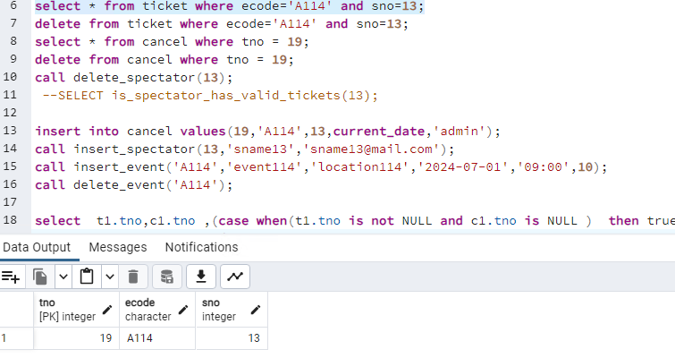

Sql -call delete_spectator(13);

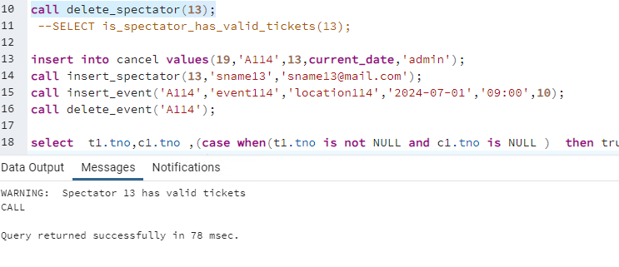

* Delete Spectator when spectator has valid tickets but cancelled

insert into cancel values(19,'A114',13,current_date,'admin');

call delete_spectator(13);

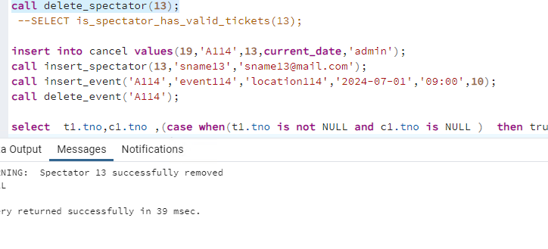

. **Transactions of Interest(D)**

* Delete an event – transaction D

Event record gets deleted for ecode ‘A101’

Ticket record gets deleted for ecode ‘A101’

Cancel has the cancelled record for ‘A101’

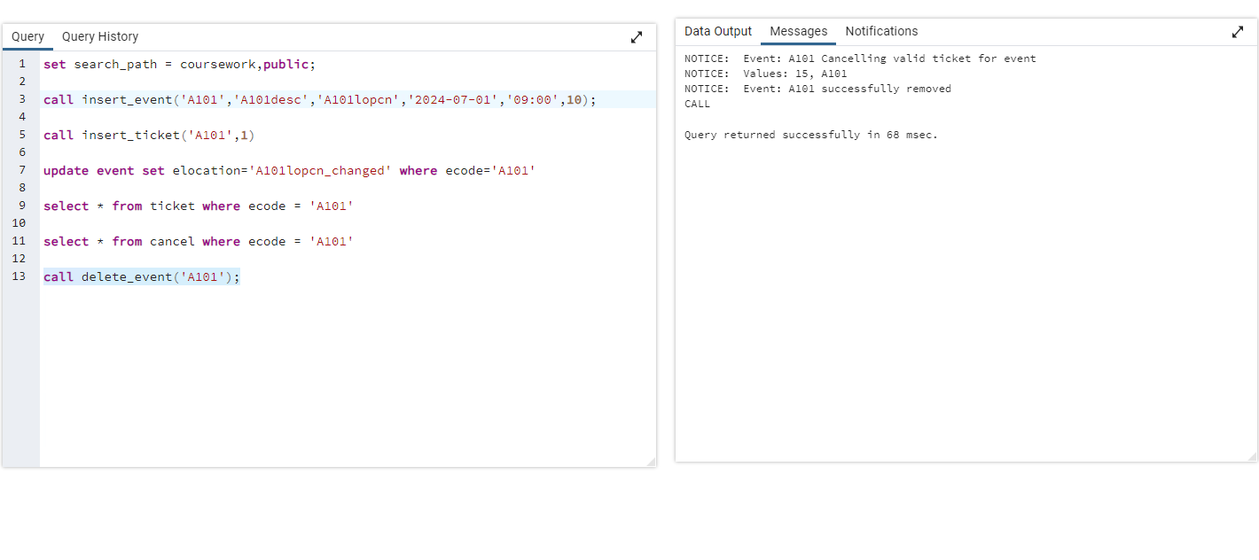

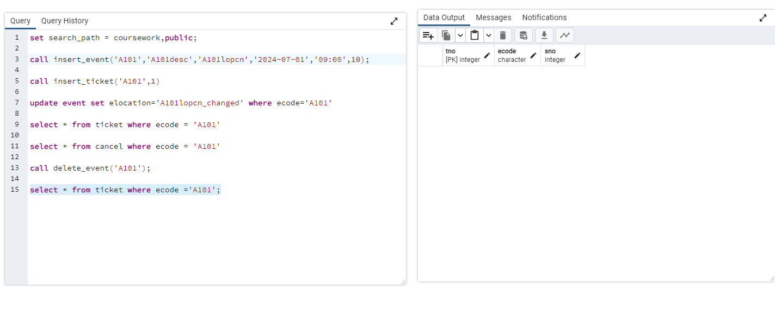

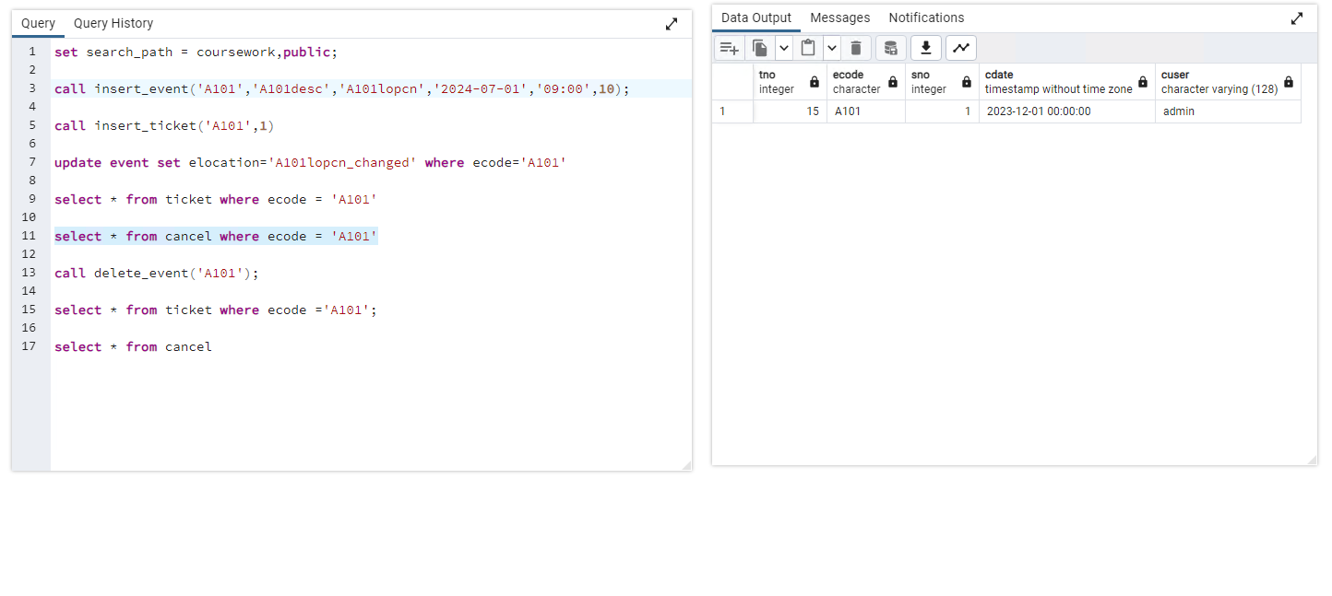

* **Transactions of Interest(E)**

Issue a ticket for an event

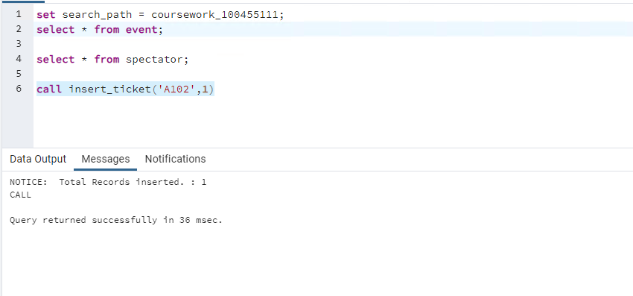

* **Issue ticket for more than 1 ticket for the same event and spectator no**

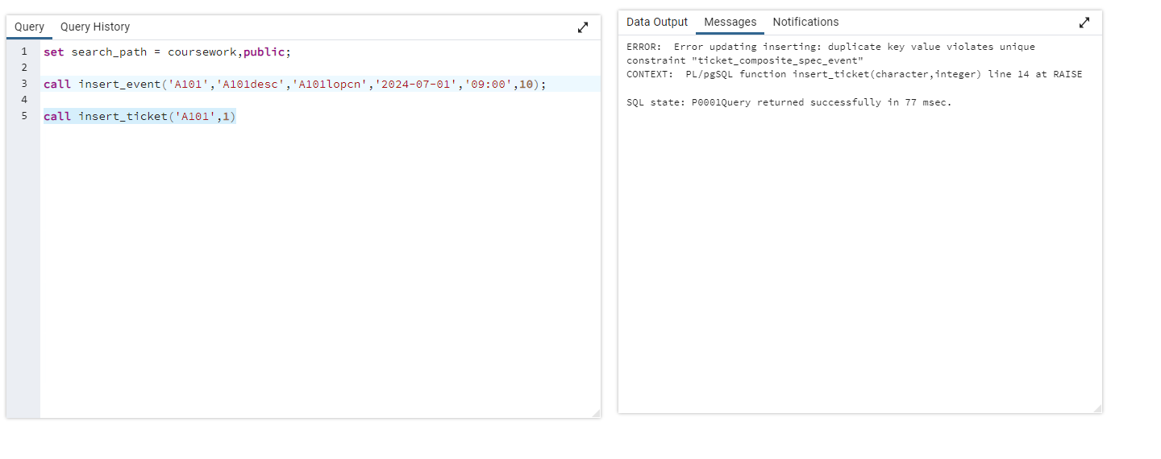

* **Transactions of Interest(F)**

report showing the total number of spectators liable to travel to a location

select * from total_spectator_per_date_per_location;

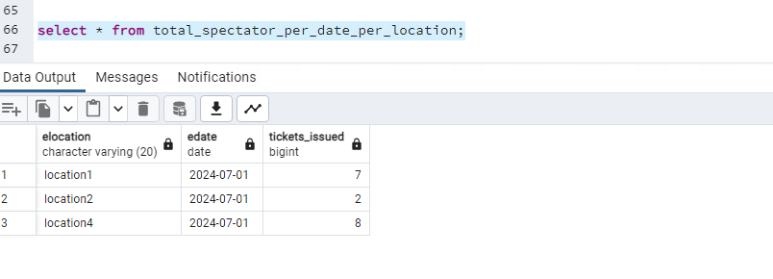

g. Transactions of Interest(G)

report showing the total number of tickets issued for each event.

select * from total_tickets_issued_per_event ;

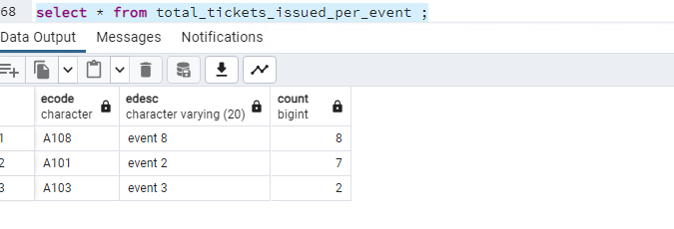

**h.** Transactions of Interest(H)

**report showing the total number of tickets issued for each event by the event code**

select * from total_tickets_issued_per_event where ecode='A101';

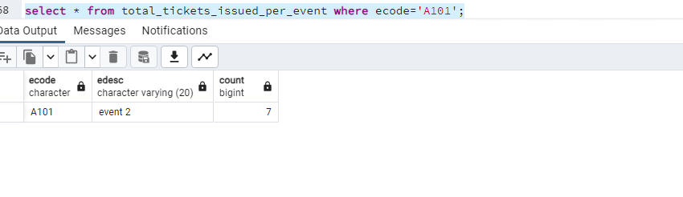

1. Transactions of Interest(I)

**report showing the schedule for a given spectator**

select * from report_spectator_schedule where sno=1;

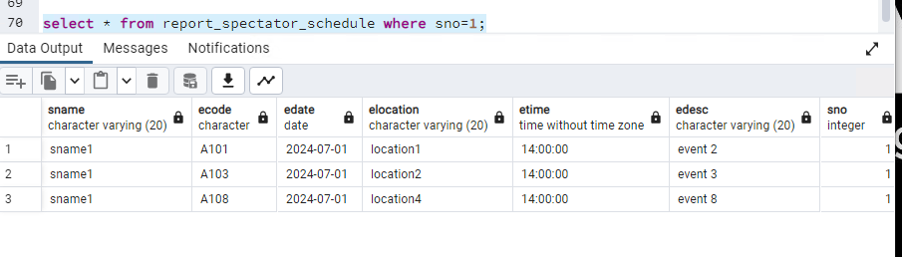

1. **j.** Transactions of Interest(J)

**Given a specific ticket reference number, display the name of the spectator and the event code for the ticket and indicate if the ticket is valid or is cancelled.**

select * from ticket_status_report where tno=9

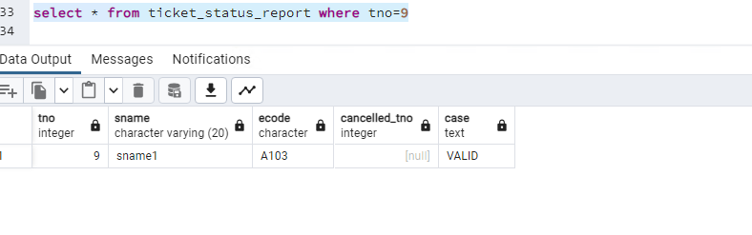

select * from ticket_status_report where tno=12

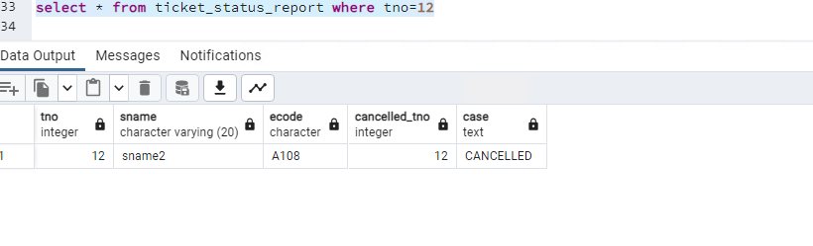

**k.** Transactions of Interest(K)

**View the details of all cancelled tickets for a specific event.**

select * from cancelled_tickets_report where ecode='A108';

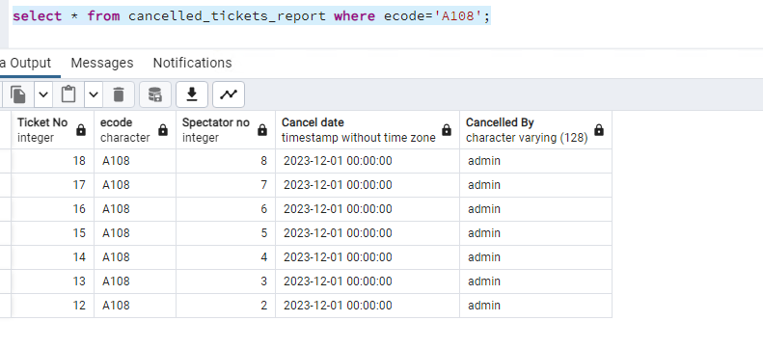

**l.** Transactions of Interest(L)

**Delete the contents of the database tables**

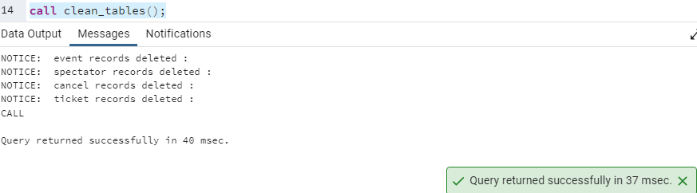

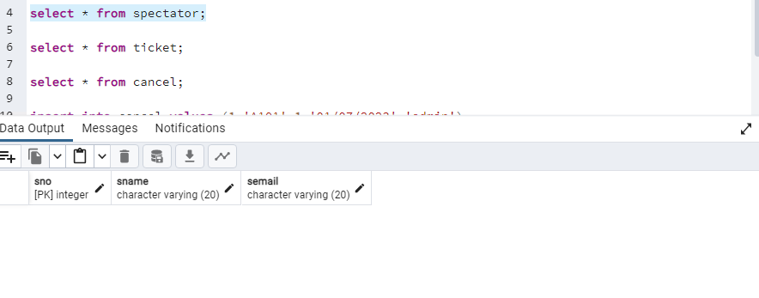

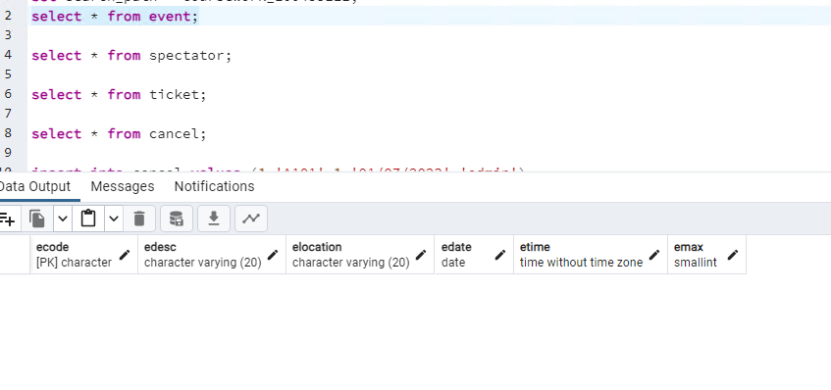

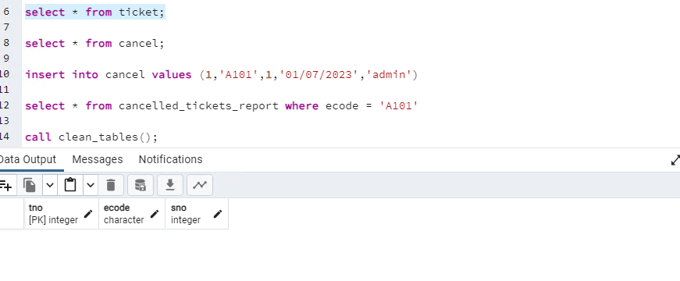

* **When event location changes , ticket gets cancelled**

