**Exercise 2 – Express JS**

(Templating with EJS & Pug, Static Files, Form Handling, Multer)

1. **Create an Express.js app using EJS** that renders a movie gallery:
   * Render a list of movies with titles and ratings.
   * Use a layout file with a header/footer and external CSS to style the cards.
   * Highlight movies with a rating above 8 in a different color using conditional rendering.

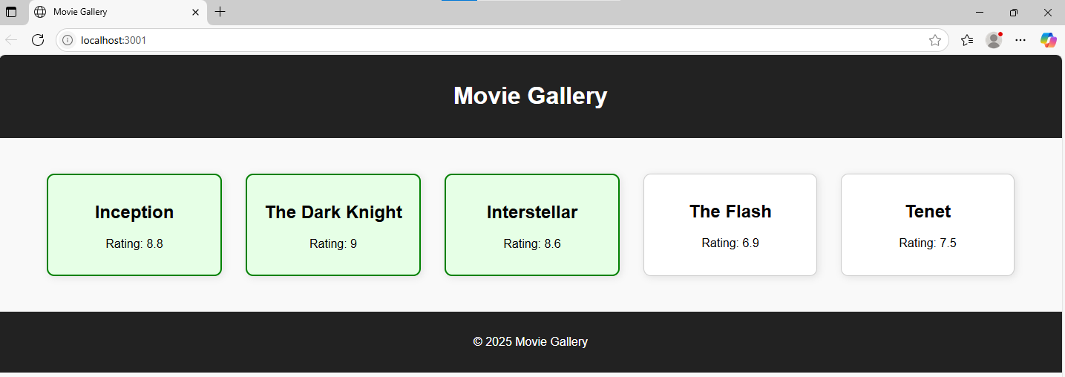

1. **Build a recipe page using Pug templating**:
   * Pass dynamic recipe data (name, ingredients, steps) to the Pug view.
   * Apply external CSS for layout and inline CSS for highlighting ingredients.
   * Include a virtual path for serving images used in the recipe view (/assets).
2. **Design a feedback form** for a travel website using Express and multer:
   * The form should collect name, email, and a screenshot of an issue.
   * Use multer.diskStorage() to save the image to an uploads/ folder.
   * On submission, display the input and image preview using EJS.