**Exercise 1 – React JS**

**(Components, Lists, Keys, prop validation and CSS)**

1. Develop a React-JS application using a functional component that renders a list of countries with their capitals using .map(). Each list item must have a unique key, and the list should be styled using an external CSS file.
2. Create a class component in React-JS that displays a list of restaurants, where each restaurant contains a nested list of menu items and apply unique keys for each item.
3. Create a functional component in React-JS that displays a 5 Vehicle Info Card in a row with details like Model, Manufacturer, Year, and Fuel Type. Use inline CSS to style the card layout and appearance.

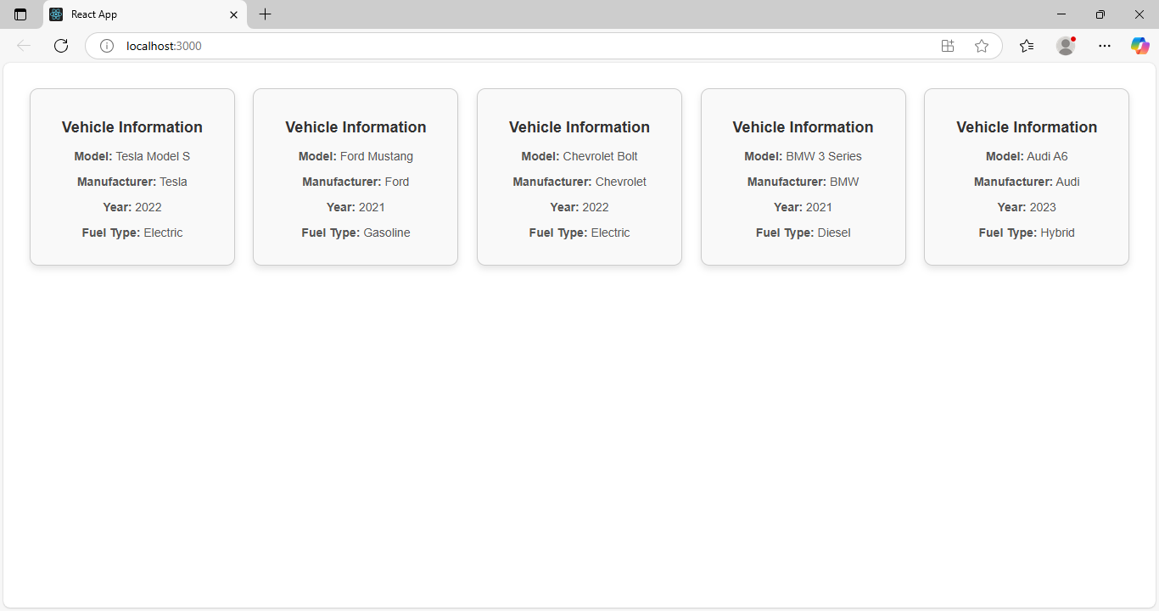

**Exercise 2 – React JS**

**(Components, Lists, Keys, prop validation and CSS)**

1. Design a class-based React-JS component called CourseCard that receives props such as course title (string), duration in weeks (number), and instructor name (string). Use prop-types to validate that all props are required and of the correct type.
2. Build a functional component in React-JS that renders a grid of famous landmarks (name, location, country). Use external CSS to apply styles like borders, spacing, and hover effects to each item.
3. Design a React class component with prop validation using PropTypes to ensure correct data types for props?

