Face Detection & Recognition in Organic Video: A Comparative Study for Sport Celebrities Database

In this paper author is giving comparative study on face detection and recognition by using different algorithms such as HaarCascade Classifier and MMOD (Max-Margin object detection) for face detection. LSBH (Local binary pattern histogram), and CNN-based Pruned ResNet34 for face recognition.

Author is giving comparative study on HaarCascade and ResNet34 and then giving comparative study on MMOD and LSBH. In both detection and recognition algorithms HaarCascade and ResNet34 is giving better performance so we are developing this algorithms.

To train algorithms author has used sports celebrities organic video images dataset and Celebrity dataset but organic video dataset is not available on internet so we have used below celebrity dataset.

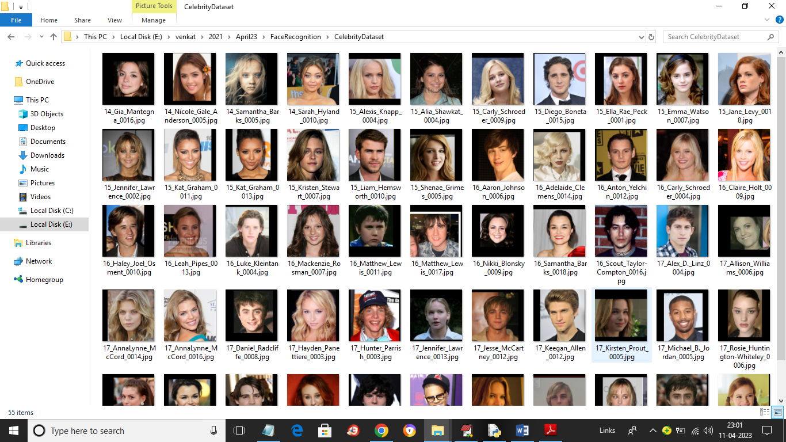

So by using above celebrity dataset we will train ResNet34 for face recognition. To implement this project we have designed following modules

1. Upload Celebrities Dataset: using this module we will upload dataset to application
2. Preprocess Dataset: using this module we will read all images and then apply HaarCascade classifier to detect faces, normalize and shuffle faces and then split entire dataset into train and test where application using 80% dataset for training and 20% for testing
3. Train HaarCascade & ResNet34: HaarCascade face features will be input to ResNet34 to train a model which can be used to recognized faces. 80% training images will be input to ResNet34 to train a model and then apply 20% test images on trained model to calculate prediction accuracy.
4. ResNet34 Training Graph: using this module we will plot ResNet34 training accuracy and loss graph
5. Detect & Recognized Face using Test Images: using this module we will upload test image and then detect face using HaarCascade and then apply ResNet34 for face recognition.

SCREEN SHOTS

To run project double click on run.bat file to get below screen

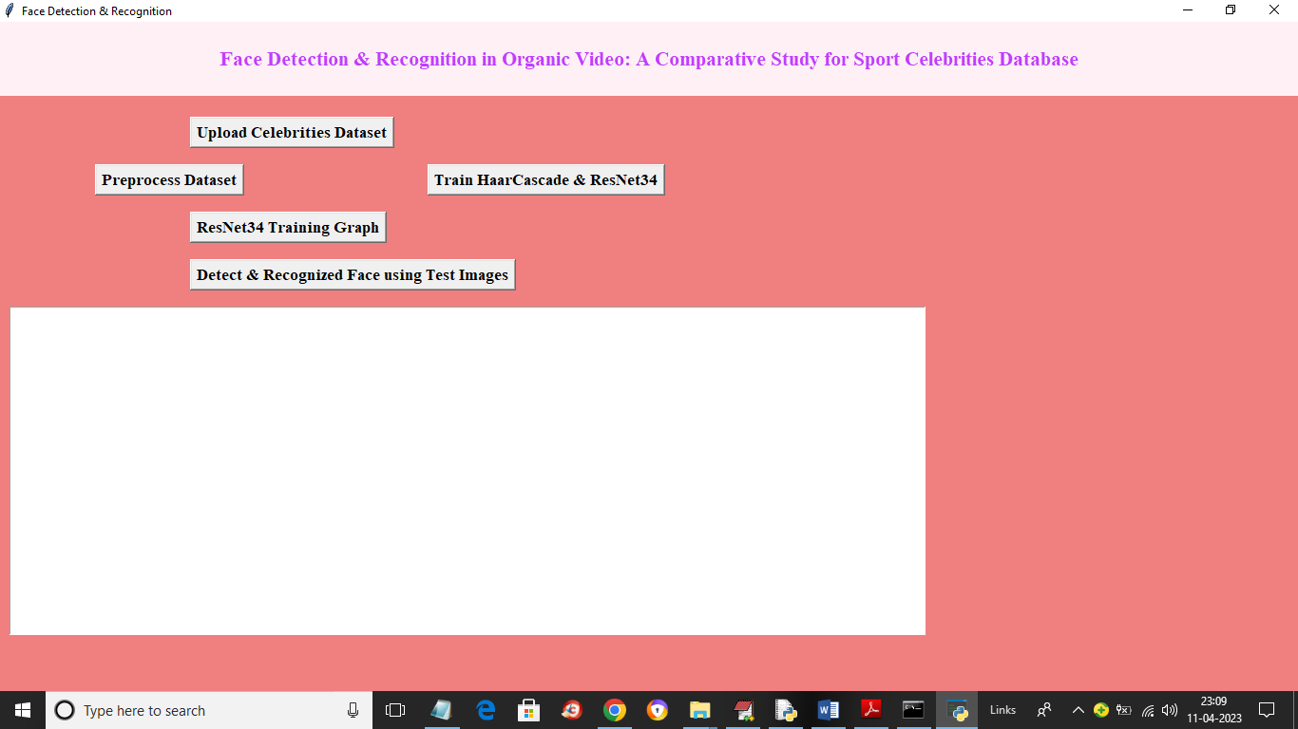

In above screen click on ‘Upload Celebrities Dataset’ button to upload dataset and get below screen

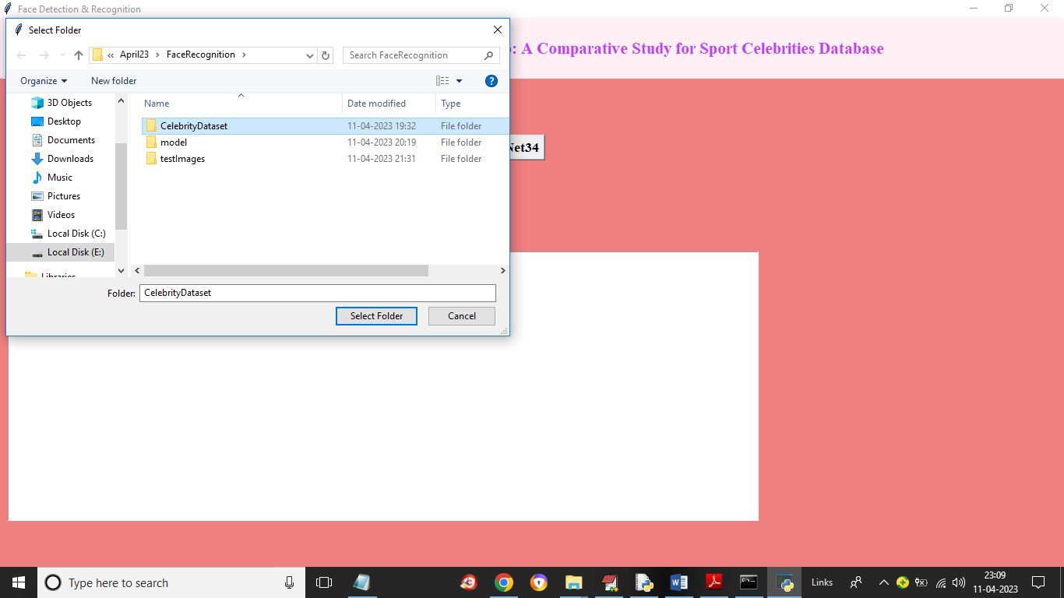

In above screen selecting and uploading ‘Celebrities Dataset’ folder and then click on ‘Select Folder’ button to load dataset and get below output

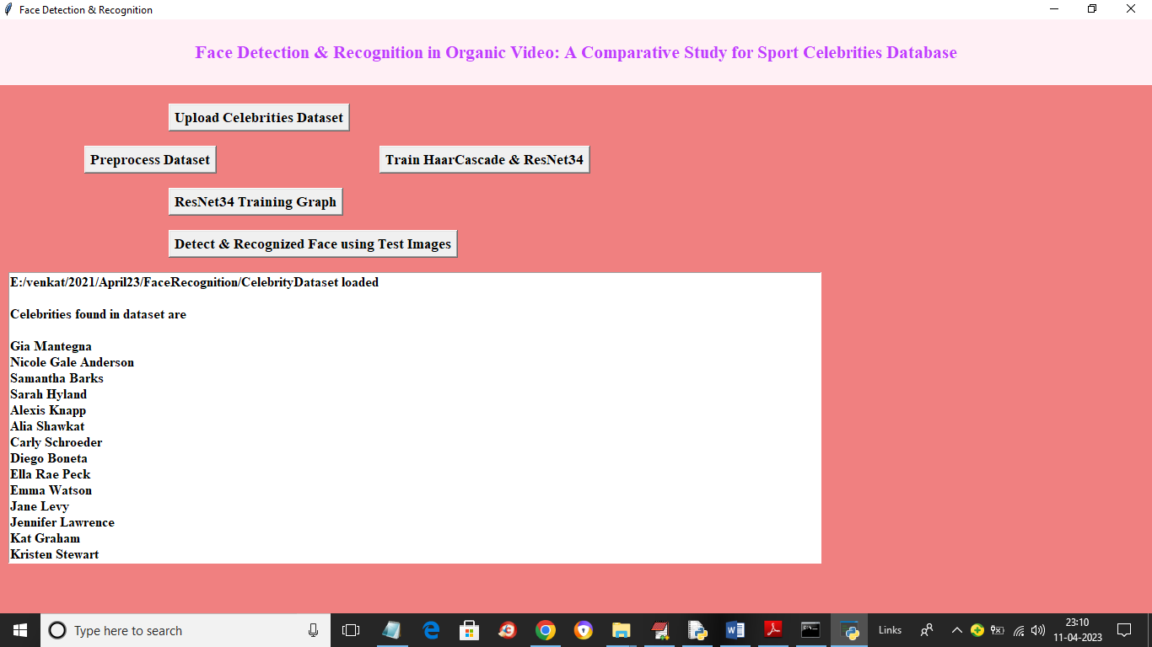

In above screen dataset loaded and we can see the names of loaded celebrity images and now click on ‘Preprocess Dataset’ button to process images like normalizing, shuffling, detecting faces and splitting it to train and test and get below output

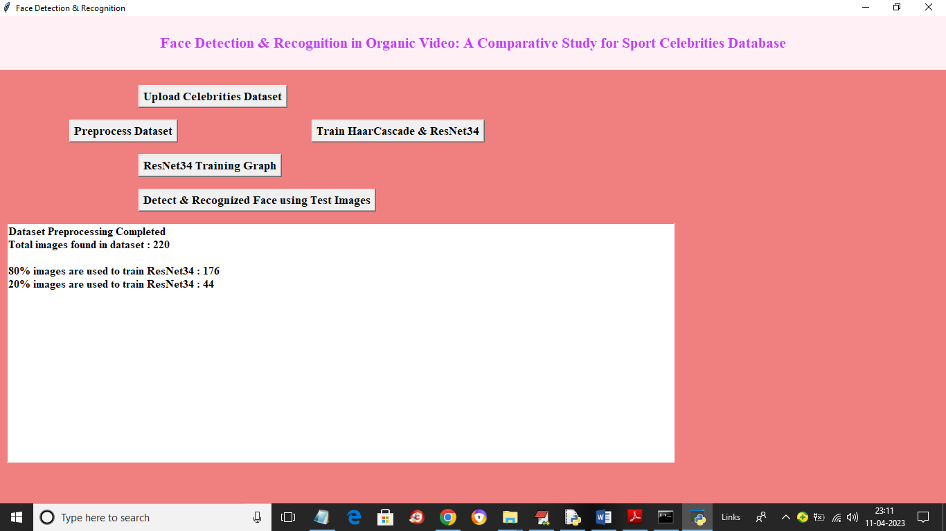

In above screen dataset processing completed and now we can see total images found in dataset and then we can see number of images using for training and testing. Now click on ‘Train HaarCascade & ResNet34’ button to train model and get below output

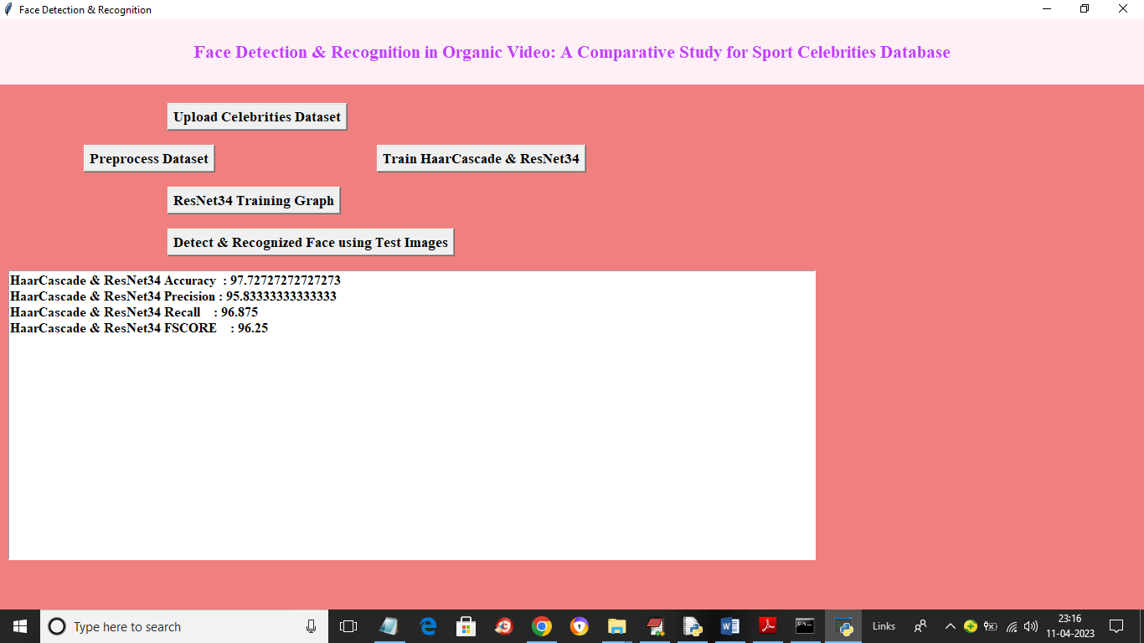

In above screen ResNet34 model trained and we got its accuracy on test data is 97% and now click on ‘ResNet34 Training Graph’ button to get below graph

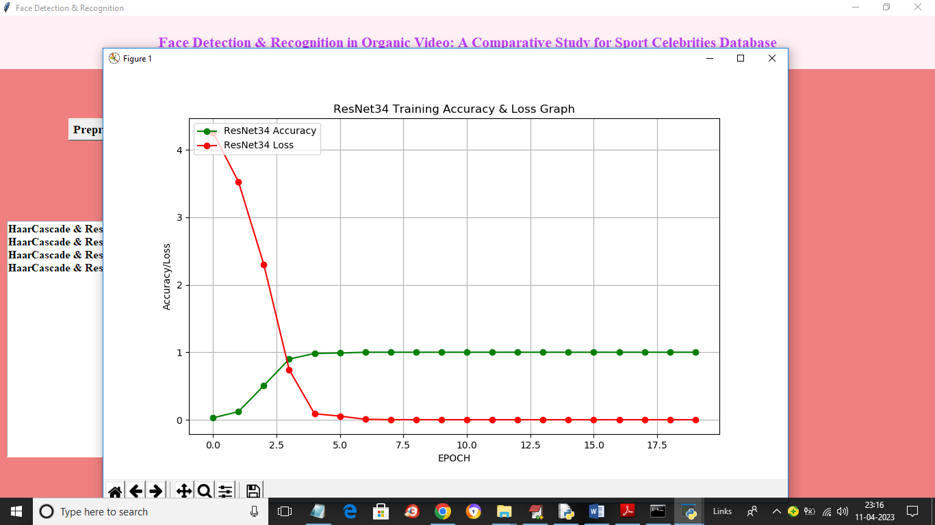

In above graph x-axis represents training epoch and y-axis represents training accuracy and loss. In above graph red line represents loss and blue line represents accuracy and with each increasing epoch accuracy got increase and reached to 1 and loss got decrease and reached to 0. Now click on ‘Detect & Recognized Face using Test Images’ button to upload image and recognize faces

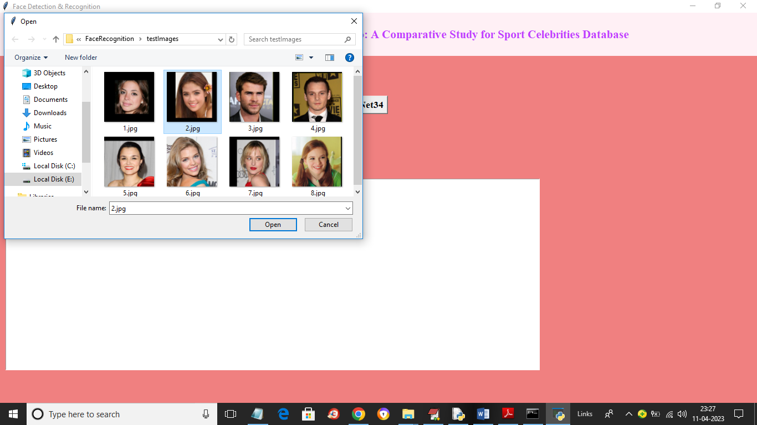

In above screen selecting and uploading ‘2.jpg’ and then click on ‘Open’ button to load image and get below output

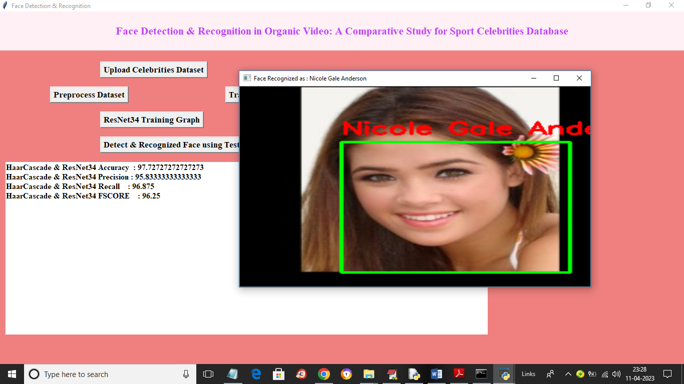

In above screen with green line face is detected using HaarCascade and then face recognize as ‘Nicole Gale’ using ResNet34. Similarly you can upload and test other images

