GDP – I SUMMER 2023

Professional Based Learning (PBL) project Explorer

**Client Name**: Gary Zhao

**Institution:** Northwest Missouri State University

**Team Members:**

Srinidhi Balmuri (Lead)

Samyuktha Pandula

Bala Harinadh Palavelli

Anil Kumar Palavelli

Divya sri Boppudi

Lella Pitchaiah

Krishna Sai Balupari

**2.Problem Statement:** The goal of the Northwest Professional-Based Learning (PBL) Project Explorer is to give teachers and students a place to post ideas for PBL projects and talk about them. The goal of the project is to make it easier for people in the Northwest community to work together and get involved. Users will be able to share project ideas, get comments, and show interest in working on these ideas.

Faculty and students in the Northwest area are the main users of the project. Faculty and students can make ideas for PBL projects, and anyone can look at these projects, show interest by sending requests, and talk about the projects.

**3.Functional Requirements:**

**ID:** FR#01

**Title:** Authentication

**Description:** Users should be able to log in, register, verify email, and reset passwords.

**Priority:** 1

**Dependency:** None

**ID:** FR#02

**Title:** Post a new project

**Description:** Able to post a project

**Priority:** 1

**Dependency:** None

**ID:** FR#03

**Title:** User Profile Page

**Description:** Users can add and view their profile details, including name, education, projects completed, etc.

**Priority:** 2

**Dependency:** FR#01

**ID:** FR#04

**Title:** Projects page on user dashboard

**Description:** Display active and expired projects, allow filtering by project status, and provide pagination for better user experience.

**Priority:** 2

**Dependency:** FR#01

**ID:** FR#05

**Title:** Posted project full page with discussion forum.

**Description:** Show project details, enable user participation in discussion forums, handle comment and message flagging, and allow project flagging.

**Priority:** 1

**Dependency:** FR#01, FR#02, FR#04

**ID:** FR#06

**Title:** Requests posted page on user dashboard.

**Description:** List all the requests posted by the user for other projects, including pending, approved, and rejected requests, with pagination.

**Priority:** 2

**Dependency:** FR#01, FR#02

**ID:** FR#07

**Title:** Seekings page on user dashboard.

**Description:** Display all seekings posted by the user, with pagination for better user experience.

**Priority:** 2

**Dependency:** FR#01, FR#02

**ID:** FR#08

**Title:** Replies posted on user dashboard.

**Description:** List all the replies posted by other users for the user's seeking, with pagination.

**Priority:** 2

**Dependency:** FR#01, FR#05

**ID:** FR#09

**Title:** Requests listing of a single project.

**Description:** Display all requests received for a specific project, provide pagination and search functionality by person name, and link usernames to user profile pages.

**Priority:** 2

**Dependency:** FR#01, FR#02

**ID:** FR#10

**Title:** Request full page posted by the user.

**Description:** Display detailed information of a user's request, including attached documents, and provide contact options.

**Priority:** 2

**Dependency:** FR#01, FR#09

**4.User Interfaces:**

User Dashboard

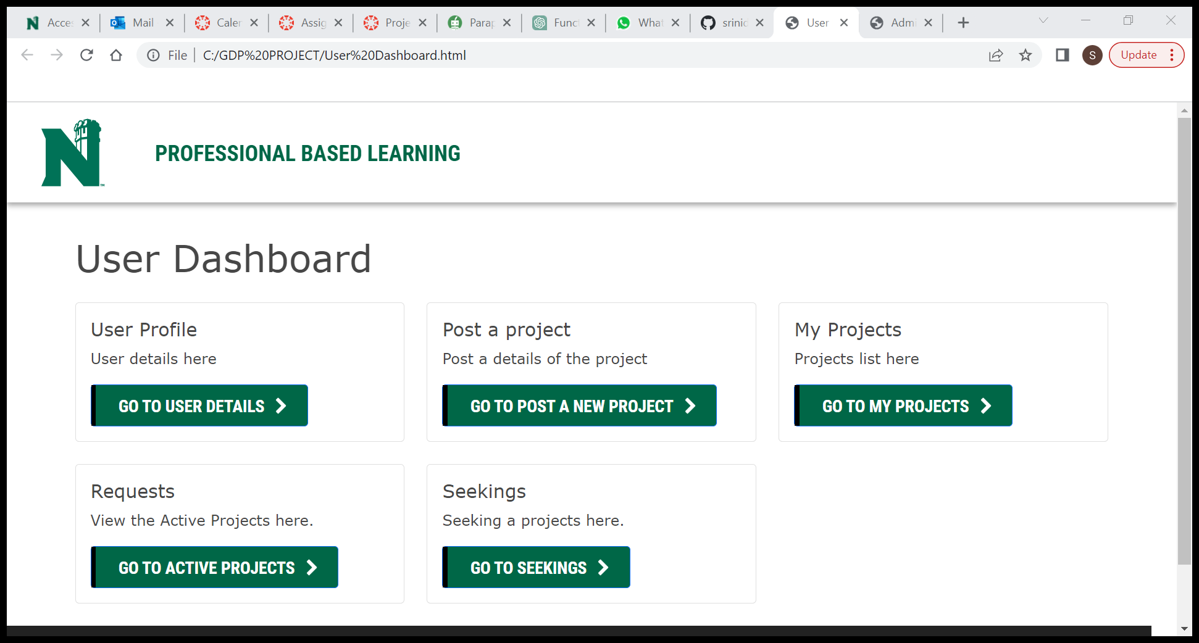

Admin Dashboard

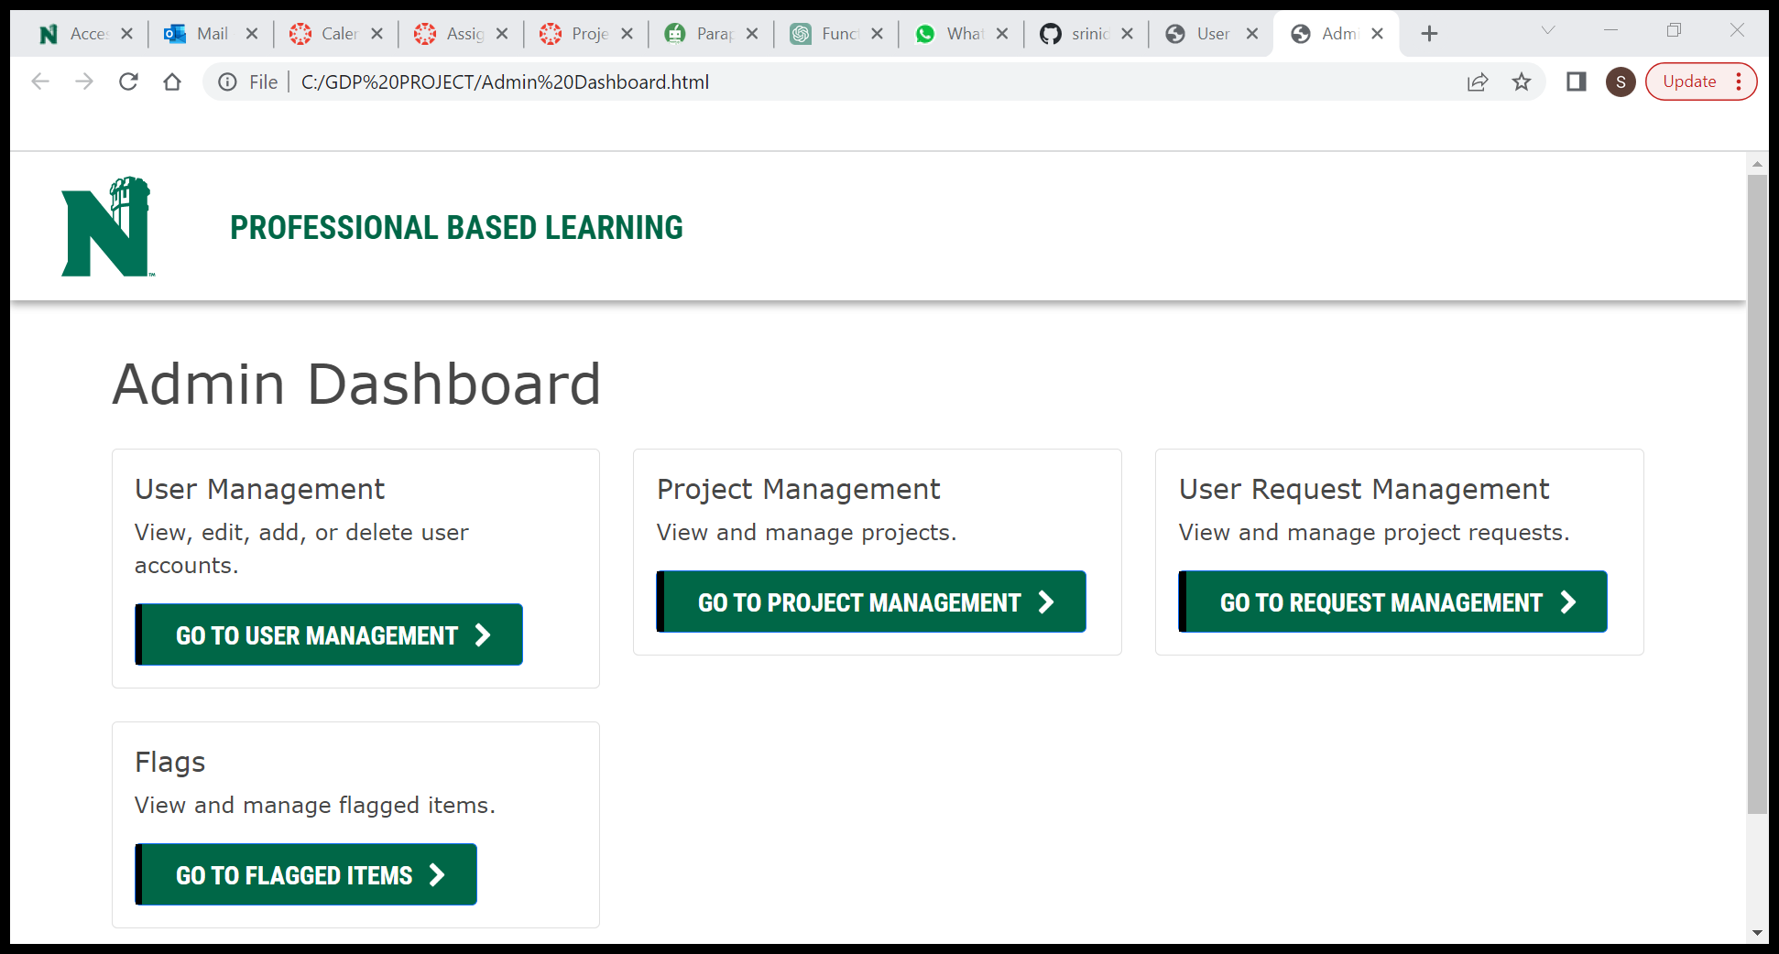

**5.Non-Functional Requirements:**

Non-functional requirements specify the characteristics and qualities that the Northwest Professional-Based Learning (PBL) Project Explorer should possess. Here are some non-functional requirements for the project:

**Usability:** The platform should have an easy-to-use design that makes it simple for teachers, students, and other users to find their way around, post projects, join talks, and handle their accounts.

**Performance:** The system should be quick to respond and be able to handle a lot of users at once. It should have fast response times for sharing projects, reading, and other tasks to make sure users have a good time.

**Security:** To safeguard user data, prevent illegal access, and guarantee system integrity, the platform should have strong security mechanisms in place. This comprises safe systems for authentication and authorization, encryption of private information, and defense against widespread security flaws.

**Privacy:** The platform must respect user privacy and adhere to all applicable data protection laws. Users should have control over their data, including the opportunity to amend or remove it as required, and personal information should be managed securely.

**Accessibility:** The platform should follow accessibility guidelines to make sure that people with disabilities may use it successfully. This includes supporting keyboard navigation, offering alternate text for pictures, and being compatible with assistive technology.

**6.UML Diagrams:**

**7.Technologies that will be Used:**

**Front End Technologies:**

HTML: This is used in the development of web pages.

CSS: Used for styling the web pages.

Bootstrap: To make responsive web pages

**Backend Technologies:**

Java: This is used for development of backend logic.

**Database:**

SQL: Data base to store data.

**8.Gantt Chart:**



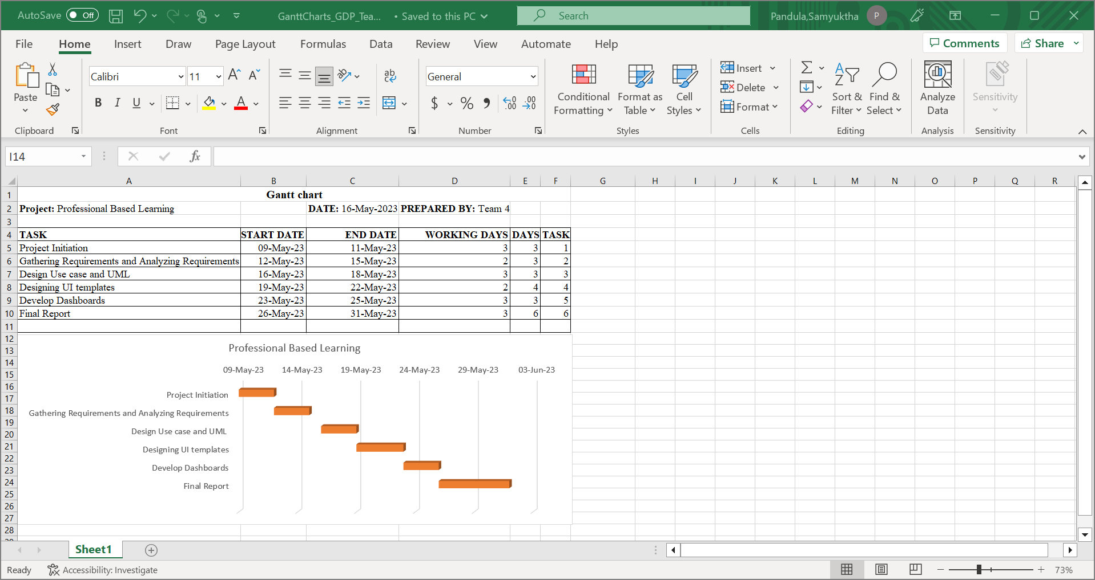

**9.Git-Hub link:**

<https://github.com/srinidhi1404/PBLProjectexplorerTeam04>