**DBMS - MINI PROJECT**

**“IPL Auction management database”**

Submitted By:

Srinidhi Bharadwaj

PES1UG20CS143

V Semester Section C

**ABSTRACT**

//Short Description and Scope of the Project

**ER Diagram**

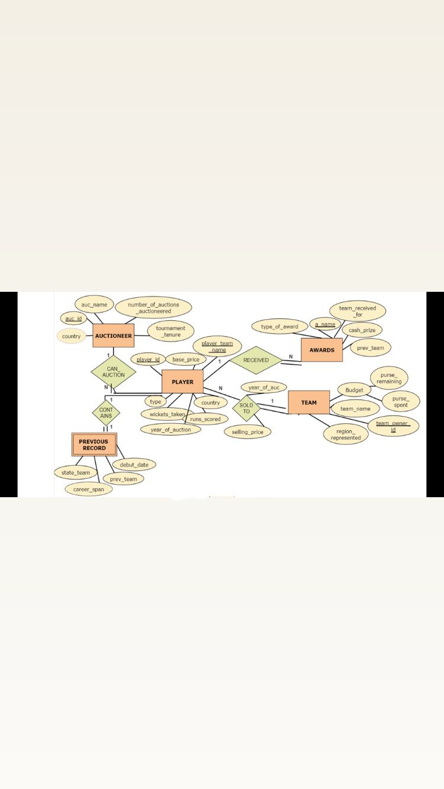

**Relational Schema**

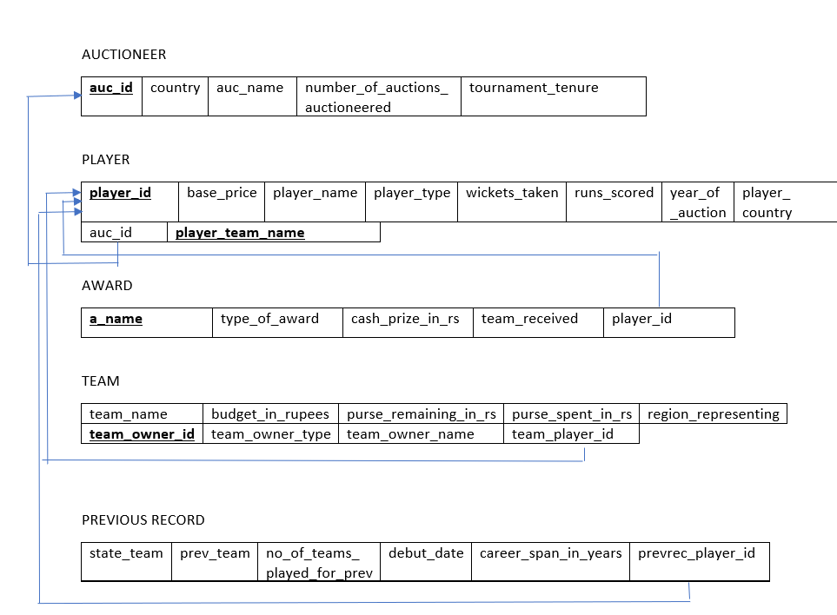

**DDL statements - Building the database**

1. create table auctioneer(auc_id varchar(10),country varchar(10),auc_name varchar(20),number_of_auctions_auctioneered int,tournament_tenure int,primary key(auc_id));

2. create table player(player_id varchar(20),player_team_name varchar(20),primary key(player_id,player_team_name),base_price int,player_name varchar(50),player_type varchar(20),wickets_take int, runs_scored int,player_country varchar(20),year_of_auction varchar(20),player_auc_id varchar(10),foreign key(player_auc_id) references auctioneer(auc_id));

3. create table award(a_name varchar(10),type_of_award varchar(20),cash_prize_in_rupees int,team_received_for varchar(10),award_player_id varchar(20),foreign key(award_player_id) references player(player_id));

4. create table team(team_name varchar(20),budget_in_rupees int,purse_remaining_in_rupees int,purse_spent_in_rupees int,region_representing varchar(20),team_owner_id varchar(10),primary key(team_owner_id),team_owner_type varchar(20),team_owner_name varchar(20),team_player_id varchar(20));

5. create table previous_records(state_team varchar(10),prev_team varchar(10),no_of_teams_played_for_prev int,debut_date DATE,career_span_in_years int,prevrec_player_id varchar(20),foreign key(prevrec_player_id)references player(player_id));

**Populating the Database**

#for player table:

insert into player values("007","DC",2,"Axar Patel","All-rounder",86,1059,"India","2023","2k23001",8);

#for auctioneer

insert into auctioneer values("2k23002","Australia","Billy",8,2);

#for award:

insert into award values("MOT","Trophy and cash",100000,"DC","007");

#for previous_record:

insert into previous_records values("DC","CSK",3,2014-01-21,8,"009");

#for team:

insert into team values ("RCB",90,67,23,"Bangalore","OW001","Business man","Malya");

**Tools Used**

* **Tkinter**
* **Python**
* **Mysql**
* **Python mysql.connector**

**Queries**

**Join queries (at least 6)**

1. names of players who have won at least one award

Query: select player.player_id,player.player_name,award.a_name,award.type_of_award

from player

inner join award

on player.player_id = award.award_player_id;

output screenshot:

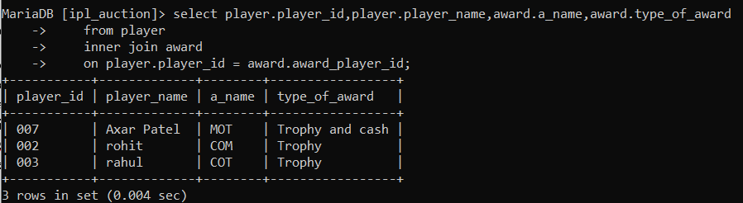

2. names of players who have played more than 10 years of ipl.

Query: select player.player_id,player.player_name, previous_records.career_span_in_years,previous_records.debut_date

from player

inner join previous_records

on player.player_id = previous_records.prevrec_player_id

where previous_records.career_span_in_years > 10;

Output screenshot:

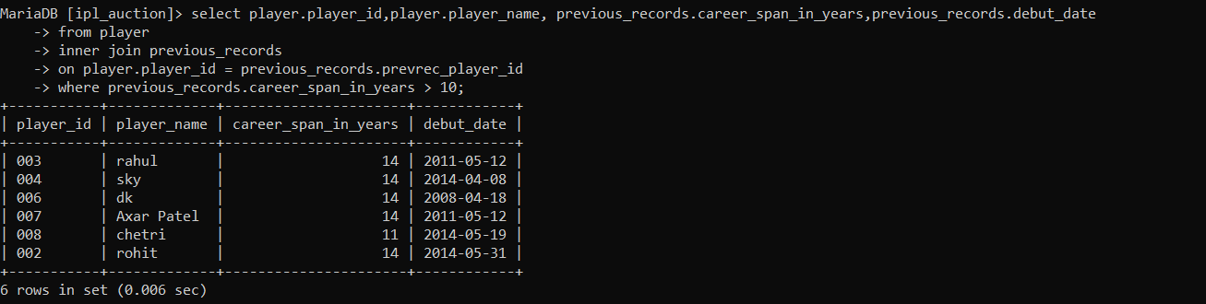

3. display previous records of those players, who have played for more than one team.

Query: select * from previous_records p where exists(select prevrec_player_id from previous_records r where p.prevrec_player_id = r.prevrec_player_id and no_of_teams_played_for_prev > 1);

Output screenshot:

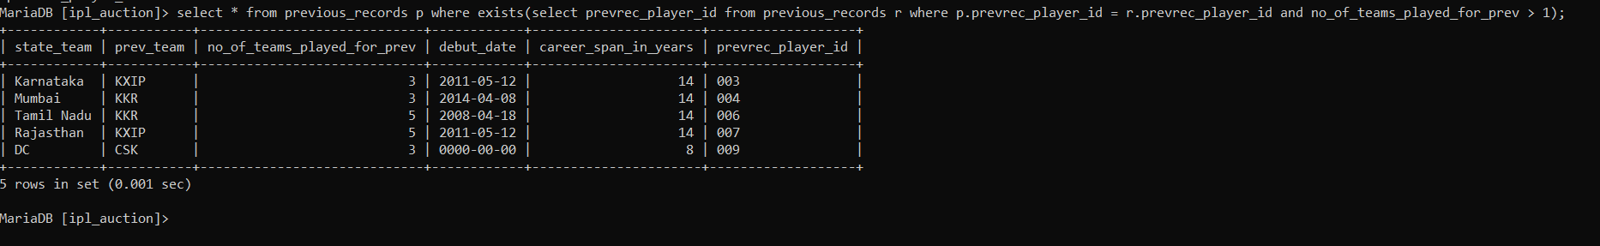

4. display player details of players who have scored more than 2000 runs.

Query: select * from player p where exists( select player_id from player r where p.player_id = r.player_id AND runs_scored > 2000);

Output screenshot:

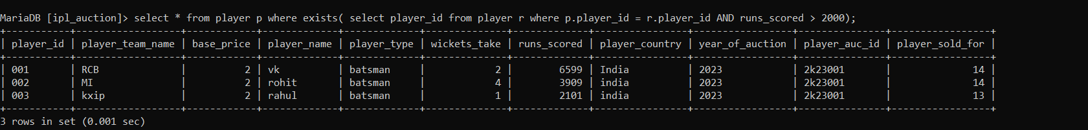

5. display those previous records who's career has lasted more than 10 years:

Query:

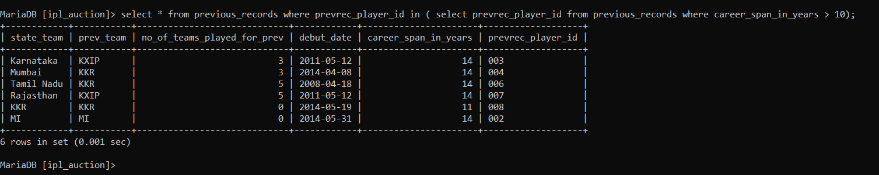

6. display those players details who have taken more than 20 wickets:

Query: select * from player where player_id in (select player_id from player where wickets_take > 20); 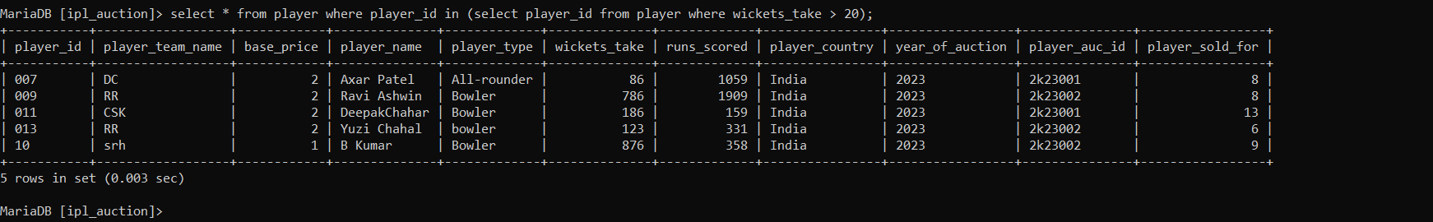

**Aggregate Functions (at least 2)**

Showcase at least 2 Aggregate function queries. Write the query in English Language, Show the equivalent SQL statement and also screenshot of the query and the results

--The function is to display the amount of money spent an average of budget spent per team for each player.

Query and Aggregate funtions as a function:

delimiter $$

Create function get_budget(T_name varchar(255))

returns varchar(255)

deterministic

begin

declare temp int;

declare temp1 int;

select sum(player_sold_for) into temp

from player

where player_team_name= T_name;

select avg(player_sold_for) into temp1 from player where player_team_name =T_name;

return(CONCAT("budget left ",(90-temp),"Cr"," Team avg salary spent: ",temp1));

end;

$$

delimiter ;

select distinct player_team_name,get_budget(player_team_name) from player;

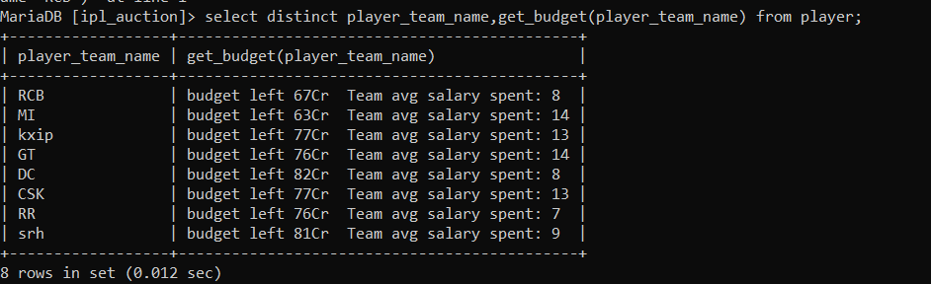

**Set Operations (at least 2)**

Showcase at least 2 Set Operations queries . Write the query in English Language, Show the equivalent SQL statement and also screenshot of the query and the results

1. Display those player details who either have 1000 runs or 100 wickets

Query: select * from player where ( runs_scored > 1000 or wickets_take > 100);

**Output screenshot:**

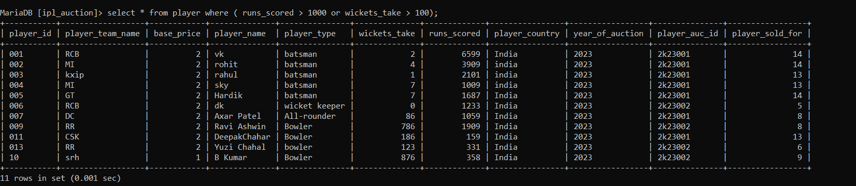

**2) display those I players who have been sold for more than 10cr:**

**Query: select * from player where ( player_sold_for > 10 and player_team_name = "MI");**

**Output screenshot:**

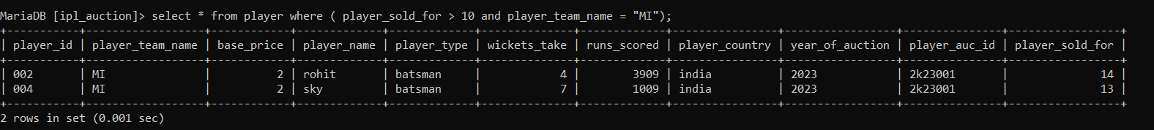

**View (atleast 1)**

Creation:

Cmd: create view experienced_batsman as select player_name,player_team_name,runs_scored from player where runs_scored > 2000;

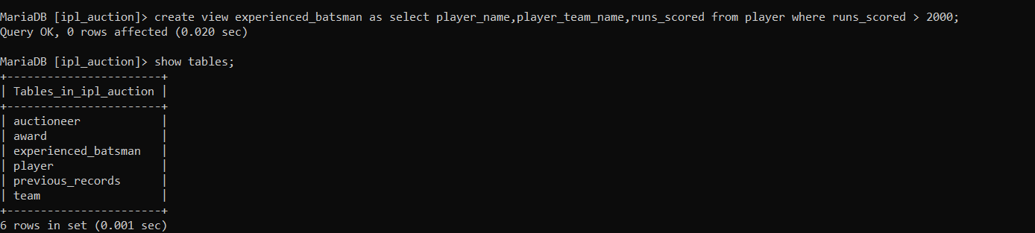

Create a query to find details of any experienced batsman who play for RCB

Query: select * from experienced_batsman where player_team_name="RCB";

Output screenshot: 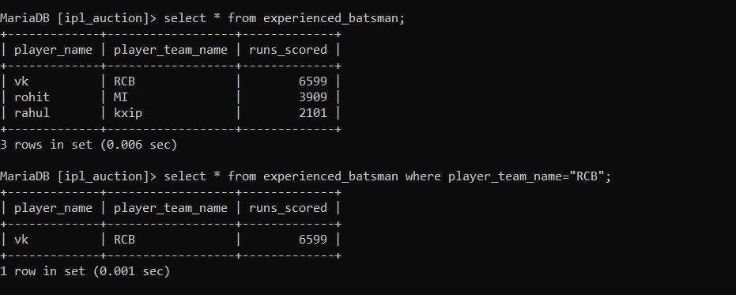

**Triggers (Functions or Procedures)**

The function is called when the following button is clicked in the front end. It outputs your team’s budget left and average salary spent on a player.

Screenshots:

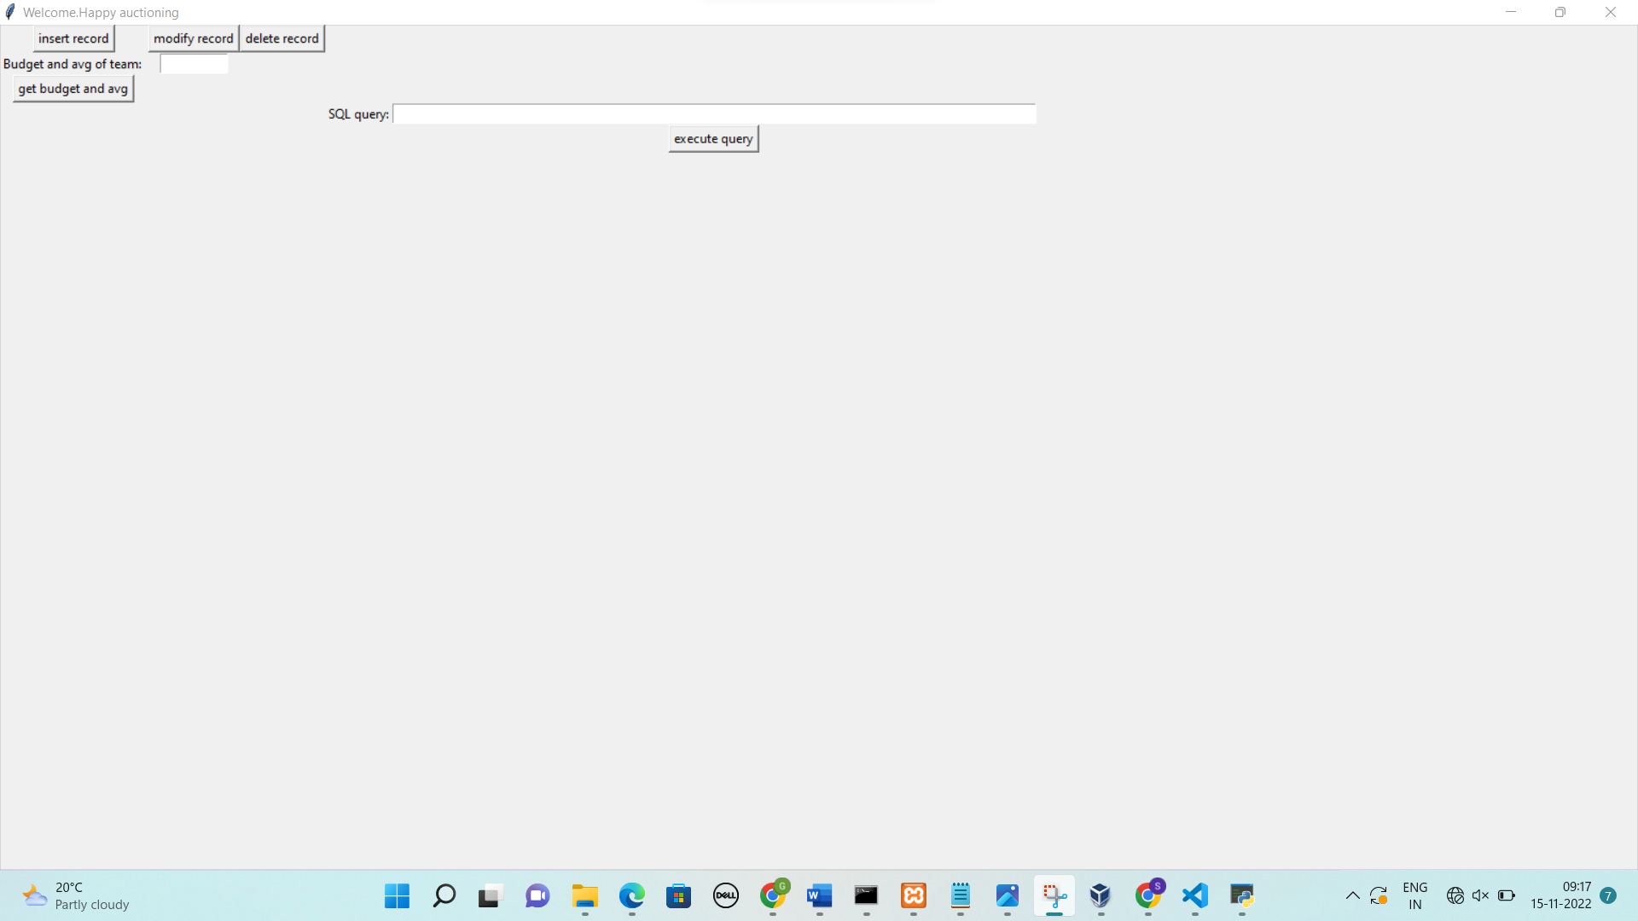

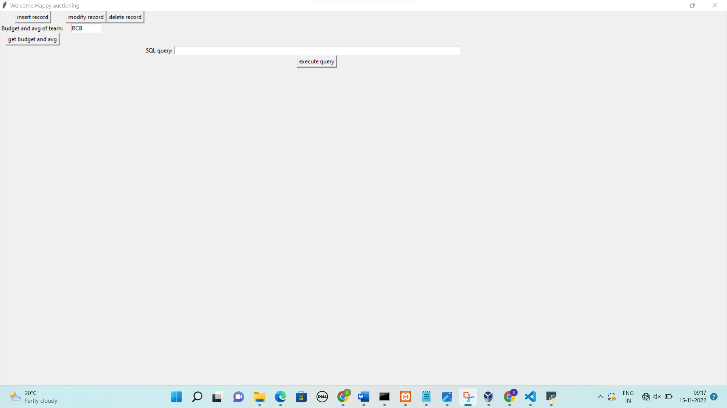

After you click on ( [get budget and avg]):

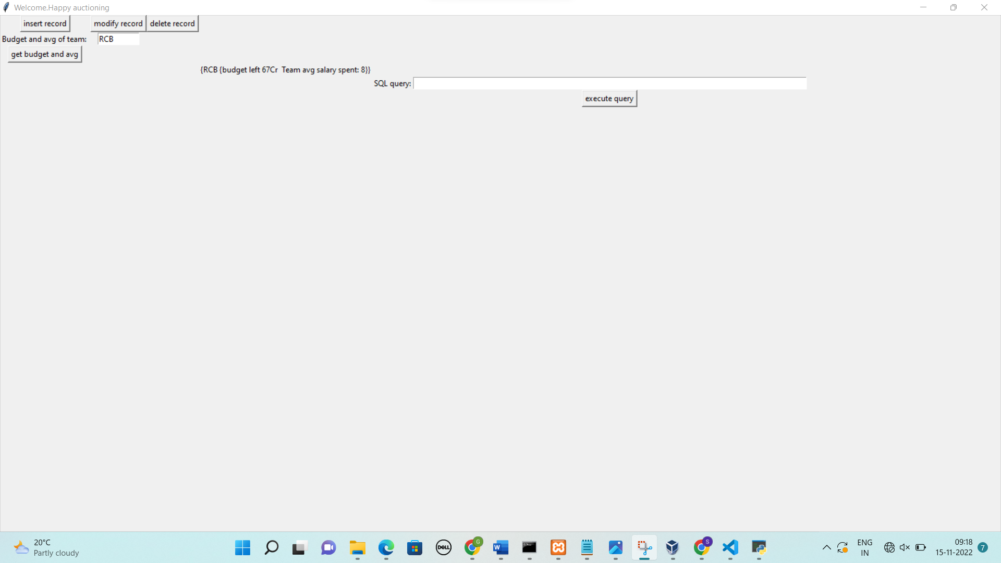

Trigger: auctioneer not qualified enough if he has no experience previously.

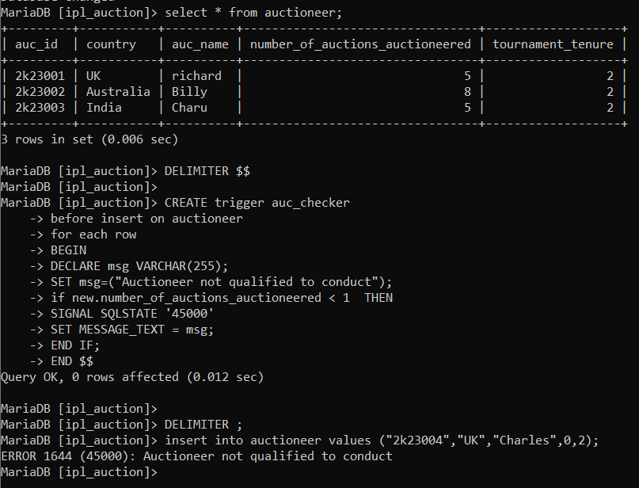

**Developing a Frontend**

The frontend should support

1. Addition, Modification and Deletion of records from any chosen table
   1. Addition:

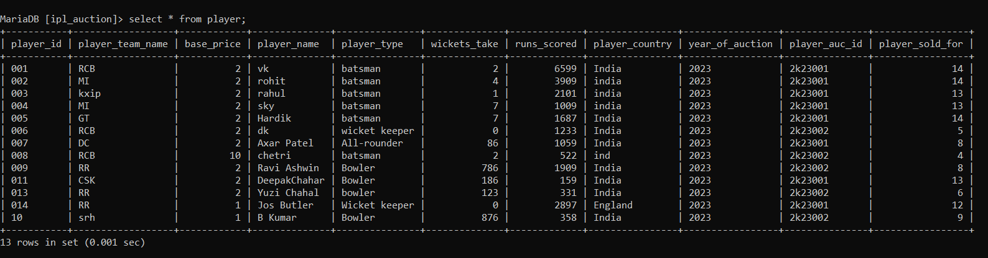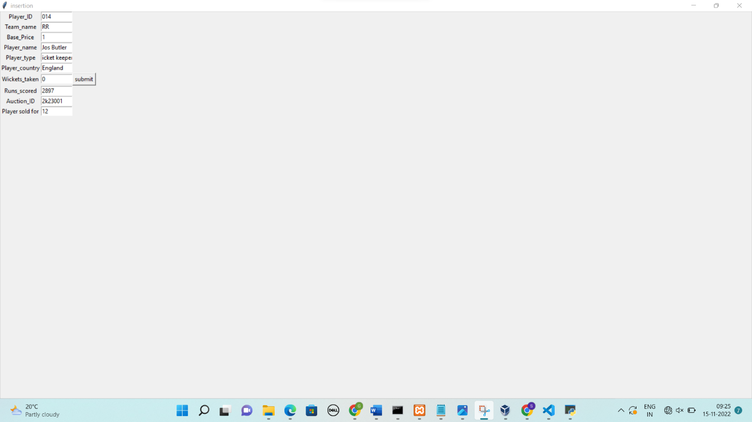

* 1. 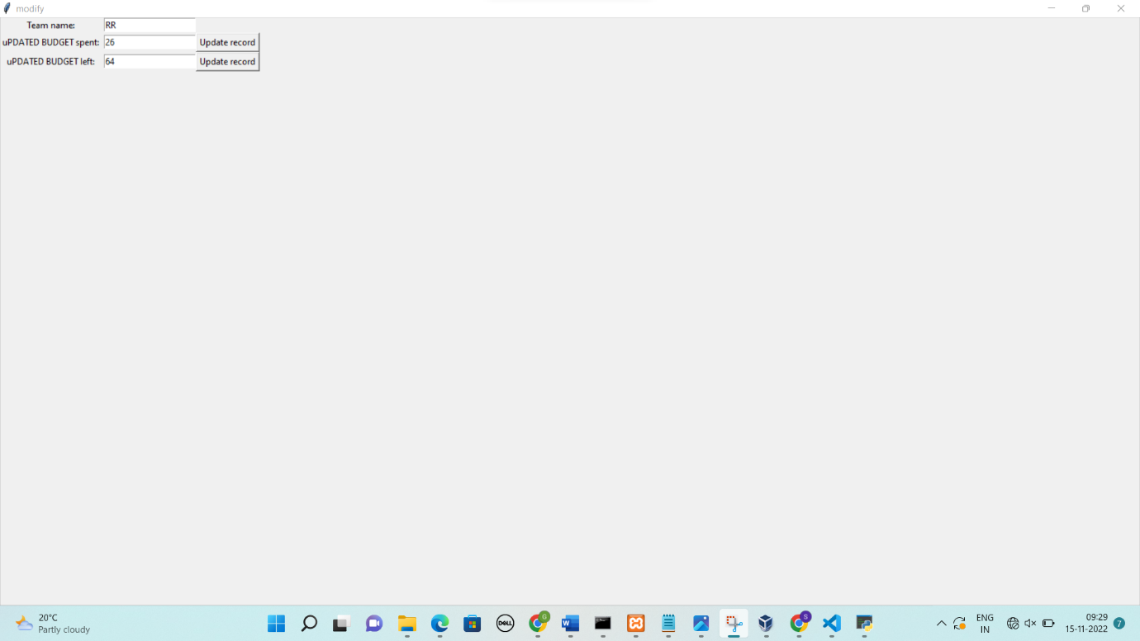Modify:

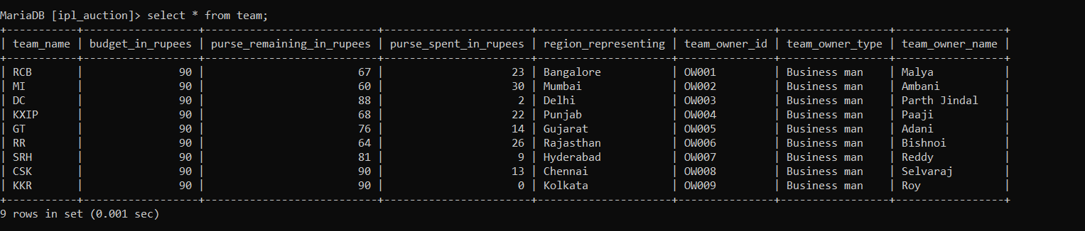

* 1. Delete:

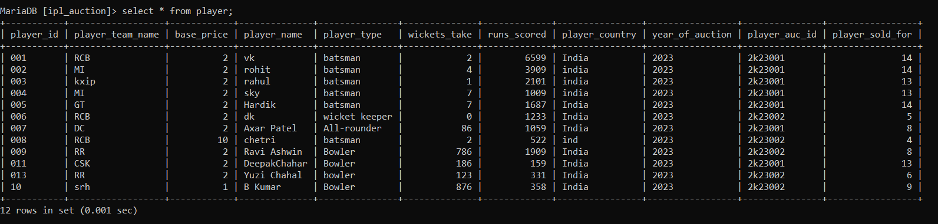

1. There should be a window to accept and run any SQL statement and display the result

