**NAME: SRINIDHI SESHADRI**

**REG NO: 18BEC1196**

**DIGITAL COMMUNICATION SYSTEMS**

**ASSIGNMENT PART-A**

**Section 1 :** Look around, observe, and describe a non-linear phenomenon. Describe, IN YOUR OWN words, the phenomenon, why do you think it is non-linear. This portion of the answer must be from personal observation, analysis and/or experience. And it has to be scientific in nature. (Not something that is personal/emotional in nature). Describe your thought process in arriving at the conclusion that you reach about the non-linear nature of the phenomenon. Confirm this with already existing material. Make sure you give the sources for whatever material you refer to confirm the process.

**ANSWER:**

The non-linear phenomenon I want to choose is the speed of a vehicle. The reason I feel that this phenomenon is non-linear is because it varies continuously with respect to time.

When the vehicle starts, it has a speed of 0. It gradually increases as we drive. Sometimes we may speed up and travel at a high speed. But while breaking, speed may drop. Since road travel is never smooth, speeds keep fluctuating every now and then. At one time instant, the speed could be around 40 Km/hr while at the next time instant, speed could either increase to 70 Kmph or drop to 10 Kmph and when we end our journey, we go back to 0Kmph.

When we plot this, we can observe that the Y-axis ie speed varies constantly with time and even when we visualize it in the frequency domain, we can see the variation. Hence it is difficult to uniformly categorize it, for example if we are going for quantization of the values, we can’t go for a uniform quantization of the speed values as to reduce the quantization error, we may keep on increasing the value of number of levels. And hence we will have a larger number of levels if we were to quantize and as the number of levels goes on increasing, the number of bits per level also increases.

But our aim is not to use a large number of levels or have a higher number of bits per level, and this cannot work too as our aim is to reduce the number of bits for efficient transmission with less quantization error. Hence it could be quantized using a non-uniform quantizer. Hence, by using this methodology, I have concluded that the speed of a vehicle can be a non-linear phenomenon.

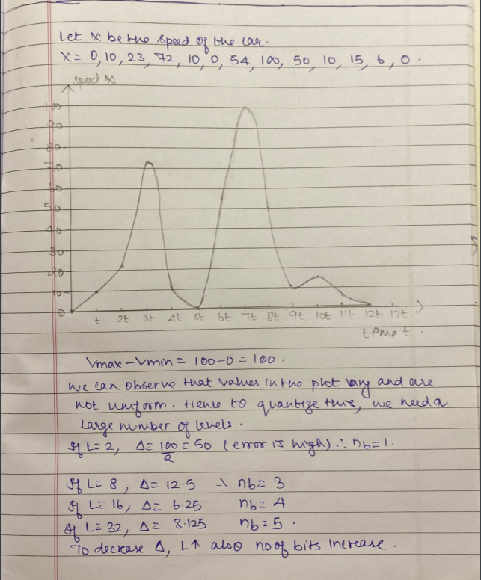

Sources referred:

1. Digital Communications Bernard Sklar
2. <https://www.science.org.au/curious/technology-future/physics-speeding-cars>
3. <https://www.sciencedirect.com/science/article/pii/S0386111216300449>
4. <https://www.ncbi.nlm.nih.gov/pmc/articles/PMC6679017/>

**Feedback obtained:**

1) The phenomena stated above is non-linear only if we see it at a **large time period**. But if we were to see it at a **small time period**, speed is not really non-linear.

To rectify this issue, here I have assumed that we are taking the measurements of speed not at small but at larger time intervals so it would represent the non-linearity caused in the signal. Also, if I were to design an accident prevention mechanism (just an application example), I would not want the data for small intervals of time but would instead prefer the data collected at unequal and larger time intervals.

Another non-linear phenomena we can observe here is the energy dissipation. We understand that energy is directly proportional to the work done. Example- Ascending a staircase will require more work to be done by the person as compared to descending the staircase, hence when the work done is more, the energy used to do the work would also be more.

We know that the roads on which we drive are not even. When the vehicle begins to move, it starts from 0 and accelerates to reach 20kmph. When it begins from zero, we can observe that the vehicle would require more work to be done in reaching 20 and hence the energy dissipation would be high. As the vehicle moves, we can notice that the energy dissipation changes non-linearly.

**PART B:** Having confirmed that your phenomenon is non-linear in nature, think on how to actually digitize the “data” that makes up the phenomenon. The idea is to record the phenomenon. How would it be done? What kind of transducer should/could be used? What kind of quantization should/could be done? Can the sampling capture the true characteristics of the phenomenon? How would you even characterize the phenomenon? A highly detailed analyses should accompany your answer to this section.

**a) Speed vs Time phenomenon:**

To record the speed of the vehicle, I am planning to use a LIDAR gun. LIDAR guns are extremely accurate.

The LIDAR gun clocks the time it takes a burst of infrared light to reach a car, bounce off and return back to the starting point. By multiplying this time by the speed of light, the LIDAR system determines how far away the object is. Unlike traditional police radar, LIDAR does not measure change in wave frequency. Instead, it sends out many infrared laser bursts in a short period of time to collect multiple distances. By comparing these different distance samples, the system can calculate how fast the car is moving. These guns take several hundred samples per second, and they are extremely accurate.

From the output of the LIDAR guns kept at multiple intervals on the road, I am planning to collect the speed values in this manner. Also, when the speed is collected, I would be recording the time instant when it is collected too. In this manner I can plot a speed vs time plot and perform any operation as required. Since this plotted waveform is not a continuous one, but rather a discrete one and hence there is no need for going for sampling. A transducer such as a piezoelectric transducer can be used to convert the waves into electrical format and display the value of speed recorded.

**b) Energy dissipated:**

As mentioned above, the roads on which we drive are not smooth. In many countries, the roads are coarse and distorted. When a vehicle starts from rest, it has to do a considerable amount of work to go from 0Kmph to 20Kmph. When more work is done, of course the heat produced will be more (when a machine exerts more, more heat is generated) and hence the energy dissipated by the vehicle will also be more. Once it has acquired a speed of 20Kmph, going to 30Kmph will not require more work to be done and hence the energy dissipation would reduce. Let us assume the person is braking and this time, the dissipated energy can become 0 and again as the vehicle continues its journey, the dissipated energy will keep varying non-linearly with speed.

We can use a transducer which will help us in converting the heat produced to electricity, we can use a thermoelectric generator for this purpose. The output will be a non-linear random continuous signal which will need to be sampled. To see the effectiveness of sampling, we may need to go with oversampling as we can observe the value at the smallest next interval. If we sample at a large time interval, it will still show us the non-linearity but may not reconstruct the signal like the original one.

**SECTION 3:** Having analysed the phenomenon in some detail, can you create a mathematical model (highly simplified in the case of complex phenomenon)? Or if the phenomenon is already described in existing literature, can you recreate that? Write a MATLAB program that:

i. Generates sample points of that phenomenon

ii. Samples the phenomenon (In MATLAB, i and ii are basically the same, if you take the easy way out) iii. Quantize the sampled values

iv. Reconstruct the phenomenon

**Code for phenomenon a:**

**%% Speed vs time senario %%**

clc;

clear all;

close all;

t=[0 6 10 15 18 19 20 28 40 45 50 60 67 90 99 100 120];

s=[0 10 15 10 20 20 21 50 0 15 28 60 2 110 120 65 0 ];

subplot(4,1,1)

stem(t,s)

% Quantization Process

vmax=120;

vmin=-vmax;

del=(vmax-vmin)/256;

part=vmin:del:vmax; % level are between vmin and vmax with difference of del

code=vmin-(del/2):del:vmax+(del/2); % Contaion Quantized valuses

[ind,q]=quantiz(s,part,code); % Quantization process

% ind contain index number and q contain quantized values

l1=length(ind);

l2=length(q);

for i=1:l1

if(ind(i)~=0) % To make index as binary decimal so started from 0 to N

ind(i)=ind(i)-1;

end

i=i+1;

end

for i=1:l2

if(q(i)==vmin-(del/2)) % To make quantize value inbetween the levels

q(i)=vmin+(del/2);

end

end

subplot(4,1,2);

stem(q);grid on; % Display the Quantize values

title('Quantized Signal');

ylabel('Amplitude--->');

xlabel('Time--->');

% Encoding Process

% figure

code=de2bi(ind,'left-msb'); % Cnvert the decimal to binary

k=1;

for i=1:l1

for j=1:8

coded(k)=code(i,j); % convert code matrix to a coded row vector

j=j+1;

k=k+1;

end

i=i+1;

end

subplot(4,1,3); grid on;

stairs(coded); % Display the encoded signal

axis([0 100 -2 3]); title('Encoded Signal');

ylabel('Amplitude--->');

xlabel('Time--->');

% Demodulation Of PCM signal

qunt=reshape(coded,8,length(coded)/8);

index=bi2de(qunt','left-msb'); % Getback the index in decimal form

q=del*index+vmin+(del/2); % getback Quantized values

subplot(4,1,4); grid on;

stem(t,q); % Plot Demodulated signal

title('Demodulated Signal');

ylabel('Amplitude--->');

xlabel('Time--->');

**Output for phenomenon a:**



**Code for phenomenon b:**

%% Energy dissipation senario

clc;

clear all;

close all;

t = [0:.1:2*pi];

smax = 1500;

smin = 0.8;

s = smin + (smax-smin)*rand(1,length(t));

figure(1)

subplot(5,1,1)

plot(t, s)

title('Input Signal');

ylabel('Amplitude--->');

xlabel('Time--->');

grid

subplot(5,1,2)

stem(t,s)

title('sampled Signal');

ylabel('Amplitude--->');

xlabel('Time--->');

% Quantization Process

vmax=1500;

vmin=0.8;

del=(vmax-vmin)/256;

part=vmin:del:vmax; % level are between vmin and vmax with difference of del

code=vmin-(del/2):del:vmax+(del/2); % Contaion Quantized valuses

[ind,q]=quantiz(s,part,code); % Quantization process

% ind contain index number and q contain quantized values

l1=length(ind);

l2=length(q);

for i=1:l1

if(ind(i)~=0) % To make index as binary decimal so started from 0 to N

ind(i)=ind(i)-1;

end

i=i+1;

end

for i=1:l2

if(q(i)==vmin-(del/2)) % To make quantize value inbetween the levels

q(i)=vmin+(del/2);

end

end

subplot(5,1,3);

stem(q);grid on; % Display the Quantize values

title('Quantized Signal');

ylabel('Amplitude--->');

xlabel('Time--->');

% Encoding Process

% figure

code=de2bi(ind,'left-msb'); % Cnvert the decimal to binary

k=1;

for i=1:l1

for j=1:8

coded(k)=code(i,j); % convert code matrix to a coded row vector

j=j+1;

k=k+1;

end

i=i+1;

end

subplot(5,1,4); grid on;

stairs(coded); % Display the encoded signal

axis([0 100 -2 3]); title('Encoded Signal');

ylabel('Amplitude--->');

xlabel('Time--->');

% Demodulation Of PCM signal

qunt=reshape(coded,8,length(coded)/8);

index=bi2de(qunt','left-msb'); % Getback the index in decimal form

q=del*index+vmin+(del/2); % getback Quantized values

subplot(5,1,5); grid on;

plot(t,q); % Plot Demodulated signal

axis([0 7 0.8 1511])

title('Demodulated Signal');

ylabel('Amplitude--->');

xlabel('Time--->');

partition = [0.8:.2:1500];

codebook = [0.5:.2:1500]; % Codebook length must be equal to the number of partition intervals

%quantiz Produce a quantization index and a quantized output value.

[index,quants] = quantiz(s,partition,codebook);

figure(2)

subplot(3,1,1)

plot(t, s)

xlabel('Time')

ylabel('Amplitude')

title('Decoded Quantized signal');

grid

subplot(3,1,2)

plot(t,s,'x',t,quants,'.')

title('Quantization of energy dissipated wave')

xlabel('Time')

ylabel('Amplitude')

legend('Original sampled wave','Quantized wave');

axis([0 7 0.8 1555])

% There is no decode quantizer function in this toolbox.

% The decode computation can be done using the command Y = CODEBOOK(INDX+1).

dq=codebook(index+1);

subplot(3,1,3)

plot(t,dq)

axis([0 7 0.8 1555]);

xlabel('Time')

ylabel('Amplitude')

title('Decoded Quantized signal');

**Output for phenomenon b:**





**RESULTS:**

In both the phenomena, we have successfully sampled and quantized the signal and also have been successful at reconstructing the quantized signal so as to get the same input signal.

**REFERENCES:**

<https://www.google.com/search?q=energy+and+work+relation&rlz=1C1CHBF_enIN811IN811&sxsrf=ALeKk03GvyaMnVjuXJ8kPywN-pNlw1qHdA:1603948888404&tbm=isch&source=iu&ictx=1&fir=a2v9lrPWbk1KZM%252ChgtagbOZu0HVUM%252C_&vet=1&usg=AI4_-kQwnu6KPoQ0UUII6MWsFUxTFDX2sQ&sa=X&ved=2ahUKEwjFtuydh9nsAhUk6XMBHQPuCbgQ_h16BAgDEAU#imgrc=AxvbcSrZfFmP6M>

<https://www.neltronics.com.au/how-does-a-speed-camera-or-radar-gun-work/>

<https://en.wikipedia.org/wiki/Thermoelectric_generator#:~:text=A%20thermoelectric%20generator%20(TEG)%2C,a%20form%20of%20thermoelectric%20effect>).

<https://www.electrical4u.com/linear-variable-differential-transformer/>

<https://www.bbc.co.uk/bitesize/guides/zqbwpbk/revision/2#:~:text=Whenever%20there%20is%20a%20change,is%20lost%20to%20the%20surroundings>.

**GITHUB LINK:**

<https://github.com/srinidhi2018seshadri/Digital_communication_DA1_2>