**UNIT 4: FUZZY LOGIC**

* **Refer examples taken on fuzzy set solved in class.**

**Crisp Set**

* In a crisp set, an element is either a member of the set or not

**e.g:** A = Set of even numbers = {2, 4, 6, …}

B = Set of odd number = {1, 3, 5, …}

**Fuzzy Set**

* A Fuzzy set is a set whose elements have degrees of membership.
* Fuzzy sets are an extension of the classical notion of set (known as a Crisp Set).
* More mathematically, a fuzzy set is a pair (A, μA) where A is a set and μA : A → [0, 1].
* For all x ∈ A, μA(x) is called the grade of membership of x.  
  If μA(x) = 1, we say that x is Fully Included in (A, μA), and if μA(x) = 0, we say that x is Not Included in (A, μA).
* If there exists some x ∈ A such that μA(x) = 1, we say that (A, μA)is Normal. Otherwise, we say that (A, μA) is Subnormal.

**Example**:

* Words like young, tall, good or high are fuzzy.
* There is no single quantitative value which defines the term young.
* For some people, age 25 is young, and for others, age 35 is young.
* The concept young has no clean boundary.
* Age 35 has some possibility of being young and usually depends on the context in which it is being considered.

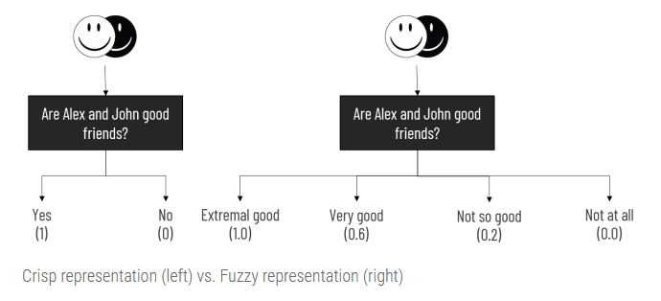

**Properties of fuzzy sets**

### **Support**:

* The **support** of a fuzzy set A is the set of all points x ∈ X such that μA(x) > 0
* Support( A ) = { x | μA(x) > 0, x ∈ X }
* Graphically, we can define support of fuzzy set as,

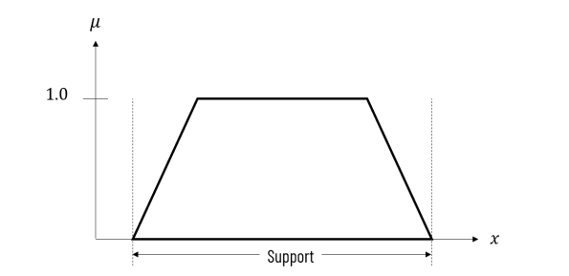

**Core**

* The core of a fuzzy set A is the set of all points x ∈ X such that μA(x) = 1
* Core( A ) = { x | μA(x) = 1, x ∈ X }
* All fuzzy sets might not have core present in it.

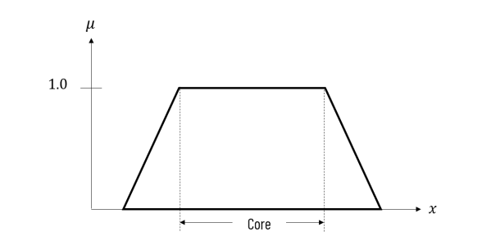

**Boundary:**

* Boundary comprises those elements x of the universe such that 0 < μA(x) < 1
* Boundary( A ) = { x | 0 < μA(x) < 1 , x ∈ X }
* We can treat boundary as the difference of support and core.
* Graphically, it is represented as

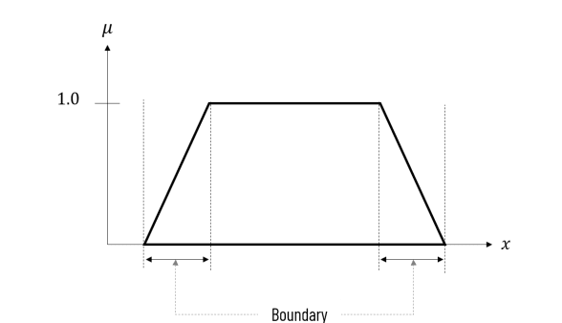

**Fuzzy relation**

* Fuzzy relation defines the mapping of variables from one fuzzy set to another.

Let A be a fuzzy set on universe X and B be a fuzzy set on universe Y, then the Cartesian product between fuzzy sets A and B will result in a fuzzy relation R which is contained with the full Cartesian product space or it is subset of cartesian product of fuzzy subsets. Formally, we can define fuzzy relation as,

R = A x B

and

R ⊂ (X x Y) where the relation R has membership function,

μR(x, y) = μA x B(x, y) = min( μA(x), μB(y) )

Let A = {a1, a2, …, an} and B = {b1, b2, .., bm}, then fuzzy relation between A and B is described by the **fuzzy relation matrix** as,

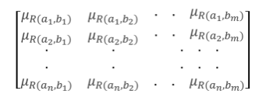

We can also consider fuzzy relation as a mapping from the cartesian space (X, Y) to the interval [0, 1]. The strength of this mapping is represented by the membership function of the relation for every tuple μR(x, y)

We can also consider fuzzy relation as a mapping from the cartesian space (X, Y) to the interval [0, 1]. The strength of this mapping is represented by the membership function of the relation for every tuple μR(x, y)

**Example:**01

Given A = { (a1, 0.2), (a2, 0.7), (a3, 0.4) } and B = { (b1, 0.5), (b2, 0.6)}, find the relation over A x B

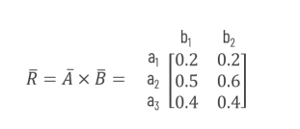

Fuzzification

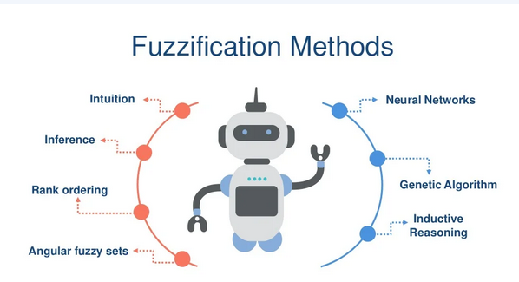

**Defuzzification**

To transform the fuzzy results in to crisp, defuzzification is performed. Defuzzification is the process of converting a fuzzified output into a single crisp value with respect to a fuzzy set.

This method considers values with maximum membership. There are different maxima methods with different conflict resolution strategies for multiple maxima.

* First of Maxima Method (FOM)
* Last of Maxima Method (LOM)
* Mean of Maxima Method (MOM)

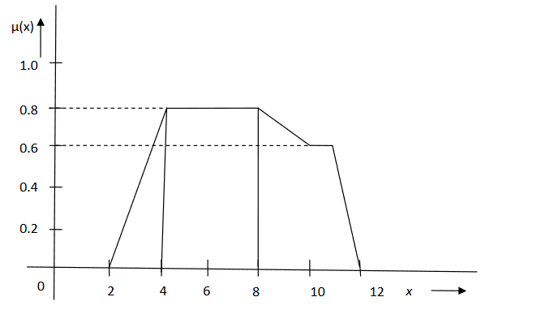

**First of Maxima Method (FOM)**

This method determines the smallest value of the domain with maximum membership value

The defuzzified value x ∗ of the given fuzzy set will be x ∗ =4.

**Last of Maxima Method (LOM)**

Determine the largest value of the domain with maximum membership value. In the example given for FOM, the defuzzified value for LOM method will be x∗= 8

**Mean of Maxima Method (MOM)**

In this method, the defuzzified value is taken as the element with the highest membership values. When there are more than one element having maximum membership values, the mean value of the maxima is taken.

Let A be a fuzzy set with membership function μA(x) defined over x € X, where X is a universe of discourse. The defuzzified value is let say x∗ of a fuzzy set and is defined as

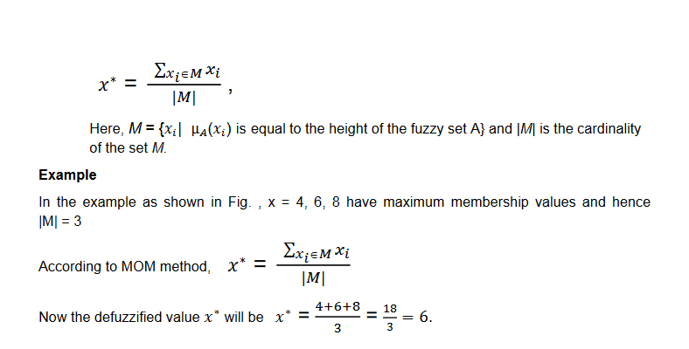

**Types of Membership Function**

**Triangular Membership function**

Let a, b and c represent the x coordinates of the three vertices of μA (x) in a fuzzy set A (a: lower boundary and c: upper boundary where membership degree is zero, b: the centre where membership degree is 1).

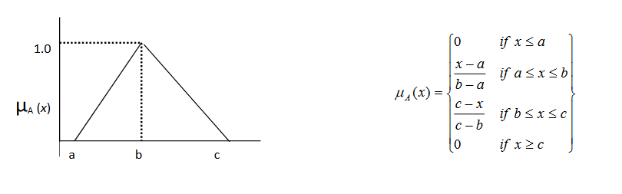

**Trapezoidal membership function:**

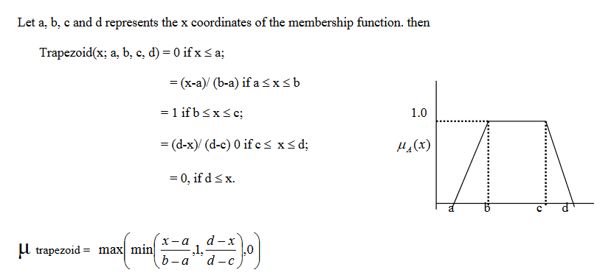

**Gaussian membership function**

The Gaussian membership function is usually represented as Gaussian(x:c,s) where c, s represents the mean and standard deviation.

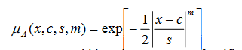

Here c represents centre, s represents width and m represents fuzzification factor.

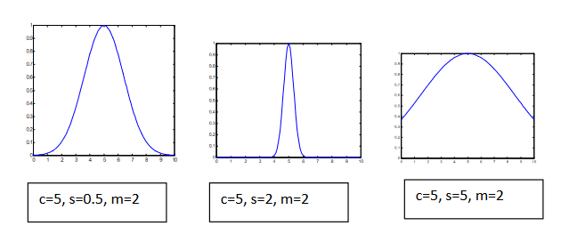

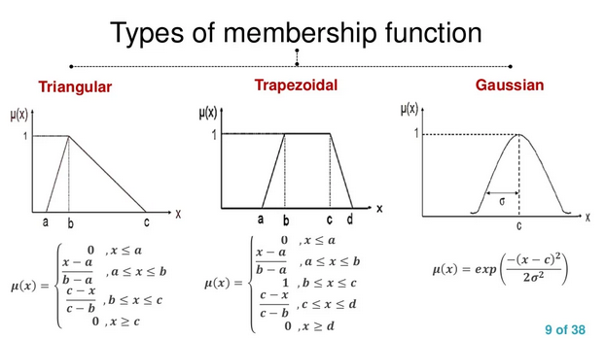

**Applications of fuzzy logic control Systems**

FLC systems find a wide range of applications in various industrial and commercial products and systems. In several applications- related to nonlinear, time-varying, ill-defined systems and also complex systems – FLC systems have proved to be very efficient in comparison with other conventional control systems.

* The fuzzy logic controller can be applied to automatic control systems, for example, autonomous vehicle systems.
* we can use the concept of Fuzzy Set Theory to help us make a decision in various areas such as finance and management

