Constraint Satisfaction
Introduction
Many problems in AI can be viewed as problems of constraint satisfaction in which the goal is to discover some problem state that satisfies a given set of constraints. Example includes cryptarithmetic puzzles. By viewing a problem as one of constraint satisfaction, it is often possible to reduce substantially the amount of search that is required as compared with a method that attempts to form partial solutions directly by choosing specific values for components of the eventual solution. For example, a straightforward search procedure to solve a cryptarithmetic problem might operate in a state space of partial solutions in which letters are assigned particular numbers as their values. A depth-first control scheme could then follow a path of assignments, until either a solution or an inconsistency is discovered. In contrast, a constraint satisfaction approach to solving this problem avoids making guesses on particular assignments of numbers to letters until it has to. Instead, the initial set of constraints, which says that each number may correspond to only one letter and that the sums of the digits must be as they are given in the problem, is first augmented to include restrictions that can be inferred from the rules of arithmetic. Then, although guessing may still be required, the number of allowable guesses is reduced and so the degree of search is curtailed.
Constraint satisfaction is a search procedure that operates in a space of constraint sets. The initial state contains the constraints that are originally given in the problem description. A Goal State is that each letter has been assigned a unique numeric value.
Constraint satisfaction is a two-step process. First, constraints are discovered and propagated as far as possible throughout the system. Then, if there is still not a solution, search begins. A guess about something is made and added as a new constraint. Propagation can then occur with this new constraint, and so forth. Constraint propagation terminates for one of two reasons. First, a contradiction may be detected. If this happens, then there is no solution consistent with all the known constraints. If the contradiction involves only those constraints that were given as part of the problem specification, then no solution exists. The second possible reason for termination is that the propagation has run out of steam and there are no further changes that can be made on the basis of current knowledge. If this happens and a solution has not yet been adequately specified, then search is necessary to get the process moving again. At this point, the second step begins. Some hypothesis about a way to strengthen the constraints must be made. This usually means guessing a particular value for some letter. Once this has been done, constraint propagation can begin again from this new state. If a solution is found, it can be reported. If still more guesses are required, they can be made. If a contradiction is detected, then backtracking can be used to try a different guess and proceed with it.
The general form of the constraint satisfaction procedure is as follows:

Until a complete solution is found or until all paths have led to dead ends, do

1. Select an unexpanded node of the search graph.

2. Apply the constraint inference rules to the selected node to generate all possible new constraints.

3. If the set of constraints contains a contradiction, then report that this path is a dead end.

4. If the set of constraints describes a complete solution then report success.

5. If neither a constraint nor a complete solution has been found then apply the rules to generate new partial solutions. Insert these partial solutions into the search graph.

Example: consider the crypt arithmetic problems.

SEND
+ MORE
----------
MONEY
----------

CONSTRAINTS:-
1. No two digit can be assigned to same letter.

2. Only single digit number can be assign to a letter.

3. No two letters can be assigned same digit.

4. Assumption can be made at various levels such that they do not contradict each other.

5. The problem can be decomposed into secured constraints.

6. Any of search techniques may be used.

7. Backtracking may be performed as applicable.

8. Rule of arithmetic may be followed.

Initial state of problem.
No two letters have the same value. The sums of the digits must be as shown in the problem.
D=? E=? Y=? N=? R=? O=? S=? M=?
C1=? C2=?
C1 ,C2, C3 stands for the carry variables respectively.

Goal State: the digits to the letters must be assigned in such a manner so that the sum is satisfied.

The solution process proceeds in cycles. At each cycle, two significant things are done:
1. Constraints are propagated by using rules that correspond to the properties of arithmetic.
2. A value is guessed for some letter whose value is not yet determined.
In the first step, it does not usually matter a great deal what order the propagation is done in, since all available propagations will be performed before the step ends. In the second step, though, the order in which guesses are tried may have a substantial impact on the degree of search that is necessary. A few useful heuristics can help to select the best guess to try first. The result of the first few cycles of processing this example is shown in Fig. below. Since constraints never disappear at lower levels, only the ones being added are shown for each level. C1, C2, C3, and C4 indicate the carry bits out of the columns, numbering from the right. Initially, rules for propagating constraints generate the following additional constraints:
• M = 1, since two single-digit numbers plus a carry cannot total more than 19.
• S = 8 or 9, since S +M +C3 > 9 (to generate the carry) and M = 1, S + 1 + C3 > 9. So S+ C3 > 8 and C3 is at most 1.
• o = 0, since S + M(1) + C3 ( <= 1) must be at least 10 to generate a carry and it can be at most 11. But M is already 1, so o must be 0.
• N =E or E + 1, depending on the value ofC2. But N cannot have the same value as E. So N = E+ 1 and C2 is 1.
• In order for C2 to be 1, the sum of N + R + Cl must be greater than 9, so N + R must be greater than 8.
• N + R cannot be greater than 18, even with a carry in, so E cannot be 9.
At this point, let us assume that no more constraints can be generated. Then, to make progress from here, we must guess. Suppose E is assigned the value 2. (We chose to guess a value for E because it occurs three times and thus interacts highly with the other letters.) Now the next cycle begins. The constraint propagator now observes that:
• N = 3. Since N = E + 1.
• R = 8 or 9, since R + N (3) + Cl (1 or 0) = 2 or 12. But since N is already 3, the sum of these nonnegative numbers cannot be less than 3. Thus R + 3 + (0 or 1) = 12 and R = 8 or 9.
- 2 + D = Y or 2 + D = 10 + Y, from the sum in the rightmost column.
Again, assuming no further constraints can be generated, a guess is required. Suppose Cl is chosen to guess a value for. If we try the value 1, then we eventually reach dead ends, as shown in the Fig. When this happens, the process will backtrack and try C1 = 0.
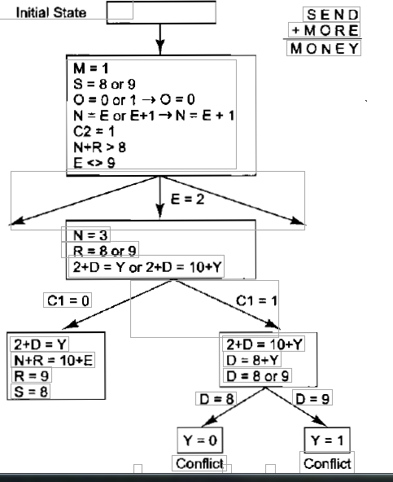
For Cl to be 1, the following must hold: 2 + D = 10 + Y. For this to be the case, D would have to be 8 or 9. But both S and R must be either 8 or 9 and three letters cannot share two values. So Cl cannot be 1.

N-Queens
The n-queens problem, may be stated as follows: find a placement of n queens on an n×n chessboard, such that no one queen can be attacked by any other. While it has been well known that the solution to the n-queens problem is n, numerous solutions have been published since the original problem was proposed. Many of these solutions rely on providing a specific formula for placing queens or transposing smaller solutions sets to provide solutions for larger values of n.
Empirical observations of smaller-size problems show that the number of solutions increases exponentially with increasing n. Alternatively, search-based algorithms have been developed. For example, a backtracking search, will systematically generate all possible solution sets for a given n×n board. In practice, however, backtracking approaches provide a very limited class of solutions for large size boards because it is difficult for a backtracking search to find solutions that are significantly distinct in the solution space.
We can represent the N-queens as a constraint satisfaction problem. A Constraint Satisfaction Problem consists of 3 components:
1. A set of variables.
2. A set of values for each of the variables.
3. A set of constraints between various collections of variables.
We must find a value for each of the variables that satisfies all of the constraints. A constraint is a relation between a local collection of variables. The constraint restricts the values that these variables can simultaneously have. Although each constraint is over a local collection of variables, finding a global assignment to all of the variables that satisfies all of the constraints is hard. The solution techniques work by cleverly searching through the space of possible assignments of values to variables. If each variable has d values and there are n variables we have d^{n} possible assignments. We need to know where to place each of the N queens. So we could have N variables each of which has as a value 1…N². The values represent where on the chessboard we will place the i-th variable.
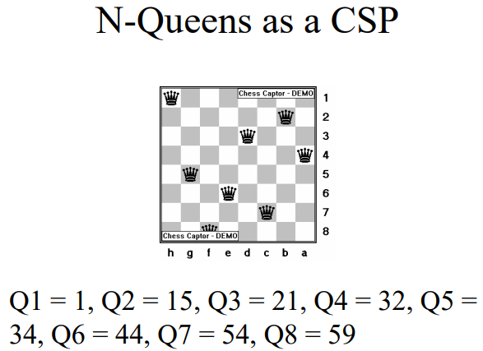
The 4-Queens Problem
The 4-Queens Problem consists of placing four queens on a 4 x 4 chessboard so that no two queens can attack each other. That is, no two queens are allowed to be placed on the same row, the same column or the same diagonal. The following figure illustrates a solution to the 4-Queens Problem: none of the 4 queens can attack each other.
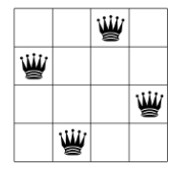
In CSP we translate a real problem into a mathematical model with variables and constraints. Variables represent decisions and constraints restrain the variables from taking arbitrary values. For instance, to model the 4-Queens Problem, we could use a binary variable x_{ij} that indicates if a queen is present on the given (i, j) square (x_{ij} = 1) or not (x_{ij} = 0). The first index i denotes the i^{th} row and the second index j the j^{th} column. We need several constraints to model that no two queens can attack each other. To limit the number of queens to 4, we can add the following constraint:
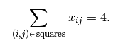
This constraint ensures that we place 4 queens on the chessboard. In general, constraints only permit possible combinations of values of variables corresponding to real solutions.
CSP solvers are mainly based on two concepts:
propagation: variables can have different values but the solver must remove some of those values to keep all the variables values compatible with the model. In CSP, clever algorithms are devised to remove those values in an efficient manner. These algorithms propagate the current state of the solver and removes incompatible or undesirable values.
backtracking: from time to time, the solver is stuck because it tried to assign some values to some variables that are just not possible (or desirable) because they don’t respect the constraints. The solver must then challenge its previous choices and try other values. This is called backtracking. Backtracking also occurs when the solver finds a solution but continues the search and tries to find another solution.
To better understand, let’s have a look at a real solving process. In the following Figures, crosses represent the action of removing values from variables’ domain. The solver starts by placing the first queen in the upper left corner. Because of the model we gave to the solver, it knows that there cannot be any other queen in the same column, hence the gray crosses on the following Figure. One constraint tells the solver that there cannot be another queen on the same diagonal with a negative slope (the diagonals going down then right). One constraint tells the solver that no two queens can be on the same row, hence the next red crosses.
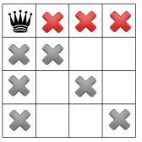
After this first step, only the white squares are still available to place the three remaining queens. The process of excluding some squares is what is called propagation.
The second step starts with the solver trying to place a second queen. It does so in the first available square from the top in the second column. As in the first step, the solver knows that no other queen can be placed in a column where it just placed a queen, hence the new gray crosses in the next Figure. The propagation is as follow: The same negative diagonal constraint as in step 1 tells the solver that no queen can be on the negative diagonal of the second queen, hence the red cross.
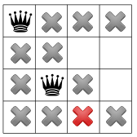
Another constraint for the diagonals with positive slopes (diagonals going up then right) tells the solver that no queen can be placed on the positive diagonal of second queen, hence the red cross.
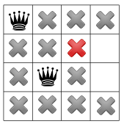
Now, we have a failure as there is no possibility to place a third queen in the third column: there simply can not be a solution with this configuration. The solver has to backtrack!
The solver decides to challenge its last decision to place the second queen in the third row from the top and places it in the fourth row. The propagation is as follow: First, the square with the red cross is removed because of the positive diagonal constraint. This leaves only one possibility to place a queen in the fourth column.
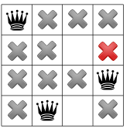
The “no two queen on the same row” constraint removes one more square in the third column, leaving only one square to place the last remaining queen.
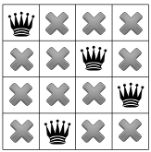
This is of course not possible and the negative diagonal constraint tells the solver that no queen can be on a negative diagonal from the fourth queen. Since there is one, the solver concludes that there is a failure. It has to backtrack again!
First, it tries to challenge its last choice for the second queen but it detects that there are no more other choices. The solver has to challenge its first choice to place the first queen in the first row and places the first queen in the first column second row. The propagation can now take place: Two values are taken away because of the negative diagonal constraint:
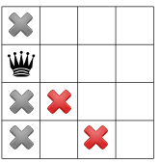
while the positive diagonal constraint one:
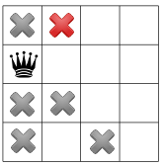
Now comes the turn of the “no two queen on the same row” constraint and it is responsible of removing the next three squares marked by red crosses:
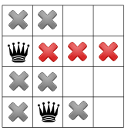
The positive diagonal constraint kicks in and forbids the red square leaving no choice to place a third queen in the third column first row.
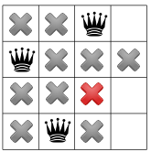
The “no two queen on the same row” constraint forbids any other queen to be placed on the fourth row:
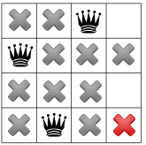
and any other queen on the first row, leaving no choice but to place the fourth queen in the fourth column third row:
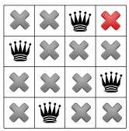
The solver finds out that the model is respected, so we have our first solution! Should the solver continue the search, it would have to backtrack and try to place the first queen in the first column third row.
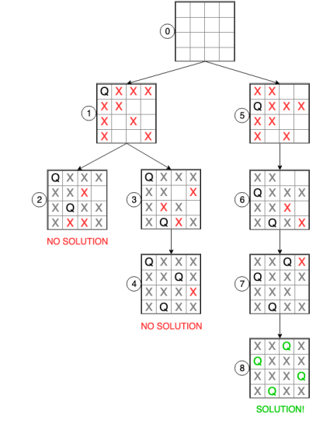
Constraints for N-Queens
The constraints are the key component in expressing a problem as a CSP. The constraints are determined by how the variables and the set of values are chosen. Each constraint consists of: A set of variables it is over. A specification of the sets of assignments to those variables that satisfy the constraint.
The idea is that we break the problem up into a set of distinct conditions each of which have to be satisfied for the problem to be solved. In N-Queens: No queen can attack any other queen. Given any two queens Qi and Qj they cannot attack each other. Now we translate each of these individual conditions into a separate constraint. Qi cannot attack Qj (i ≠ j). Qi is a queen to be placed in column i, Qj is a queen to be placed in column j. The value of Qi and Qj are the rows the queens are to be placed in.
Queens can attack each other if:
1. Vertically, if they are in the same column--- this is impossible as Qi and Qj are placed in different columns.
2. Horizontally, if they are in the same row---we need the constraint Qi ≠ Qj.
3. Along a diagonal---they cannot be the same number of columns apart as they are rows apart: we need the constraint |i-j| ≠ |Qi-Qj| (| | is absolute value).
Representing the Constraints
- Between every pair of variables (Qi, Qj) (i ≠ j), we have a constraint Cij.
2. For each Cij, an assignment of values to the variables Qi = A and Qj = B, satisfies this constraint if and only if
1. A ≠ B
2. |A-B| ≠ |i-j|
A solution to the N-Queens problem will be any assignment of values to the variables Q1,…,QN that satisfies all of the constraints. Constraints can be over any collection of variables. In N-Queens we only need binary constraints---constraints over pairs of variables.

Constraint Propagation

