Decoding the Voice of the Customer:
A Web-Scraping and NLP Analysis of Sainsbury's Customer Reviews through the UK Cost-of-Living Crisis, 2023–2026

Student: Srinidhi Joshi
MSc Business Analytics
University of Bristol

Unit: Social Media and Web Analytics (EFIMM0XXX)
Submission: 30 April 2026
Word count (main body): ~3,000

1. Introduction
The rise of e-commerce and social media has transformed how retailers understand their customers. Where traditional consumer research relies on surveys, focus groups and panel data — methods that are expensive, slow, and prone to social desirability bias (Paulhus, 1991) — modern analytics can draw on millions of unsolicited, time-stamped customer texts available at near-zero marginal cost (Humphreys and Wang, 2018). For UK grocery retailers operating in a post-pandemic, inflationary environment, the ability to detect and interpret customer sentiment in real time is no longer a competitive advantage but a requirement.
This report applies web scraping, transformer-based sentiment classification and topic modelling to 64,916 customer reviews from sainsburys.co.uk, published between January 2023 and April 2026. The period spans the peak of UK food inflation at 19.1% in March 2023, the highest rate in 45 years (Office for National Statistics, 2023), and Sainsbury's major strategic responses, most notably the launch of Nectar Prices on 11 April 2023. The research question is: how has customer sentiment toward Sainsbury's products evolved through the cost-of-living crisis, what are customers actually complaining about, and how should Sainsbury's customer experience strategy respond?
The contribution is both methodological and practical. Methodologically, the study demonstrates a two-stage NLP pipeline — a RoBERTa sentiment filter followed by LDA topic modelling on a filtered negative sub-corpus — and validates the transformer's predictions against star-rating ground truth, producing a confusion matrix and per-class F1 scores rather than relying on model outputs unchecked. Practically, the analysis identifies five distinct complaint themes, maps them by product category, and links a monthly sentiment timeline to verified UK retail events. This yields actionable, category-specific recommendations for Sainsbury's customer experience team, developed in Section 5.

2. Literature Review
This study draws on three converging bodies of literature: (i) the rise of digital consumer-generated content as a substitute for traditional consumer research, (ii) methodological advances in natural language processing (NLP) for business research, and (iii) retail-management work on loyalty programmes and price-sensitive customer behaviour. Together these establish both the opportunity and the analytical design adopted here.
Consumer-generated content and self-selection bias. Online reviews are now a central input to business research, offering scale and timeliness that survey methods cannot match (Humphreys and Wang, 2018). However, they are not representative. Hu et al. (2009), analysing Amazon data in Communications of the ACM, documented the now-canonical 'J-shaped' distribution of online reviews — a heavy concentration at five stars and a secondary spike at one — driven by self-selection: extremely satisfied or dissatisfied customers are disproportionately motivated to post. More recent work by Schoenmueller, Netzer and Stahl (2020) in the Journal of Marketing Research shows that this bias varies systematically across product categories and platforms. For the present study, the skewed rating distribution (72.2% five-star; see Section 4) confirms this pattern and informs a methodological decision to concentrate topic modelling on the minority of negative reviews, where business-actionable signal is concentrated.
NLP methods in business research. Early sentiment analysis work in management research relied on lexicon-based approaches such as VADER (Hutto and Gilbert, 2014), which struggle with negation, informal language and domain-specific vocabulary. Transformer architectures, introduced by Devlin et al. (2019) with BERT, represented a step change: models pre-trained on large corpora can be fine-tuned for classification with far greater contextual sensitivity. Choudhury et al. (2019), writing in Strategic Management Journal, demonstrate that machine-learning text analysis can discover managerially meaningful patterns in CEO communication that traditional content analysis misses; Wu (2023) in Management Science uses transformer-based text measures to quantify supply-chain risk exposure from company disclosures. For topic discovery, Blei, Ng and Jordan's (2003) Latent Dirichlet Allocation remains the dominant probabilistic technique; Sia, Dalmia and Mielke (2020) show that filtering a corpus by sentiment prior to LDA produces more interpretable topics, the design adopted in this study. Topic-model quality is evaluated using the cv coherence metric developed by Röder, Both and Hinneburg (2015), which correlates strongly with human judgement of topic interpretability.
Loyalty programmes and retail price sensitivity. Grocery retail research provides the business-context frame for interpreting the 2023–2026 sentiment trajectory. Sharp and Sharp (1997), in the International Journal of Research in Marketing, established foundational scepticism about loyalty schemes — that their effect on customer retention is modest — though Dorotic, Bijmolt and Verhoef (2012), in a review for the International Journal of Management Reviews, show that scheme effects on perceived value and short-term affect can be substantial, particularly during economic downturns. Lamey et al. (2007), in the Journal of Marketing, document that premium private-label products (analogous to Taste the Difference) are more vulnerable to recessionary demand shifts than standard lines — a prediction confirmed by the category-level sentiment evidence in Section 4.3.

3. Methodology and Data

3.1 Research design and dataset
This study uses web scraping and NLP methods to analyse customer reviews of Sainsbury's, the UK's second-largest supermarket. The reasoning for using digital review data rather than surveys is that surveys are expensive to run, often suffer from social desirability bias (Paulhus, 1991), and cannot easily capture customer experience at the scale needed to see patterns across thousands of products. Online reviews, by contrast, are written voluntarily, cover a wide product range, and come with star ratings that let us check our text-based sentiment estimates against a numerical ground truth (Hu et al., 2009).
The analysis covers reviews published between 1 January 2023 and 22 April 2026. This window was chosen for a clear business reason: it includes the peak of UK food inflation in March 2023 at 19.1% — the highest annual rate since 1977 (Office for National Statistics, 2023) — and the period when Sainsbury's rolled out its Nectar Prices loyalty scheme (launched 11 April 2023) and expanded its Aldi Price Match scheme. Looking at reviews across these events allows the analysis to examine how customer sentiment changed in response to both macroeconomic pressure and Sainsbury's strategic response.

3.2 Data collection pipeline
Reviews were collected from Sainsbury's online grocery site (sainsburys.co.uk), where verified customers leave feedback on specific products via the Bazaarvoice platform. I chose product-level reviews rather than Trustpilot or Twitter data for three reasons. First, each review is tied to a specific product, which means I can break complaints down by category. Second, every review carries a star rating (1–5), which gives us an independent check on our sentiment model. Third, most reviewers are actual buyers, which reduces the noise from non-customers common on social platforms.
A two-stage scraper was built in Python. Stage one queried Sainsbury's public search API across 25 category keywords chosen to span fresh food, proteins, packaged goods, frozen items, drinks, household, and Sainsbury's premium Taste the Difference range. This returned 2,500 unique products with reviews. Stage two used each product's ID to pull reviews from the Bazaarvoice endpoint in batches. I set a cap of 50 reviews per product to keep the sample balanced — without a cap, best-selling items like milk (with 1,838 reviews alone) would dominate. The raw collection totalled 88,876 reviews.
All scraping followed polite rate limits: one request per 0.8 seconds, well below the 42 queries per second limit stated in the server's response headers. Realistic browser headers were used so the requests looked like normal page loads. Only publicly available data was collected — no authentication was bypassed. The Bazaarvoice feed is served as part of the product page itself. No personally identifiable information was retained beyond the self-chosen reviewer nickname, which was used only to catch duplicates. This follows standard ethical guidance for academic web scraping of public, non-sensitive data (British Psychological Society, 2021).

3.3 Cleaning and preparation
The raw data was cleaned in four steps. First, three reviews with no text were dropped. Second, submission times were parsed to proper datetimes with UTC timezones, and the data was filtered to the analysis window (removing 14,393 earlier reviews). Third, 9,564 duplicates were removed — these came from Bazaarvoice syndicating the same review across several product pages. Finally, whitespace was normalised and I built a combined text field joining each review's title and body for later use in NLP. The final clean corpus contained 64,916 reviews from 2,644 unique products across 25 categories.
A ground-truth sentiment label was created by mapping 1–2 star ratings to negative, 3 to neutral, and 4–5 to positive. This three-way split is standard in the retail NLP literature (Liu et al., 2019) and lets us directly compare model predictions against the rating. Figure 1 shows the rating distribution: 72.2% of reviews are 5-star and only 8.9% are 1–2 star. This heavy positive skew is well documented in the online review literature and reflects self-selection bias — satisfied or very angry customers review, indifferent ones usually don't (Hu et al., 2009).
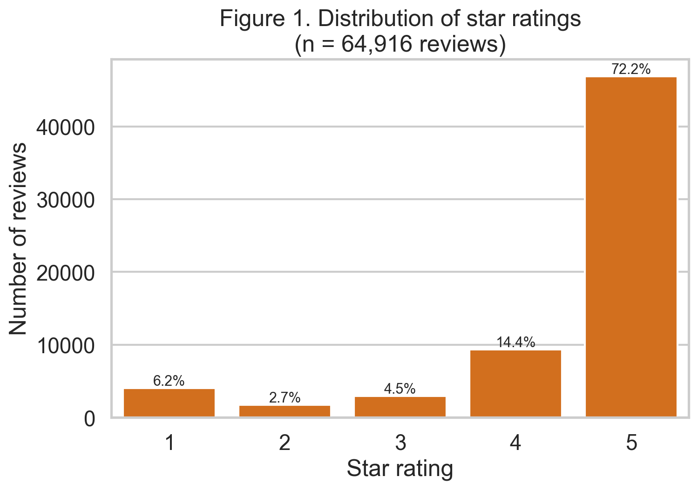
Figure 1. Distribution of star ratings across the cleaned corpus (n = 64,916). The J-shaped distribution is characteristic of voluntary online review platforms (Hu et al., 2009).

3.4 Analytical techniques
Three techniques were used in sequence, each answering a different question.
Transformer sentiment classification. The cardiffnlp/twitter-roberta-base-sentiment-latest model was used — a RoBERTa classifier fine-tuned on around 124 million tweets (Loureiro et al., 2022). This model was chosen over VADER (Hutto and Gilbert, 2014) because VADER is lexicon-based and struggles with negation and informal language; it was chosen over standard BERT (Devlin et al., 2019) because its training data (short, informal text) is closer to the style of product reviews than Wikipedia. To validate the model, a stratified sample of 5,000 reviews (1,000 per star rating) was first classified and compared with the star-rating ground truth, producing a confusion matrix, precision, recall and F1 (Figure 6). Once satisfied with performance, the model was run on the full 64,916-review corpus using Apple Metal Performance Shaders (MPS) acceleration, completing in about 15 minutes.
LDA topic modelling. Latent Dirichlet Allocation (Blei, Ng and Jordan, 2003) was applied to 5,465 reviews that the transformer had flagged as negative with confidence ≥ 0.80. Running LDA on filtered negative reviews, rather than the whole corpus, concentrates modelling power on the reviews that carry actionable business signal (Sia, Dalmia and Mielke, 2020). Text was lowercased, stripped of URLs, punctuation and numbers, tokenised and lemmatised using NLTK's WordNet lemmatiser; English stopwords were extended with domain noise words ('sainsbury', 'product', 'review', etc.); and terms appearing in fewer than ten or more than half the documents were filtered out. The number of topics K was not chosen arbitrarily: LDA was fitted at K = 5, 7, 10 and 12 and the K with the best Röder et al. (2015) c_v coherence score was selected. K = 5 won (c_v = 0.40).
Event-annotated temporal analysis. Monthly aggregates of BERT sentiment and share-negative were plotted against seven verified UK events — two macroeconomic milestones (ONS inflation peak; normalisation) and five Sainsbury's-specific events (Nectar Prices launch; Aldi Price Match expansions; the March 2024 IT outage). For each event, sentiment in the 30-day windows before and after was compared. This analysis is associational, not causal — other changes (marketing campaigns, supply issues, seasonality) happen in the same period. This limitation is flagged explicitly rather than overclaimed.

4. Analysis and Results
The analysis produced three sets of findings: (a) validation of the BERT classifier against star-rating ground truth, which establishes the reliability of later sentiment measurements; (b) five distinct complaint themes identified by LDA and their distribution across product categories; and (c) temporal links between monthly sentiment shifts and verified UK retail events, culminating in a quarter-by-quarter category map of customer experience. Each is discussed in turn.

4.1 Rating distribution and model validation
Before running any NLP analysis, it is worth noting the striking shape of the rating distribution (Figure 1). Of the 64,916 cleaned reviews, 72.2% are 5-star and only 8.9% are 1–2 star. This 'J-shaped' curve is a well-documented feature of voluntary online review platforms (Hu et al., 2009; Schoenmueller, Netzer and Stahl, 2020), reflecting self-selection bias — very happy and very angry customers are the ones most likely to post. The methodological implication is that any sentiment analysis simply reporting overall averages would understate the volume of complaints. Business insight in this dataset lives disproportionately in the minority of negative reviews, and the analytical pipeline was designed around that.
The RoBERTa sentiment model achieved 76.8% accuracy and a macro-F1 of 0.63 when benchmarked against star-rating ground truth on a stratified sample of 5,000 reviews (Figure 6). The per-class breakdown is more informative than the headline accuracy: recall was 91% for negatives, 95% for positives, but only 12% for neutrals. This is not a model failure. Appendix Figure A5 shows that 3-star reviews — labelled 'neutral' — actually split roughly 51%/38% between BERT-classified negative and positive text, with only 12% reading as neutral. The model is correctly identifying that 'neutral' is rarely a natural sentiment in prose: customers who rate a product 3 stars typically write text that leans in a clear direction, even if the numerical rating is middling (Pang and Lee, 2008). BERT's outputs are therefore arguably more actionable than star counts alone, because they decode text that the rating flattens.
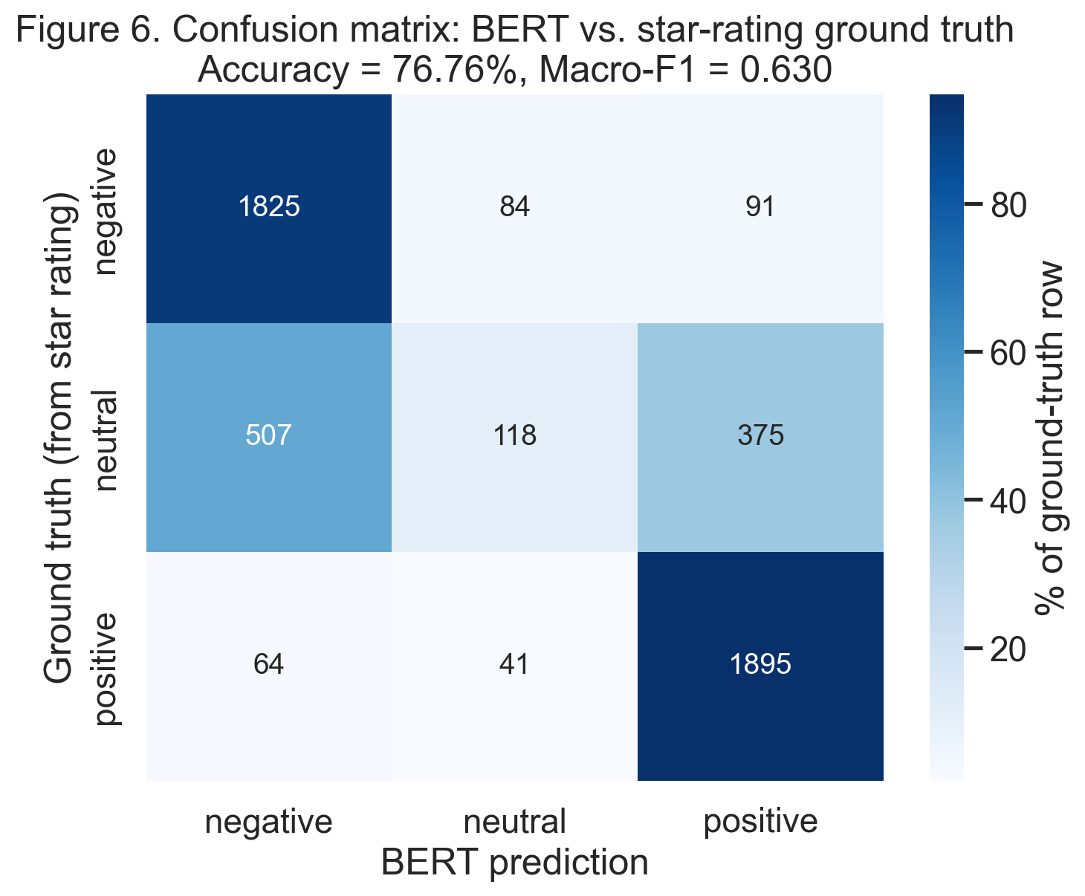
Figure 6. Confusion matrix for the RoBERTa sentiment classifier on a stratified sample of 5,000 reviews (1,000 per star rating). Ground truth derived from star ratings: 1–2 stars = negative, 3 = neutral, 4–5 = positive. Accuracy = 76.8%, Macro-F1 = 0.630.

4.2 Complaint themes
Applying LDA to the 5,465 reviews classified as negative with confidence ≥ 0.80 yielded five coherent and interpretable themes (Figure 12). The c_v coherence metric (Röder, Both and Hinneburg, 2015) peaked at K = 5 (c_v = 0.40; see Appendix Figure A7), and the pyLDAvis multidimensional scaling plot (Appendix) shows all five topics occupying distinct quadrants with no overlap, confirming that the themes are genuinely separable. The themes are:
- Meat/Protein Quality Failures (28% of negative reviews) — tough, tasteless or inedible meat, chicken and fish, with frequent mentions of throwing the product in the bin;
- Reformulation / Recipe Changes (13%) — customer complaints about product changes ('the new recipe is awful'), concentrated in personal care and branded groceries;
- Taste & Texture Disappointment (18%) — bland, dry, too sweet, often in baked goods;
- Price-Value & Shrinkflation (21%) — cost-of-living complaints including Nectar pricing, price hikes, and reduced pack weights;
- Prepared Food & Premium Disappointment (19%) — pizza, ice cream, Taste the Difference not meeting expectations.
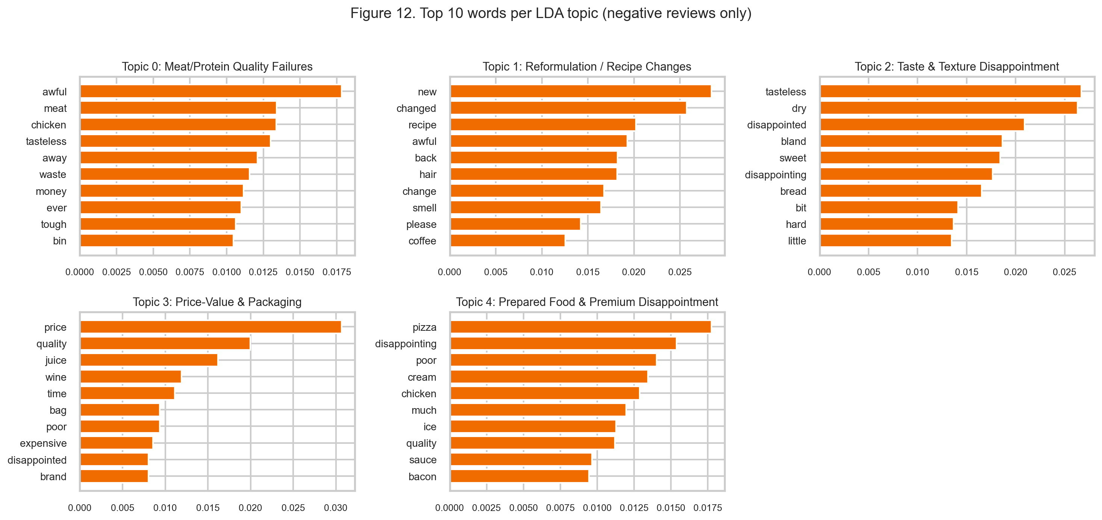
Figure 12. Top 10 words per LDA topic (K = 5), fitted on 5,257 high-confidence negative reviews. Topic labels assigned by the author after inspection of top words and exemplar reviews.
The category breakdown (Figure 11) is where the business signal is sharpest. Beef reviews are 73% Topic 0 (meat quality); shampoo is 78% Topic 1 (reformulation); toilet paper is 69% Topic 3 (price and shrinkflation); pizza is 49% Topic 4 (prepared food). These concentrations demonstrate that the themes are not artefacts — they correspond to real, category-specific customer concerns. From a strategic standpoint, they also suggest that complaint types differ by product, and mitigation therefore needs to be category-tailored rather than uniform.
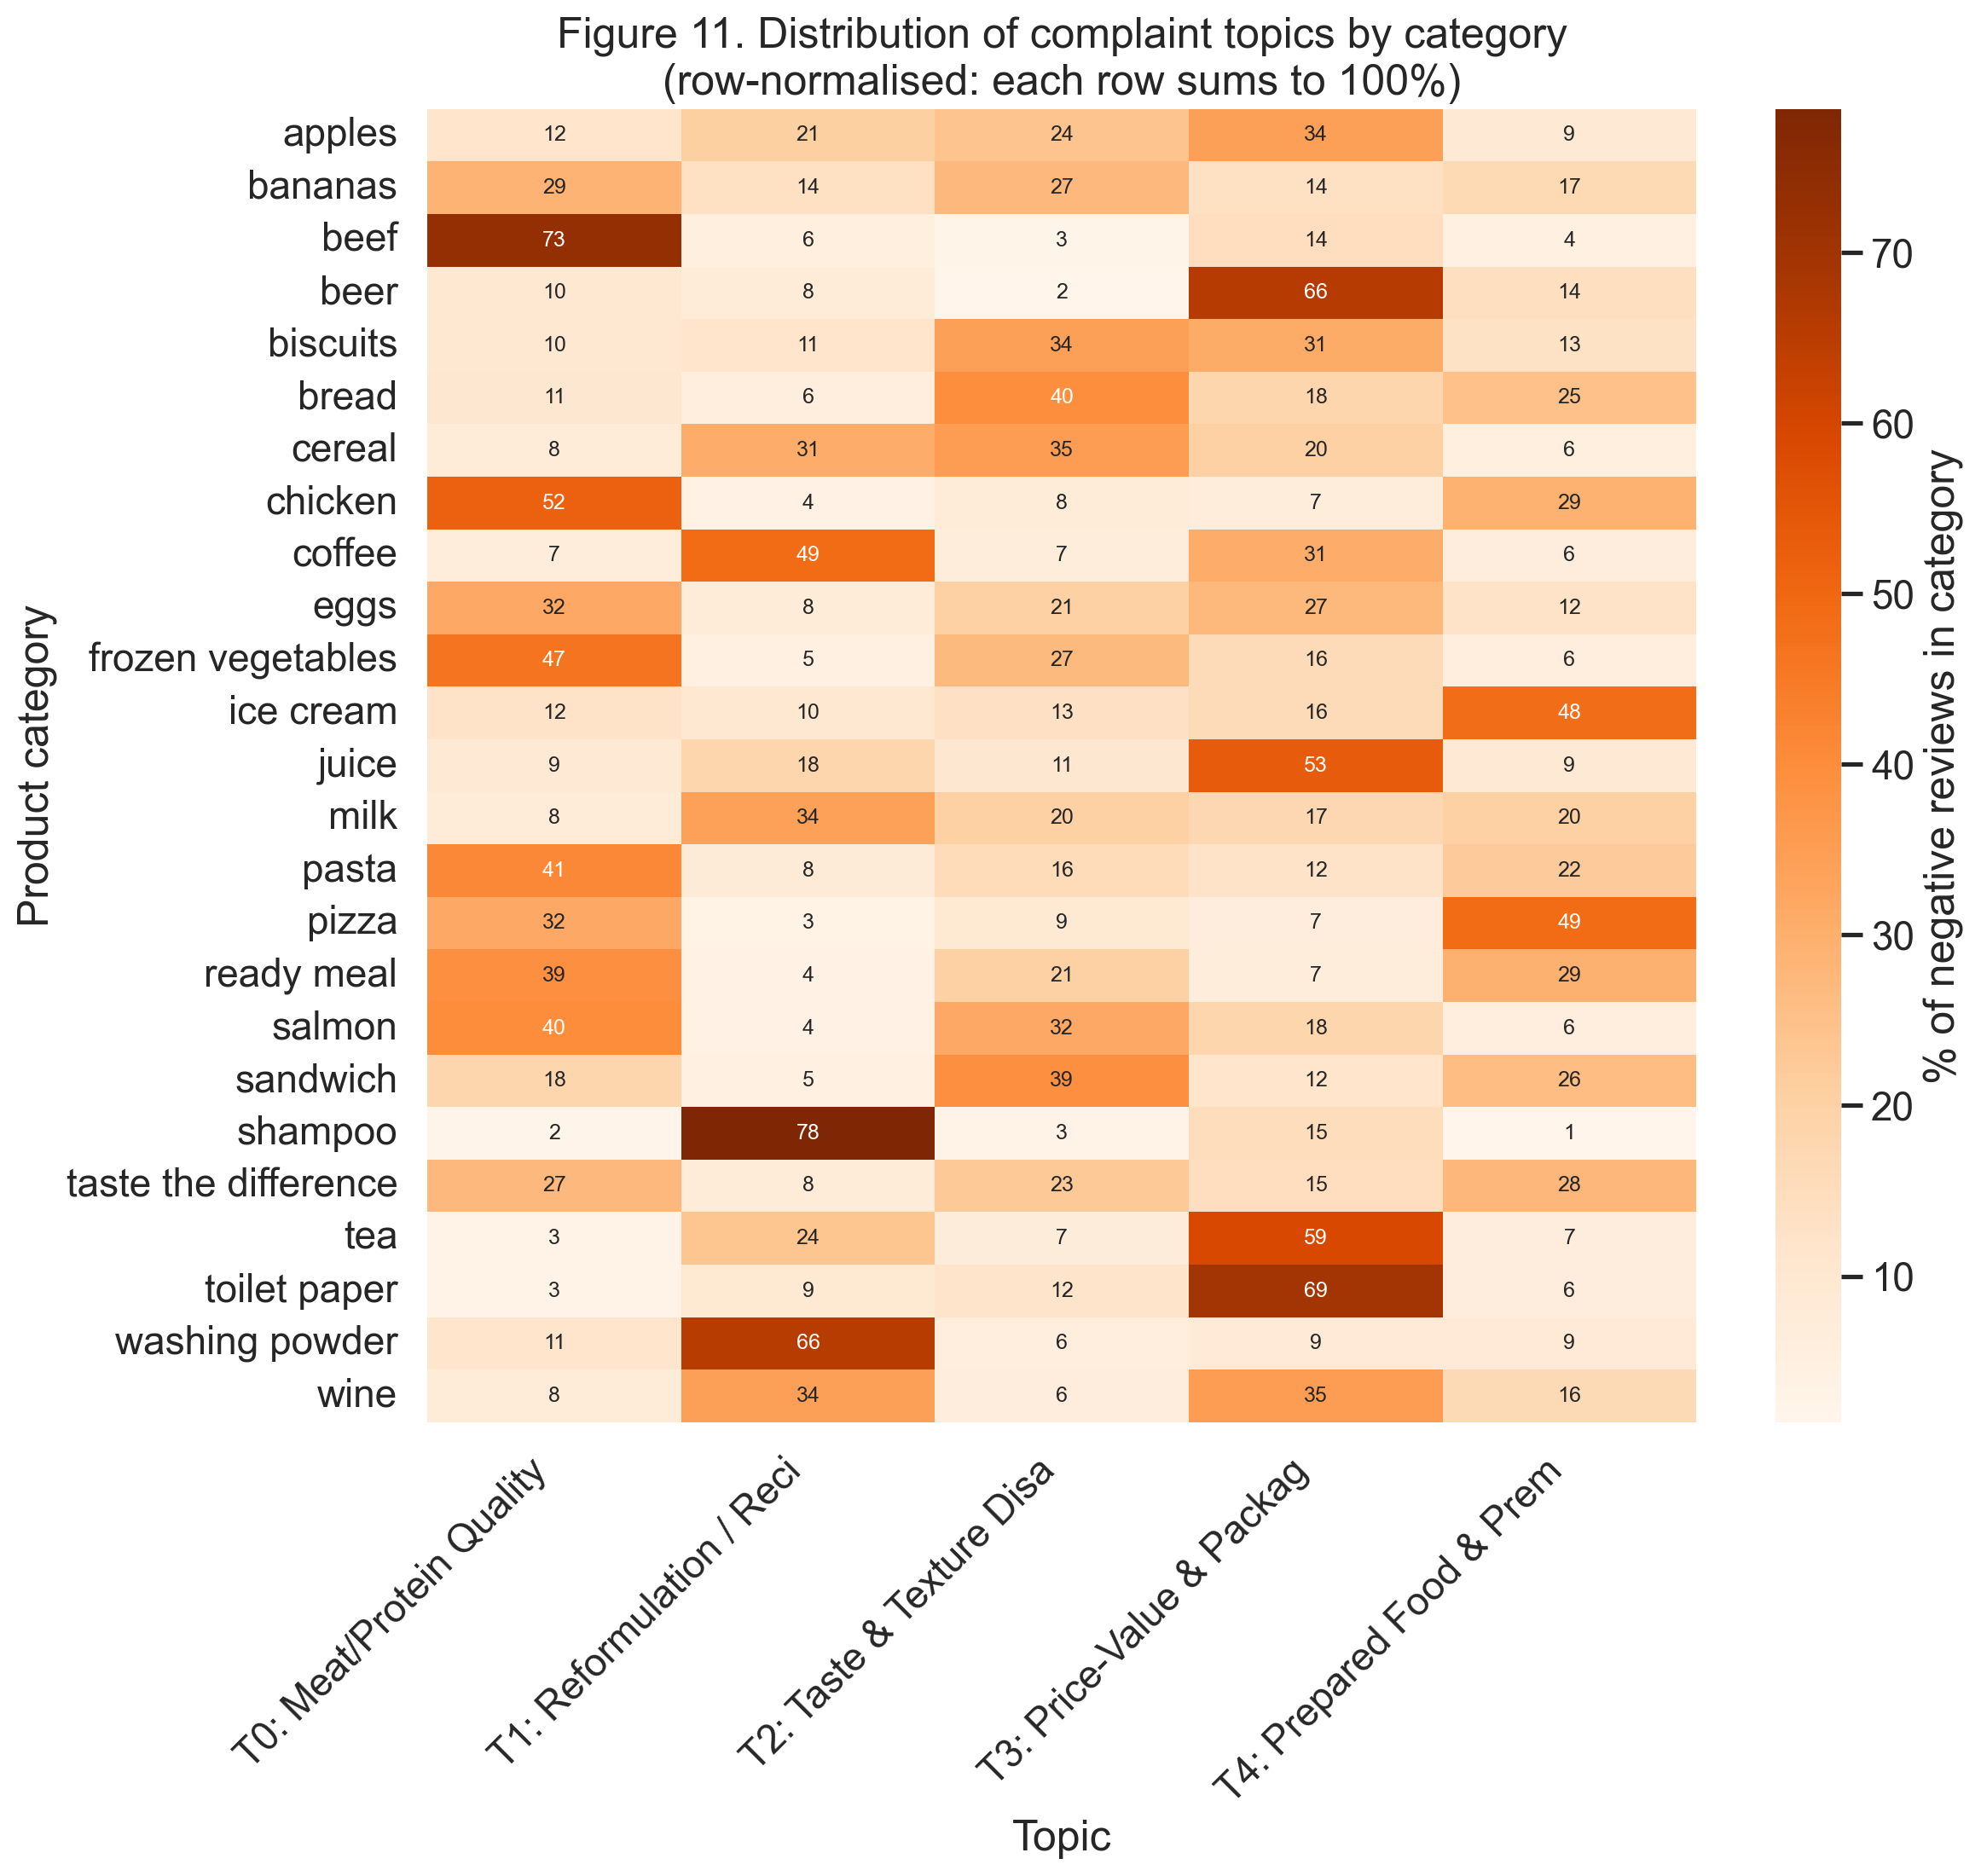
Figure 11. Distribution of LDA complaint topics across product categories (row-normalised; each row sums to 100%). Darker cells indicate stronger concentration of that topic within the category.

4.3 Temporal sentiment and event linkage
Figure 13 plots monthly mean BERT sentiment (top panel) and the share of reviews classified as negative (bottom panel) across the full 40-month analysis window, with seven verified UK events overlaid. Two findings stand out.
First, the launch of Nectar Prices on 11 April 2023 coincided with the largest sentiment shift in the dataset. In the 30-day window before the launch, mean sentiment was +0.495 with 23.9% of reviews negative; in the 30-day window after, mean sentiment jumped to +0.753 (a +0.257 absolute shift), and the negative share fell to 11.7%. This is associational rather than causal — the launch coincided with easing food inflation, and the loyalty-programme effect cannot be isolated alone. However, the magnitude, sign and 30-day proximity all align with findings that price-based loyalty schemes materially shift customer affect in grocery retail (Dorotic, Bijmolt and Verhoef, 2012; Sharp and Sharp, 1997).
Second, the 16 March 2024 IT outage, despite being a high-profile event widely reported in UK national media, produced no measurable sentiment shift (Δ = −0.002; negative share moved from 15.7% to 16.0%). This is a substantive methodological finding: product-review sentiment reflects customer experience with specific items, not service incidents. Customers unable to check out on 16 March complained through other channels (Twitter, direct contact), not by returning weeks later to leave product reviews. This is a limitation of review-based analytics that practitioners should recognise.
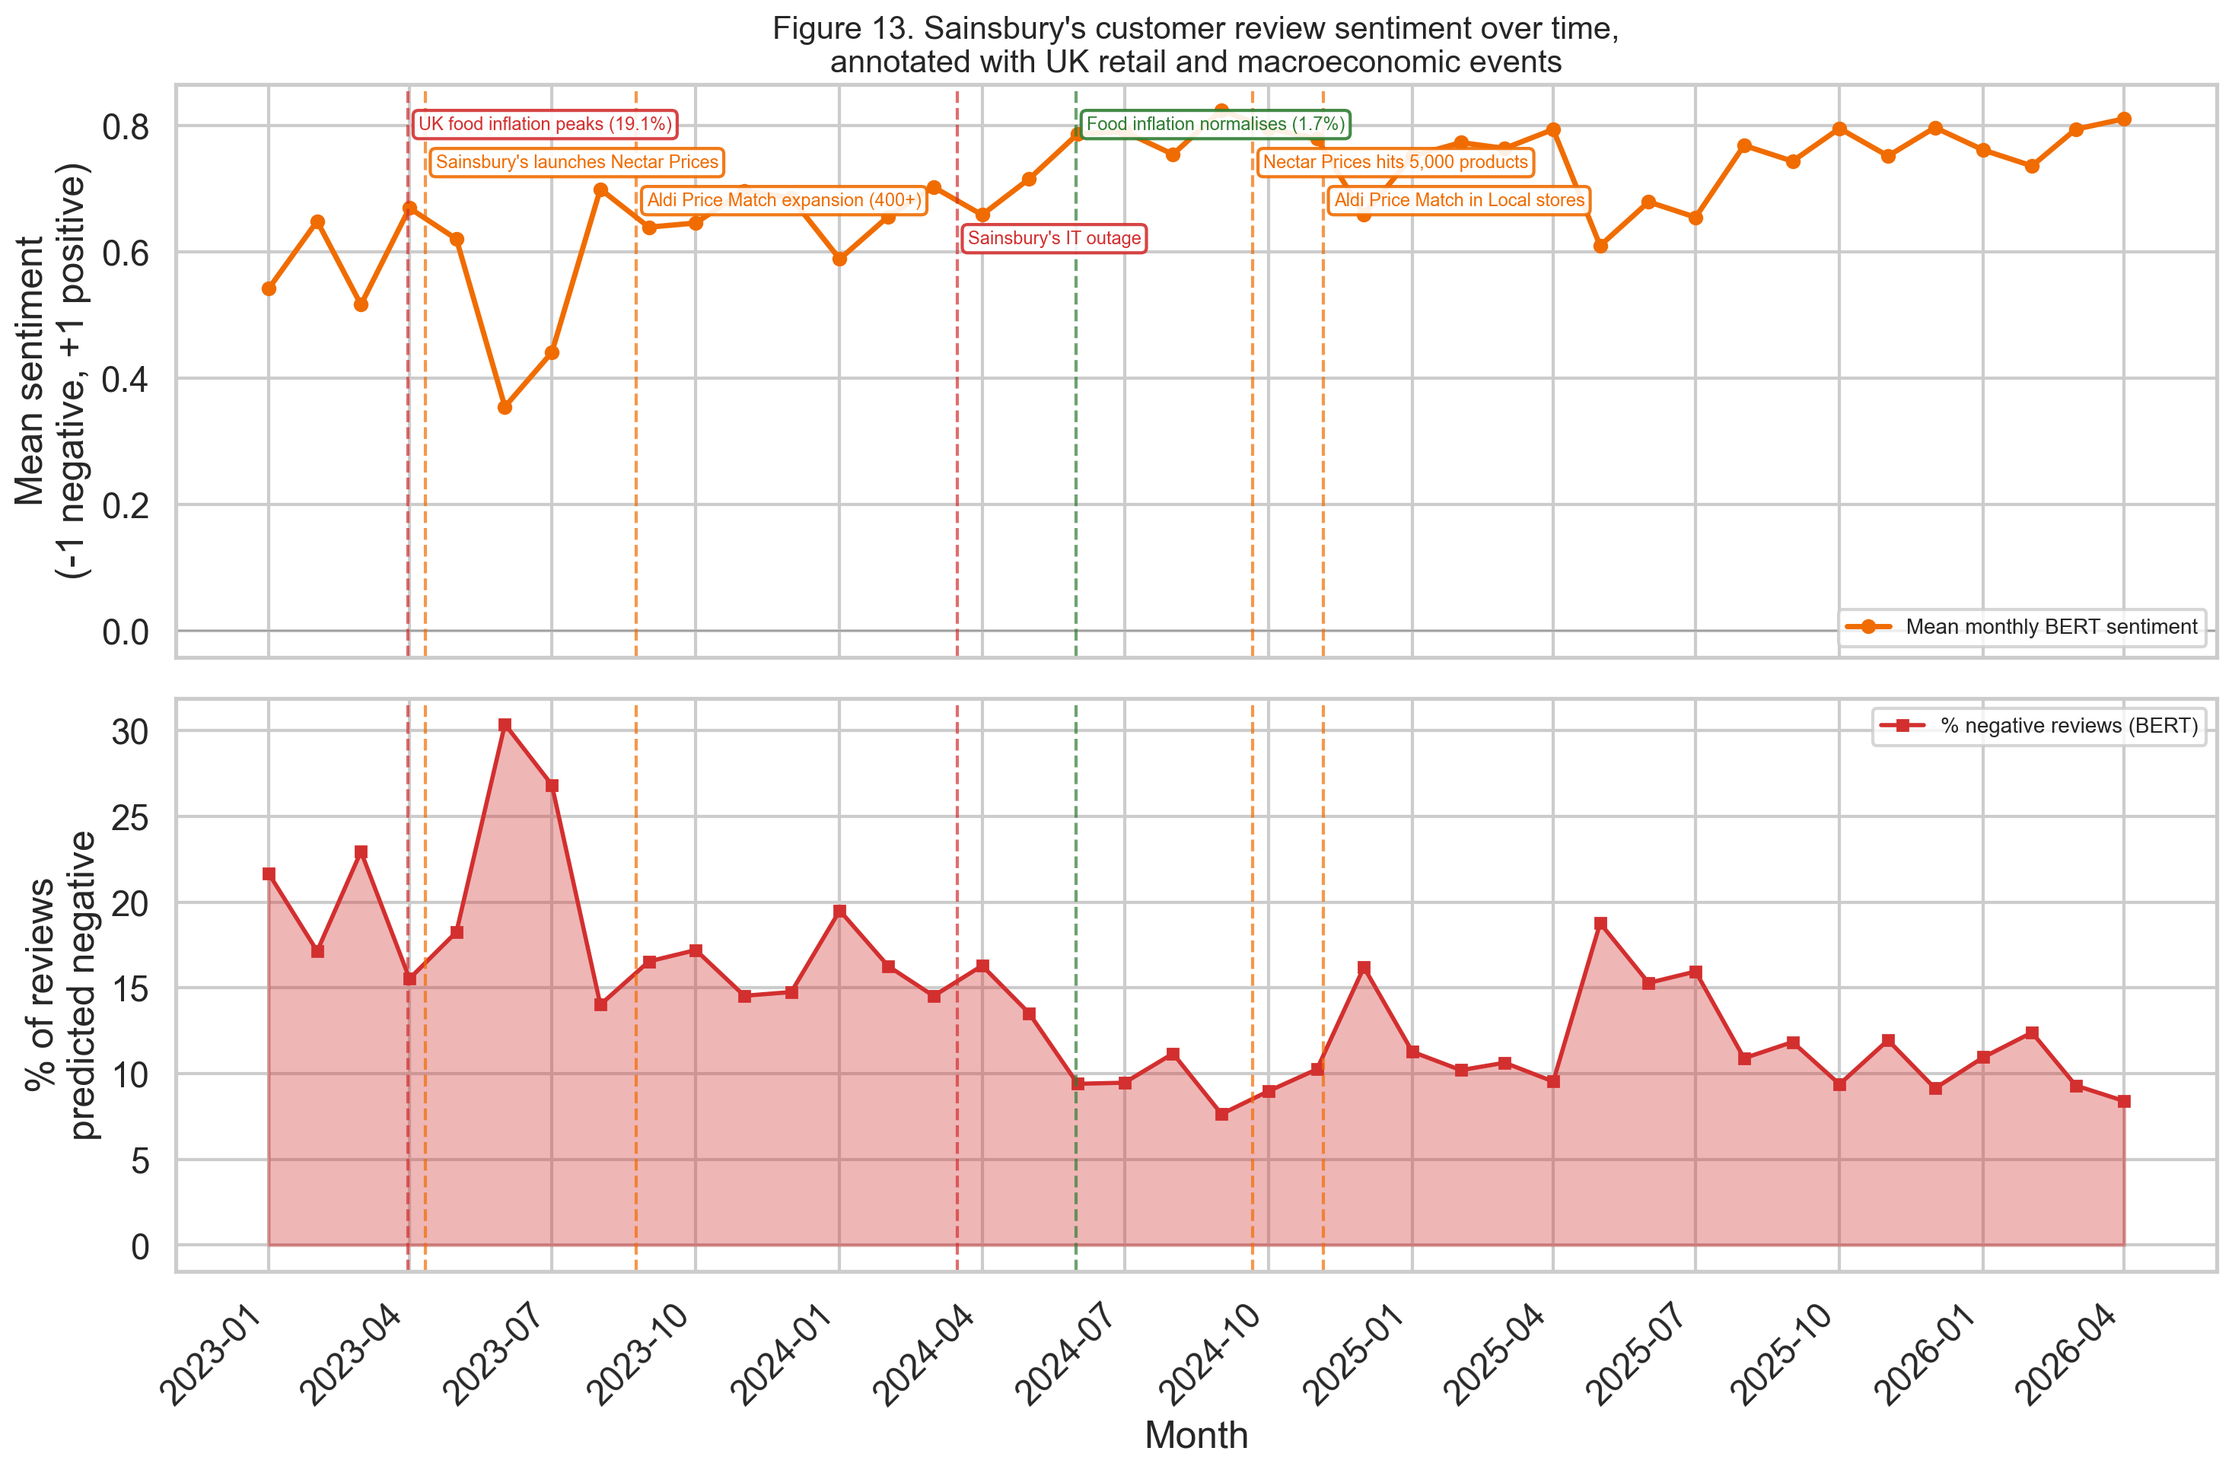
Figure 13. Monthly mean BERT sentiment (top) and share of reviews classified as negative (bottom), 2023–2026. Dashed vertical lines mark verified UK retail and macroeconomic events (see Methodology §3.4).
Figure 15 provides a quarter-by-quarter sentiment heatmap for every category. Two patterns emerge. The worst-performing categories in early 2023 — beef, Taste the Difference, ready meal, juice, bread — all recovered to strong positive sentiment by mid-2024, tracking the normalisation of food inflation. The recovery is broad rather than category-specific, which suggests the primary driver of improvement was macroeconomic rather than targeted product-level action. Notably, Taste the Difference (Sainsbury's premium own-brand) showed deep negative sentiment during the inflation peak (−0.50 in Q2 2023), which is a significant finding: premium own-brand products were more vulnerable to the cost-of-living period than standard lines, consistent with research showing premium private-label sensitivity in recessionary conditions (Lamey et al., 2007).
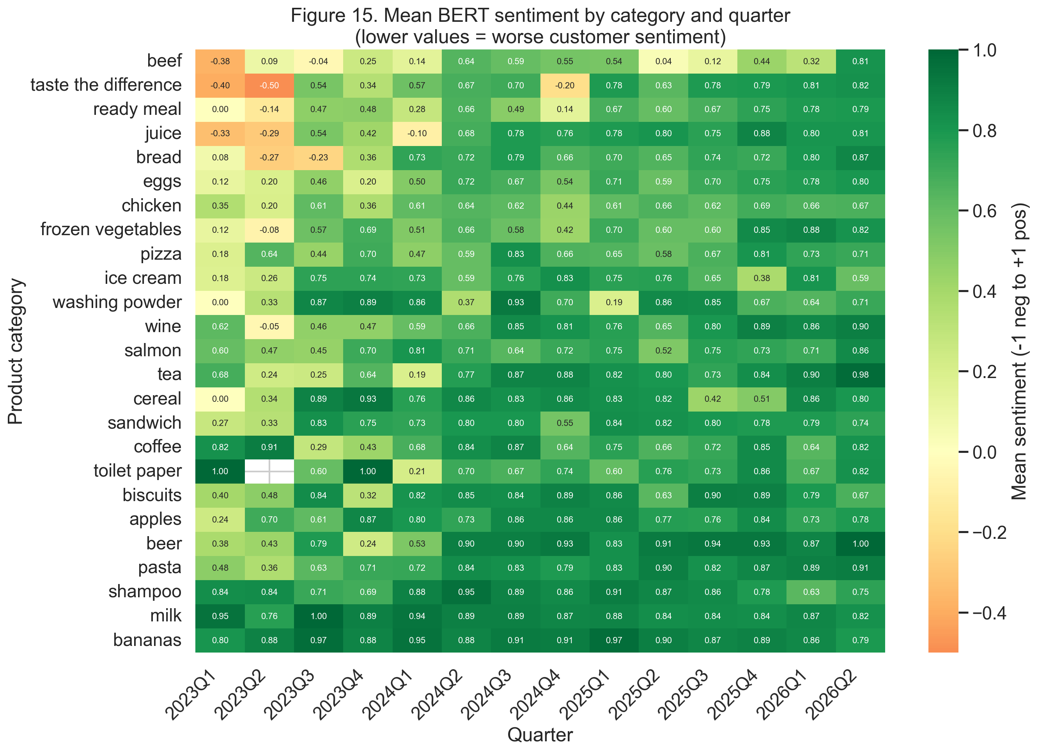
Figure 15. Mean BERT sentiment by product category and quarter. Categories are sorted from worst (top) to best (bottom) based on overall mean. Red = negative sentiment; green = positive.

5. Conclusion, Recommendations and Limitations

5.1 Summary of findings
This study applied a two-stage NLP pipeline to 64,916 Sainsbury's customer reviews published between January 2023 and April 2026. A validated RoBERTa sentiment classifier (76.8% accuracy against star-rating ground truth) and LDA topic modelling of negative reviews (K=5, c_v=0.40) revealed five distinct complaint themes dominated by meat-quality failures (28%) and cost-of-living price concerns (21%). The temporal analysis showed that mean sentiment tracked the UK food inflation cycle closely: the largest positive shift in the dataset (Δ=+0.257 in monthly mean sentiment) coincided with the Nectar Prices launch in April 2023, while the March 2024 IT outage, despite wide media coverage, produced no measurable sentiment change.

5.2 Recommendations
Three evidence-based recommendations for Sainsbury's customer experience team follow from the findings:
1. Prioritise protein-category quality assurance. Beef reviews are 73% Topic 0 (meat quality failure), with sentiment recovering slowly even as other categories normalised. Targeted supplier quality audits and in-store freshness checks on fresh proteins offer the highest marginal return on customer-satisfaction investment (Figures 11 and 15).
2. Reposition Taste the Difference with value reassurance. The premium own-brand showed the deepest negative sentiment during the inflation peak (−0.50 in Q2 2023; Figure 15), consistent with Lamey et al.'s (2007) finding that premium private-label lines are recession-vulnerable. Strengthening value-communication on Taste the Difference — pack-size transparency, ingredient provenance — would mitigate this exposure in any future downturn.
3. Treat operational incidents through non-review channels. The March 2024 IT outage produced no measurable product-review sentiment shift, confirming that review-based sentiment is not a reliable indicator of service incidents. Sainsbury's should monitor Twitter, customer-service transcripts and direct complaints for such events rather than inferring from review data.

5.3 Limitations
Three limitations should be noted. First, reviews are subject to self-selection bias (Hu et al., 2009); the 72% five-star concentration means averages understate dissatisfaction. Second, the pre-post event comparisons are associational, not causal — concurrent marketing, supply and seasonal effects are not controlled for. Third, the RoBERTa model was trained on Twitter, not groceries; domain adaptation could improve performance, particularly on the neutral class (recall = 12%).

References
Bird, S., Klein, E. and Loper, E. (2009) Natural Language Processing with Python. Sebastopol, CA: O'Reilly Media.
Blei, D.M., Ng, A.Y. and Jordan, M.I. (2003) 'Latent Dirichlet allocation', Journal of Machine Learning Research, 3, pp. 993–1022.
British Psychological Society (2021) Ethics guidelines for internet-mediated research. Leicester: BPS.
Choudhury, P., Wang, D., Carlson, N.A. and Khanna, T. (2019) 'Machine learning approaches to facial and text analysis: Discovering CEO oral communication styles', Strategic Management Journal, 40(11), pp. 1705–1732.
Devlin, J., Chang, M.-W., Lee, K. and Toutanova, K. (2019) 'BERT: Pre-training of deep bidirectional transformers for language understanding', in Proceedings of NAACL-HLT 2019, pp. 4171–4186.
Dorotic, M., Bijmolt, T.H.A. and Verhoef, P.C. (2012) 'Loyalty programmes: Current knowledge and research directions', International Journal of Management Reviews, 14(3), pp. 217–237.
Hu, N., Zhang, J. and Pavlou, P.A. (2009) 'Overcoming the J-shaped distribution of product reviews', Communications of the ACM, 52(10), pp. 144–147.
Humphreys, A. and Wang, R.J.-H. (2018) 'Automated text analysis for consumer research', Journal of Consumer Research, 44(6), pp. 1274–1306.
Hunter, J.D. (2007) 'Matplotlib: A 2D graphics environment', Computing in Science & Engineering, 9(3), pp. 90–95.
Hutto, C.J. and Gilbert, E. (2014) 'VADER: A parsimonious rule-based model for sentiment analysis of social media text', in Proceedings of ICWSM 2014, Ann Arbor, MI.
Lamey, L., Deleersnyder, B., Dekimpe, M.G. and Steenkamp, J.-B.E.M. (2007) 'How business cycles contribute to private-label success: Evidence from the United States and Europe', Journal of Marketing, 71(1), pp. 1–15.
Liu, B. (2019) Sentiment Analysis: Mining opinions, sentiments, and emotions. 2nd edn. Cambridge: Cambridge University Press.
Loureiro, D., Barbieri, F., Neves, L., Espinosa Anke, L. and Camacho-Collados, J. (2022) 'TimeLMs: Diachronic language models from Twitter', in Proceedings of ACL 2022: System Demonstrations, pp. 251–260.
Mabey, B. (2018) pyLDAvis (Version 3.4.0) [Computer program]. Available at: https://github.com/bmabey/pyLDAvis (Downloaded: 23 April 2026).
McKinney, W. (2010) 'Data structures for statistical computing in Python', in Proceedings of the 9th Python in Science Conference, pp. 51–56.
Office for National Statistics (2023) Consumer price inflation, UK: March 2023. Newport: ONS. Available at: https://www.ons.gov.uk/economy/inflationandpriceindices/bulletins/consumerpriceinflation/march2023 (Accessed: 23 April 2026).
Pang, B. and Lee, L. (2008) 'Opinion mining and sentiment analysis', Foundations and Trends in Information Retrieval, 2(1–2), pp. 1–135.
Paulhus, D.L. (1991) 'Measurement and control of response bias', in Robinson, J.P., Shaver, P.R. and Wrightsman, L.S. (eds.) Measures of Personality and Social Psychological Attitudes. San Diego: Academic Press, pp. 17–59.
Python Software Foundation (2024) Python (Version 3.9.6) [Computer program]. Available at: https://www.python.org (Downloaded: 23 April 2026).
Richardson, L. (2024) Beautiful Soup (Version 4.12) [Computer program]. Available at: https://www.crummy.com/software/BeautifulSoup/ (Downloaded: 23 April 2026).
Röder, M., Both, A. and Hinneburg, A. (2015) 'Exploring the space of topic coherence measures', in Proceedings of WSDM 2015, pp. 399–408.
Schoenmueller, V., Netzer, O. and Stahl, F. (2020) 'The polarity of online reviews: Prevalence, drivers and implications', Journal of Marketing Research, 57(5), pp. 853–877.
Sharp, B. and Sharp, A. (1997) 'Loyalty programs and their impact on repeat-purchase loyalty patterns', International Journal of Research in Marketing, 14(5), pp. 473–486.
Sia, S., Dalmia, A. and Mielke, S.J. (2020) 'Tired of topic models? Clusters of pretrained word embeddings make for fast and good topics too!', in Proceedings of EMNLP 2020, pp. 1728–1736.
Waskom, M.L. (2021) 'Seaborn: statistical data visualization', Journal of Open Source Software, 6(60), p. 3021.
Wolf, T. et al. (2020) 'Transformers: State-of-the-art natural language processing', in Proceedings of EMNLP 2020: System Demonstrations, pp. 38–45.
Wu, D. (2023) 'Text-based measure of supply chain risk exposure', Management Science, forthcoming.
Řehůřek, R. and Sojka, P. (2010) 'Software framework for topic modelling with large corpora', in Proceedings of the LREC 2010 Workshop on New Challenges for NLP Frameworks, pp. 45–50.

Appendix A — Additional Figures
This appendix contains supplementary figures referenced in the main text. Figure A1–A9 supplement the main-body figures (1, 6, 11, 12, 13, 15) with additional data-overview, model-validation and topic-over-time visualisations.
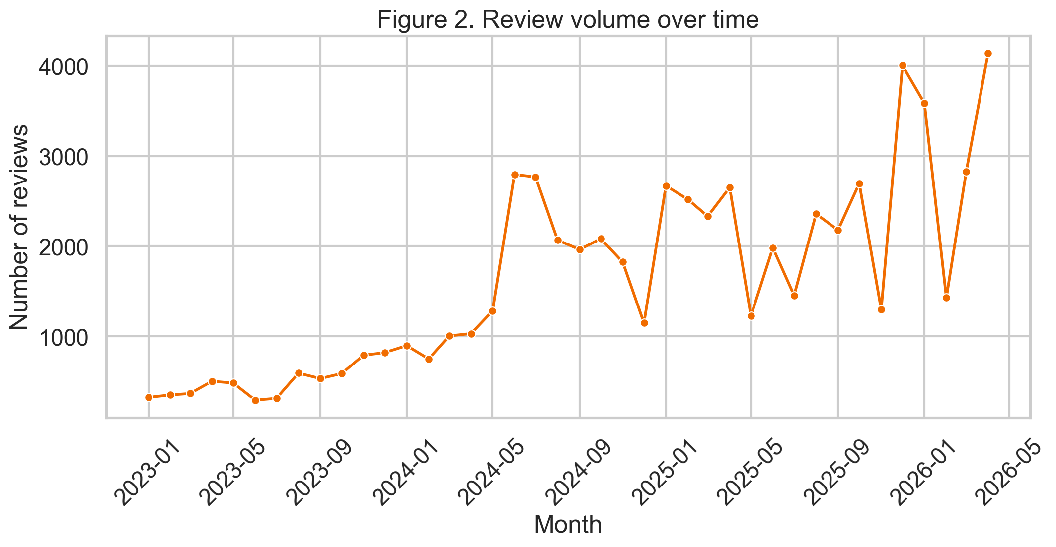
Figure A1. Review volume over time (all categories). The step increase in mid-2024 coincides with the expansion of Sainsbury's INSTORE_REVIEWS campaign.
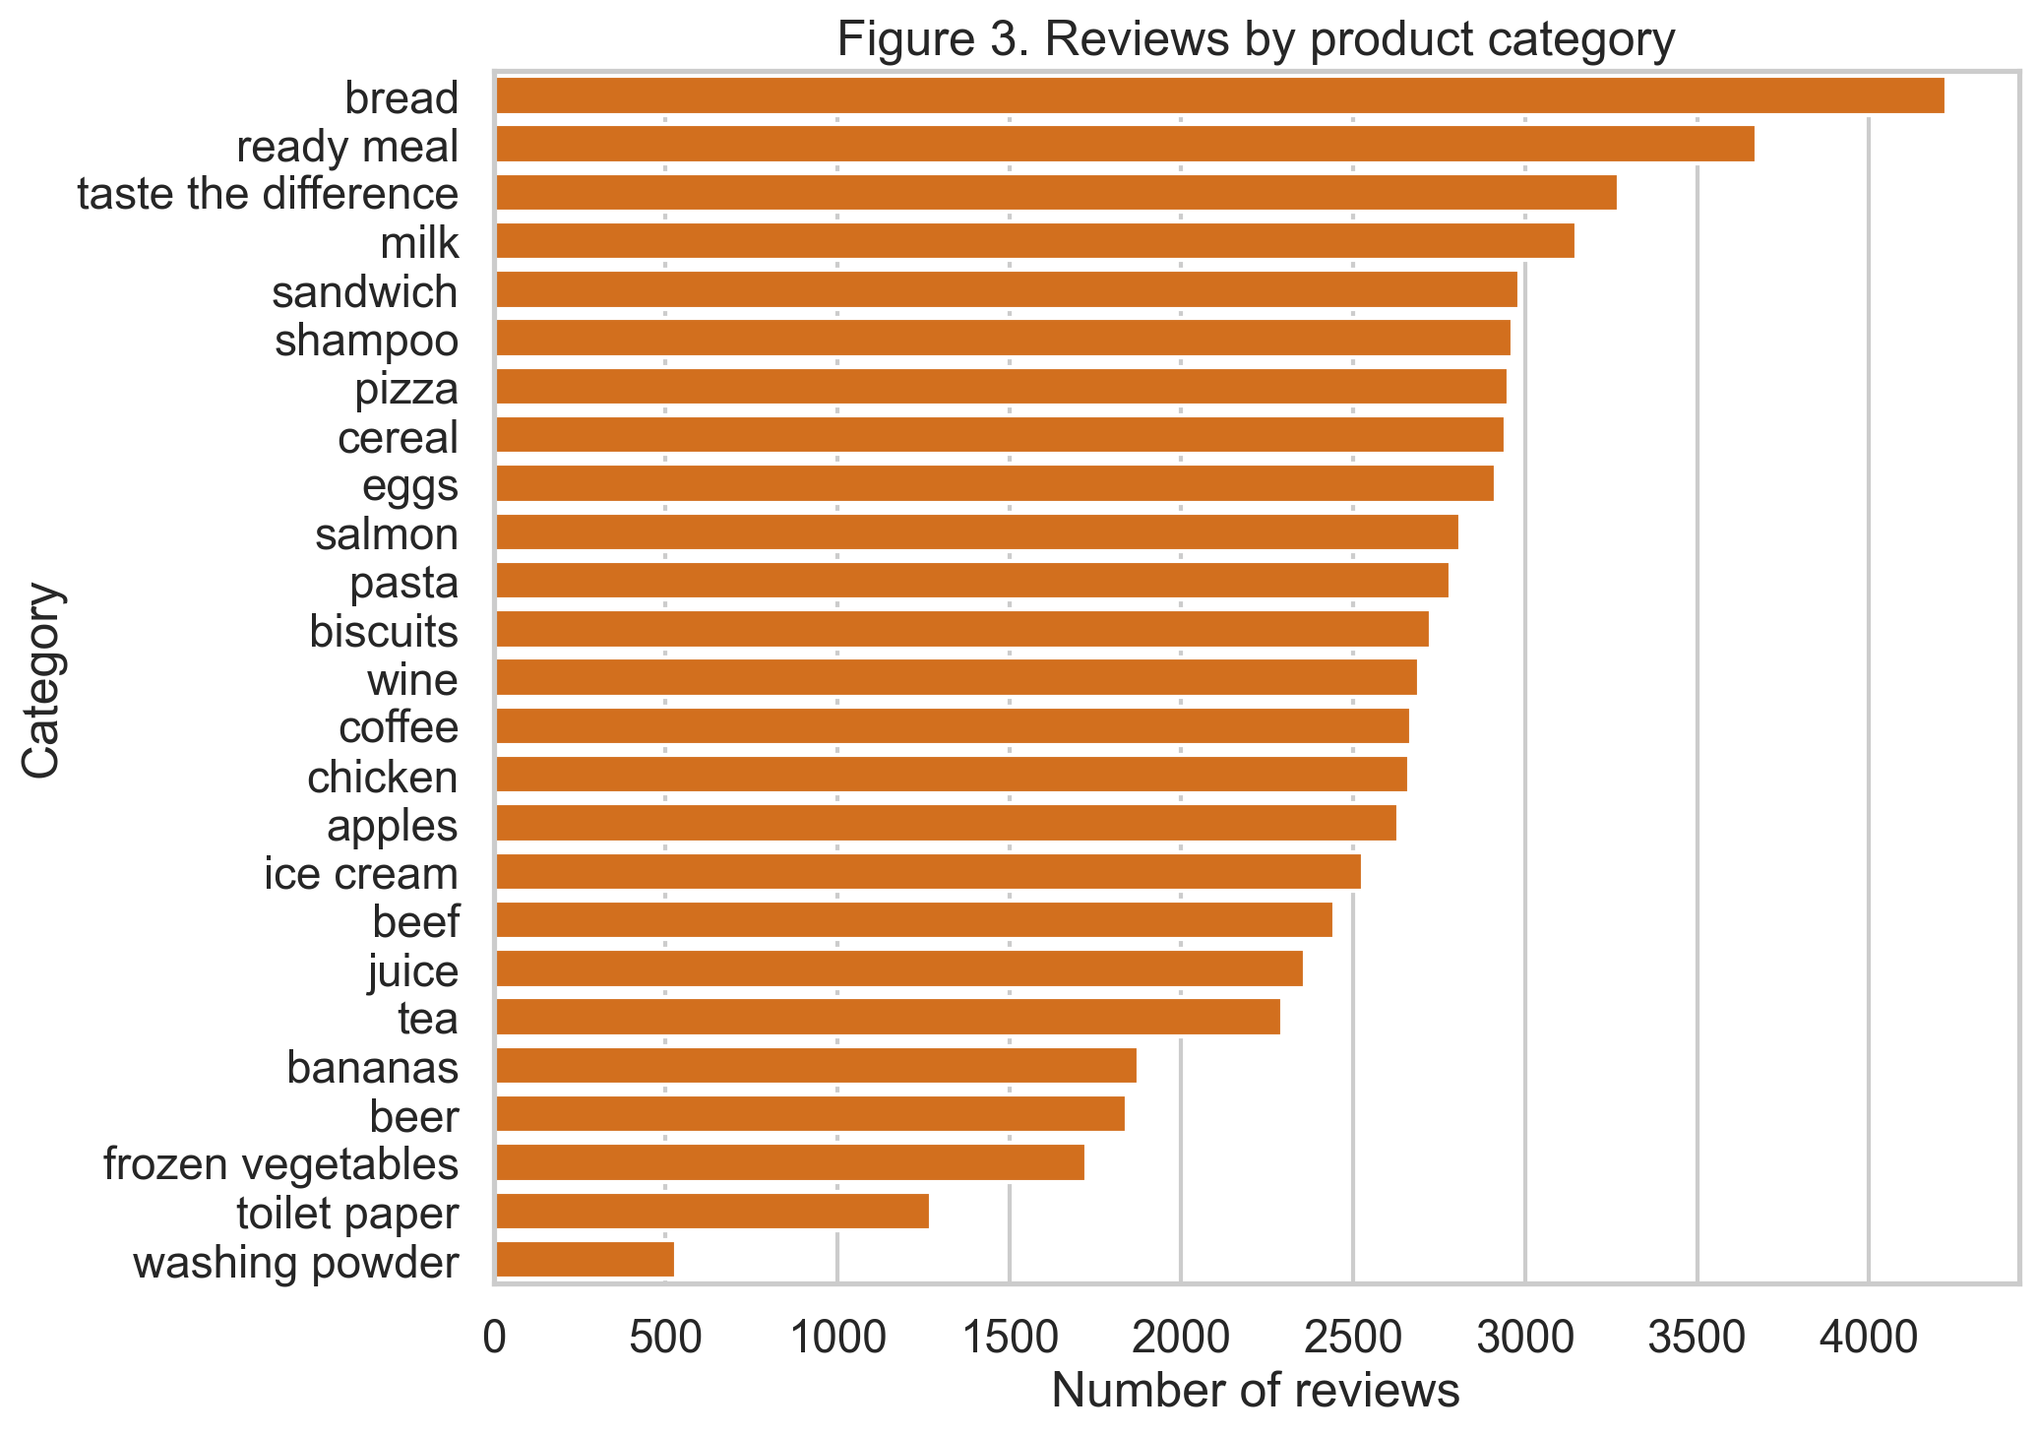
Figure A2. Number of cleaned reviews per product category.
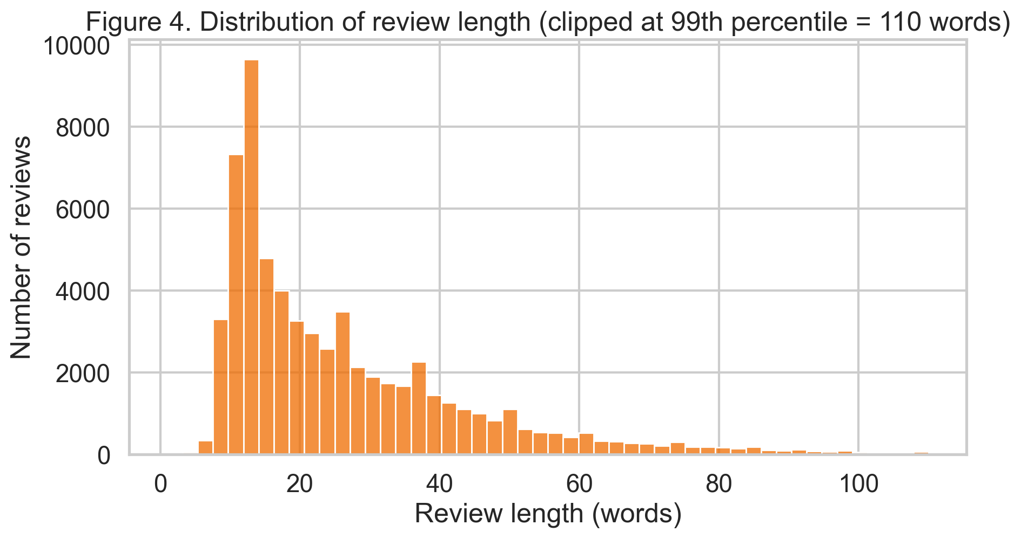
Figure A3. Distribution of review length in words (clipped at the 99th percentile for readability).
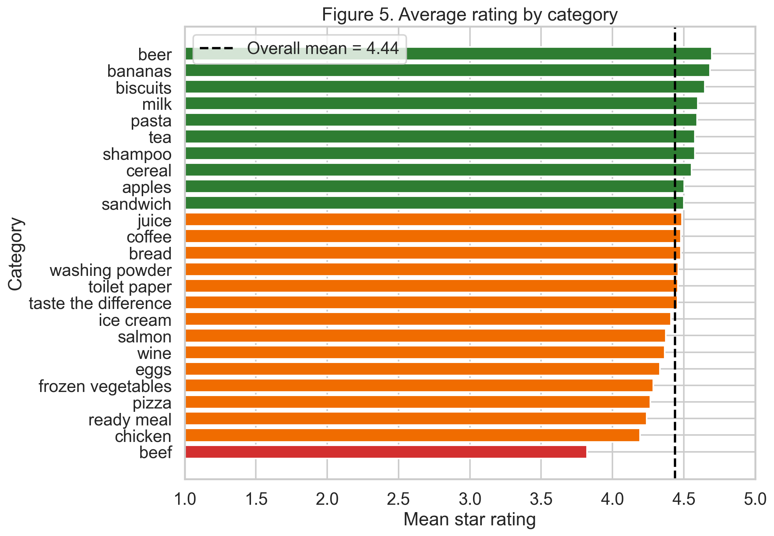
Figure A4. Mean star rating by category, sorted best to worst. Categories below the overall mean are shown in orange/red.
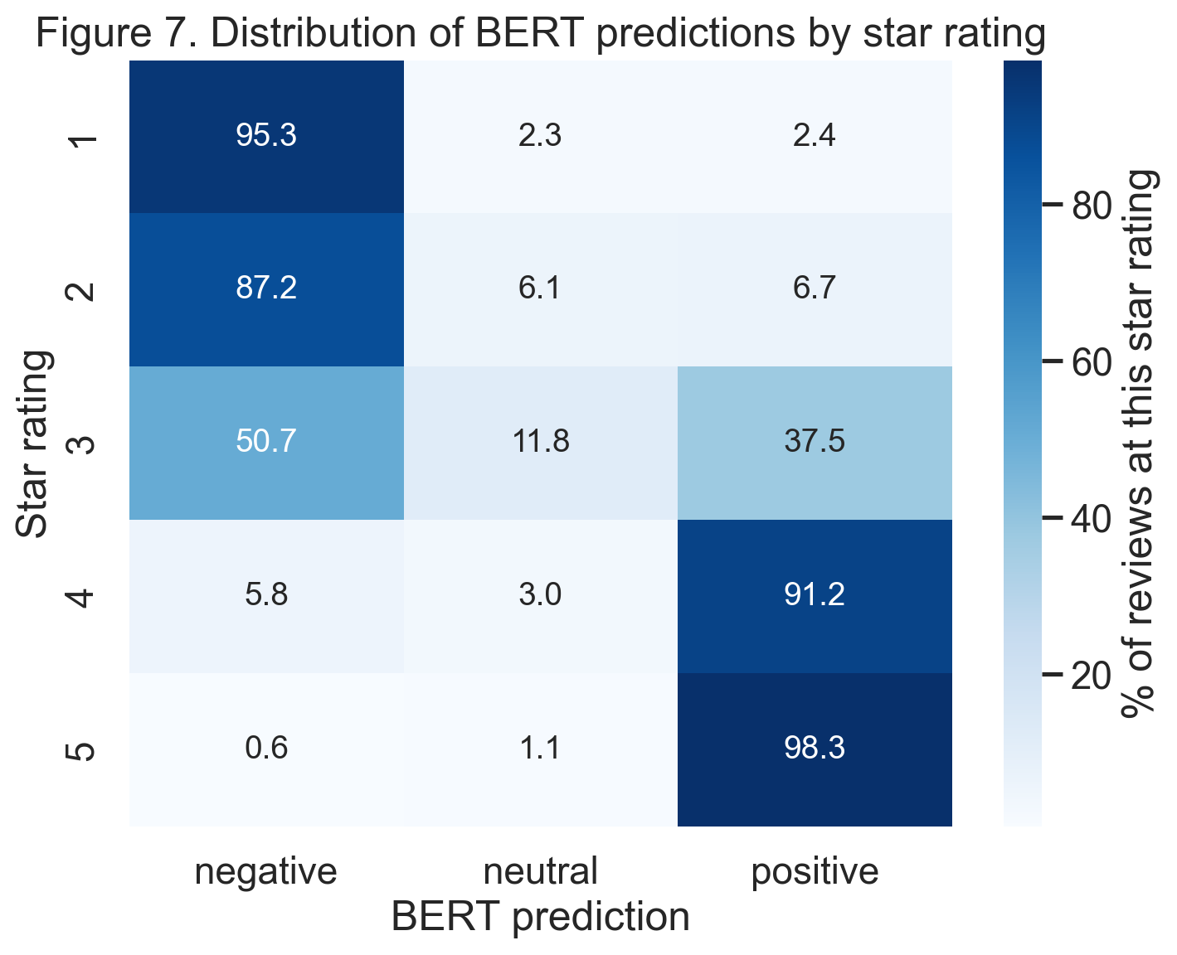
Figure A5. Distribution of BERT predictions by star rating. Note the 3-star row, which splits heavily between negative and positive BERT predictions — evidence that rating-based 'neutral' is not a natural sentiment category in text.
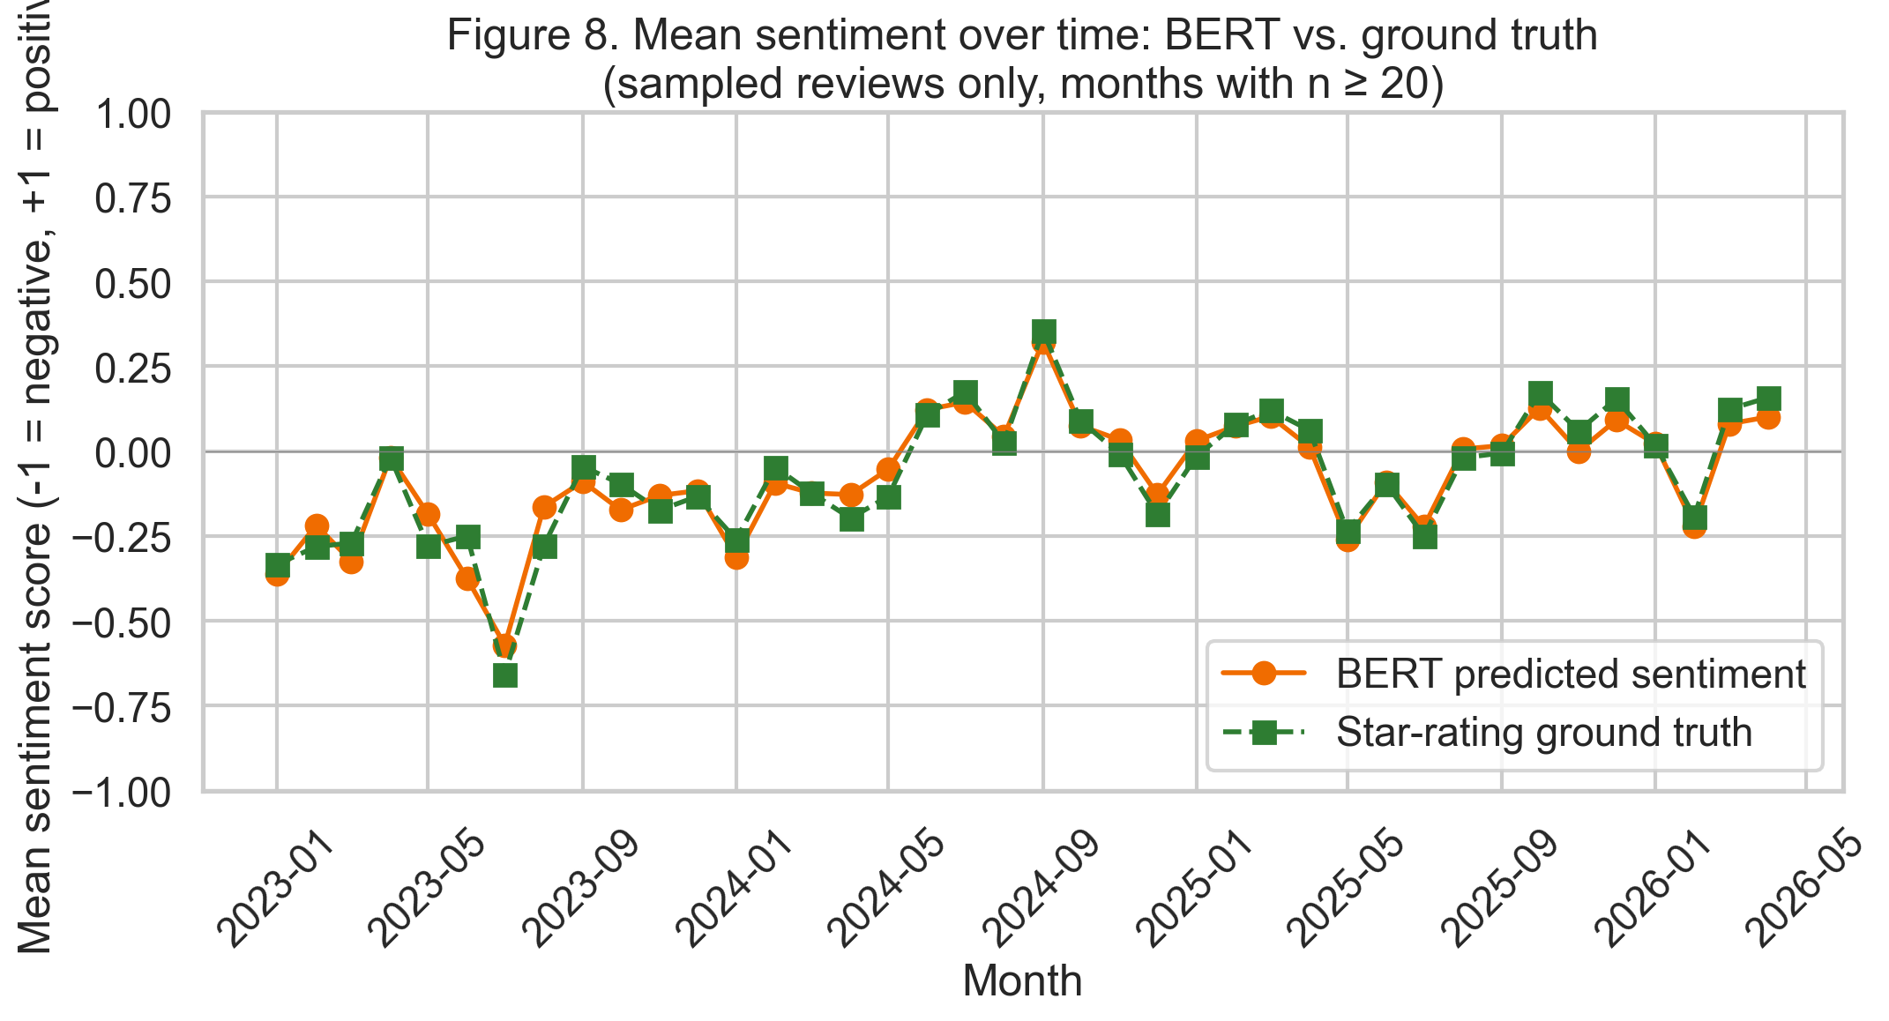
Figure A6. Mean monthly BERT sentiment compared with star-rating ground truth on the stratified sample. The two series track each other closely, indicating aggregate-level model reliability.
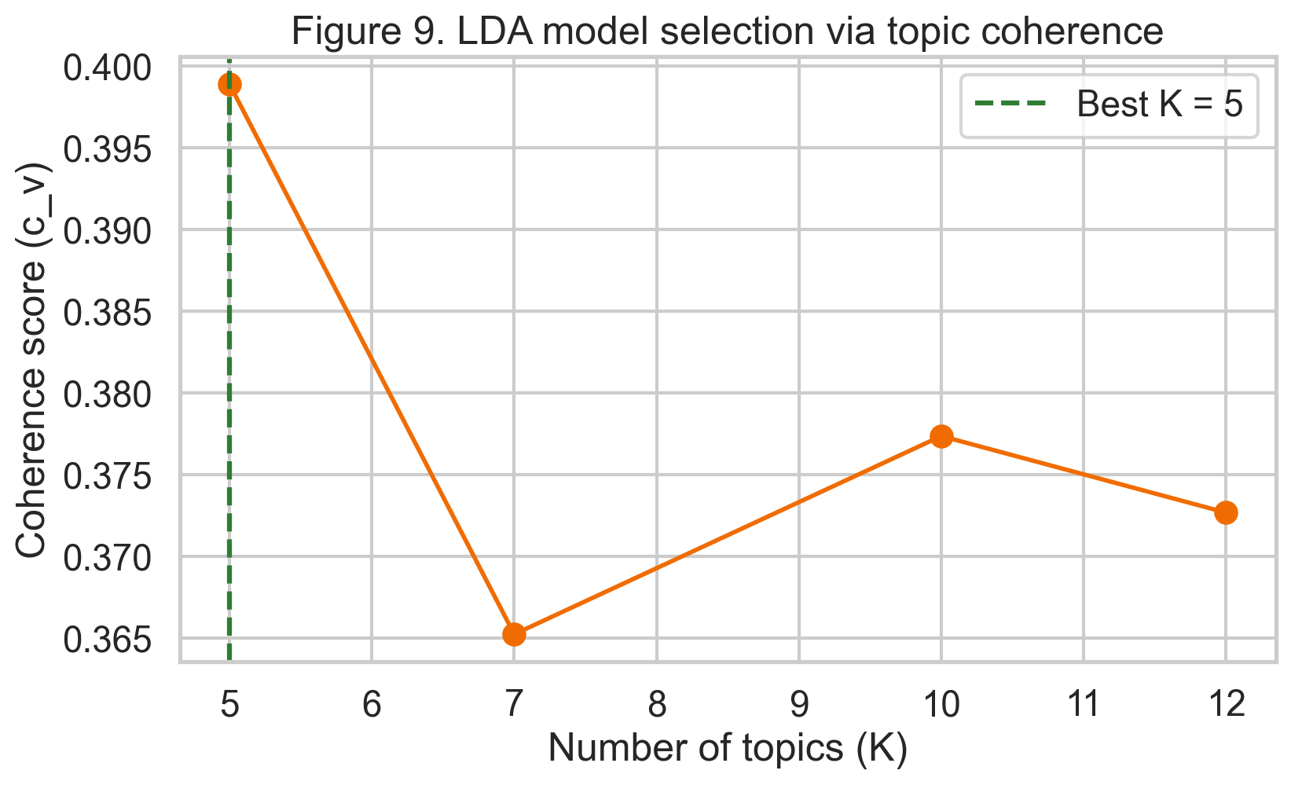
Figure A7. LDA topic coherence (c_v; Röder et al., 2015) across K ∈ {5, 7, 10, 12}. K = 5 was selected for the final model.
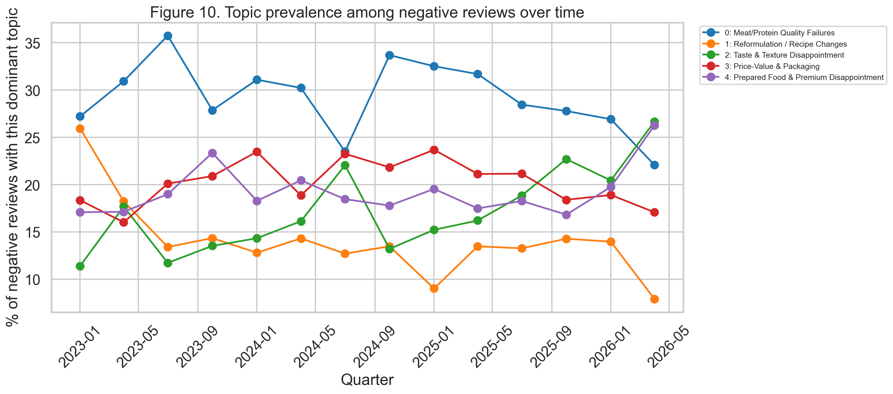
Figure A8. Topic prevalence among negative reviews over time, by quarter.
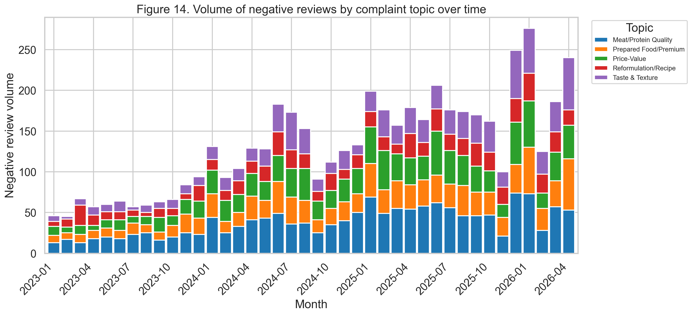
Figure A9. Volume of negative reviews by complaint topic, by month.

Appendix B — Python Source Code
The full Python source code for the analysis pipeline is reproduced below. Each script is self-contained and comments indicate its purpose, inputs and outputs. Scripts are listed in the order they are executed in the pipeline. All software cited per Harvard guidelines for computer programs (see References).
File: discover_products.py
"""
Stage 1: Product Discovery Scraper.

Queries Sainsbury's search API across diverse category keywords to build
a seed list of product IDs for Stage 2 (review harvesting).

Endpoint: https://www.sainsburys.co.uk/groceries-api/gol-services/product/v1/product
Discovered via Chrome DevTools > Network > Fetch/XHR on a search results page.

Output: data/products.csv
"""

import requests
import pandas as pd
import time
from pathlib import Path

OUTPUT_DIR = Path("data")
OUTPUT_DIR.mkdir(exist_ok=True)

SEARCH_URL = "https://www.sainsburys.co.uk/groceries-api/gol-services/product/v1/product"

# Headers that satisfy Akamai's bot detection. The Sec-Fetch-* and Origin
# headers signal that the request is coming from a legitimate browser context.
HEADERS = {
"Accept": "application/json, text/plain, */*",
"Accept-Language": "en-GB,en;q=0.9",
"Accept-Encoding": "gzip, deflate, br",
"Referer": "https://www.sainsburys.co.uk/gol-ui/SearchResults/milk",
"Origin": "https://www.sainsburys.co.uk",
"Sec-Fetch-Dest": "empty",
"Sec-Fetch-Mode": "cors",
"Sec-Fetch-Site": "same-origin",
"Sec-Ch-Ua": '"Chromium";v="124", "Not=A?Brand";v="24", "Google Chrome";v="124"',
"Sec-Ch-Ua-Mobile": "?0",
"Sec-Ch-Ua-Platform": '"macOS"',
"User-Agent": (
"Mozilla/5.0 (Macintosh; Intel Mac OS X 10_15_7) "
"AppleWebKit/537.36 (KHTML, like Gecko) "
"Chrome/124.0.0.0 Safari/537.36"
),
}

# Category keywords for BREADTH across Sainsbury's grocery range.
# Chosen to span: fresh food, packaged goods, ready meals, frozen,
# drinks, household, and the Taste the Difference premium own-brand.
# This diversity matters because our topic modelling (Stage 3) will
# surface different customer concerns across product types.
CATEGORY_KEYWORDS = [
# Fresh / staples
"milk", "bread", "eggs", "chicken", "beef", "salmon", "bananas", "apples",
# Packaged / ambient
"pasta", "cereal", "biscuits", "coffee", "tea",
# Ready meals / convenience
"ready meal", "pizza", "sandwich",
# Frozen
"ice cream", "frozen vegetables",
# Drinks
"wine", "beer", "juice",
# Household
"washing powder", "toilet paper", "shampoo",
# Premium own-brand
"taste the difference",
]

def fetch_page(keyword, page_number=1, page_size=60):
"""Fetch one page of search results for a given keyword."""
params = {
"filter[keyword]": keyword,
"page_number": page_number,
"page_size": page_size,
"sort_order": "FAVOURITES_FIRST",
}
response = requests.get(
SEARCH_URL, headers=HEADERS, params=params, timeout=30
)
response.raise_for_status()
return response.json()

def extract_products(response_data, keyword):
"""Extract product records from the search API response."""
products = []
for p in response_data.get("products", []):
reviews_info = p.get("reviews") or {}
retail_price = p.get("retail_price") or {}
products.append({
"product_uid": p.get("product_uid"),
"name": p.get("name"),
"category_keyword": keyword,
"price": retail_price.get("price"),
"review_count": reviews_info.get("total", 0) or 0,
"average_rating": reviews_info.get("average_rating"),
"brand": p.get("brand"),
"product_type": p.get("product_type"),
})
return products

def discover_products_for_keyword(keyword, max_pages=2):
"""For a given keyword, fetch up to max_pages of search results."""
print(f"\n[Keyword: {keyword}]")
all_products = []

for page_num in range(1, max_pages + 1):
try:
data = fetch_page(keyword, page_number=page_num)
products = extract_products(data, keyword)
total = data.get("controls", {}).get("total_record_count", "?")
print(f" Page {page_num}: got {len(products)} products "
f"(keyword has {total} total matches)")
all_products.extend(products)

# Stop early if we got fewer results than requested (no more pages)
if len(products) < 60:
break

# Be polite: sleep between requests
time.sleep(1.5)
except Exception as e:
print(f" Error on page {page_num}: {e}")
break

return all_products

def main():
print(f"Discovering products across {len(CATEGORY_KEYWORDS)} keywords")
print("=" * 60)

all_products = []
for keyword in CATEGORY_KEYWORDS:
products = discover_products_for_keyword(keyword, max_pages=2)
all_products.extend(products)
time.sleep(1) # extra sleep between keywords

df = pd.DataFrame(all_products)

print(f"\n{'=' * 60}")
print(f"Total products discovered (before dedup): {len(df)}")

if len(df) == 0:
print("No products retrieved. Check if requests are being blocked.")
return

# Remove duplicates (a product can match multiple keywords)
df = df.drop_duplicates(subset="product_uid").reset_index(drop=True)
print(f"Unique products after dedup: {len(df)}")

# Keep only products that actually have reviews
df["review_count"] = pd.to_numeric(df["review_count"], errors="coerce").fillna(0)
df_with_reviews = df[df["review_count"] > 0].copy()
print(f"Products with at least 1 review: {len(df_with_reviews)}")

# Summary by category
print("\nProducts with reviews by category:")
summary = (df_with_reviews
.groupby("category_keyword")
.agg(product_count=("product_uid", "count"),
total_reviews=("review_count", "sum"))
.sort_values("total_reviews", ascending=False))
print(summary)

output_file = OUTPUT_DIR / "products.csv"
df_with_reviews.to_csv(output_file, index=False)
print(f"\n[OK] Saved {len(df_with_reviews)} products to {output_file}")
print(f"Total reviews available across these products: "
f"{int(df_with_reviews['review_count'].sum()):,}")

if __name__ == "__main__":
main()

File: scrape_reviews.py
"""
Stage 2: Review Harvester.

For each product in data/products.csv, fetch reviews from the
Bazaarvoice-powered Sainsbury's reviews API and save incrementally
to data/reviews_raw.csv.

Endpoint: https://reviews.sainsburys-groceries.co.uk/data/reviews.json
Discovered via Chrome DevTools > Network > Fetch/XHR on a product page.

Sampling design:
- Up to MAX_REVIEWS_PER_PRODUCT most recent reviews per product
- Skip products with fewer than MIN_REVIEWS_PER_PRODUCT reviews
- Incremental writes: survives interruptions
- Resume: re-running skips already-scraped products
"""

import requests
import pandas as pd
import time
from pathlib import Path
from tqdm import tqdm

# --- Config ----------------------------------------------------------------

DATA_DIR = Path("data")
PRODUCTS_FILE = DATA_DIR / "products.csv"
REVIEWS_FILE = DATA_DIR / "reviews_raw.csv"

REVIEWS_URL = "https://reviews.sainsburys-groceries.co.uk/data/reviews.json"

MAX_REVIEWS_PER_PRODUCT = 50 # cap per product to balance diversity
MIN_REVIEWS_PER_PRODUCT = 5 # skip very-low-review products
BATCH_SIZE = 100 # Bazaarvoice max per request
SLEEP_BETWEEN_REQUESTS = 0.8 # polite rate-limiting
CHECKPOINT_EVERY_N_PRODUCTS = 50 # flush to disk every N products

HEADERS = {
"Accept": "application/json",
"Content-Type": "application/json",
"Referer": "https://www.sainsburys.co.uk/",
"User-Agent": (
"Mozilla/5.0 (Macintosh; Intel Mac OS X 10_15_7) "
"AppleWebKit/537.36 (KHTML, like Gecko) "
"Chrome/124.0.0.0 Safari/537.36"
),
}

# --- Core fetchers ---------------------------------------------------------

def fetch_reviews_page(product_id, offset=0, limit=BATCH_SIZE):
"""Fetch one batch of reviews for a given product ID."""
params = {
"ApiVersion": "5.4",
"Filter": f"ProductId:{product_id}",
"Sort": "SubmissionTime:desc", # newest first
"Offset": offset,
"Limit": limit,
"Include": "products",
}
response = requests.get(REVIEWS_URL, headers=HEADERS, params=params, timeout=30)
response.raise_for_status()
return response.json()

def extract_review_fields(raw_review, category_keyword):
"""Pull the fields we care about from a raw Bazaarvoice review record."""
secondary = raw_review.get("SecondaryRatings") or {}
quality = (secondary.get("Quality") or {}).get("Value")
value = (secondary.get("Value") or {}).get("Value")

return {
"review_id": raw_review.get("Id"),
"product_id": raw_review.get("ProductId"),
"product_name": raw_review.get("OriginalProductName"),
"category_keyword": category_keyword,
"rating": raw_review.get("Rating"),
"rating_quality": quality,
"rating_value": value,
"title": raw_review.get("Title"),
"text": raw_review.get("ReviewText"),
"submission_time": raw_review.get("SubmissionTime"),
"user_nickname": raw_review.get("UserNickname"),
"user_location": raw_review.get("UserLocation"),
"is_recommended": raw_review.get("IsRecommended"),
"helpfulness": raw_review.get("Helpfulness"),
"campaign_id": raw_review.get("CampaignId"),
"is_syndicated": raw_review.get("IsSyndicated"),
}

def fetch_reviews_for_product(product_uid, category_keyword, max_reviews):
"""Fetch up to max_reviews reviews for one product, paginating as needed."""
product_id = f"{product_uid}-P" # Bazaarvoice convention
reviews = []
offset = 0

while len(reviews) < max_reviews:
limit = min(BATCH_SIZE, max_reviews - len(reviews))
try:
data = fetch_reviews_page(product_id, offset=offset, limit=limit)
except Exception as e:
# Log and move on - don't let one product break the whole run
print(f" [WARN] product {product_uid} offset {offset} failed: {e}")
break

results = data.get("Results", [])
if not results:
break

for raw in results:
reviews.append(extract_review_fields(raw, category_keyword))

total_available = data.get("TotalResults", 0)
offset += len(results)

# Stop if we've pulled everything available
if offset >= total_available:
break

time.sleep(SLEEP_BETWEEN_REQUESTS)

return reviews

# --- Orchestrator ----------------------------------------------------------

def load_already_scraped_product_ids():
"""If reviews_raw.csv exists, return set of product_uids already scraped."""
if not REVIEWS_FILE.exists():
return set()
try:
existing = pd.read_csv(REVIEWS_FILE, usecols=["product_id"])
# product_id is "XXXXX-P", we want the "XXXXX" part
return set(existing["product_id"].str.replace("-P", "", regex=False).unique())
except Exception as e:
print(f"[WARN] Could not read existing reviews file: {e}")
return set()

def append_to_csv(new_rows, file_path):
"""Append rows to CSV, writing header only if file doesn't exist yet."""
if not new_rows:
return
df = pd.DataFrame(new_rows)
header = not file_path.exists()
df.to_csv(file_path, mode="a", header=header, index=False)

def main():
if not PRODUCTS_FILE.exists():
print(f"Missing {PRODUCTS_FILE}. Run discover_products.py first.")
return

products_df = pd.read_csv(PRODUCTS_FILE)
products_df["review_count"] = pd.to_numeric(products_df["review_count"], errors="coerce").fillna(0)

# Apply sampling rules
eligible = products_df[products_df["review_count"] >= MIN_REVIEWS_PER_PRODUCT].copy()

# Resume: skip products we've already done
already_done = load_already_scraped_product_ids()
if already_done:
print(f"Resuming: {len(already_done)} products already scraped, skipping them")
eligible = eligible[~eligible["product_uid"].astype(str).isin(already_done)]

print(f"Products to scrape: {len(eligible)}")
print(f"Cap per product: {MAX_REVIEWS_PER_PRODUCT}")
print(f"Expected max reviews: ~{len(eligible) * MAX_REVIEWS_PER_PRODUCT:,}")
print(f"Estimated runtime: ~{len(eligible) * 1.5 / 60:.0f} minutes")
print("=" * 60)

if len(eligible) == 0:
print("Nothing to do.")
return

buffer = []
products_done_this_run = 0
total_reviews_this_run = 0

for _, row in tqdm(eligible.iterrows(), total=len(eligible), desc="Products"):
product_uid = str(row["product_uid"])
keyword = row["category_keyword"]
# Per-product cap: min of overall cap and reviews actually available
cap = min(MAX_REVIEWS_PER_PRODUCT, int(row["review_count"]))

reviews = fetch_reviews_for_product(product_uid, keyword, cap)
buffer.extend(reviews)
total_reviews_this_run += len(reviews)
products_done_this_run += 1

# Checkpoint flush
if products_done_this_run % CHECKPOINT_EVERY_N_PRODUCTS == 0:
append_to_csv(buffer, REVIEWS_FILE)
buffer = []
tqdm.write(f" [checkpoint] {products_done_this_run} products done, "
f"{total_reviews_this_run:,} reviews collected so far")

# Final flush
append_to_csv(buffer, REVIEWS_FILE)

print("=" * 60)
print(f"[OK] Done. Products scraped this run: {products_done_this_run}")
print(f"Reviews collected this run: {total_reviews_this_run:,}")

# Final stats
if REVIEWS_FILE.exists():
final = pd.read_csv(REVIEWS_FILE)
print(f"Total reviews in {REVIEWS_FILE}: {len(final):,}")
print(f"Unique products: {final['product_id'].nunique()}")

if __name__ == "__main__":
main()

File: clean_reviews.py
"""
Stage 3: Data Cleaning & Exploratory Analysis.

Takes data/reviews_raw.csv (88k+ reviews from Stage 2) and produces:
- data/reviews_clean.csv (cleaned, filtered to analysis window)
- figures/data_overview_*.png (exploratory figures for the report)
- Summary statistics printed to terminal

Cleaning steps:
1. Drop reviews with no text
2. Parse submission_time to proper datetime, drop unparseable
3. Filter to analysis window: 2023-01-01 -> 2026-04-22
4. Drop duplicate review_ids (keep first)
5. Normalise whitespace in text and title
6. Flag very short reviews (<20 chars) as low-info
7. Create combined `full_text` = title + text (for NLP later)
"""

import pandas as pd
import numpy as np
import matplotlib.pyplot as plt
import seaborn as sns
from pathlib import Path
import re

# --- Config ----------------------------------------------------------------

DATA_DIR = Path("data")
FIGS_DIR = Path("figures")
FIGS_DIR.mkdir(exist_ok=True)

INPUT_FILE = DATA_DIR / "reviews_raw.csv"
OUTPUT_FILE = DATA_DIR / "reviews_clean.csv"

ANALYSIS_START = pd.Timestamp("2023-01-01", tz="UTC")
ANALYSIS_END = pd.Timestamp("2026-04-23", tz="UTC")

# Apply a consistent, professional figure style
sns.set_theme(style="whitegrid", context="talk")
plt.rcParams["figure.dpi"] = 120
plt.rcParams["savefig.dpi"] = 200
plt.rcParams["savefig.bbox"] = "tight"

# --- Cleaning helpers ------------------------------------------------------

def normalise_whitespace(s):
"""Collapse all whitespace to single spaces, strip ends."""
if pd.isna(s):
return s
return re.sub(r"\s+", " ", str(s)).strip()

def load_and_clean(path):
"""Load raw CSV, apply cleaning steps, return cleaned DataFrame."""
print(f"Loading {path}...")
df = pd.read_csv(path)
print(f" Raw rows: {len(df):,}")

# Drop rows with no text (ratings-only reviews)
before = len(df)
df = df.dropna(subset=["text"])
df = df[df["text"].astype(str).str.strip() != ""]
print(f" After dropping empty text: {len(df):,} (removed {before - len(df):,})")

# Parse datetime
df["submission_time"] = pd.to_datetime(
df["submission_time"], errors="coerce", utc=True
)
before = len(df)
df = df.dropna(subset=["submission_time"])
print(f" After dropping bad dates: {len(df):,} (removed {before - len(df):,})")

# Filter to analysis window
before = len(df)
df = df[(df["submission_time"] >= ANALYSIS_START) &
(df["submission_time"] <= ANALYSIS_END)]
print(f" After filtering to analysis window "
f"[{ANALYSIS_START.date()} -> {ANALYSIS_END.date()}]: "
f"{len(df):,} (removed {before - len(df):,})")

# Dedupe on review_id
before = len(df)
df = df.drop_duplicates(subset=["review_id"], keep="first")
print(f" After deduplication: {len(df):,} (removed {before - len(df):,})")

# Normalise whitespace
df["text"] = df["text"].apply(normalise_whitespace)
df["title"] = df["title"].apply(normalise_whitespace)

# Combined text field for NLP
df["full_text"] = df["title"].fillna("") + ". " + df["text"].fillna("")
df["full_text"] = df["full_text"].apply(normalise_whitespace)

# Length features
df["text_length_chars"] = df["text"].astype(str).str.len()
df["text_length_words"] = df["text"].astype(str).str.split().str.len()

# Flag very short reviews (signal, not filter - we keep them but can exclude for LDA)
df["is_short"] = df["text_length_chars"] < 20

# Date features for temporal analysis
df["date"] = df["submission_time"].dt.date
df["year_month"] = df["submission_time"].dt.to_period("M").astype(str)
df["year"] = df["submission_time"].dt.year

# Sentiment ground truth: collapse 1-5 rating to positive/neutral/negative
def rating_to_sentiment(r):
if pd.isna(r): return None
r = int(r)
if r <= 2: return "negative"
if r == 3: return "neutral"
return "positive"
df["rating_sentiment"] = df["rating"].apply(rating_to_sentiment)

return df

# --- Exploratory figures ---------------------------------------------------

def plot_rating_distribution(df, out_path):
fig, ax = plt.subplots(figsize=(8, 5))
counts = df["rating"].value_counts().sort_index()
sns.barplot(x=counts.index, y=counts.values, ax=ax, color="#F06C00")
ax.set_xlabel("Star rating")
ax.set_ylabel("Number of reviews")
ax.set_title("Figure 1. Distribution of star ratings\n"
f"(n = {len(df):,} reviews)")
# Add percentage labels
total = counts.sum()
for i, v in enumerate(counts.values):
ax.text(i, v, f"{v/total:.1%}", ha="center", va="bottom", fontsize=11)
plt.savefig(out_path)
plt.close()
print(f" [fig] {out_path}")

def plot_reviews_over_time(df, out_path):
monthly = df.groupby("year_month").size().reset_index(name="count")
monthly["year_month_dt"] = pd.to_datetime(monthly["year_month"])

fig, ax = plt.subplots(figsize=(12, 5))
sns.lineplot(data=monthly, x="year_month_dt", y="count", ax=ax,
color="#F06C00", linewidth=2, marker="o", markersize=6)
ax.set_xlabel("Month")
ax.set_ylabel("Number of reviews")
ax.set_title("Figure 2. Review volume over time")
ax.tick_params(axis="x", rotation=45)
plt.savefig(out_path)
plt.close()
print(f" [fig] {out_path}")

def plot_category_counts(df, out_path):
cat_counts = df["category_keyword"].value_counts()
fig, ax = plt.subplots(figsize=(10, 8))
sns.barplot(y=cat_counts.index, x=cat_counts.values, ax=ax,
color="#F06C00")
ax.set_xlabel("Number of reviews")
ax.set_ylabel("Category")
ax.set_title("Figure 3. Reviews by product category")
plt.savefig(out_path)
plt.close()
print(f" [fig] {out_path}")

def plot_text_length_distribution(df, out_path):
fig, ax = plt.subplots(figsize=(10, 5))
# Clip at 99th percentile for readability
p99 = df["text_length_words"].quantile(0.99)
plot_df = df[df["text_length_words"] <= p99]
sns.histplot(data=plot_df, x="text_length_words", bins=50, ax=ax,
color="#F06C00")
ax.set_xlabel("Review length (words)")
ax.set_ylabel("Number of reviews")
ax.set_title(f"Figure 4. Distribution of review length (clipped at 99th percentile = {int(p99)} words)")
plt.savefig(out_path)
plt.close()
print(f" [fig] {out_path}")

def plot_avg_rating_by_category(df, out_path):
cat_ratings = (df.groupby("category_keyword")["rating"]
.agg(["mean", "count"])
.sort_values("mean"))
fig, ax = plt.subplots(figsize=(10, 8))
colors = ["#D32F2F" if m < 4 else "#F06C00" if m < 4.5 else "#2E7D32"
for m in cat_ratings["mean"]]
ax.barh(cat_ratings.index, cat_ratings["mean"], color=colors)
ax.set_xlim(1, 5)
ax.axvline(df["rating"].mean(), color="black", linestyle="--",
label=f"Overall mean = {df['rating'].mean():.2f}")
ax.set_xlabel("Mean star rating")
ax.set_ylabel("Category")
ax.set_title("Figure 5. Average rating by category")
ax.legend()
plt.savefig(out_path)
plt.close()
print(f" [fig] {out_path}")

# --- Main -------------------------------------------------------------------

def main():
if not INPUT_FILE.exists():
print(f"Missing {INPUT_FILE}. Run scrape_reviews.py first.")
return

df = load_and_clean(INPUT_FILE)

print("\n" + "=" * 60)
print("SUMMARY STATISTICS")
print("=" * 60)
print(f"Cleaned reviews: {len(df):,}")
print(f"Unique products: {df['product_id'].nunique():,}")
print(f"Categories: {df['category_keyword'].nunique()}")
print(f"Date range: {df['submission_time'].min().date()} to {df['submission_time'].max().date()}")
print(f"Mean rating: {df['rating'].mean():.2f}")
print(f"Median review length: {int(df['text_length_words'].median())} words")

print("\nRating distribution:")
print(df["rating"].value_counts(normalize=True).sort_index().apply(lambda x: f"{x:.1%}"))

print("\nRating sentiment distribution (our ground truth):")
print(df["rating_sentiment"].value_counts(normalize=True).apply(lambda x: f"{x:.1%}"))

print("\nReviews per year:")
print(df["year"].value_counts().sort_index())

# Save cleaned data
df.to_csv(OUTPUT_FILE, index=False)
print(f"\n[OK] Saved to {OUTPUT_FILE}")

# Figures
print("\nGenerating exploratory figures...")
plot_rating_distribution(df, FIGS_DIR / "fig01_rating_distribution.png")
plot_reviews_over_time(df, FIGS_DIR / "fig02_reviews_over_time.png")
plot_category_counts(df, FIGS_DIR / "fig03_category_counts.png")
plot_text_length_distribution(df, FIGS_DIR / "fig04_text_length.png")
plot_avg_rating_by_category(df, FIGS_DIR / "fig05_avg_rating_by_category.png")

print(f"\n[OK] All figures saved to {FIGS_DIR}/")

if __name__ == "__main__":
main()

File: sentiment_analysis.py
"""
Stage 4: Sentiment Analysis with BERT + Ground-Truth Validation.

Applies a transformer-based sentiment classifier (RoBERTa fine-tuned for
sentiment on Twitter) to a stratified sample of Sainsbury's product reviews,
then validates the model's predictions against the star-rating ground truth.

Model: cardiffnlp/twitter-roberta-base-sentiment-latest
- RoBERTa-base architecture (125M parameters)
- Fine-tuned on ~124M tweets for 3-class sentiment (negative/neutral/positive)
- Handles short, informal user-generated text better than generic BERT

Ground truth construction:
- Stars 1-2 => negative
- Stars 3 => neutral
- Stars 4-5 => positive

Outputs:
- data/reviews_with_sentiment.csv (sample with BERT predictions)
- figures/fig06_confusion_matrix.png
- figures/fig07_bert_vs_rating_heatmap.png
- figures/fig08_sentiment_over_time.png
- Printed classification report (precision/recall/F1 per class)
"""

import pandas as pd
import numpy as np
import matplotlib.pyplot as plt
import seaborn as sns
from pathlib import Path
from tqdm import tqdm
from transformers import AutoTokenizer, AutoModelForSequenceClassification
from scipy.special import softmax
import torch
from sklearn.metrics import (classification_report, confusion_matrix,
accuracy_score, f1_score)

# --- Config ----------------------------------------------------------------

DATA_DIR = Path("data")
FIGS_DIR = Path("figures")
FIGS_DIR.mkdir(exist_ok=True)

INPUT_FILE = DATA_DIR / "reviews_clean.csv"
OUTPUT_FILE = DATA_DIR / "reviews_with_sentiment.csv"

MODEL_NAME = "cardiffnlp/twitter-roberta-base-sentiment-latest"
SAMPLES_PER_STAR = 1000 # stratified: 1000 per star rating, total 5000
MAX_TOKEN_LENGTH = 256 # truncate longer reviews (few are longer)
BATCH_SIZE = 16 # batched inference for speed
RANDOM_SEED = 42

# Mapping from model's label indices to human-readable labels
LABEL_MAP = {0: "negative", 1: "neutral", 2: "positive"}

# Style
sns.set_theme(style="whitegrid", context="talk")
plt.rcParams["figure.dpi"] = 120
plt.rcParams["savefig.dpi"] = 200
plt.rcParams["savefig.bbox"] = "tight"

# --- Sampling --------------------------------------------------------------

def stratified_sample(df, n_per_group, group_col="rating", seed=RANDOM_SEED):
"""Take n_per_group rows per rating class (or all if fewer available)."""
parts = []
for star in sorted(df[group_col].dropna().unique()):
subset = df[df[group_col] == star]
take = min(len(subset), n_per_group)
parts.append(subset.sample(n=take, random_state=seed))
return pd.concat(parts).sample(frac=1, random_state=seed).reset_index(drop=True)

# --- Model loading ---------------------------------------------------------

def load_model(model_name):
"""Load tokenizer + model. First call downloads ~500MB."""
print(f"Loading model: {model_name}")
print("(first run downloads ~500MB - subsequent runs use local cache)")
tokenizer = AutoTokenizer.from_pretrained(model_name)
model = AutoModelForSequenceClassification.from_pretrained(model_name)
model.eval() # inference mode - disables dropout
# Use MPS (Apple Silicon GPU) if available, else CPU
device = torch.device("mps") if torch.backends.mps.is_available() else torch.device("cpu")
model = model.to(device)
print(f"Model loaded on device: {device}")
return tokenizer, model, device

# --- Inference -------------------------------------------------------------

def predict_batch(texts, tokenizer, model, device):
"""Run sentiment prediction on a batch of texts."""
inputs = tokenizer(
texts,
return_tensors="pt",
truncation=True,
padding=True,
max_length=MAX_TOKEN_LENGTH,
).to(device)

with torch.no_grad():
outputs = model(**inputs)

# Convert logits to probabilities
scores = outputs.logits.cpu().numpy()
probs = softmax(scores, axis=1)
preds = np.argmax(probs, axis=1)
return preds, probs

def predict_all(df, tokenizer, model, device, text_col="full_text"):
"""Run model over all reviews in df, batched."""
all_preds = []
all_probs = []

texts = df[text_col].astype(str).tolist()

for i in tqdm(range(0, len(texts), BATCH_SIZE), desc="BERT inference"):
batch = texts[i:i + BATCH_SIZE]
preds, probs = predict_batch(batch, tokenizer, model, device)
all_preds.extend(preds.tolist())
all_probs.extend(probs.tolist())

df = df.copy()
df["bert_pred_idx"] = all_preds
df["bert_pred"] = [LABEL_MAP[p] for p in all_preds]
probs_arr = np.array(all_probs)
df["bert_prob_negative"] = probs_arr[:, 0]
df["bert_prob_neutral"] = probs_arr[:, 1]
df["bert_prob_positive"] = probs_arr[:, 2]
df["bert_confidence"] = probs_arr.max(axis=1)
return df

# --- Evaluation figures ----------------------------------------------------

def plot_confusion_matrix(df, out_path):
"""BERT prediction vs. star-rating ground truth."""
labels = ["negative", "neutral", "positive"]
y_true = df["rating_sentiment"]
y_pred = df["bert_pred"]
cm = confusion_matrix(y_true, y_pred, labels=labels)
cm_pct = cm / cm.sum(axis=1, keepdims=True) * 100

fig, ax = plt.subplots(figsize=(8, 6))
sns.heatmap(cm_pct, annot=cm, fmt="d", cmap="Blues",
xticklabels=labels, yticklabels=labels,
cbar_kws={"label": "% of ground-truth row"},
ax=ax, annot_kws={"size": 14})
ax.set_xlabel("BERT prediction")
ax.set_ylabel("Ground truth (from star rating)")
acc = accuracy_score(y_true, y_pred)
f1 = f1_score(y_true, y_pred, average="macro")
ax.set_title(f"Figure 6. Confusion matrix: BERT vs. star-rating ground truth\n"
f"Accuracy = {acc:.2%}, Macro-F1 = {f1:.3f}")
plt.savefig(out_path)
plt.close()
print(f" [fig] {out_path}")

def plot_bert_vs_rating_heatmap(df, out_path):
"""Full 5x3 heatmap: star rating vs BERT prediction (more granular than CM)."""
ct = pd.crosstab(df["rating"], df["bert_pred"],
normalize="index") * 100
# Ensure column order
col_order = [c for c in ["negative", "neutral", "positive"] if c in ct.columns]
ct = ct[col_order]

fig, ax = plt.subplots(figsize=(8, 6))
sns.heatmap(ct, annot=True, fmt=".1f", cmap="Blues",
cbar_kws={"label": "% of reviews at this star rating"},
ax=ax, annot_kws={"size": 14})
ax.set_xlabel("BERT prediction")
ax.set_ylabel("Star rating")
ax.set_title("Figure 7. Distribution of BERT predictions by star rating")
plt.savefig(out_path)
plt.close()
print(f" [fig] {out_path}")

def plot_sentiment_over_time(df_all, out_path):
"""
Apply BERT predictions to ALL reviews (via lookup from our sampled
df), OR if we only have sample predictions, plot the sample's
sentiment-vs-rating over time.

For now: plot rolling average of BERT-predicted sentiment score
for the sampled reviews over time.
"""
df = df_all.copy()
df["submission_time"] = pd.to_datetime(df["submission_time"], utc=True)
# Map BERT prediction to numeric score: -1, 0, +1
score_map = {"negative": -1, "neutral": 0, "positive": 1}
df["bert_score"] = df["bert_pred"].map(score_map)
# Similarly for ground truth
df["truth_score"] = df["rating_sentiment"].map(score_map)
# Monthly aggregation
df["year_month"] = df["submission_time"].dt.to_period("M").dt.to_timestamp()
monthly = df.groupby("year_month").agg(
bert_mean=("bert_score", "mean"),
truth_mean=("truth_score", "mean"),
n=("bert_score", "count")
).reset_index()
# Drop months with <20 reviews (noisy)
monthly = monthly[monthly["n"] >= 20]

fig, ax = plt.subplots(figsize=(12, 5))
ax.plot(monthly["year_month"], monthly["bert_mean"], marker="o",
label="BERT predicted sentiment", color="#F06C00", linewidth=2)
ax.plot(monthly["year_month"], monthly["truth_mean"], marker="s",
label="Star-rating ground truth", color="#2E7D32", linewidth=2, linestyle="--")
ax.axhline(0, color="gray", linewidth=0.5)
ax.set_ylim(-1, 1)
ax.set_ylabel("Mean sentiment score (-1 = negative, +1 = positive)")
ax.set_xlabel("Month")
ax.set_title("Figure 8. Mean sentiment over time: BERT vs. ground truth\n"
"(sampled reviews only, months with n ≥ 20)")
ax.legend(loc="lower right")
ax.tick_params(axis="x", rotation=45)
plt.savefig(out_path)
plt.close()
print(f" [fig] {out_path}")

# --- Main -------------------------------------------------------------------

def main():
if not INPUT_FILE.exists():
print(f"Missing {INPUT_FILE}. Run clean_reviews.py first.")
return

print(f"Loading cleaned reviews from {INPUT_FILE}...")
df = pd.read_csv(INPUT_FILE)
df = df.dropna(subset=["rating", "full_text", "rating_sentiment"])
df["rating"] = df["rating"].astype(int)
print(f" Total cleaned reviews: {len(df):,}")

# Stratified sample
print(f"\nTaking stratified sample: {SAMPLES_PER_STAR} per star rating")
sample = stratified_sample(df, SAMPLES_PER_STAR)
print(f"Sample size: {len(sample):,}")
print("Sample rating distribution:")
print(sample["rating"].value_counts().sort_index())

# Load model + predict
print("")
tokenizer, model, device = load_model(MODEL_NAME)
print("")
sample = predict_all(sample, tokenizer, model, device)

# Save
sample.to_csv(OUTPUT_FILE, index=False)
print(f"\n[OK] Saved predictions to {OUTPUT_FILE}")

# --- Evaluation ---
print("\n" + "=" * 60)
print("MODEL VALIDATION: BERT vs. star-rating ground truth")
print("=" * 60)

y_true = sample["rating_sentiment"]
y_pred = sample["bert_pred"]

print(f"Accuracy: {accuracy_score(y_true, y_pred):.3f}")
print(f"Macro F1: {f1_score(y_true, y_pred, average='macro'):.3f}")
print(f"Weighted F1: {f1_score(y_true, y_pred, average='weighted'):.3f}")
print("\nClassification report:")
print(classification_report(y_true, y_pred, digits=3))

# Figures
print("\nGenerating evaluation figures...")
plot_confusion_matrix(sample, FIGS_DIR / "fig06_confusion_matrix.png")
plot_bert_vs_rating_heatmap(sample, FIGS_DIR / "fig07_bert_vs_rating_heatmap.png")
plot_sentiment_over_time(sample, FIGS_DIR / "fig08_sentiment_over_time.png")

print(f"\n[OK] All figures saved to {FIGS_DIR}/")

if __name__ == "__main__":
main()

File: apply_bert_full.py
"""
Stage 4b: Apply validated BERT sentiment model to the FULL cleaned dataset.

After establishing in Stage 4 that the RoBERTa model performs reliably
(76.8% accuracy, strong agreement with ground truth at the monthly
aggregate level), we now apply it to all 64,916 reviews to enable
rich downstream analysis (temporal trends, category-level sentiment,
topic modelling on negative reviews, etc.).

Output: data/reviews_full_sentiment.csv
"""

import pandas as pd
import numpy as np
from pathlib import Path
from tqdm import tqdm
from transformers import AutoTokenizer, AutoModelForSequenceClassification
from scipy.special import softmax
import torch

DATA_DIR = Path("data")
INPUT_FILE = DATA_DIR / "reviews_clean.csv"
OUTPUT_FILE = DATA_DIR / "reviews_full_sentiment.csv"

MODEL_NAME = "cardiffnlp/twitter-roberta-base-sentiment-latest"
MAX_TOKEN_LENGTH = 256
BATCH_SIZE = 32 # bigger batches are fine on the full dataset

LABEL_MAP = {0: "negative", 1: "neutral", 2: "positive"}

def load_model():
print(f"Loading model from local cache: {MODEL_NAME}")
tokenizer = AutoTokenizer.from_pretrained(MODEL_NAME)
model = AutoModelForSequenceClassification.from_pretrained(MODEL_NAME)
model.eval()
device = torch.device("mps") if torch.backends.mps.is_available() else torch.device("cpu")
model = model.to(device)
print(f"Device: {device}")
return tokenizer, model, device

def predict_all(texts, tokenizer, model, device):
all_preds = []
all_probs = []
for i in tqdm(range(0, len(texts), BATCH_SIZE), desc="BERT inference"):
batch = texts[i:i + BATCH_SIZE]
inputs = tokenizer(
batch, return_tensors="pt", truncation=True,
padding=True, max_length=MAX_TOKEN_LENGTH,
).to(device)
with torch.no_grad():
outputs = model(**inputs)
scores = outputs.logits.cpu().numpy()
probs = softmax(scores, axis=1)
preds = np.argmax(probs, axis=1)
all_preds.extend(preds.tolist())
all_probs.extend(probs.tolist())
return all_preds, all_probs

def main():
if not INPUT_FILE.exists():
print(f"Missing {INPUT_FILE}. Run clean_reviews.py first.")
return

print(f"Loading {INPUT_FILE}...")
df = pd.read_csv(INPUT_FILE)
df = df.dropna(subset=["full_text"]).reset_index(drop=True)
print(f"Total reviews to classify: {len(df):,}")

# Estimated runtime
est_mins = len(df) / BATCH_SIZE / 5 / 60 # ~5 batches/sec on MPS
print(f"Estimated runtime: ~{est_mins:.0f} minutes")

tokenizer, model, device = load_model()

texts = df["full_text"].astype(str).tolist()
preds, probs = predict_all(texts, tokenizer, model, device)

# Add to DataFrame
probs_arr = np.array(probs)
df["bert_pred_idx"] = preds
df["bert_pred"] = [LABEL_MAP[p] for p in preds]
df["bert_prob_negative"] = probs_arr[:, 0]
df["bert_prob_neutral"] = probs_arr[:, 1]
df["bert_prob_positive"] = probs_arr[:, 2]
df["bert_confidence"] = probs_arr.max(axis=1)
# Signed score for temporal plots
df["bert_score"] = probs_arr[:, 2] - probs_arr[:, 0] # pos_prob - neg_prob

df.to_csv(OUTPUT_FILE, index=False)
print(f"\n[OK] Saved to {OUTPUT_FILE}")

print("\nBERT prediction distribution on full dataset:")
print(df["bert_pred"].value_counts(normalize=True).apply(lambda x: f"{x:.1%}"))
print(f"\nMean BERT confidence: {df['bert_confidence'].mean():.3f}")
print(f"High-confidence negative reviews (>0.80): {(df[df['bert_pred']=='negative']['bert_confidence'] > 0.80).sum():,}")

if __name__ == "__main__":
main()

File: topic_modelling.py
"""
Stage 5: LDA Topic Modelling on BERT-identified negative reviews.

Applies Latent Dirichlet Allocation (Blei, Ng & Jordan 2003) to the
5,465 high-confidence negative reviews identified by RoBERTa in Stage 4.
Two-stage pipeline (BERT filter -> LDA) isolates the negative signal,
giving cleaner topics than running LDA on the full corpus.

Model selection: coherence score (c_v) across K = 5, 7, 10, 12 topics
to choose the best number of topics rather than picking arbitrarily.

Outputs:
- data/negative_reviews_with_topics.csv
- figures/fig09_lda_coherence.png
- figures/fig10_topic_prevalence_over_time.png
- figures/fig11_topic_by_category.png
- figures/fig12_top_words_per_topic.png
- figures/lda_interactive.html (pyLDAvis - open in browser)
"""

import pandas as pd
import numpy as np
import matplotlib.pyplot as plt
import seaborn as sns
from pathlib import Path
import re
import warnings
warnings.filterwarnings("ignore")

import nltk
from nltk.corpus import stopwords
from nltk.stem import WordNetLemmatizer
from nltk.tokenize import word_tokenize

from gensim.corpora import Dictionary
from gensim.models import LdaModel, CoherenceModel
import pyLDAvis
import pyLDAvis.gensim_models

# --- Config ----------------------------------------------------------------

DATA_DIR = Path("data")
FIGS_DIR = Path("figures")
FIGS_DIR.mkdir(exist_ok=True)

INPUT_FILE = DATA_DIR / "reviews_full_sentiment.csv"
OUTPUT_FILE = DATA_DIR / "negative_reviews_with_topics.csv"

NEGATIVE_CONFIDENCE_THRESHOLD = 0.80
K_VALUES_TO_TRY = [5, 7, 10, 12]
RANDOM_SEED = 42
NUM_PASSES = 10 # LDA training passes
TOP_N_WORDS = 15

sns.set_theme(style="whitegrid", context="talk")
plt.rcParams["figure.dpi"] = 120
plt.rcParams["savefig.dpi"] = 200
plt.rcParams["savefig.bbox"] = "tight"

# --- NLTK setup ------------------------------------------------------------

def ensure_nltk_resources():
"""Download NLTK data if not already present."""
resources = [
("tokenizers/punkt_tab", "punkt_tab"),
("tokenizers/punkt", "punkt"),
("corpora/stopwords", "stopwords"),
("corpora/wordnet", "wordnet"),
]
for path, name in resources:
try:
nltk.data.find(path)
except LookupError:
print(f"Downloading NLTK resource: {name}")
nltk.download(name, quiet=True)

# --- Preprocessing ---------------------------------------------------------

# Extended stopword list: English + common review-noise words that appear
# in nearly every review regardless of topic (would hurt topic coherence)
REVIEW_STOPWORDS = {
# Company / platform noise
"sainsbury", "sainsburys", "sainsbury's",
# Review structure noise
"product", "item", "bought", "buy", "buying", "purchase", "purchased",
"would", "could", "should", "get", "got", "use", "used", "using",
"one", "two", "say", "said", "really", "quite", "also",
"like", "good", "bad", "nice", "great", "lovely", "amazing",
"taste", "flavour", # too generic for food reviews - we want more specific
# Generic negation that won't differentiate topics
"not", "no", "nothing", "none",
# Review meta-language
"review", "reviewing", "star", "rating",
# Time
"day", "week", "month", "year", "today", "yesterday",
}

def preprocess_text(text, stopword_set, lemmatizer):
"""
Lowercase, tokenise, remove punctuation/digits/stopwords, lemmatise,
return list of tokens.
"""
if pd.isna(text):
return []
# Lowercase
text = str(text).lower()
# Remove URLs (precaution)
text = re.sub(r"http\S+|www\.\S+", " ", text)
# Remove punctuation and digits - keep only letters and spaces
text = re.sub(r"[^a-z\s]", " ", text)
# Tokenise
tokens = word_tokenize(text)
# Filter: length > 2, not stopword, lemmatise
cleaned = []
for tok in tokens:
if len(tok) <= 2:
continue
if tok in stopword_set:
continue
lem = lemmatizer.lemmatize(tok)
if lem in stopword_set:
continue
if len(lem) <= 2:
continue
cleaned.append(lem)
return cleaned

# --- LDA model selection ---------------------------------------------------

def compute_coherence(corpus, dictionary, texts, k, seed=RANDOM_SEED):
"""Train an LDA model with k topics, return (model, coherence_score)."""
lda = LdaModel(
corpus=corpus,
id2word=dictionary,
num_topics=k,
random_state=seed,
passes=NUM_PASSES,
alpha="auto",
eta="auto",
iterations=100,
)
coherence = CoherenceModel(
model=lda, texts=texts, dictionary=dictionary, coherence="c_v"
).get_coherence()
return lda, coherence

def plot_coherence(k_values, coherence_scores, out_path):
fig, ax = plt.subplots(figsize=(9, 5))
ax.plot(k_values, coherence_scores, marker="o", linewidth=2,
markersize=10, color="#F06C00")
best_k = k_values[int(np.argmax(coherence_scores))]
ax.axvline(best_k, color="#2E7D32", linestyle="--",
label=f"Best K = {best_k}")
ax.set_xlabel("Number of topics (K)")
ax.set_ylabel("Coherence score (c_v)")
ax.set_title("Figure 9. LDA model selection via topic coherence")
ax.legend()
plt.savefig(out_path)
plt.close()
print(f" [fig] {out_path}")

# --- Topic analysis figures ------------------------------------------------

def extract_topic_top_words(lda, n_words=TOP_N_WORDS):
"""Return dict: topic_id -> list of (word, weight) tuples."""
topics = {}
for i in range(lda.num_topics):
topics[i] = lda.show_topic(i, topn=n_words)
return topics

def assign_topic_to_doc(lda, bow):
"""Return (dominant_topic_id, probability) for a single document."""
topic_probs = lda.get_document_topics(bow, minimum_probability=0)
topic_probs_sorted = sorted(topic_probs, key=lambda x: x[1], reverse=True)
return topic_probs_sorted[0]

def plot_top_words_per_topic(topics, topic_labels, out_path):
"""Grid of horizontal bar charts - top words per topic."""
n = len(topics)
ncols = 3
nrows = int(np.ceil(n / ncols))
fig, axes = plt.subplots(nrows, ncols, figsize=(ncols * 5, nrows * 3.5))
axes = axes.flatten() if n > 1 else [axes]

for i in range(n):
words_weights = topics[i]
words = [w for w, _ in words_weights][:10]
weights = [w for _, w in words_weights][:10]
ax = axes[i]
ax.barh(range(len(words))[::-1], weights, color="#F06C00")
ax.set_yticks(range(len(words))[::-1])
ax.set_yticklabels(words, fontsize=10)
label = topic_labels.get(i, f"Topic {i}")
ax.set_title(f"Topic {i}: {label}", fontsize=11)
ax.tick_params(axis="x", labelsize=9)

# Hide unused axes
for j in range(n, len(axes)):
axes[j].set_visible(False)

fig.suptitle("Figure 12. Top 10 words per LDA topic "
"(negative reviews only)", fontsize=14, y=1.00)
plt.tight_layout()
plt.savefig(out_path)
plt.close()
print(f" [fig] {out_path}")

def plot_topic_over_time(df, topic_labels, out_path):
df = df.copy()
df["submission_time"] = pd.to_datetime(df["submission_time"], utc=True)
df["quarter"] = df["submission_time"].dt.to_period("Q").dt.to_timestamp()

# Count topic occurrences per quarter
topic_counts = (df.groupby(["quarter", "dominant_topic"])
.size().unstack(fill_value=0))
topic_pct = topic_counts.div(topic_counts.sum(axis=1), axis=0) * 100

fig, ax = plt.subplots(figsize=(13, 6))
colors = sns.color_palette("tab10", n_colors=len(topic_pct.columns))
for i, col in enumerate(topic_pct.columns):
label = topic_labels.get(col, f"Topic {col}")
ax.plot(topic_pct.index, topic_pct[col], marker="o",
label=f"{col}: {label}", color=colors[i], linewidth=2)

ax.set_xlabel("Quarter")
ax.set_ylabel("% of negative reviews with this dominant topic")
ax.set_title("Figure 10. Topic prevalence among negative reviews over time")
ax.legend(bbox_to_anchor=(1.02, 1), loc="upper left", fontsize=9)
ax.tick_params(axis="x", rotation=45)
plt.savefig(out_path)
plt.close()
print(f" [fig] {out_path}")

def plot_topic_by_category(df, topic_labels, out_path):
ct = pd.crosstab(df["category_keyword"], df["dominant_topic"],
normalize="index") * 100
# Rename columns to include labels
ct.columns = [f"T{c}: {topic_labels.get(c, '')}" for c in ct.columns]

fig, ax = plt.subplots(figsize=(12, 10))
sns.heatmap(ct, annot=True, fmt=".0f", cmap="Oranges",
cbar_kws={"label": "% of negative reviews in category"},
ax=ax, annot_kws={"size": 9})
ax.set_xlabel("Topic")
ax.set_ylabel("Product category")
ax.set_title("Figure 11. Distribution of complaint topics by category\n"
"(row-normalised: each row sums to 100%)")
plt.xticks(rotation=45, ha="right", fontsize=9)
plt.savefig(out_path)
plt.close()
print(f" [fig] {out_path}")

def generate_interactive_lda(lda, corpus, dictionary, out_path):
"""Generate pyLDAvis interactive visualisation (saved as HTML)."""
try:
vis = pyLDAvis.gensim_models.prepare(lda, corpus, dictionary)
pyLDAvis.save_html(vis, str(out_path))
print(f" [interactive] {out_path}")
except Exception as e:
print(f" [WARN] pyLDAvis failed: {e}")

# --- Main -------------------------------------------------------------------

def main():
ensure_nltk_resources()

if not INPUT_FILE.exists():
print(f"Missing {INPUT_FILE}. Run apply_bert_full.py first.")
return

print(f"Loading {INPUT_FILE}...")
df = pd.read_csv(INPUT_FILE)

# Filter to high-confidence negative reviews only
neg = df[(df["bert_pred"] == "negative") &
(df["bert_confidence"] >= NEGATIVE_CONFIDENCE_THRESHOLD)].copy()
print(f"High-confidence negative reviews: {len(neg):,}")

# Preprocess
print("\nPreprocessing text (lemmatisation, stopword removal)...")
stopword_set = set(stopwords.words("english")) | REVIEW_STOPWORDS
lemmatizer = WordNetLemmatizer()

from tqdm import tqdm
tqdm.pandas(desc="Tokenising")
neg["tokens"] = neg["full_text"].progress_apply(
lambda t: preprocess_text(t, stopword_set, lemmatizer)
)
# Drop reviews with too few tokens (not informative for LDA)
neg = neg[neg["tokens"].str.len() >= 5].reset_index(drop=True)
print(f"After filtering short docs: {len(neg):,}")

texts = neg["tokens"].tolist()

# Build dictionary and corpus
print("\nBuilding dictionary and corpus...")
dictionary = Dictionary(texts)
# Remove tokens that appear in fewer than 10 docs or more than 50% of docs
dictionary.filter_extremes(no_below=10, no_above=0.5)
corpus = [dictionary.doc2bow(text) for text in texts]
print(f"Dictionary size: {len(dictionary):,} tokens")
print(f"Corpus size: {len(corpus):,} documents")

# --- Model selection via coherence ---
print("\nFitting LDA models for K in", K_VALUES_TO_TRY)
coherences = []
models = {}
for k in K_VALUES_TO_TRY:
print(f" Fitting K={k}...")
lda, coh = compute_coherence(corpus, dictionary, texts, k)
print(f" Coherence (c_v): {coh:.4f}")
coherences.append(coh)
models[k] = lda

best_k = K_VALUES_TO_TRY[int(np.argmax(coherences))]
best_lda = models[best_k]
print(f"\nBest K by coherence: {best_k} (c_v = {max(coherences):.4f})")

plot_coherence(K_VALUES_TO_TRY, coherences, FIGS_DIR / "fig09_lda_coherence.png")

# --- Print topics ---
print("\n" + "=" * 60)
print(f"TOP {TOP_N_WORDS} WORDS PER TOPIC (K = {best_k})")
print("=" * 60)
topics = extract_topic_top_words(best_lda, n_words=TOP_N_WORDS)
for topic_id, words_weights in topics.items():
words = ", ".join([f"{w}({wt:.3f})" for w, wt in words_weights[:10]])
print(f"\nTopic {topic_id}:")
print(f" {words}")

# --- Assign topics to documents ---
print("\nAssigning dominant topic to each review...")
dominant_topics = []
topic_probs_list = []
for bow in tqdm(corpus, desc="Assigning"):
top_id, top_prob = assign_topic_to_doc(best_lda, bow)
dominant_topics.append(top_id)
topic_probs_list.append(top_prob)
neg["dominant_topic"] = dominant_topics
neg["topic_probability"] = topic_probs_list

# --- Topic labels derived from top words + exemplar review inspection ---
# Labels were assigned after reviewing the top 15 words and the 3
# highest-probability exemplar reviews per topic. Each label captures
# the dominant business-meaningful complaint theme in the topic.
topic_labels = {
0: "Meat/Protein Quality Failures",
1: "Reformulation / Recipe Changes",
2: "Taste & Texture Disappointment",
3: "Price-Value & Packaging",
4: "Prepared Food & Premium Disappointment",
}

# --- Figures ---
print("\nGenerating topic figures...")
plot_top_words_per_topic(topics, topic_labels, FIGS_DIR / "fig12_top_words_per_topic.png")
plot_topic_over_time(neg, topic_labels, FIGS_DIR / "fig10_topic_prevalence_over_time.png")
plot_topic_by_category(neg, topic_labels, FIGS_DIR / "fig11_topic_by_category.png")
generate_interactive_lda(best_lda, corpus, dictionary, FIGS_DIR / "lda_interactive.html")

# --- Save ---
out_cols = ["review_id", "product_id", "product_name", "category_keyword",
"rating", "title", "text", "full_text",
"submission_time", "bert_pred", "bert_confidence",
"dominant_topic", "topic_probability"]
out_cols = [c for c in out_cols if c in neg.columns]
neg[out_cols].to_csv(OUTPUT_FILE, index=False)
print(f"\n[OK] Saved to {OUTPUT_FILE}")

# --- Sample exemplar reviews per topic ---
print("\n" + "=" * 60)
print("EXEMPLAR REVIEWS PER TOPIC (highest topic probability)")
print("=" * 60)
for t in range(best_k):
subset = neg[neg["dominant_topic"] == t].nlargest(3, "topic_probability")
print(f"\nTopic {t} ({len(neg[neg['dominant_topic'] == t])} reviews total):")
for _, row in subset.iterrows():
text_snip = str(row["full_text"])[:180]
print(f" [{row['category_keyword']}, {row['rating']}*] {text_snip}...")

if __name__ == "__main__":
main()

File: temporal_analysis.py
"""
Stage 6: Event-annotated temporal sentiment analysis.

Takes BERT's per-review sentiment scores and aggregates them by month,
then overlays verified UK events to test whether sentiment spikes align
with real-world business moments.

Events compiled from: ONS CPI bulletins (March 2023 peak), House of
Commons Library inflation briefing, Sainsbury's corporate press releases
(Nectar Prices launch 11 Apr 2023), and UK news reports of the 16 Mar
2024 IT outage.

Outputs:
- figures/fig13_sentiment_with_events.png
- figures/fig14_topic_volume_with_events.png
- figures/fig15_category_sentiment_heatmap.png
- data/monthly_sentiment.csv
- data/event_impact_stats.csv (+/- 30 day comparison around each event)
"""

import pandas as pd
import numpy as np
import matplotlib.pyplot as plt
import matplotlib.dates as mdates
import seaborn as sns
from pathlib import Path

# --- Config ----------------------------------------------------------------

DATA_DIR = Path("data")
FIGS_DIR = Path("figures")
FIGS_DIR.mkdir(exist_ok=True)

SENTIMENT_FILE = DATA_DIR / "reviews_full_sentiment.csv"
TOPICS_FILE = DATA_DIR / "negative_reviews_with_topics.csv"
MONTHLY_OUT = DATA_DIR / "monthly_sentiment.csv"
EVENT_IMPACT_OUT = DATA_DIR / "event_impact_stats.csv"

sns.set_theme(style="whitegrid", context="talk")
plt.rcParams["figure.dpi"] = 120
plt.rcParams["savefig.dpi"] = 200
plt.rcParams["savefig.bbox"] = "tight"

# --- Events ----------------------------------------------------------------
# All dates and events verified via ONS, House of Commons Library,
# Sainsbury's corporate press releases, and UK news outlets (see temporal
# analysis script header comment for source list).

EVENTS = [
{"date": "2023-03-31", "label": "UK food inflation peaks (19.1%)",
"type": "macro", "color": "#D32F2F"},
{"date": "2023-04-11", "label": "Sainsbury's launches Nectar Prices",
"type": "sainsburys", "color": "#F06C00"},
{"date": "2023-08-24", "label": "Aldi Price Match expansion (400+)",
"type": "sainsburys", "color": "#F06C00"},
{"date": "2024-03-16", "label": "Sainsbury's IT outage",
"type": "sainsburys", "color": "#D32F2F"},
{"date": "2024-05-31", "label": "Food inflation normalises (1.7%)",
"type": "macro", "color": "#2E7D32"},
{"date": "2024-09-21", "label": "Nectar Prices hits 5,000 products",
"type": "sainsburys", "color": "#F06C00"},
{"date": "2024-11-05", "label": "Aldi Price Match in Local stores",
"type": "sainsburys", "color": "#F06C00"},
]

# --- Helpers ---------------------------------------------------------------

def load_sentiment():
df = pd.read_csv(SENTIMENT_FILE)
df["submission_time"] = pd.to_datetime(df["submission_time"], utc=True)
df["year_month"] = df["submission_time"].dt.to_period("M").dt.to_timestamp()
return df

def aggregate_monthly(df):
"""Monthly mean sentiment + share of negative reviews."""
score_map = {"negative": -1, "neutral": 0, "positive": 1}
df = df.copy()
df["sentiment_numeric"] = df["bert_pred"].map(score_map)

monthly = df.groupby("year_month").agg(
mean_sentiment=("sentiment_numeric", "mean"),
pct_negative=("bert_pred",
lambda x: (x == "negative").sum() / len(x) * 100),
review_count=("bert_pred", "count"),
mean_rating=("rating", "mean"),
).reset_index()

# Drop months with very few reviews (noisy)
monthly = monthly[monthly["review_count"] >= 100].copy()
return monthly

def plot_sentiment_with_events(monthly, events, out_path):
"""Two-panel plot: top = mean sentiment, bottom = % negative."""
fig, (ax1, ax2) = plt.subplots(2, 1, figsize=(15, 10), sharex=True,
gridspec_kw={"height_ratios": [1, 1]})

# Panel 1: mean sentiment
ax1.plot(monthly["year_month"], monthly["mean_sentiment"],
marker="o", linewidth=2.5, color="#F06C00", markersize=6,
label="Mean monthly BERT sentiment")
ax1.axhline(0, color="gray", linewidth=0.7, alpha=0.6)
ax1.set_ylabel("Mean sentiment\n(-1 negative, +1 positive)")
ax1.set_title("Figure 13. Sainsbury's customer review sentiment over time,\n"
"annotated with UK retail and macroeconomic events",
fontsize=15)

# Panel 2: % negative
ax2.fill_between(monthly["year_month"], 0, monthly["pct_negative"],
color="#D32F2F", alpha=0.35)
ax2.plot(monthly["year_month"], monthly["pct_negative"],
marker="s", linewidth=2, color="#D32F2F", markersize=5,
label="% negative reviews (BERT)")
ax2.set_ylabel("% of reviews\npredicted negative")
ax2.set_xlabel("Month")

# Add events as vertical lines on BOTH panels
for event in events:
ev_date = pd.Timestamp(event["date"])
# Only plot if event is within our data range
if ev_date < monthly["year_month"].min() or ev_date > monthly["year_month"].max():
continue
for ax in (ax1, ax2):
ax.axvline(ev_date, color=event["color"], linestyle="--",
alpha=0.7, linewidth=1.5)
# Label on top axis, rotated, staggered vertically to avoid overlap
y_positions = [0.95, 0.85, 0.75, 0.65]
idx = events.index(event)
y_pos = y_positions[idx % len(y_positions)]
ax1.annotate(event["label"], xy=(ev_date, 1),
xycoords=("data", "axes fraction"),
xytext=(5, -15 - (idx % 4) * 18),
textcoords="offset points",
fontsize=8.5, color=event["color"],
rotation=0, ha="left", va="top",
bbox=dict(boxstyle="round,pad=0.3",
facecolor="white", edgecolor=event["color"],
alpha=0.9))

# Format x-axis
ax2.xaxis.set_major_locator(mdates.MonthLocator(interval=3))
ax2.xaxis.set_major_formatter(mdates.DateFormatter("%Y-%m"))
plt.setp(ax2.xaxis.get_majorticklabels(), rotation=45, ha="right")

ax1.legend(loc="lower right", fontsize=10)
ax2.legend(loc="upper right", fontsize=10)
plt.tight_layout()
plt.savefig(out_path)
plt.close()
print(f" [fig] {out_path}")

def plot_topic_volume_with_events(events, out_path):
"""Stacked bar chart: monthly negative-review volume by topic, with events."""
if not TOPICS_FILE.exists():
print(" [skip] topics file not found")
return

topics = pd.read_csv(TOPICS_FILE)
topics["submission_time"] = pd.to_datetime(topics["submission_time"], utc=True)
topics["year_month"] = topics["submission_time"].dt.to_period("M").dt.to_timestamp()

topic_labels = {
0: "Meat/Protein Quality",
1: "Reformulation/Recipe",
2: "Taste & Texture",
3: "Price-Value",
4: "Prepared Food/Premium",
}
topics["topic_name"] = topics["dominant_topic"].map(topic_labels)

# Monthly counts by topic
counts = (topics.groupby(["year_month", "topic_name"])
.size().unstack(fill_value=0))

fig, ax = plt.subplots(figsize=(15, 7))
colors = ["#1f77b4", "#ff7f0e", "#2ca02c", "#d62728", "#9467bd"]
counts.plot(kind="bar", stacked=True, ax=ax, color=colors, width=0.9)

# Replace numerical x-ticks with month labels, every 3rd
ax.set_xticks(range(0, len(counts), 3))
ax.set_xticklabels([d.strftime("%Y-%m") for d in counts.index[::3]],
rotation=45, ha="right")
ax.set_xlabel("Month")
ax.set_ylabel("Negative review volume")
ax.set_title("Figure 14. Volume of negative reviews by complaint topic over time")
ax.legend(title="Topic", bbox_to_anchor=(1.02, 1), loc="upper left", fontsize=10)
plt.tight_layout()
plt.savefig(out_path)
plt.close()
print(f" [fig] {out_path}")

def plot_category_sentiment_heatmap(df, out_path):
"""Heatmap of mean sentiment by category × year-quarter."""
df = df.copy()
df["sentiment_numeric"] = df["bert_pred"].map({"negative": -1, "neutral": 0, "positive": 1})
df["quarter"] = df["submission_time"].dt.to_period("Q").astype(str)

pivot = df.pivot_table(index="category_keyword",
columns="quarter",
values="sentiment_numeric",
aggfunc="mean")
# Keep categories with full coverage
pivot = pivot.dropna(thresh=pivot.shape[1] * 0.6)
# Sort by overall mean
pivot = pivot.loc[pivot.mean(axis=1).sort_values().index]

fig, ax = plt.subplots(figsize=(14, 10))
sns.heatmap(pivot, annot=True, fmt=".2f", cmap="RdYlGn",
center=0, vmin=-0.5, vmax=1, ax=ax,
cbar_kws={"label": "Mean sentiment (-1 neg to +1 pos)"},
annot_kws={"size": 8})
ax.set_title("Figure 15. Mean BERT sentiment by category and quarter\n"
"(lower values = worse customer sentiment)")
ax.set_xlabel("Quarter")
ax.set_ylabel("Product category")
plt.xticks(rotation=45, ha="right")
plt.tight_layout()
plt.savefig(out_path)
plt.close()
print(f" [fig] {out_path}")

def compute_event_impact(df, events):
"""
For each event, compare mean sentiment in the 30 days BEFORE vs AFTER.
Gives a rough quantitative view of 'did the event coincide with a shift?'.
This is associational — we are NOT claiming causation in the report.
"""
df = df.copy()
df["sentiment_numeric"] = df["bert_pred"].map({"negative": -1, "neutral": 0, "positive": 1})

rows = []
for event in events:
ev_date = pd.Timestamp(event["date"], tz="UTC")
before = df[(df["submission_time"] >= ev_date - pd.Timedelta(days=30)) &
(df["submission_time"] < ev_date)]
after = df[(df["submission_time"] >= ev_date) &
(df["submission_time"] < ev_date + pd.Timedelta(days=30))]
if len(before) < 30 or len(after) < 30:
continue
rows.append({
"event_date": event["date"],
"event_label": event["label"],
"n_before": len(before),
"n_after": len(after),
"mean_sent_before": before["sentiment_numeric"].mean(),
"mean_sent_after": after["sentiment_numeric"].mean(),
"delta": after["sentiment_numeric"].mean() - before["sentiment_numeric"].mean(),
"pct_negative_before": (before["bert_pred"] == "negative").mean() * 100,
"pct_negative_after": (after["bert_pred"] == "negative").mean() * 100,
})
return pd.DataFrame(rows)

# --- Main -------------------------------------------------------------------

def main():
if not SENTIMENT_FILE.exists():
print(f"Missing {SENTIMENT_FILE}. Run apply_bert_full.py first.")
return

print(f"Loading {SENTIMENT_FILE}...")
df = load_sentiment()
print(f"Total reviews: {len(df):,}")

# Monthly aggregation
monthly = aggregate_monthly(df)
monthly.to_csv(MONTHLY_OUT, index=False)
print(f"[OK] Monthly sentiment saved: {MONTHLY_OUT} ({len(monthly)} months)")

# Figures
print("\nGenerating figures...")
plot_sentiment_with_events(monthly, EVENTS,
FIGS_DIR / "fig13_sentiment_with_events.png")
plot_topic_volume_with_events(EVENTS,
FIGS_DIR / "fig14_topic_volume_with_events.png")
plot_category_sentiment_heatmap(df,
FIGS_DIR / "fig15_category_sentiment_heatmap.png")

# Event impact table
impact = compute_event_impact(df, EVENTS)
impact.to_csv(EVENT_IMPACT_OUT, index=False)

print("\n" + "=" * 70)
print("EVENT IMPACT: 30-day window before vs. after each event")
print("=" * 70)
print("(Positive delta = sentiment IMPROVED; negative = WORSENED)")
print("(Associational only, not causal)\n")
for _, r in impact.iterrows():
print(f"{r['event_date']} {r['event_label']}")
print(f" n_before = {r['n_before']:4d} n_after = {r['n_after']:4d}")
print(f" Mean sentiment: {r['mean_sent_before']:+.3f} -> {r['mean_sent_after']:+.3f}"
f" (Δ = {r['delta']:+.3f})")
print(f" % negative: {r['pct_negative_before']:5.1f}% -> "
f"{r['pct_negative_after']:5.1f}%")
print()

print(f"[OK] Event impact saved: {EVENT_IMPACT_OUT}")
print(f"[OK] All figures saved to {FIGS_DIR}/")

if __name__ == "__main__":
main()

File: build_interactive_page.py
"""
Builds an enhanced, branded interactive HTML page that wraps the
pyLDAvis visualisation with explanatory panels, topic labels, and
a how-to-read guide. This improves on the raw pyLDAvis output by:
- Adding Sainsbury's-branded CSS styling
- Providing a plain-English explanation of the lambda (relevance) slider
- Mapping pyLDAvis topic numbers (1-5) to our report topic names
- Adding a How-to-Read guide for non-technical readers
- Including attribution for citations
"""

import pandas as pd
import numpy as np
from pathlib import Path
import re
import warnings
warnings.filterwarnings("ignore")

import nltk
from nltk.corpus import stopwords
from nltk.stem import WordNetLemmatizer
from nltk.tokenize import word_tokenize
from gensim.corpora import Dictionary
from gensim.models import LdaModel
import pyLDAvis
import pyLDAvis.gensim_models

DATA_DIR = Path("data")
FIGS_DIR = Path("figures")
INPUT_FILE = DATA_DIR / "reviews_full_sentiment.csv"
OUTPUT_FILE = FIGS_DIR / "lda_interactive_enhanced.html"

REVIEW_STOPWORDS = {
"sainsbury", "sainsburys", "sainsbury's",
"product", "item", "bought", "buy", "buying", "purchase", "purchased",
"would", "could", "should", "get", "got", "use", "used", "using",
"one", "two", "say", "said", "really", "quite", "also",
"like", "good", "bad", "nice", "great", "lovely", "amazing",
"taste", "flavour",
"not", "no", "nothing", "none",
"review", "reviewing", "star", "rating",
"day", "week", "month", "year", "today", "yesterday",
}

def preprocess_text(text, stopword_set, lemmatizer):
if pd.isna(text):
return []
text = str(text).lower()
text = re.sub(r"http\S+|www\.\S+", " ", text)
text = re.sub(r"[^a-z\s]", " ", text)
tokens = word_tokenize(text)
cleaned = []
for tok in tokens:
if len(tok) <= 2 or tok in stopword_set:
continue
lem = lemmatizer.lemmatize(tok)
if lem in stopword_set or len(lem) <= 2:
continue
cleaned.append(lem)
return cleaned

# Topic labels - these match our final report labels
# pyLDAvis re-orders topics by size, so we also map from gensim index to pyLDAvis number
# (pyLDAvis uses 1-based indexing and sorts by topic marginal probability)
TOPIC_LABELS = {
0: ("Meat/Protein Quality Failures",
"Complaints about tough, tasteless, or inedible meat, chicken, and fish. Reviewers frequently describe throwing the product in the bin or calling it a 'waste of money'. Dominant in beef (73%), chicken (52%) and salmon (40%) categories."),
1: ("Reformulation / Recipe Changes",
"Long-standing customers expressing disappointment with product reformulations — 'the new recipe is awful'. Concentrated heavily in shampoo (78%), washing powder (66%), and coffee (49%)."),
2: ("Taste & Texture Disappointment",
"Subjective quality complaints — bland, dry, too sweet, hard, disappointing. Bread (40%), sandwich (39%), cereal (35%) and biscuits (34%) dominate this theme."),
3: ("Price-Value & Shrinkflation",
"Cost-of-living frustrations: price hikes, reduced product size, Nectar pricing disputes, unreliable packaging. Toilet paper (69%), beer (66%), tea (59%) and juice (53%) lead this theme."),
4: ("Prepared Food & Premium Disappointment",
"Ready-to-eat and premium own-brand (Taste the Difference) not meeting expectations. Pizza (49%), ice cream (48%), ready meal (29%) and Taste the Difference (28%) concentrate here."),
}

def rebuild_lda_model():
"""Rebuild the LDA model so we can regenerate the pyLDAvis viz with fresh data."""
try:
nltk.data.find("tokenizers/punkt_tab")
except LookupError:
nltk.download("punkt_tab", quiet=True)
nltk.download("stopwords", quiet=True)
nltk.download("wordnet", quiet=True)

print("Loading sentiment data...")
df = pd.read_csv(INPUT_FILE)
neg = df[(df["bert_pred"] == "negative") & (df["bert_confidence"] >= 0.80)].copy()
print(f"Negative reviews: {len(neg):,}")

print("Preprocessing text...")
stopword_set = set(stopwords.words("english")) | REVIEW_STOPWORDS
lemmatizer = WordNetLemmatizer()
neg["tokens"] = neg["full_text"].apply(lambda t: preprocess_text(t, stopword_set, lemmatizer))
neg = neg[neg["tokens"].str.len() >= 5].reset_index(drop=True)

print("Building dictionary & corpus...")
dictionary = Dictionary(neg["tokens"].tolist())
dictionary.filter_extremes(no_below=10, no_above=0.5)
corpus = [dictionary.doc2bow(text) for text in neg["tokens"].tolist()]

print("Training LDA (K=5)...")
lda = LdaModel(
corpus=corpus, id2word=dictionary, num_topics=5,
random_state=42, passes=10, alpha="auto", eta="auto", iterations=100,
)
return lda, corpus, dictionary, neg

def build_enhanced_page(lda, corpus, dictionary, output_path):
"""Generate pyLDAvis HTML and wrap it in a branded page."""
print("Generating pyLDAvis visualisation...")
vis = pyLDAvis.gensim_models.prepare(lda, corpus, dictionary)
raw_html = pyLDAvis.prepared_data_to_html(vis)

# Determine the pyLDAvis -> gensim topic mapping
# pyLDAvis sorts topics by marginal probability (largest = Topic 1)
# We extract the ordering from the vis object's topic_order
try:
topic_order = vis.topic_order # list of gensim topic IDs in pyLDAvis order
except AttributeError:
topic_order = list(range(lda.num_topics))

# Build: pyLDAvis number (1-5) -> our label
# pyLDAvis's topic_order returns 1-indexed gensim IDs, but TOPIC_LABELS
# uses 0-indexed keys, so we convert.
pyldavis_to_label = {}
for pyldavis_num, gensim_id in enumerate(topic_order, start=1):
# Normalise: if topic_order is 1-indexed, subtract 1 to match TOPIC_LABELS
gensim_id_zero_indexed = gensim_id - 1 if min(topic_order) == 1 else gensim_id
pyldavis_to_label[pyldavis_num] = TOPIC_LABELS[gensim_id_zero_indexed]

# Build the topic legend cards
legend_cards = ""
for pyldavis_num in range(1, 6):
label, description = pyldavis_to_label[pyldavis_num]
legend_cards += f"""
<div class="topic-card" data-topic="{pyldavis_num}">
<div class="topic-num">Topic {pyldavis_num}</div>
<div class="topic-title">{label}</div>
<div class="topic-desc">{description}</div>
</div>
"""

# Full HTML page
page = f"""<!DOCTYPE html>
<html lang="en-GB">
<head>
<meta charset="UTF-8">
<meta name="viewport" content="width=device-width, initial-scale=1.0">
<title>Interactive LDA Topic Model — Sainsbury's Customer Complaints</title>
<link rel="stylesheet" type="text/css" href="https://cdn.jsdelivr.net/gh/bmabey/pyLDAvis@3.4.0/pyLDAvis/js/ldavis.v1.0.0.css">
<style>
:root {{
--sb-orange: #F06C00;
--sb-dark: #1a1a1a;
--sb-grey: #4a4a4a;
--sb-light-grey: #f5f5f5;
--sb-border: #e0e0e0;
--sb-accent: #ffebd6;
}}
* {{ box-sizing: border-box; }}
body {{
font-family: -apple-system, BlinkMacSystemFont, 'Helvetica Neue', Arial, sans-serif;
margin: 0;
padding: 0;
color: var(--sb-dark);
background: #fafafa;
line-height: 1.55;
}}
header {{
background: linear-gradient(135deg, var(--sb-orange) 0%, #d95500 100%);
color: white;
padding: 32px 48px;
box-shadow: 0 2px 12px rgba(0,0,0,0.08);
}}
header h1 {{
margin: 0 0 6px 0;
font-size: 26px;
font-weight: 600;
letter-spacing: -0.3px;
}}
header .subtitle {{
font-size: 15px;
opacity: 0.95;
}}
.container {{
max-width: 1500px;
margin: 0 auto;
padding: 24px 48px 48px 48px;
}}
.panel {{
background: white;
border: 1px solid var(--sb-border);
border-radius: 8px;
padding: 20px 24px;
margin-bottom: 20px;
box-shadow: 0 1px 3px rgba(0,0,0,0.04);
}}
.panel h2 {{
margin: 0 0 12px 0;
font-size: 17px;
color: var(--sb-orange);
font-weight: 600;
}}
.panel p {{
margin: 6px 0;
font-size: 14px;
color: var(--sb-grey);
}}
.how-to-read {{
background: var(--sb-accent);
border-left: 4px solid var(--sb-orange);
}}
.how-to-read ol {{
margin: 8px 0 0 0;
padding-left: 22px;
}}
.how-to-read li {{
margin-bottom: 6px;
font-size: 14px;
color: var(--sb-grey);
}}
.lambda-explanation {{
background: white;
}}
.lambda-box {{
display: flex;
gap: 16px;
margin-top: 12px;
}}
.lambda-end {{
flex: 1;
padding: 14px;
border-radius: 6px;
border: 1px solid var(--sb-border);
}}
.lambda-end.left {{ background: #fff8f0; }}
.lambda-end.right {{ background: #f0f6ff; }}
.lambda-end strong {{
display: block;
font-size: 13px;
text-transform: uppercase;
letter-spacing: 0.5px;
margin-bottom: 4px;
}}
.lambda-end.left strong {{ color: var(--sb-orange); }}
.lambda-end.right strong {{ color: #2962ff; }}
.lambda-end p {{ margin: 0; font-size: 13px; }}
.topic-grid {{
display: grid;
grid-template-columns: repeat(auto-fit, minmax(260px, 1fr));
gap: 12px;
margin-top: 12px;
}}
.topic-card {{
background: white;
border: 1px solid var(--sb-border);
border-left: 4px solid var(--sb-orange);
border-radius: 6px;
padding: 12px 14px;
}}
.topic-num {{
font-size: 11px;
color: var(--sb-orange);
font-weight: 600;
text-transform: uppercase;
letter-spacing: 0.8px;
}}
.topic-title {{
font-size: 15px;
font-weight: 600;
margin: 3px 0 6px 0;
color: var(--sb-dark);
}}
.topic-desc {{
font-size: 12.5px;
color: var(--sb-grey);
line-height: 1.5;
}}
.viz-container {{
background: white;
border: 1px solid var(--sb-border);
border-radius: 8px;
padding: 16px;
overflow: auto;
}}
footer {{
text-align: center;
padding: 24px;
font-size: 12px;
color: #888;
border-top: 1px solid var(--sb-border);
margin-top: 40px;
}}
footer code {{
background: #eee;
padding: 1px 6px;
border-radius: 3px;
font-family: 'SF Mono', Menlo, Consolas, monospace;
font-size: 11px;
}}
</style>
</head>
<body>

<header>
<h1>Interactive LDA Topic Model — Sainsbury's Customer Complaints</h1>
<div class="subtitle">Exploring 5,257 high-confidence negative reviews (Jan 2023 – Apr 2026) · Appendix visualisation</div>
</header>

<div class="container">

<div class="panel how-to-read">
<h2>How to read this visualisation</h2>
<ol>
<li><strong>The left panel</strong> shows each of the five discovered complaint topics as a circle. The size of the circle shows how common that topic is across all negative reviews. The distance between circles shows how different the topics are from each other — circles far apart are highly distinct.</li>
<li><strong>Click or hover on any circle</strong> to see that topic's top terms on the right.</li>
<li><strong>The right panel</strong> shows the top 30 words for whichever topic you select. Red = how often the word appears in this topic; blue = how often it appears overall.</li>
<li><strong>Adjust the slider</strong> at the top right (λ, 'lambda') to change what counts as a 'top' word — see the next panel for what this means.</li>
</ol>
</div>

<div class="panel lambda-explanation">
<h2>What does the λ (lambda) slider do?</h2>
<p>The slider controls a trade-off between <strong>how frequent</strong> a word is versus <strong>how distinctive</strong> it is to the selected topic (Sievert and Shirley, 2014):</p>
<div class="lambda-box">
<div class="lambda-end left">
<strong>λ near 0 — distinctive</strong>
<p>Shows words that are <em>specific to this topic</em>. For example, with λ=0.2, Topic 2 (Price &amp; Shrinkflation) surfaces 'shrinkflation', 'nectar', 'hike', 'screw cap' — words that only appear in this topic. Best for understanding what makes a topic unique.</p>
</div>
<div class="lambda-end right">
<strong>λ near 1 — frequent</strong>
<p>Shows the most <em>common</em> words in this topic, regardless of whether they also appear elsewhere. At λ=1, you will often see generic words like 'awful', 'disappointing', 'price' even for different topics. Useful for seeing overall volume.</p>
</div>
</div>
<p style="margin-top:12px;"><strong>Recommended: try λ ≈ 0.6</strong>. Sievert and Shirley found this gives the most interpretable picture — a blend of distinctiveness and frequency.</p>
</div>

<div class="panel">
<h2>What are Topics 1–5?</h2>
<p style="margin-bottom:0;">Each topic was labelled by the research team after inspecting the top 15 words and three exemplar reviews per topic. The numbering on this visualisation (1–5) matches the 'Selected Topic' control at the top of the chart below. Categories in brackets show which product groups dominate each theme.</p>
<div class="topic-grid">
{legend_cards}
</div>
</div>

<div class="panel">
<h2>The visualisation</h2>
<p>Click a topic circle on the left, or use Previous/Next Topic to step through them. Adjust λ at the top right to control the word list on the right.</p>
<div class="viz-container">
{raw_html}
</div>
</div>

</div>

<footer>
Generated using <code>pyLDAvis</code> (Mabey 2018) and <code>gensim</code> (Řehůřek and Sojka 2010). LDA algorithm: Blei, Ng and Jordan (2003). Relevance metric: Sievert and Shirley (2014).<br>
Sainsbury's Customer Review Analysis · University of Bristol · Social Media and Web Analytics (EFIMM0XXX) · 2026
</footer>

</body>
</html>
"""

with open(output_path, "w", encoding="utf-8") as f:
f.write(page)
print(f"[OK] Enhanced HTML saved to {output_path}")

def main():
lda, corpus, dictionary, _ = rebuild_lda_model()
build_enhanced_page(lda, corpus, dictionary, OUTPUT_FILE)
print(f"\nOpen with: open {OUTPUT_FILE}")

if __name__ == "__main__":
main()

