Name: Srinidhi K
Reg no: 23MIS0655
Slot: L39+L40
User Interface and User Experience Design Lab

Jugaad Concept

The existing file upload portal was redesigned using simple UI/UX improvements without changing its functionality. The new design organizes the layout, adds useful buttons, and improves navigation. This low-cost improvement enhances usability and reduces user confusion.

Description

The original upload page had a cluttered layout with limited options, making it difficult to use. The redesigned interface includes better spacing, multiple batch selection, and features like Preview, Download, Delete Upload, and Cancel Upload. These changes make the file upload process simpler, faster, and more user-friendly.

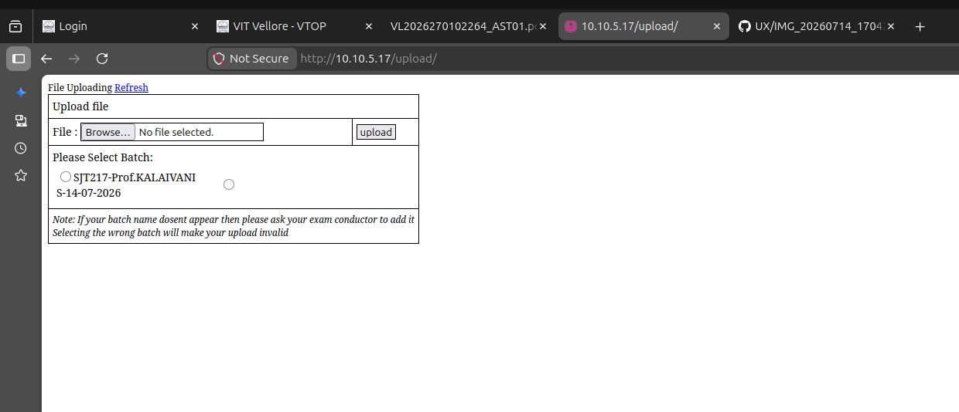
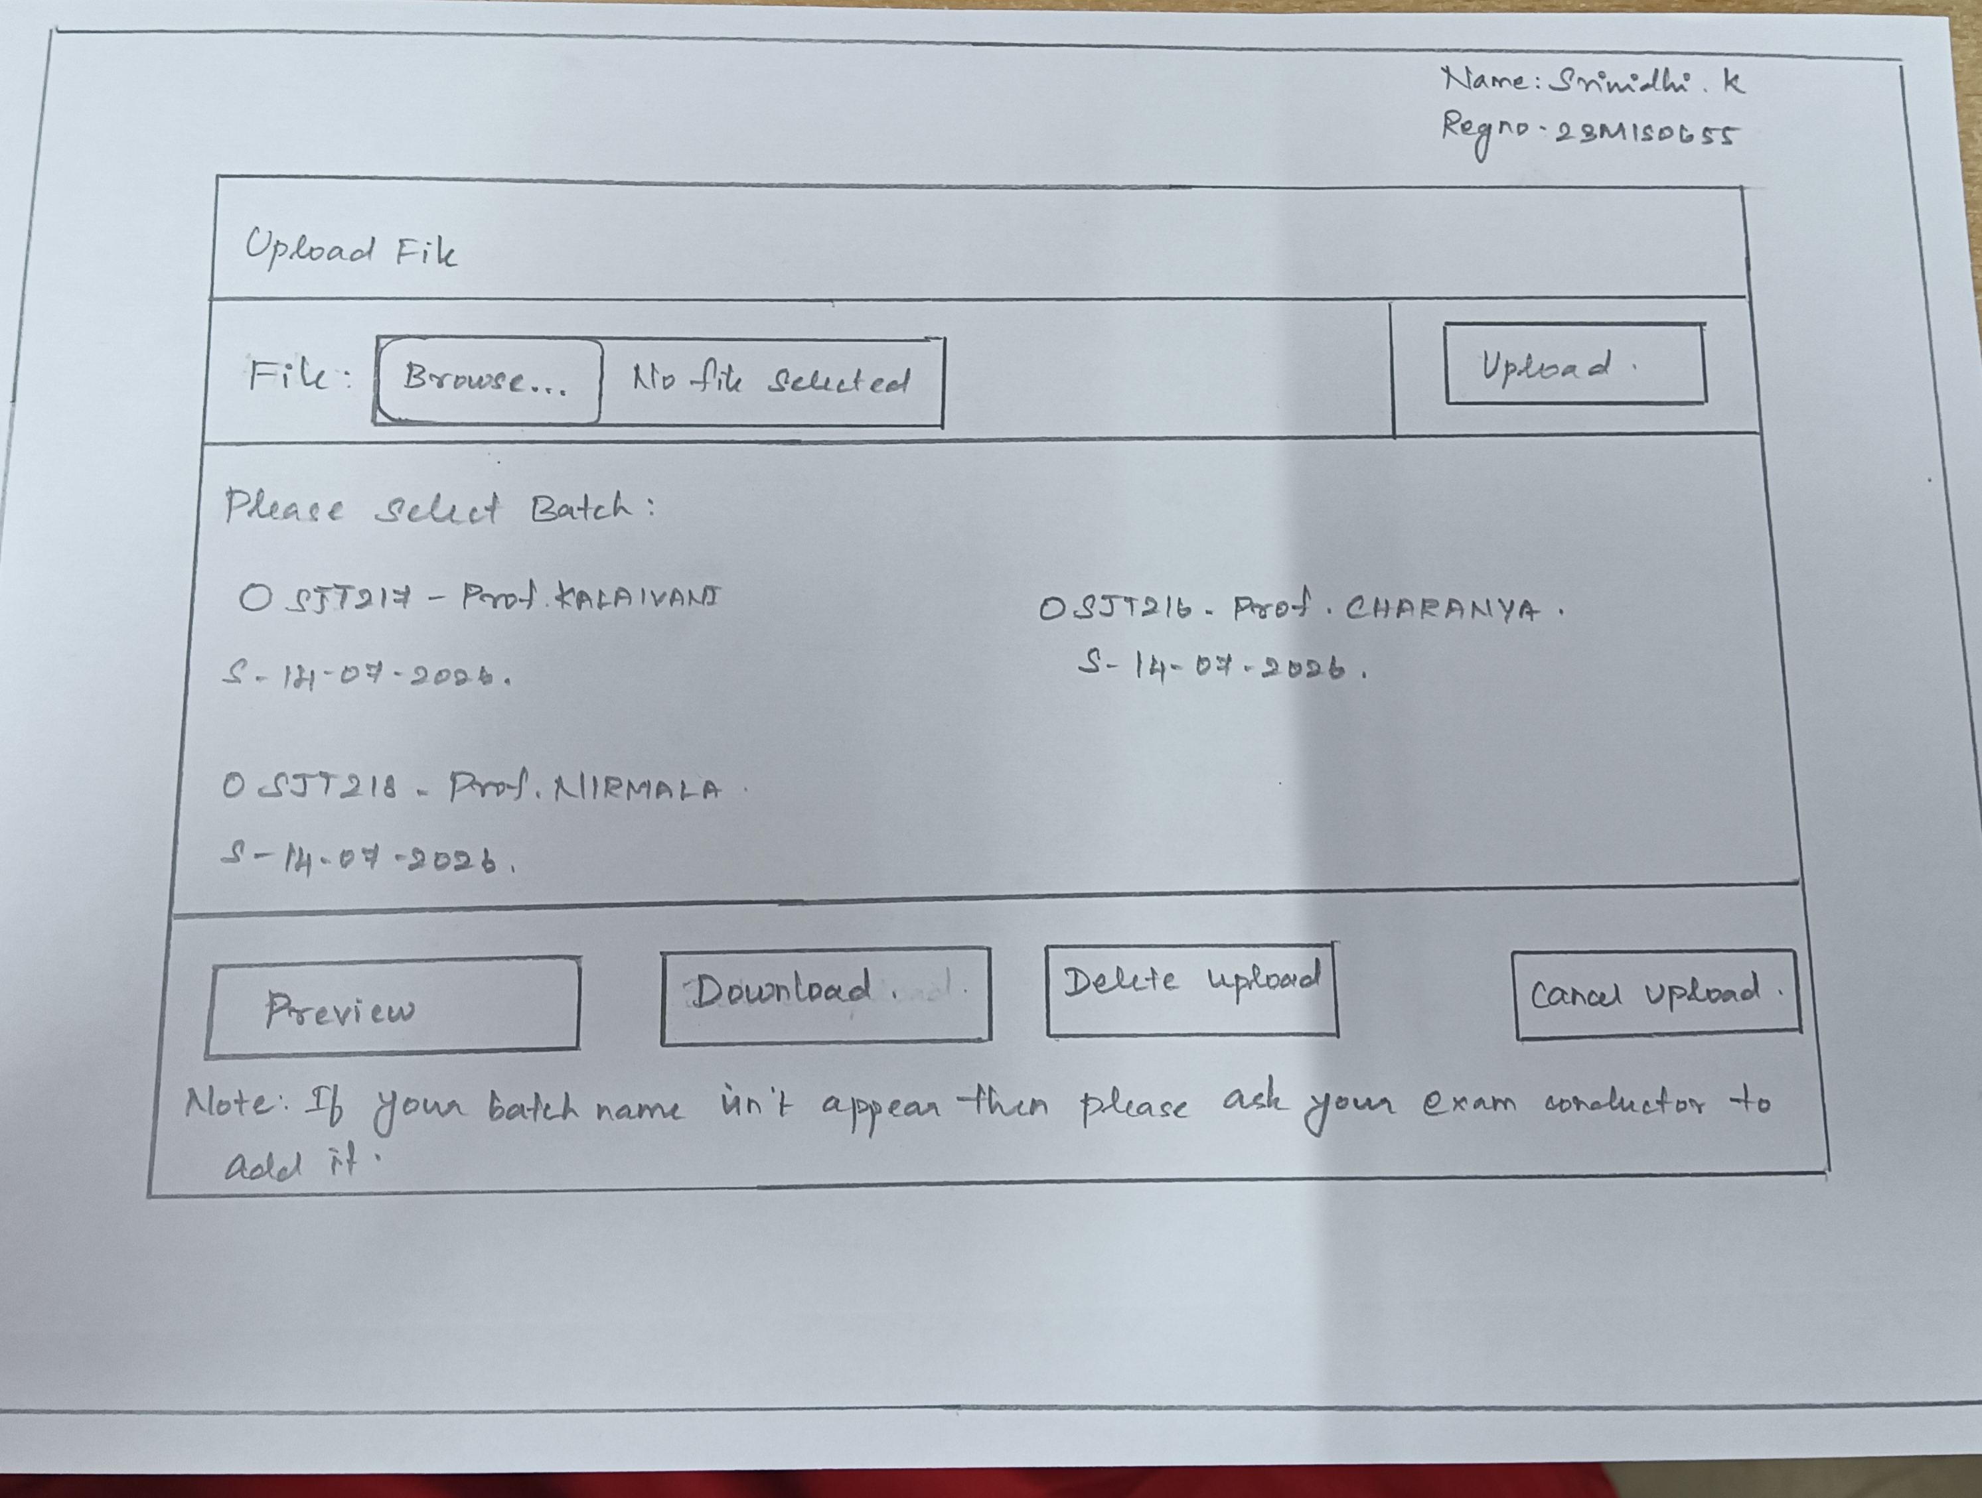

Benefits:

Improved user experience through a clean and organized layout.

Better visibility of available batches.

Added Preview option to verify files before submission.

Download option for checking uploaded files.

Delete Upload option to remove incorrect uploads.

Cancel Upload option to stop accidental submissions.

Proper spacing and alignment improve readability.

Reduces user confusion and minimizes upload errors.

Achieves better usability without changing the backend system.

Materials Used

Existing file upload webpage

A4 paper

Pencil

Scale (Ruler)

Eraser

Black pen/marker

Limitations

Only the user interface is redesigned; backend functionality remains unchanged.

Additional features require implementation by developers.

Does not address server-side performance or security issues.

Actual effectiveness depends on proper software development and testing.

