TIC-TAC-TOE
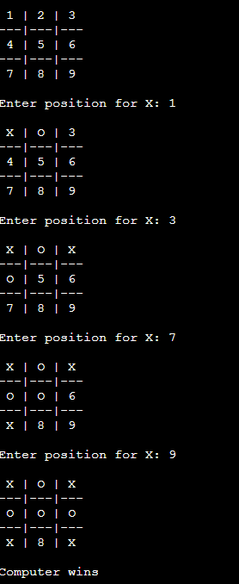

VACUUM CLEANER
