Explainable AI for Intrusion Detection Systems: LIME and SHAP Applicability on Multi-Layer Perceptron
In this project you ask to implement LSTM and TCN algorithm to predict intrusion detection from CIC-IDS dataset and then compare each algorithm performance in terms of precision, recall, accuracy, FCSORE, confusion matrix graph and ROC graph.
To check model performance we have added perturbation to test data which is unknown to model and after perturbation both algorithm manages to get accuracy over 98%.
After training model we have explained model using SHAP tool which will explain which features contribute most to model to predict correct label.
Each algorithm trained on 80% dataset and then tested on 20% test data and to implement this project we have implemented following modules
- Upload CICIDS Dataset: using this module we will upload dataset details and then application will read and display dataset values and then find and plot graph of normal and attack count
- Pre-process Dataset: using this module we will apply pre-process technique on dataset to remove missing values and then convert all non-numeric data into numeric data
- Train & Test Split: using this module will split dataset into train and test where application using 80% dataset for training and 20% for testing
- Run LSTM Algorithm: using this module we will input 80% dataset to LSTM to train a model and 20% test data will be applied on trained model to calculate prediction accuracy
- Run TCN Algorithm: using this module we will input 80% dataset to TCN to train a model and 20% test data will be applied on trained model to calculate prediction accuracy
- Comparison Graph: using this module we will plot accuracy comparison graph between all algorithms
- Summary Model Explanation: using this module will explain model performance using summary plot which will show which features contribute most for correct prediction
- Violin Model Explanation: using this module will explain model performance using violin plot which will show which features contribute most for correct prediction
- Predict Attack from Test Data: using this module we will upload test data and then LSTM model will analyse dataset and then predict weather dataset contains normal or attack features
SCREEN SHOTS
To run project double click on ‘run.bat’ file to get below screen
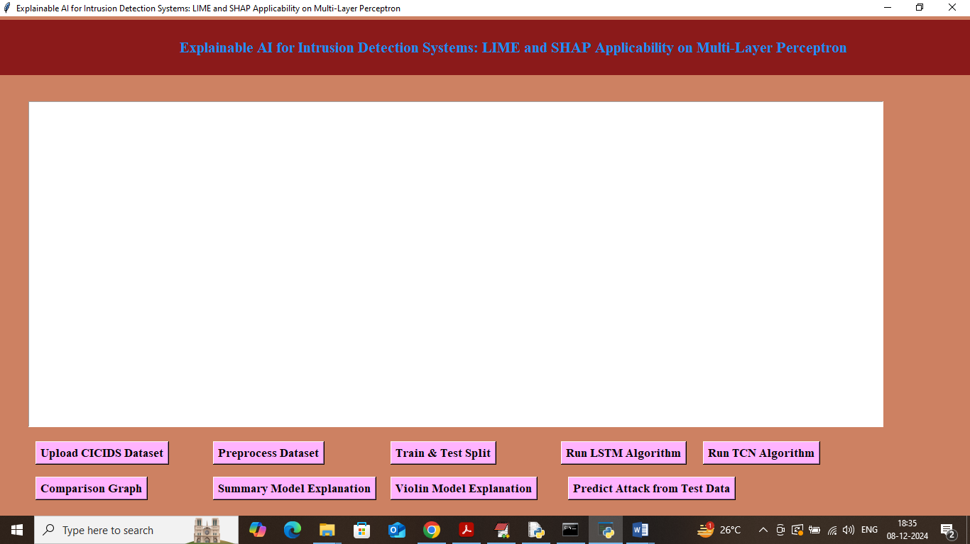
In above screen click on ‘Upload CICIDS Dataset’ button to load dataset and get below output
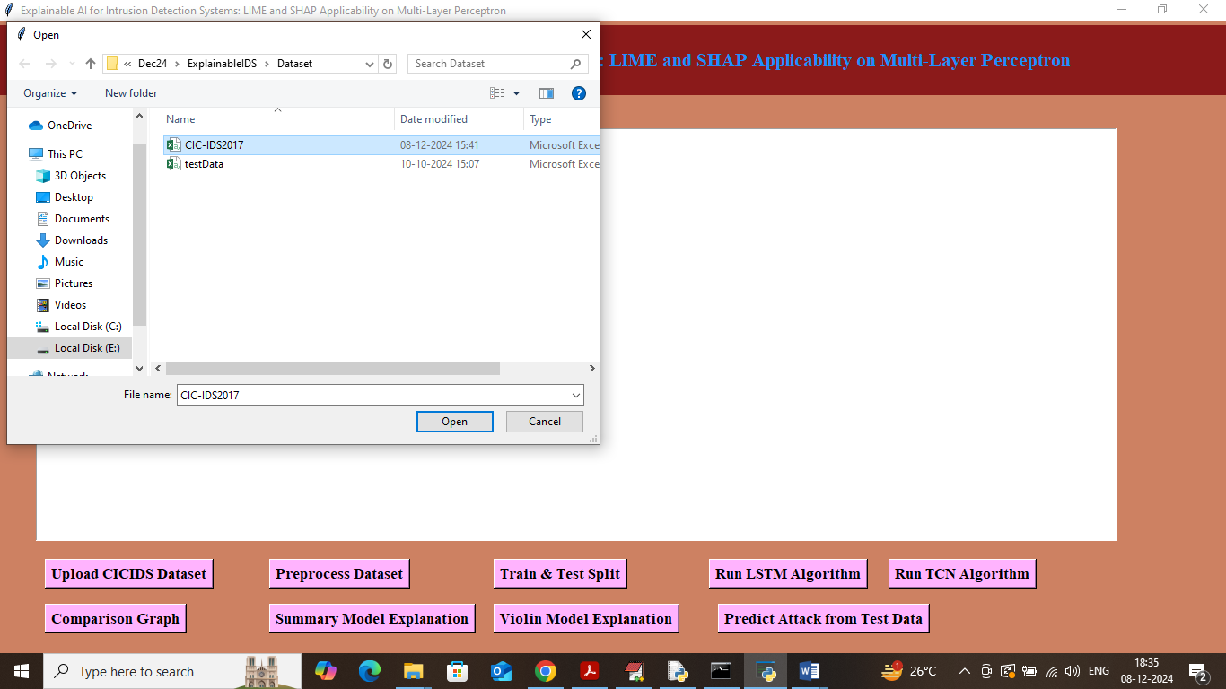
In above screen selecting and uploading CICIDS dataset and then click on ‘Open’ button to load dataset and get below output
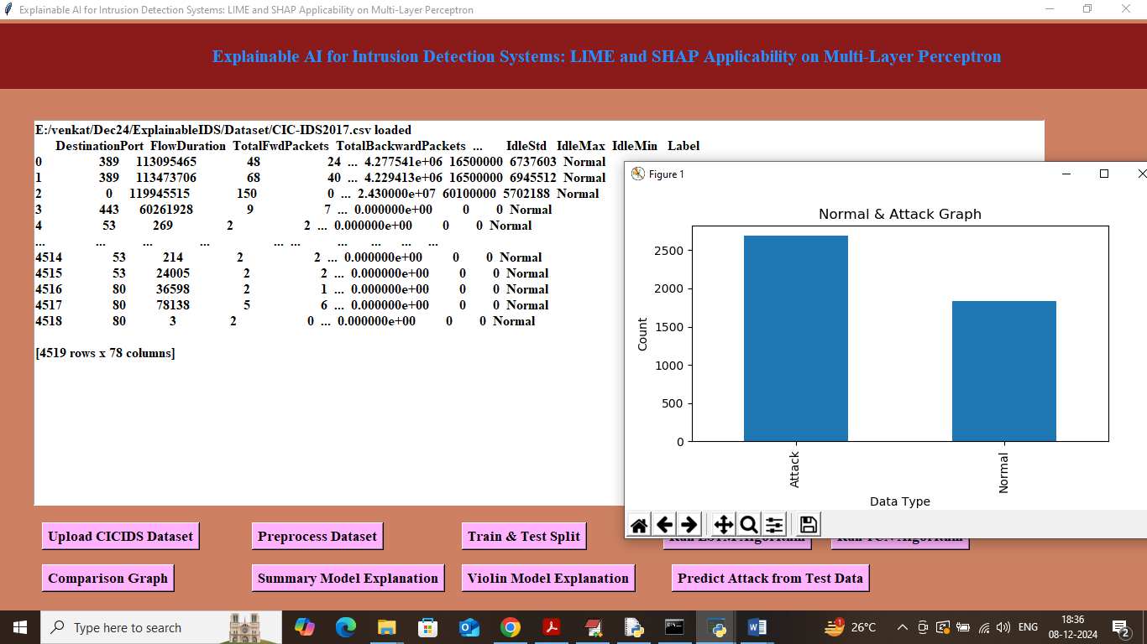
In above screen dataset loaded and in graph x-axis represents Normal and Attack label and y-axis represents number of records and in above dataset values we can see some are non-numeric and some are numeric and machine learning algorithms accept only numeric values so we need to process dataset to encode non-numeric values to numeric values so click on ‘Pre-process Dataset’ button to get below output
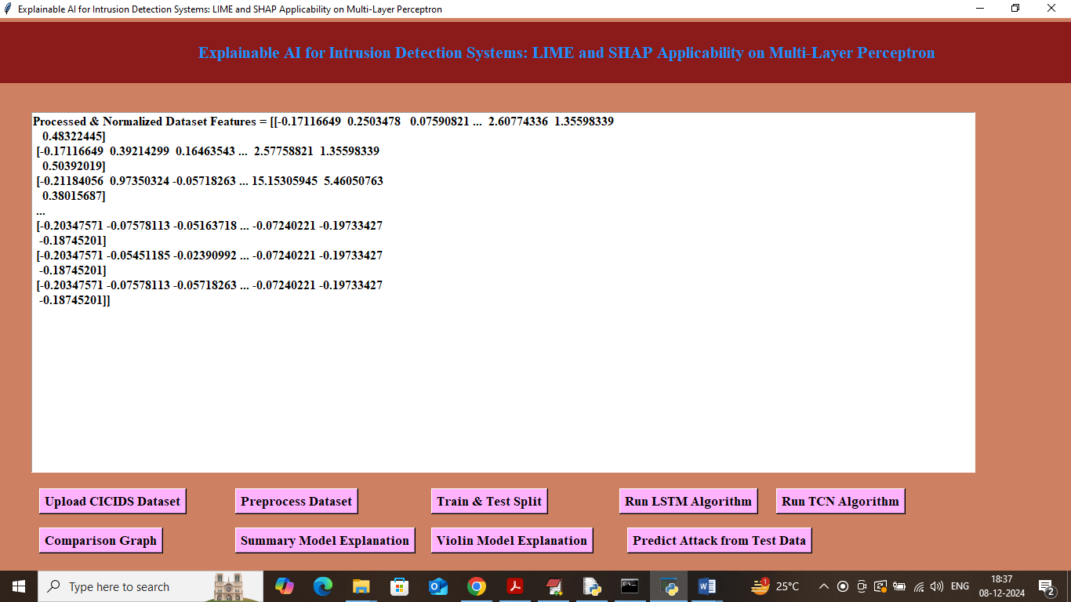
In above screen we can see all values are converted to numeric format and then all values are normalized using Standard Scaler algorithm. Now click on ‘Train & Test Split’ button to split dataset into train and test and then will get below output
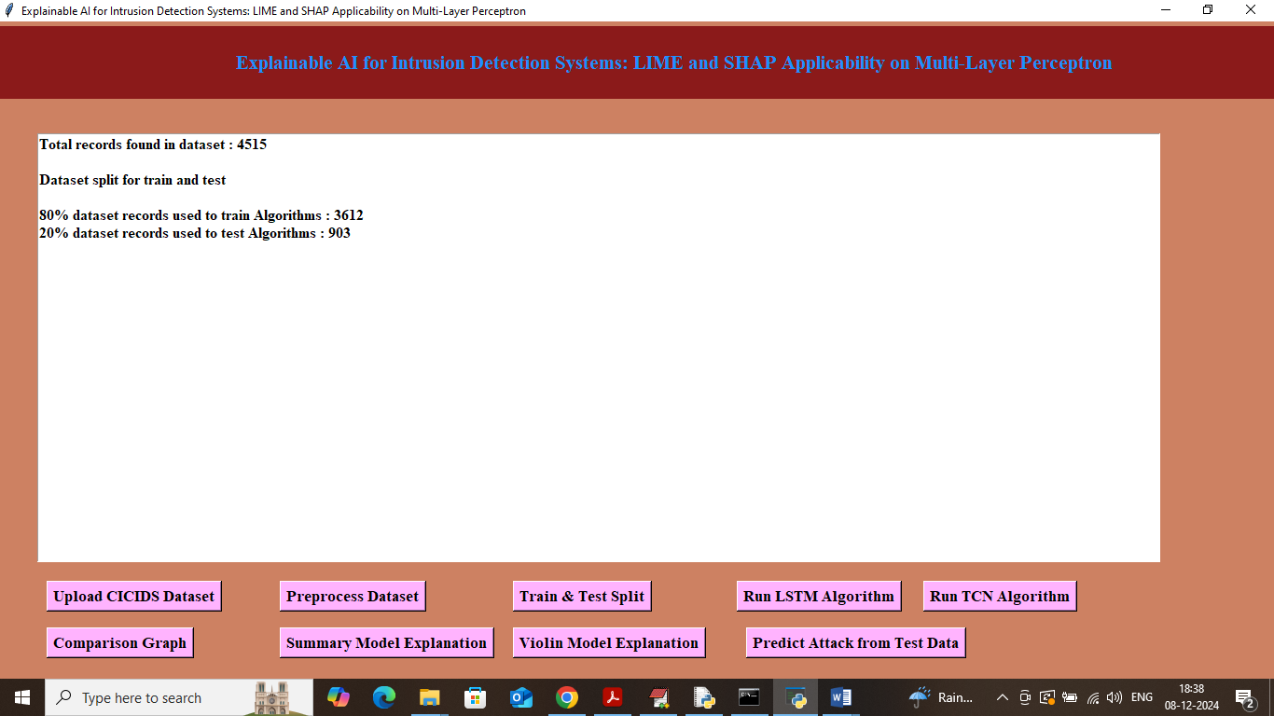
In above screen can see dataset contains 4515 records where application using 80% records (3612) for training and 903 (20%) records for testing. Now click on ‘Run LSTM Algorithm’ button to train LSTM on 80% dataset and test on 20% data to get below prediction accuracy
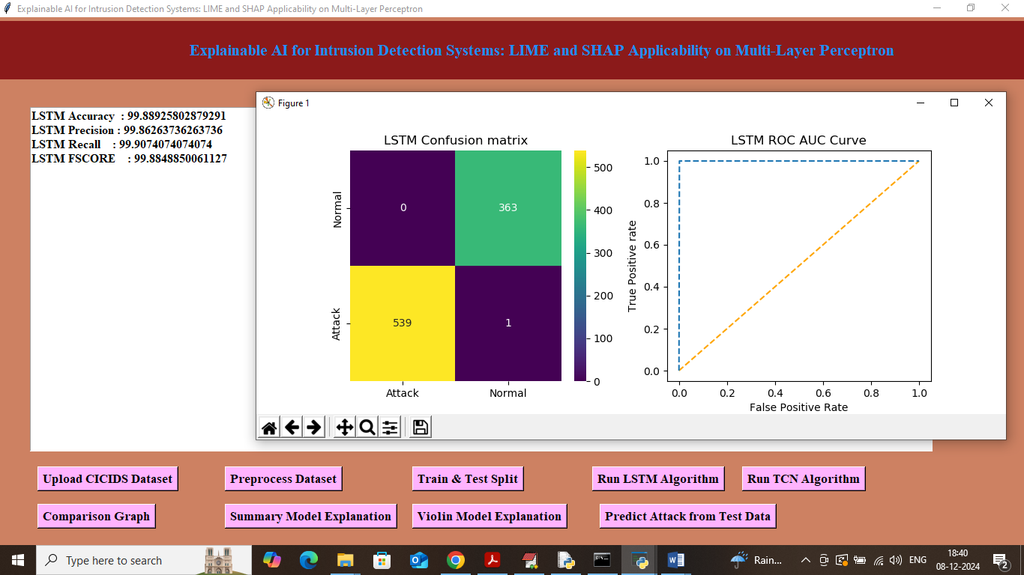
In above screen with LSTM we got 99.88% accuracy and we can see other metrics like precision, recall and FSCORE. In confusion matric graph x-axis represents Predicted Labels and y-axis represents True Labels and then yellow and green colour boxes in diagonal represents correct prediction and remaining blue boxes contains incorrect prediction count. In ROC curve graph x-axis represents False Positive Rate and Y-axis represents True Positive Rate and if blue line comes on top of orange line then all predictions are correct and if goes below orange line then predictions are incorrect. Now close above graph and then click on ‘Run TCN Algorithm’ button to get below output
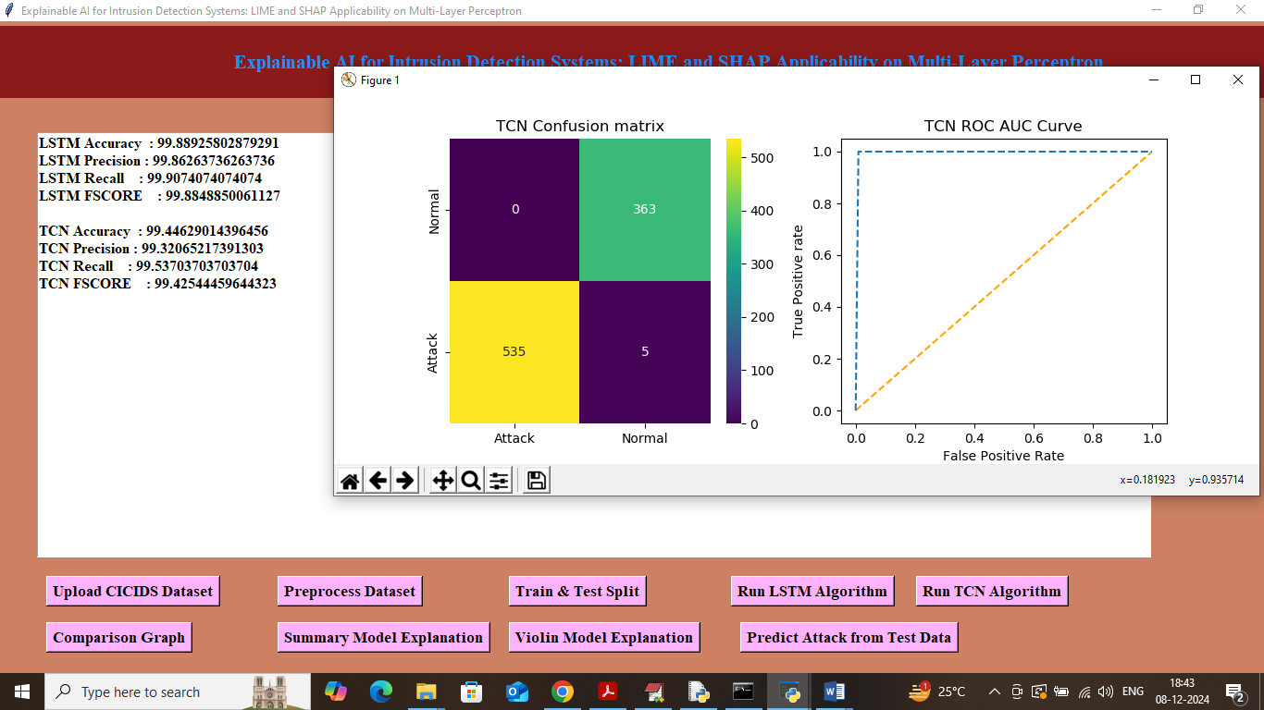
In above screen TCN got 99.44% accuracy and can see other metrics also. Now click on ‘Comparison Graph’ button to get below output
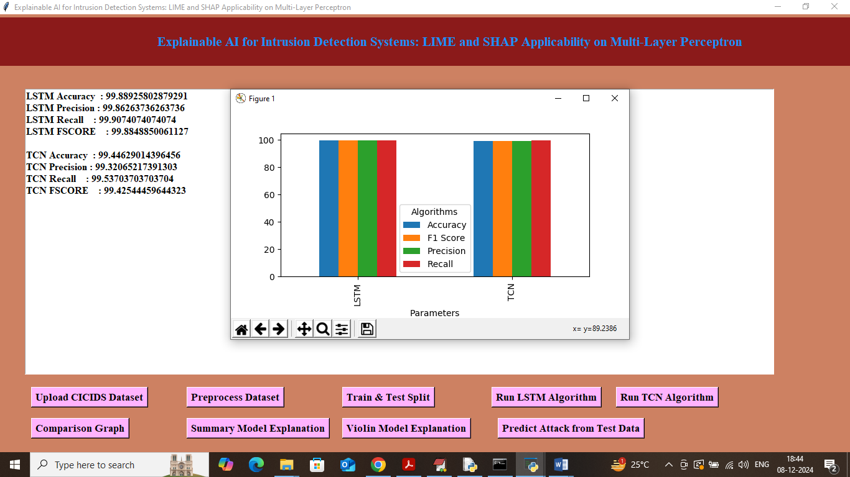
In above graph x-axis represents algorithm names and y-axis represents metric values like accuracy, precision, recall in different bar colour and in all algorithms LSTM got high accuracy. Now close above graph and then click on ‘Summary Model Explanation’ to get below explanation graph from SHAP
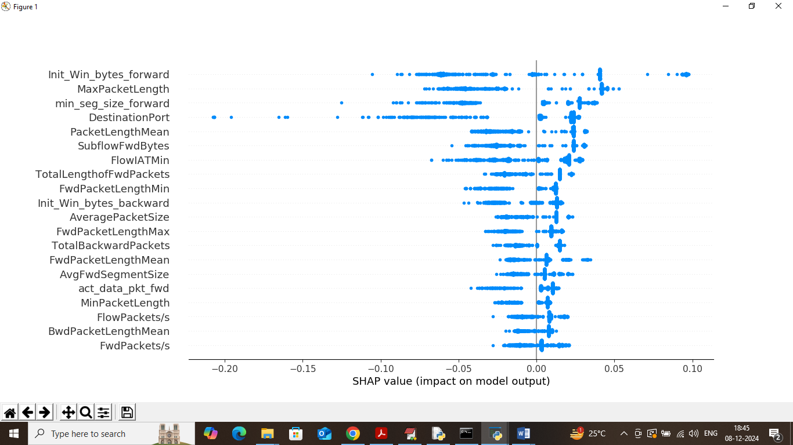
In above summary plot explanation graph we can see features names at left hand side and then blue dots represents percentage of that features contribution. In above graph features with more dots contributing most to model in prediction. Now click on ‘Violin Model Explanation’ button to get below explanation
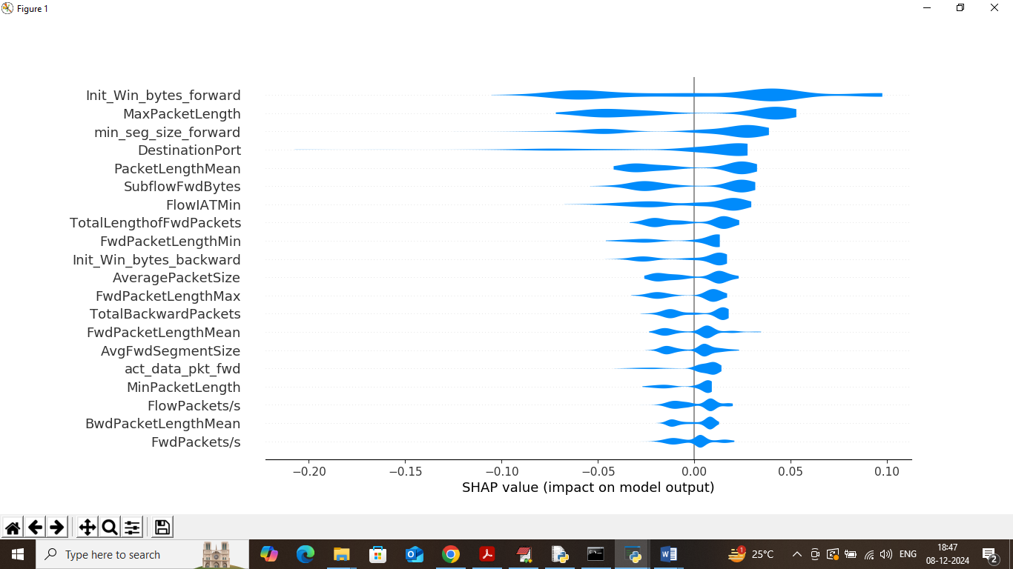
Above violin graph also explain which features is contributing most for correct class label prediction. Now click on ‘Predict Attack from Test Data’ button to upload test data and get below page
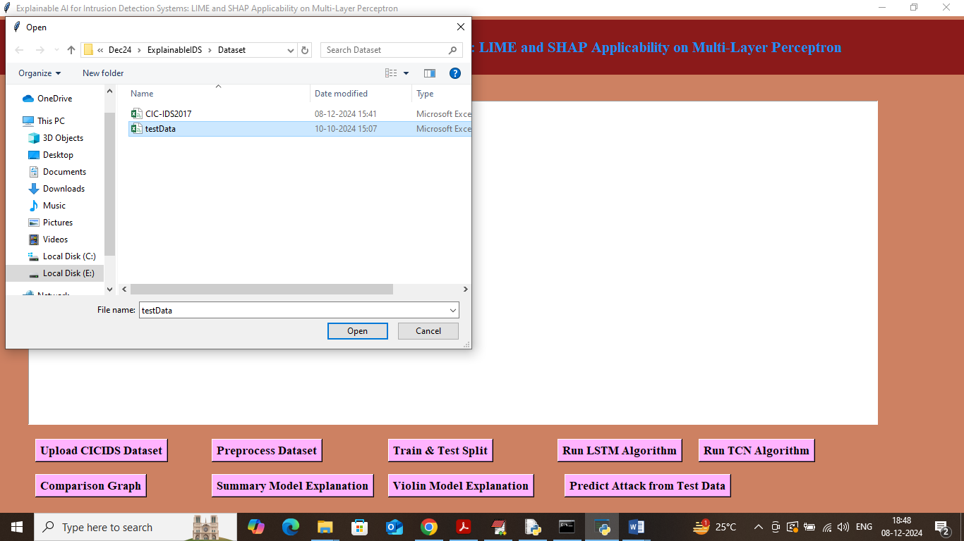
In above screen selecting and uploading testData.csv file and then click on ‘Open’ button to get below output
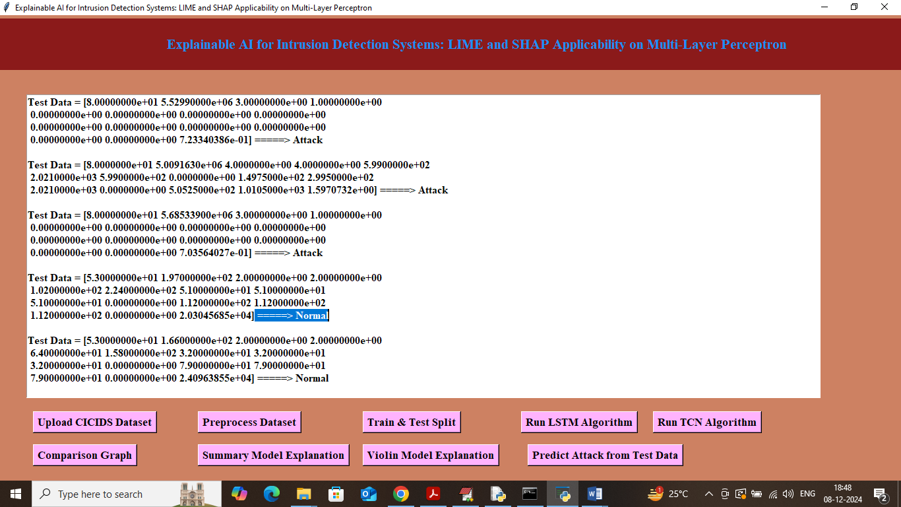
In above screen in square bracket we can see test data values and after arrow symbol can see predicted output as Normal or Attack.

