**Phase 2: Create a Custom AMI with NGINX and Instance ID Page**

**Step 1: Launch a Base EC2 Instance Manually**

* Go to **AWS Console > EC2 > Launch Instance**
* AMI: Amazon Linux 2
* Instance type: t2.micro
* Security Group: allow **HTTP (80)** and **SSH (22)**
* Key Pair: Select or create a new one
* Launch the instance

Step 2: Connect to Instance via SSH and Install and Configure NGINX

ssh -i "your-key.pem" ec2-user@<EC2-Public-IP>

Once you entered to instance, run below commands:

sudo yum update -y

sudo yum install -y nginx

sudo systemctl start nginx

sudo systemctl enable nginx

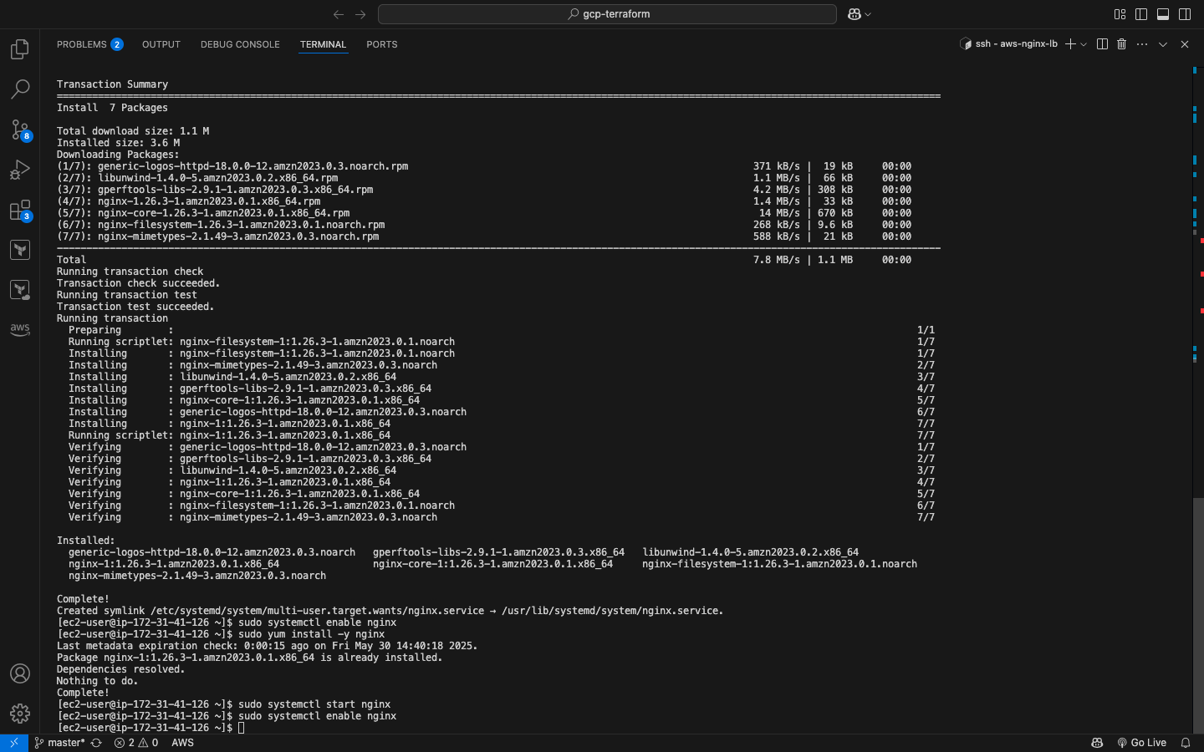

Step 3: Add Dynamic Page with Instance ID

Once you're inside the EC2 terminal:

Vi gen-page.sh

Paste the following into the file:

#!/bin/bash

INSTANCE_ID=$(curl -s http://169.254.169.254/latest/meta-data/instance-id)

echo "<html>

<head>

<title>Welcome to Srinidhi's website of nginx and load balancer project</title>

</head>

<body style=\"font-family:Arial; text-align:center; margin-top:100px; background-color:#f0f8ff;\">

<h1 style=\"color:#2e8b57;\">Welcome to Srinidhi's website of nginx and load balancer project</h1>

<h2>Running on Instance: <span style=\"color:#ff4500;\">$INSTANCE_ID</span></h2>

</body>

</html>" | sudo tee /usr/share/nginx/html/index.html

Check it works:

In Terminal: curl localhost

In browser:

**Step 4: Create Custom AMI**

* Go to **EC2 > Instances**
* Right-click your instance → **Image > Create Image**
* Name: nginx-custom-ami
* Click **Create Image**
* Wait for the AMI to be "available" under **EC2 > AMIs**
* Copy the **AMI ID** : [ami-0a45f7147e2f5f17a](https://us-east-2.console.aws.amazon.com/ec2/home?region=us-east-2#ImageDetails:imageId=ami-0a45f7147e2f5f17a)

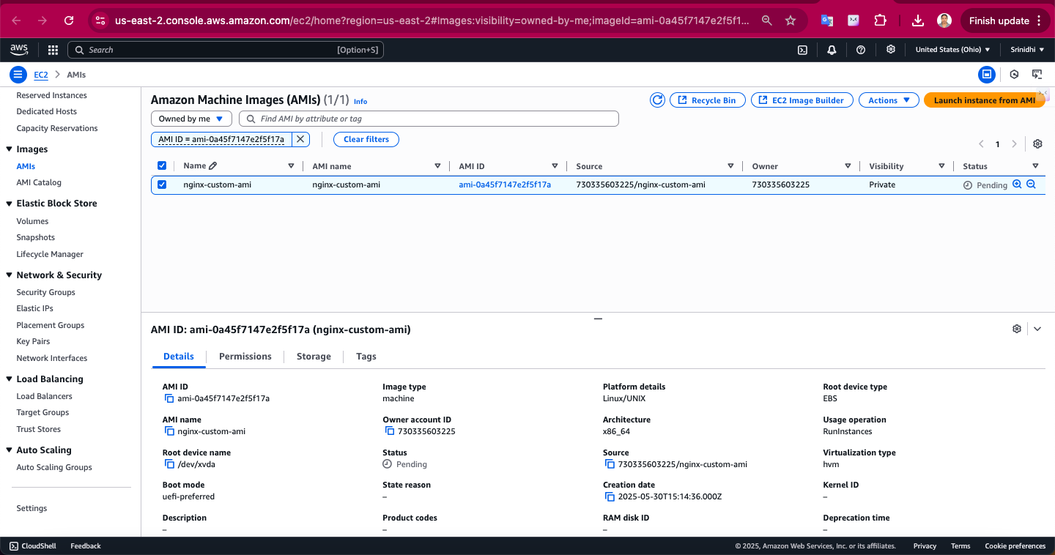

Phase 2: Terraform Project Setup

Step 1: Create Project Folder and Terraform Files

You'll need:

* main.tf
* variables.tf
* outputs.tf
* gen-page.sh

Link to check Terraform Code: <https://github.com/srinidhisivakumar/aws-nginx-lb>

Phase 3: Run Terraform

Step 1: Initialize

terraform init

Step 2: Plan

terraform plan -var="ami_id= [ami-0a45f7147e2f5f17a](https://us-east-2.console.aws.amazon.com/ec2/home?region=us-east-2#ImageDetails:imageId=ami-0a45f7147e2f5f17a) " -var="key_name=nginx-lb.pem"

Step 3: Apply

terraform apply -var="ami_id= [ami-0a45f7147e2f5f17a](https://us-east-2.console.aws.amazon.com/ec2/home?region=us-east-2#ImageDetails:imageId=ami-0a45f7147e2f5f17a) " -var="key_name=nginx-lb.pem"

**Phase 4: Test & Capture Outputs (Uploaded video in github)**

1. Copy the DNS from Terraform output.
2. Paste it into your browser.
3. Refresh the page multiple times to see both instance IDs appear

<http://nginx-lb-1762917563.us-east-2.elb.amazonaws.com/>

Video Link: <https://github.com/srinidhisivakumar/aws-nginx-lb/tree/master/video-output>

VPC console:

Security Group inbound rules:

