University of Bridgeport

SPRING 2016

COMPUTER SCIENCE

Course CPSC- 350-11 – Advance Database Design



Assignment: Project -1 (phase 3)
Title: AIR RESERVATION SYSTEM

Professor Name: Jeongkyu Lee

Submitted by: ARUNA VEERAMREDDY-1004293

When: On Campus

Team Information

Number: Group 17

Name: SRINIJA KATIKINENI

AIR RESERVATION SYSTEM

INTRODUCTION:

The Air Reservation system database maintains the details of the airline schedules,passenger reservation,Fares tariffs(change in rate of the ticket) and ticket records.Airlines has many ways of distribution such as their own reservation system,information in Global Distribution System(GDS), Direct distribution channel.
All distributors of reservation system access GDS by standardized messaging which follow a standards set by International Civil Aviation OrganiZation(ICAO) and International Air Transport Association(IATA) because airline reservation system are business critical applications,and functionally complex and relatively expensive.
The Air Reservation System database contains the inventory system,PNR(Passenger Name Record),Ticketing ,Fare Tariffs and many more.

ABSTRACT:
The Air reservation system of a flight includes the details of the different departments of the FLIGHT .The Flight sitting capacity, Distributors of the flight tickets,Type of the ticket,Airport details,staff in the flight,Luggage and Customs/Immigrations.

The Airport details of the flight such the Types of the Airport,Airport Terminal,Runway of the Flight.

Airlines maintains the information of the Airline codes which is unique for the Flight,code share flights ,name of the companies holding Airline,types of airlines,Schedule of the Flights, details of the connecting flights and Fair of the ticket.

PNR(Passenger Name Record ) contains personal information such as name,contact information,address,any special services requests e.g. for vegetarian meal,wheel chair faculty.

The Seating includes the details of the capacity of the flight,number of seats under the quote of each distributor and own reservation system ,if it is done by the distributor the name of the distributor and his price per ticket,Number of vacant seats.

The details of the staff includes the name of the Captain,Level officers in the flight,Flight attendant,flight engineer,Load master, pilot,Purse and Deadheading.

Luggage the number of bags to be allowed ,weight of each bag, bag tag, luggage lock,checkin process of bags is done either online or direct and allowing of cabin bags as per the class of the ticket taken.

The customs/Immigration maintains the details of the Landing card,Border Control,Departure,Passport,Travel documents and Visa(types).

QUERIES:

1)Get the availability of the flight starting from the city(nearest Airport name) to the city along with the type(direct or connecting) and schedule of the flights.

2)Get number of vacant seats in each class with seat map gives the place and position of the seat and the fair of the ticket along with the airline code.

3)The charge of the Ticket,the Taxes on the Ticket fare,Amount taken for insurance and other taxes sum to the total amount taken from the passenger.

4)Get details of any Packages such as Fare of the ticket if both To and Fro ticket is booked or if Ticket and Hotel is booked,if tickets for a group is booked,any offers other offers in sorted order of lowest to highest.

5)Get the details of the flight that filled less than 25% of their seats and different flight that are connected with destination from different places of starting e.g. If the passenger want to go to (NEWYORK)JFK from HYDERABAD (RGI) there is no direct flight to JFK but the connecting flight are from Hyderabad to different places such as Dubai,Abu dhabi......so on to JFK.

6)Get the Air ways which allows maximum luggage and the allowing weight of the cabin bag and size of each bag and charge for any extra luggage.

7)Get the details of the passengers which includes the name,address,contact and the type of the visa he/she holds.

8)Get the availability of the seat in the immediate flight in case of any emergence along with the cost of the ticket and percentage of extra amount taken compared to preplan booked flight.

9)Get whether the checkin can be done through online process with the details the airport authority if the checkin luggage is missed or lost.

10)Get the list of the checkin seats,number of persons booked the ticket and not checked in ,number cancellations and number of refunds done and final chart of seats.

11)Checking of the delay of the flight,cancellation of the flights,reasons of cancellation,refund of money and arrangement of new flights.

12)The details of the any change in terminals for boarding and landing in the Airports and optional terminal for immediate landing of the flight in case of any technical issues in the flight.

13)Get immigration time for different visa holders in the particular airport and port of entry of the person.

DESCRIPTION

The database represents each Airport by a unique Airport Code, the Airport City Name, and the City and the State in which the Airport is located.
- Each airline flight has a unique number and the name of the Airline that runs the flight.
- A flight is composed of one or more flight legs. Each flight leg has a leg number, Departure Airport and Scheduled Departure Time, and an arrival airport and Scheduled Arrival Time.
- The Passenger reserves Seats in the flights which has a unique seat numbers and details of the passenger name and passenger contact Known as PNR(Passenger Name Record).
- Flight contains Employees with a unique identity number and name of the employee and the Employees are categorized into Flight attendants who attend the for serve the customers and Flight Engineers and Pilot.

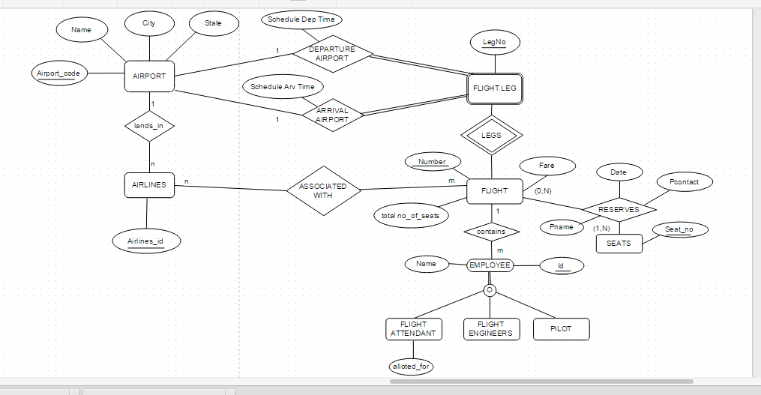

ER DIAGRAM

RELATIONAL SCHEMA FOR AIR RESERVATION SYSTEM:
AIRPORT
Airport_code(PK)
Name
City
State
AIRLINES
Airline_id (PK)
Airport_code (FK)
Flight_number

FLIGHT
Flight_number(PK)
Airline_id (FK)
Airport_code (FK)
Flight_fare
Total_number_of_seats

SEAT RESERVATION
Flight_number (FK)
Leg_number(FK)
Date
Seat_number (PK)
Passenger_name
Passenger_phone

FLIGHT_LEG
Flight_number (FK)
Leg_number (PK)
Departure_airport_code
Scheduled_departure_time
Arrival_airport_code
Scheduled_arrival_time

EMPLOYEE
Flight number (FK)
Employee _id (PK)
Employee_name

FLIGHT_ATTENDENT
Flight_number
Employee_id
Employee_name
Flight_attendent_alloted_for

FLIGHT_ENGINEERS
Engineer_id
Flight_number
Engineer_name

PILOT
Pilot_id
Flight_number
Flight_number

PRIMARY AND FOREIGN KEYS:

Airport_code: It is the primary key of AIRPORT. It is unique for each and every airport. It acts as foreign key for AIRLINES.
Airline_id: It is the primary key for AIRLINES. It is unique for all Airlines and Airport code is the Foreign Key.
Flight_number: It is the primary key of FLIGHT. It is unique for every Flight. It acts as a foreign key for FLIGHT_LEG, SEAT_RESERVATION, FLIGHT_ATTENDENT and AIRLINES.
Leg_number: It is the primary key for FLIGHT_LEG. It is unique for every Flight_leg. It is a foreign key for SEAT_RESERVATION.
Seat_number: It is the primary key for SEAT_RESERVATION. It is unique for every seat.
Employee_id: It is the primary key for EMPLOYEE. IT is unique for every employee.
Engineer_id: It is the primary Key for FLIGHT_ENGINEERS. It is unique for every Engineer.
Pilot_id: It is the primary key for PILOT. It is unique for all the pilots.

