Hi Ma'am...

as i am uploading database

sfcredhelp.sql-->it is not a table Ma'am

step to import the database

step1-go to control panel start the apache and mysql

step2-after that it will display the port no,beside stop "Admin" is displayed in the MYSQL

step3- click on that! i will direct to the bowser

Step4-on left hand side click on “New”



Step5- on the right side it will display this ,enter the database name as **sfcredhelp** only…

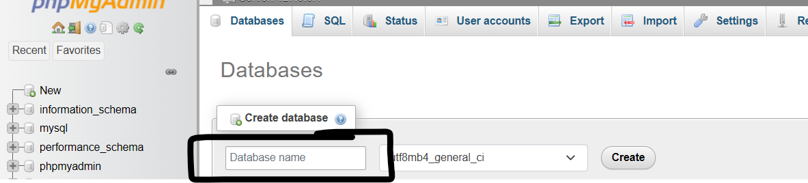

Step6-as we can see the sfcredhelp

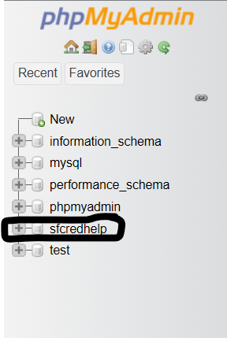

Step7-click on the database sfcredhelp click on the “import”

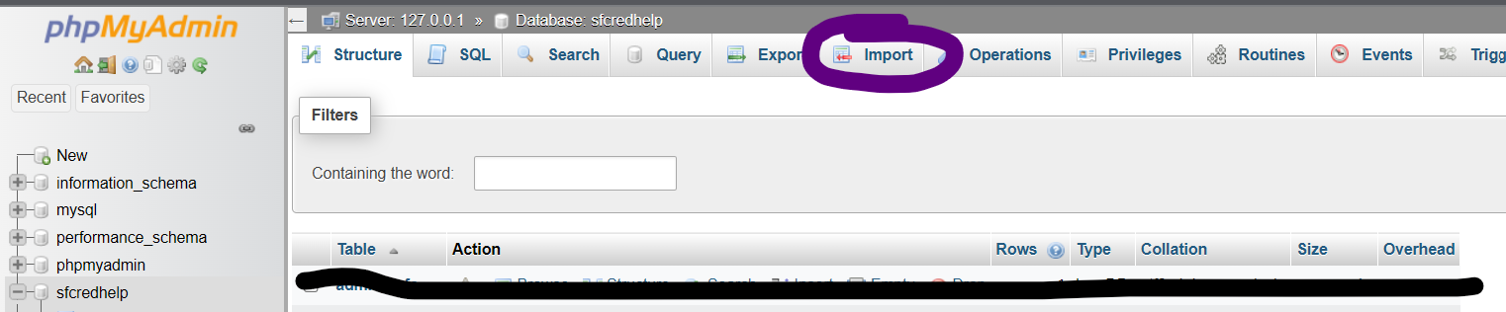

Step8-chose the file

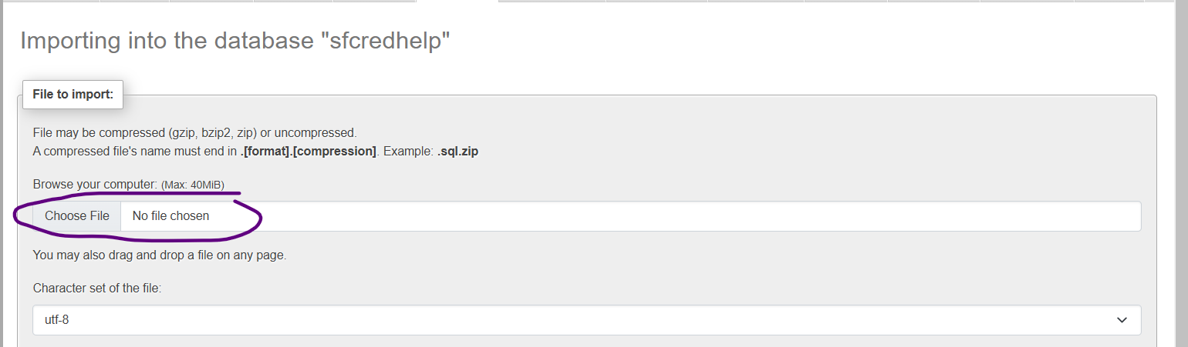

Step9-on the page scroll down “click on import”

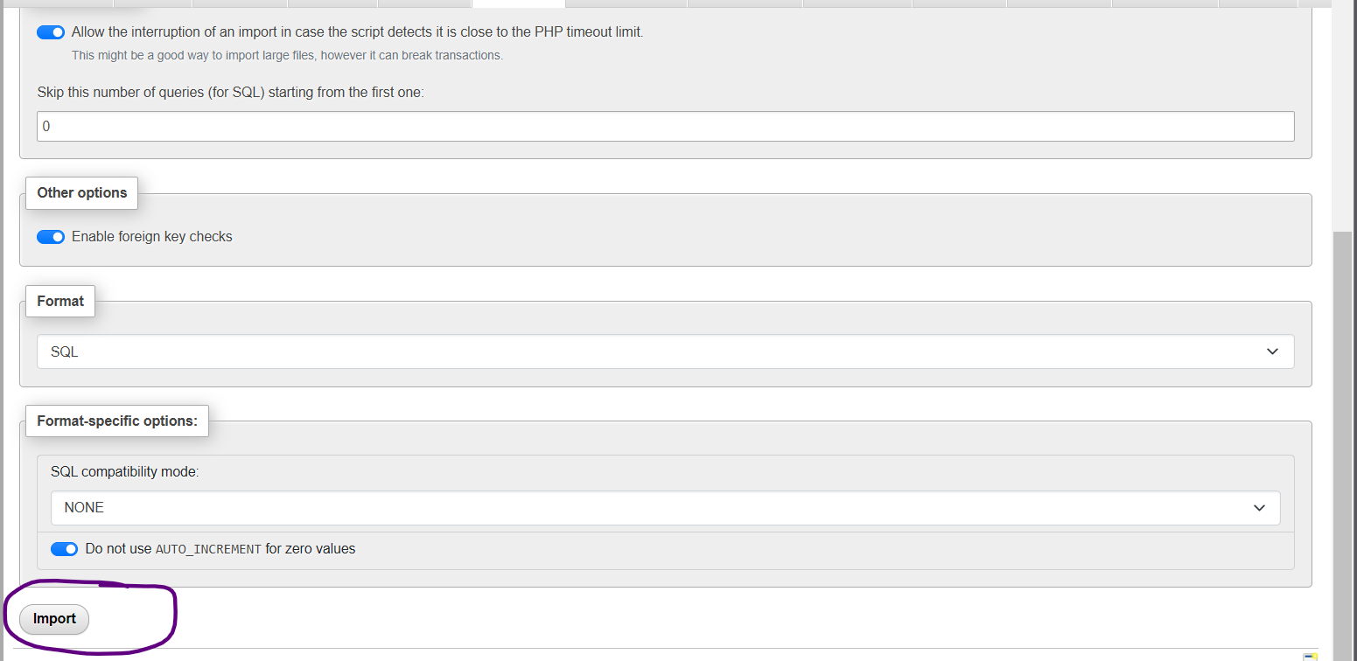

Step-10

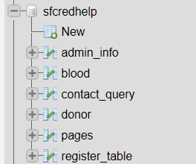

Rather than importing each table in the database which is not efficient,even though I will upload the remain separate table in the folder…

Thank you:)</>……