**HerHaven**

A report submitted for the course

**Application Development_ Full Stack Explore**

**III B.Tech. II Semester**

**by**

**M .Srinija - 2211CS030103**

**Srinethri Shinde - 2211CS030153**

**V. Mamatha - 2211CS030168**

Under the esteemed guidance of

**Mr. K. Ramesh**

**(Asst.Professor)**



**Department of Data Science**

**Malla Reddy Univeristy**

Maisammaguda, Dulapally,

Hyderabad, Telangana 500100  
[www.mallareddyuniversity.ac.in](http://www.mallareddyuniversity.ac.in/)  
**2024-25**

***CERTIFICATE***

This is to certify that this bonafide record of the Application Development entitled **HerHaven** submitted by **Ms. M. Srinija (2211CS030103), Ms. Srinethri Shinde (2211CS030153), Ms. V. Mamatha (2211CS030168)** of  **III** year **II** semester to the Malla Reddy University, Hyderabad. Thisbonafide record of work carried out by us under the guidance of our supervision. The contents of this report, in full or in parts, have not been submitted to any other Organization for the award of any Degree.

|  |  |  |
| --- | --- | --- |
| **Internal Guide:**  **Mr. K. Ramesh**  **Assistant Professor** |  | **Dean, Data Science**  **Dr.GS Naveen Kumar** |
|  | **External Examiner** |  |

**Date:**

**ABSTRACT**

HerHaven is a digital community forum designed exclusively for women, providing a safe, inclusive, and empowering space for connection, conversation, and support. The platform encourages women to share their experiences, seek advice, and engage in meaningful discussions on topics that matter to them. With features such as multi-step sign-up, secure login, post creation, comment threads, and user profiles, HerHaven ensures a seamless user experience. A unique emergency request button is also integrated for quick help in critical situations. Developed using React for the frontend and Spring Boot with MongoDB for the backend, HerHaven offers a seamless experience for users to engage in meaningful discussions, share knowledge, and seek mentorship. All user data and posts are securely stored in MongoDB, while Spring Boot efficiently handles server-side logic and API communication. The forum includes tools like search and filter to help users navigate posts efficiently. Through inspirational content and interactive discussions, HerHaven aims to foster a nurturing environment where women can grow together, support one another, and build lasting connections across various walks of life.

**CONTENTS**

|  |  |  |
| --- | --- | --- |
|  |  |  |

|  |  |  |
| --- | --- | --- |
| Certificate | | i |
| Abstract | | ii |
| Contents |  | iii |
| List of Figures | | iv |
| Chapter1 | Introduction | 1 |
|  | 1.1 Introduction to HerHaven | 1 |
|  | 1.2 Crafting The Solutions | 1 |
|  | 1.3 Benefits of HerHaven | 2 |
| Chapter2 | Review of Relevant Literature | 3 |
| Chapter3 | Methodology | 4 |
| Chapter4 | Results and Discussions | 6 |
| Chapter5 | Conclusion and Future Scope of Study | 13 |
| References |  | 15 |

**LIST OF FIGURES**

|  |  |  |
| --- | --- | --- |
| **Figure** | **Title** | **Page** |
| 3.1 | Methodology | 5 |
| 4.1 | Home Page | 6 |
| 4.2 | SignUp for User | 6 |
| 4.3 | Basic Information (i) | 7 |
| 4.4 | Basic Information (ii) | 7 |
| 4.5 | Basic Information (iii) | 8 |
| 4.6 | Basic Information (iv) | 8 |
| 4.7 | Login page | 9 |
| 4.8 | Forum page | 9 |
| 4.9 | Post page | 10 |
| 4.10 | New post creation | 10 |
| 4.11 | Profile page | 11 |
| 4.12 | Edit profile page | 11 |
| 4.13 | Emergency request sent successfully | 12 |
| 4.14 | Emergency request mail sent | 12 |

**Chapter 1: Introduction**

**1.1 Introduction to HerHaven**

HerHaven is a digital women community forum designed to empower, support, and connect women from all walks of life. In today’s digital world, there are very few platforms specifically dedicated to addressing the unique needs, challenges, and voices of women. Many existing forums are either too generic or lack the supportive environment required to discuss sensitive topics. Women often face issues related to safety, lack of mentorship, and the absence of a space where they can freely express themselves or seek guidance.

HerHaven bridges this gap by creating a secure, inclusive, and engaging space for meaningful conversations, peer support, and professional development. The platform encourages users to connect through posts, comments, discussions, and mentorship, fostering a sense of belonging and empowerment. HerHaven is not just a forum—it's a movement toward building stronger communities of women through shared experiences and mutual support.

**1.2 Crafting the Solutions**

1. **Safe and Secure Environment:**

HerHaven prioritizes user privacy and safety by ensuring that user data is protected and content is moderated. It creates a respectful, judgment-free space where women can express themselves openly.

1. **Women-Centric Discussion Forum:**

Unlike generic platforms, HerHaven focuses on topics that matter most to women—mental health, career growth, relationships, health, and personal development—making it more relevant and supportive.

1. **Emergency Request Feature:**   
   HerHaven includes a "Safe Button" that enables users to send emergency alerts or support requests when they feel unsafe, adding a unique layer of real-time protection.
2. **Community Support and Peer Engagement:**  
   Users can like, comment, and interact with each other’s posts, building a strong network of mutual encouragement and understanding.
3. **Robust Technologies:**

Built with React, the platform provides a responsive and dynamic user interface, allowing for real-time updates and seamless navigation across devices. HerHaven uses Spring Boot for server-side logic and MongoDB for flexible, scalable database storage, supporting fast data retrieval and high performance even as the user base grows.

**1.3 Benefits of HerHaven**

HerHaven offers numerous benefits that make it a valuable tool for women seeking connection, growth, and support. One of its primary advantages is the sense of community it fosters—users can engage in open discussions, share stories, and build supportive networks. The platform also encourages mentorship, helping users to find guidance in both personal and professional aspects of life. With its easy-to-use interface and inclusive design, HerHaven ensures that women of all ages and backgrounds can navigate the platform effortlessly. The emergency request feature adds a layer of safety, which is especially crucial for women facing distress or needing immediate support. Additionally, the platform is scalable and can be enhanced with AI and mobile support in the future, ensuring continued growth and relevance. Ultimately, HerHaven promotes self-expression, empowerment, and connection in a digital world where such safe spaces are much needed.

**Chapter 2 : Review of Relevant Literature**

1. **"Digital Communities for Women Empowerment"** *by A. Patel and S. Reddy (2020)*This study explores the impact of women-focused digital platforms on personal growth, peer support, and collective empowerment. It underscores how platforms like HerHaven can foster safe and inclusive spaces, enabling users to share experiences and find mentorship. The study highlights that interactive features such as forums and emergency support systems play a crucial role in trust-building within women-only communities.
2. **"Designing Inclusive Online Spaces"** *by J. Morrison and K. Lewis (2021)*  
   This research emphasizes the importance of inclusive UX/UI design in creating meaningful digital experiences. It advocates for step-based onboarding systems and personalized navigation flows—both of which are implemented in HerHaven to improve user engagement. The paper also supports the use of responsive layouts and secure authentication for community-based platforms.
3. **"Community-Driven Development and Web Technologies"** *by N. Gupta and H. Lin(2022)*This paper discusses how modern tech stacks like React for frontend and Spring Boot with MongoDB for backend facilitate scalable, real-time community platforms. It supports the integration of JSON Server for quick prototyping and validates HerHaven’s tech choices to efficiently manage user profiles, forums, and data-driven features like emergency requests and discussion boards.

**Chapter 3: Methodology**

1. **Project Planning**

The development process began with thorough project planning, where the primary objectives were defined—creating a safe, interactive platform for women to connect and support each other. User requirements were gathered through research and informal discussions, helping the team understand key expectations such as secure access, community interaction, and emergency support features. Based on these insights, a detailed development roadmap was established to guide the implementation process in phases.

1. **Technology Selection**

To ensure scalability and responsiveness, a robust technology stack was chosen. React.js was selected for the frontend due to its component-based structure and dynamic rendering capabilities. Spring Boot with MongoDB was used for the backend to manage APIs and server-side logic efficiently. MongoDB served as the database for storing user information, forum posts, comments, and emergency alerts, offering flexibility through its NoSQL document structure.

1. **Database Design**

The database was designed to support all major functionalities of the platform. Collections were created for storing user profiles, forum, individual posts, comments, and emergency requests. Relationships between data entities were structured to allow quick data retrieval and updates, ensuring the application remained fast and responsive even as the user base grew.

1. **Feature Development**

Feature development was carried out incrementally to ensure smooth integration and testing. The homepage, complete with navigation and a hero section, was built first, followed by the implementation of user authentication systems including signup and login. A dedicated forum page was developed with search and filter functionalities to enhance user engagement. Additional features included post creation, user profile viewing/editing, and a crucial emergency request button to send alerts when needed. The interface was designed to be mobile-friendly and intuitive.

1. **Testing and Debugging**

Comprehensive testing was conducted throughout development to ensure reliability and usability. Unit tests verified the correctness of individual components, while integration testing ensured seamless communication between the frontend and backend. Bugs and inconsistencies were resolved promptly to maintain a high-quality user experience.

1. **Deployment**

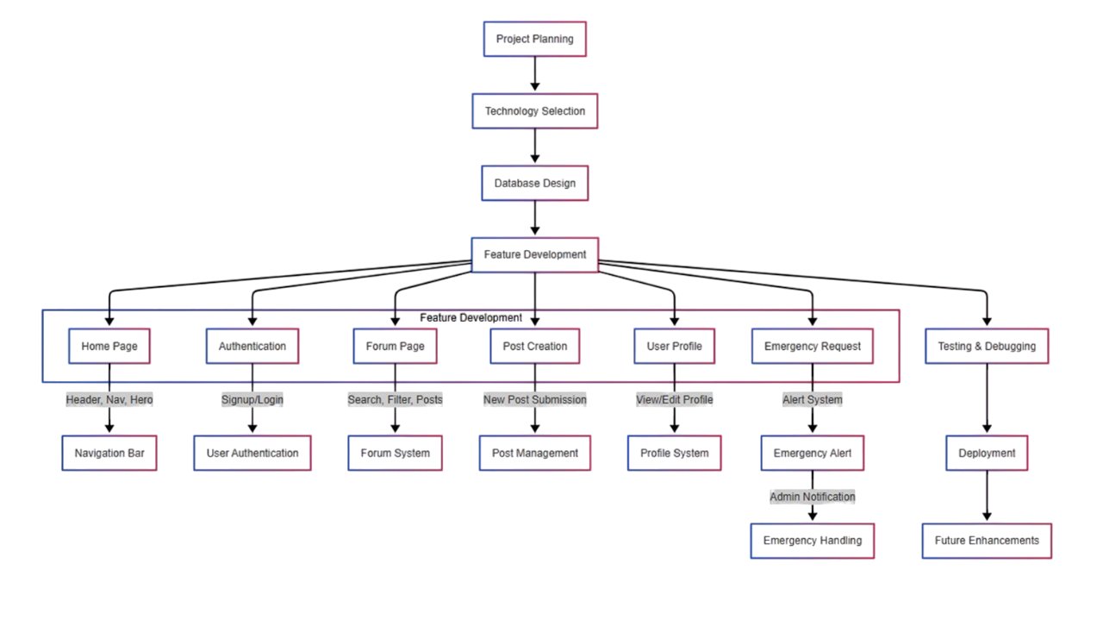After successful testing, the HerHaven platform was deployed using cloud-based infrastructure for optimal performance and accessibility. The frontend was hosted on Vercel, while the backend was deployed on Render. Monitoring tools were implemented to track system performance and user activity post-launch.

**Fig:3.1 Methodology**

**Chapter 4: Results and Discussions**

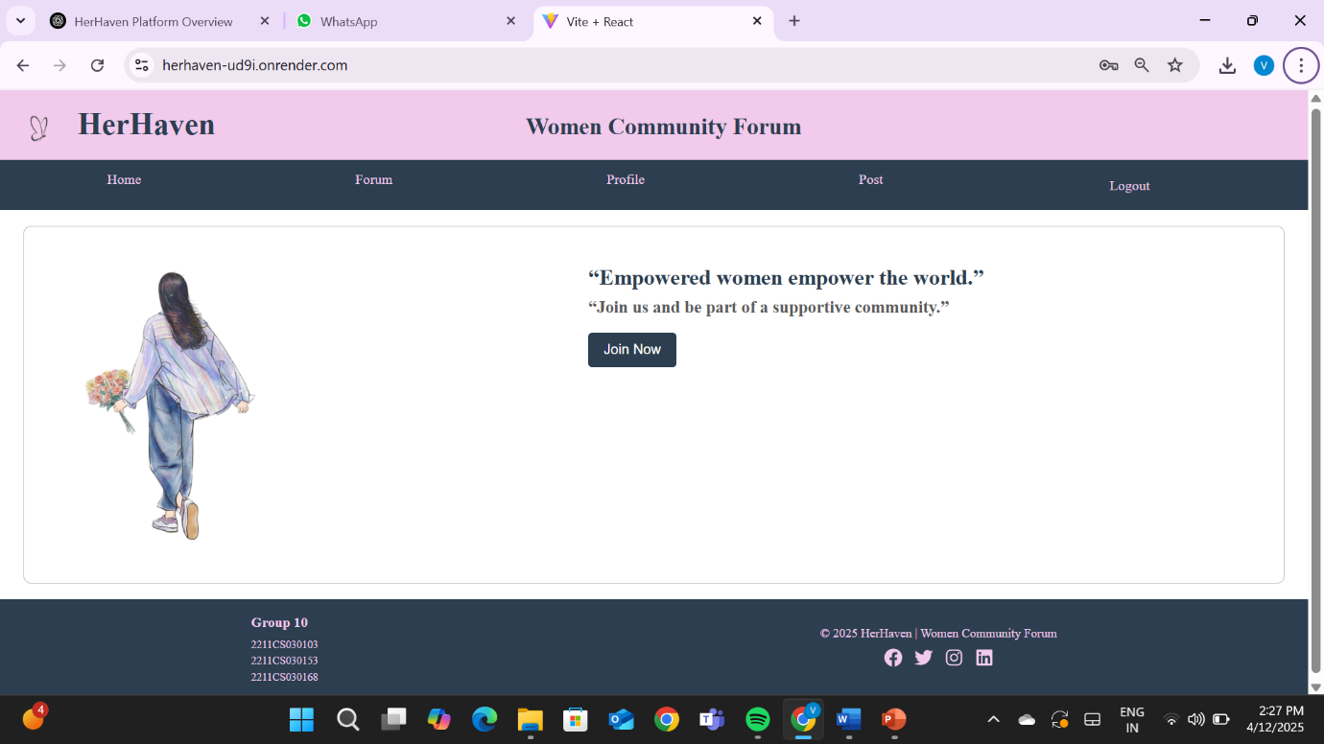

**Fig:4.1 Home Page**

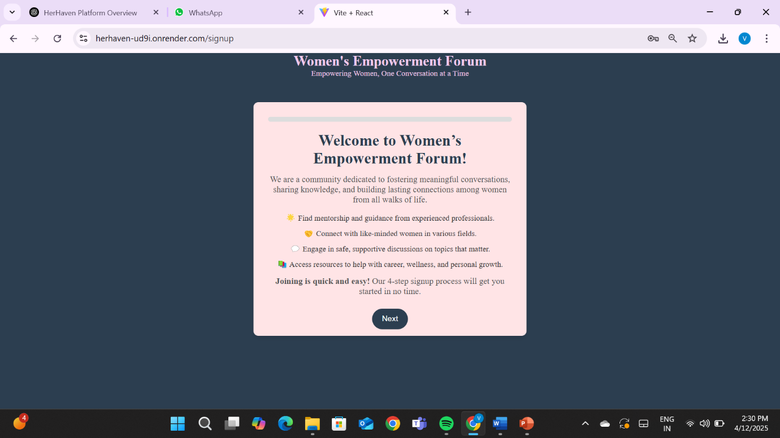

**Fig:4.2 SignUp for User**

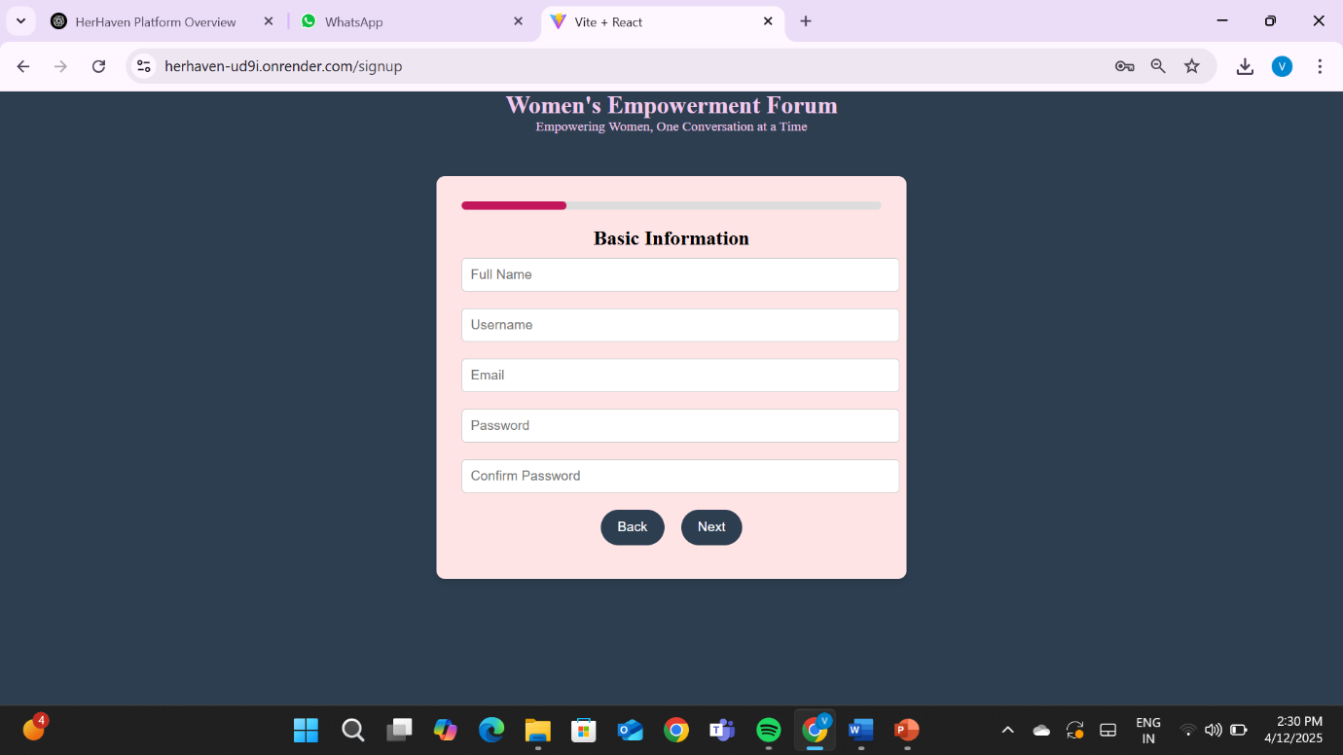

**Fig:4.3 Basic Information (i)**

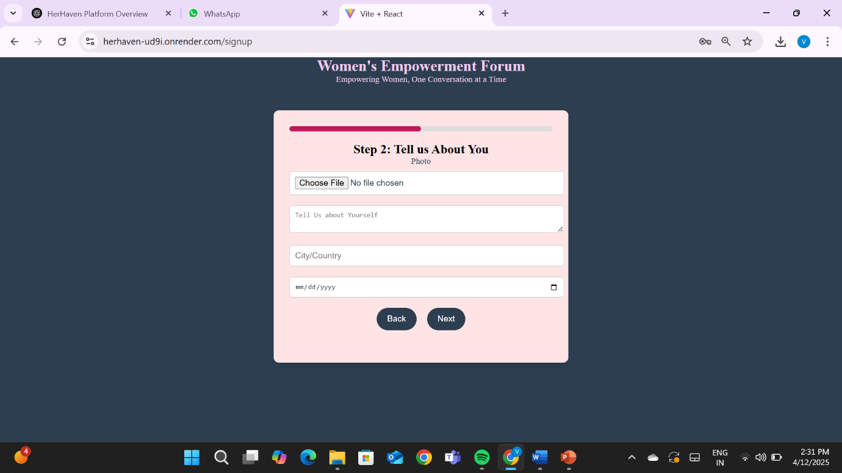

**Fig:4.4 Basic Information (ii)**

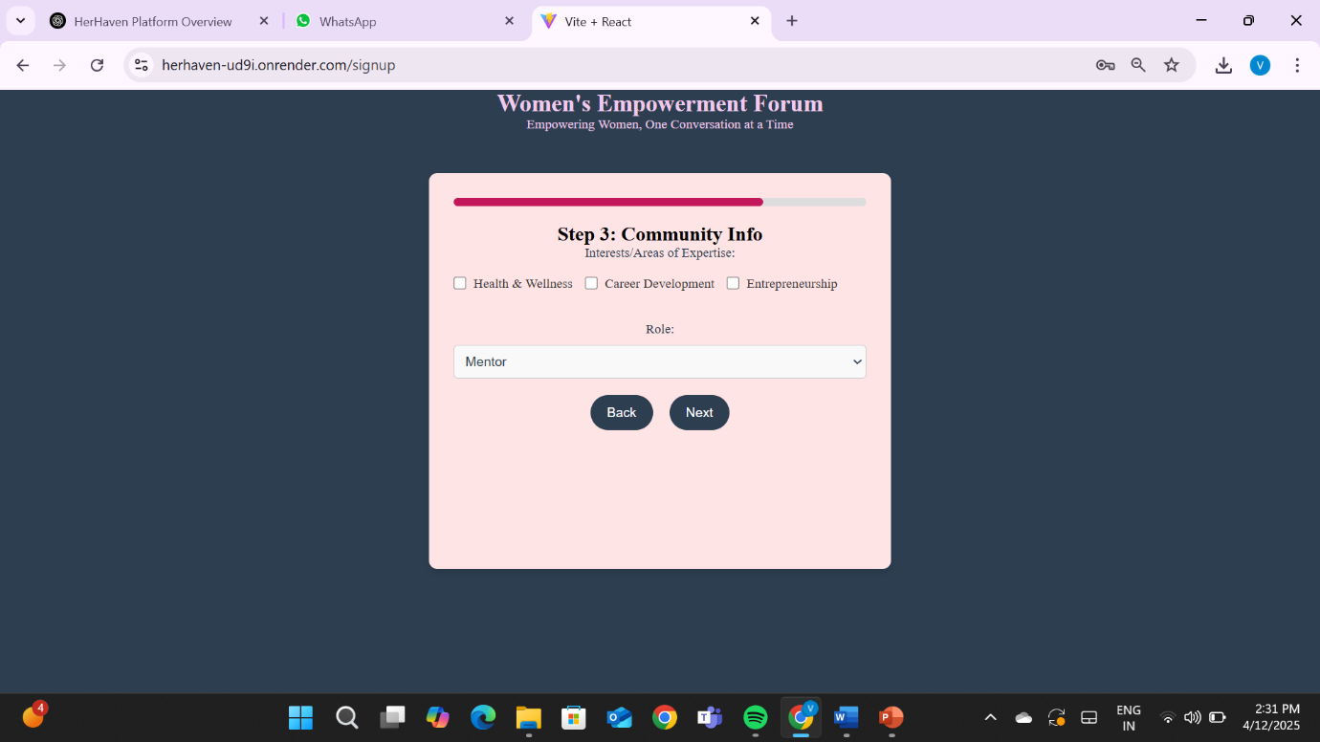

**Fig:4.5 Basic Information (iii)**

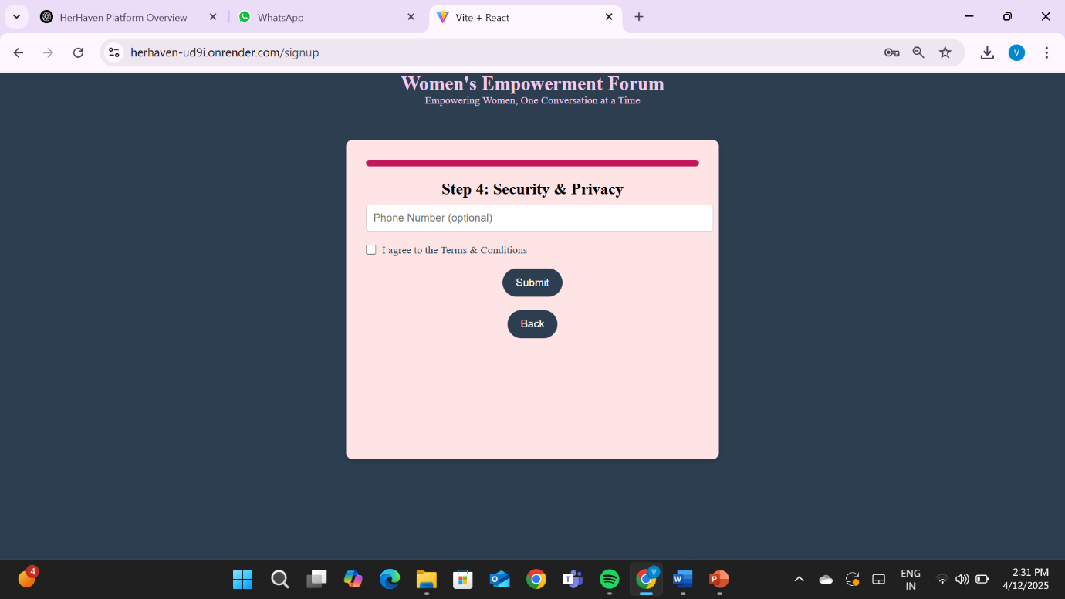

**Fig:4.6 Basic Information (iv)**

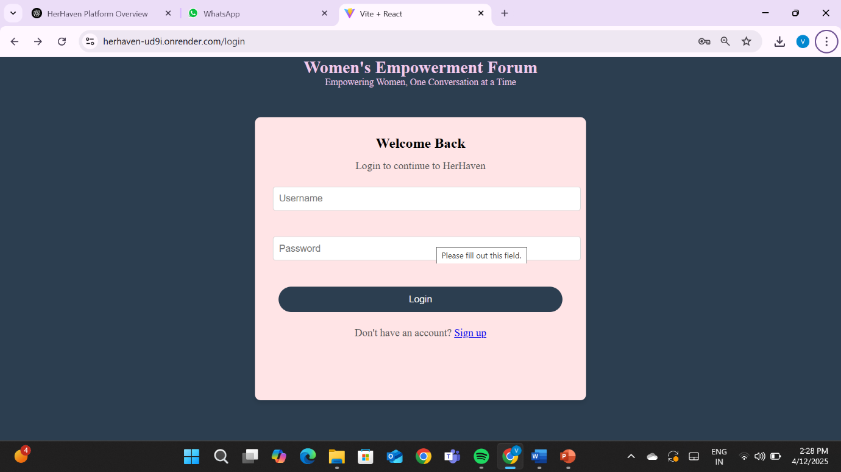

**Fig:4.7 Login Page**

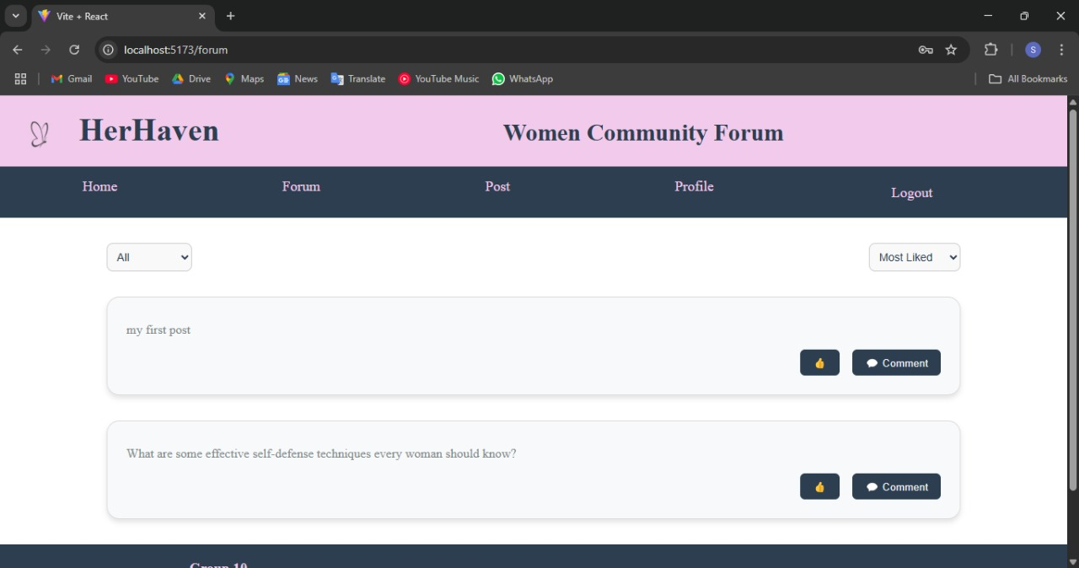

**Fig:4.8 Forum Page**

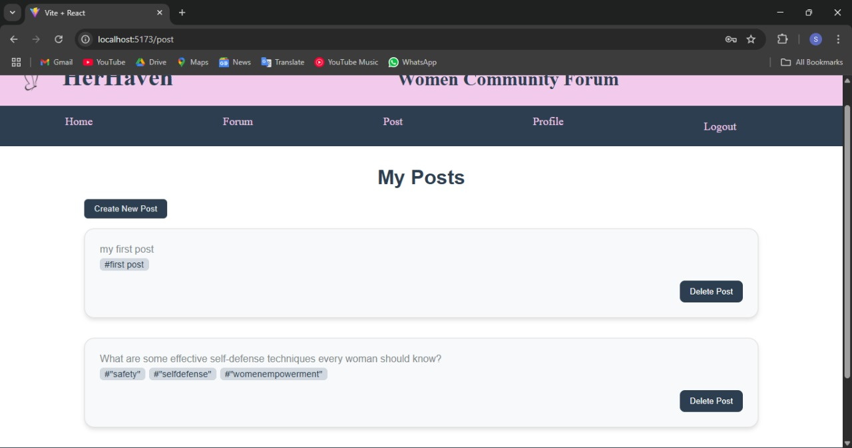

**Fig:4.9 Post Page**

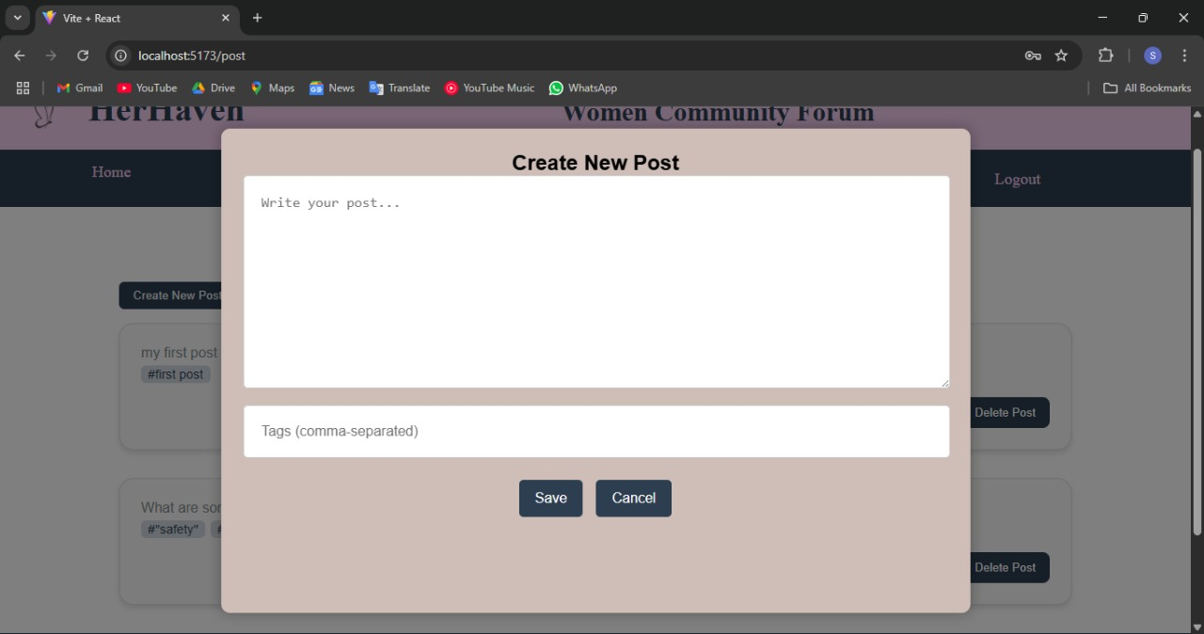

**Fig:4.10 New post creation**

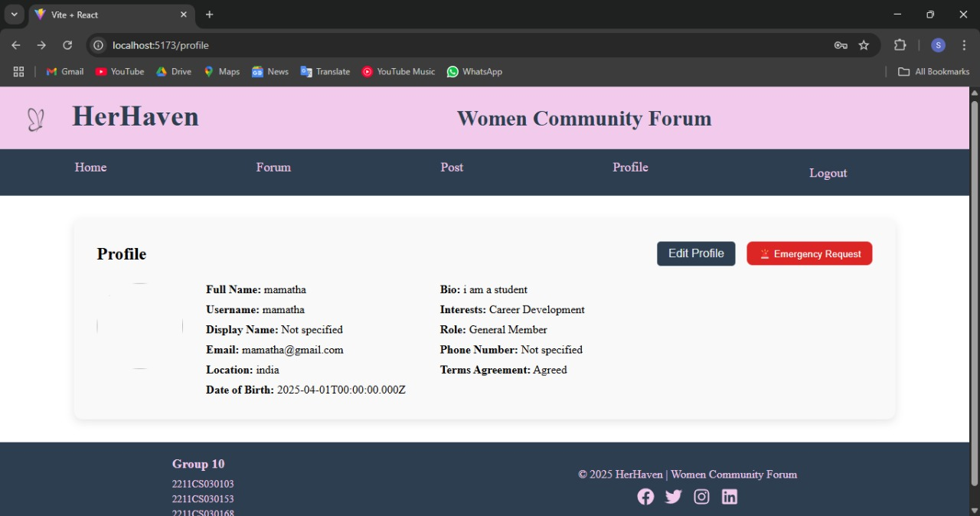

**Fig:4.11 Profile Page**

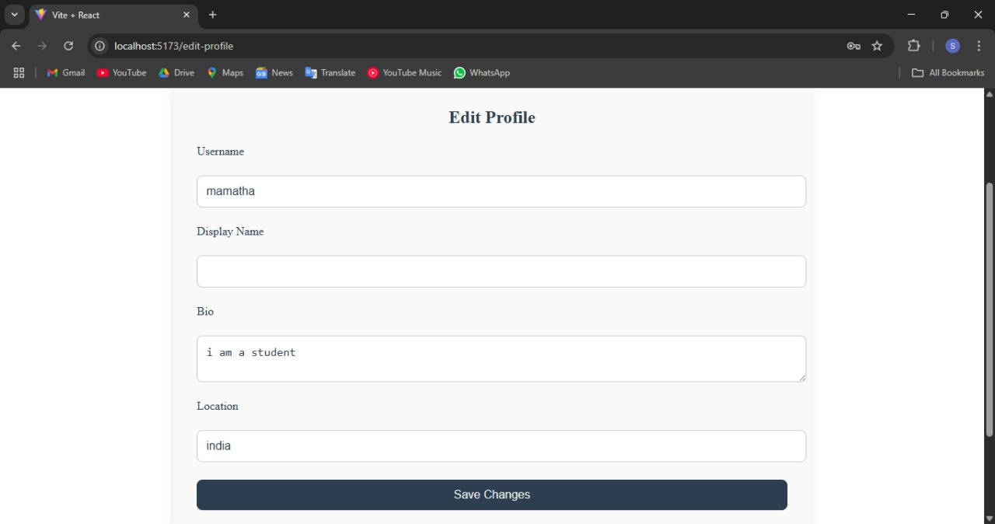

**Fig:4.12Edit Profile Page**

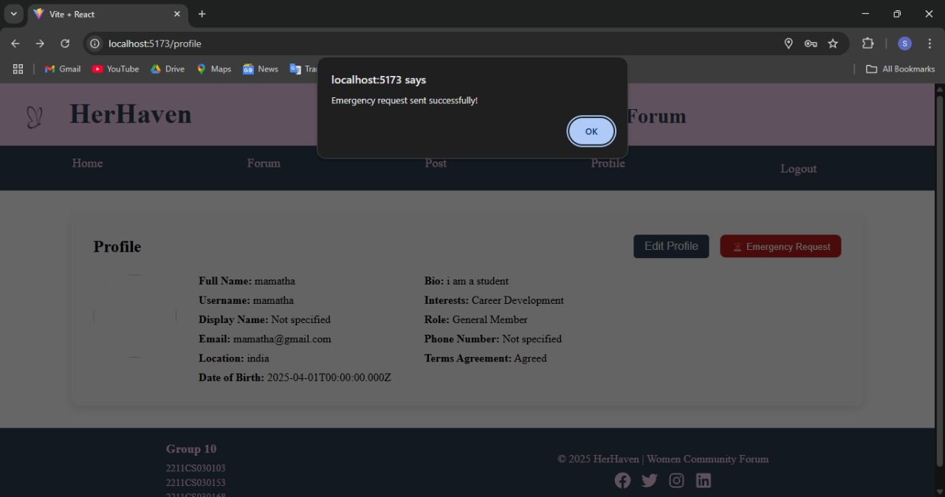

**Fig:4.13 Emergency request sent successfully**

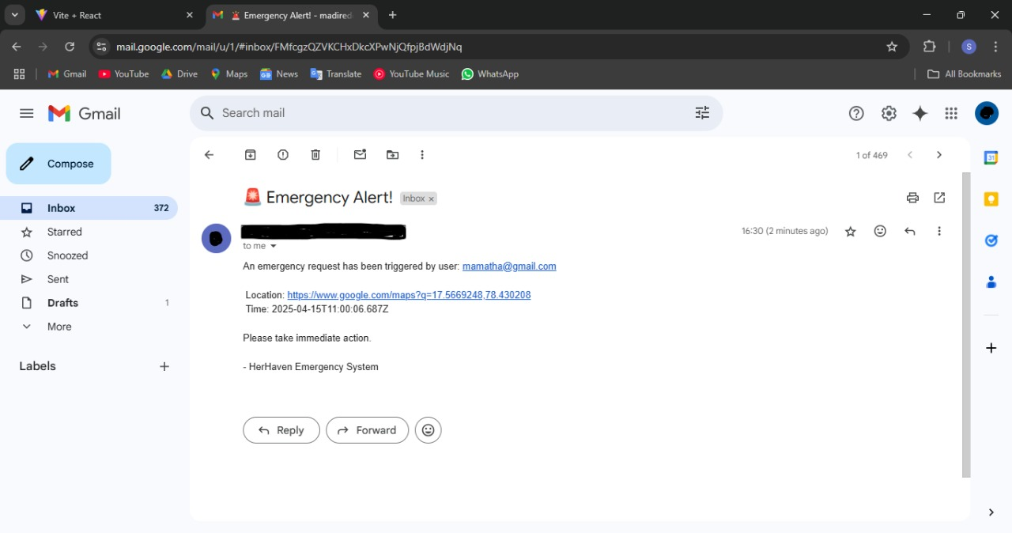

**Fig:4.14 Emergency Request mail sent**

**Chapter 5 : Conclusions and Future Scope of Study**

**Conclusion**

In conclusion, HerHaven is an innovative platform designed to empower women by providing a digital space for connection, knowledge sharing, and mutual support. By integrating features such as discussion boards, mentorship programs, and resource sharing, the app creates a supportive and collaborative community for women. Its clean, user-friendly interface ensures easy navigation, whether for users seeking help, guidance, or simply a place to share experiences. The platform's accessibility and inclusivity make it an ideal tool for fostering growth, empowerment, and shared knowledge.

The development of HerHaven utilizes a robust tech stack, incorporating React for the front-end, Spring Boot for the back-end, and MongoDB for database management. This combination ensures a seamless, scalable, and efficient platform that can accommodate growing user bases while maintaining smooth performance. The multi-step signup process and secure login provide a personalized experience, making users feel safe and valued in the community.

HerHaven is not just a women’s forum but a dynamic platform that emphasizes safety, personal growth, and connectivity. Its thoughtful design, supported by modern technology, promises to make a lasting impact on its users, encouraging them to connect, learn, and grow together. The vision behind HerHaven is to create a supportive space where women can share their stories, seek guidance, and build a network that empowers them both personally and professionally.

**Future Scope to Study**

1. **AI-Driven Personalization:**

Implementing machine learning algorithms to personalize content recommendations, mentorship suggestions, and community discussions based on user preferences and activities, enhancing user engagement and experience.

1. **Mobile App Development:**

Expanding HerHaven into a mobile application, offering users a more accessible and seamless experience across devices, with features like push notifications and location-based services for community events.

1. **Gamification for User Engagement:**

Introducing gamification elements such as reward systems, achievements, and leaderboards to increase user participation, encourage positive interactions, and sustain long-term engagement within the community.

1. **Multilingual Support and Global Expansion:**

Studying the potential for supporting multiple languages and regional forums to reach a broader, international audience, ensuring the platform is accessible and inclusive to women across different cultures and backgrounds.

1. **Enhanced Security and Privacy Features:**

Future development could focus on implementing advanced security measures, such as end-to-end encryption and stronger user data protection, ensuring that the platform remains a safe and trustworthy space for women to connect.

**Top of Form**

**Bottom of Form**

**References:**

[1] <https://www.7cups.com/forum/women> - **7 Cups Women’s Forum** - Online support and discussions for women.

[2] <https://www.womens-forum.com/> - **Women’s Forum** - Global platform for women empowerment.

[3] <https://www.w3schools.com/REACT/DEFAULT.ASP-> Learning resource for React development.