Personalized Travel Planning System

In this project we are designing Personalized Travel Planning System where user can search desired travel destination by entering his desire details such as AGE, Gender, ratings, place name like wildlife, heritage, pilgrimage, museum, park etc. All existing recommendation system will be based on ratings of other users recommendation but won’t accept user parameters so our propose system will perform recommendation based on user parameters.

In propose application we have taken INDIAN cities dataset with ratings and other details.

Below is the dataset screen shots which contains user details and place details in separate files

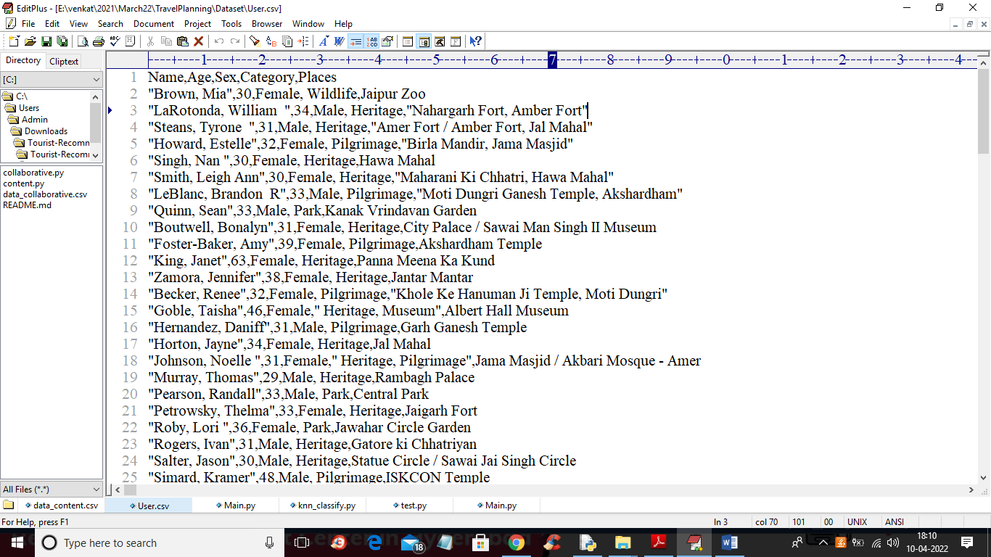

In above screen we have user details like age and gender and his favourite places and below dataset showing nearby places with ratings and website URL, distance and duration

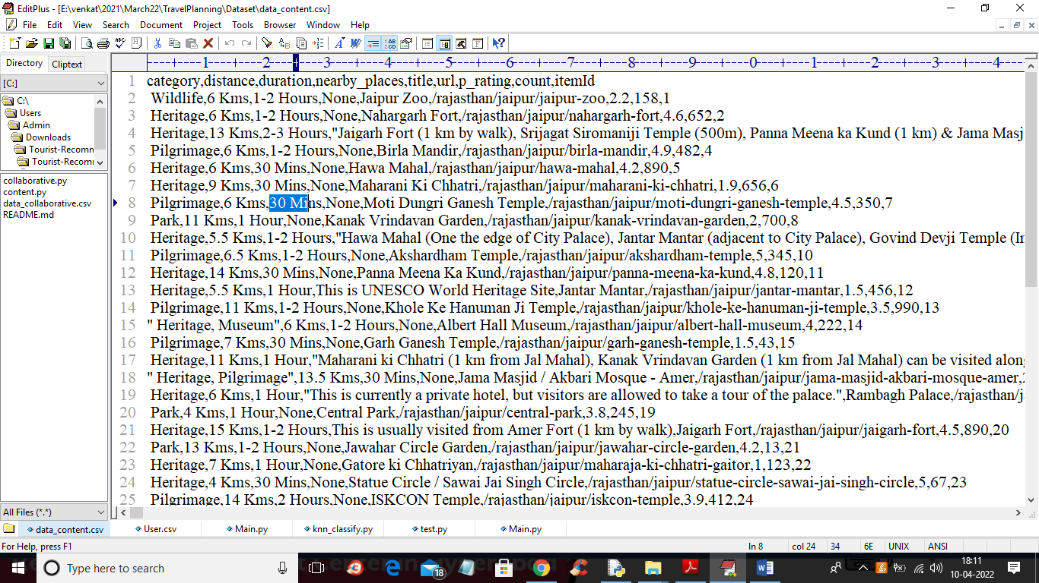

We will use above dataset for travel planning recommendations

To implement this project we have designed following modules

1. Upload Travel Dataset: using this module we will upload dataset to application
2. Preprocess Dataset: using this module we will process dataset to replace missing values
3. Build Collaborative & Clustering Model: using this module we will build collaborative and clustering model using users favourite places and ratings and then convert entire dataset into numeric vector so we train this vector with machine learning algorithm
4. Train KNN Algorithm: above vector will be input to machine learning KNN algorithm to train recommendation model. This model can predict close destination places based on user input parameters
5. Predict Recommendation: this module will take user parameter as input and then apply KNN model to predict closed destinations

SCREEN SHOTS

To run project double click on ‘run.bat’ file to get below output

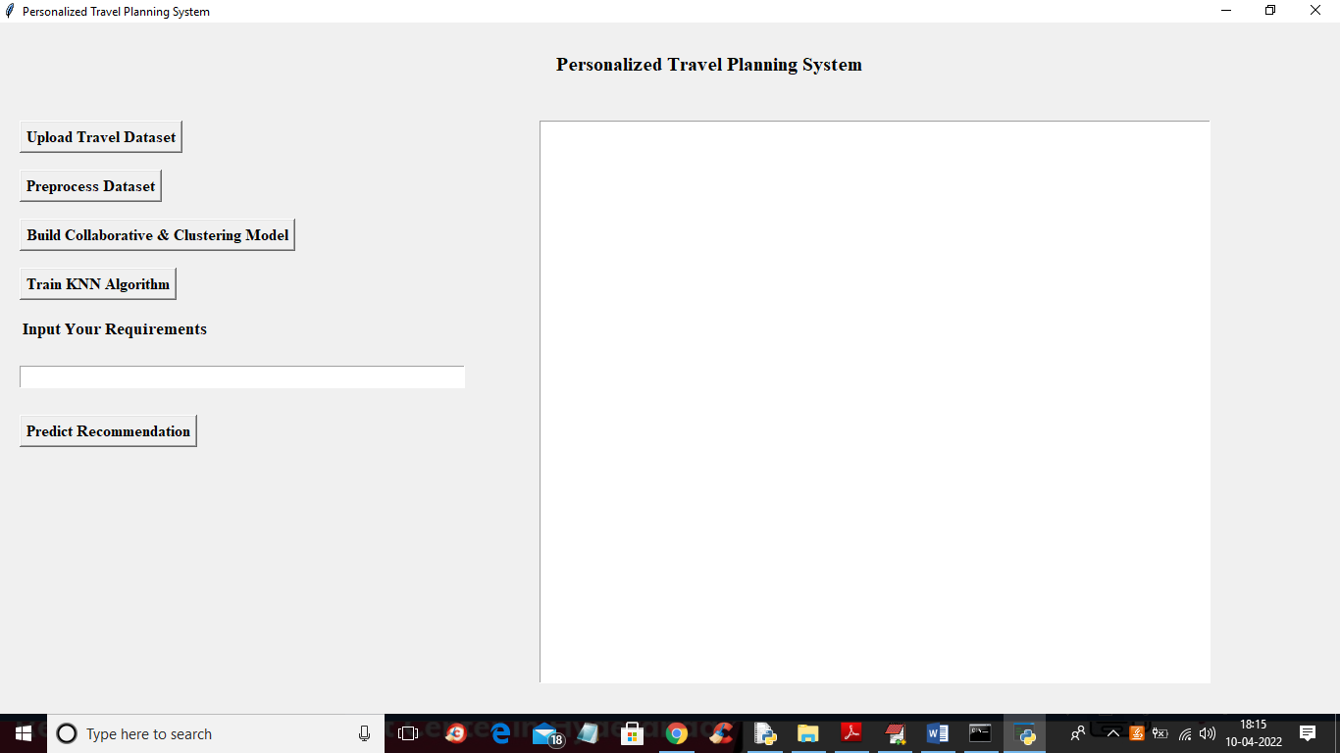

In above screen click on ‘Upload Travel Dataset’ button to upload dataset and to get below output

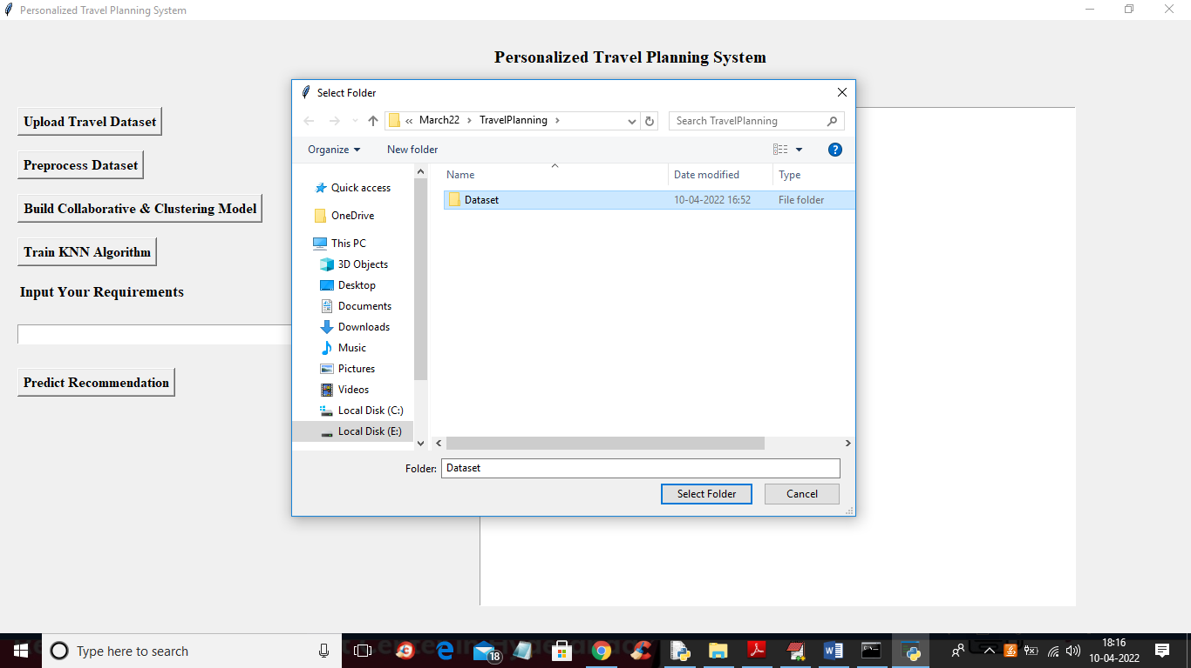

In above screen selecting and uploading ‘Dataset’ folder and then click on ‘Select Folder’ button to load dataset and to get below output

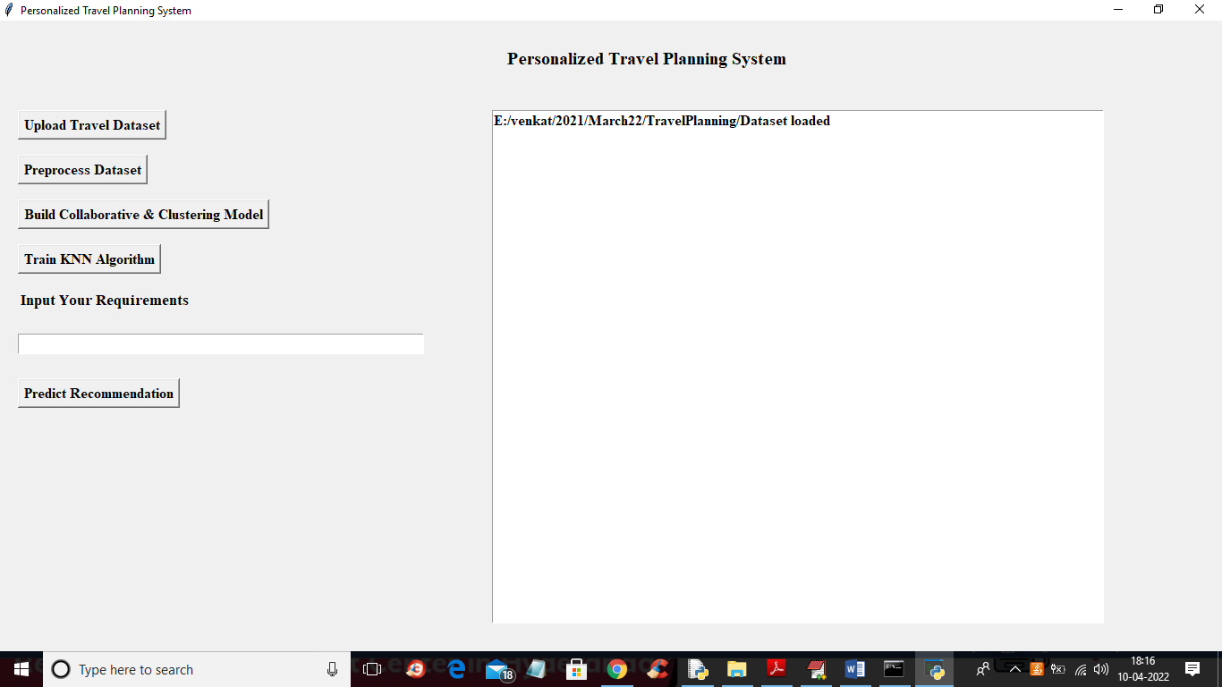

In above screen dataset loaded and now click on ‘Preprocess Dataset’ button to remove missing values from the dataset

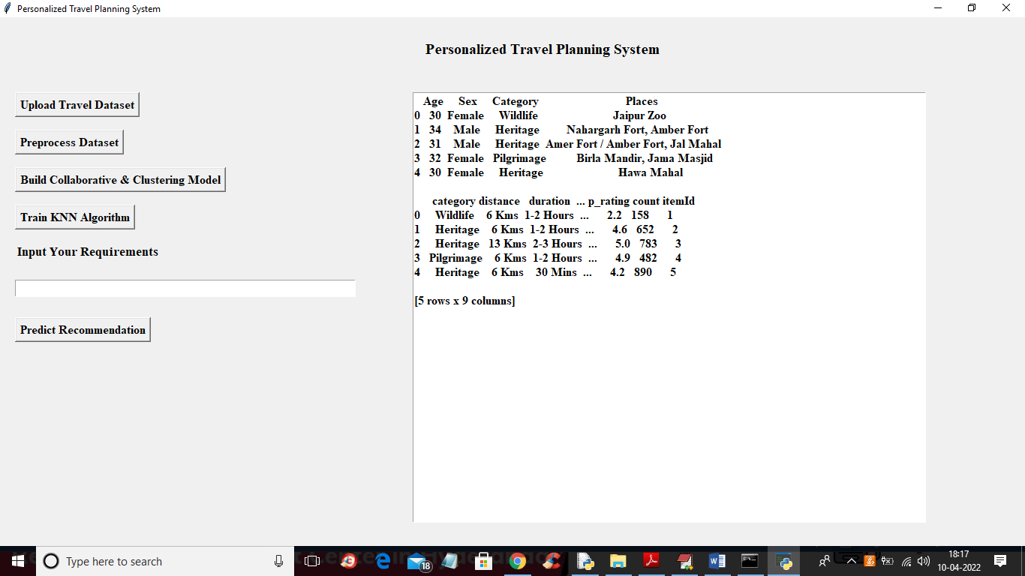

In above screen dataset is process and displaying data without any missing values and now click on ‘Build Collaborative & Clustering Model’ button to build model based on user ratings and favourite places and all related data will be put in same cluster.

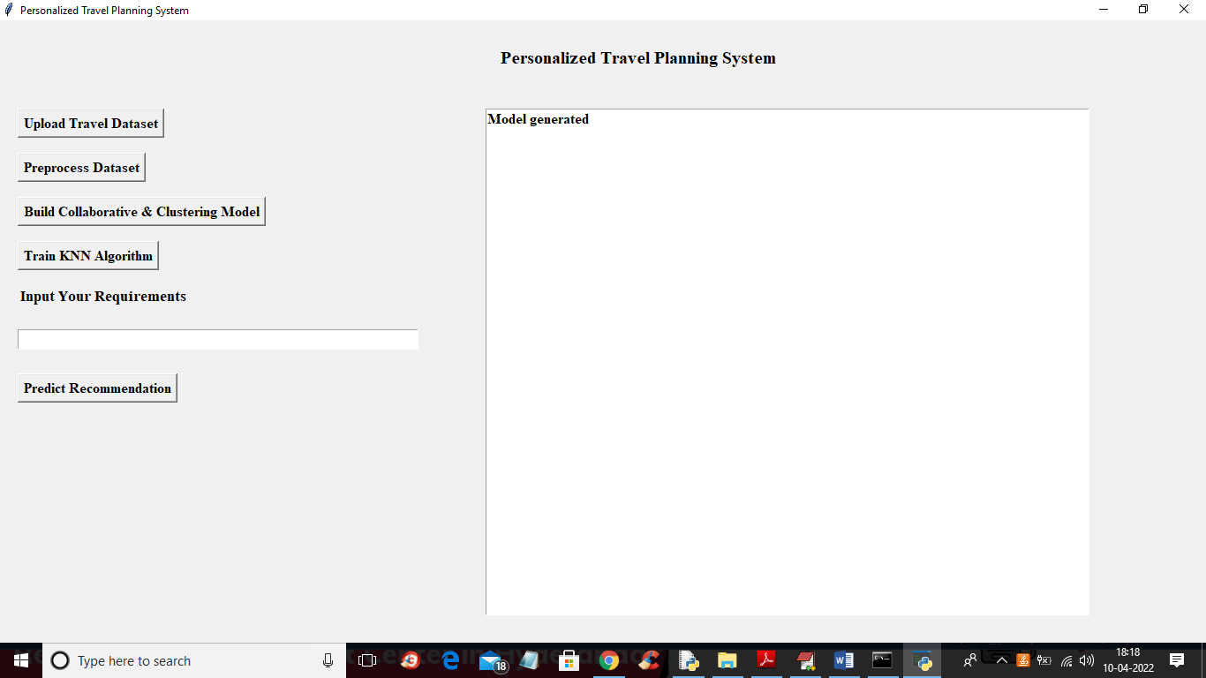

In above screen collaborative model generated and now click on ‘Train KNN Algorithm’ to train ML algorithm and get below output

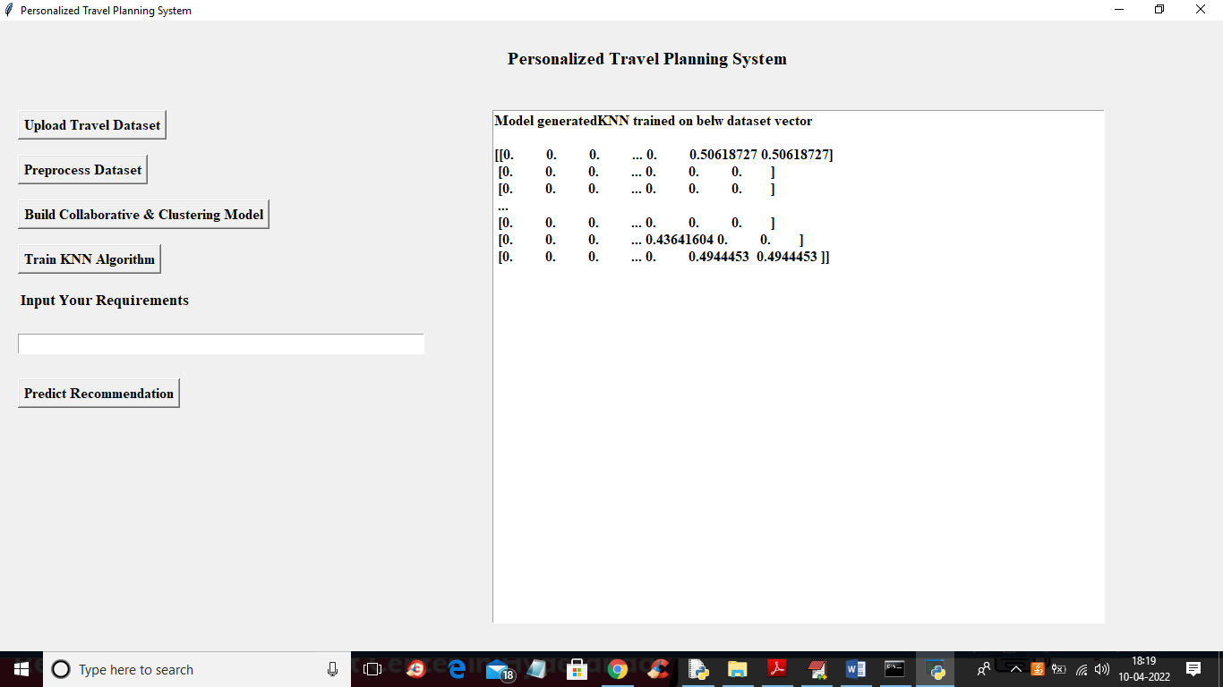

In above screen we can see the vector generated from dataset and then train KNN algorithm and now enter your desired parameters

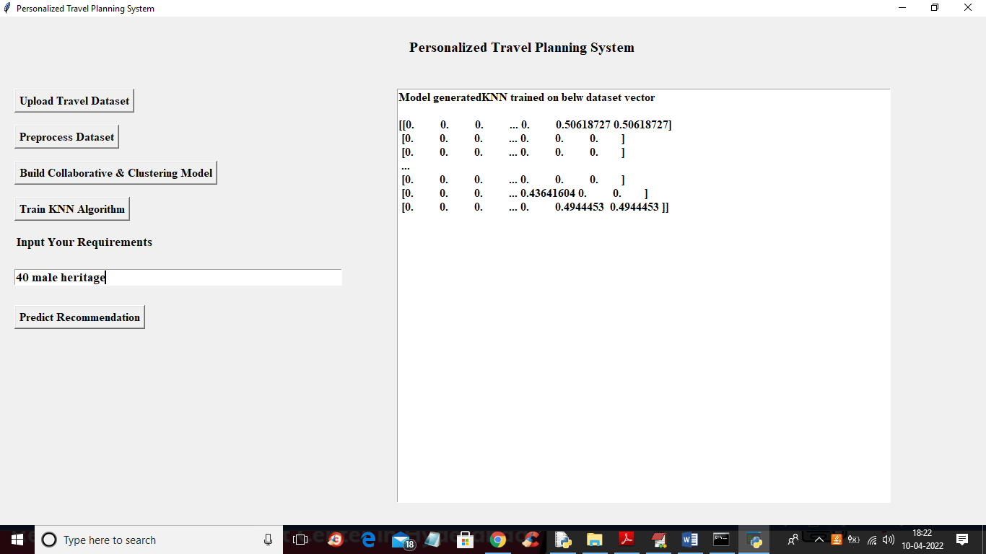

In above screen user entered input parameters as age 40 and gender is male and preferred location is heritage and click on button to get below output

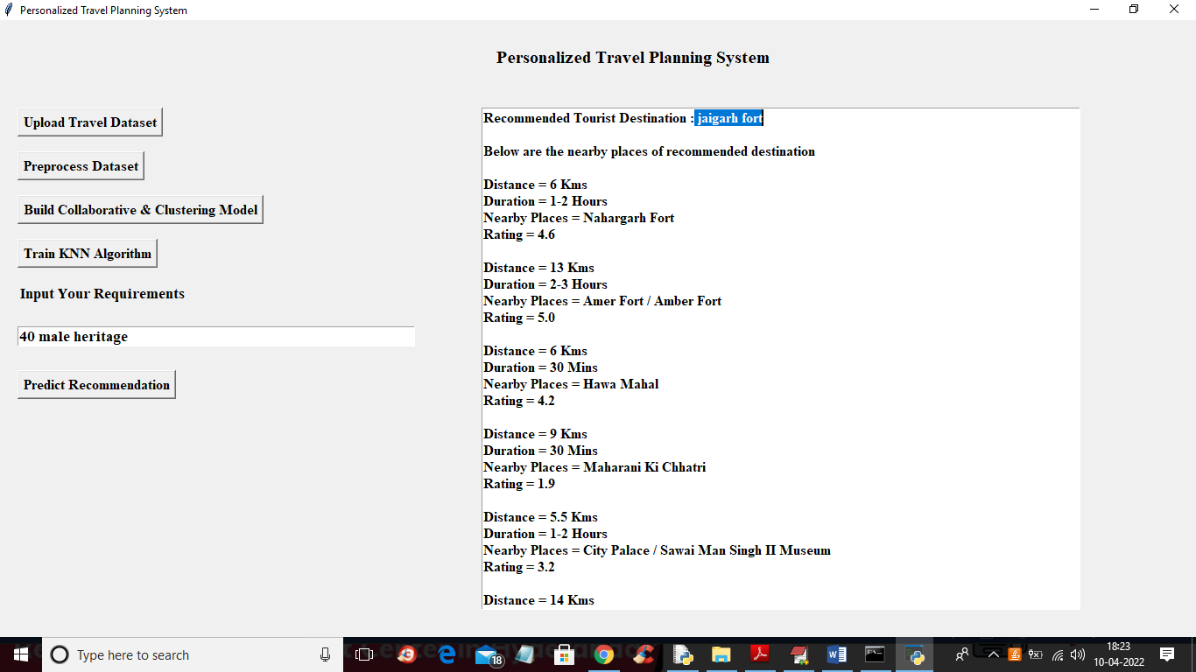

In above screen in first line we got the recommended destination is ‘jaigrah fort’ and then displaying all nearby places with distance, duration and ratings and similarly you can query your parameters to get recommendation

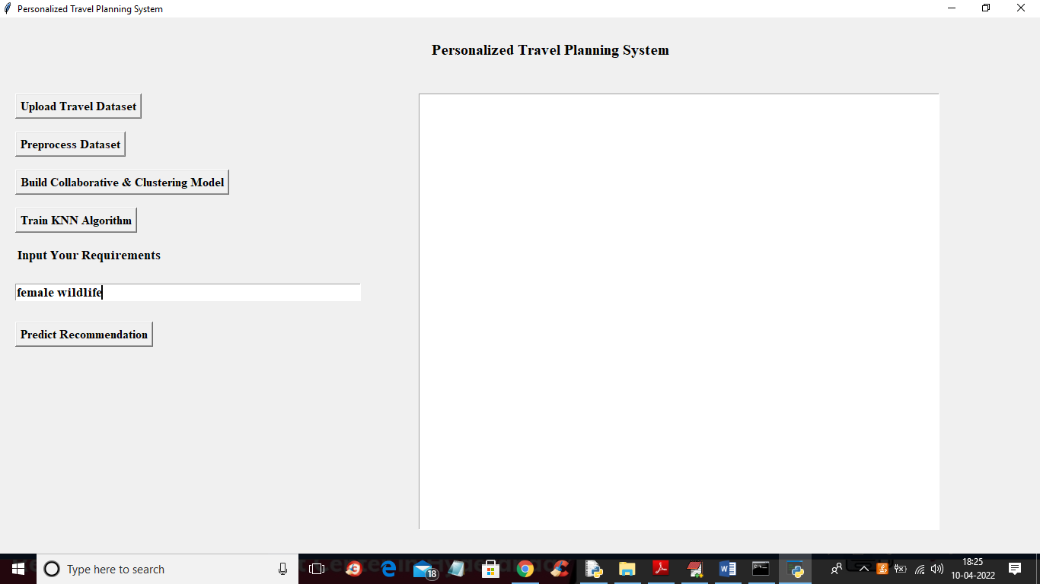

In above screen I entered query as ‘female wildlife’ where user is female and interested in places of wildlife and press predict button to get below output

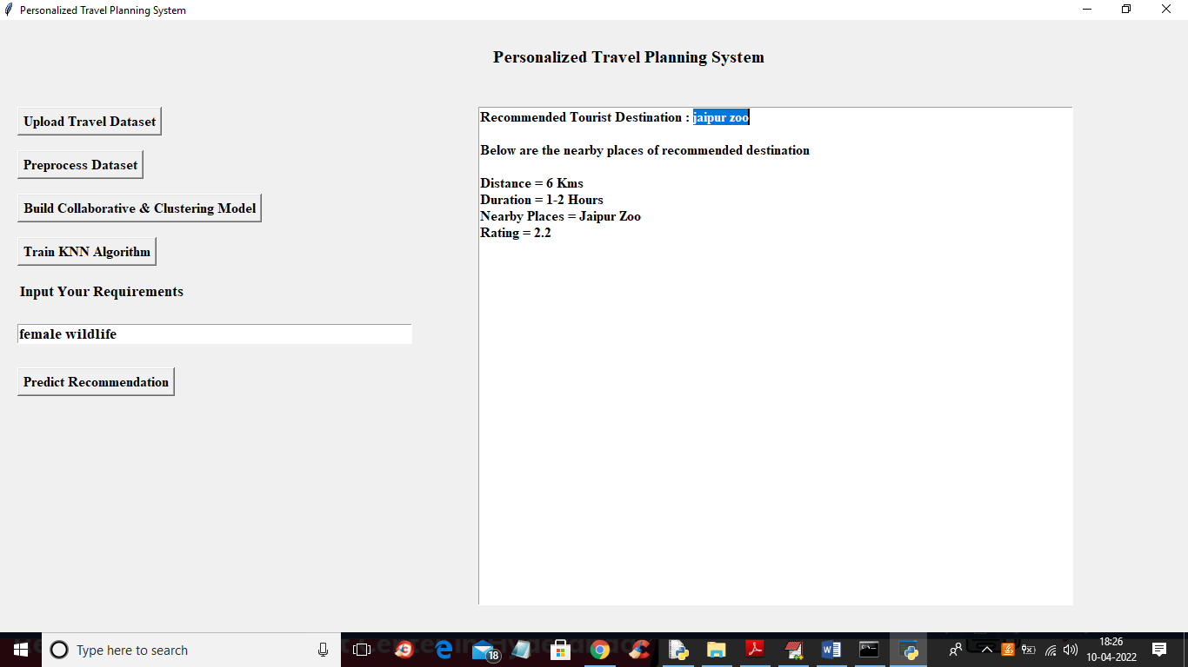

In above screen recommended place is ‘jaipur zoo’ and then displaying distance, duration with raings