NAME: S.Srinika
Roll.No: 2420030617
Section: 1

Experiment 1: Case Study
Problem Statement: Choose a real-world case study of the Amazon Online Shopping Platform, create user stories for different stakeholders, select an appropriate software development process model, identify suitable programming languages and technologies, and propose an implementation and evaluation strategy for building a scalable, secure, and user-friendly e-commerce application.
Real-World Case Study: Amazon Online Shopping Platform
1. Functional Requirements
Customer
- Register and login
- Search and filter products
- View and compare products
- Manage cart and wishlist
- Place orders and make payments
- Track, cancel, or return orders
- Manage addresses and reviews
Guest User
- Browse products
- Search and compare products
Premium User
- Free fast delivery
- Exclusive offers
- Priority customer support
Seller (Brand Partner)
- Register business
- Manage products
- Monitor inventory and sales
Delivery Partner
- Receive delivery assignments
- Update delivery status
- Verify delivery using OTP
Customer Support Executive
- View customer orders
- Process returns and refunds
Administrator
- Manage products and categories
- Manage inventory and orders
- Manage customers and reviews
- Generate reports

2. User Stories
User ID | User Story | Priority | Story Points
US-01 | As a customer, I want to create a new account using my email address or mobile number so that I can securely access Amazon. | High | 8
US-02 | As a customer, I want to log in securely so that I can access my orders, addresses, and payment methods. | High | 5
US-03 | As a customer, I want to search and filter products by category, brand, price, and ratings so that I can quickly find suitable products. | High | 8
US-04 | As a customer, I want to view detailed product information, including reviews and ratings, so that I can make informed purchasing decisions. | High | 5
US-05 | As a customer, I want to add, update, or remove products from my shopping cart so that I can manage my purchases before checkout. | High | 8
US-06 | As a customer, I want to make secure online payments and track my order status so that I can complete purchases safely. | High | 13
US-07 | As a premium user, I want free fast delivery and exclusive offers so that I receive additional membership benefits. | Medium | 3
US-08 | As a seller, I want to register my business and upload products so that I can sell products on Amazon. | High | 8
US-09 | As a delivery partner, I want to receive delivery assignments and verify deliveries using OTP so that orders are delivered securely. | Medium | 5
US-10 | As a customer support executive, I want to process returns, replacements, and refunds so that customer issues are resolved quickly. | Medium | 5
US-11 | As an administrator, I want to manage products, categories, and inventory so that customers always see updated information. | High | 8
US-12 | As an administrator, I want to generate sales reports and manage customer accounts so that I can monitor business performance and maintain platform security. | Medium | 5

3. Selected Software Development Process Model
Agile Scrum
Reason for Selection
- Requirements change frequently.
- Continuous customer feedback.
- Incremental feature delivery.
- Faster development cycles.
- Easy bug fixing.
- Suitable for large-scale web applications.
- Supports continuous integration and deployment.
- Enables regular testing after every sprint.
Sprint Plan
Sprint | Features
Sprint 1 | User Registration & Login
Sprint 2 | Product Catalog, Search & Filters
Sprint 3 | Shopping Cart & Wishlist
Sprint 4 | Order Processing & Checkout
Sprint 5 | Payment Gateway Integration
Sprint 6 | Seller & Admin Dashboard
Sprint 7 | Delivery Tracking, Testing & Deployment

4. Programming Language Selection
Backend
- Java
- Spring Boot
Reasons
- Highly secure
- Scalable
- Enterprise-level framework
- REST API support
- Fast development
- Excellent database connectivity
Frontend
- HTML5
- CSS3
- JavaScript
- React.js
Database
- MySQL
Other Technologies
- REST API
- JWT Authentication
- Razorpay / Stripe Payment Gateway
- Git
- Docker
- AWS EC2
- Nginx
- Maven

5. System Architecture
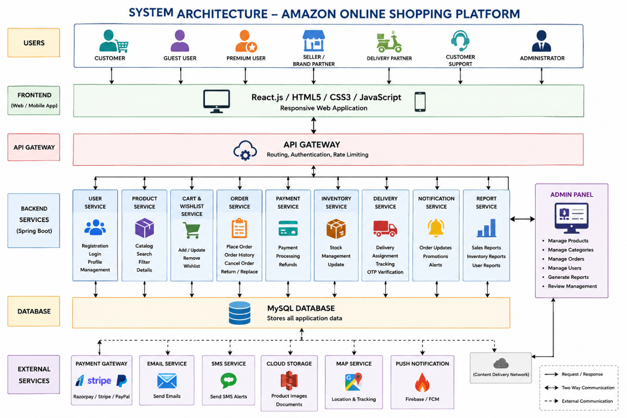

6. Implementation Strategy
Phase 1 – Requirement Analysis
- Gather customer requirements.
- Identify system stakeholders.
- Prepare Software Requirement Specification (SRS).
- Create user stories.
- Prepare use case diagrams.

Phase 2 – System Design
- Design database schema.
- Create ER diagram.
- Prepare UML diagrams.
- Design user interface wireframes.
- Define REST APIs.
- Design overall system architecture.

Phase 3 – Development
Customer Module
- Registration & Login
- Product Search
- Product Details
- Shopping Cart
- Wishlist
- Checkout
- Payment Integration
- Order Tracking
- Reviews
Seller Module
- Product Management
- Inventory Management
- Sales Dashboard
Admin Module
- Product Management
- Customer Management
- Order Management
- Inventory Monitoring
- Reports
Delivery Module
- Delivery Assignment
- OTP Verification
- Live Order Status

Phase 4 – Testing
Unit Testing
- Registration
- Login
- Product Search
- Shopping Cart
- Payment
Integration Testing
- Cart + Payment
- Order + Inventory
- Seller + Product
- Delivery + Order
System Testing
- Complete application testing
User Acceptance Testing (UAT)
- Verify customer requirements
- Validate business workflows

Phase 5 – Deployment
- Docker Containers
- AWS EC2
- MySQL Database Server
- Nginx Web Server
- GitHub Repository
- CI/CD Pipeline

7. Evaluation Strategy
Evaluation Parameter | Method
Functional Accuracy | Requirement verification
Performance | Load testing using Apache JMeter
Security | Authentication, Authorization & Penetration Testing
Reliability | Continuous monitoring
Usability | User feedback survey
Scalability | Concurrent user testing
Database Performance | Query optimization
Maintainability | Code review & documentation

8. Expected Outcomes
- Secure online shopping platform.
- Fast product search and secure payments.
- Efficient order and inventory management.
- Real-time order tracking.
- Improved customer satisfaction.
- Scalable and reliable system.

