Adaptive Software Engineering
Name: S.Srinika
Roll no: 2420030617
Section - 1

Experiment-8: SonarQube
Step 1: Install SonarQube, SonarScanner, Notepad++, and JDK
Go to the C Drive and open the SonarQube folder. Open the bin folder, then open Edit Environment Variables. In Windows, open Edit System Environment Variables, select Path, click Edit, then New, and paste the SonarQube bin path.
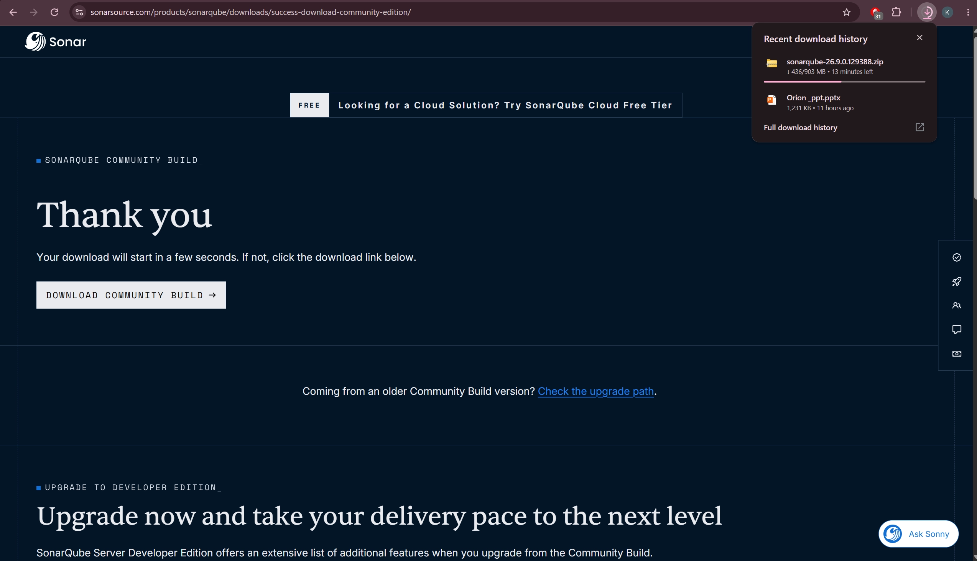
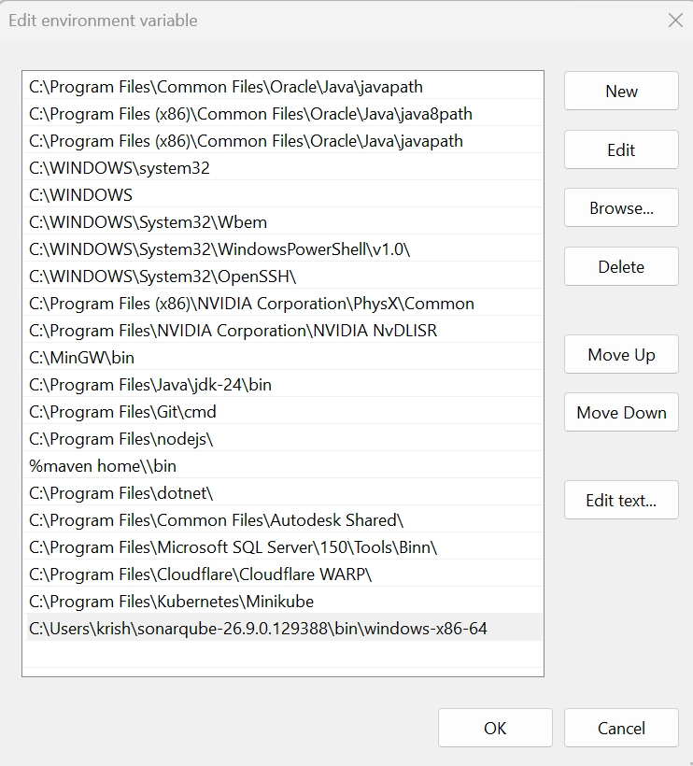
Step 2: Install SonarScanner
Open the web browser and search for SonarScanner Installation. Open the Sonar Documentation, choose your operating system, download the ZIP file, extract it, then go to the SonarScanner bin folder and add its path to the System Environment Variables.
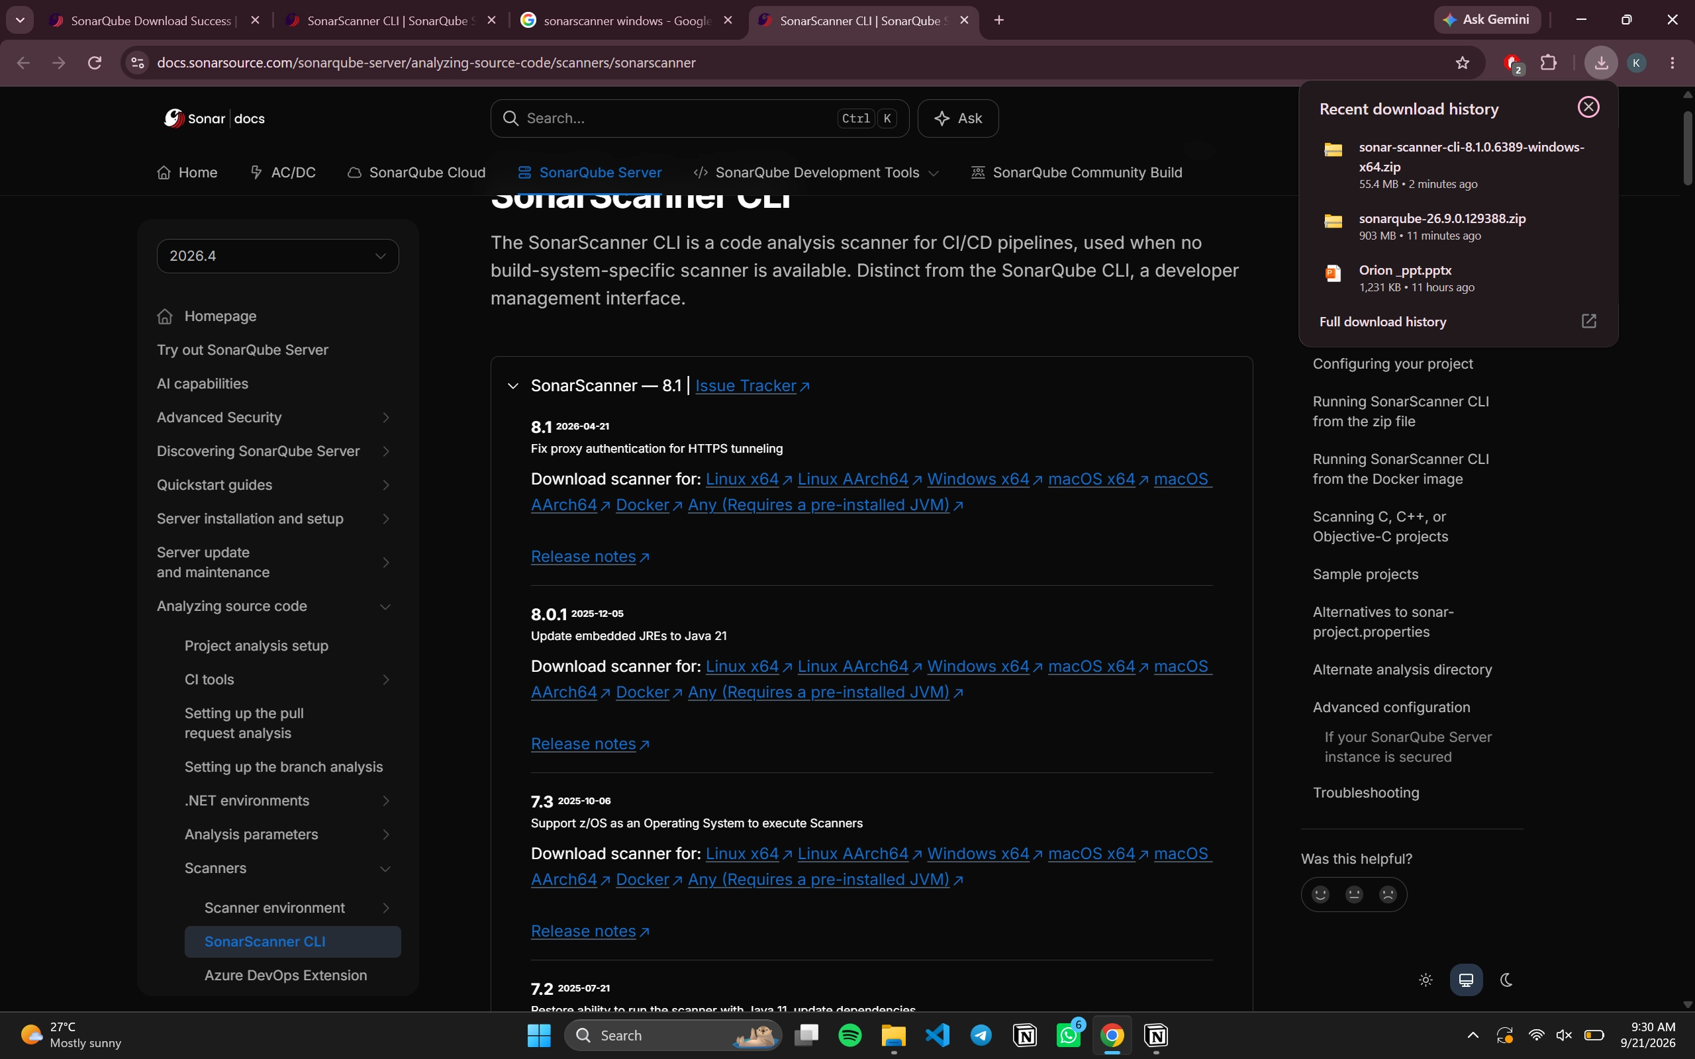
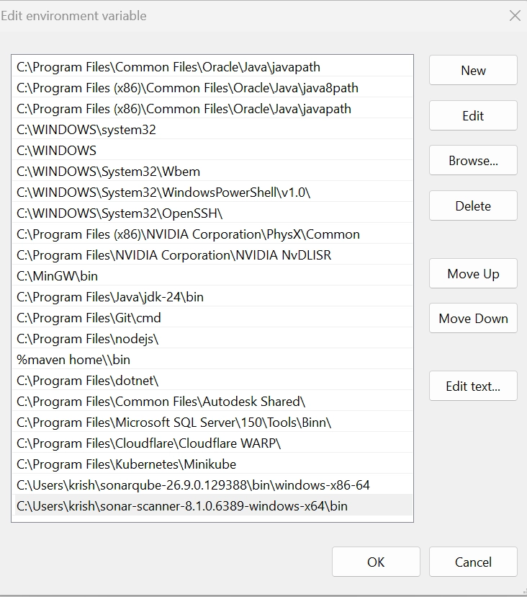

Step 3: Start the SonarQube Server
Open Command Prompt, type StartSonar, and press Enter. When the CE process is up, SonarQube is operational. Keep the Command Prompt window minimized and open http://localhost:9000 in your browser.
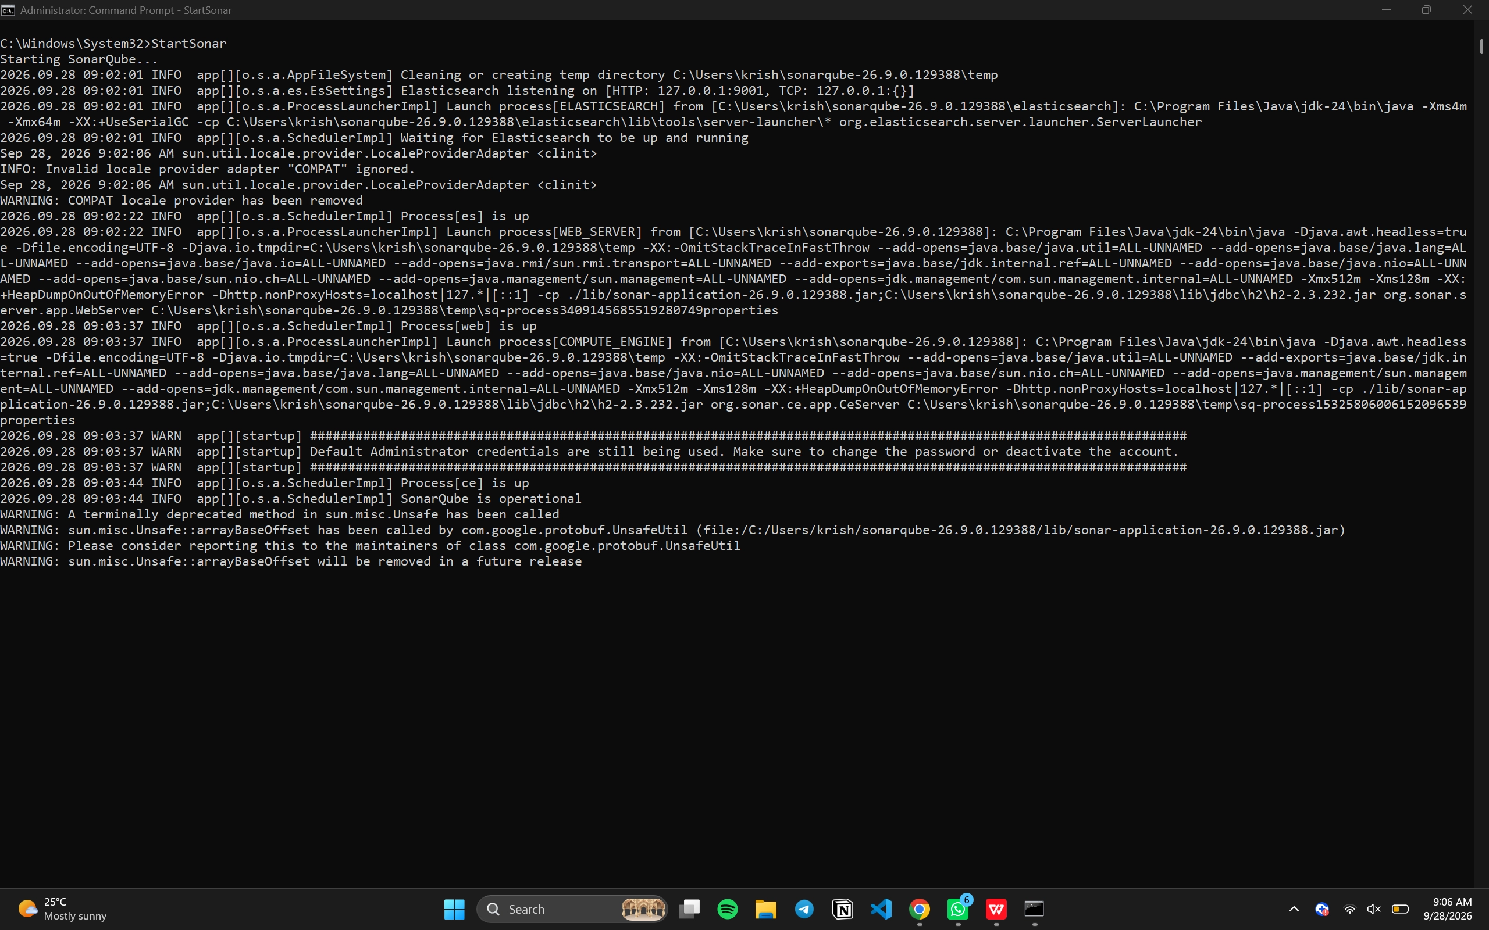

Default Login
Username: admin
Password: admin
Change the password when prompted.
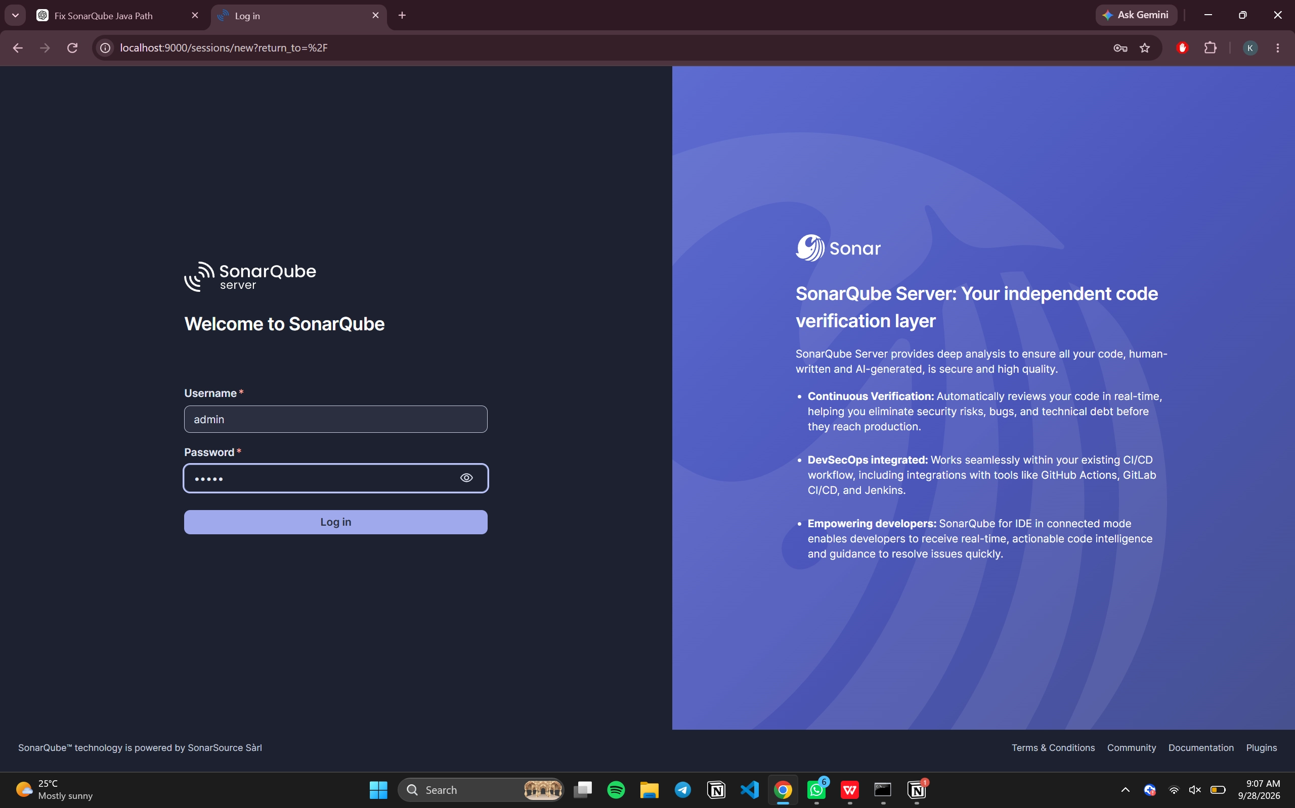

Create a Local Project
Enter the project name, click Next, choose 'Follows the Instance's Default', click Create Project, choose Locally, generate a token, copy it safely, and click Continue.
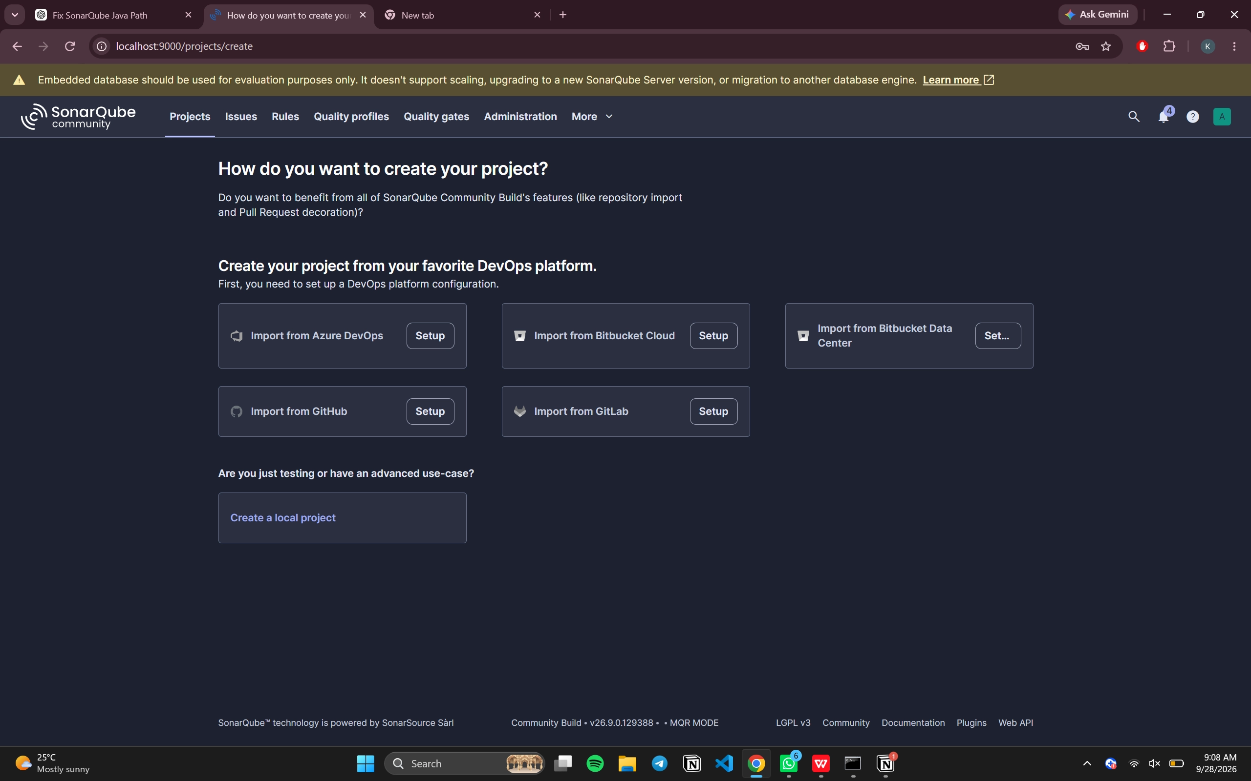
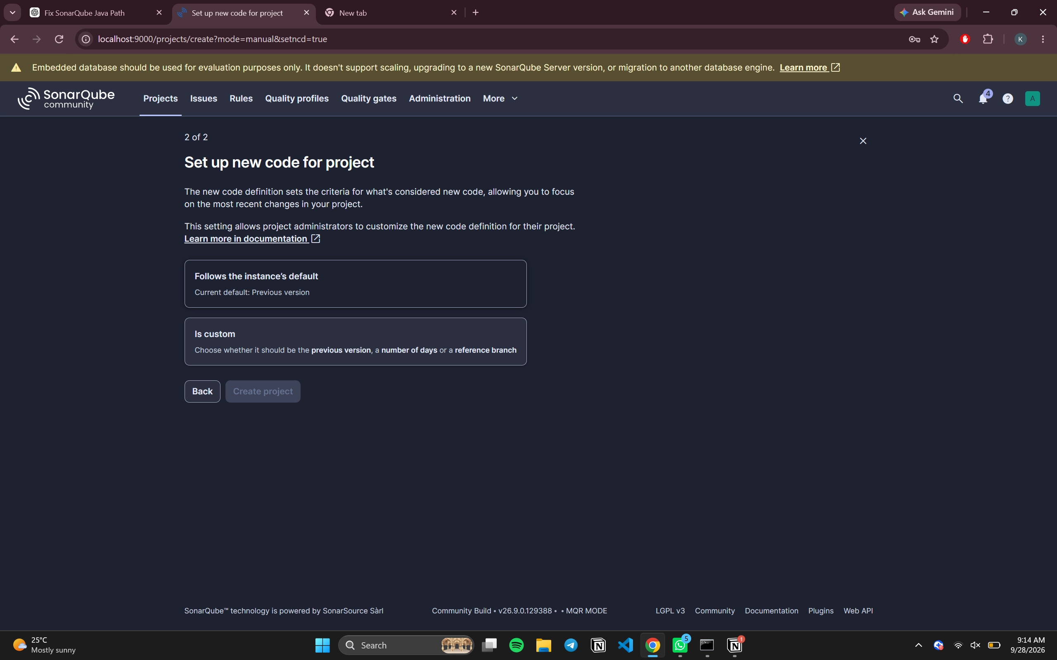

Step 4: Check SonarScanner Installation
Open a new Command Prompt while SonarQube is still running and verify the installation.
sonar-scanner -v
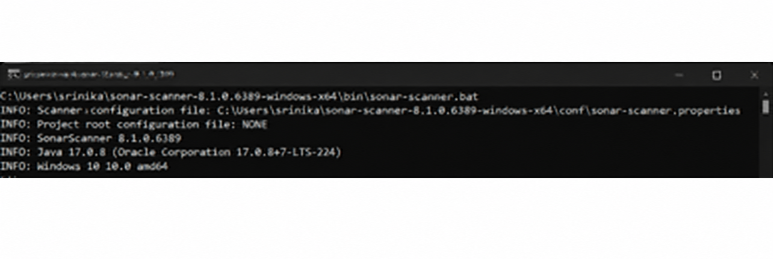

Step 5: Create the Project Files
Create a folder, save the Java program using Notepad++, and create a configuration file named sonar-project.properties.
Configuration file contents:
sonar.projectKey=addition
sonar.projectName=addition
sonar.sources=.
sonar.java.binaries=.
sonar.host.url=http://localhost:9000
sonar.token=<generated_token>
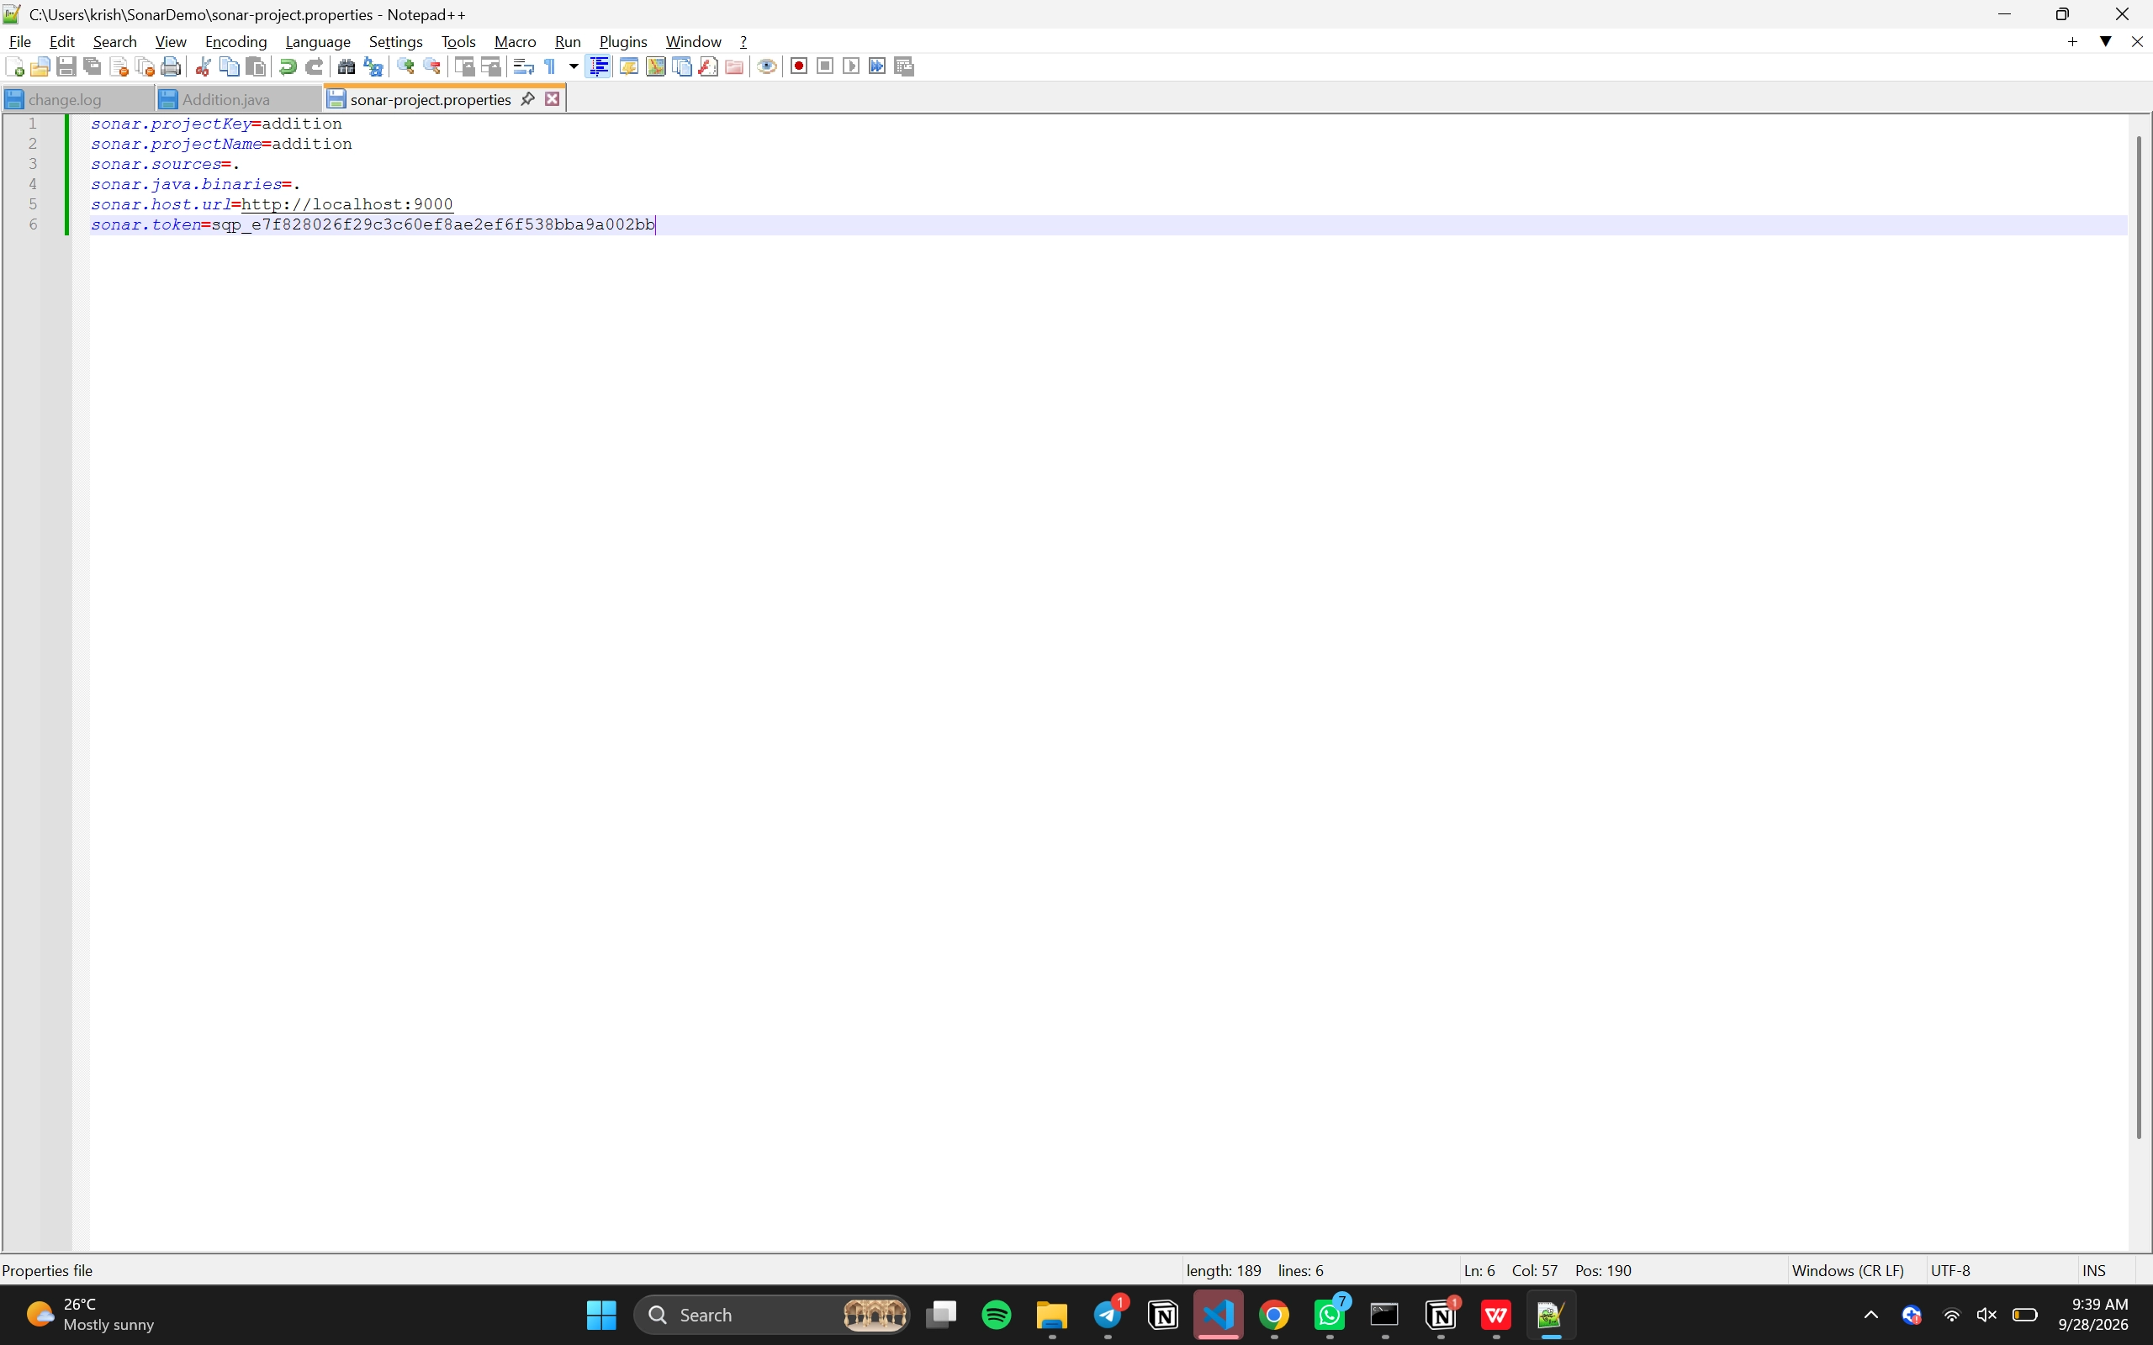
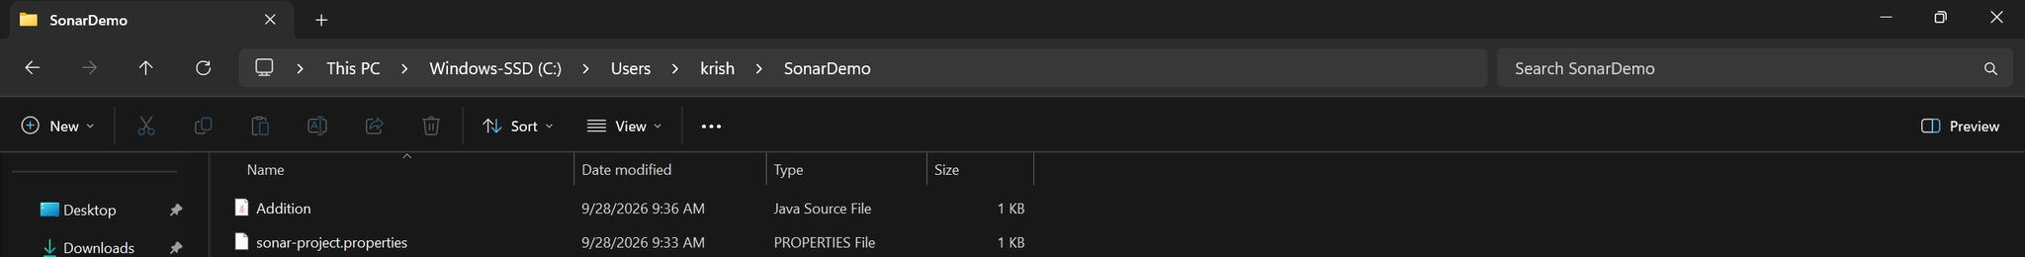

Step 6: Compile and Scan the Program
Compile the Java program to generate the .class file, then run SonarScanner.
Commands:
cd C:\Users\krish\SonarDemo
javac addition.java
sonar-scanner
After successful scanning, you should get EXECUTION SUCCESS.
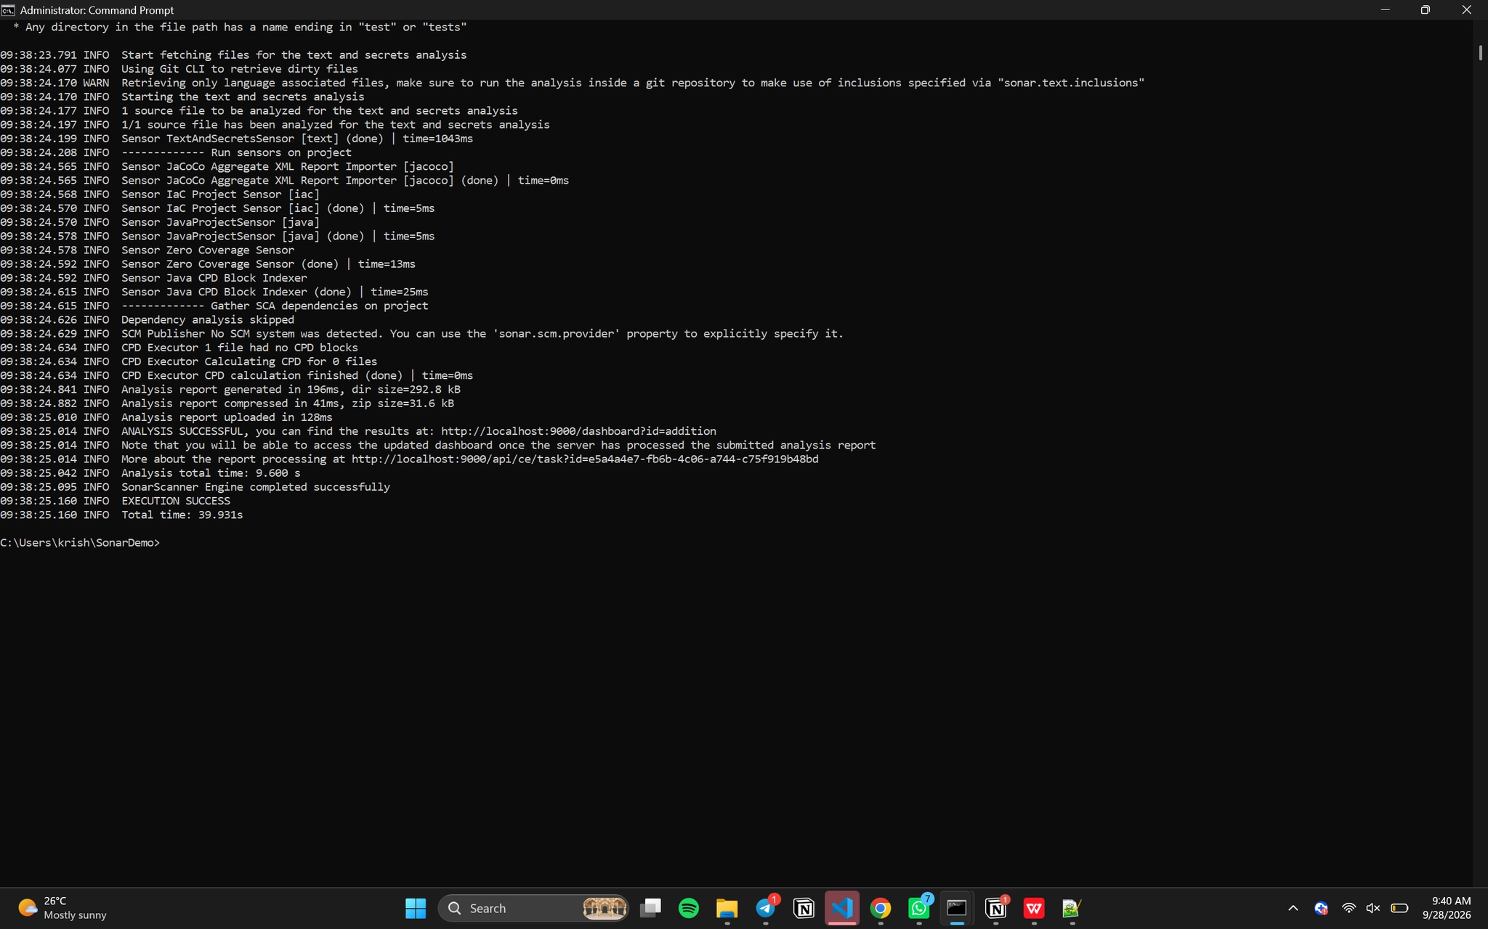

Basic SonarQube Workflow
Install SonarQube
↓
Install SonarScanner
↓
Configure Environment Variables
↓
Start SonarQube Server
↓
Generate Token
↓
Create Java Project
↓
Compile Java Program
↓
Run SonarScanner
↓
View Results on http://localhost:9000
