Customer Segmentation Using DBSCAN Density-Based Clustering
Data Mining Project Report | Weka Implementation & Analysis

1. Problem Statement
The objective of this project is to segment mall customers based on their annual income and spending behavior using the DBSCAN density-based clustering algorithm in Weka. The algorithm identifies dense groups of customers and detects noise or outlier customers without requiring the number of clusters to be specified in advance. The resulting customer segments can be analyzed to understand different purchasing behaviors and support targeted marketing strategies.
2. Dataset Description
The Mall Customers dataset contains information about customers visiting a shopping mall. The dataset has 200 instances and 5 attributes.
Attribute | Description
CustomerID | Unique customer identifier
Genre | Male / Female
Age | Customer's age in years
Annual Income (k$) | Annual income in thousands of dollars
Spending Score (1-100) | Spending score assigned by the mall based on customer behavior

For this project, we use only Annual Income (k$) and Spending Score (1-100) because these two attributes are particularly useful for understanding customer purchasing behavior. The other attributes (CustomerID, Genre, Age) are removed during preprocessing.
3. What is Customer Segmentation?
Customer segmentation means dividing customers into groups based on similarities in their characteristics or behavior. For example, the algorithm might discover groups such as lower-income customers with lower spending, lower-income customers with higher spending, higher-income customers with lower spending, and higher-income customers with higher spending. The actual clusters are determined by DBSCAN and the descriptions are assigned afterward by examining the resulting groups.
4. DBSCAN Algorithm
4.1 Definition
DBSCAN stands for Density-Based Spatial Clustering of Applications with Noise. Unlike K-Means, DBSCAN does not require the number of clusters to be specified beforehand. It looks for areas where data points are densely packed together and groups them into clusters.
4.2 Parameters
Parameter | Symbol | Description
Epsilon | ε | Defines the radius of the neighborhood around a data point
MinPts | MinPts | Minimum number of points required to form a dense region

4.3 Point Classification
DBSCAN classifies each data point into one of three distinct types:
- 1. Core Point: A point that has at least MinPts number of points (including itself) within its ε-neighborhood. Core points are located in sufficiently dense regions.
- 2. Border Point: A point that is within the ε-neighborhood of a core point but does not itself have MinPts points in its own ε-neighborhood. Border points lie on the edge of a cluster.
- 3. Noise Point: A point that is neither a core point nor a border point. Noise points do not belong to any cluster and represent outliers.
4.4 How Clusters Form
The algorithm operates through the following sequence:
- Step 1: Find all core points — points with at least MinPts neighbors within ε distance.
- Step 2: Connect core points that are within ε distance of each other into the same cluster.
- Step 3: Assign each border point to the cluster of its nearest core point.
- Step 4: All remaining points that are not core or border points are classified as noise.
4.5 Advantages Over K-Means
- • No Fixed K: Does not require the number of clusters (K) to be specified in advance.
- • Arbitrary Shapes: Can discover clusters of arbitrary shape, not limited to spherical clusters.
- • Noise Detection: Automatically identifies noise and outlier points.
- • Robustness: Works exceptionally well with real-world data containing anomalies and noise.
5. Implementation in Weka
5.1 Tool and Version
- Tool: Weka 3.9.6 (GUI Explorer)
- Algorithm Package: optics_dbScan (installed via Weka Package Manager)
5.2 Step-by-Step Procedure
Step 1: Load the Dataset — Opened Weka Explorer and loaded the Mall_Customers.csv file. The dataset contained 200 instances and 5 attributes.
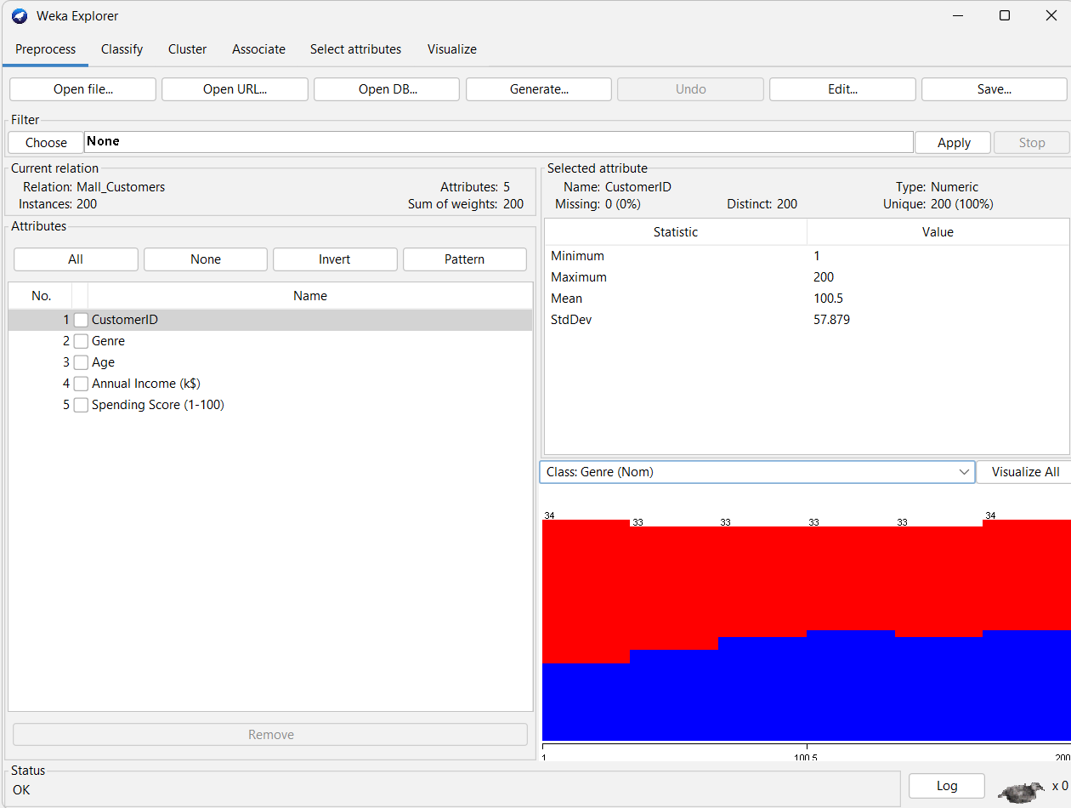
Step 2: Remove Unnecessary Attributes — Selected the checkboxes for CustomerID, Genre, and Age attributes. Clicked the Remove button to delete these three columns. Only Annual Income (k$) and Spending Score (1-100) were retained for clustering.
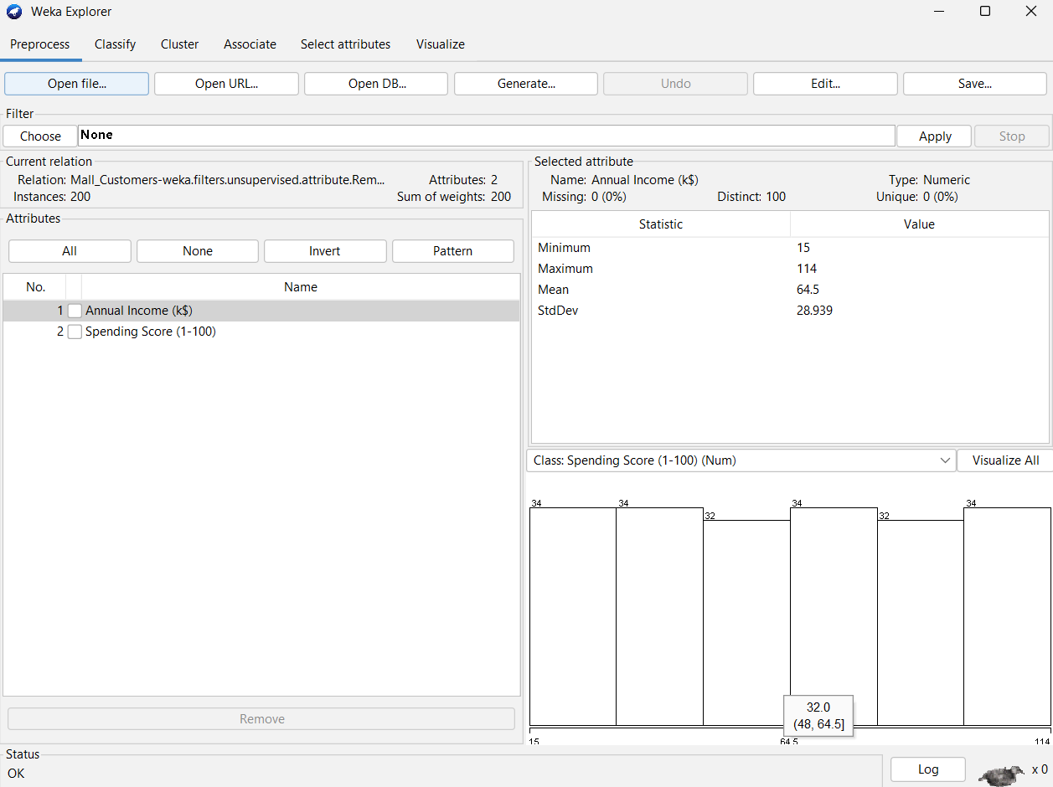
Step 3: Set Class to No Class — In the class dropdown at the bottom-left of the Preprocess tab, selected "No class" because DBSCAN is an unsupervised algorithm and does not use class labels.
Step 4: Normalize the Data — Applied the Normalize filter weka.filters.unsupervised.attribute.Normalize) to scale both attributes to the range [0, 1]. Normalization was necessary because DBSCAN is a distance-based algorithm. Without normalization, the Annual Income attribute (range 15 to 114) would dominate the Spending Score attribute (range 1 to 99) in distance calculations, producing incorrect clusters.
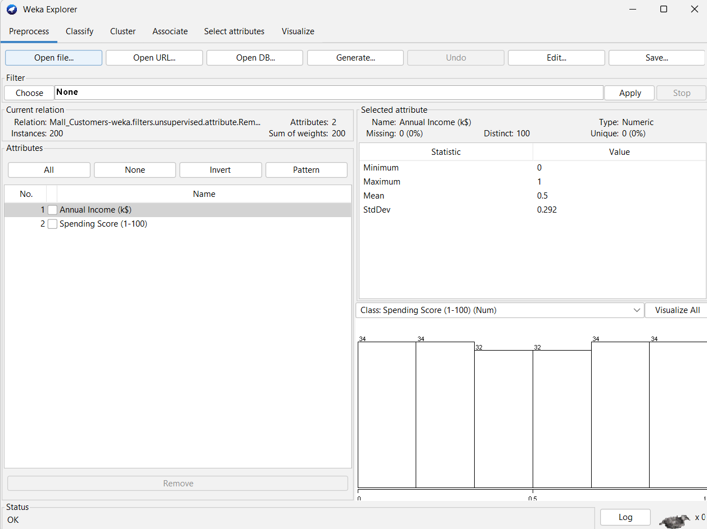
Step 5: Save Preprocessed Data — Saved the normalized dataset as mall_normalized.arff for reference and reproducible experimentation.
Step 6: Install DBSCAN Package — DBSCAN is not included by default in Weka. Opened Tools → Package Manager, found the optics_dbScan package, and clicked Install. Restarted Weka after installation.
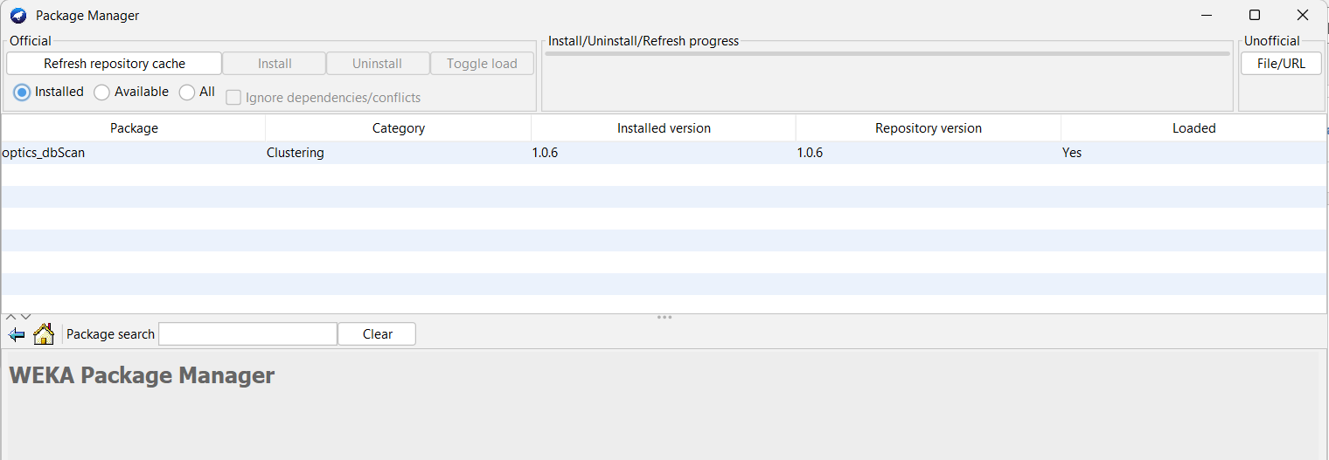
Step 7: Select DBSCAN Clusterer — Navigated to the Cluster tab. Clicked Choose and selected weka → clusterers → DBSCAN.
Step 8: Set DBSCAN Parameters — Clicked on the DBSCAN text to open the parameter window and set epsilon (E) = 0.06 and minPoints (M) = 5.
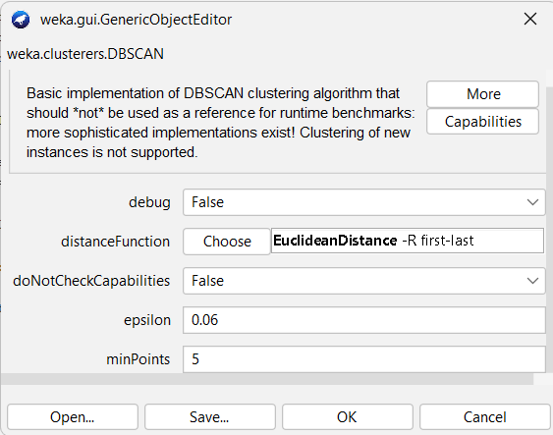
Step 9: Set Cluster Mode — Selected "Use training set" under Cluster mode.
Step 10: Run DBSCAN — Clicked the Start button and observed the clustering results in the output window.
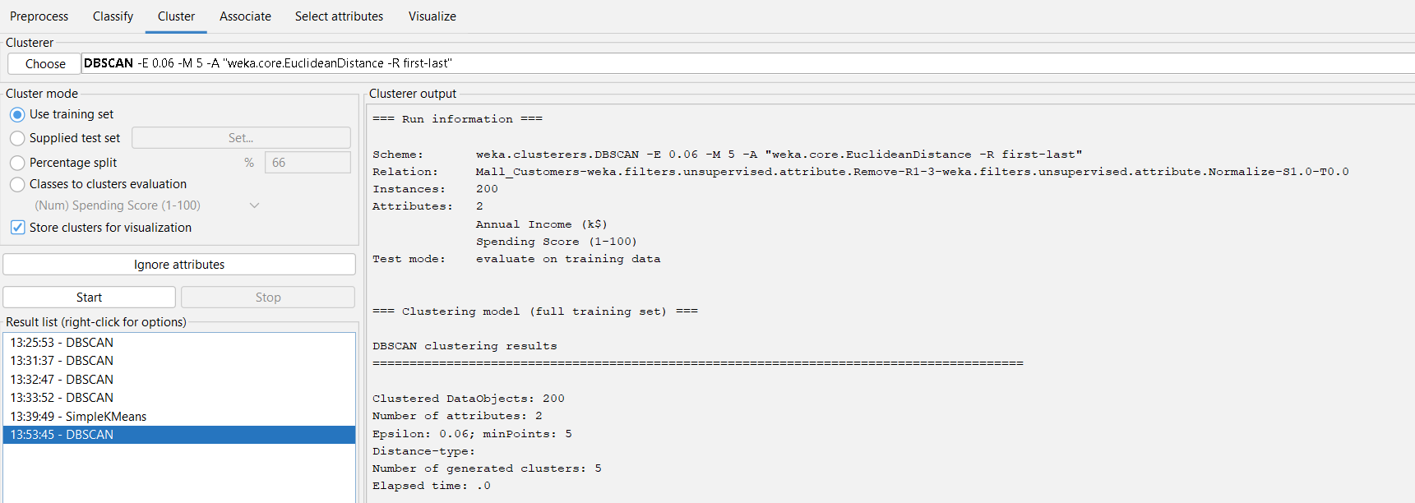
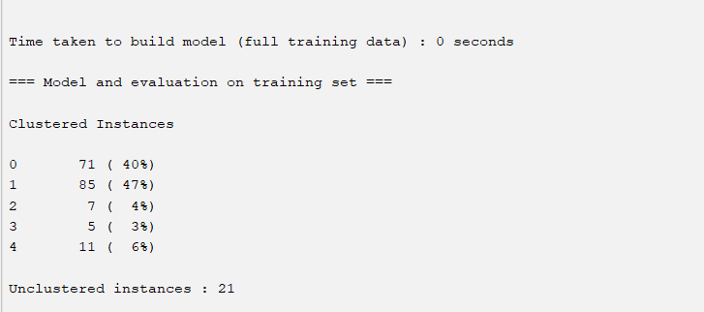
Step 11: Visualize Results — Clicked "Visualize cluster assignments" to view the scatter plot. Set X-axis to Annual Income and Y-axis to Spending Score.
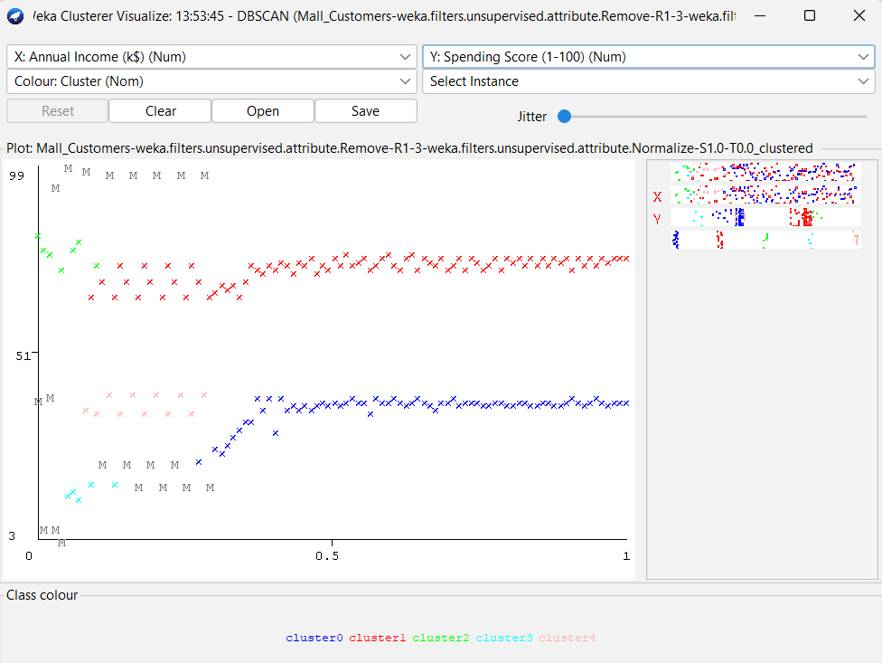
6. Parameter Selection
6.1 Why Normalization Was Necessary
Without normalization, the Annual Income attribute (range 15 to 114) and Spending Score (range 1 to 99) have very different scales. When DBSCAN calculates Euclidean distance, the larger-scale attribute dominates. With epsilon = 9 on the unscaled data, all 200 points merged into a single cluster because the epsilon neighborhood was too large relative to the data spread. After normalization, both attributes contribute equally to distance calculations, and a much smaller epsilon value produces meaningful clusters.
6.2 Parameter Experiments
Different values of epsilon and MinPts were tested systematically. The results are summarized below:
Trial | Epsilon | MinPts | Normalized? | Clusters | Noise Points | Observation
1 | 9.0 | 5 | No | 1 | 0 | Epsilon too large on unscaled data — all 200 points merged into 1 cluster
2 | 0.12 | 5 | Yes | 3 | 0 | Epsilon still too large — only spending-based split with 3 clusters
3 | 0.08 | 5 | Yes | 3 | 12 | Some noise detected but still only 3 clusters found
4 | 0.06 | 5 | Yes | 5 | 21 | Best result — 5 meaningful clusters with 21 noise points detected

6.3 Final Selected Parameters
📌 Optimal Configuration
Selected Parameters: Epsilon (ε) = 0.06 | MinPts = 5
Reason: This combination produces 5 distinct and meaningful customer segments while correctly identifying 21 outlier customers as noise points. The clusters vary in size from 5 to 85, reflecting the true density distribution of the data.

6.4 Relationship Between Epsilon and Results
Smaller epsilon values produce more clusters and more noise points because each point has fewer neighbors, leading to more fragmentation. Larger epsilon values produce fewer clusters and less noise because more points connect to each other, eventually merging into fewer large clusters. The goal is to find an epsilon that balances cluster granularity with noise detection.
7. Results
7.1 DBSCAN Clustering Output
Algorithm Configuration: weka.clusterers.DBSCAN -E 0.06 -M 5
Number of generated clusters: 5 | Number of noise (outlier) points: 21
Cluster | Number of Instances | Percentage
Cluster 0 | 71 | 40%
Cluster 1 | 85 | 47%
Cluster 2 | 7 | 4%
Cluster 3 | 5 | 3%
Cluster 4 | 11 | 6%
Noise | 21 | 11%
Total | 200 | 100%

7.2 Cluster Visualization
The scatter plot shows the 200 customers plotted with Annual Income on the X-axis and Spending Score on the Y-axis. Each cluster is displayed in a different color. Noise points (outlier customers) are shown in gray. The clusters form distinct dense regions in the plot, with noise points scattered in areas of low density between or away from the clusters.

7.3 Point Classification Summary
Type | Count | Description
Core Points | Core subset | Points in dense regions that form the backbone of each cluster (at least 5 neighbors within ε = 0.06)
Border Points | Border subset | Points on the edges of clusters (within ε of a core point but not dense enough to be core)
Noise Points | 21 | Points in low-density regions, not belonging to any cluster
8. Cluster Interpretation and Business Insights
8.1 Segment Descriptions
Cluster | Segment Name | Description | Marketing Strategy
0 | High Spenders | 71 customers with high spending scores across various income levels. These are the mall's most active shoppers. | Offer premium products, loyalty reward programs, exclusive deals, and personalized recommendations to retain these valuable customers.
1 | Low Spenders | 85 customers with low spending scores. These customers visit the mall but spend relatively little. | Target with discounts, promotional offers, flash sales, and budget-friendly product recommendations to increase their spending.
2 | Ultra High Spenders | 7 customers with extremely high spending scores. This is a small but very valuable group. | Provide VIP treatment, personal shopping assistance, early access to new products, and exclusive membership benefits.
3 | Ultra Low Spenders | 5 customers with minimal spending. This is a small group that spends very little. | Focus on value deals, entry-level products, and awareness campaigns to engage these customers.
4 | Moderate Spenders | 11 customers with spending scores between the main high and low bands. These customers have potential to move up. | Use upselling techniques, targeted promotions, and mid-range product recommendations to increase their spending.
Noise | Outlier Customers | 21 customers with unusual or atypical income-spending patterns that do not fit any dense group. | Investigate individually. Some may be new customers, some may have unusual behavior worth monitoring, and some may represent errors or anomalies.

8.2 Business Applications
- 1. Targeted Marketing: Design different marketing campaigns for each segment rather than using a one-size-fits-all approach.
- 2. Resource Allocation: Allocate marketing budget proportionally, spending more on high-value segments like High Spenders and Ultra High Spenders.
- 3. Outlier Investigation: The 21 noise points represent customers with unusual behavior. These could be new customers, potential fraud cases, or uniquely valuable individuals worth investigating.
- 4. Customer Retention: Focus retention efforts on High Spenders to prevent them from moving to competitors.
- 5. Customer Growth: Implement strategies to move Low Spenders and Moderate Spenders toward higher spending categories.
- 6. VIP Programs: Create exclusive programs for the Ultra High Spenders segment (7 customers) who represent the highest value per customer.
9. Comparison with K-Means Clustering
9.1 K-Means Setup
To compare DBSCAN with K-Means, we ran SimpleKMeans on the same normalized dataset with K = 5 (same number of clusters as DBSCAN found).
9.2 K-Means Results
Cluster | Number of Instances | Percentage
Cluster 0 | 36 | 18%
Cluster 1 | 51 | 26%
Cluster 2 | 35 | 18%
Cluster 3 | 29 | 14%
Cluster 4 | 49 | 25%
Noise | 0 | 0%

9.3 Comparison Table
Feature | DBSCAN | K-Means
Number of clusters | Discovered automatically (5) | Must be specified manually (K=5)
Noise/Outlier detection | Yes — 21 outliers detected | No — all 200 points assigned to clusters
Smallest cluster size | 5 (Ultra Low Spenders) | 29
Largest cluster size | 85 (Low Spenders) | 51
Cluster shape | Any shape (density-based) | Spherical only (centroid-based)
Small meaningful groups | Found clusters of size 7, 5, and 11 | Merged small groups into larger clusters
Prior knowledge required | Only epsilon and MinPts | Must know K in advance
Outlier handling | Separates outliers as noise | Forces outliers into nearest cluster

9.4 Why DBSCAN is Better for This Task
- 1. Automatic Cluster Discovery: DBSCAN discovered the number of clusters on its own. K-Means required us to guess K=5 beforehand.
- 2. Outlier Detection: DBSCAN identified 21 outlier customers that K-Means would have incorrectly grouped into clusters. In real-world customer data, outliers may represent fraudulent accounts, data entry errors, or uniquely valuable customers that need individual attention.
- 3. Small Group Detection: DBSCAN found small but meaningful customer groups (7 and 5 customers) that represent niche segments. K-Means forced these into larger clusters, losing this information.
- 4. No Spherical Assumption: K-Means assumes clusters are spherical around centroids. Real customer data often has irregular cluster shapes, which DBSCAN handles naturally.
- 5. Business Value: The ability to detect outliers is crucial for business applications. Identifying unusual customer behavior can prevent fraud, reveal new market opportunities, and improve data quality.
10. Why This Project Fits the Data Mining Syllabus
The Data Mining syllabus Unit V specifically includes Density-Based Methods — DBSCAN as a topic. This project demonstrates the practical application of this syllabus topic using real-world customer data. While the existing lab work demonstrates Simple K-Means clustering, this project provides experience with a fundamentally different clustering approach that addresses K-Means' limitations, specifically the inability to detect noise and the requirement to pre-specify the number of clusters.
11. Conclusion
This project successfully applied DBSCAN density-based clustering to segment 200 mall customers based on their annual income and spending behavior using Weka 3.9.6. The key findings are:
- 1. Five distinct customer segments were discovered automatically without specifying the number of clusters in advance.
- 2. Twenty-one outlier customers were automatically identified as noise points, representing unusual income-spending patterns that require individual investigation.
- 3. Data normalization was essential for meaningful clustering because DBSCAN relies on distance calculations and the original attributes had different scales.
- 4. The optimal parameters were epsilon = 0.06 and MinPts = 5, determined through systematic experimentation with different values.
- 5. DBSCAN proved more suitable than K-Means for customer segmentation because it detects outliers, finds clusters of varying sizes, and does not require prior knowledge of the number of clusters.
The resulting customer segments can support targeted marketing strategies, helping the mall design different promotions for different customer groups and investigate unusual customer behavior. This project demonstrates the practical value of density-based clustering methods in real-world data mining applications.

