Task 1: Python File Handling & Automation
Alfido Tech Internship | Python Developer Track

Objective
Understand Python file handling, automation logic, and exception handling by implementing read and write operations on .txt and .csv files, automating file system tasks such as rename, move, and delete, and protecting every operation with try-except blocks.

Technologies Used
Language: Python 3.x
IDE: VS Code
Modules: os, shutil, csv (all built-in)
Concepts: File I/O, Exception Handling, File Automation

Code Overview
The script is divided into seven functions, each handling one file operation. write_text_file() and read_text_file() use Python's built-in open() context manager to safely write and read .txt files. write_csv_file() and read_csv_file() use the csv module for structured data. rename_file() wraps os.rename(), move_file() uses shutil.move(), and delete_file() uses os.remove(). Every function uses specific except clauses such as FileNotFoundError, PermissionError, and IOError to give clear and useful error messages.

Code Screenshot
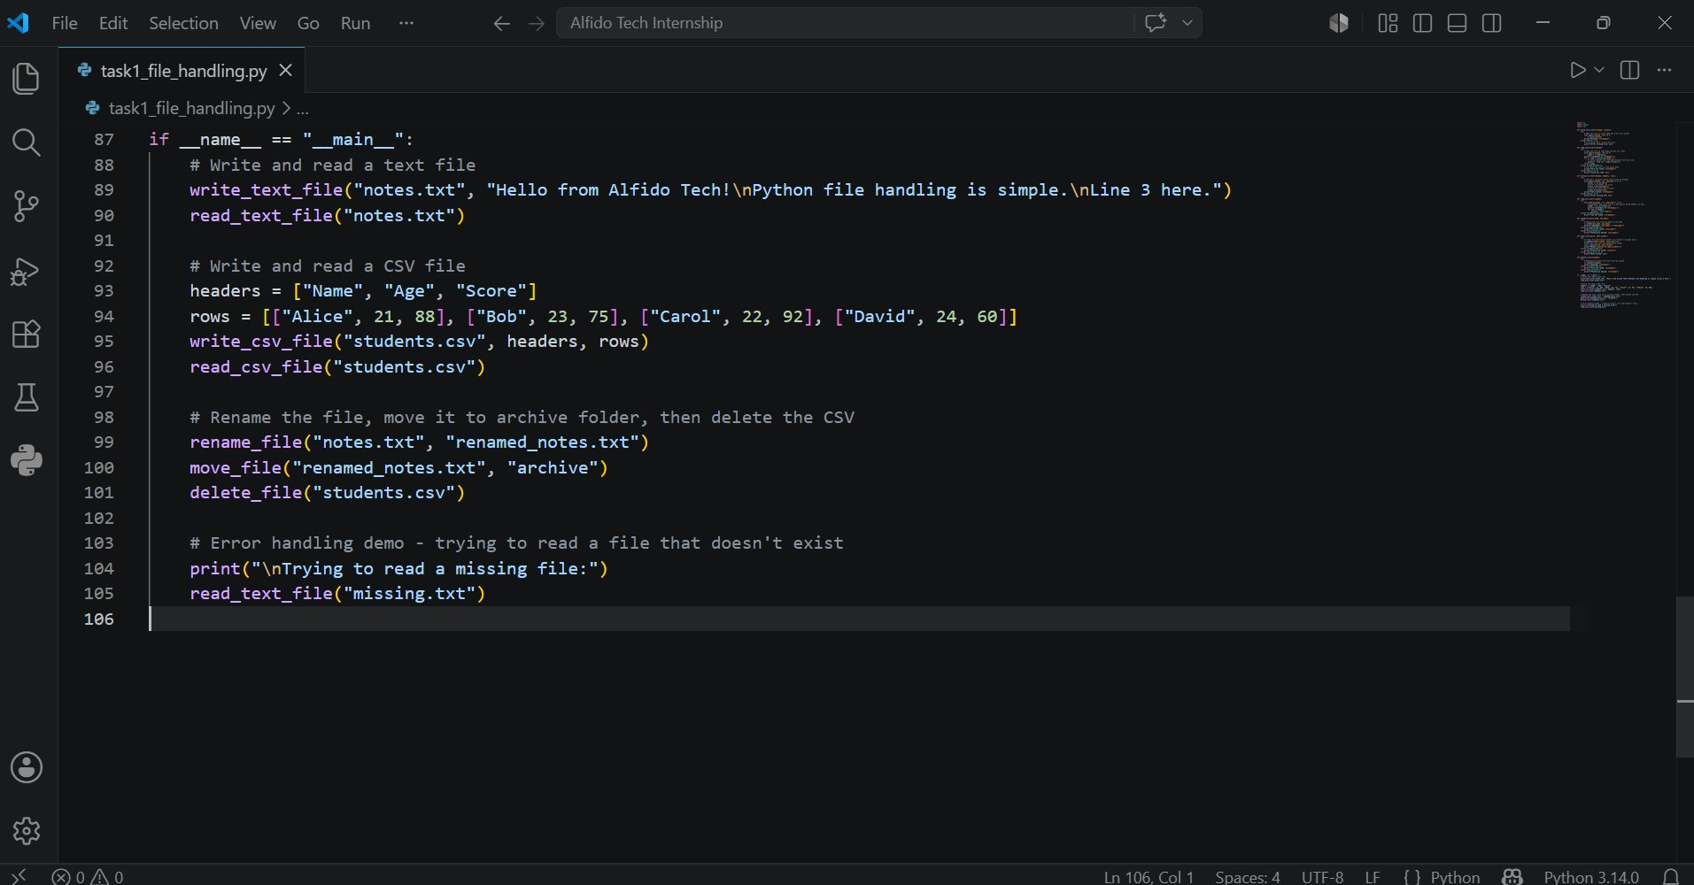

Output Screenshot
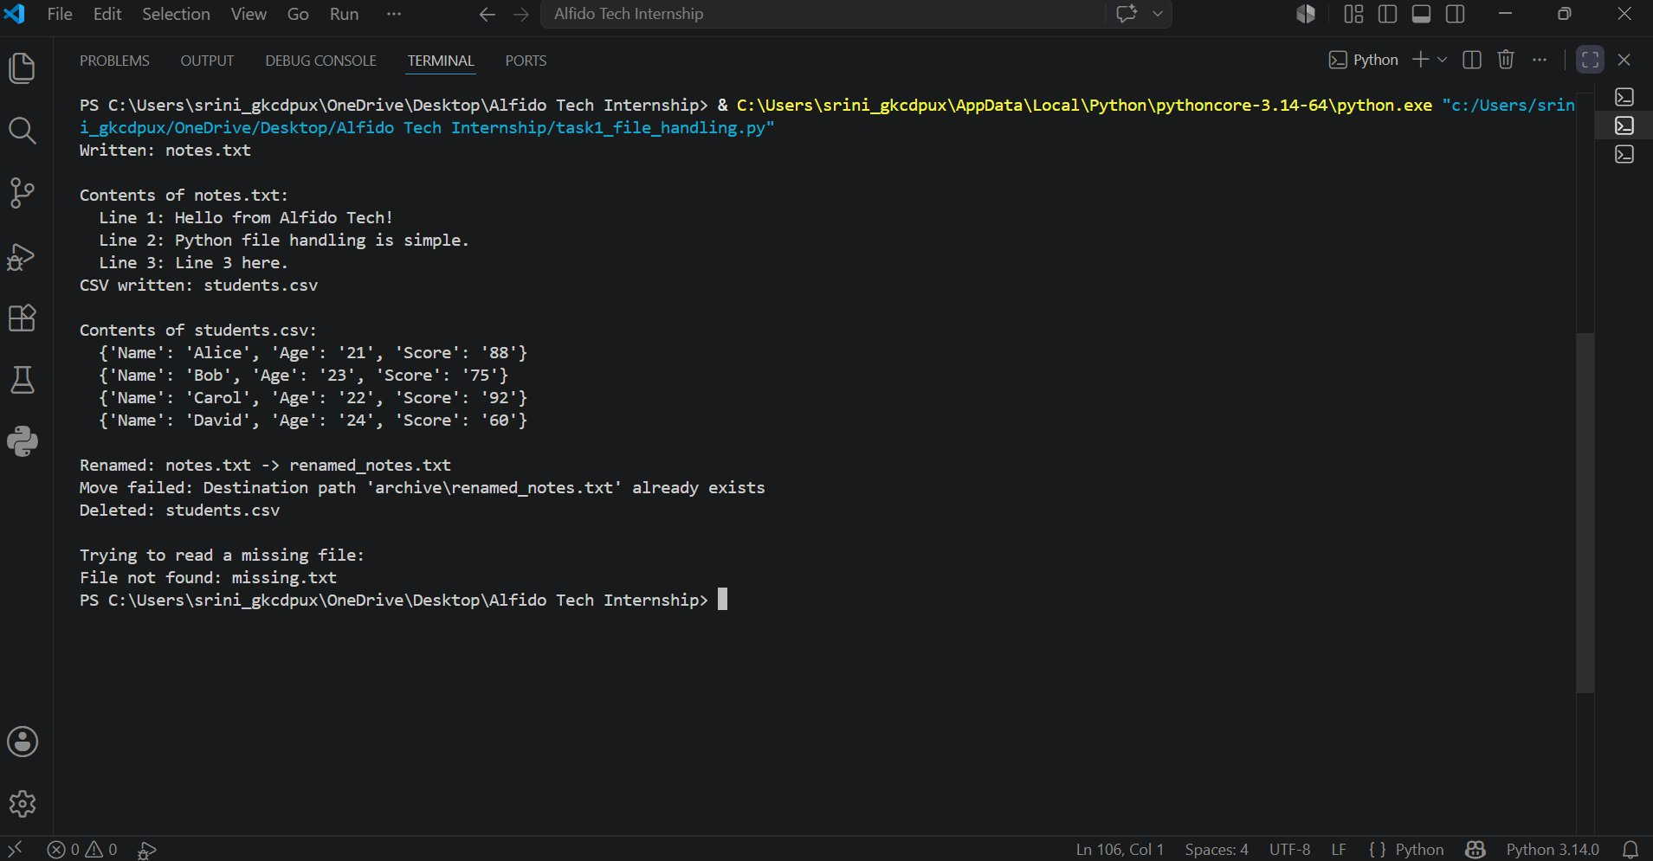

GitHub Repository
GitHub Repository: https://github.com/srinikhareddy21/Alfido-Tech-Python-Internship.git

Conclusion
Successfully implemented Python file handling and automation covering .txt and .csv read/write, rename, move, and delete operations. All functions use targeted try-except blocks that distinguish between different error types, providing clear feedback for every failure case.

