Task 2: API Integration & JSON Handling
Alfido Tech Internship | Python Developer Track

Objective
Learn how Python communicates with external APIs and handles JSON data by fetching real weather data, parsing the JSON response, applying filter logic, and handling all possible API errors gracefully.

Technologies Used
Language: Python 3.x
IDE: VS Code
Library: requests (pip install requests)
API: Open-Meteo (free, no API key required)
Concepts: HTTP Requests, JSON Parsing, Error Handling, Data Filtering

Code Overview
The script fetches a 7-day weather forecast for three cities: Mumbai, London, and New York using the Open-Meteo API. fetch_weather() sends a GET request with query parameters and uses raise_for_status() to catch HTTP errors. The JSON response is parsed into a Python dictionary. filter_hot_hours() filters hourly data to show only hours above 28 degrees Celsius. Mumbai's data is saved to a local JSON file using json.dump() and reloaded using json.load(). A mock_data() fallback is included in case the network is unavailable.

Code Screenshot
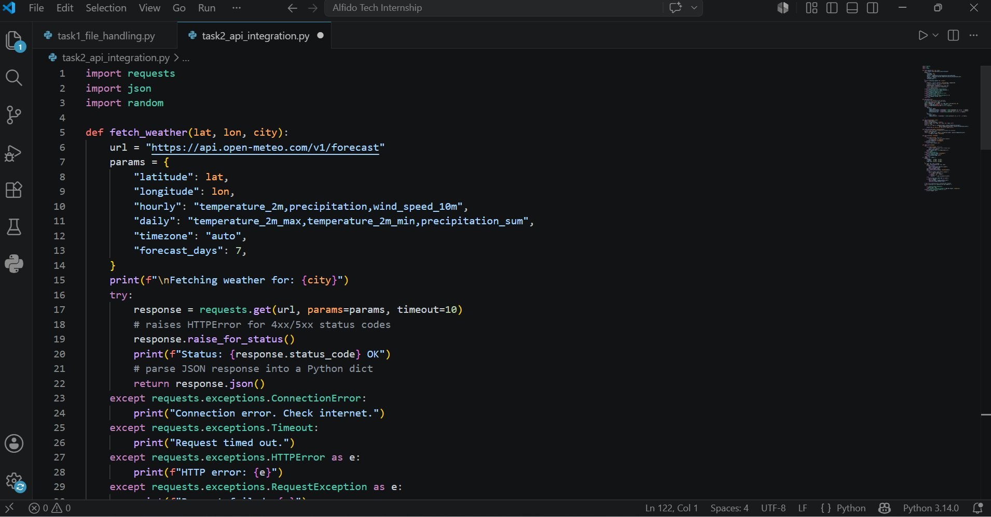

The screenshot shows the fetch_weather() function which sends the API request with parameters like latitude, longitude, hourly and daily fields, and timezone. raise_for_status() ensures any 4xx or 5xx HTTP response is caught as an exception. The response is parsed using .json() which converts the API response into a Python dictionary for easy access.

Output Screenshot
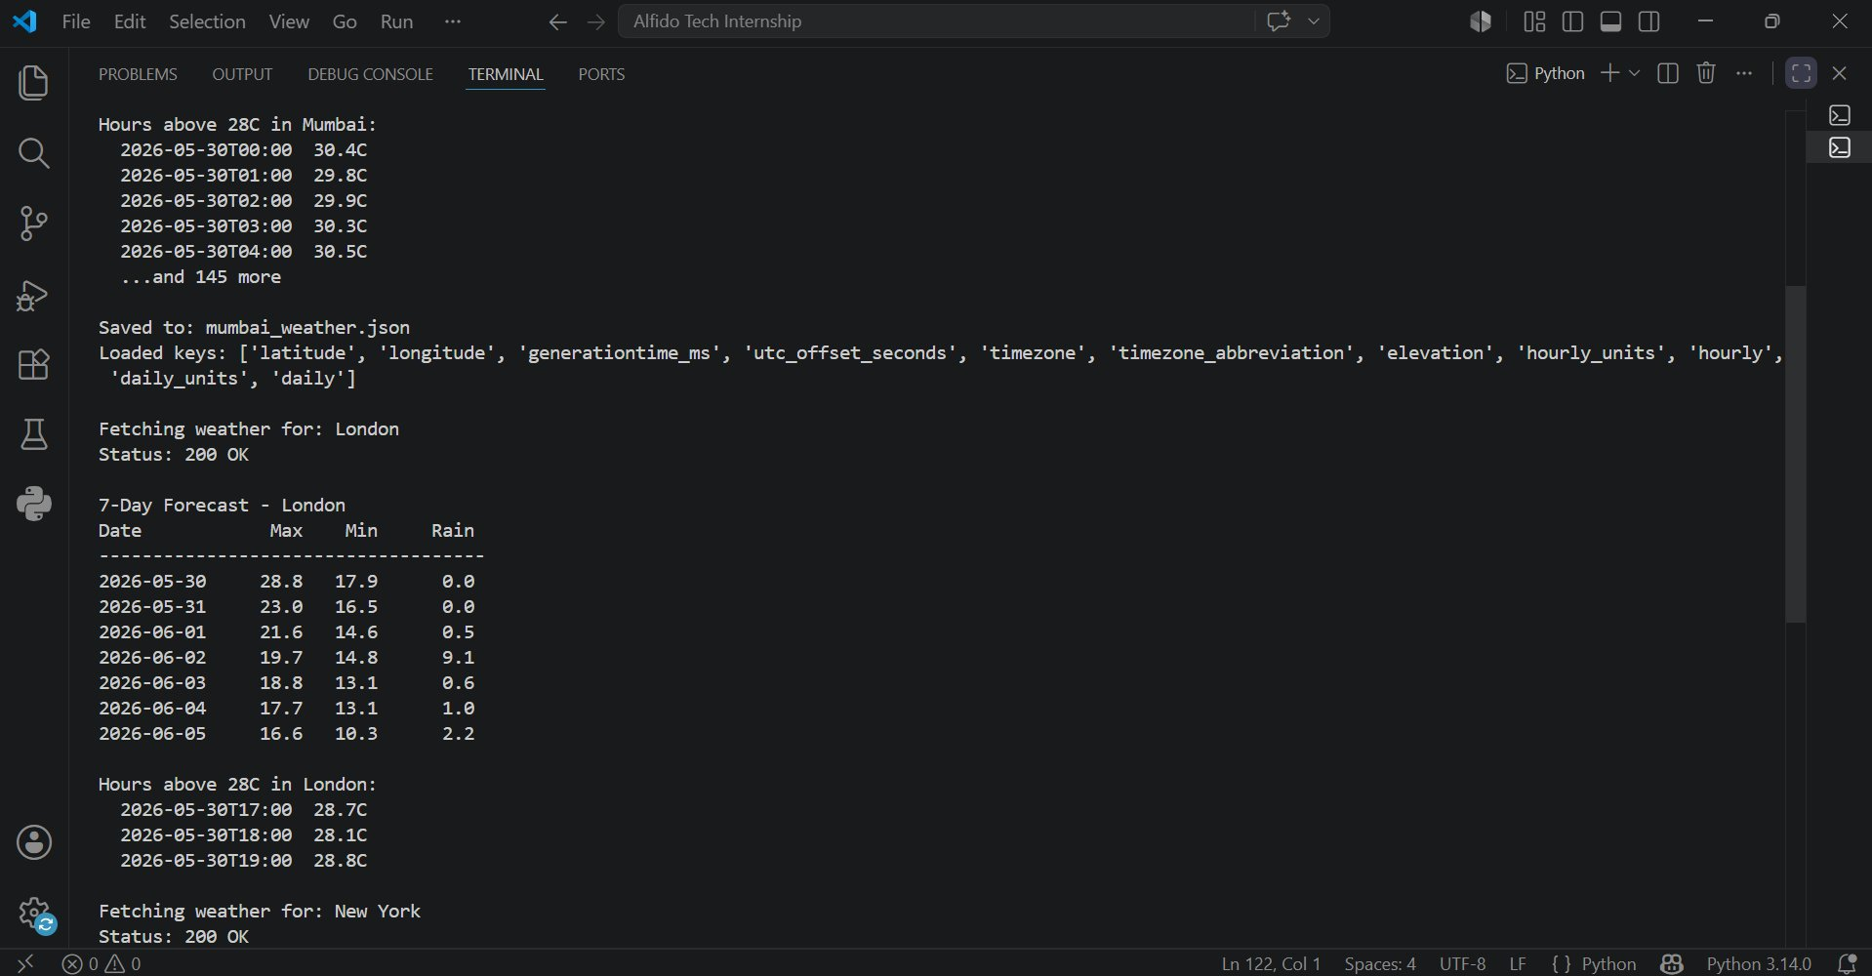

The output shows the live 7-day forecast table for London with date, max temperature, min temperature, and rainfall. It also shows hours above 28 degrees Celsius for Mumbai and London with exact timestamps. The JSON file for Mumbai is saved and successfully reloaded, confirming the keys in the response. The script connected to the real API and returned Status 200 OK for each city.

GitHub Repository
GitHub Repository: https://github.com/srinikhareddy21/Alfido-Tech-Python-Internship.git

Conclusion
Successfully integrated the Open-Meteo API to fetch and display live weather data for multiple cities. The script parses JSON responses, filters data based on temperature thresholds, saves results to disk, and handles all API errors including connection errors, timeouts, and HTTP errors.

