Task 3: Data Analysis with Pandas
Alfido Tech Internship | Python Developer Track

Objective
Demonstrate data analysis skills using the Pandas library by loading a student dataset, cleaning missing data, applying filtering and grouping operations, and summarizing key insights.

Technologies Used
Language: Python 3.x
IDE: VS Code
Library: pandas (pip install pandas)
Dataset: 20 student records with Name, Gender, Age, Subject, Score, Grade, and City
Concepts: Data Cleaning, Filtering, Grouping, Aggregation, Descriptive Statistics

Code Overview
The dataset is loaded using pd.read_csv() wrapped in a try-except block. Missing Score values are filled with the median to avoid skewing the average, and missing City values are replaced with Unknown. Boolean indexing is used to filter students scoring above 85, female students in Math, and students who failed. groupby() is used to calculate average, highest, and lowest scores per subject and city, and to compare scores by gender. Finally, the cleaned dataset is exported to a CSV file.

Code Screenshot
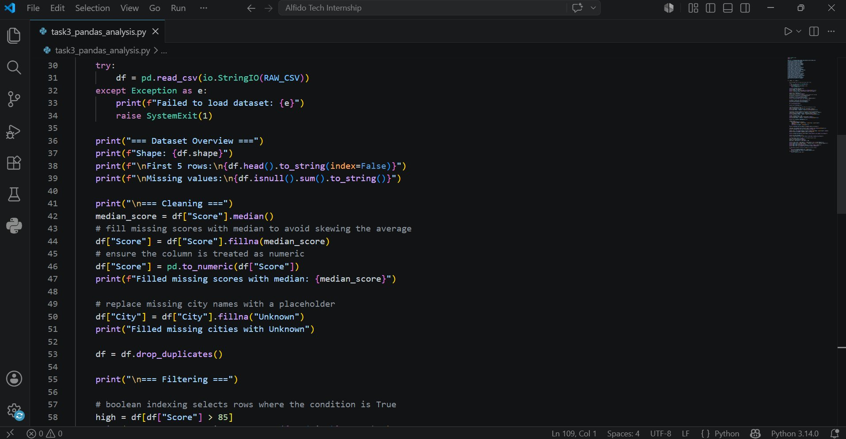

Output Screenshot
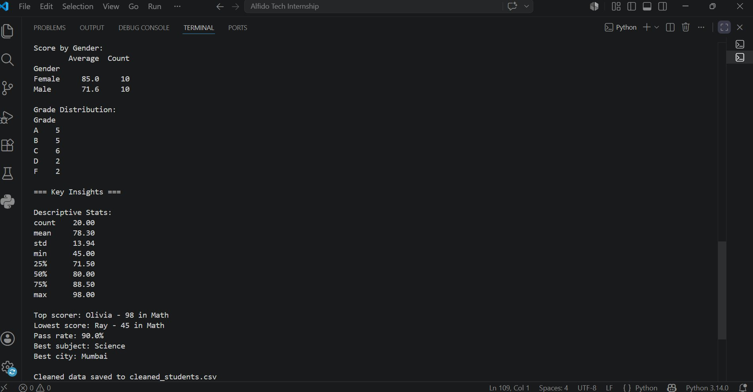

Key Insights
The analysis of 20 student records produced the following insights:

1. The overall average score across all students is 78.30 with a standard deviation of 13.94, showing moderate variation in performance.
2. Female students outperformed male students with an average score of 85.0 compared to 71.6 for males.
3. Science had the highest average score among all subjects, making it the best performing subject overall.
4. Mumbai students had the highest average score compared to Delhi, Chennai, and other cities.
5. The top scorer was Olivia with 98 in Math, while the lowest scorer was Ray with 45 in Math.
6. The overall pass rate was 90%, with only 2 students scoring below 60.
7. Grade C was the most common grade with 6 students, followed by A and B with 5 each.

GitHub Repository
GitHub Repository: https://github.com/srinikhareddy21/Alfido-Tech-Python-Internship.git

Conclusion
Successfully performed data analysis on a student dataset using Pandas. The script covers data loading, cleaning, filtering, grouping, and aggregation. The insights reveal meaningful patterns in student performance across gender, subject, and city.

