CURRENT TOPICS IN COMPUTER SCIENCE
An Authentication and Access Control Framework for CoAP-based Internet of Things

Pablo Punal Pereira, Jens Eliasson, Jerker Delsing ˜
Dept. of Computer science, Electrical and Space Engineering
Lulea University of Technology ˚
Lulea, Sweden ˚
Email: pablo.punal@ltu.se

Abstract- Now a day; Internet of Things (IOT) and Cyber-Physical Systems (CPS) are two very interesting and hot topics, starting to appear on the market. Research has proven that the use of Service Oriented Architecture (SOA) can allow distributed applications and Machine-to-Machine (M2M) communication, even on resource constrained devices and thus play a vital role for IOT and CPS.
In the context of Internet of Things, communication between the endpoints must be secured and private. Security mechanisms for resource constrained devices has attracted great interest from the academic community, where many research groups have given solutions of using IPSec (Internet Protocol Security), VPN-tunnels, (D)TLS etc. which is feasible to use on this type of networks. Nevertheless, even though the use of these solutions are vital for SOA-based IOT networks, they do not provide any fine-grain access control.
In this paper, CoAP-based framework for service level access control on resource constrained devices is presented. This allows fine grain access control on a per service and on method basis. Users without the right credentials are not even allowed to discover available services. To demonstrate the validity of the proposed approach, several implementations are presented together with the results.

Keywords: Protocols, Authentication, Access control, Servers, IP networks, Service-oriented architecture

I. MOTIVATION

In recent days SOA is one of the most prominent buzzwords in IT sector. It is an evolution of distributed computing based on the request/response design paradigm for asynchronous and synchronous applications. An application’s business logic or individual functions are modularized and presented as service for client/consumer applications. The key feature of these services is their loose coupling nature, that implies the services are independent of the implementation. For example, a service can be implemented in J2EE and the application consuming the service can be on different platform or language. It has some of the key characteristics namely, it uses Web Services Description Language (WSDL) as the standard language to describe the services. Communication among consumers and providers or services typically happens in heterogeneous environments, with little or no knowledge about the provider. Messages between services can be viewed as key business documents processed in an enterprise. Each SOA service has a quality of service(QOS) associated with it. Some of the key features of SOA elements are security requirements such as authentication, authorization, reliable messaging, and policies regarding who can invoke services. Since the services are distributed in nature, and purely relies on communication channels to function, they are prone to vulnerable attacks from hackers, malware and other network based threats for instance, Denial of Services (DOS) attacks, eavesdropping attack etc. Hence, there is a need for these services to be protected using some communication protocols which uses strong encryption and authentication mechanisms such as IPSec, SSL etc. Internet of things and cyber physical systems are being used by millions of users, strong communication security with encryption and authentication must be maintained. For example, a paper by Kasinathan et al. also discusses that DoS attacks in WSNs (Wireless Sensor network) are often targeting 6LoWPAN, since this is a widely-used protocol for devices with low capacity. In such an attack the Internet protocol is used to send a large number of IPv6 packets over UDP or TCP. Hence, utilization of IP security for low power networks has increased during the last years.

IPsec (Internet Protocol Security) is a suite of protocols that provides security to Internet communications at the IP layer. The most common current use of IPsec is to provide a Virtual Private Network (VPN), either between two locations (gateway-to-gateway) or between a remote user and an enterprise network (host-to-gateway). IKE (Internet Key Exchange) is the key negotiation and management protocol that is most commonly used to provide dynamically negotiated and updated keying material for IPsec. IPSec has two modes of operation, the former one is transport mode, which includes an authentication header between the IP and UDP/TCP. It allows the system to validate the incoming packets but the original payload is visible and accessible to other devices in the network. The latter one is tunnel mode, which is similar to the former one except that, IP, UDP/TCP and payload are encapsulated and encrypted using Advanced Encryption Standard (AES) specifications. This mode of operation protects the data from Eavesdropping attack, which is the act of intercepting communications between two points, discards data modification and adds the possibility to detect DOS attacks.

However, IPSec needs a shared password to encrypt and decrypt all incoming and outgoing messages. If this password is static over the time, after communicating over thousand messages, there is probability for the compromise. Hence, in order to get rid of this problem, Internet Key Exchange (IKE) and IKEv2 are created. IKE is the preferred key management protocol for IPsec. It is used for peer authentication; to negotiate, modify, and delete Security Associations (SA). and to negotiate authenticated keying material for use within those SAs. IKEv2 supports several mechanisms for authenticating the parties but each endpoint uses only one of these mechanisms to authenticate itself. [RFC4739] specifies an extension to IKEv2 that allows the use of multiple authentication exchanges, using either different mechanisms or the same mechanism. This extension allows, for instance, performing certificate-based authentication of the client host followed by an EAP authentication of the user. This also allows for authentication by multiple administrative domains, if needed. This optional extension applies only to IKEv2, not to IKEv1. These protocols guarantee a safety communication between two devices and are able to create new shared passwords using circling derivative methods.

On the other hand, to protect UDP/TCP packets (on top of IPSec) there is another protocol that is used to add an extra layer of protection namely Datagram Transport Layer Security (DTLS). This protocol uses initial handshake for secure connection and communication to proceed and to set the passwords. DTLS increases the size of the packet, but this is the result of packet encapsulation. This protocol is being used in the CoAP protocol.

Nevertheless, though the use of security protocols such as IPSec, VPN-tunnels, DTLS, SSL are important for SOA based networks and systems to be protected, they do not provide fine grain access control mechanisms. For instance, if two applications are exchanging data using SOA based CoAP protocol, only the packets are protected from external tampering and access. Any request from a client already inside a protected tunnel will be accepted by the server. The use of DTLS-encrypted CoAP could be one way of achieving a per service access control, but this requires more number of key pairs to be used in order to enable per service access control where in a client could have different security access to different services, and even different access to different operations on one service. For example, a client can have POST permissions to an actuator in order to post a new result, but might not be allowed to GET the results from an actuator: If only few number of key pairs are used, fine grain access control is not possible. On another hand, though utilization of large number of keys provide peer to peer fine grain access control, management and administration of key exchange would be intricate.

Another way of approach is segregate the access control from communication security which would increase the security since another layer of security is added. In addition, client also need few keys for the IPSec and DTLS encryption and then uses the authentication service to get access to other services. This helps in making the administration and management easier as all the access rights are being centralized in the authentication service. Such access control protocols that uses this approach are Kerberos and Remote Authentication Dial in User Service (RADIUS). Kerberos is an authentication protocol which works on the basis of ticket system to enable peers communicating over a non-secure network to prove their identity to one another in a secure manner. RADIUS is also used to network authentication in wireless domains, and supports Access control, Authenticating and Accounting (AAA) techniques.

In this paper, the authors propose a CoAP based framework which solves the problem of fine grain access control, which is not possible with the other communication protocols like IPsec and DTLS. They also describe that the proposed framework mainly focuses on low overhead devices running in low power network that are commonly used in Internet of Things and cyber-physical systems. The proposed framework includes the ideas from Kerberos and RADIUS and merge the two with CoAP protocol to get a reliable access control framework for IOT devices.

II. INTRODUCTION

In recent times, most of the industrial companies rely on the networks to increase their level of automation. The growing demand for IoT technologies is driving the implementation of industrial wireless. Historically, there have been two factors that have limited the wide adoption of wireless in industrial environments: cost and security. The former looks like it will soon become extinct, as wireless sensors and IoT devices are becoming more affordable. Similarly, improvements in cyber security and an increasing awareness of best practice are making wireless a more viable option for industry. The growing demand for IoT technologies is driving the implementation of industrial wireless. The increased number of connected devices indicate an even more rapid growth in networked devices for industrial usage automation. The discovery of Stuxnet virus has opened the eyes of the industrial companies and the general public that any connected devices would be prone to vulnerable attacks from the internet and electronic security issues. Hence, much effort is dedicated to prevent and protect against cyber-attacks on networked devices

There are some networked protocols which are majorly used and gained popularity in the field of resource constrained devices. Some of them are briefly discussed here.

Constrained Application Protocol (CoAP)
The Constrained Application Protocol (CoAP) is a specialized web transfer protocol for use with constrained nodes and constrained networks. This protocol is basically designed for machine-to-machine (M2M) applications such as smart energy and building automation. It provides a request/response interaction model between application endpoints, supports built-in discovery of services and resources, and includes key concepts of the Web such as URIs and Internet media types. It is designed to easily interface with HTTP for integration with the Web while meeting specialized requirements such as multicast support, very low overhead, and simplicity for constrained environments. Constrained networks such as 6LoWPAN support the fragmentation of IPv6 packets into small link-layer frames; however, this causes significant reduction in packet delivery probability. One design goal of CoAP has been to keep message overhead small, thus limiting the need for fragmentation. One of the main goals of CoAP is to design a generic web protocol for the special requirements of this constrained environment, especially considering energy, building automation, and other machine-to-machine (M2M) applications. It offers features for M2M such as built-in discovery, multicast support, and asynchronous message exchanges, simple proxy and caching capabilities. The model of CoAP is similar to the client/server model of HTTP. However, machine-to-machine interactions typically result in a CoAP implementation acting in both client and server roles. CoAP request is equivalent to that of HTTP and is sent by a client to request an action (using a method code) on a resource (identified by a URI) on a server. The server then sends a response with a response code; this response may include a resource representation. Unlike HTTP, it works on with these interchanges asynchronously. It defines four types of messages namely Confirmable, Non-confirmable, Acknowledgement, Reset. Method codes and response codes included in some of these messages make them carry requests or responses. Requests are carried in Confirmable, Non-confirmable messages. It is a single protocol, with messaging and request/response as just features of the CoAP header.

Figure 1: CoAP Packet Format
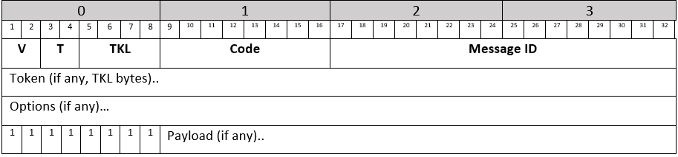

CoAP packet has maximum length of 1400 bytes, header length of 32 bits (see Figure 1). First 2 bits for version control, another 2 for message type, 4 for token length, 8 for message code and 16 for message ID.

Kerberos
Kerberos protocol relies heavily on an authentication technique that makes use of shared secrets. Kerberos provides a means of verifying the identities of client and server,
(e.g., a workstation user or a network server) on an open (unprotected) network. The basic authentication process works as follows: A client sends a request to the authentication server (AS) for "credentials" for a given server. The AS responds with these credentials, encrypted in the client's key. The credentials consist of a "ticket" for the server and a temporary encryption key (often called a "session key"). The client transmits the ticket (which contains the client's identity and a copy of the session key, all encrypted in the server's key) to the server. The session key (now shared by the client and server) is used to authenticate the client and may optionally be used to authenticate the server. It may also be used to encrypt further communication between the two parties or to exchange a separate sub-session key to be used to encrypt further communication. The implementation consists of one or more authentication servers running on physically secure hosts. The authentication servers contain a database which usually contains the information regarding the users and servers and their secret keys.

Figure 2: Kerberos Working Principle
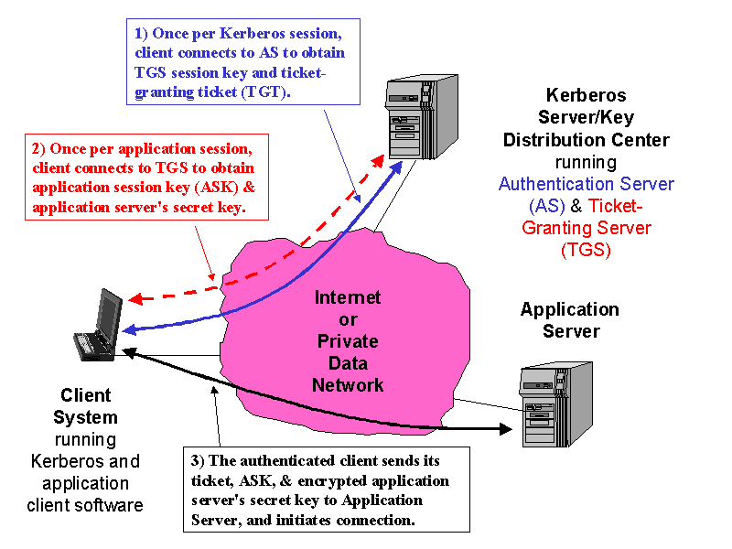

The Kerberos protocol consists of several sub-protocols (or exchanges). There are two methods by which a client can ask a Kerberos server for credentials. In the first approach, the client sends a cleartext request for a ticket for the desired server to the AS. The reply is sent encrypted in the client's secret key. Usually this request is for a ticket-granting ticket (TGT) which can later be used with the ticket-granting server (TGS). In the second method, the client sends a request to the TGS. The client sends the TGT to the TGS in the same manner as if it were contacting any other application server which requires Kerberos credentials. The reply is encrypted in the session key from the TGT. Some of the key assumptions on the environment in which it can properly function are, “Denial of service” attacks are not solved with Kerberos, Principals must keep their secret keys secret, “Password guessing” attacks are not solved by Kerberos.

RADIUS
RADIUS is a protocol for carrying information related to authentication, authorization, and configuration between a Network Access Server that desires to authenticate its links and a shared Authentication Server. It uses Password Authentication Protocol (PAP), Challenge Handshake Authentication Protocol (CHAP), or Extensible Authentication Protocol (EAP) protocols to authenticate users. It looks in text file, LDAP Servers, Database for authentication. After authentication services parameters passed back to NAS. NAS works as a client for the Radius server. Radius server is responsible for getting user connection requests, authenticating the user, and then returning all the configuration information necessary for the client to deliver service to the user. Transactions between a client and a server are authenticated using a shared key. This key is never sent over the network. Password is encrypted before sending it over the network. RADIUS supports the protocols such as PPP (point to point protocol), PAP, CHAP.

Before the Client starts communicating with the Radius Server, it is required that the secret key is shared between the Client and the Server and the Client must be configured to use Radius server to get service. Once Client is configured properly then, the client starts with Access-Request. The server sends either Access-Accept, Access-Reject, or Access-Challenge. Access-Accept keeps all the required attributes to provide service to the user and the user has granted access. Access-Challenge is used to increase the security, the server could request extra information before trust on that user. Access-Reject defines that the user has no access to any network resources. The reason could be wrong authentication. When the RADIUS server receives the Access-Request from the NAS, it searches a database for the username listed. If the username does not exist in the database, either a default profile is loaded or the RADIUS server immediately sends an Access-Reject message. This Access-Reject message can be accompanied by a text message indicating the reason for the refusal.

The RADIUS protocol and format could run over CoAP protocol because all connection features can be possible also over CoAP. Moreover, it is useful to authenticate devices over 6LoWPAN and enable access to the network. The overhead of this protocol affects only the authentication process. Therefore, it is reasonable to use in low-power and low band width networks.

Figure 3: RADIUS
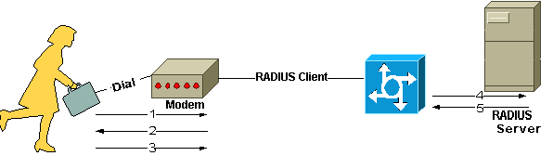

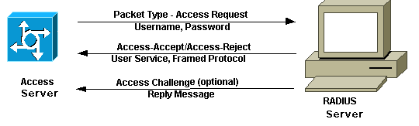

DIAMETER
Diameter is the new evolution of RADIUS but instead of UDP, it uses TCP layer for secure communication. The diameter base protocol provides following facilities like delivery of attribute value pairs(AVP), capabilities negotiation, error notification, extensibility, through addition of new commands and AVP’s, basic services necessary for application s, such as handling of user sessions or accounting.
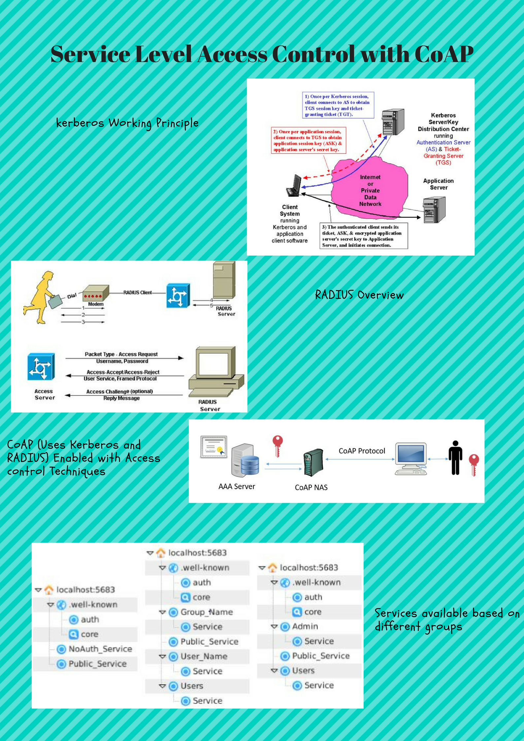

III. FRAMEWORK

In this section, the architecture proposed by the authors are explained, with their ability to provide low power authentication and access control mechanisms.

Requirements
The authors have proposed some of the basic requirements needed in order to provide a fine grain access control to the devices. The framework was designed by the authors which is optimal in terms of computation and overhead for access control and security over low power devices and network with low band width band. The communication to the access control services is enabled to all the network devices. It is possible to filter the connection to specific access control services by IPSec and DTLS. The authors also stated that the access control must be independent of other devices (there exists no relation between different accesses). The access rules and methods can be different depending on authentication policies, which could change in base of local conditions like time, power source, sensor information, position, etc. The final objective is to provide a fine grain access control per service.
Scope
The proposed framework by authors mainly focuses on providing a fine grain access control and low power authentication to the resource constrained devices. However, they have not focused on the communication security such as IPSec and DTLS. The following figure illustrates the stack of communication layers. The lowest communication security layer is based on IPSec.

Figure 4: IOT Protocol Stack
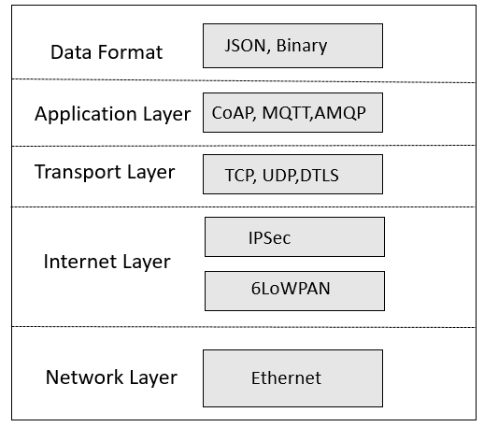

Access Control and Authentication Aspects
The proposed framework by the authors uses the key concepts of CoAP, Kerberos and RADIUS protocols in order to provide a fine grain access control to the constrained devices. The simplified architecture by the authors is defined below:

Figure 5: Simplified Architecture
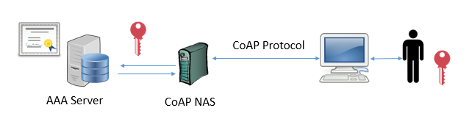

The client is a CoAP client ready to get the ticket after the login and it uses this ticket for the future requests. The AAA server validates the authentication requests and communicates the response to the NAS. Here NAS (RADIUS client) acts as a CoAP server. The CoAP server checks for the following requirements:

- The CoAP server must check for all the incoming packets with the Ticket according to the Kerberos approach. It should contain the user identity and the session key. It should be validated for giving specific permission to the users for specific services. The requests without the valid ticket should be rejected except for the reset and acknowledge messages.
- The authentication service defined by the authors (well-known/auth) must reside on the CoAP server.
- The authentication service again contains two different options namely (well-known/auth?login) to do the login and (well-known/auth?logout) to do the logout.
- If the login fails, the server must send an error message.
- If the login process succeeds, the server must create and send a new ticket together with the timeout.
- Similarly, logout process should delete the ticket on the sever side and send a message to the user that the logout was successful

Authentication Process
The author described two processes namely authentication and access control process which are different from each other. In the authentication process, the user(client) sends the request and the system must identify the user as a valid user. This is can identified by a password, or shared key or some other validator. Once the user logins successfully, the system informs the CoAP sever about the user, user permissions and timeout of the ticket and so on, At the end of this process, the CoAP-NAS send the user, the valid ticket, if the authentication is successful. Otherwise, it returns the user that the authentication failed because of incorrect user, or password or the incorrect shared key. Regarding the access control for each client request, it should include the valid user in order to identify if the user is a valid one or not. Once the server recognizes the user, it responds with a correct message. If the client request doesn’t include the valid ticket, then the server will respond with an error message. The flow of this process is shown in the following diagram.

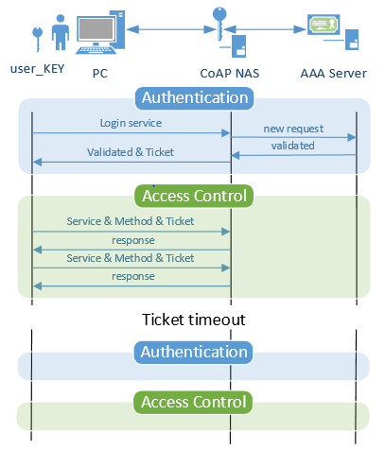

Authentication Method
The author described that during the authentication process, the authentication server (AAA server) must recognize the user as a valid user and it communicates that information to CoAP NAS. In order to make this process flexible and compatible with other standards, authors have proposed a public login CoAP service on the CoAP-NAS. This service receives a PUT request. The request normally contains the username and password as the payload which is accepted as a plain text format, username and password hash and a RADIUS packet (authors describe this as the future work). Using of two protocols namely RADIUS and CoAP gives the framework a very flexible authentication method. For this approach, author says that it is not required to have RADIUS protocol implementation on the client side. Hence, it reduces the overhead and the use of other required resources. This is mainly considered in resource constrained resources. Therefore, conversion of RADIUS packet to CoAP-RADIUS packet can be achieved in following ways. Firstly, complete RADIUS protocol lies inside CoAP packet or another alternative solution is, to omit the redundant information in two protocols as much as possible, hence deleting the attributes such as Code, Identifier, Length in the RADIUS packet. The following figures show the difference between the former one and the one after deleting the redundant information from RADIUS protocol.

Figure 6: RADIUS over CoAP Packet
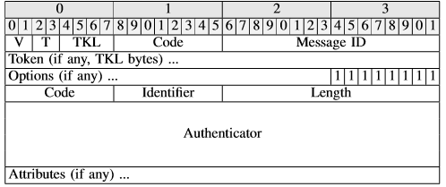

Figure 7: Compressed RADIUS over CoAP Packet
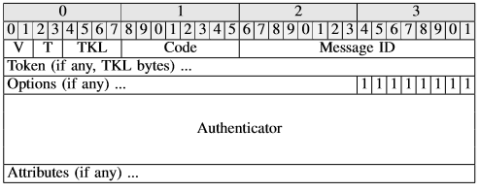

Control Method
The CoAP server handles lot of connections per second. As the increased number of requests from clients, increase the traffic and which in turn increase the size of the packet. Hence, the access control process should not increase the size of the packets, as the CoAP mainly focusses on low overhead resource constrained devices. In order to manage access control, the authors have introduced the concept of Ticket in their proposed framework. The Ticket has the following properties.
- It is unique for each user and for each session. When the session expires, the user is asked to authenticate again and the user receives a new ticket. This helps to increase the security per user.
- The expected length of the Ticket could be from 32 to 128 depending upon the requirements.
- In order to make the security little more complex, authors describe that the first Ticket could ma made as the basis in order to create a new one on each communication. This dynamic generation is made by using some crypto and hashing techniques.
On each incoming packet of CoAP from the client, CoAP sever knows the Message ID, Ticket, Service name, or URI to access and the Method (PUT, POST, GET etc.) of the packet. From the IP packet, the server knows the IP address and port number. Hence for each authentication process, server has to remember the user name, password, the IP address, port number, the generated Ticket and the timestamp for each time out. With this information, the server can check the permissions of user in the database. This process is normally done with high priority to find the validity of the Tickets. If the ticket is valid after authentication, user is send a normal response. If the Ticket is invalid, server has to respond with an error message with error ode of 406 (not found). The proposed framework by authors is able to find out whether the client is sending valid Tickets or not.

IV. SECURITY ANALYSIS

Some of the security features are described by the authors in this section.
- Eavesdropping attack: It is defined as the interception of communication between two parties by a malicious third party. Normally IP Sec and DTLS protect the system against this type of attacks. To increase the security to next level, the framework proposed by the authors could generate a new Ticket for each Message ID, hence increasing the intracity for the hackers or malicious user to predict a valid Ticket.
- Data Modification Attack: It is a type of attack where a hacker has an ability to modify the data in the message packet that is being transmitted between the sender and the user without their notice. This can be prevented by using IPsec protocol, which has an authentication header and it identifies the data change.
- Man in the Middle Attack: In this attack, the hacker or the attacker who is acting in middle of the sender and receiver can actively capture, monitor and controls the information. IPsec normally encrypts the data and will use timeouts for each IP connection increasing the difficulty to guess the password to decrypt the data.
- Spoofing Attack: In this type of attack, the attacker uses some special programs to construct IP packets that seems to originate from the valid address. Use of false IP addresses will not work over IPsec layer.
- DOS Attack: It is generally called Denial of Services attack. It prevents the user from normal usage of their computer or network. The authors state that there is no prevention from this type of attack. It is possible to decrease the overload discarding all the dirty packets directly on the IP layer, but if the attack is severe, the system will finally collapse.
- Application Layer Attack: The authors describe this as the difficult type of attack. In this attack, IPsec and DTLS will not protect the system. Only the services with the access control are protected from this type of attack.
- Replay Attack: It is an attack where the data transmission is maliciously or fraudulently repeated or destroyed.
This security features directly depends on the complexity of encryption method and the length of the keys being used. The authors also state that the current framework does not uses any cipher suite or any other hash techniques. But for the good security performance, it is best practice to use the hash techniques.

V. EXPERMIENTS AND RESULTS

The authors performed the experiment on the basis of libcoap 4.1.1. They have modified the source code to integrate the management of users and groups on each service with permissions. The Copper (Cu) Firefox add-on was used as the client side. The Copper User-Agent (Cu) for Firefox is a browser for IOT based on CoAP. It is a user friendly management tool for network embedded devices and resource constrained devices. It’s a Javascript implementation and was successfully tested at ETSI IoT CoAP Plugtest held in Paris, France in March 2012. The authors have also provided the graphical user interface. They have modified the Copper plugin in order to integrate the ticket management and to add a visual user login menu. The user menu seems in the following way:

Figure 8:Copper Login Menu
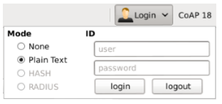

They created different services with different permissions in order to test the proposed framework for fine grain access control. They have created three user groups. They are namely, authorized user, unauthorized user and admin user.

The below screenshot was taken by the authors during their experiment with the proposed framework. Some services are accessible to public users. Some could be some specific service for non-authorized, like guest services that are not accessible by authorized users.

Figure 9: Services Available for Different Groups of Users
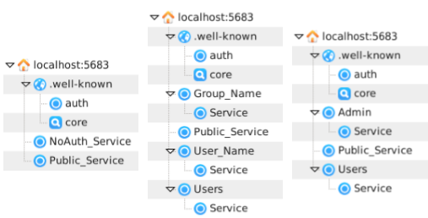

From the above figure, it is seen that, the public users have access to limited resources such as Public_Service, NoAuth _Service, whereas the private users have access to other resources such as Group_Name, User_Name User etc., and the admin users have access to other resources such as Admin service und Users etc. Each user is allowed with some methods to be performed on their services depending upon their type of access control.

Similarly, the following table shows the different packet types and the overhead obtained from using the current access control mechanism. The authors have proposed the optimum ticket size of 6-10 bytes.

Table 1:Message Size of CoAP Vs CoAP over RADIUS
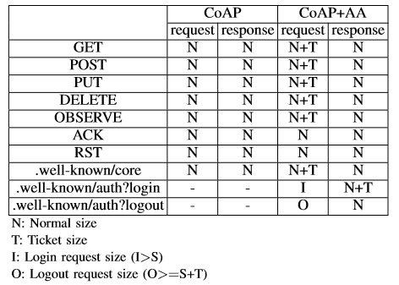

VI. FUTURE WORK

Though the current type of Kerberos for access control mechanism is beneficial, authors yet want to increase and improve it for service access control. They also would like to investigate the RADIUS for 6LowPAN that is to adopt the same type of mechanisms used by for example Wifi to 6LowPAN which further increases the network security. They also want to introduce the concept of CHAP (Challenge Handshake Authentication Protocol) to their framework which doesn’t require authentication of password from the clients. Usage of CHAP technique increases the security as it doesn’t require the password or the hash of the password. Hence, there is no option for compromising the client credentials even if the service is compromised. Authors also want to include the real. Time monitoring of the request to services, which is possible to detect when a certain IP address or user name is trying to access the service with incorrect credentials. Further, this information can be used to notify the administrator to take up further actions on the request for example blacklist their IP address in for example a firewall. The addition of firewall on different nodes would of course be advantageous as it defines different rules for different IP addresses range and in turn provide access to services based on their IP addresses range.

VII. CONCLUSION

Now-a-days, CoAP protocol is tremendously used in iot devices, resource constrained devices which contains very low band width and low overhead. CoAP protocols are mainly used on low band width layers such as 6LoWPAN over IEEE. The transmission and communication can be made more secure by using protocols such as DTLS and IPsec. But for the secure access control, using of these protocols is not sufficient. That is, controlling the access to services by IP or session level doesn’t enable fine grain access control. A user with one IP address can have read and write operations on one service whereas write operations on other service. With the existing methods, there is no good way of achieving this. Hence, the authors came up with a new solution which introduces the concept of Ticket as well as defines packet formats to add the possibility to use the normal protocol for authentication such as Kerberos and RADIUS. Hence the proposed framework with the extended definition, provides a fine grain access control to CoAP based services.
In the experiment conducted by that authors, they have used modified C-library CoAP which acts as a server and a customized version of Firefox plugin Copper as a client. They made an experiment with the above libraries and found out that the defined fine grain access control is able to find out the IP address, User, Services and the Method that are included in the request. After analyzing the request, response is send by the server depending upon the client’s permissions.
The current framework with the fine grain access control is successfully tested and executed. The authors would like to improve this in their next step by creating a distributed mechanism like Kerberos and would like to test the performance of the system in the context of memory usage, CPU consumption and the packet overhead. They also want to add a full support using decentralized AAA servers.

VIII. ACKNOWLEDGMENT

The authors would like to express their thankfulness towards their partners within Arrowhead project, the European commission and Artemis for funding to their project.

IX. REFERENCES

- What Is Eavesdropping in Computer Security? https://www.ecpi.edu/blog/what-is-eavesdropping-in-computer-security (accessed April 9, 2018).
- Common Types of Network Attacks. Microsoft TechNet. https://technet.microsoft.com/en-us/library/cc959354.aspx (accessed April 9, 2018).
- What is CHAP (Challenge-Handshake Authentication Protocol)? - Definition from WhatIs.com. SearchSecurity. http://searchsecurity.techtarget.com/definition/CHAP-Challenge-Handshake-Authentication-Protocol (accessed April 9, 2018).
- Puñal Pereira, Pablo & Eliasson, Jens & Delsing, Jerker. (2014). An Authentication and Access Control Framework for CoAP-based Internet of Things. 10.1109/IECON.2014.7049308.
- Common Types of Network Attacks. Microsoft TechNet. https://technet.microsoft.com/en-us/library/cc959354.aspx (accessed April 9, 2018).
- IP Security (IPSec). Microsoft System Center. https://technet.microsoft.com/en-us/library/cc179879.aspx (accessed April 9, 2018).
- IP Security (IPsec) and Internet Key Exchange (IKE) Document Roadmap. IETF Tools. https://tools.ietf.org/html/rfc6071 (accessed April 9, 2018).
- The Constrained Application Protocol (CoAP). IETF Tools. https://tools.ietf.org/html/rfc7252 (accessed April 9, 2018).
- IETF. https://www.ietf.org/rfc/rfc4120.txt (accessed April 9, 2018).
- Remote Authentication Dial In User Service (RADIUS). IETF Tools. https://tools.ietf.org/html/rfc2865 (accessed April 9, 2018).
- Diameter Base Protocol. IETF Tools. https://tools.ietf.org/html/rfc6733 (accessed April 9, 2018).
- Anon, (2018). [online] Available at: https://www.researchgate.net/profile/Ahmed_Jama8/publication/319943323_Survey_on_Data_Medication_Attacks/links/59c2ba66aca272295a0df479/Survey-on-Data-Medication-Attacks.pdf [Accessed 12 May 2018].
- Anon (2018) Copper (Cu) CoAP user-agent - JavaScript CoAP Implementation [Internet]. Available from: <http://people.inf.ethz.ch/mkovatsc/copper.php> [Accessed 15 May 2018].

