TriZetto AI Gateway → AWS Bedrock AgentCore
Capability Mapping & Gap Analysis Matrix
Proof of Concept Reference | Cognizant TriZetto Applied Technology Team | April 2026 | CONFIDENTIAL

Purpose
This matrix maps every significant TAG capability to its AWS Bedrock AgentCore equivalent, assigns a coverage status, and defines the specific validation action required during the PoC (Proof of Concept) engagement as defined in the TAG MCP Client Layer Modernization Scope of Work (March 2026). Use this matrix as a PoC checklist to ensure that all functional capabilities and non-functional requirements are exercised and evidenced before any go/no-go migration decision.

Coverage Status Legend
Native | AgentCore provides this capability out-of-the-box with no custom code
Configurable | Available in AgentCore but requires configuration, policy design, or parameter tuning
Requires Custom | Partial AgentCore support; custom wrapper, Lambda, or agent logic needed
Not Supported | No AgentCore equivalent; must be built externally or accepted as a gap
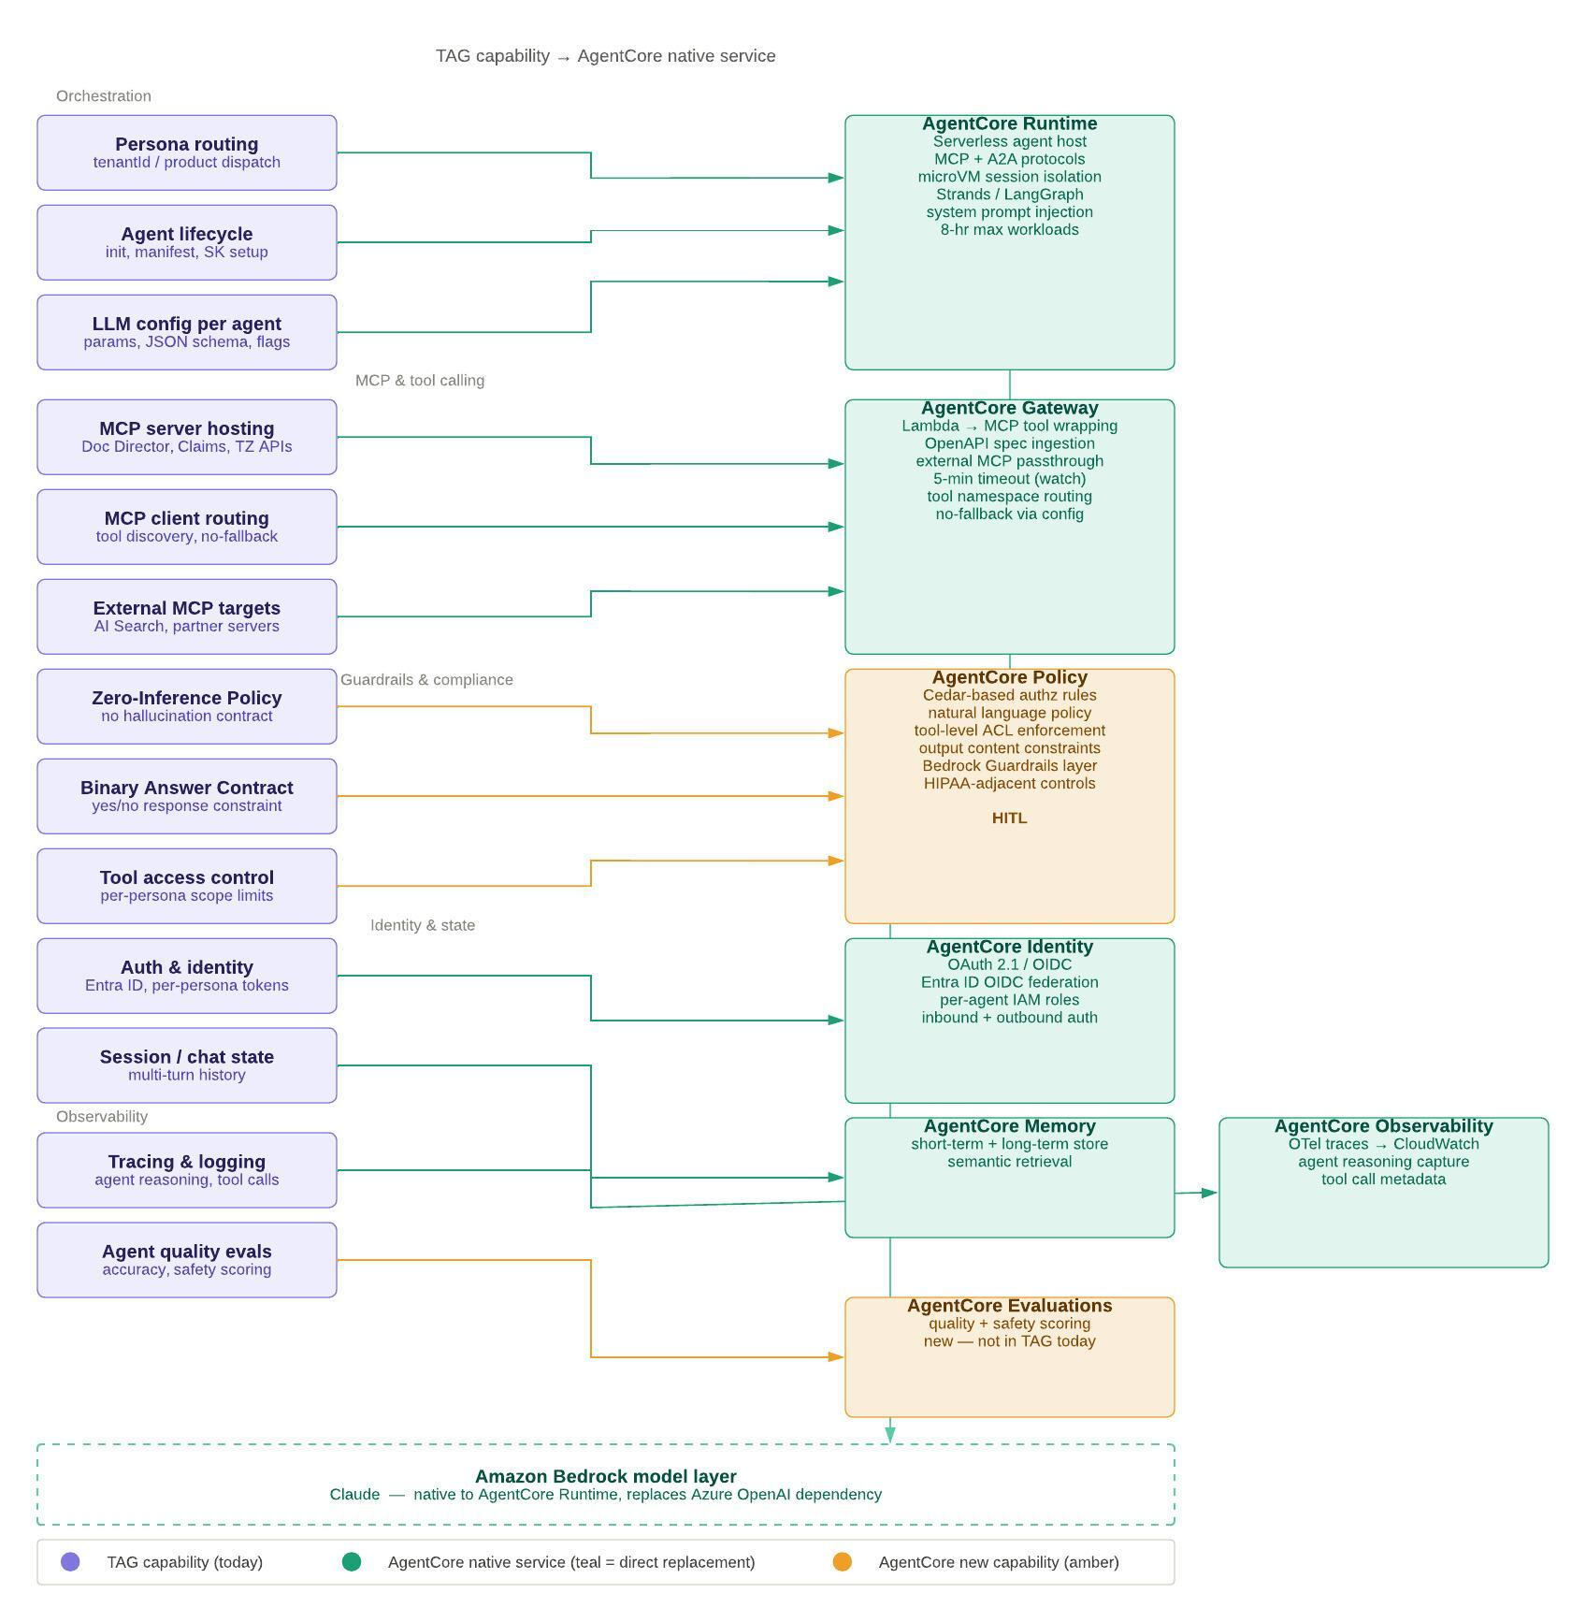

Coverage Summary
Coverage Status | Count
Native | 10
Configurable | 6
Requires Custom | 7
Not Supported | 2

Capability Mapping Matrix
Sections align to TAG's architectural layers as defined in the TAG Architecture & Developer Reference and the AgentCore SoW. Each row represents a PoC test case. (* = not required in the pilot phase)
TAG Capability | Coverage | AgentCore Equivalent | Gap / PoC Validation Action
1. Orchestration & Persona Management
Persona routing (tenantId / product dispatch) | Native | AgentCore Runtime  Serverless agent host with per-agent config and routing | Validate that tenantId-based routing logic translates to AgentCore agent config. Test persona dispatch with TAG's existing product codes.
Agent lifecycle management (init, manifest, SK setup) | Configurable | AgentCore Runtime  Agent definition via model + system prompt + tools config; Managed Harness (no-code option) | TAG Manifest schema has no direct AgentCore analog. Design custom config layer for persona manifest equivalence. Validate on PoC.
LLM config per agent (params, JSON schema, flags) | Configurable | AgentCore Runtime  Per-agent model config; model-agnostic switching supported | Verify JSON Schema structured output support in AgentCore. Test flag-level overrides per invocation — critical for TAG's Binary Answer Contract.
Multi-model backend (Azure OpenAI / Bedrock) | Configurable | AgentCore Runtime  Native Bedrock; Azure OpenAI via external API call | Azure OpenAI from AgentCore introduces cross-cloud latency. PoC must benchmark latency delta. Recommend migrating TAG personas to Bedrock models.
No-fallback routing enforcement* | Requires Custom | AgentCore Policy (Cedar)  + custom agent logic | AgentCore Runtime does not natively enforce no-fallback. Must implement deterministic error propagation in agent code or Cedar policy. Critical PoC item.
2. MCP Server Hosting & Tool Calling
MCP server hosting (Doc Director, Claims, TZ APIs) | Native | AgentCore Runtime  Containerized MCP server host; microVM session isolation | Containerize Doc Director and Claims MCP Server as ARM64 images. Validate stateless HTTP mode. Test 8-hr workload limit against TAG use cases.
MCP client routing (tool discovery, no-fallback) | Native | AgentCore Gateway  MCP server registration; tool namespace routing | Register TAG MCP servers in AgentCore Gateway. Validate tool discovery matches TAG's dynamic server registration. Watch 5-min Gateway timeout.
External MCP targets (AI Search, partner servers) | Native | AgentCore Gateway  External MCP server passthrough; OpenAPI spec ingestion | Configure per-server OAuth / API key auth in Gateway. Validate external MCP passthrough with TAG's third-party server pattern.
Azure AI Search tool (AI Search MCP Server / RAG) | Requires Custom | No native AgentCore analog.  Wrap as Lambda or OpenAPI target via AgentCore Gateway | Must wrap Azure AI Search as Lambda function or OpenAPI spec in AgentCore Gateway. Index migration not required. Latency and auth flow must be validated in PoC.
Bearer token propagation to downstream MCP tools | Configurable | AgentCore Identity  Inbound + outbound auth; per-agent IAM roles | Validate that bearer tokens from Entra ID are propagated through AgentCore to downstream MCP server calls. Token claim mapping must be verified.
3. Guardrails, Policy & Compliance
Zero-Inference Policy (no hallucination contract)* | Requires Custom | AgentCore Policy  Cedar-based authz rules; natural language policy authoring | Cedar policy model differs fundamentally from SK prompt engineering. Policy translation required. Prototype Cedar equivalent of Zero-Inference Policy in PoC.
Binary Answer Contract (yes/no response constraint)* | Requires Custom | AgentCore Policy  + system prompt enforcement | Enforce via system prompt on AgentCore Runtime agent config AND Cedar output constraint. Validate that structured output format is preserved end-to-end.
Tool access control (per-persona scope limits)* | Native | AgentCore Policy  Tool-level ACL enforcement; Cedar fine-grained authz | Define Cedar policy per persona scoping tool access. Native fit — validate policy authoring for TAG's existing persona/tool access matrix.
Output content constraints (Bedrock Guardrails) * | Native | AgentCore Policy  Bedrock Guardrails layer; HIPAA-adjacent controls | Bedrock Guardrails available natively in AgentCore Policy. Verify HIPAA BAA coverage. Validate content filtering rules match TAG's current Azure AI Content Safety config.
HIPAA compliance posture | Requires Custom | AWS HIPAA-eligible services  (partial — must verify per component) | Not all AgentCore service components confirmed under HIPAA BAA. Must obtain BAA confirmation for Runtime, Gateway, Memory, Identity, and Policy components before PoC go-live.
Human-in-the-Loop (HITL) | Configurable | AgentCore Policy  HITL escalation hooks; agent pause/resume | AgentCore Policy supports HITL patterns. Map TAG's current kill-switch and override flows to AgentCore HITL hooks. Validate user-facing experience parity.
4. Identity & Session State
Auth & identity (Entra ID, per-persona tokens) | Native | AgentCore Identity  OAuth 2.1 / OIDC; Entra ID OIDC federation; per-agent IAM roles | Configure Entra ID OIDC federation in AgentCore Identity. Validate token claim mapping for TAG's per-persona identity isolation. Least-privilege IAM role design required.
Session / chat state (multi-turn history) | Native | AgentCore Memory  Short-term in-session store; semantic retrieval | Select memory store type (in-memory vs. persistent). Validate multi-turn context fidelity against TAG's current SK conversation state. Benchmark latency and cost.
Composite memory management (short-term + long-term) * | Configurable | AgentCore Memory  Short-term + long-term semantic memory stores | AgentCore Memory supports both tiers natively. Design memory scoping strategy per persona. Validate semantic retrieval accuracy for healthcare payer domain context.
5. Observability & Tracing
Tracing & logging (agent reasoning, tool calls) | Native | AgentCore Observability  OTel traces → CloudWatch; agent reasoning capture; tool call metadata | Port Azure Application Insights dashboards to CloudWatch equivalents. Validate OTel trace completeness for tool invocations and model interactions.
Agent quality evals (accuracy, safety scoring) | Native | AgentCore Evaluations  Quality + safety scoring; LLM-based evaluator orchestration | New capability not currently in TAG. Use AgentCore Evaluations in PoC to baseline TZ Pass Through persona accuracy and safety scoring before migration.
Real-time response validation (inline hallucination detection) * | Requires Custom | AgentCore Evaluations  + Policy guardrails (partial) | AgentCore Evaluations is post-hoc, not real-time. Real-time hallucination guardrails must be implemented via Cedar Policy output constraints + Bedrock Guardrails. Custom implementation required for inline detection.
6. Agentic & Multi-Agent Orchestration
Persona-based agent dispatch (single agent per request) | Native | AgentCore Runtime  Per-agent microVM; Strands / LangGraph orchestration | Direct equivalent. Validate SK → Strands framework migration for TAG orchestration logic. Test system prompt injection fidelity.
Multi-agent collaboration (supervisor / sub-agent) | Configurable | AgentCore Runtime  Strands: Agents-as-Tools, Swarm, Graph, Workflow patterns | TAG currently uses single-agent per request. Multi-agent patterns are available in AgentCore for roadmap personas. Evaluate Strands orchestration patterns for future TAG agents.
Agent-to-Agent (A2A) protocol* | Native | AgentCore Runtime  Native A2A protocol support; Google A2A standard | A2A natively supported. Relevant for TAG's roadmap MCP interop with Neuro AI and enterprise agent platforms. Validate A2A endpoint discovery for future TAG↔Neuro integration.
Config / manifest management (env separation, audit) | Requires Custom | AgentCore runtime configs  + custom config layer needed | No direct AgentCore analog to TAG's Manifest schema. Design custom persona manifest equivalent using AgentCore runtime config + environment-separated parameter store. Key PoC deliverable.
7. Capabilities Not Supported in AgentCore (Not to be treated as a show-stopper, unless classified)
Self-hosted / on-premise deployment (non-AWS infrastructure) | Not Supported | AWS-managed infrastructure only.  No self-hosted AgentCore Runtime path. | Blocking gap for customers requiring on-premise or Azure-only deployment. TAG's current Azure SK deployment has no AgentCore equivalent. Document as hard constraint in PoC go/no-go. But we are OK with this as this version will be available only for AWS ready customers.
Azure AI Content Safety (native Azure guardrail integration) | Not Supported | Replaced by Bedrock Guardrails.  No native Azure Content Safety passthrough. | Must migrate content safety controls from Azure AI Content Safety to Amazon Bedrock Guardrails. Validate rule parity — particularly PHI/PII filtering and healthcare-specific classifiers.

PoC Validation Checklist
The following items are the minimum set that must be validated during the PoC (Phase 2, Weeks 4–8) to support a go/no-go migration decision:
# | PoC Validation Item | Success Criterion
1 | TZ Pass Through persona equivalent deployed on AgentCore Runtime | System prompt injected correctly; persona responds within <3s P95
2 | Doc Director MCP Server containerized and hosted on AgentCore Runtime | ARM64 image deployed; tool calls succeed; stateless HTTP mode confirmed
3 | Claims MCP Server registered and routable via AgentCore Gateway | Tool discovery works; no-fallback error propagation validated
4 | AI Search tool wrapped as Lambda / OpenAPI target in AgentCore Gateway | RAG queries return correct results; auth flow end-to-end verified
5 | Entra ID OIDC federation configured in AgentCore Identity | Bearer tokens issued, propagated, and accepted by downstream MCP servers
6 | Zero-Inference Policy and Binary Answer Contract prototyped in Cedar | Policy blocks out-of-scope responses; structured yes/no output enforced
7 | HIPAA BAA coverage confirmed for all AgentCore services in scope | Written BAA confirmation from AWS for Runtime, Gateway, Memory, Identity, Policy
8 | No-fallback routing implemented and tested | Explicit error returned on tool miss; no silent re-routing observed
9 | OTel tracing pipeline from AgentCore to CloudWatch validated | Tool call metadata, model interactions, and agent reasoning captured end-to-end
10 | AgentCore Evaluations baseline run on TZ Pass Through persona | Accuracy and safety scores established as migration baseline
Document Classification: Internal / AWS Partner Confidential | Cognizant TriZetto Applied Technology Team | Version 1.0 — April 2026
Based on: TAG Architecture & Developer Reference (March 2026), TAG AgentCore Scope of Work (March 2026), Neuro AI vs TAG Comparison, TAG↔AgentCore Native Architecture Diagram (April 2026)

