https://www.youtube.com/watch?v=Xfl50508LZM Hands-On Phoenix Evals for Agentic Applications
Eval Criteria:
Precision example - Spam Email needs good precision where it is OK to make real email as spam and not life threatening. For these situations you can keep false positives less to get good precision.
Recall Example - For cancer patients we must be very cautious and here we go by recall. For these patients keeping false negative is low is very important.
Cost normalized accuracy - Accuracy/cost This is trade off between accuracy vs cost to choose right model for right job and don’t pay too much.
Pairwise evaluation – AB testing kind
Cost implemented in llmwiki is https://github.com/scrollypedia/toko-mo-co https://www.youtube.com/@scrollypedia

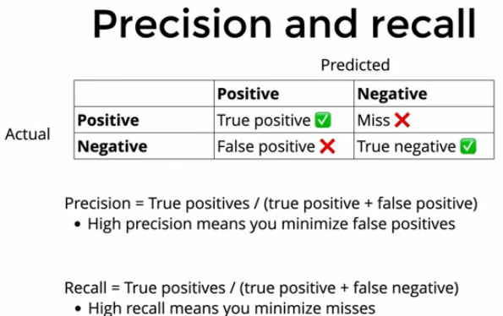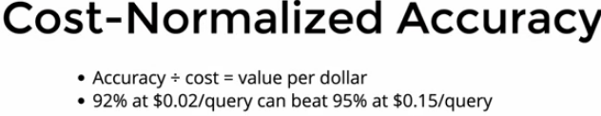
Arize is commercial version of opensource Phoenix with below features
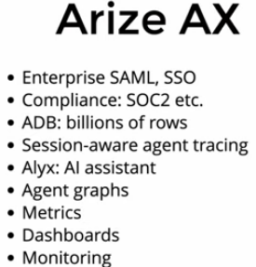
Langchin introduces deep agent like claude code, PI which are agent harness tools. Evals and traces are helping learning as the gradient dissent in traditional ML usecases either is model layer, context layer or harness layer.
