Project Report Template

Build an Employee Travel Approval Application for corporates

1.1 Overview

The cost of approval in India is roughly pegged around 8-11% of your total business travel spend. A few companies are now moving towards approval only when travel policy is being violated by employees.

Indian companies are slowly waking up to the advantages of this process.

1.2 Purpose

Approvals on time

Customized approval workflows

Increased compliance and reduced costs

Faster processing time

2 Problem Definition and Design Thinking

2.1 Empathy map

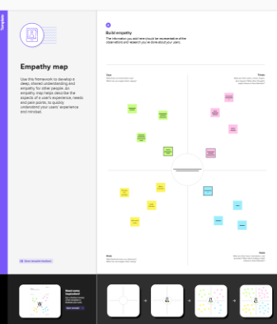

2.2 Ideation and brainstorming Map 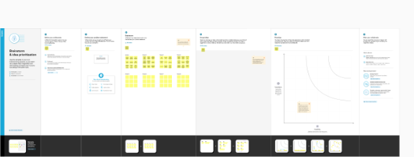

3 Result

3.1 Data Model

|  |  |
| --- | --- |
| Object name | Fields in the object |
| Object    Travel approval | |  |  | | --- | --- | | Field label | Data type | | Travel Approval | Auto Number | | Travel Approval | Master Detail Relationship | |
| Object 2  Expense Item | |  |  | | --- | --- | | Field label | Data type | | Total expenses | Roll up summary | | Amount | currency | |
| Object 3    Departments | |  |  | | --- | --- | | Field label | Data type | | Departments | Auto Number | | Expense | picklist | |

3.2 Activity and screenshot

To create the object, go to salesforce.com

After login this home page will display

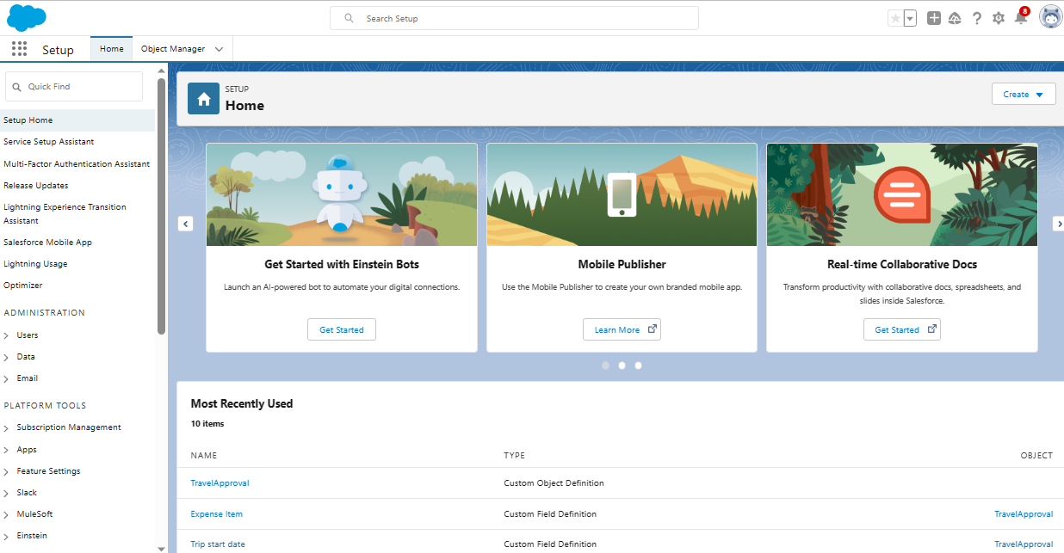

Milestone 2 creating travel application

From setup enter app manager in the quick find and select app manager

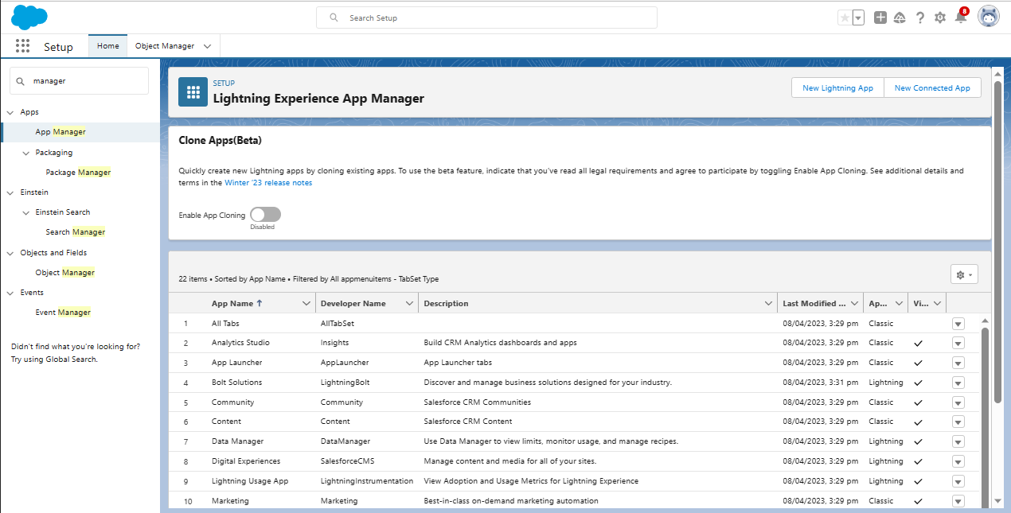

Click new lighting app enter travel approval as the app name then click next

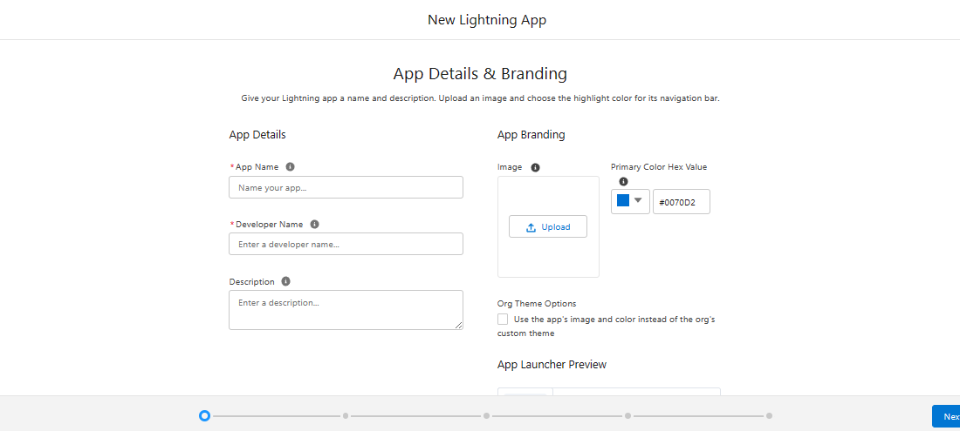

From available items select departments, travel approval, expense item, reports and dashboards and move them to selected items. Click next.

From available profiles select system administrator and move it to selected profiles. Click save and finish.

Milestone 3

Creating 3 objects

Departments

Travel approval

Expense item

Custom object creation

From the setup page click on object manager click on create click on custom object

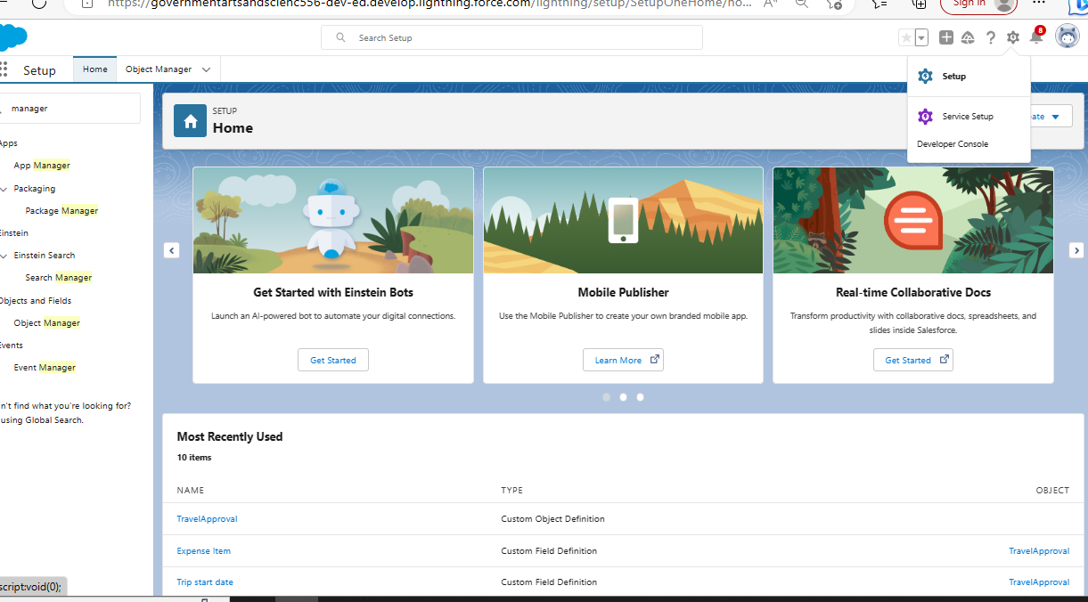

Enter the label name plural label name click on allow reports, allow search save

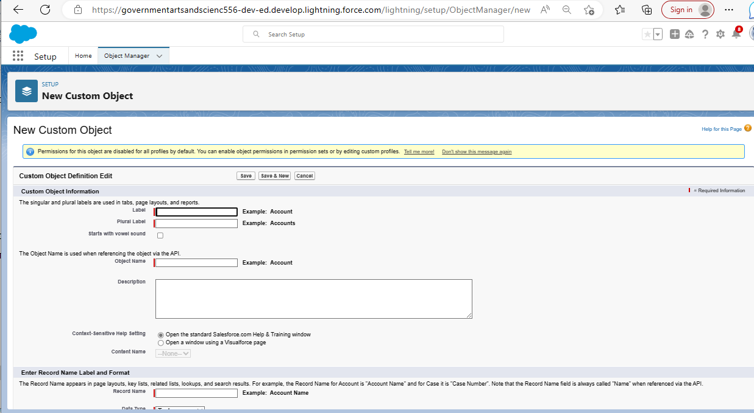

Create 3 customs and tab

Department

Travel approval

Expense item

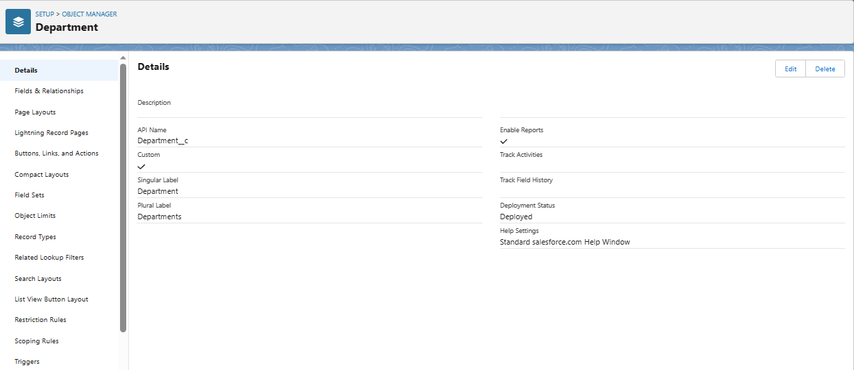

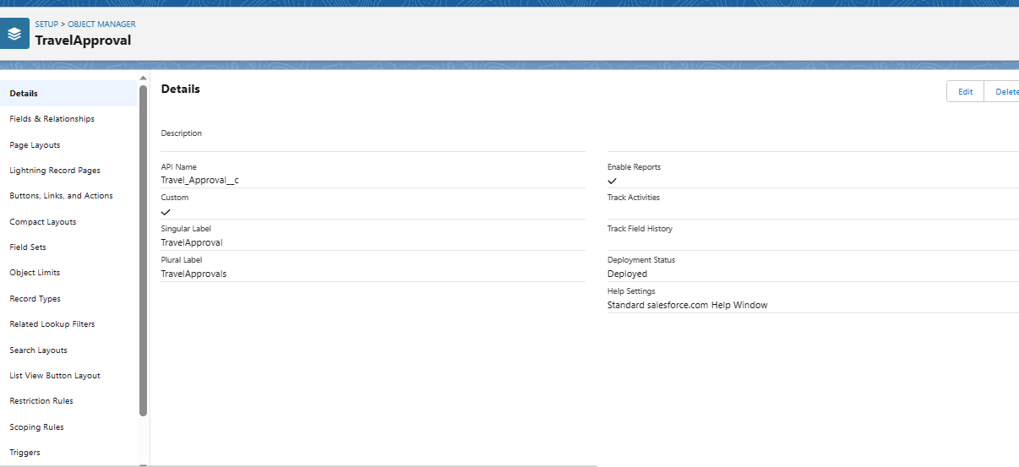

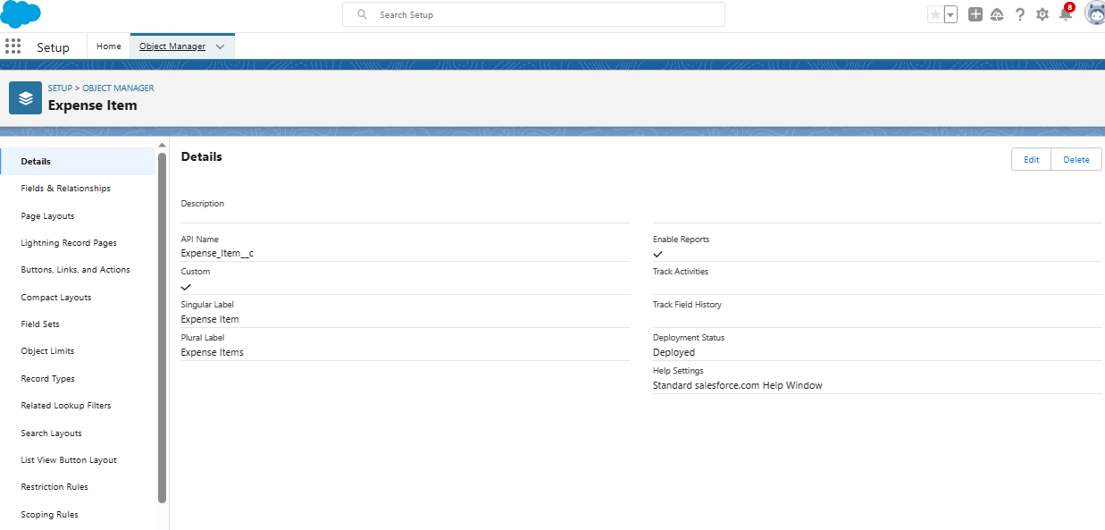

Now create a custom tab click the home tab, enter tabs in quick find and select tabs under custom object tabs click new.

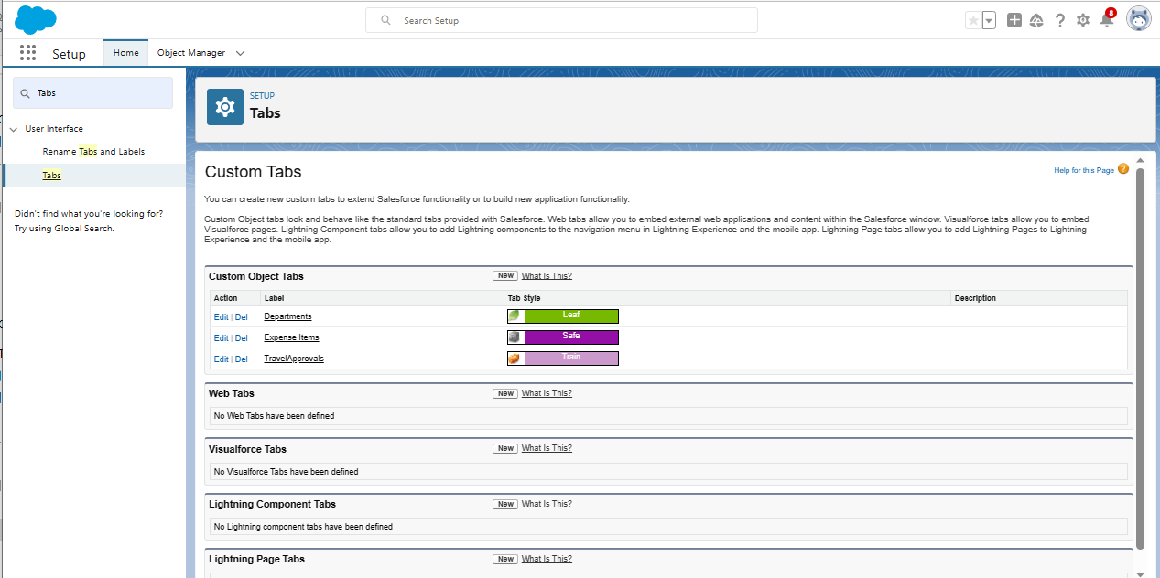

Milestone 4

Click fields and relationships and click new

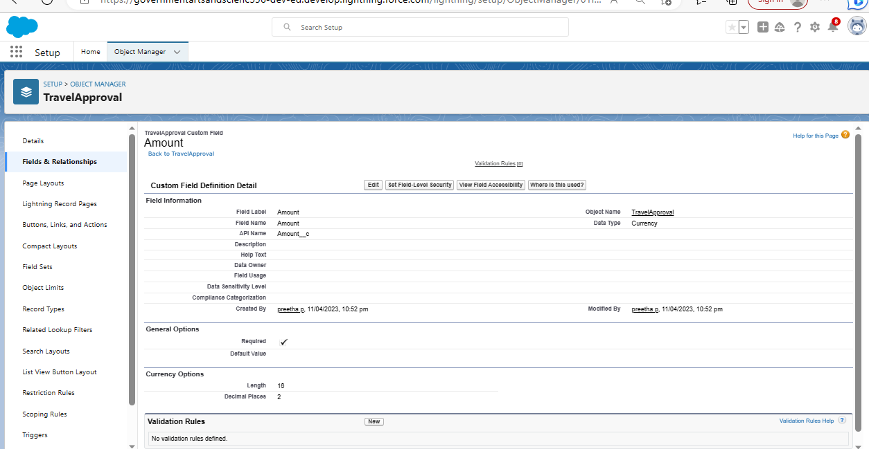

Create the expense type field

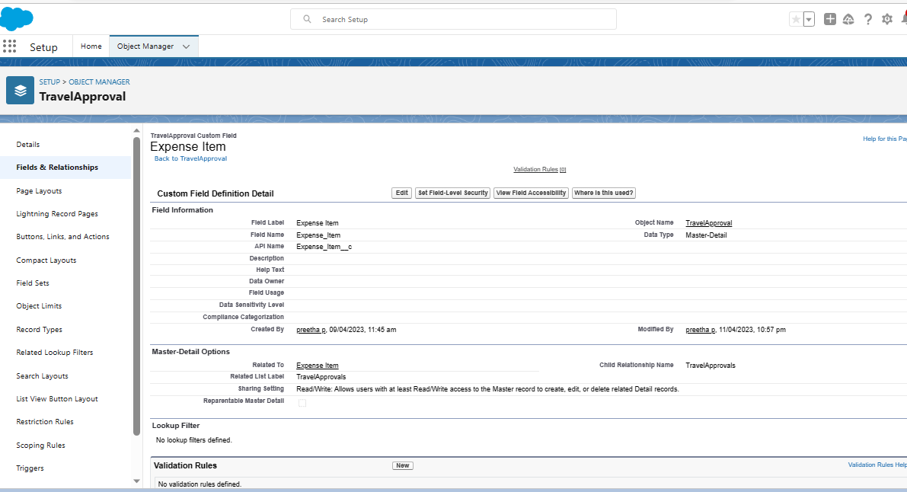

Create the travel approval field

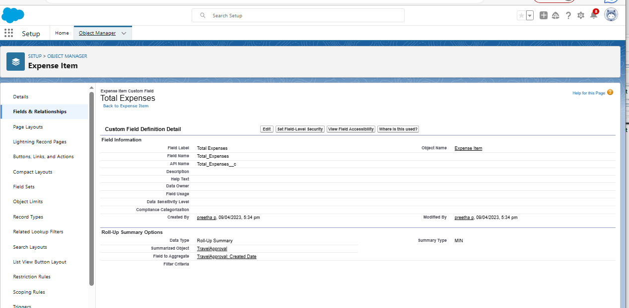

Milestone 5-Import department

In the quick find box enter data import and select data import wizard

Click launch wizard

Drag and drop the csv file you download using zip file

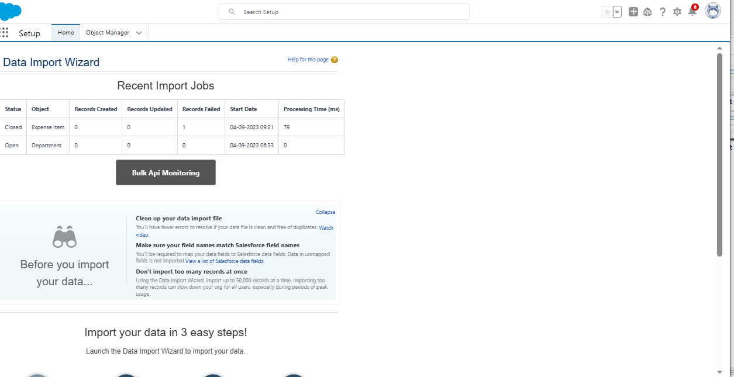

Milestone6- customize user interface

Create users and setup approvals

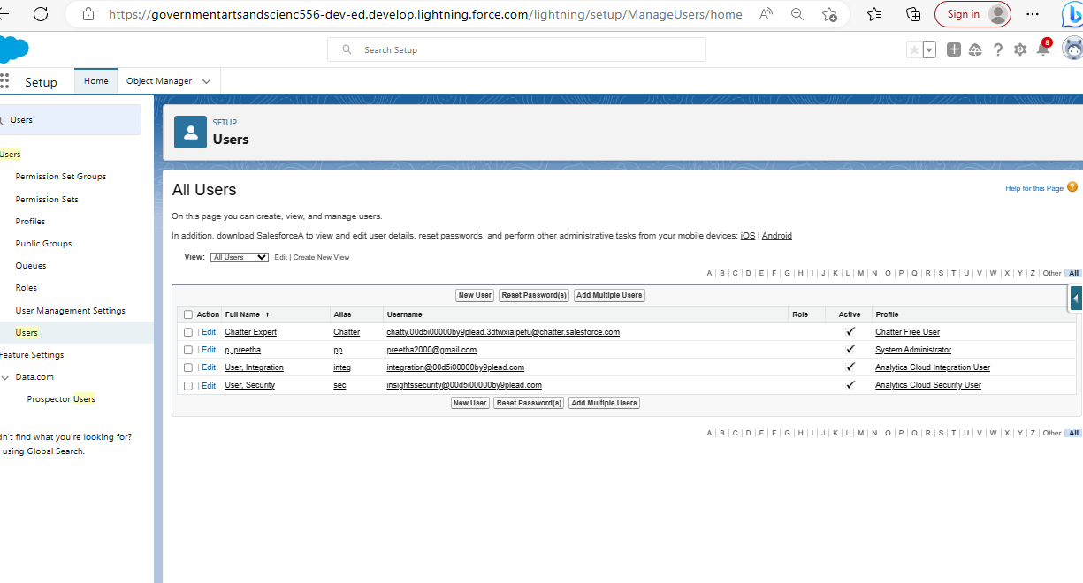

Click new user

Give the role as CEO, profile as system administrator and license as salesforce

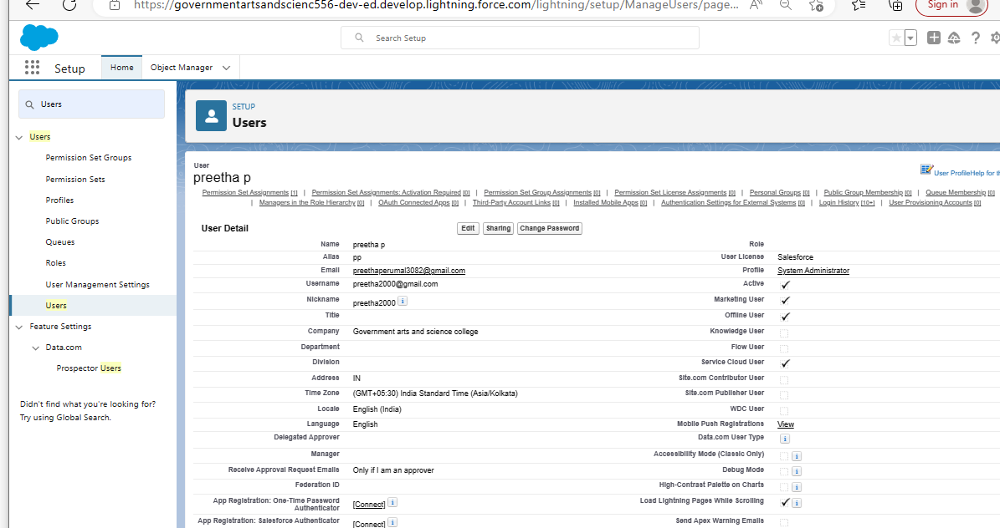

Milestone7- Use customization

Customize travel approval object page layout

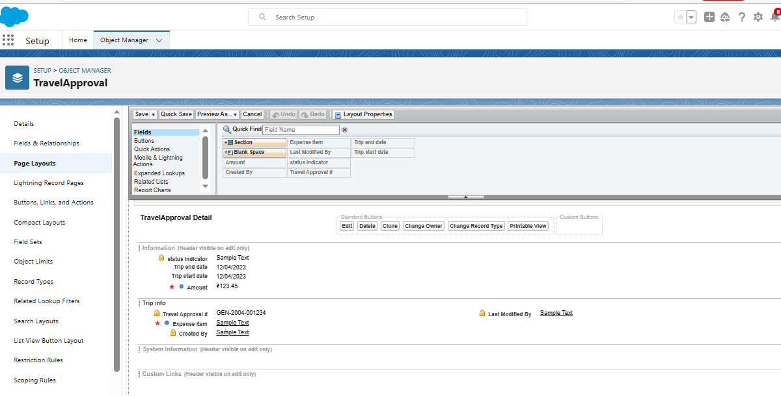

Milestone 8-add business logic to travel app

Create validation rule

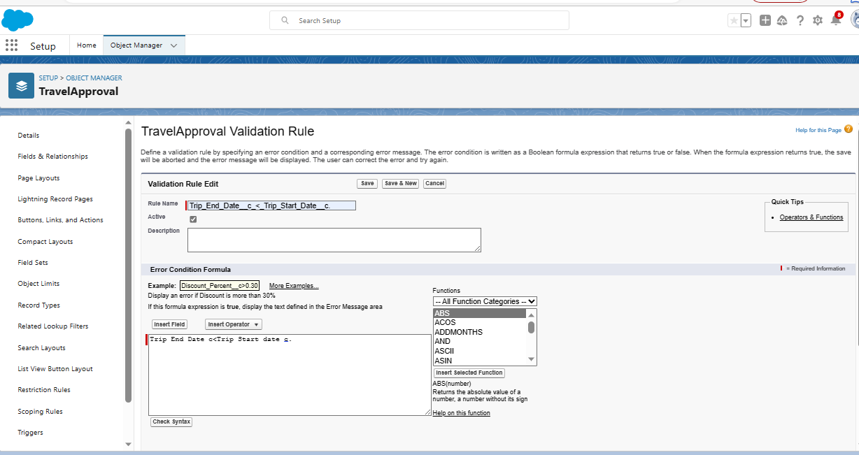

Create roll up summary fields

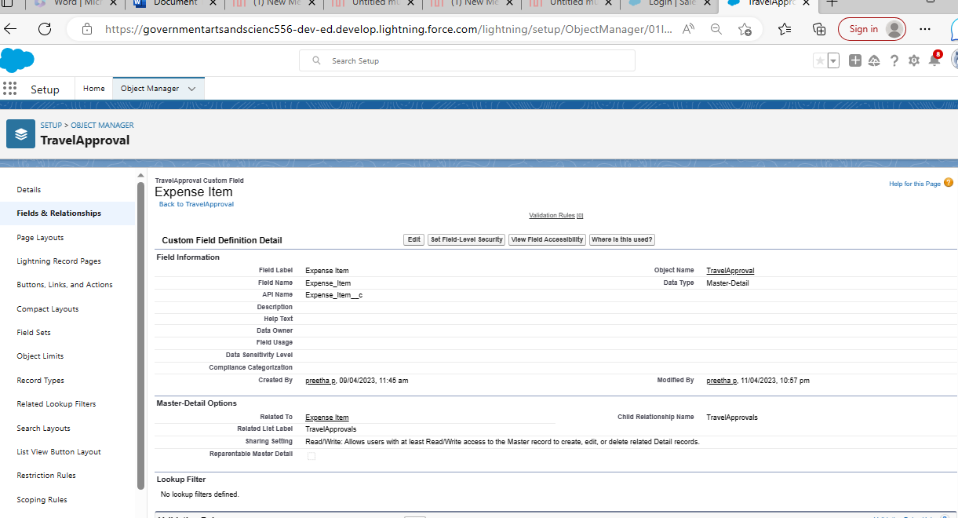

Create formula fields

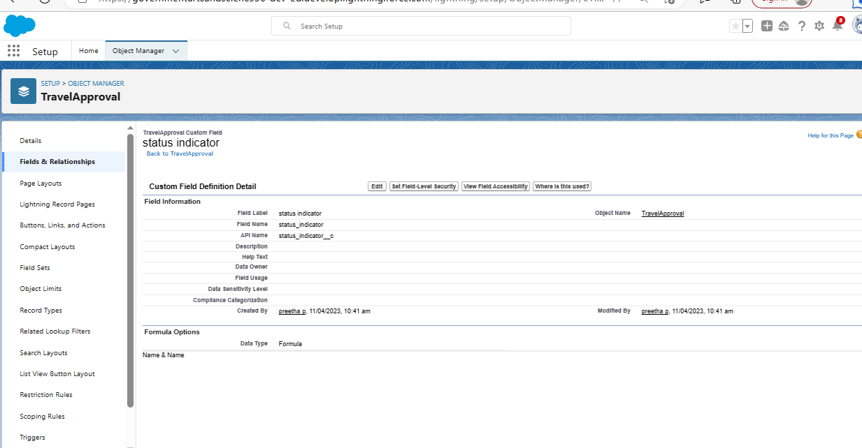

Milestone 10 what are reports

Add report

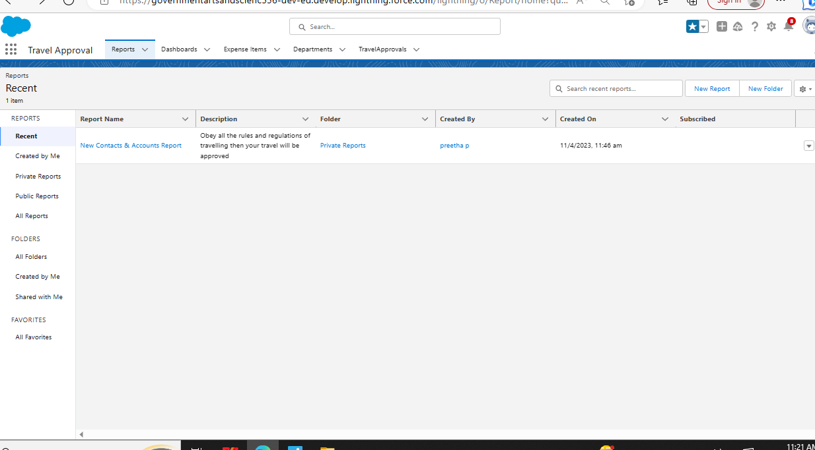

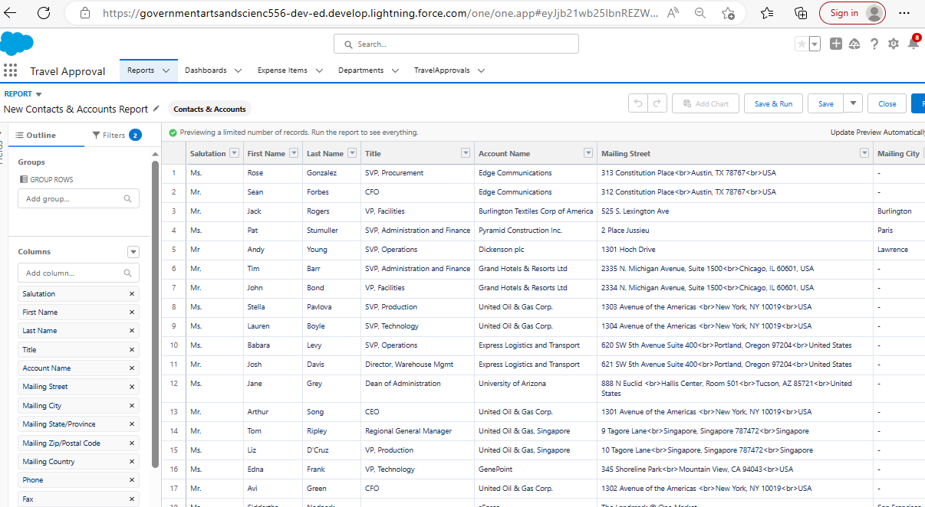

Milestone7-Dashboards

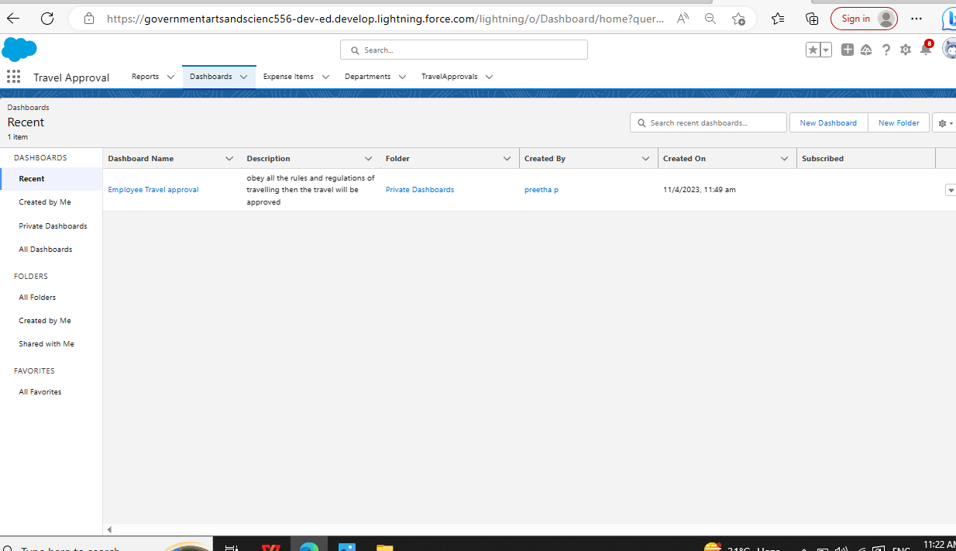

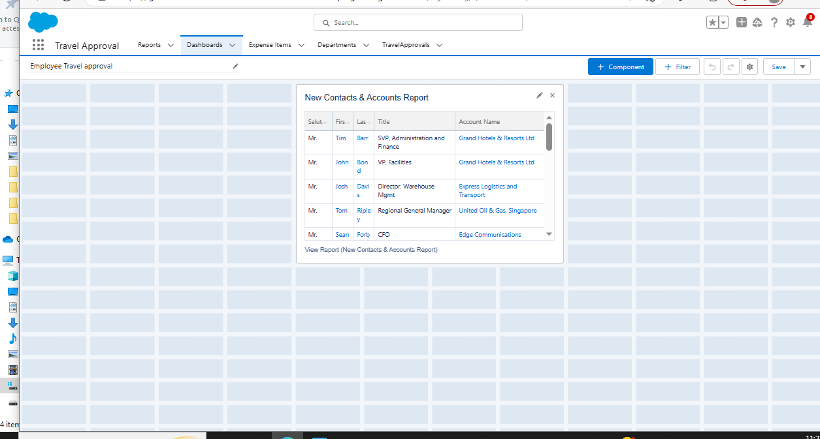

4 Trailhead profile public URL:

Team Lead: https://trailblazer.me/id/ii26p

Team memberr1: https://trailblazer.me/id/ii14c

Team member2: https://trailblazer.me/id/ii36m

Team member3: https://trailblazer.me/id/ii03s

Advantages and Disadvantages

Advantages

Approvals on time. The entire process of planning and managing a trip is a long and stressful process.

Customize approval workflows. The approval process can differ from company to company

Increase compliance and reduce costs.

Faster process.

Disadvantages

You might get sick

Sleeping in many different beds

may feel strange.

Your current worldview may collapse.

Some companies may not be willing to employ you

Application

Logging in as an employee for requesting a business trip

Entering a travel request with flight and hotel information

Logging in as a manager for approval for approving travel requests

Conclusion

As we have seen in the chapter tourism is a complex system that is Bulit up of industry sector including accommodation recreation and entertainment and beverage services.

Future scope

Travel and tourism filed involves hospitably management tour management it has endless job opportunities in India as large number of heritage and other tourists.