**44-599: Introduction to Data Visualization**

**Worksheet for drawing Sunburst Chart using RAW tool**

1. In this embedded worksheet we have two different datasets.
2. Dataset -1 (Wine Categories). Contains data of different sub categories of wine and their subcategories respectively.
3. Dataset - 2 (Oscars data). Contains data of Oscar awards by categorizing them to best picture, best actor and best actress with corresponding years.
4. Open <http://rawgraphs.io/> then press button “use it now!” and now in new tab raw tool is opened.



1. Click on upload a file then drag or select a spreadsheet Sunburst_Chart.xlsx into it, wine and Oscars sheets are loaded into the tool.
2. Select sheet named Wine, now data is displayed in comma delimited values.
3. Now select the sunburst chart from the different charts.
4. Scroll down, now you can see Map your dimensions where you have to drag and drop Parent and subcategories as shown below respectively.

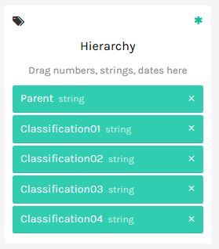

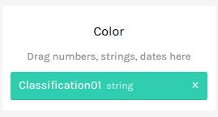

1. Scroll down to see the sunburst chart.

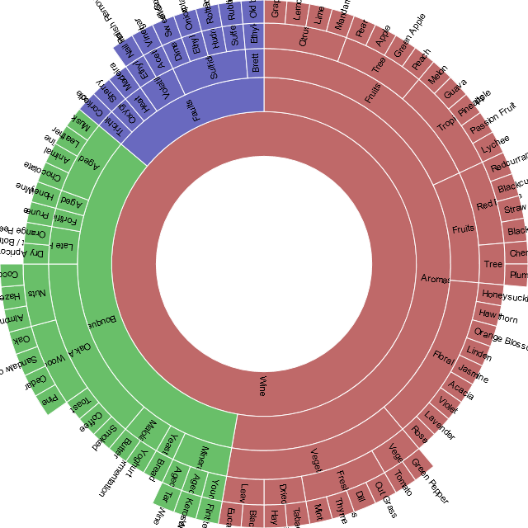

**Worksheet for drawing Sunburst Chart using Microsoft Power BI (desktop version) tool**

1. In this embedded worksheet we have two different datasets.
2. Dataset -1 (Wine Categories). Contains data of different sub categories of wine and their subcategories respectively.
3. Dataset - 2 (Oscars data). Contains data of Oscar awards by categorizing them to best picture, best actor and best actress with corresponding years.
4. Open <https://powerbi.microsoft.com> from the product menu select Power BI Desktop then new page will be opened, click on the download button and install the Power BI Desktop version.
5. After installing we have to download sunburst chart from custom visuals of power bi <https://app.powerbi.com/visuals/> .
6. Open Power BI Desktop tool click on the get data from menu and select excel sheet and load the Oscars sheet from the loaded data.
7. Import sunburst chart add on to your visualizations.
8. In Power BI any numbers in a fields are summated by default, to remove this select Year field so go to the modeling section in the top menu in the home table section there is default summarization dropdown select do not summarize from it.
9. Select sunburst chart from visualization and Drag the data fields into the groups and values as shown below:

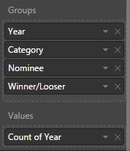

1. Then the chart is obtained as below:

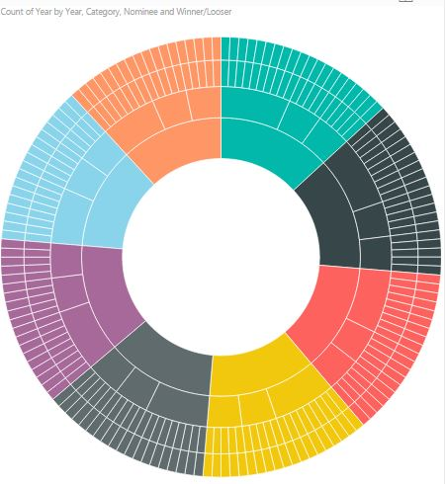

Data source:

Dataset1:

<http://ww.aculocity.com/Areas/Labs/Data/sunburst/WineTasting%20Wheel.json>

Dataset2:

<http://oscar.go.com/nominees>